SPICEiST: Subcellular RNA Pattern Enhances Cell Clustering of Imaging-Based Spatial Transcriptomics
Sungwoo Bae^{1, *}, Yuchang Seong¹, Dongjoo Lee¹, Hongyoon Choi^{1, 2, *}
¹Portrai, Inc. Republic of Korea; ²Department of Nuclear Medicine, Seoul National University Hospital, Seoul, Republic of Korea

A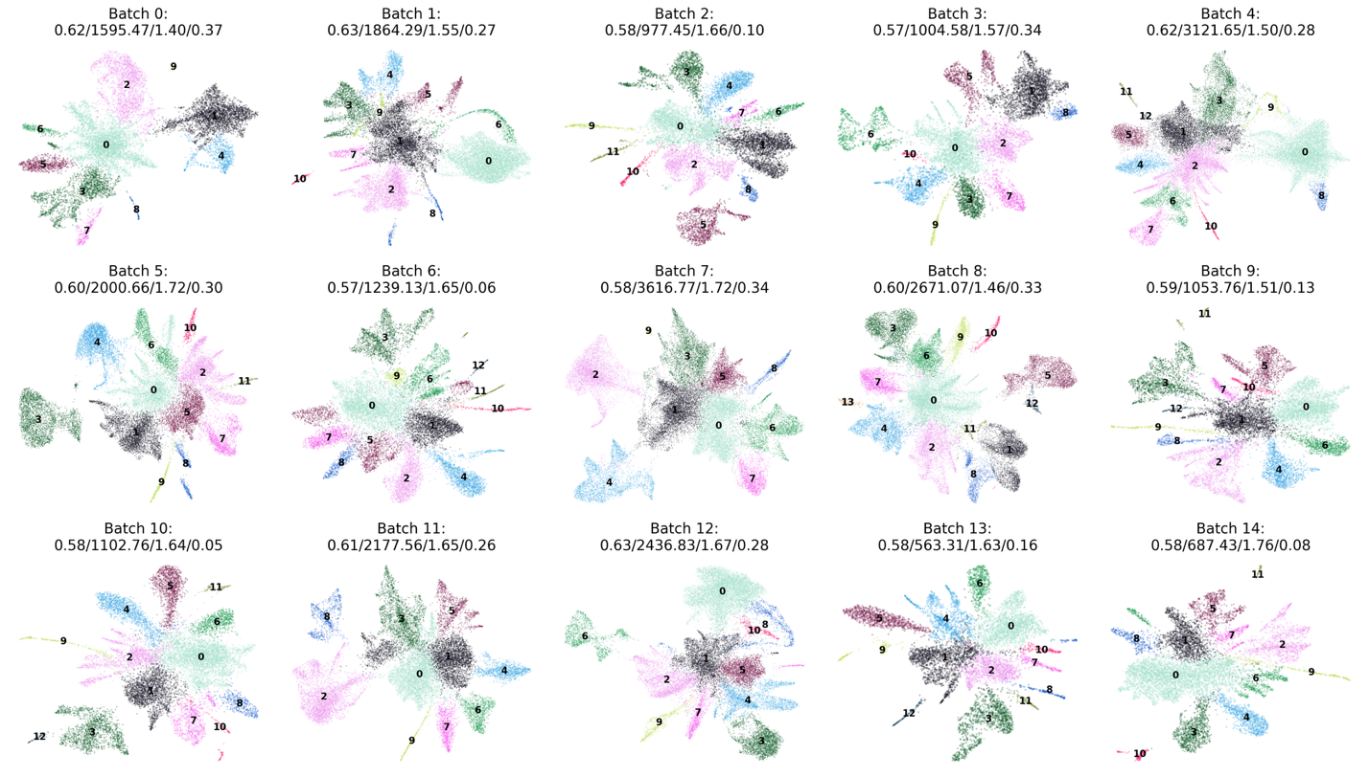
B
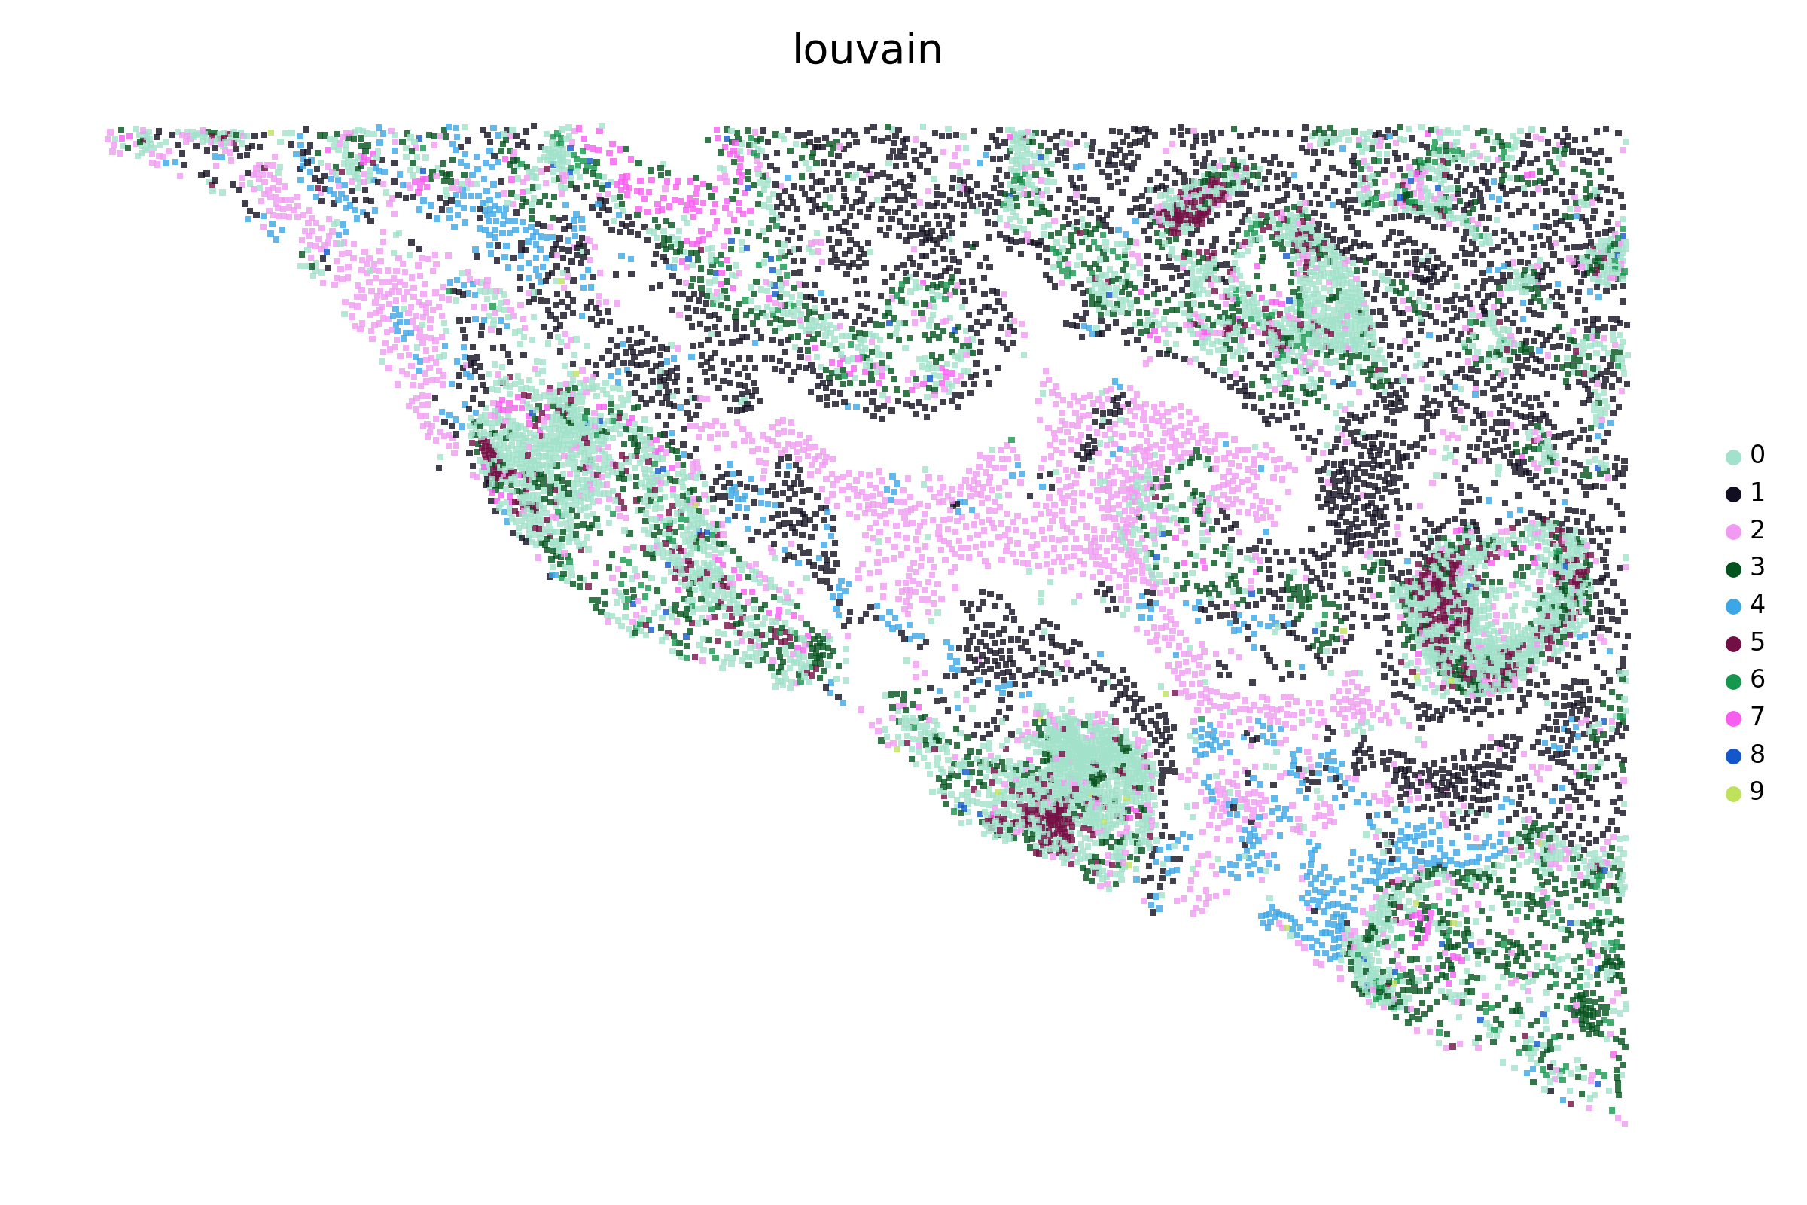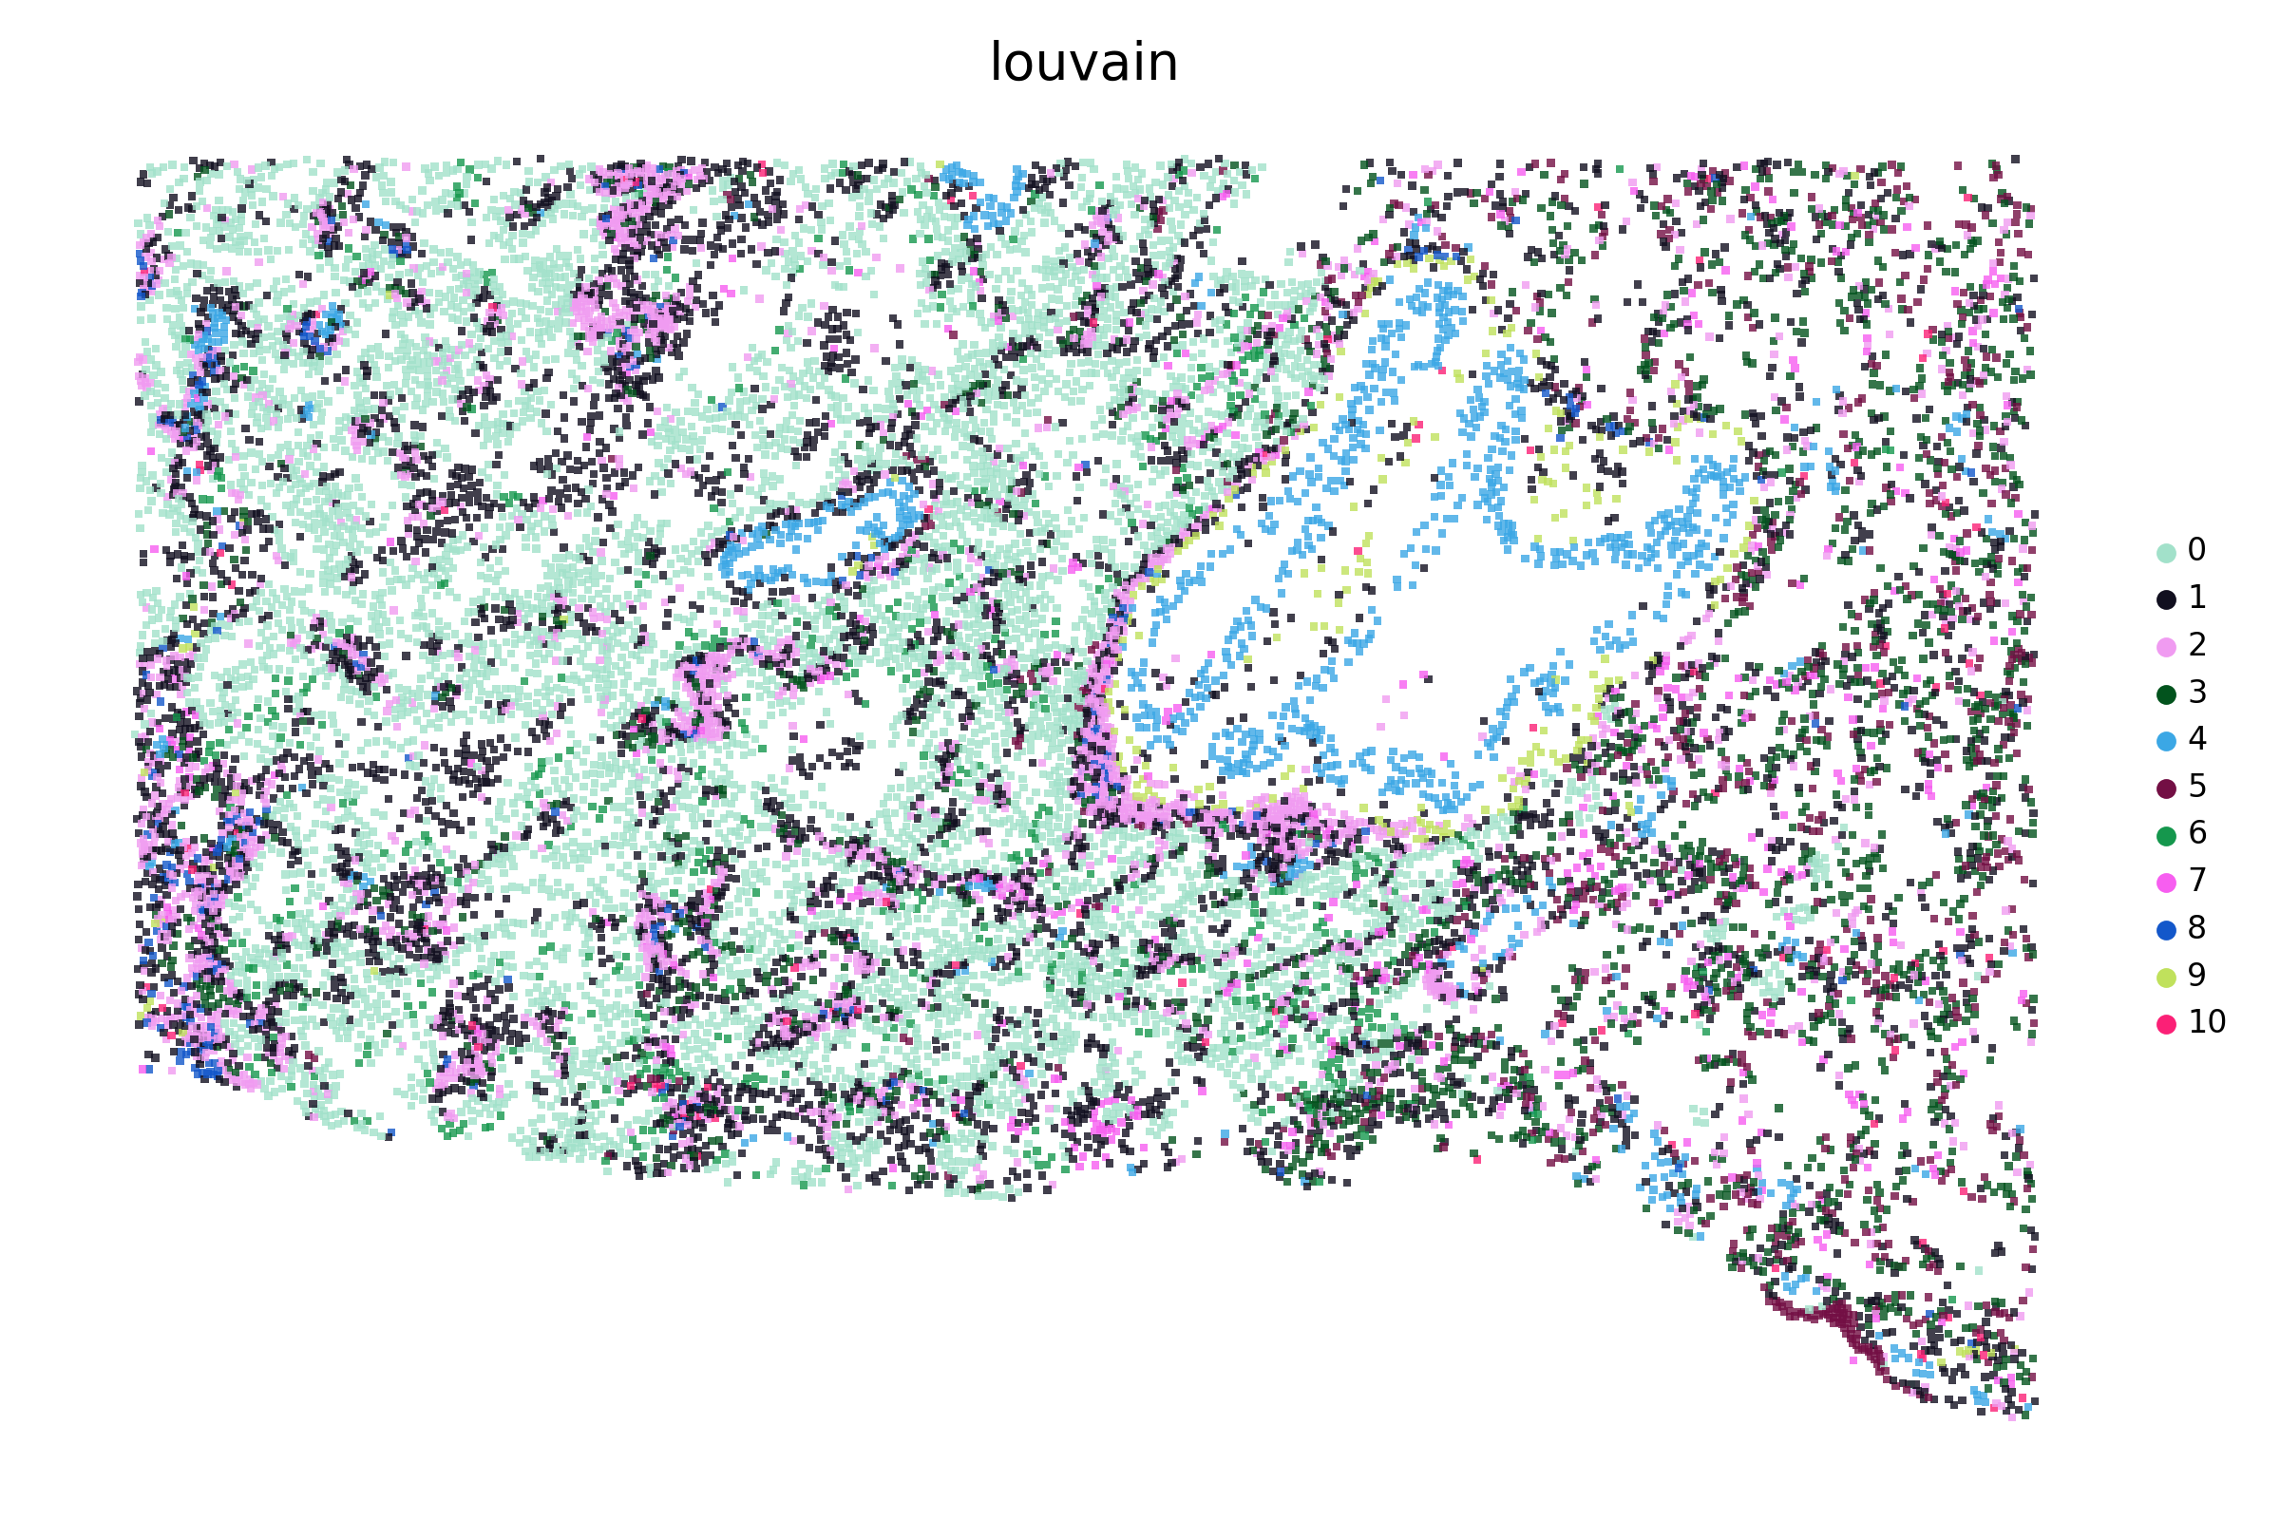
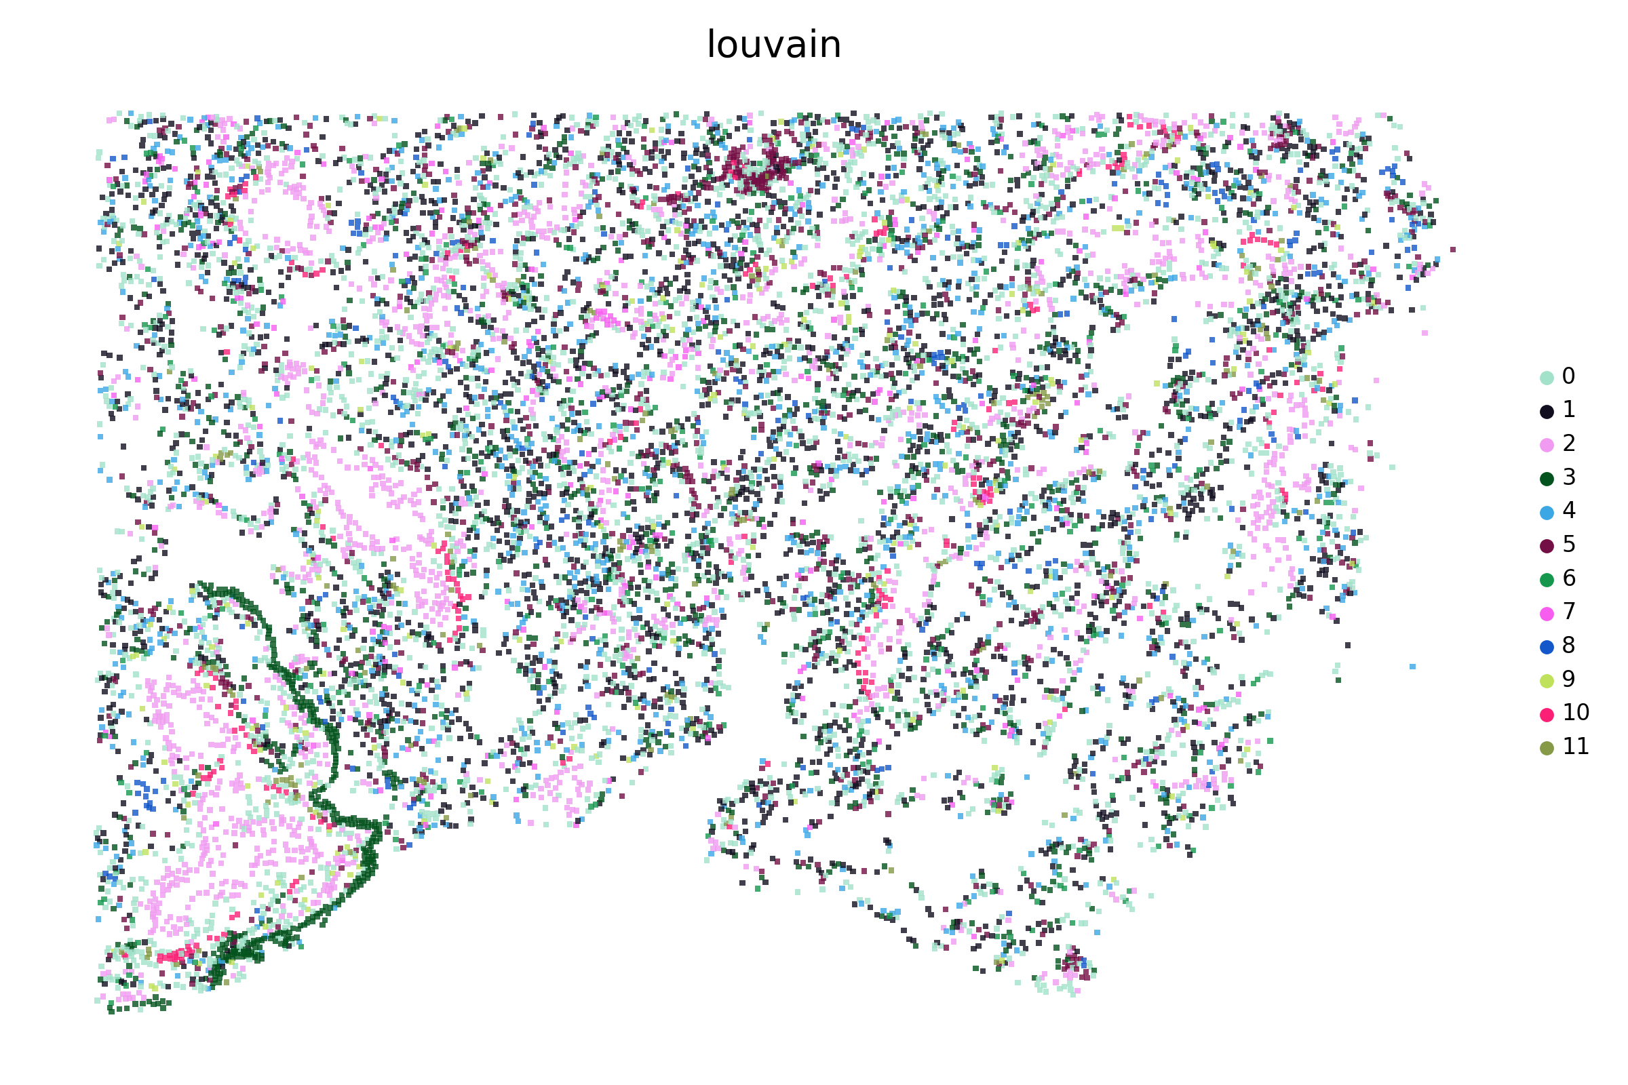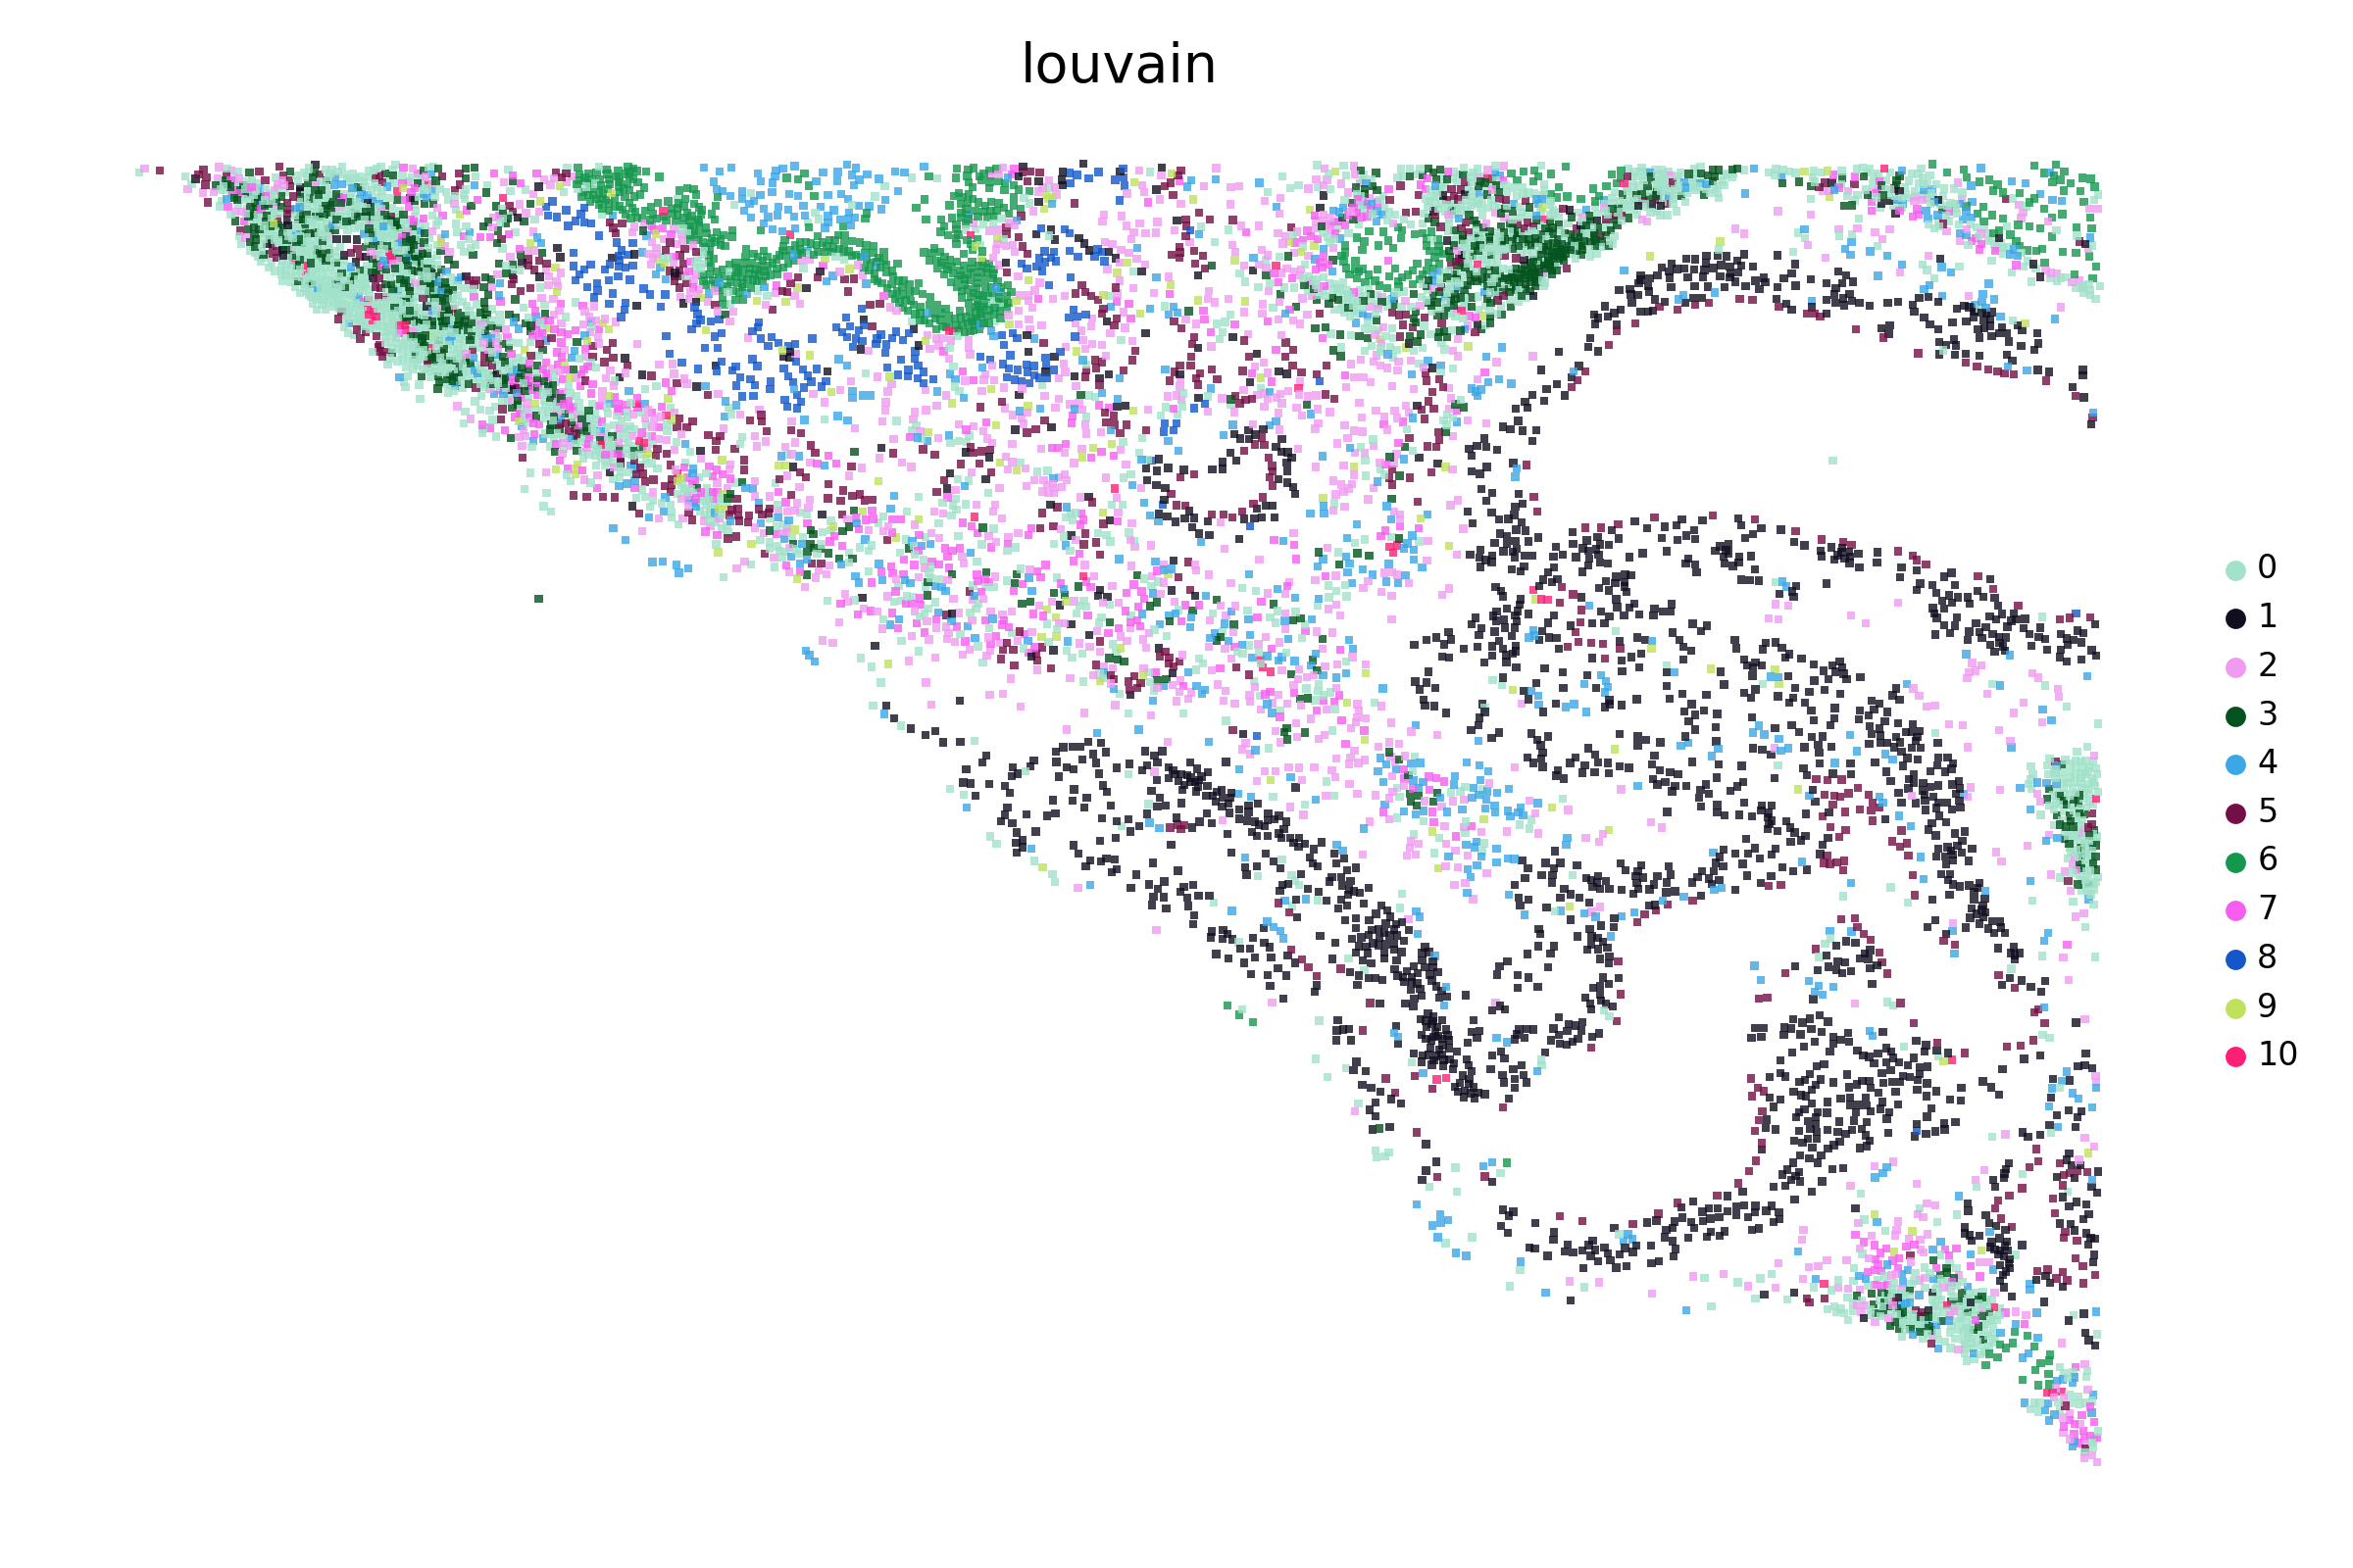

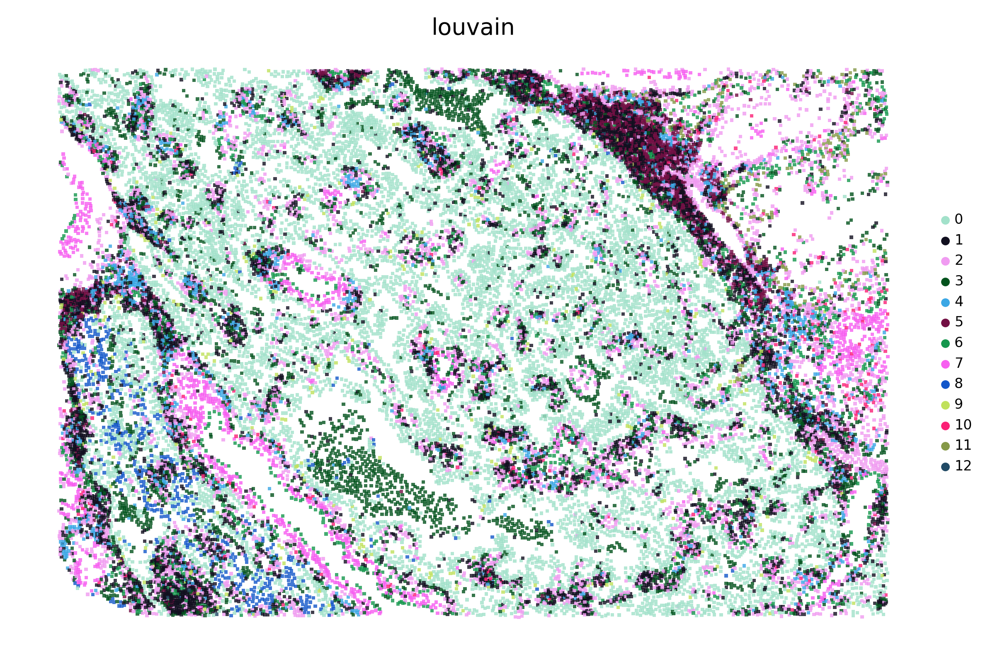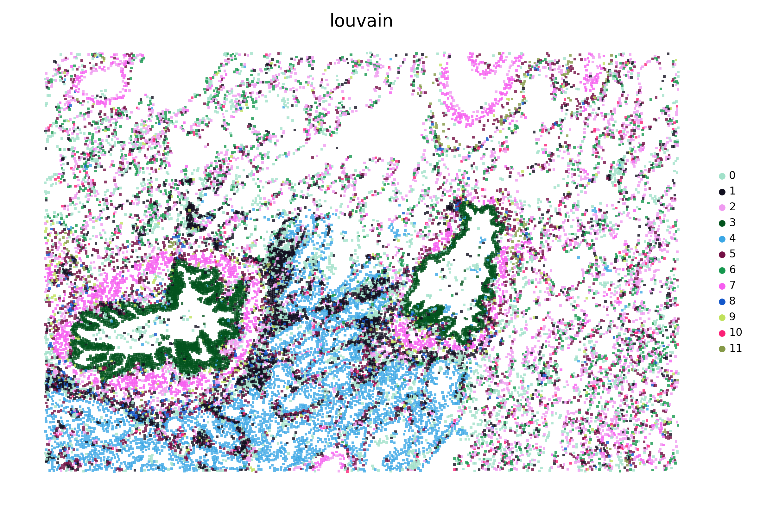
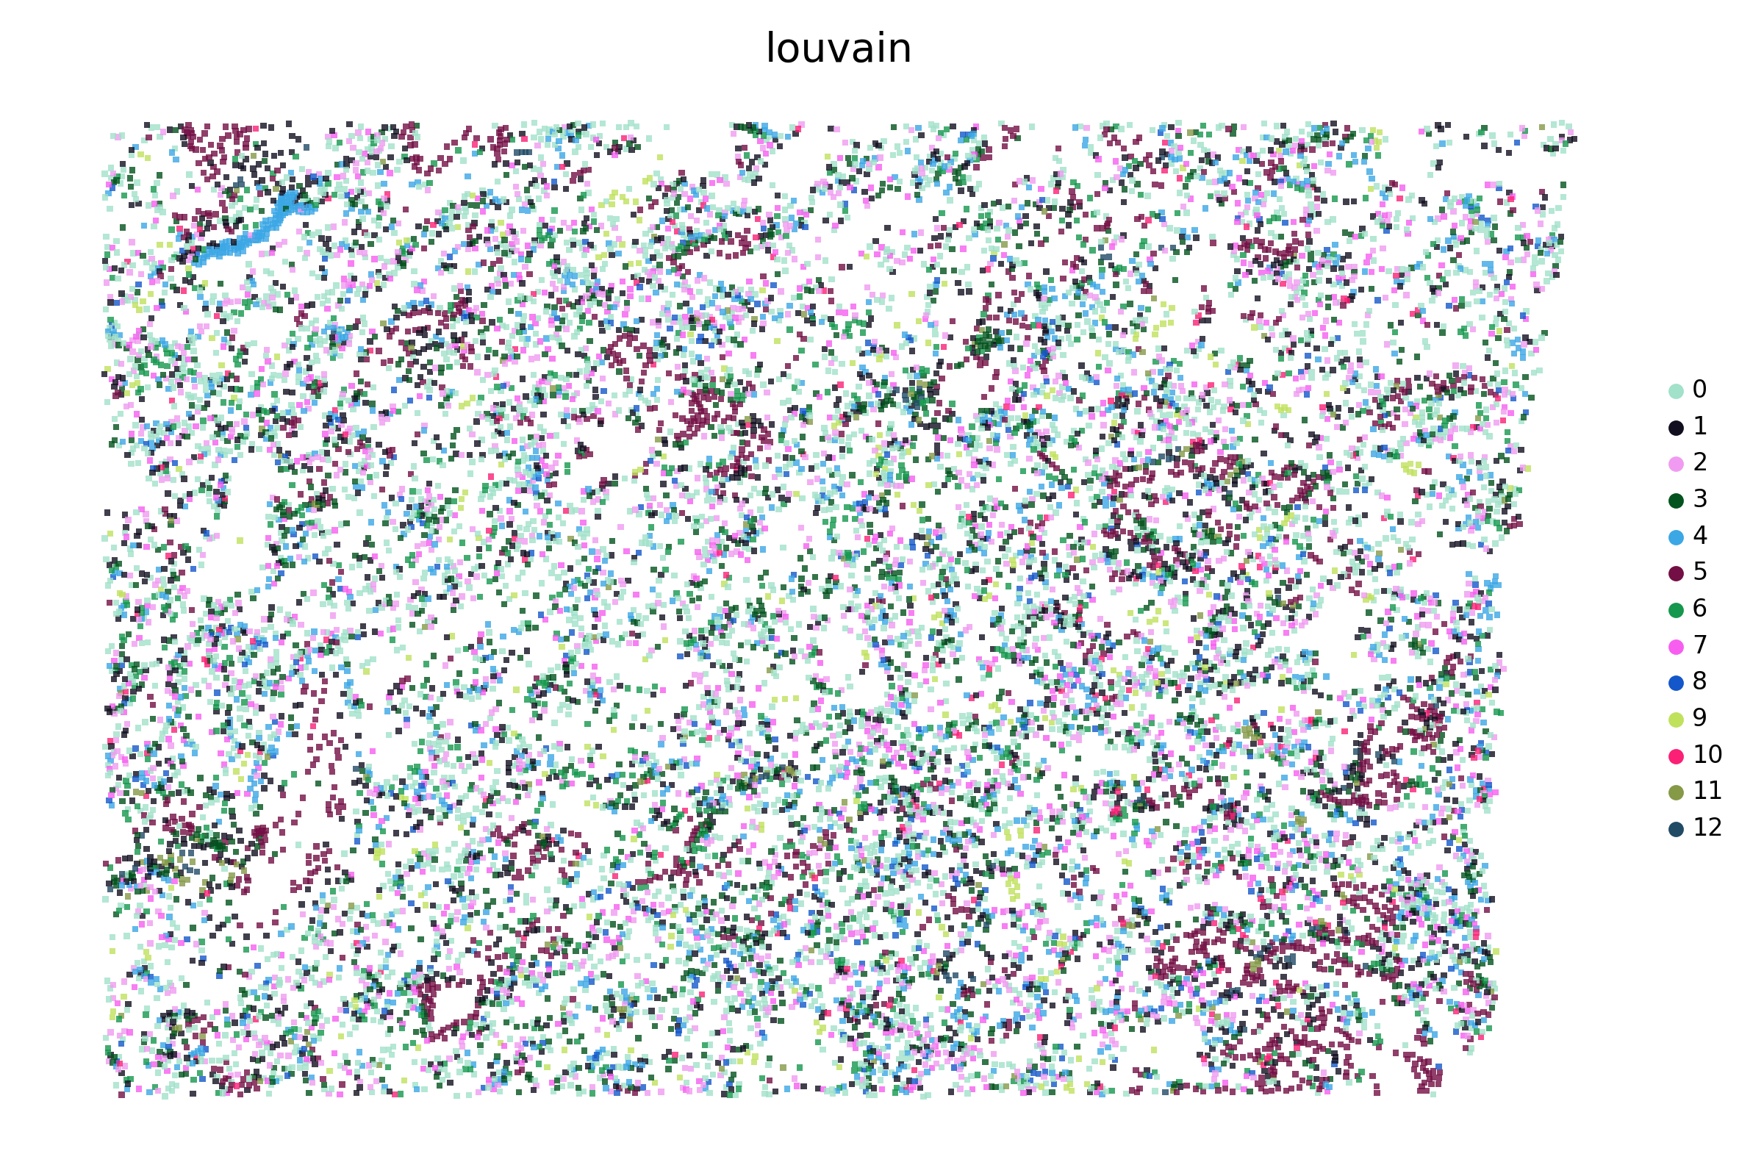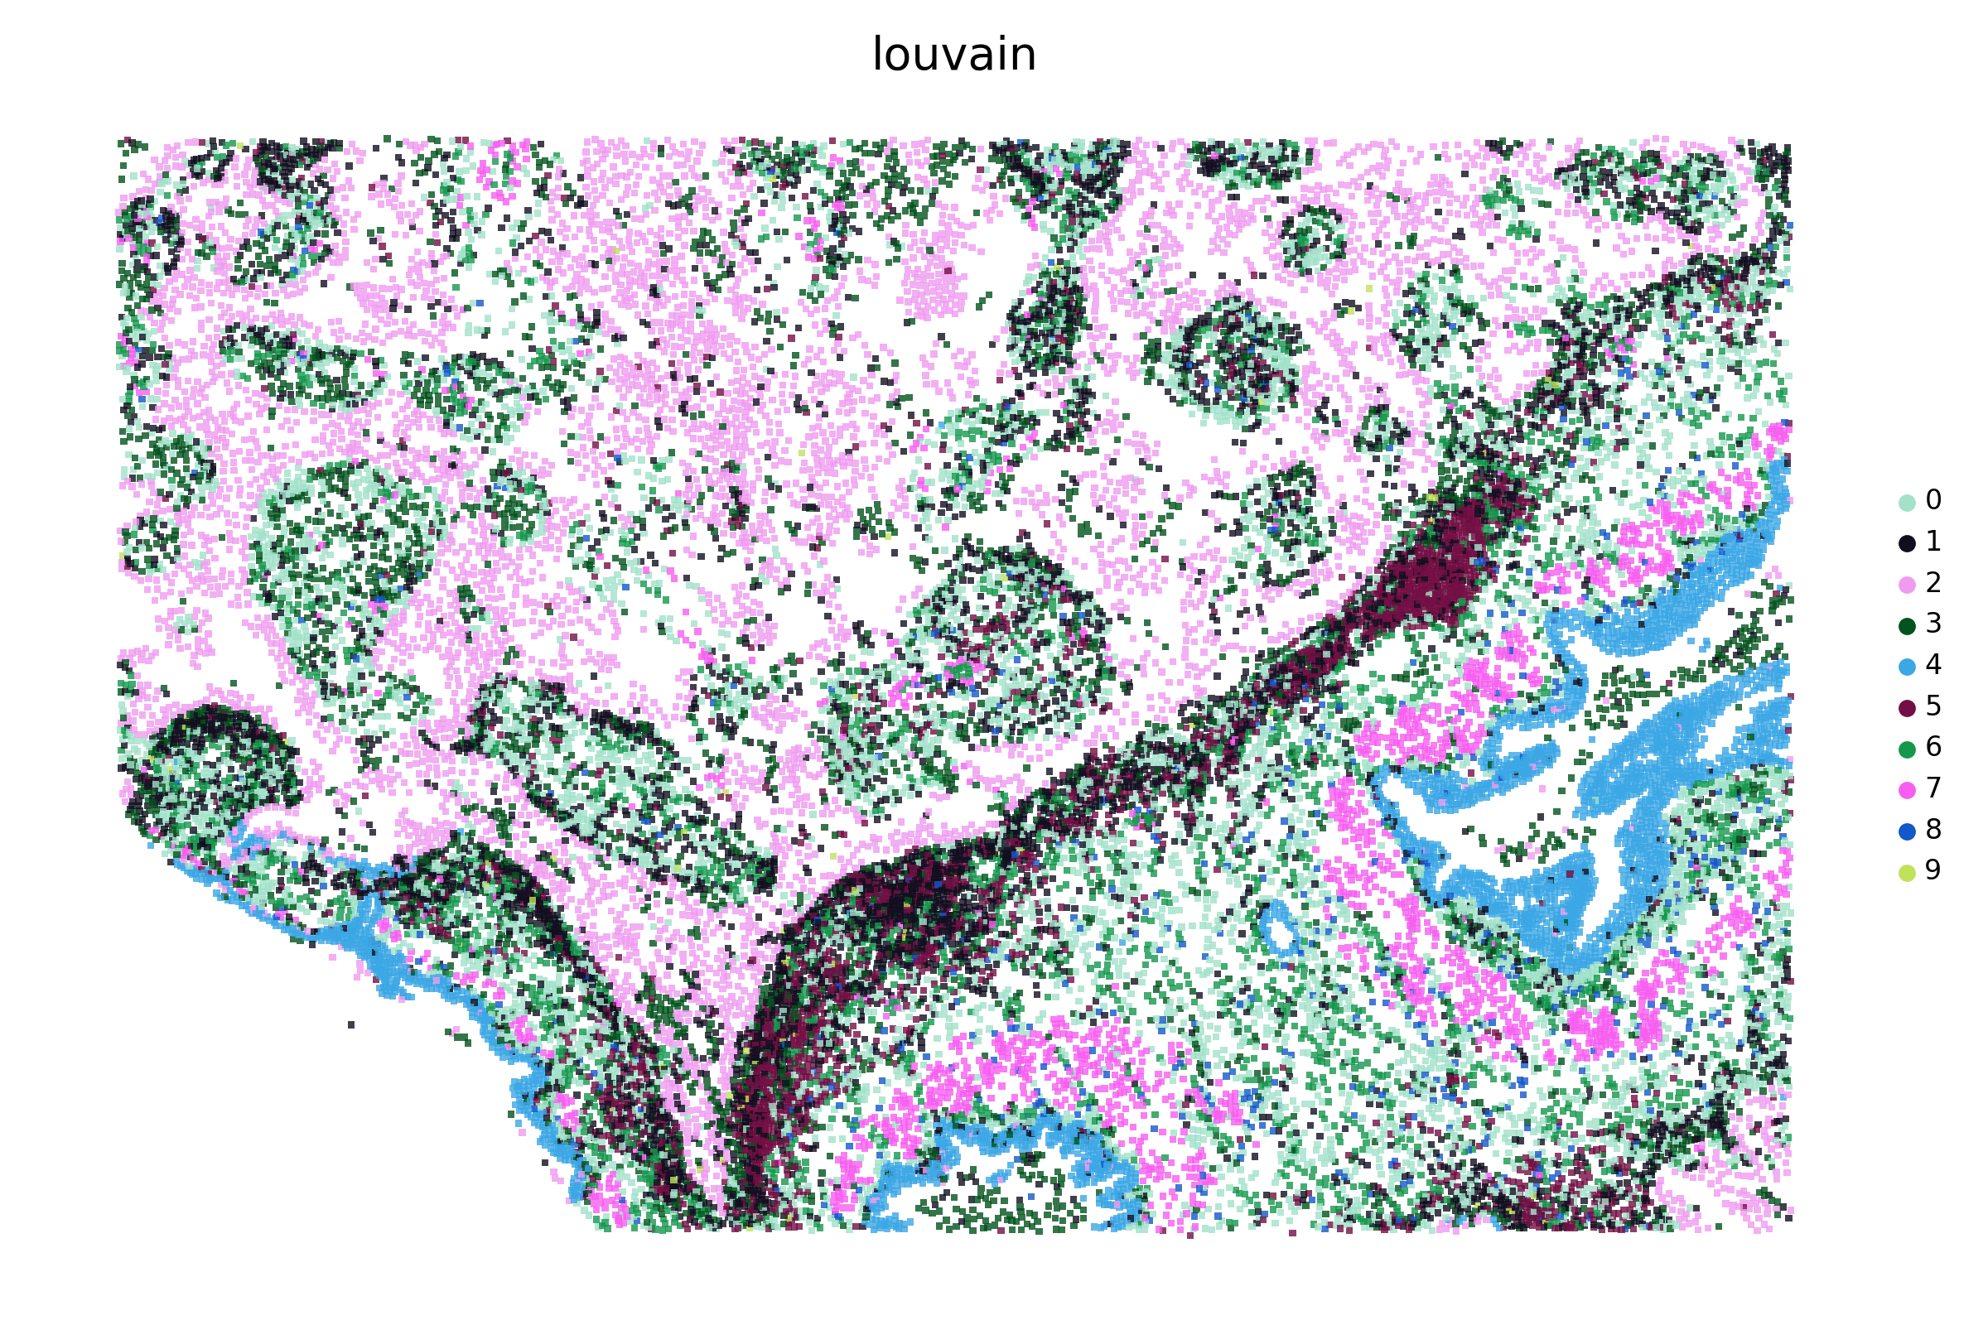
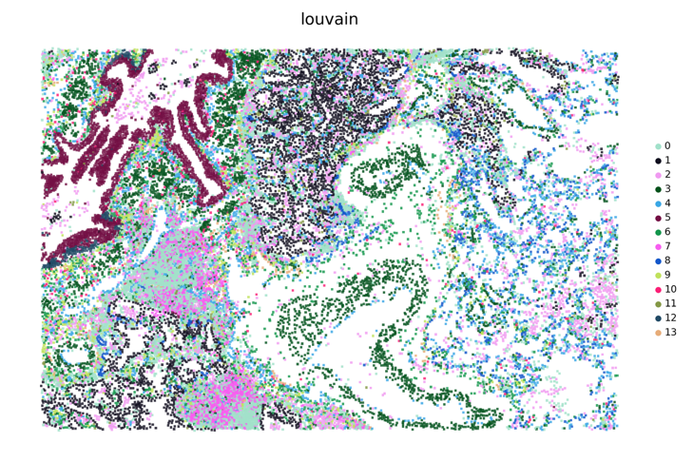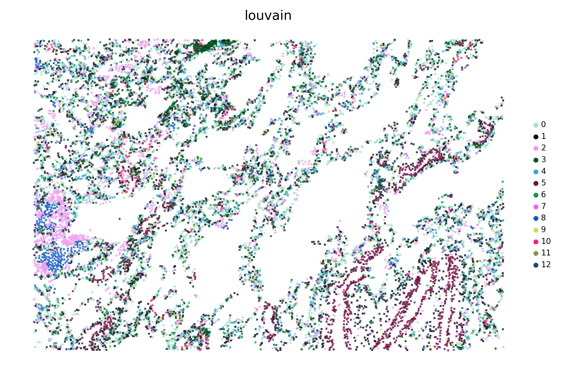
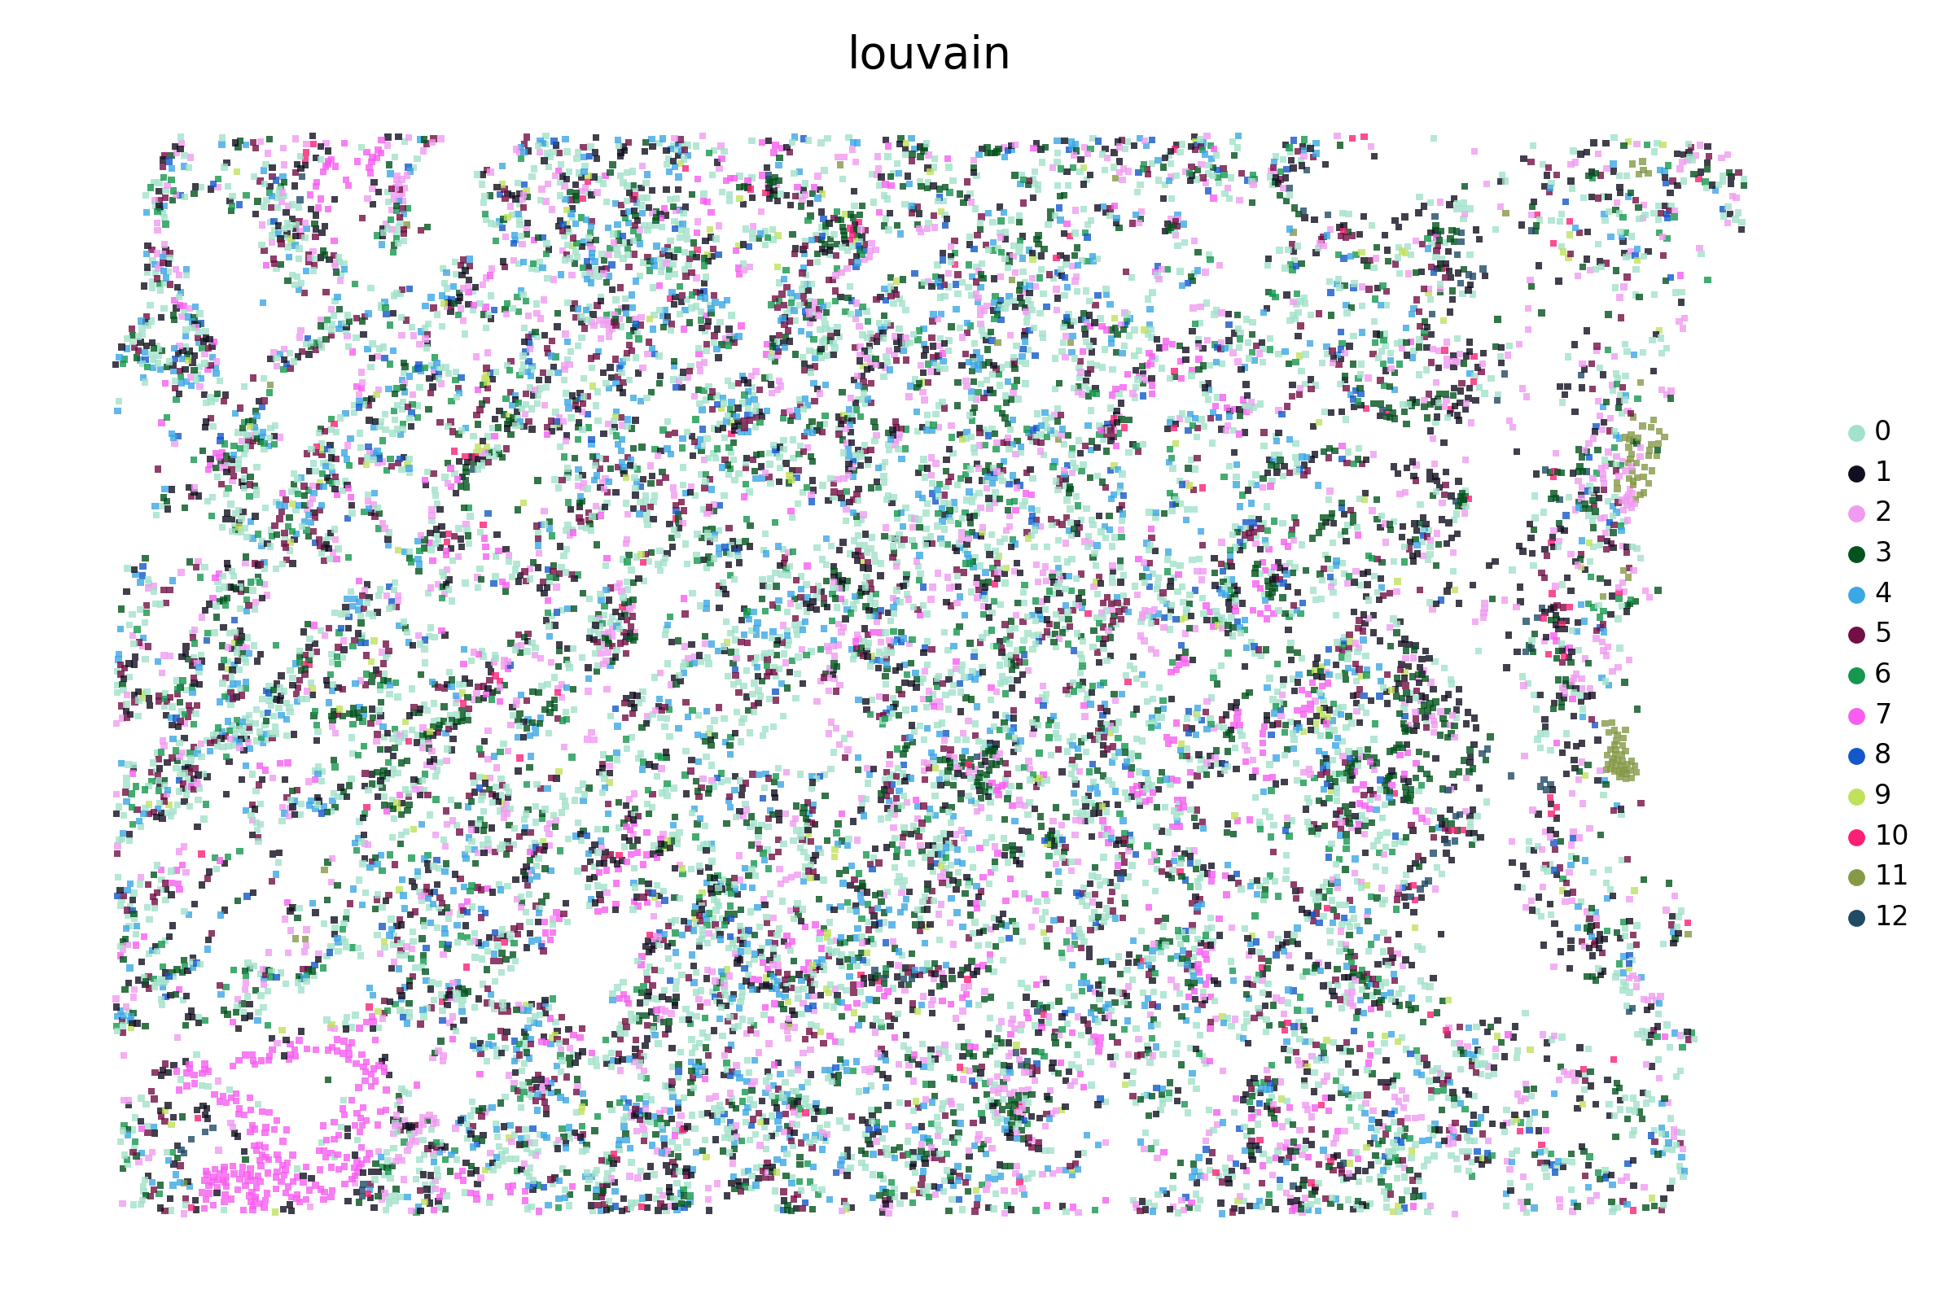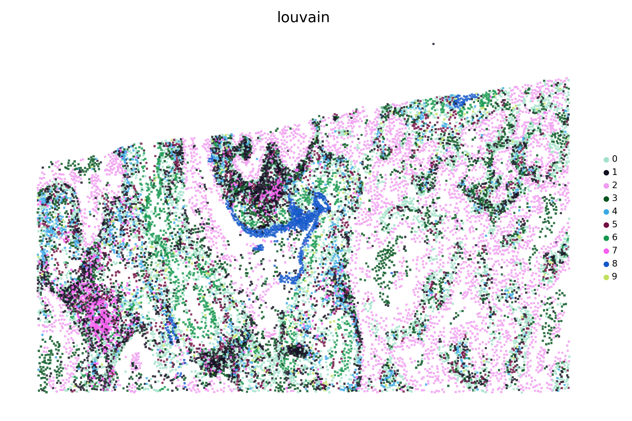

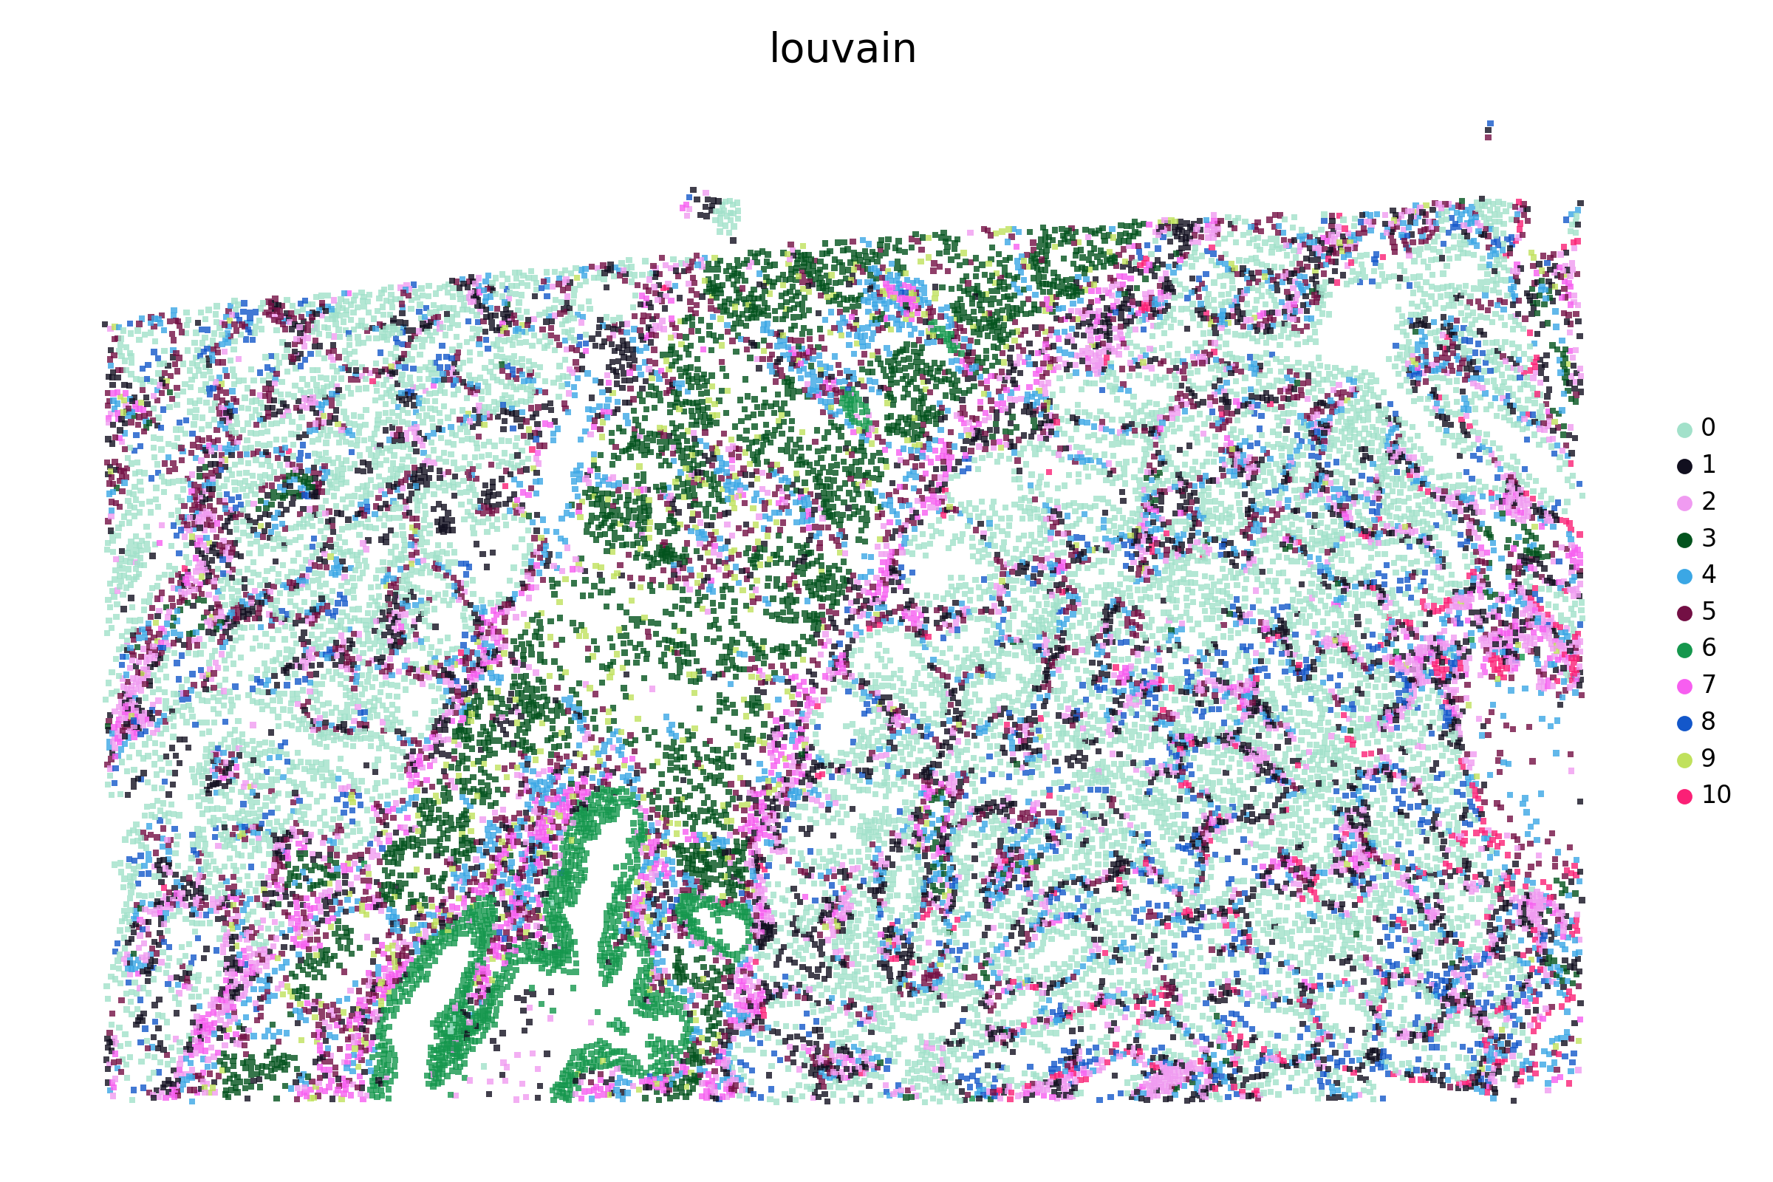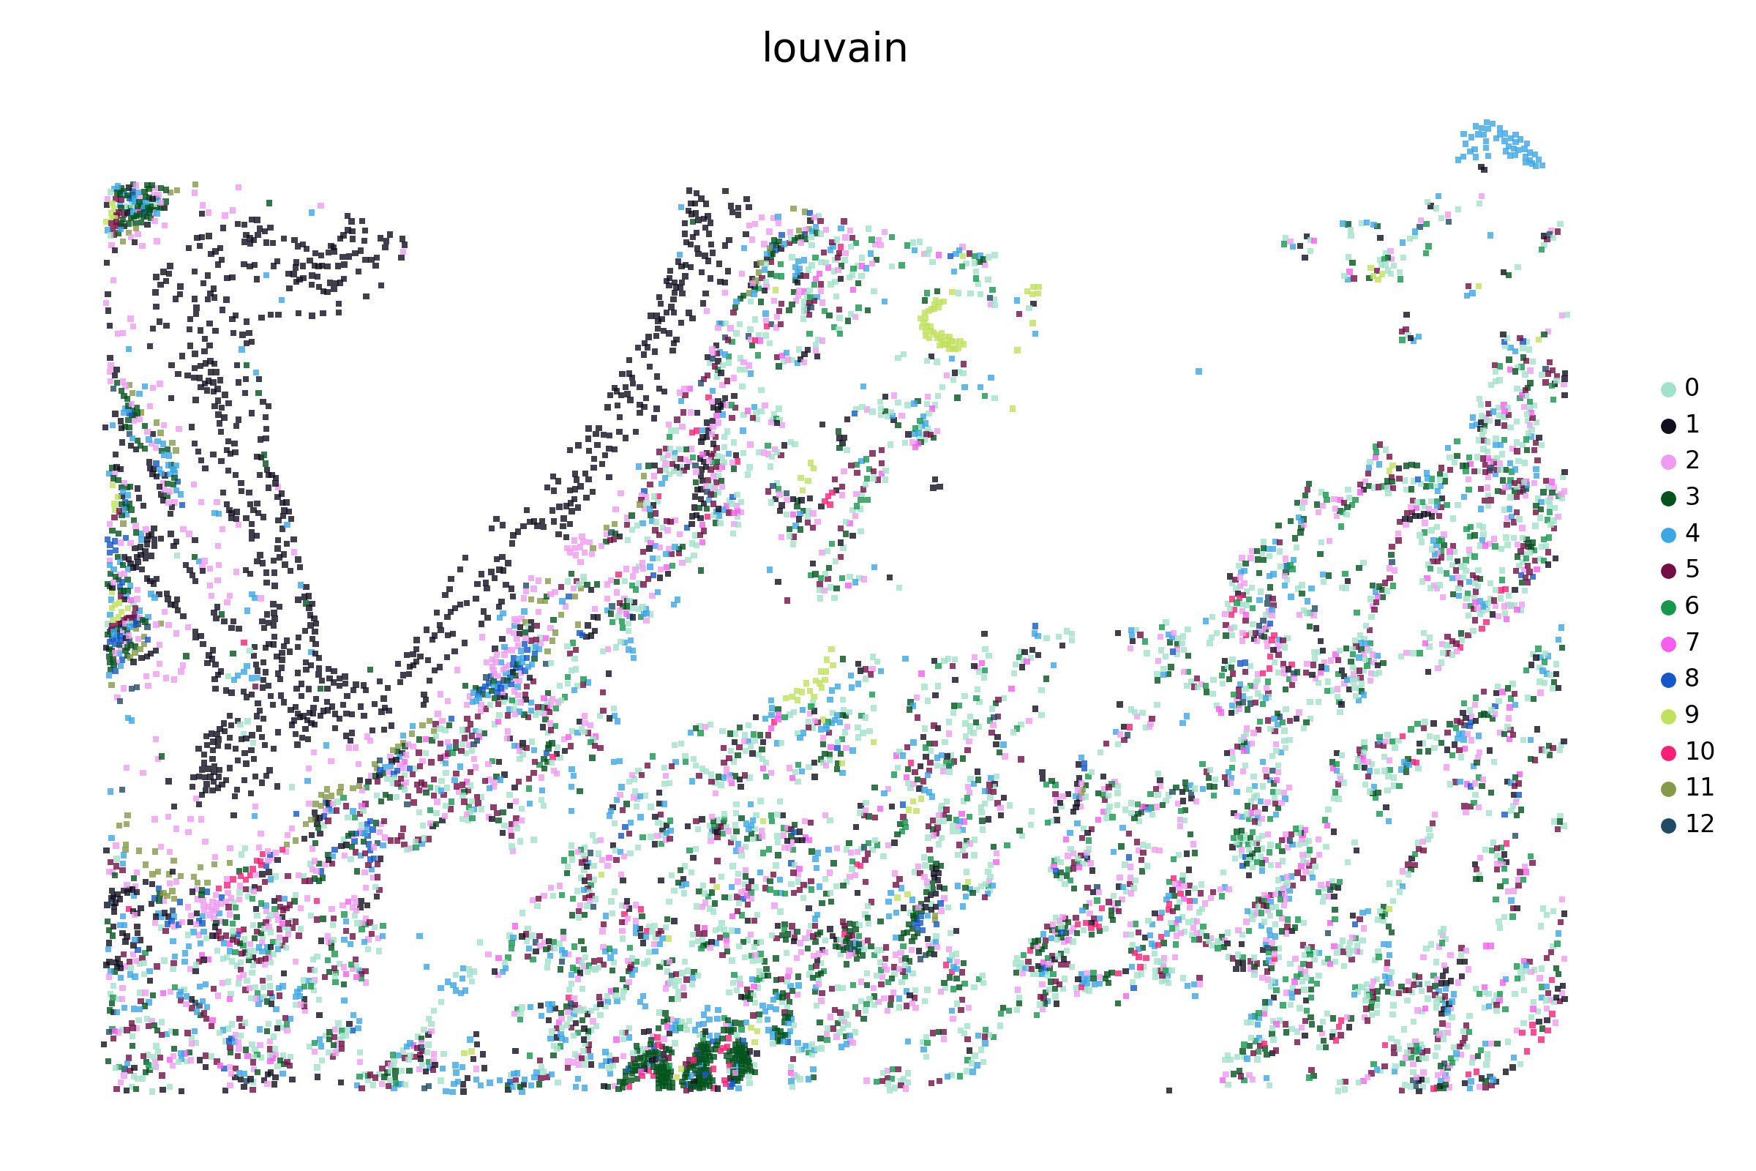
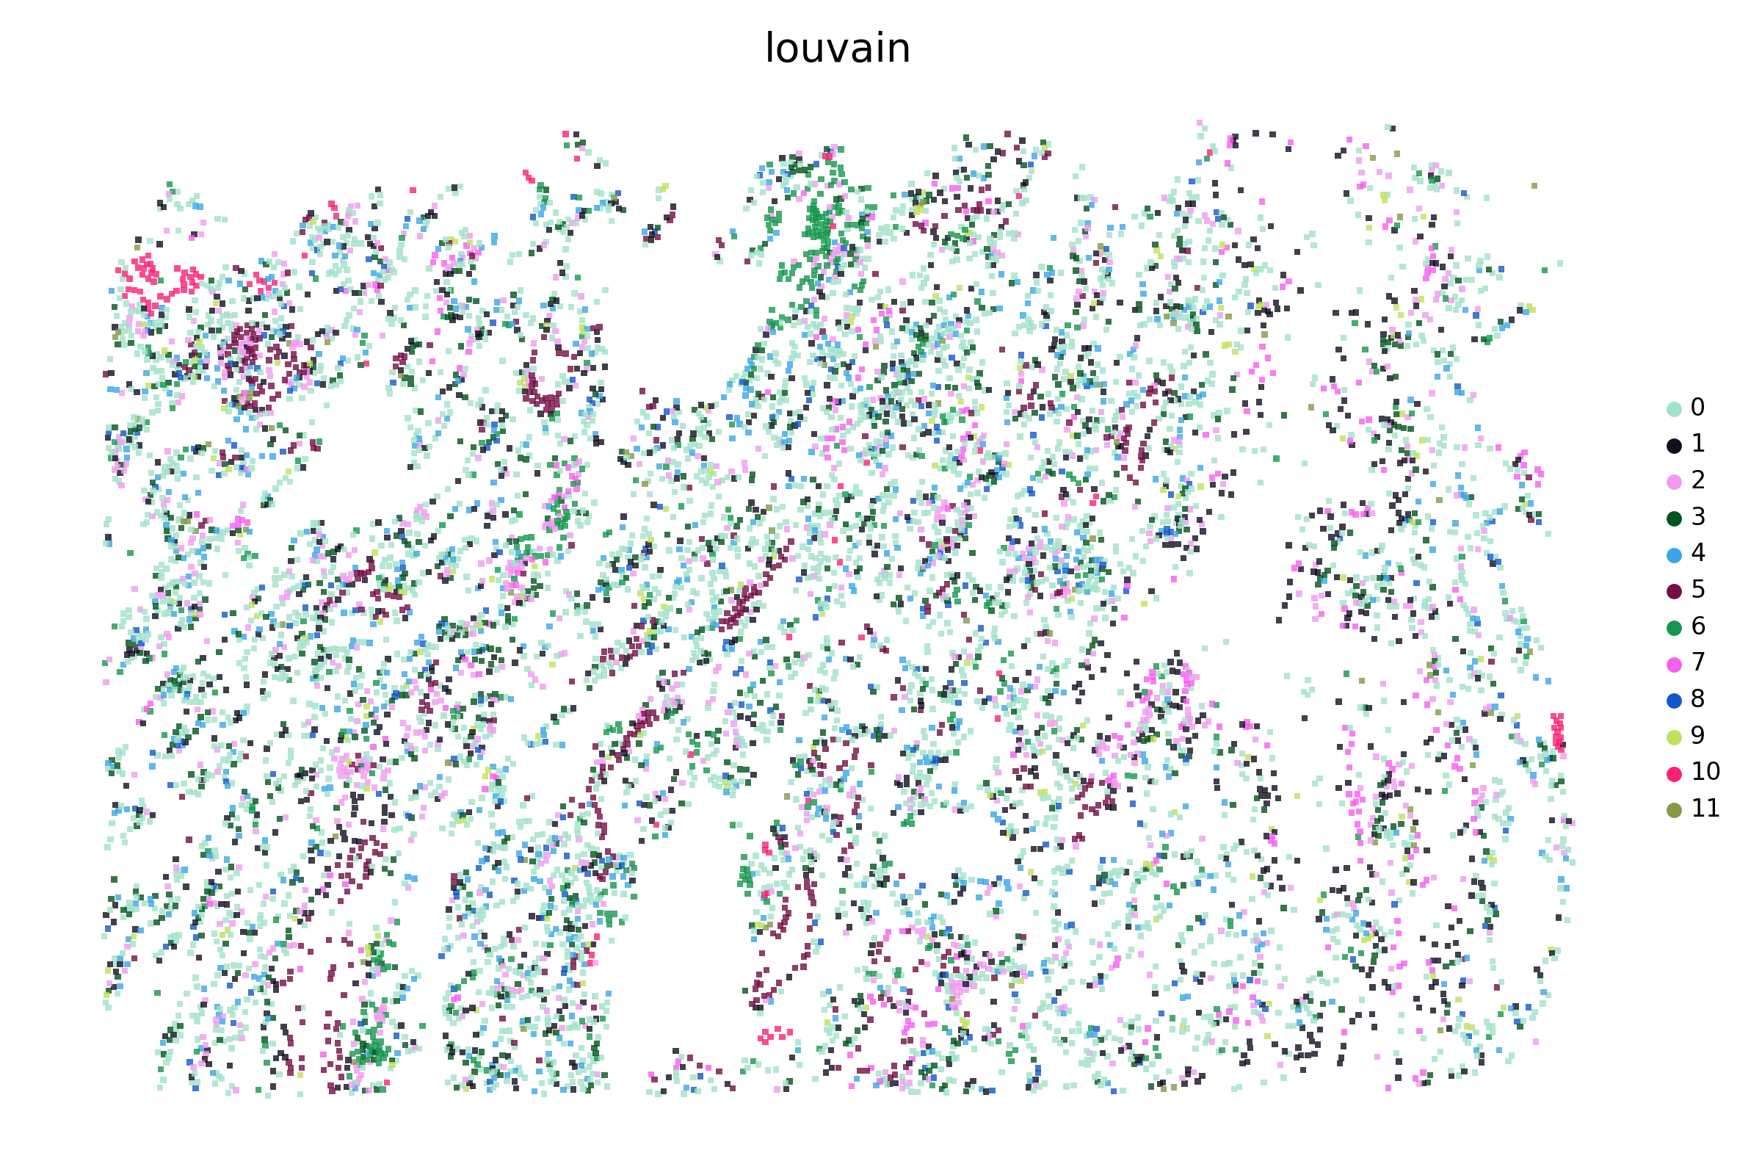
C
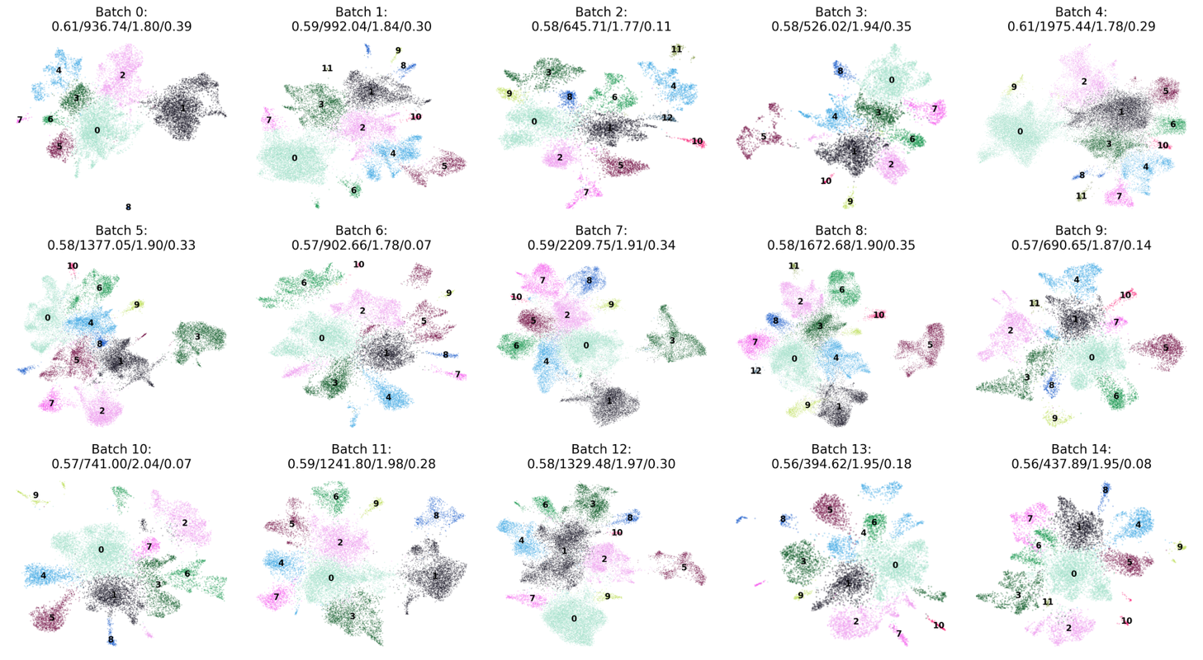

D
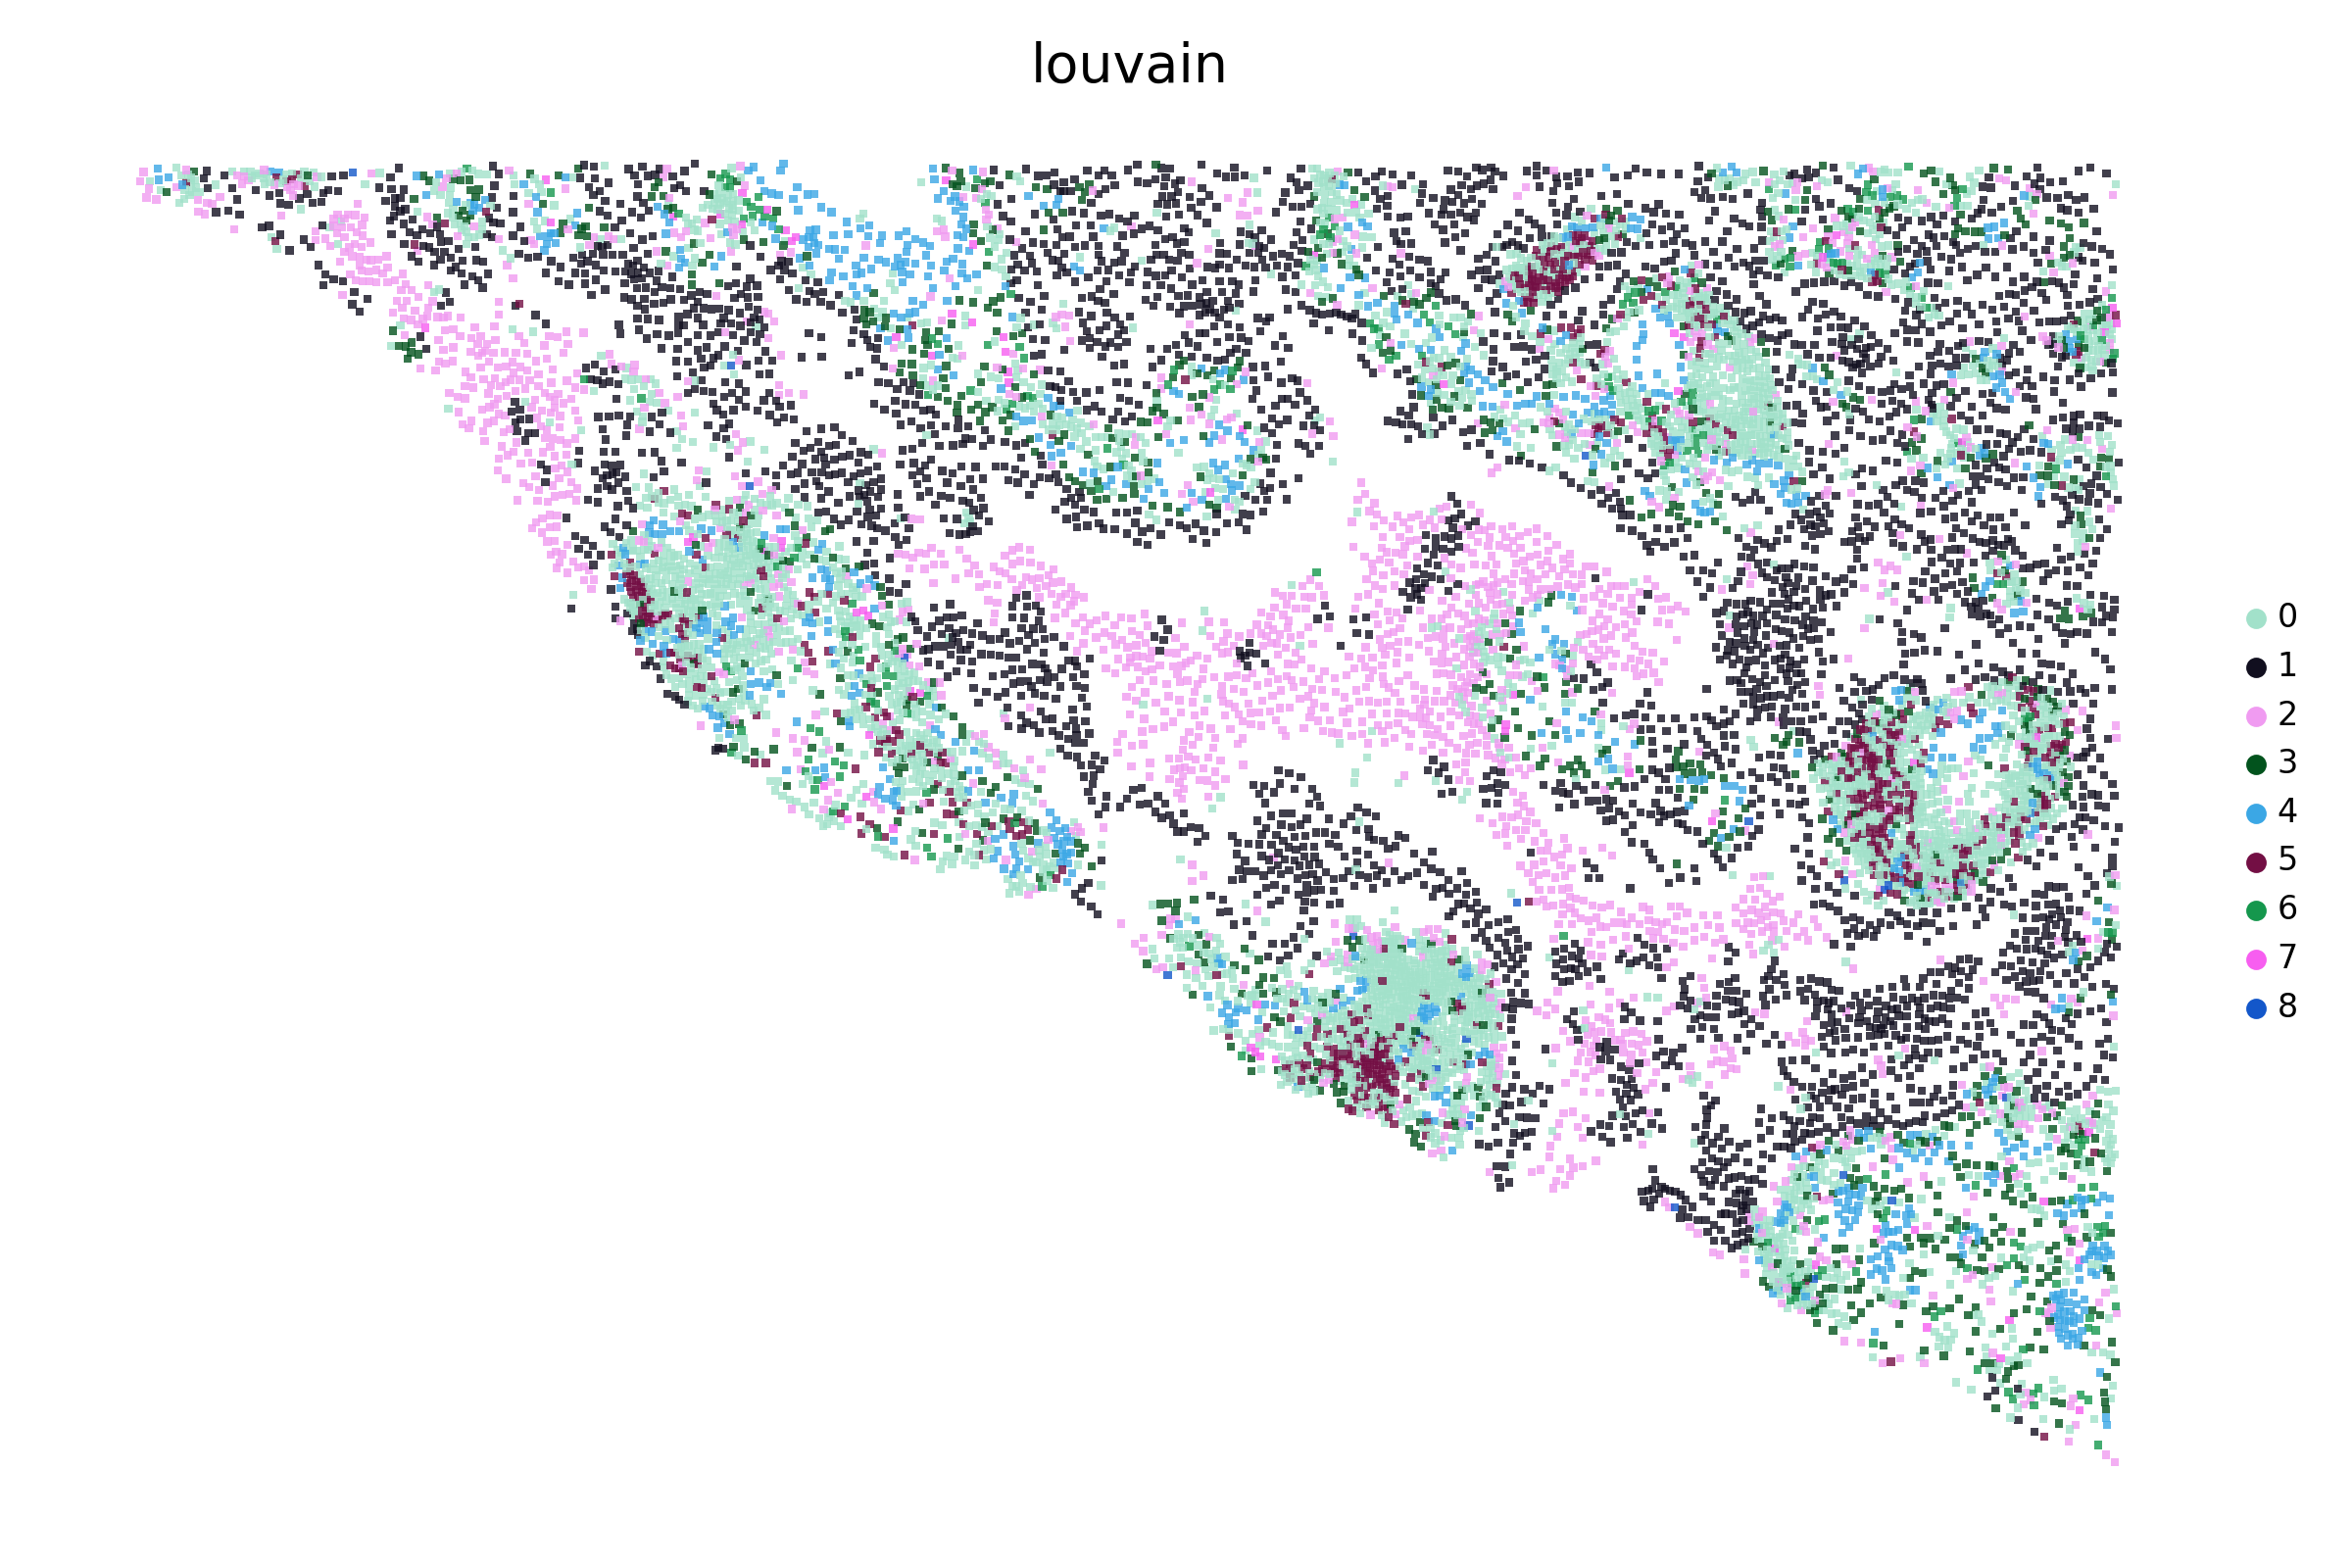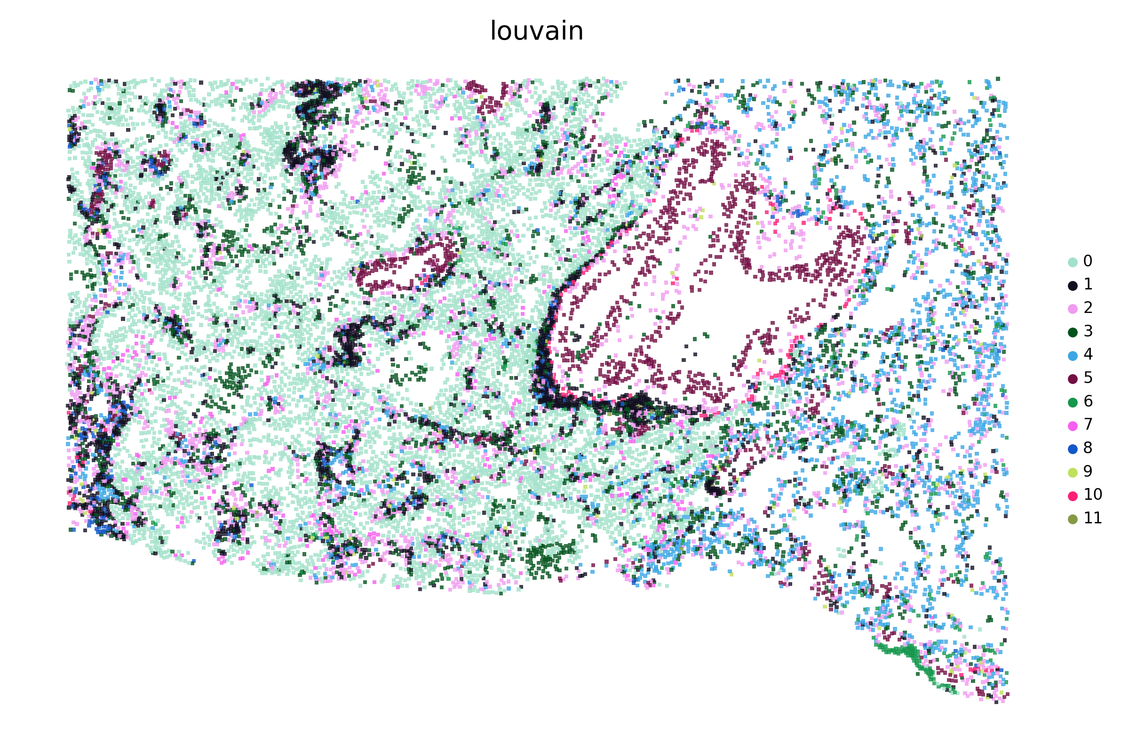
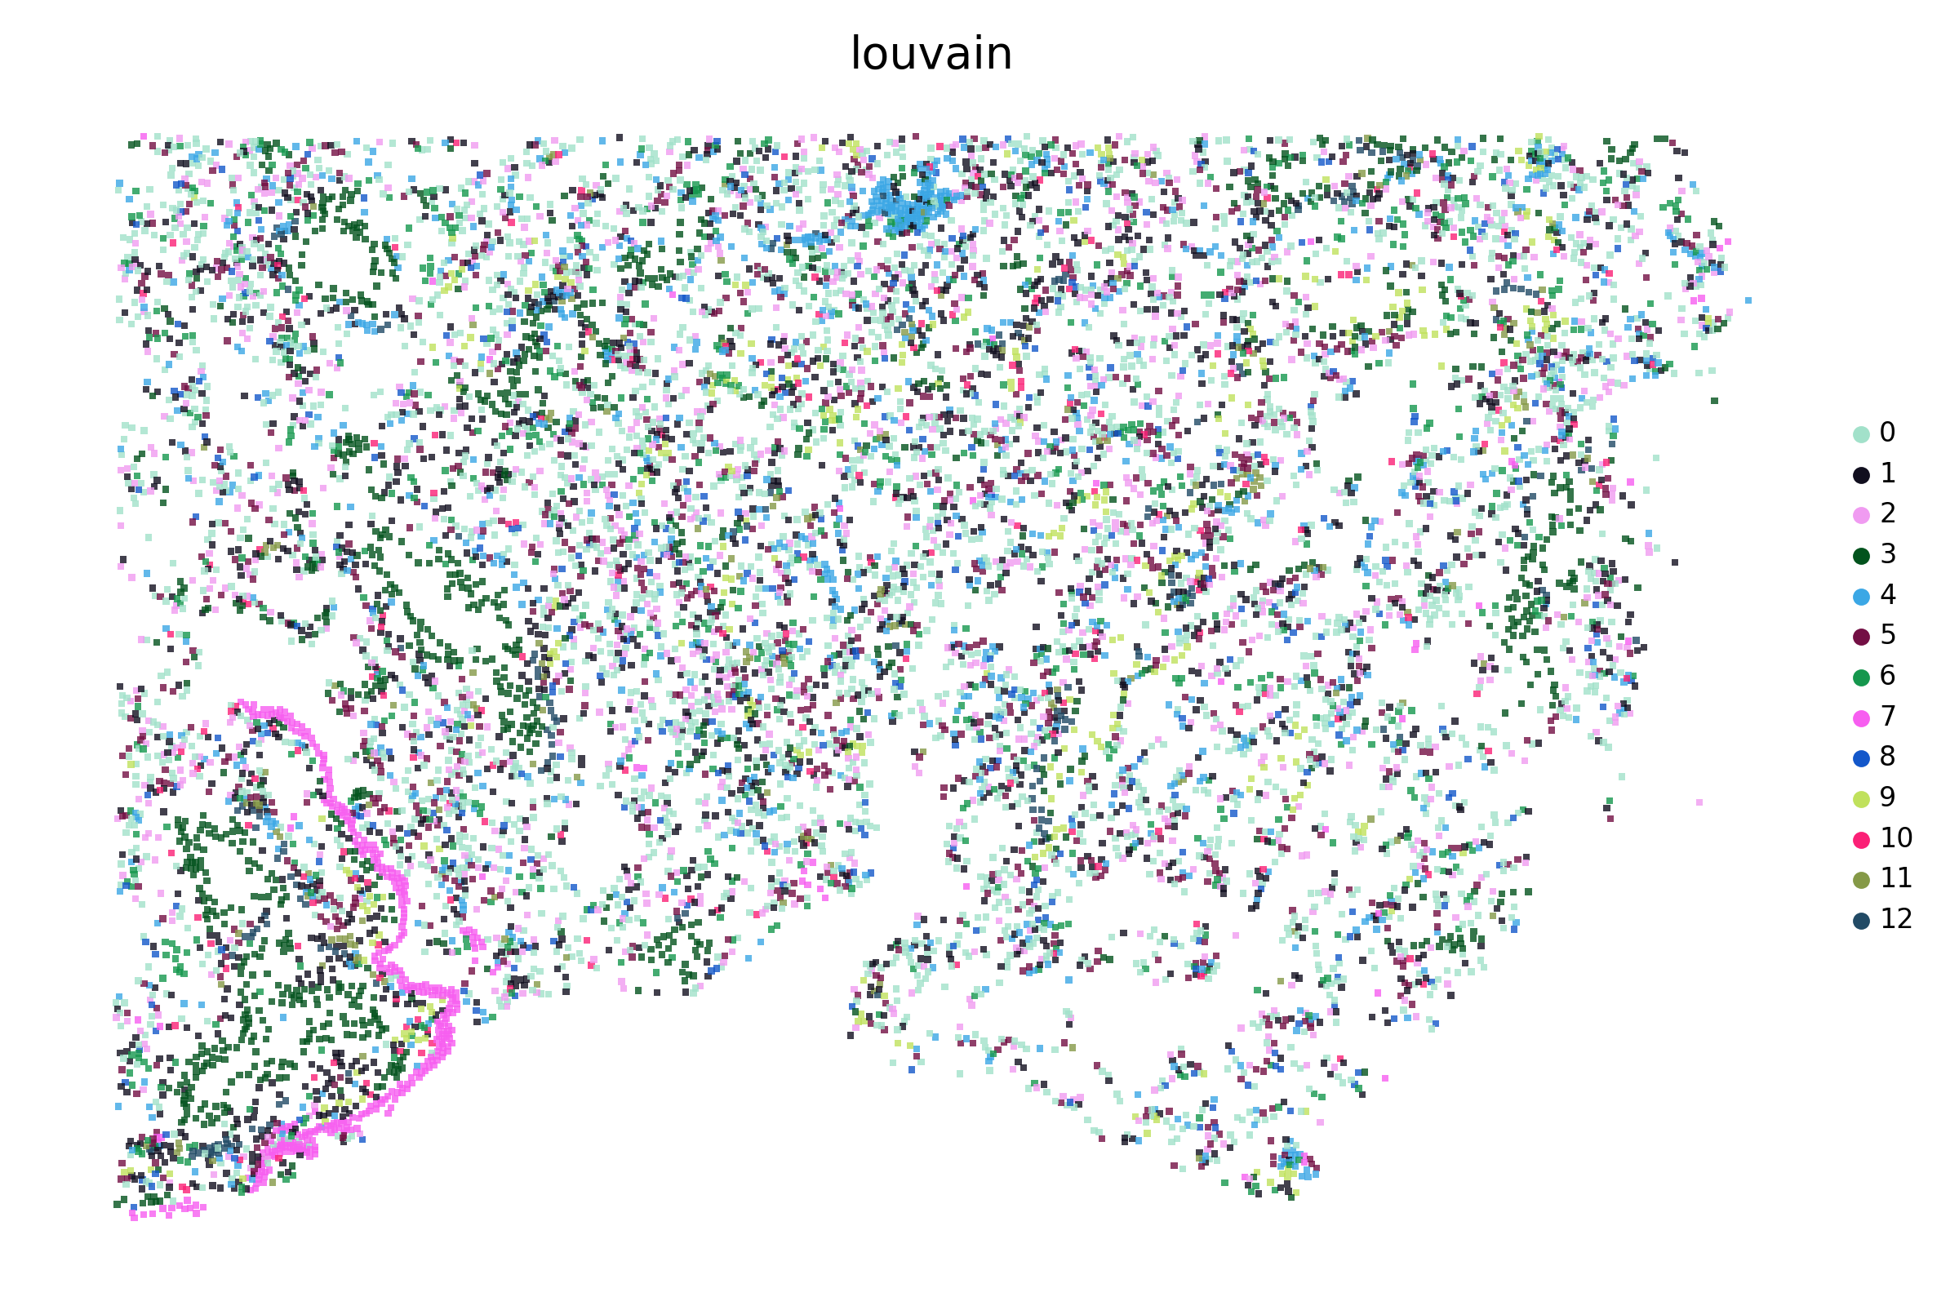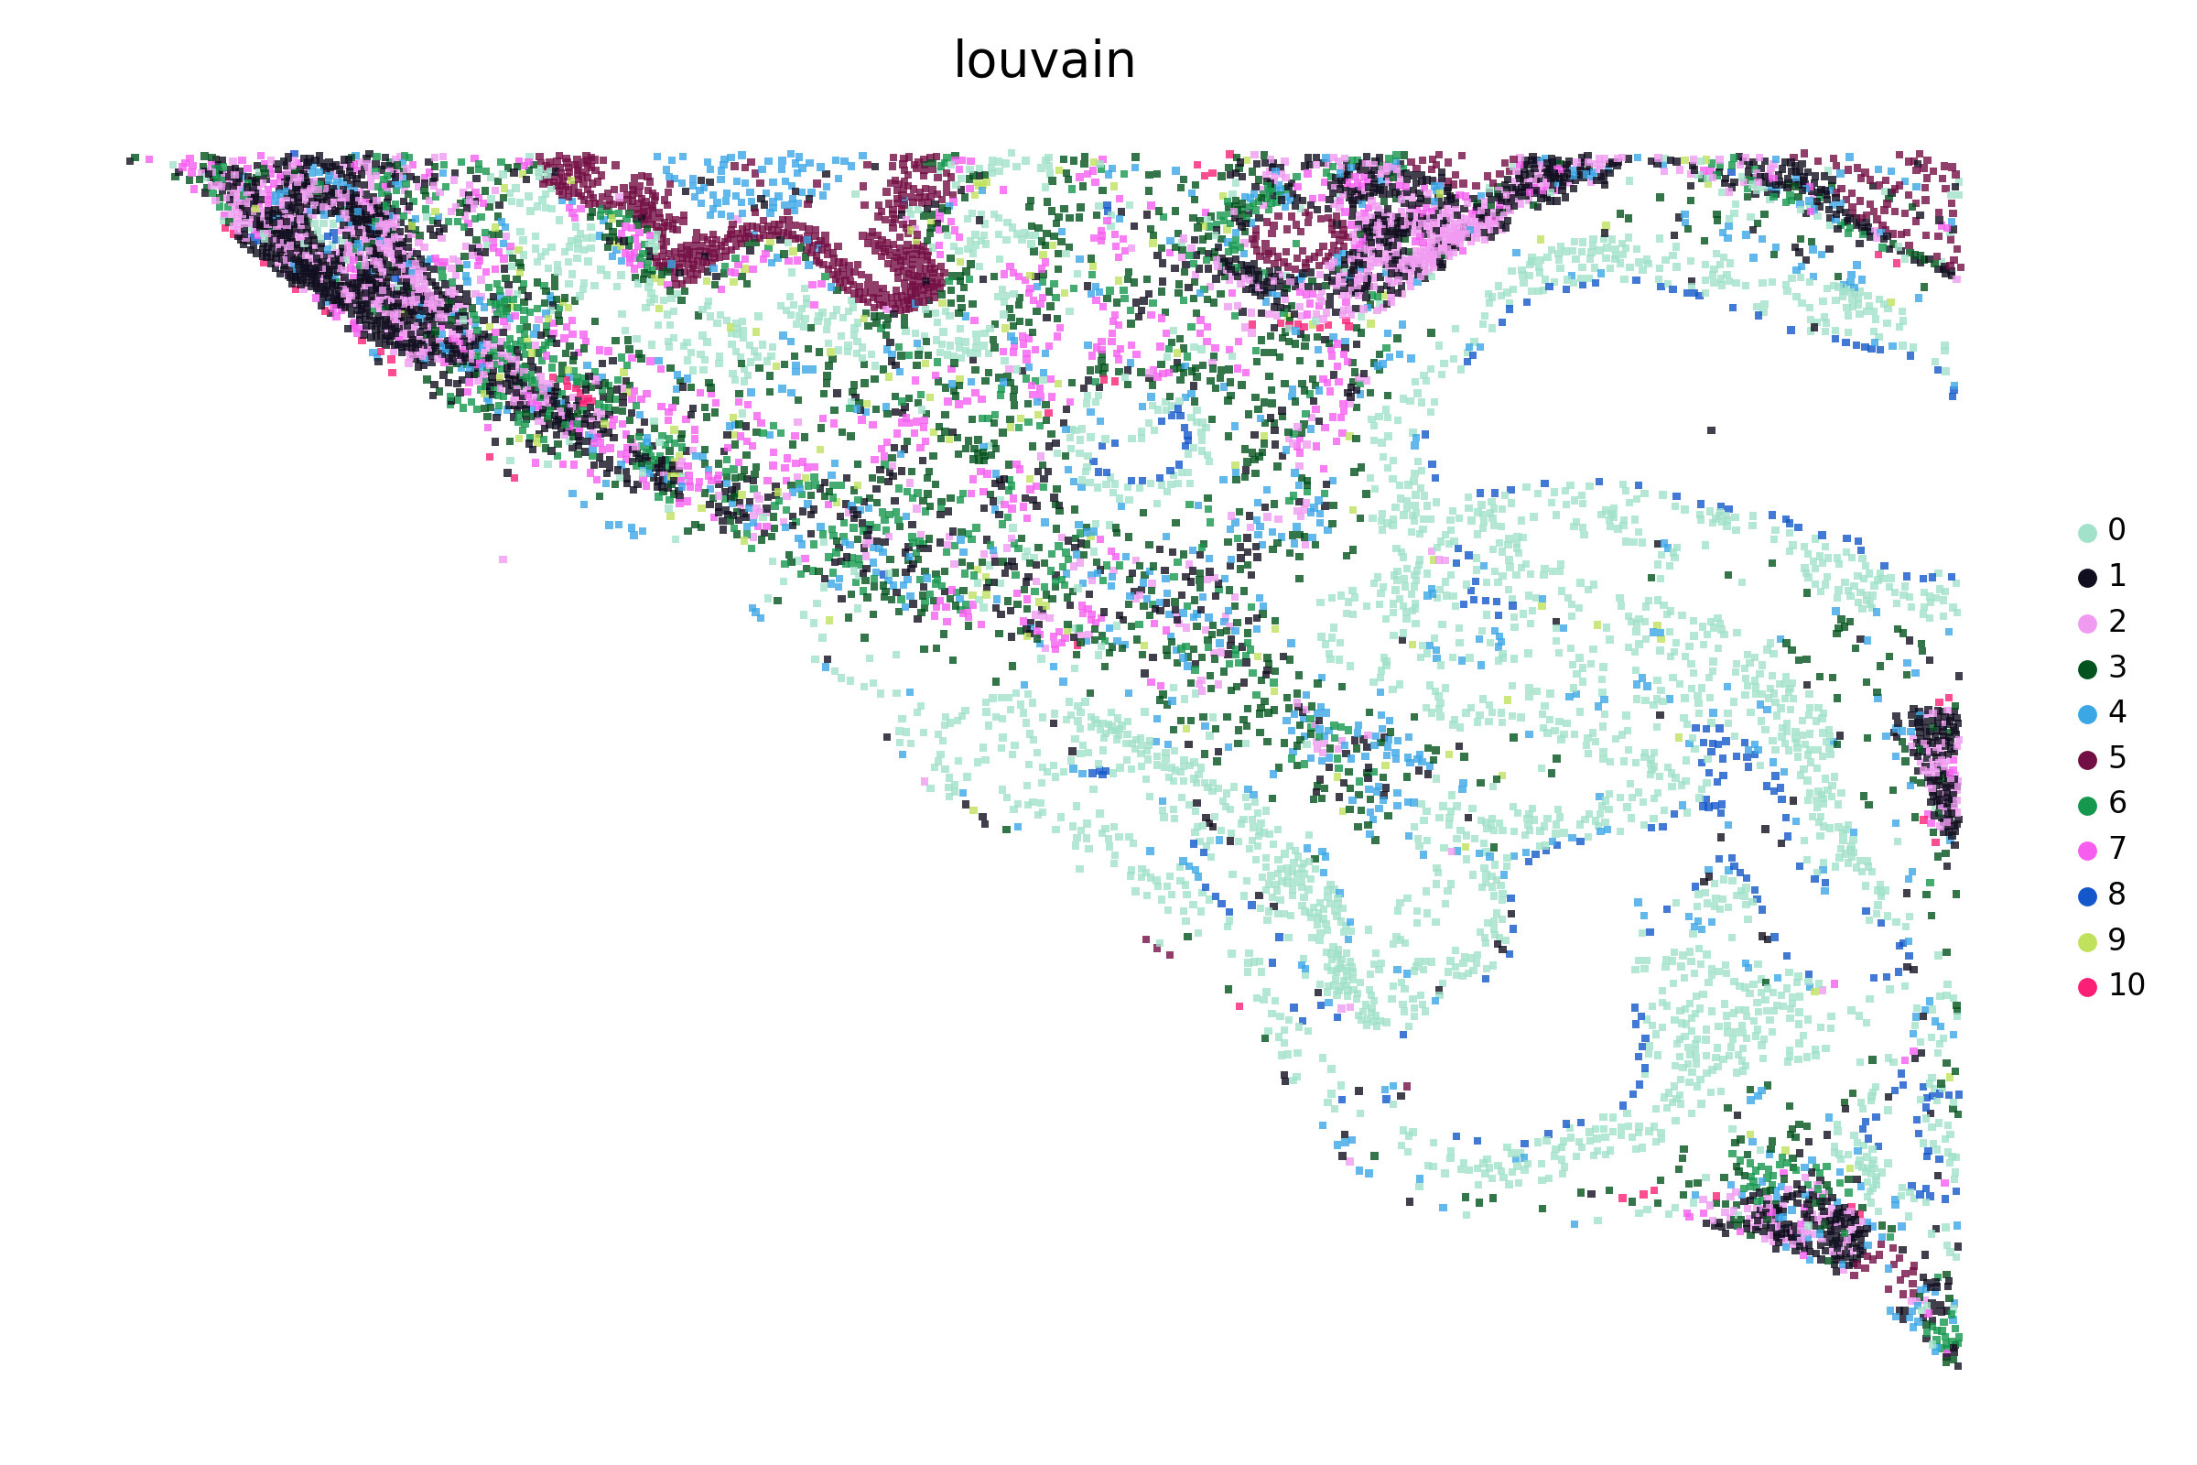
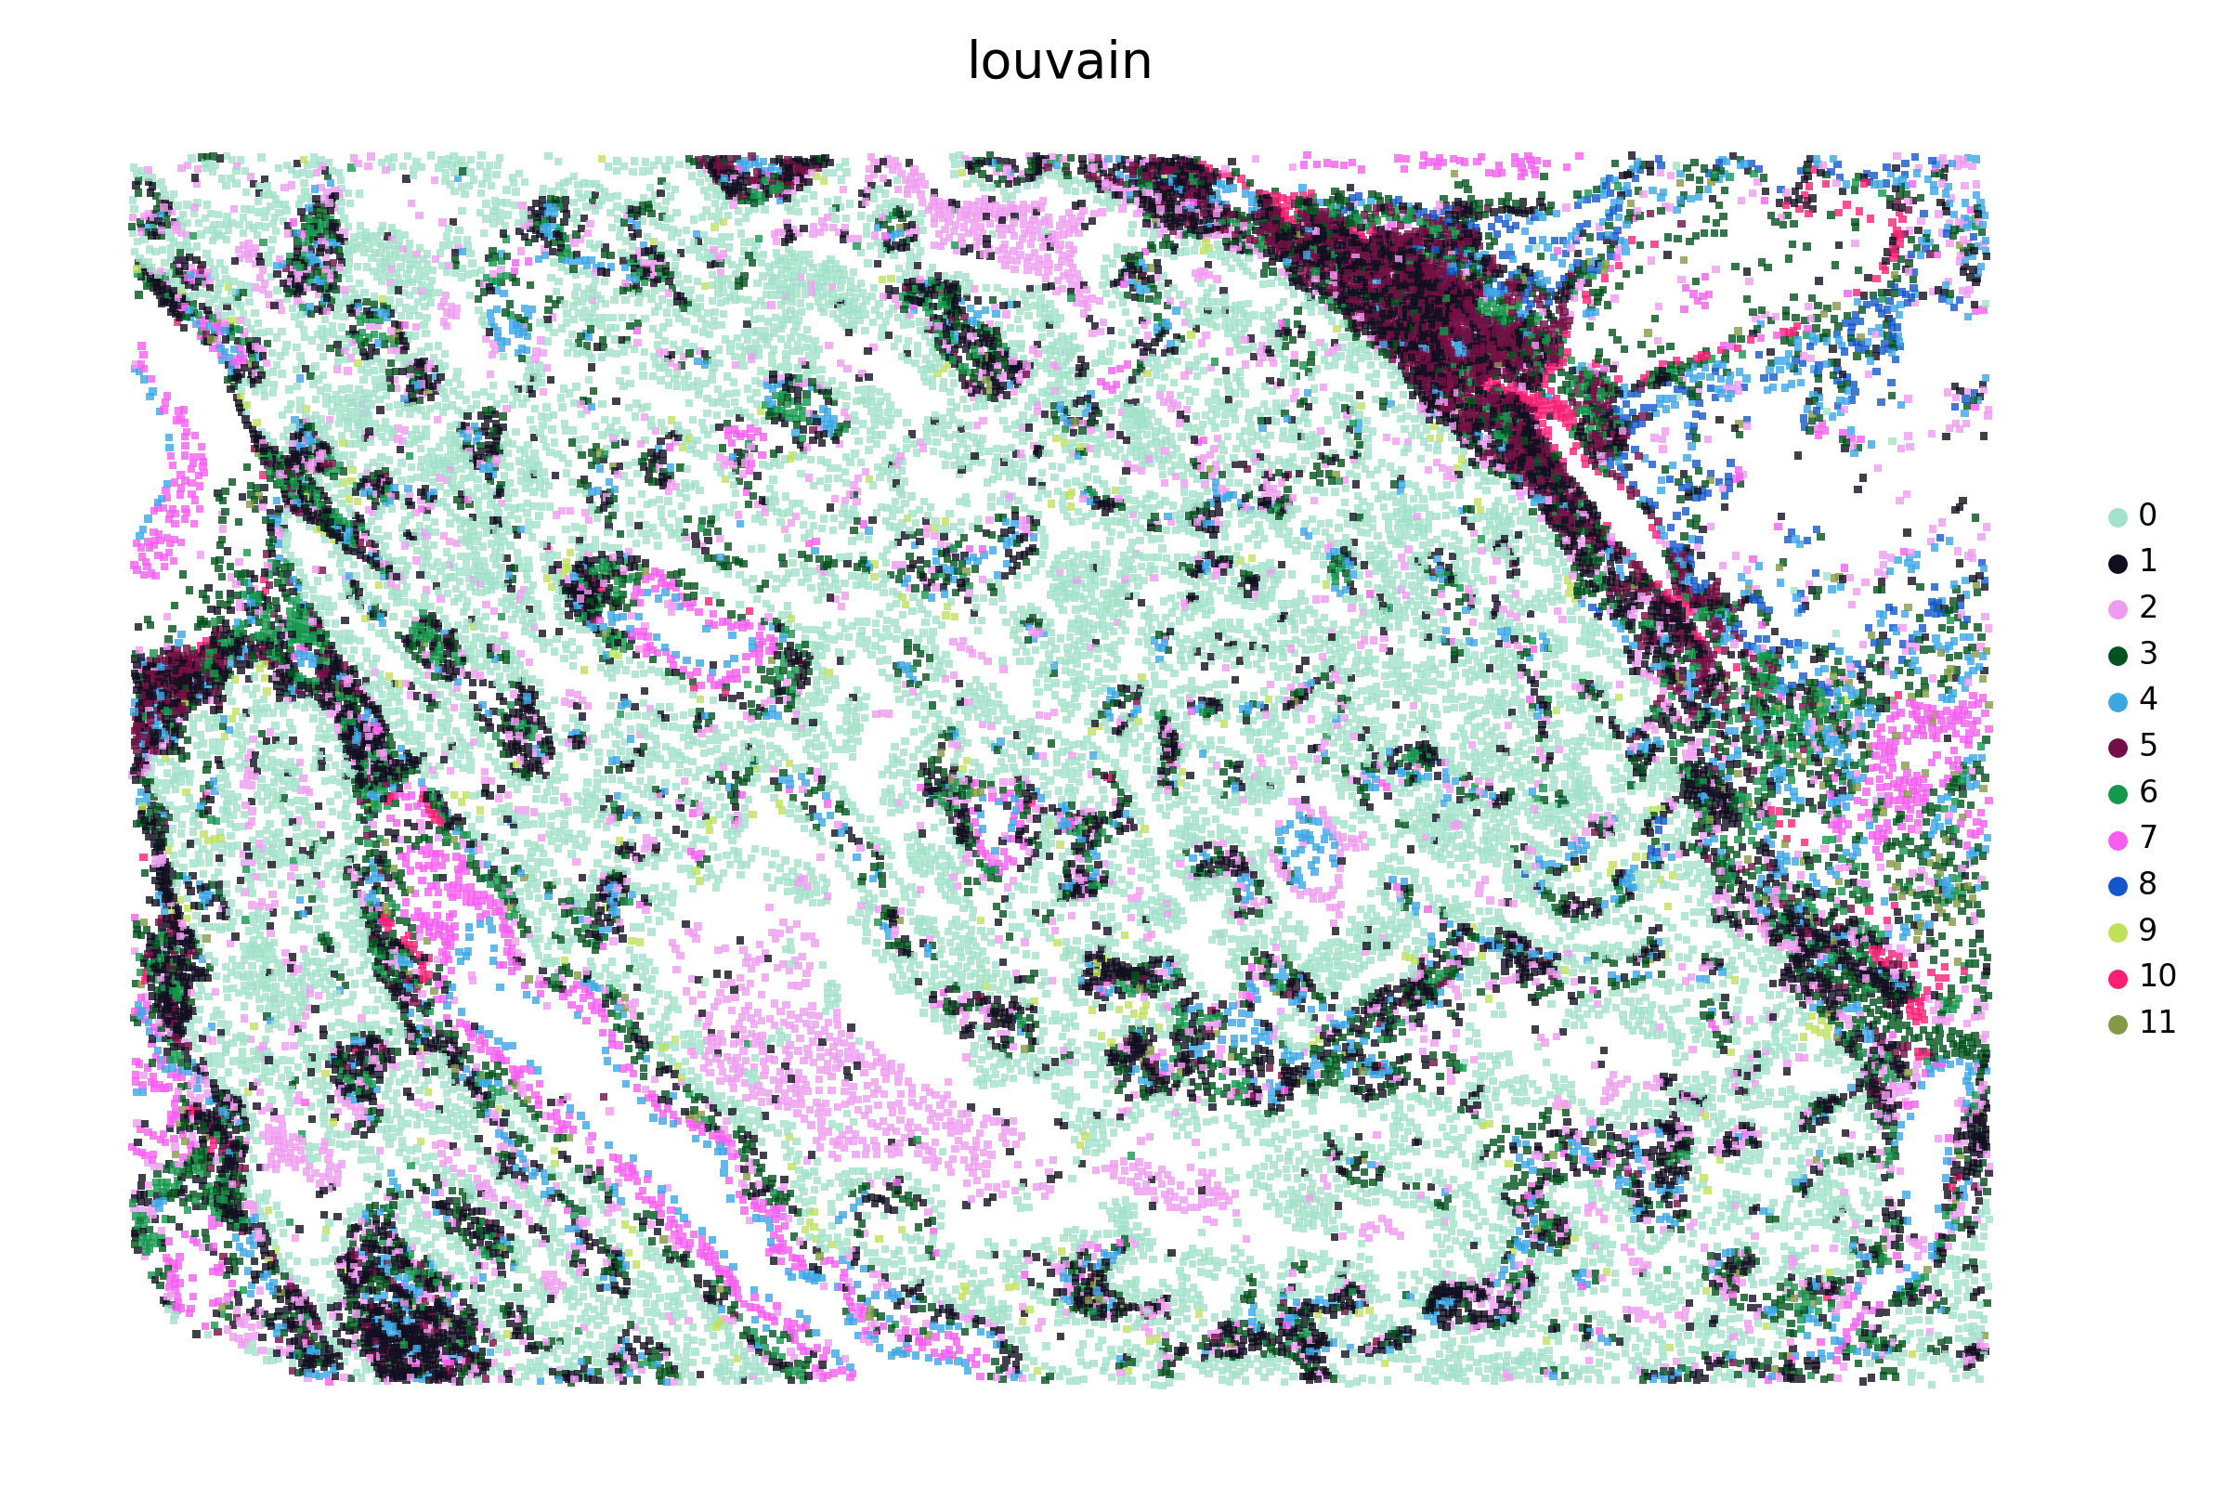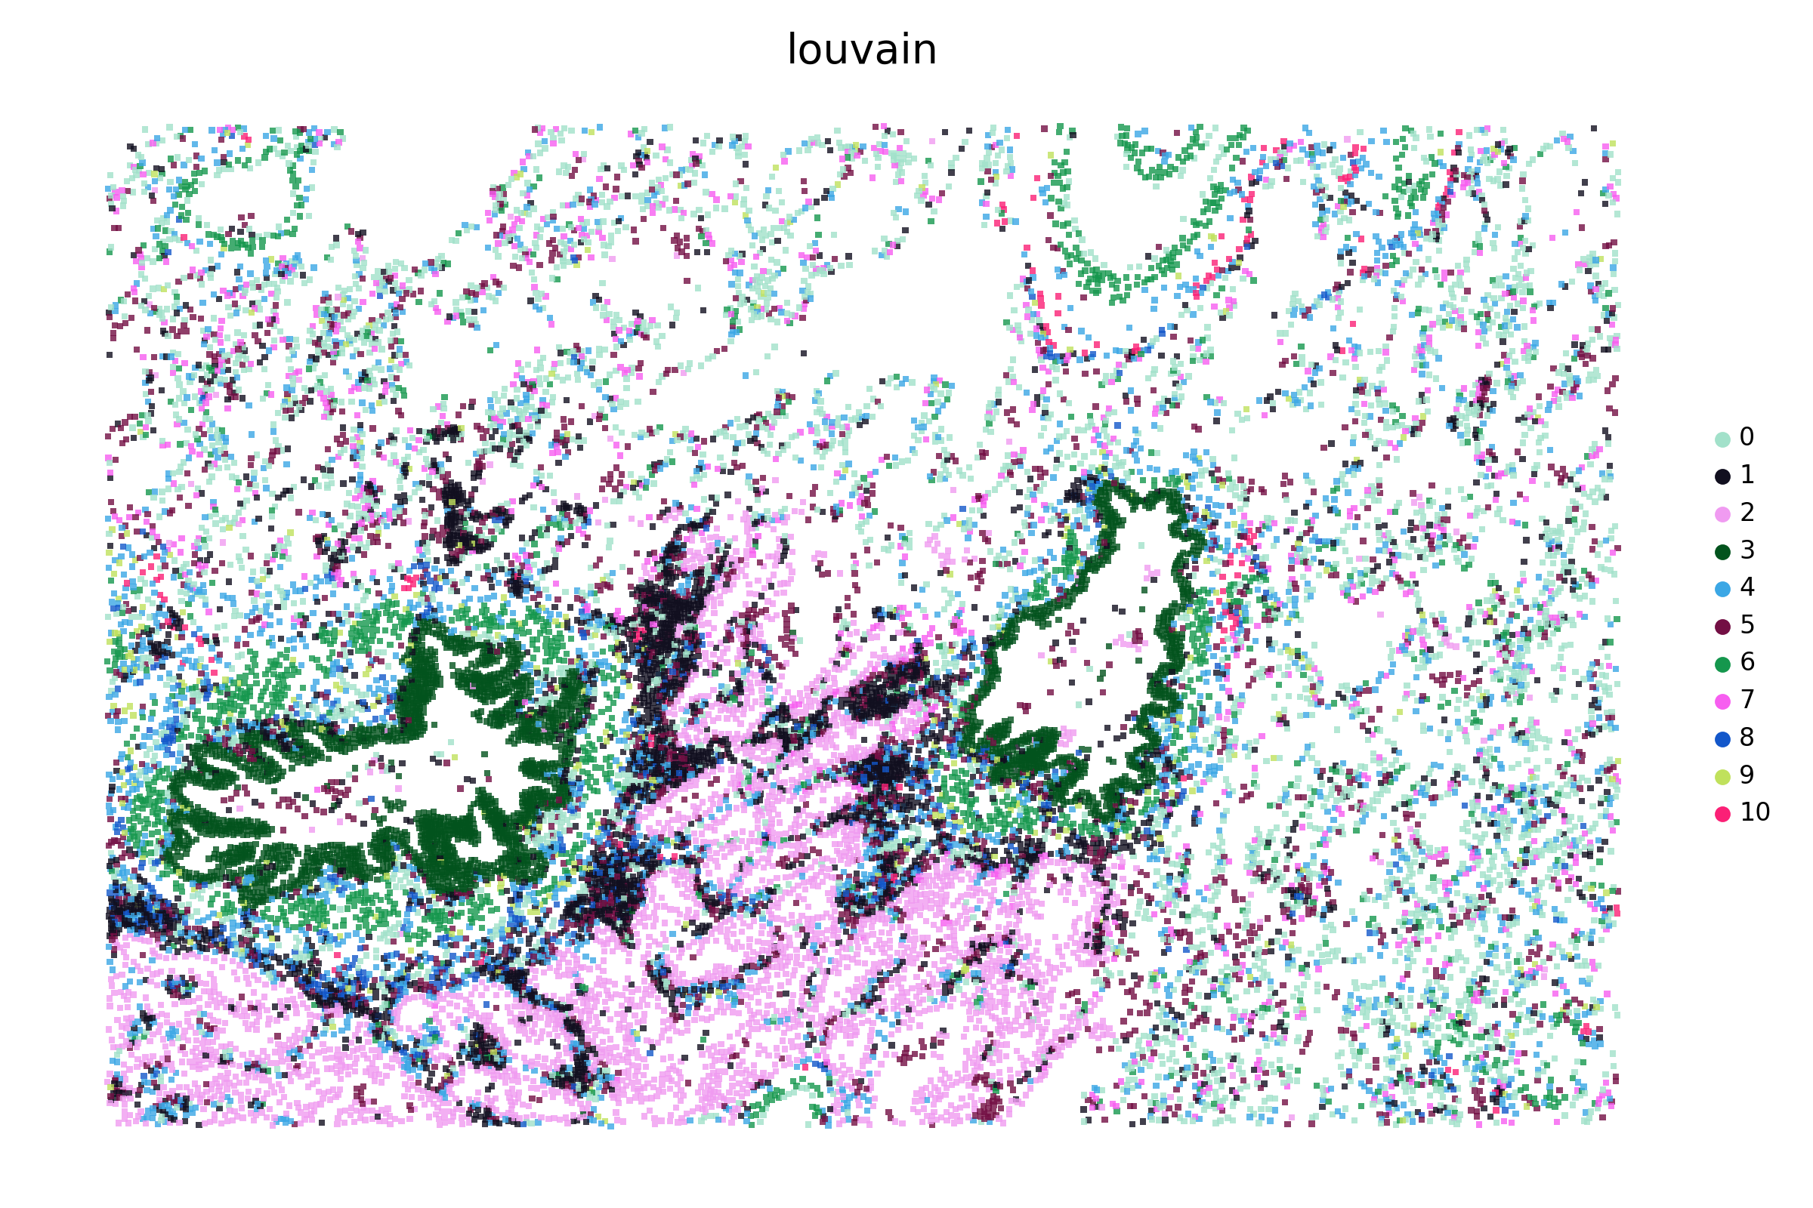
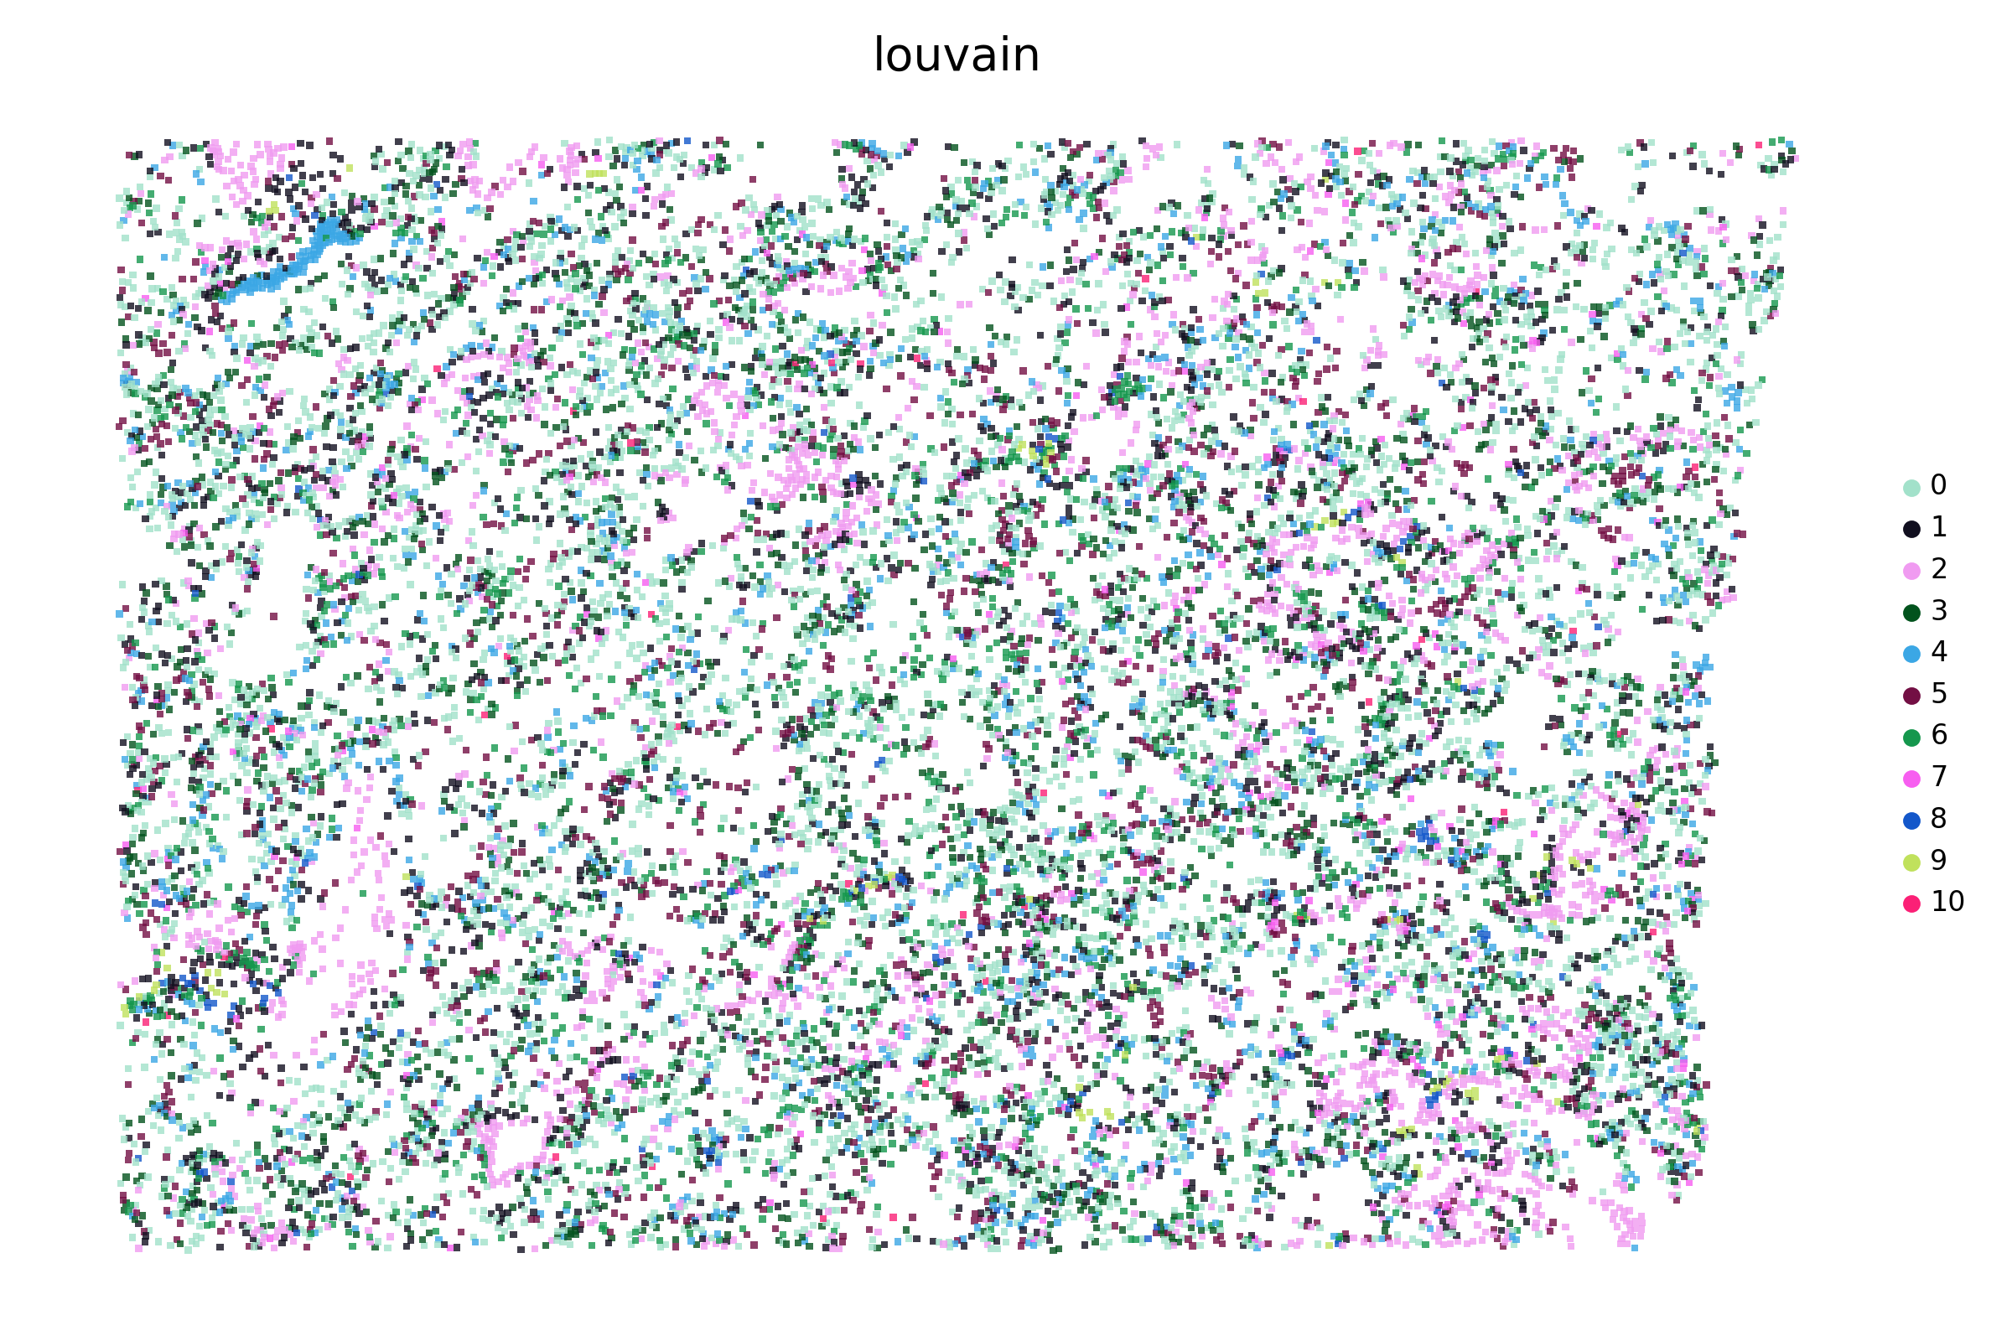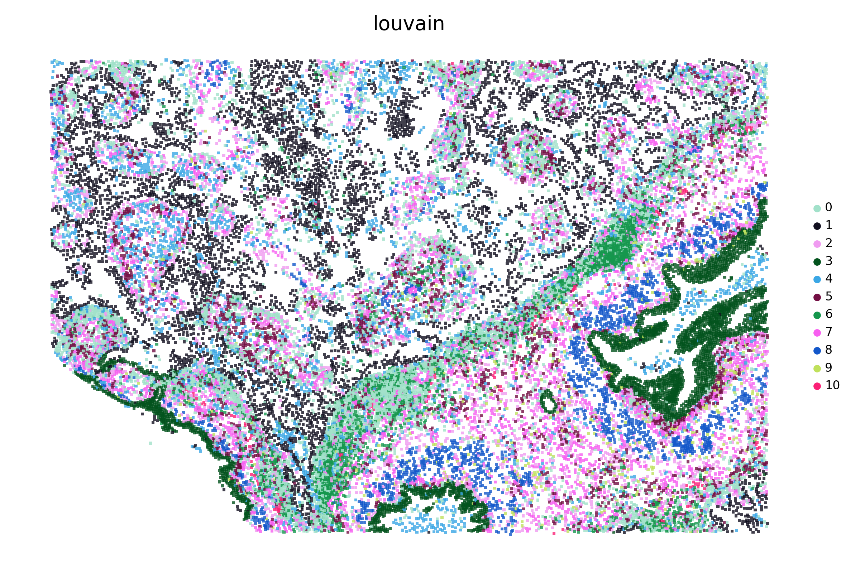
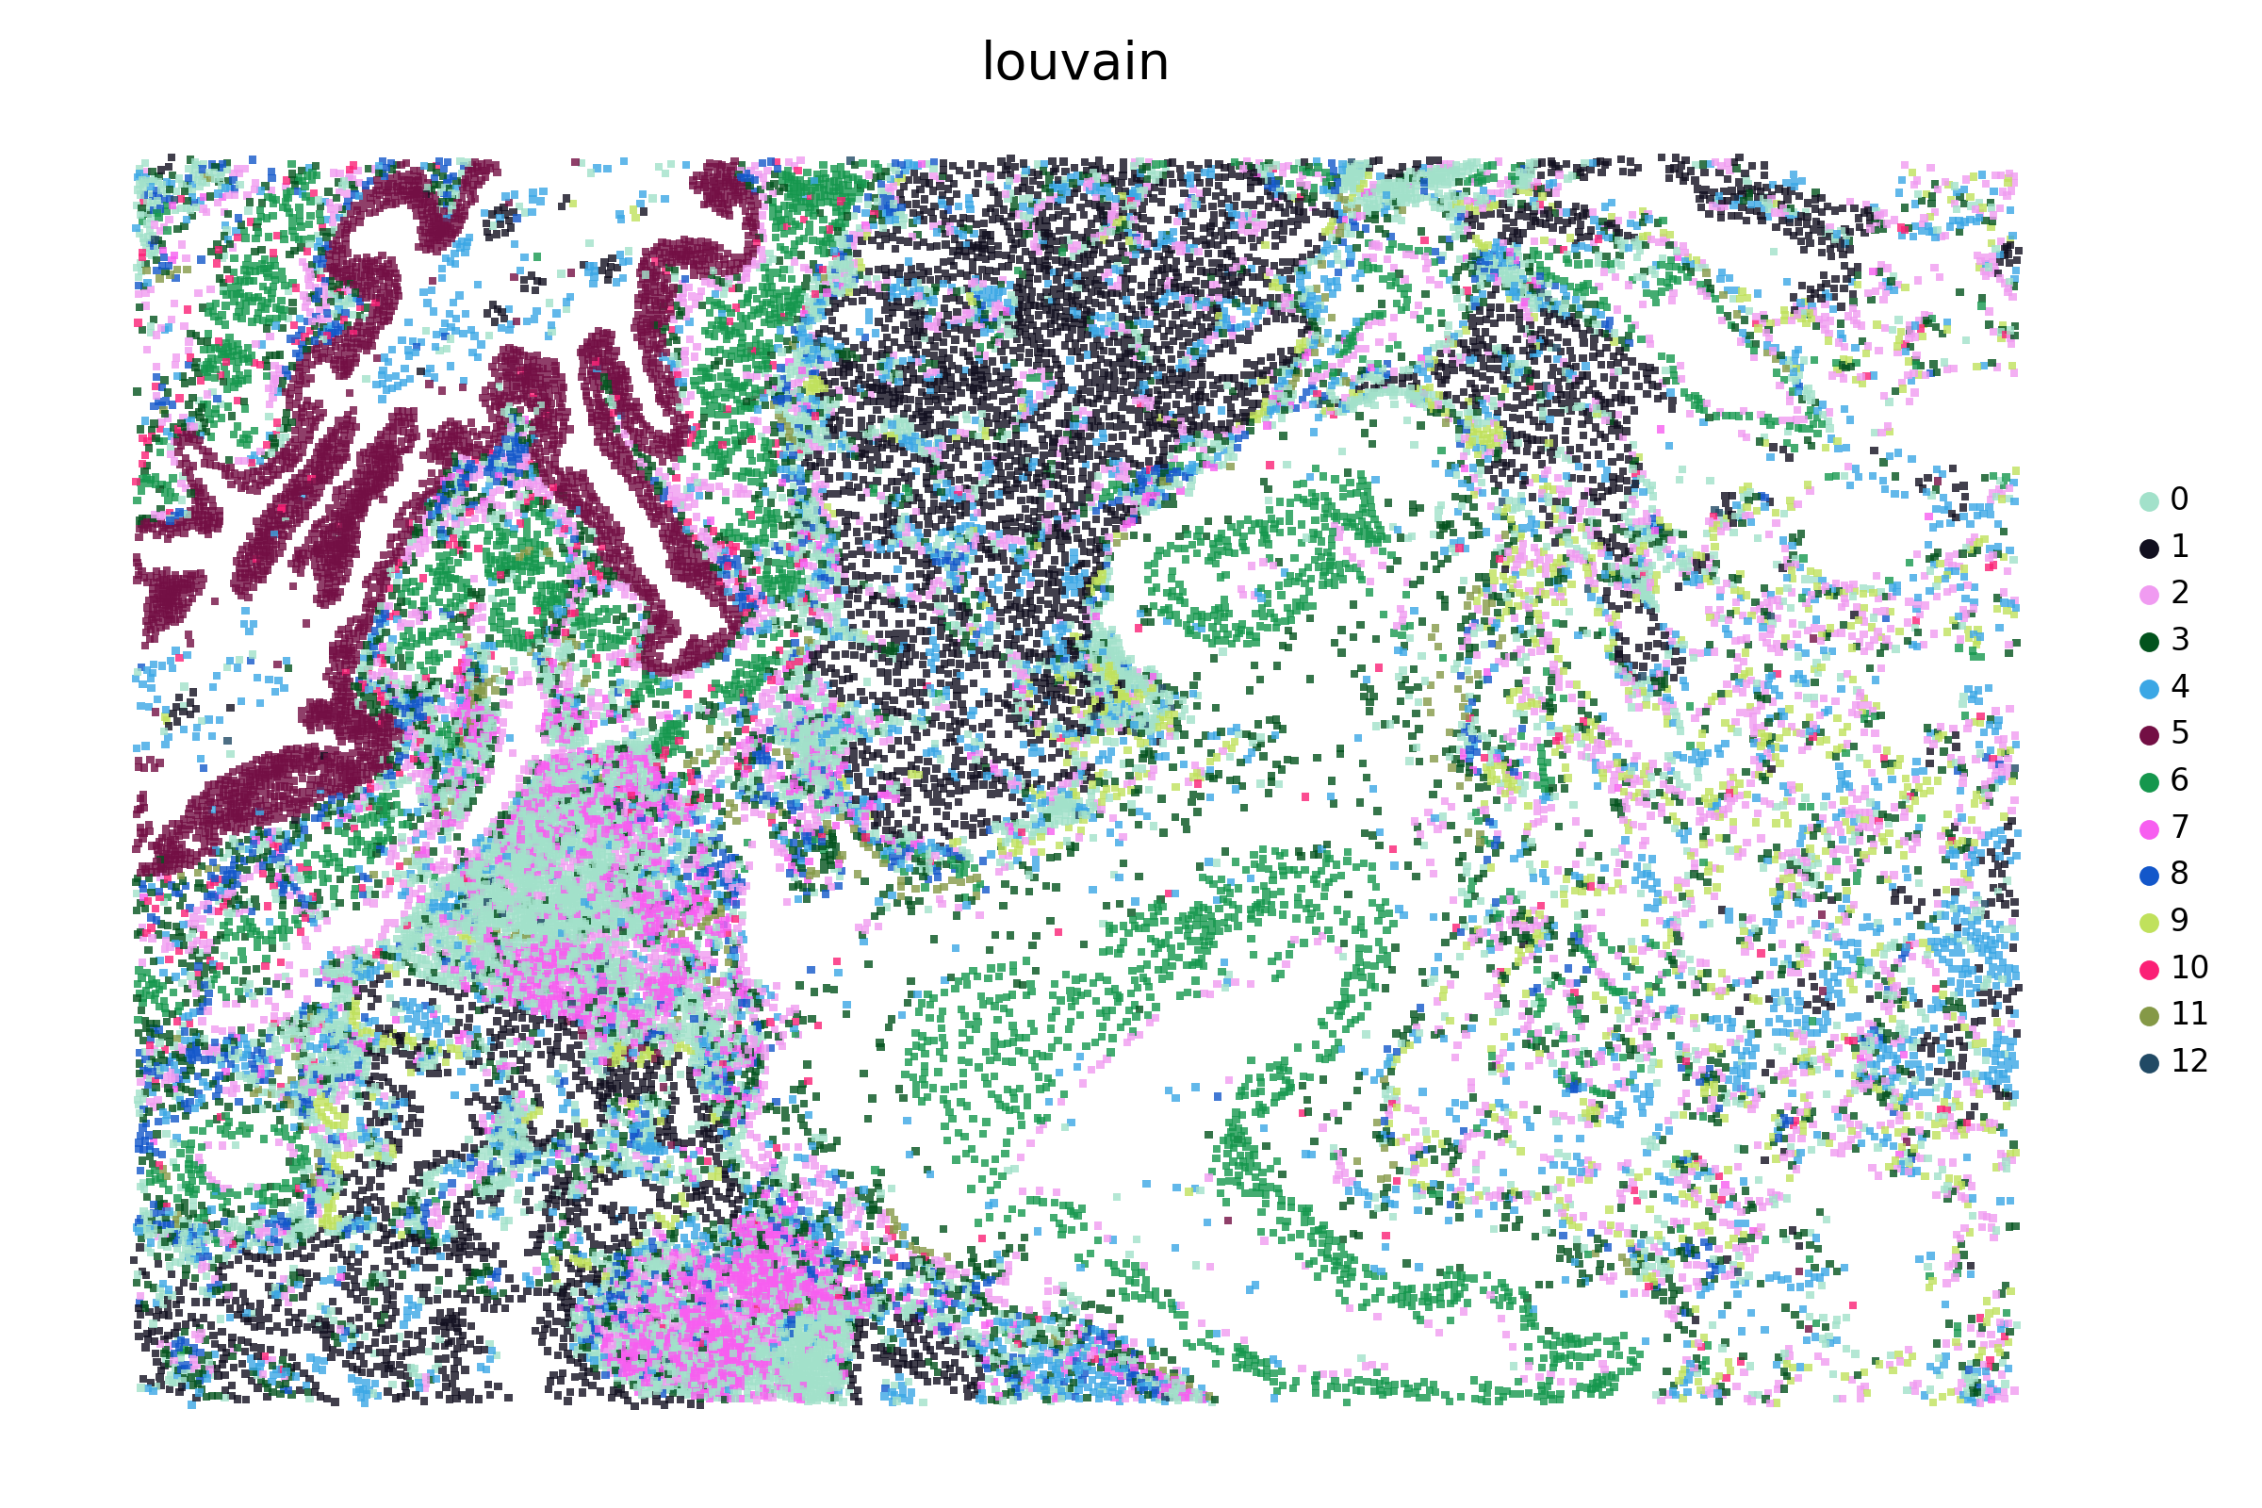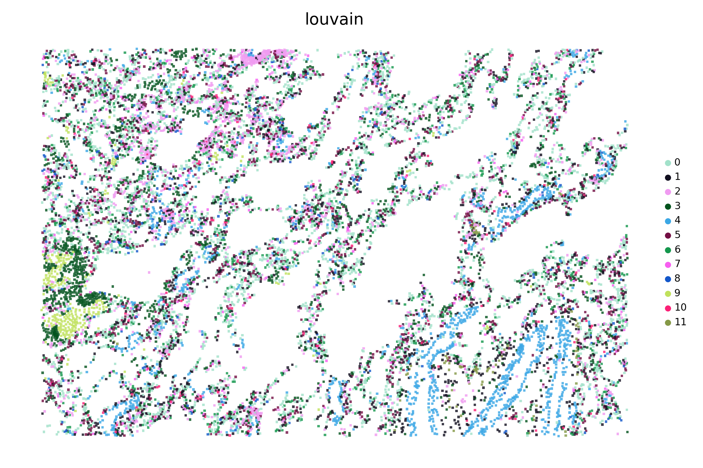
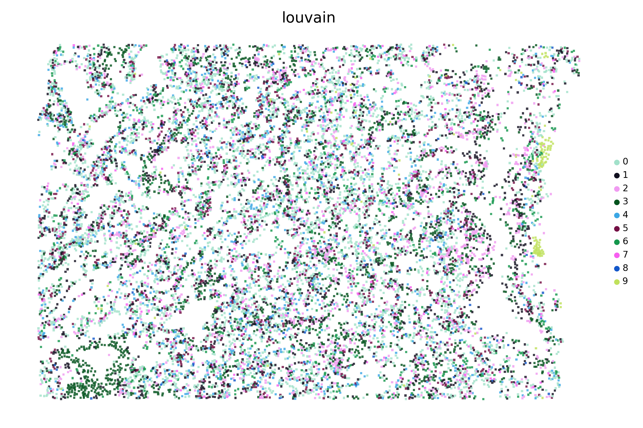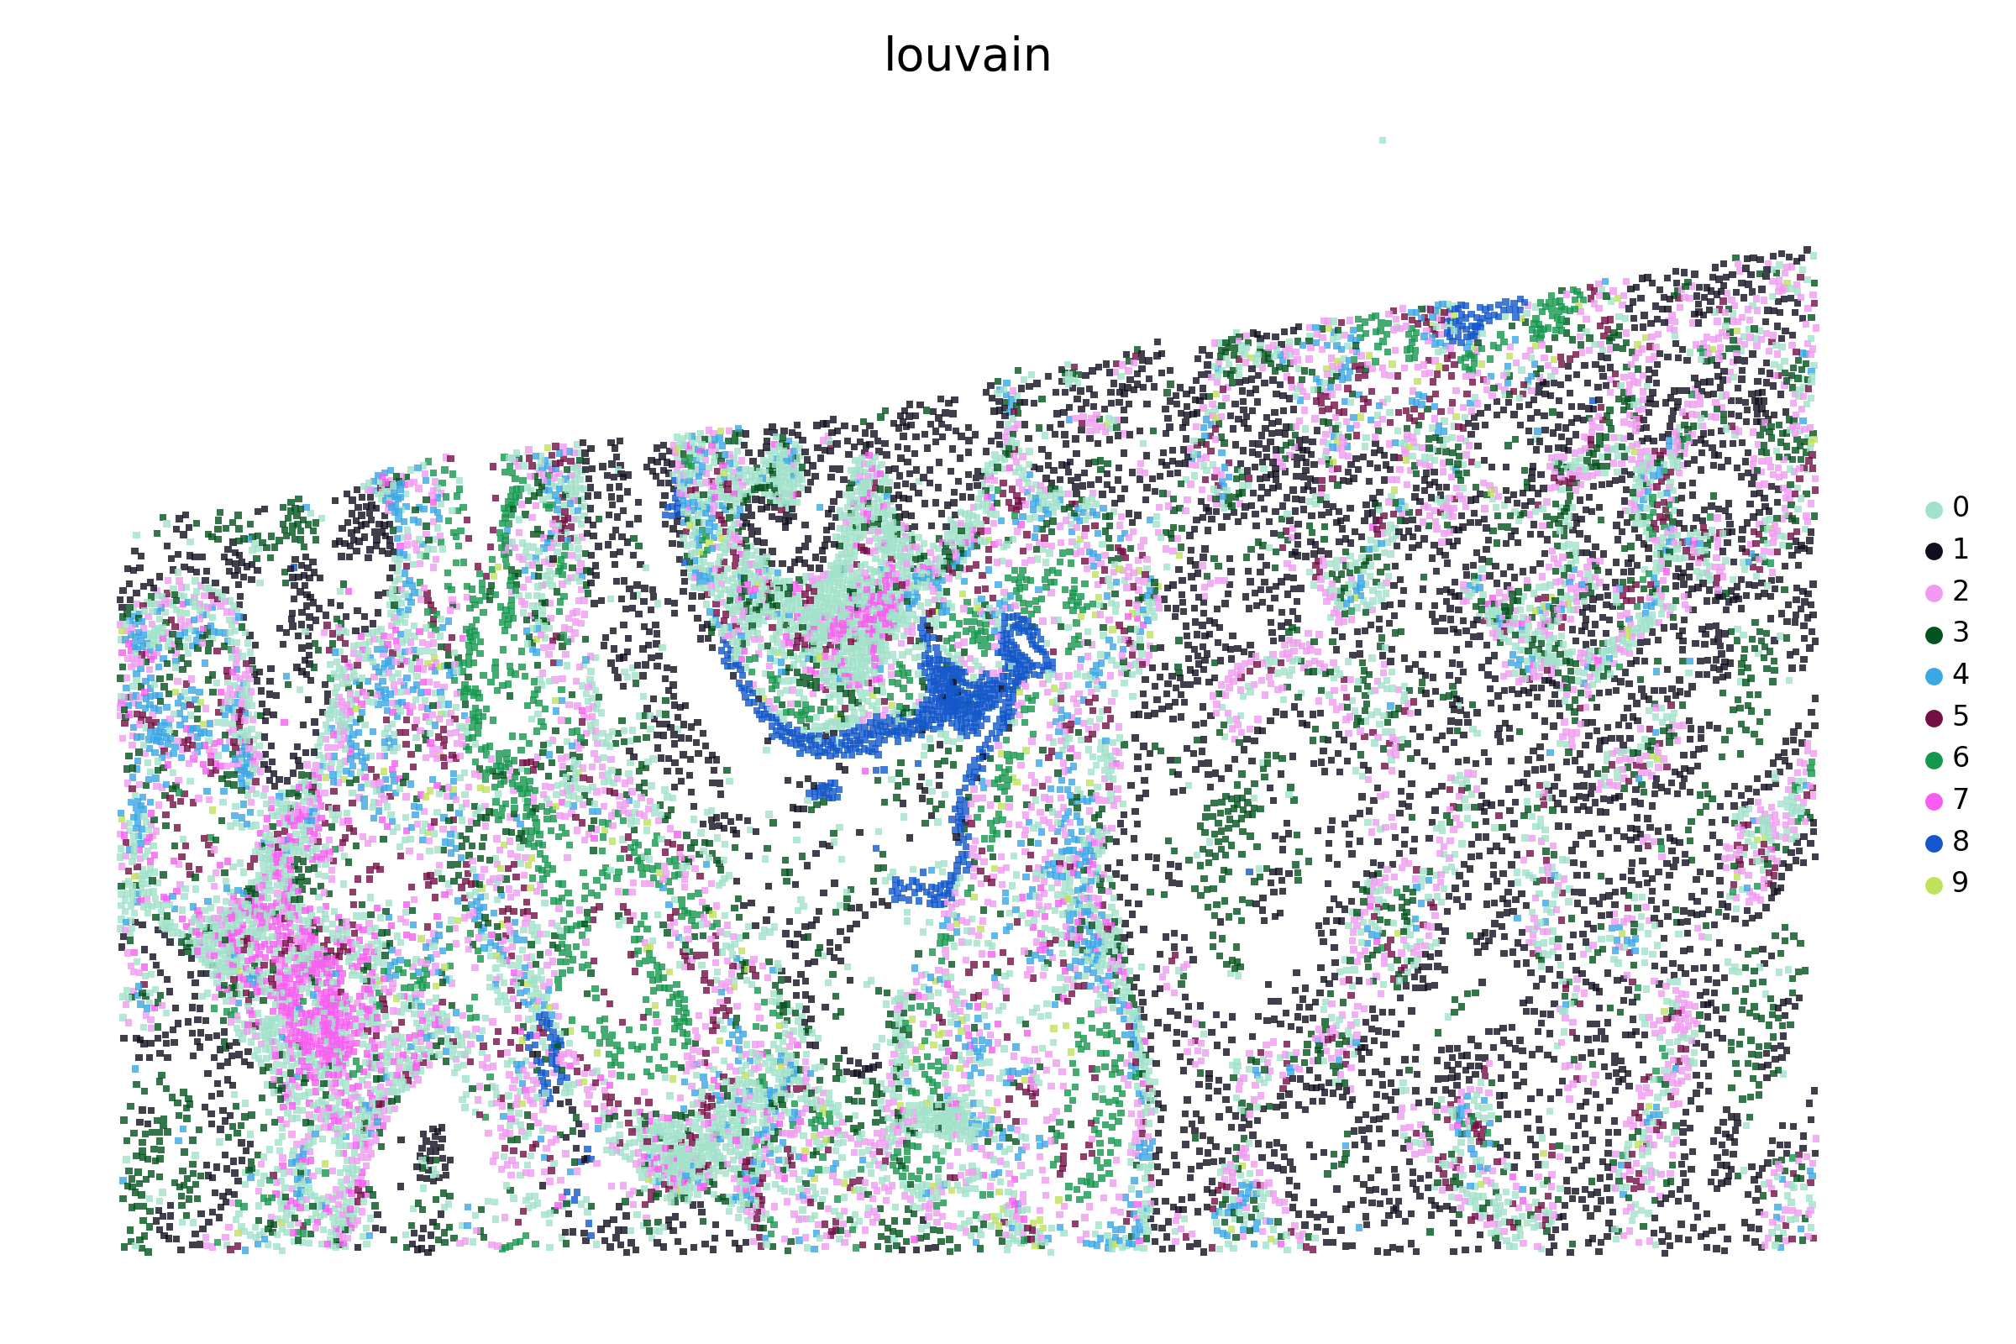
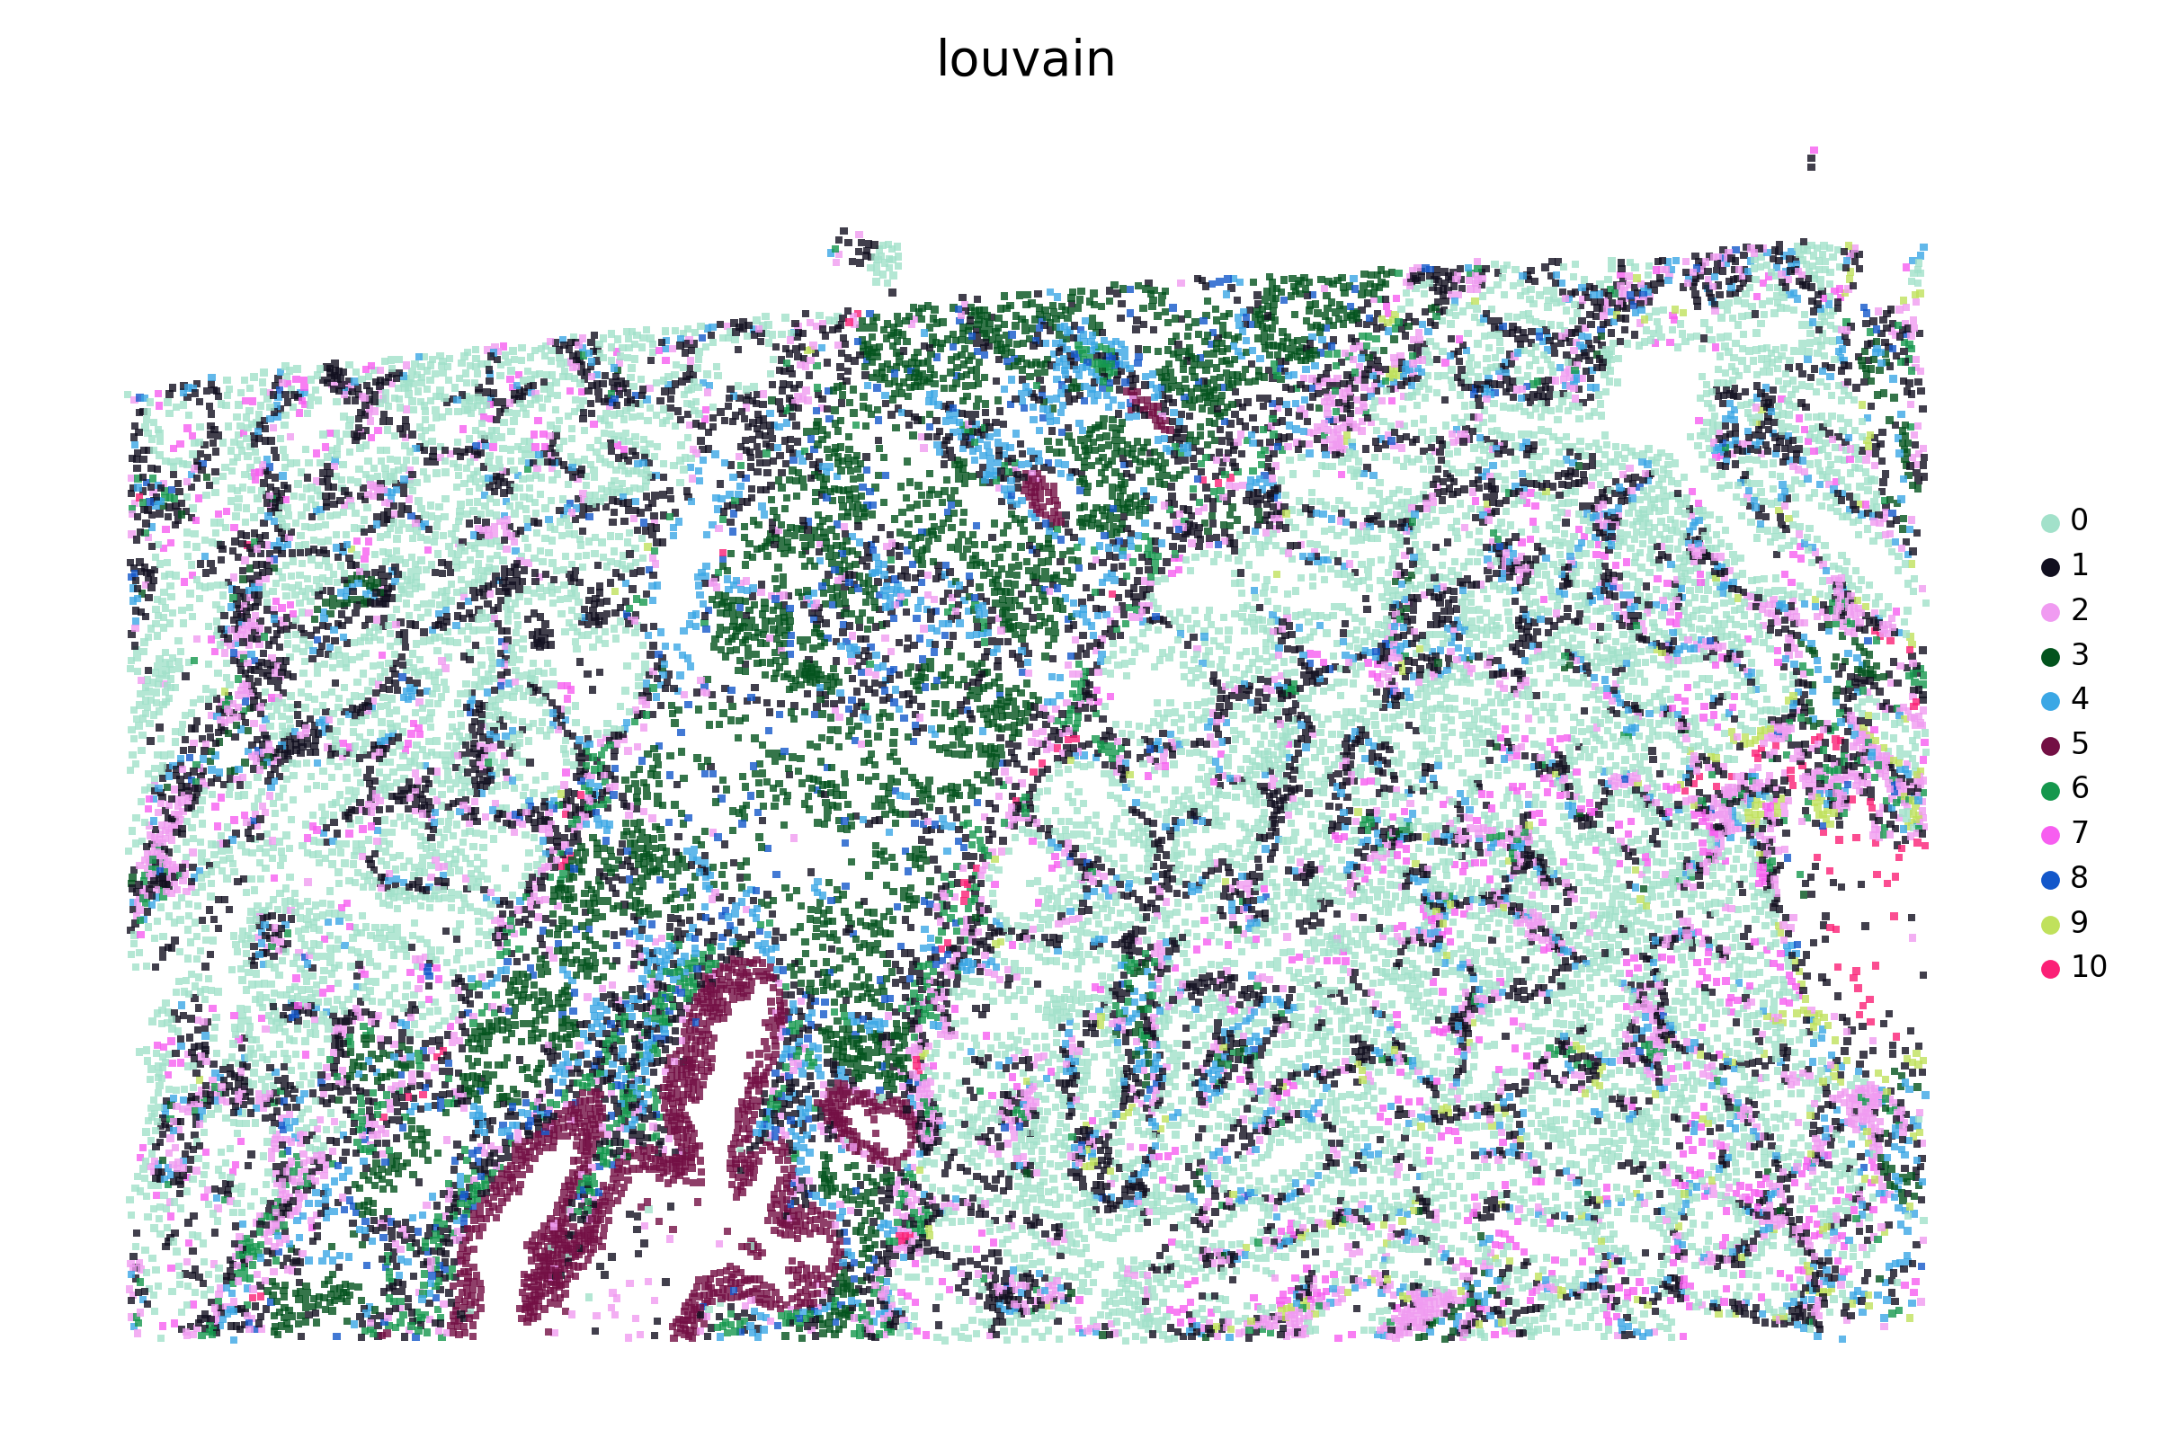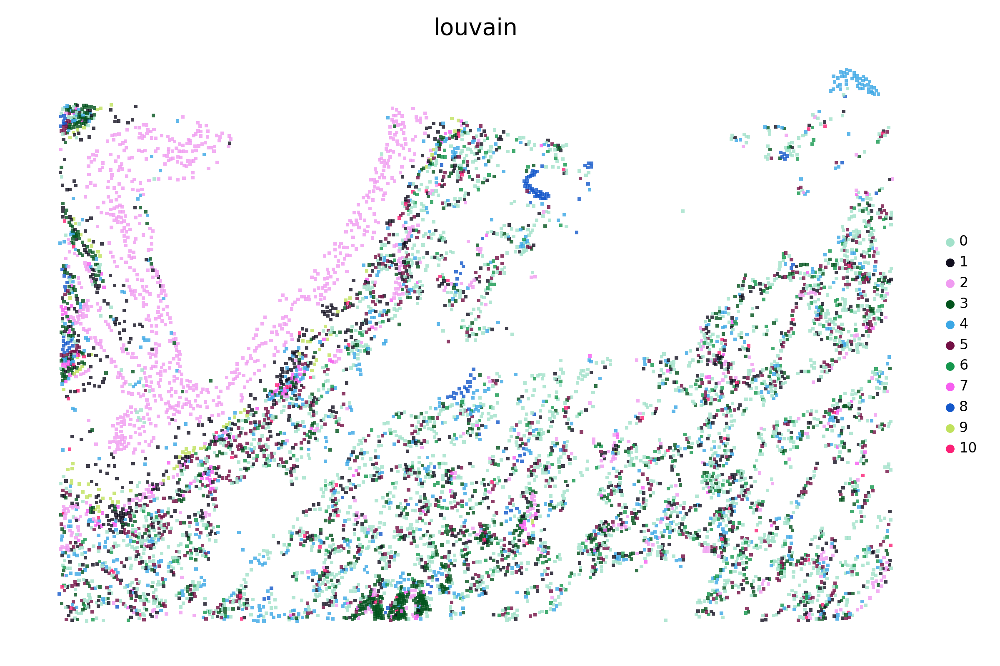
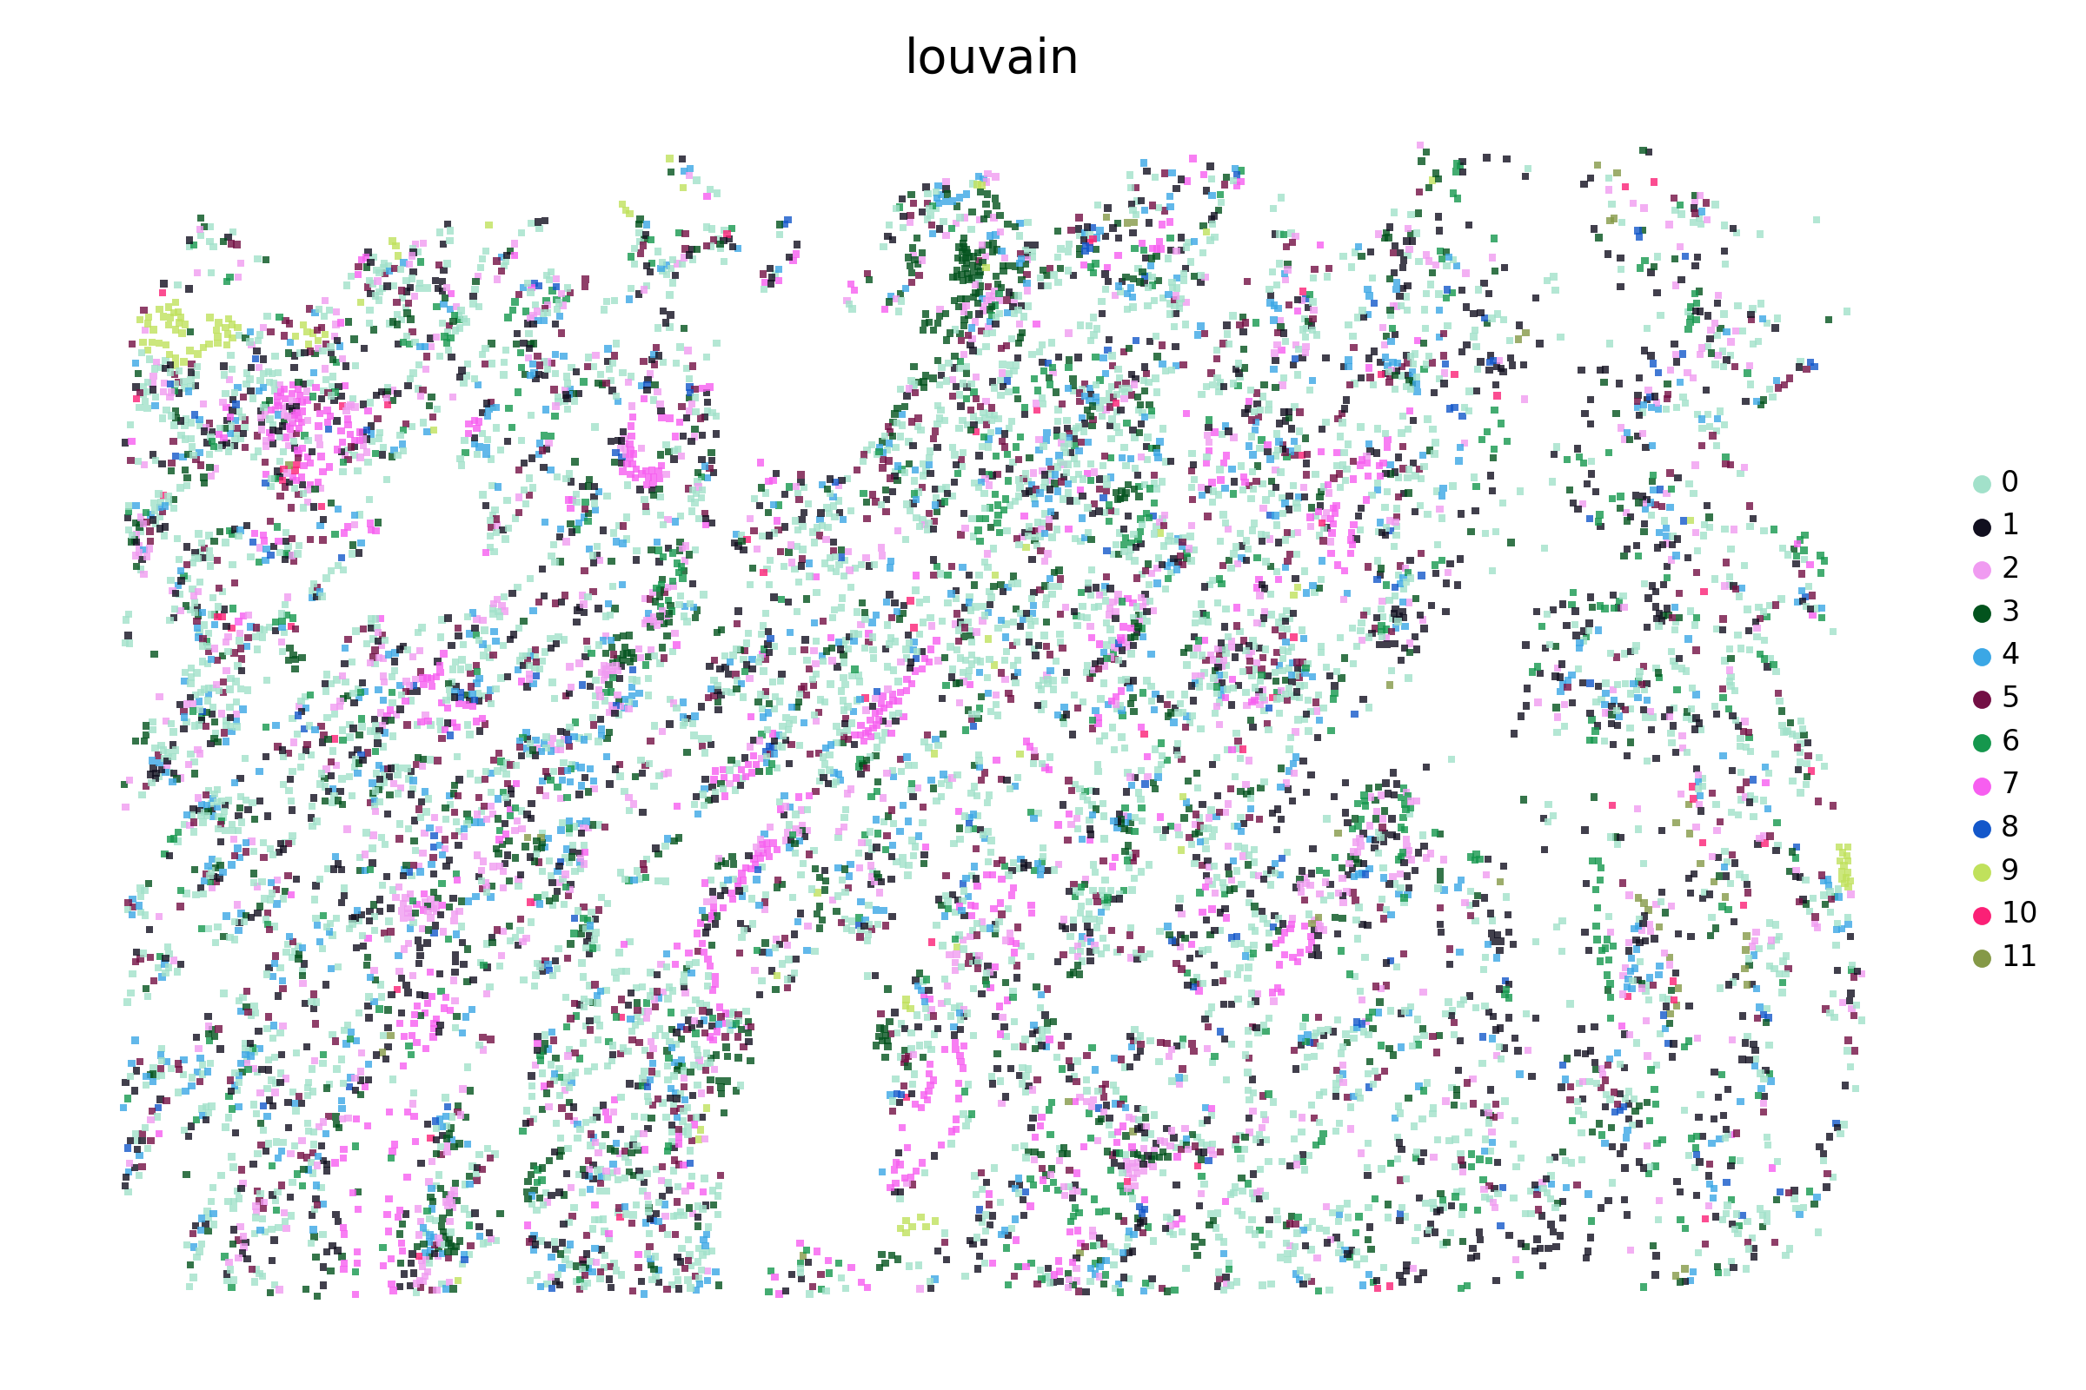
Supplementary Figure S1. Visualization of the SPICEiST clustering results compared to the cell-level, gene expression-based clustering in the Xenium lung cancer dataset with the v1 panel at a resolution of 0.3.
UMAP plots and the spatial distribution of cells illustrate the cell-level embedding and spatial distribution derived from SPICEiST-based analysis (integ; A: UMAP, B: spatial distribution of cells) and cell-level gene expression-based clustering (gex; C: UMAP, D: spatial distribution of cells), respectively. The tissue samples, obtained from patch numbers 0 to 14, are presented serially from left to right and top to bottom. The four numerical values at the top of the UMAP plot represent the ASW, CHI, DBI, and assortativity coefficient. Each dot in the plot corresponds to a cell, with color indicating the identity of the clusters.

A
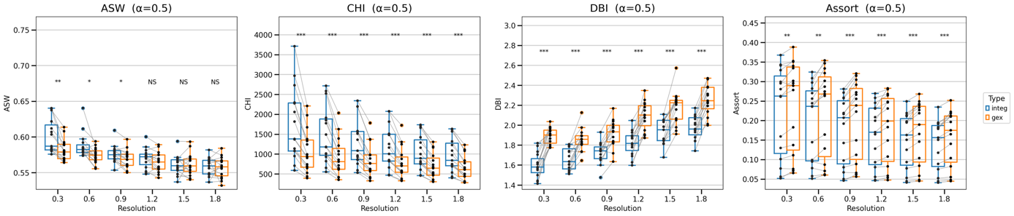
B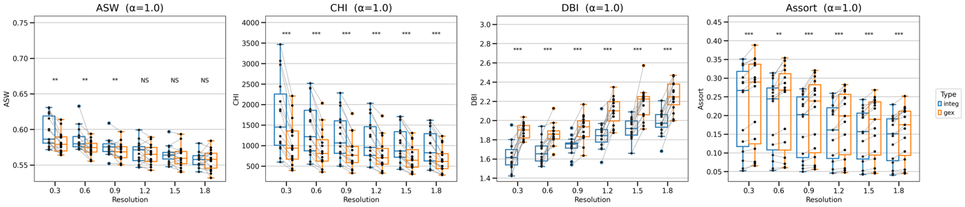

C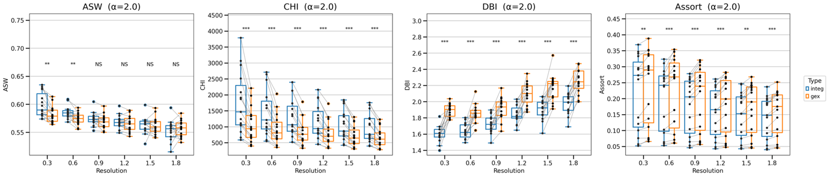

Supplementary Figure S2. Comparison of the SPICEiST (integ) clustering results with those obtained from cell-level gene expression-based (gex) clustering in the Xenium human lung cancer dataset with v1 panel.
The boxplots compare three distinct clustering performance indices: ASW, CHI, DBI, and the assortativity coefficient, across varying resolutions of cell clusters. The alpha weight for the loss was set to (A) 0.50, (B) 1.0, and (C) 2.0 during training.

A
B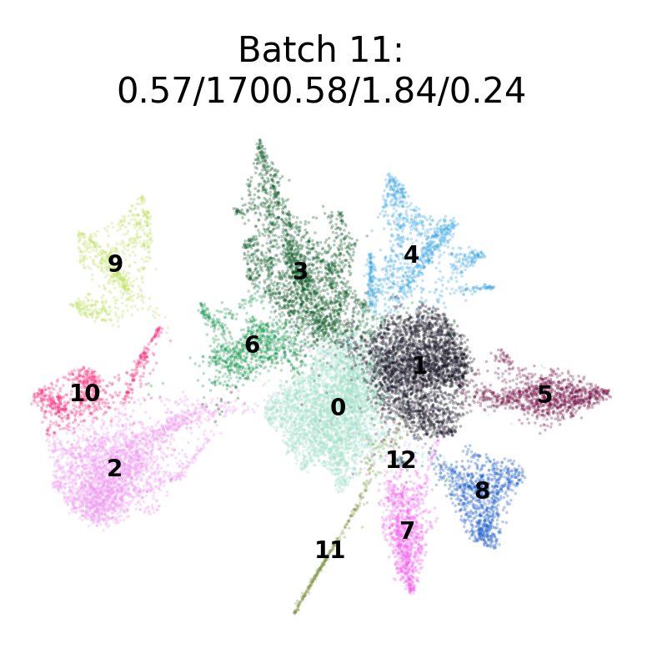
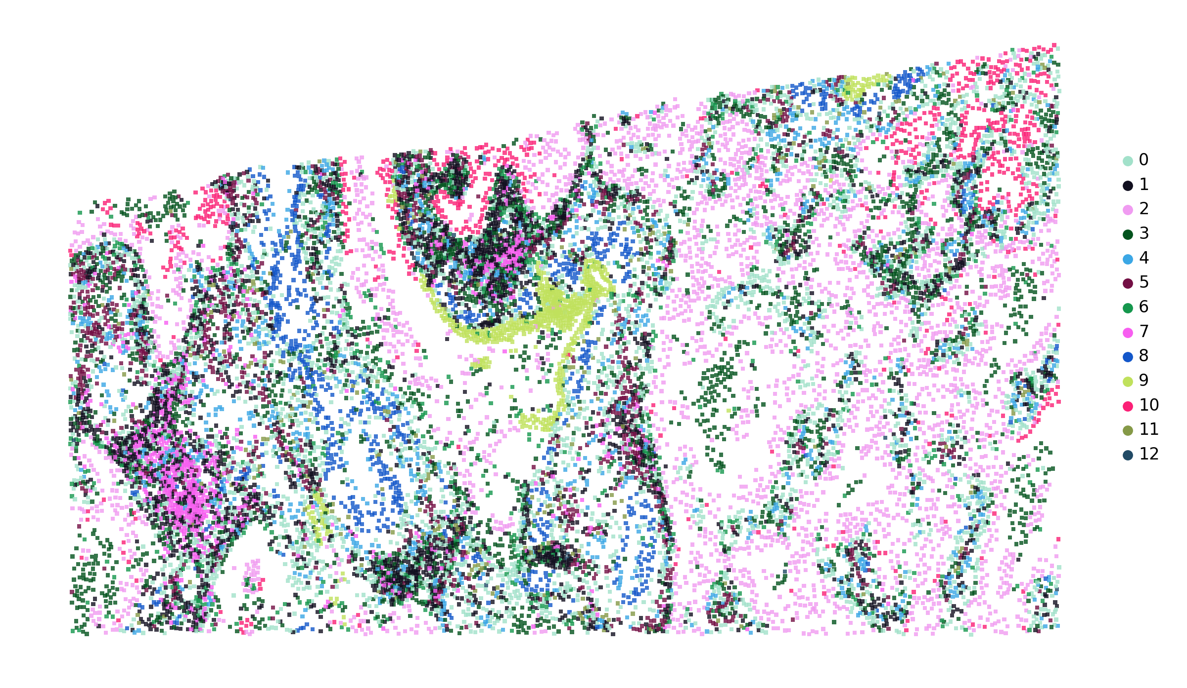

C
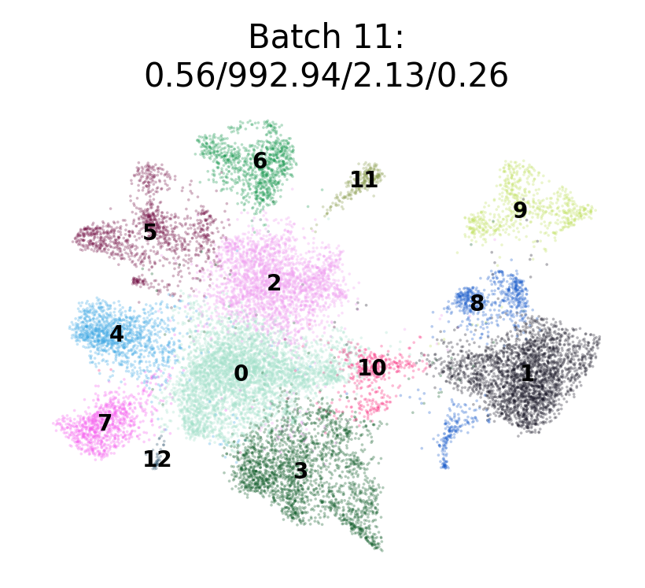
D
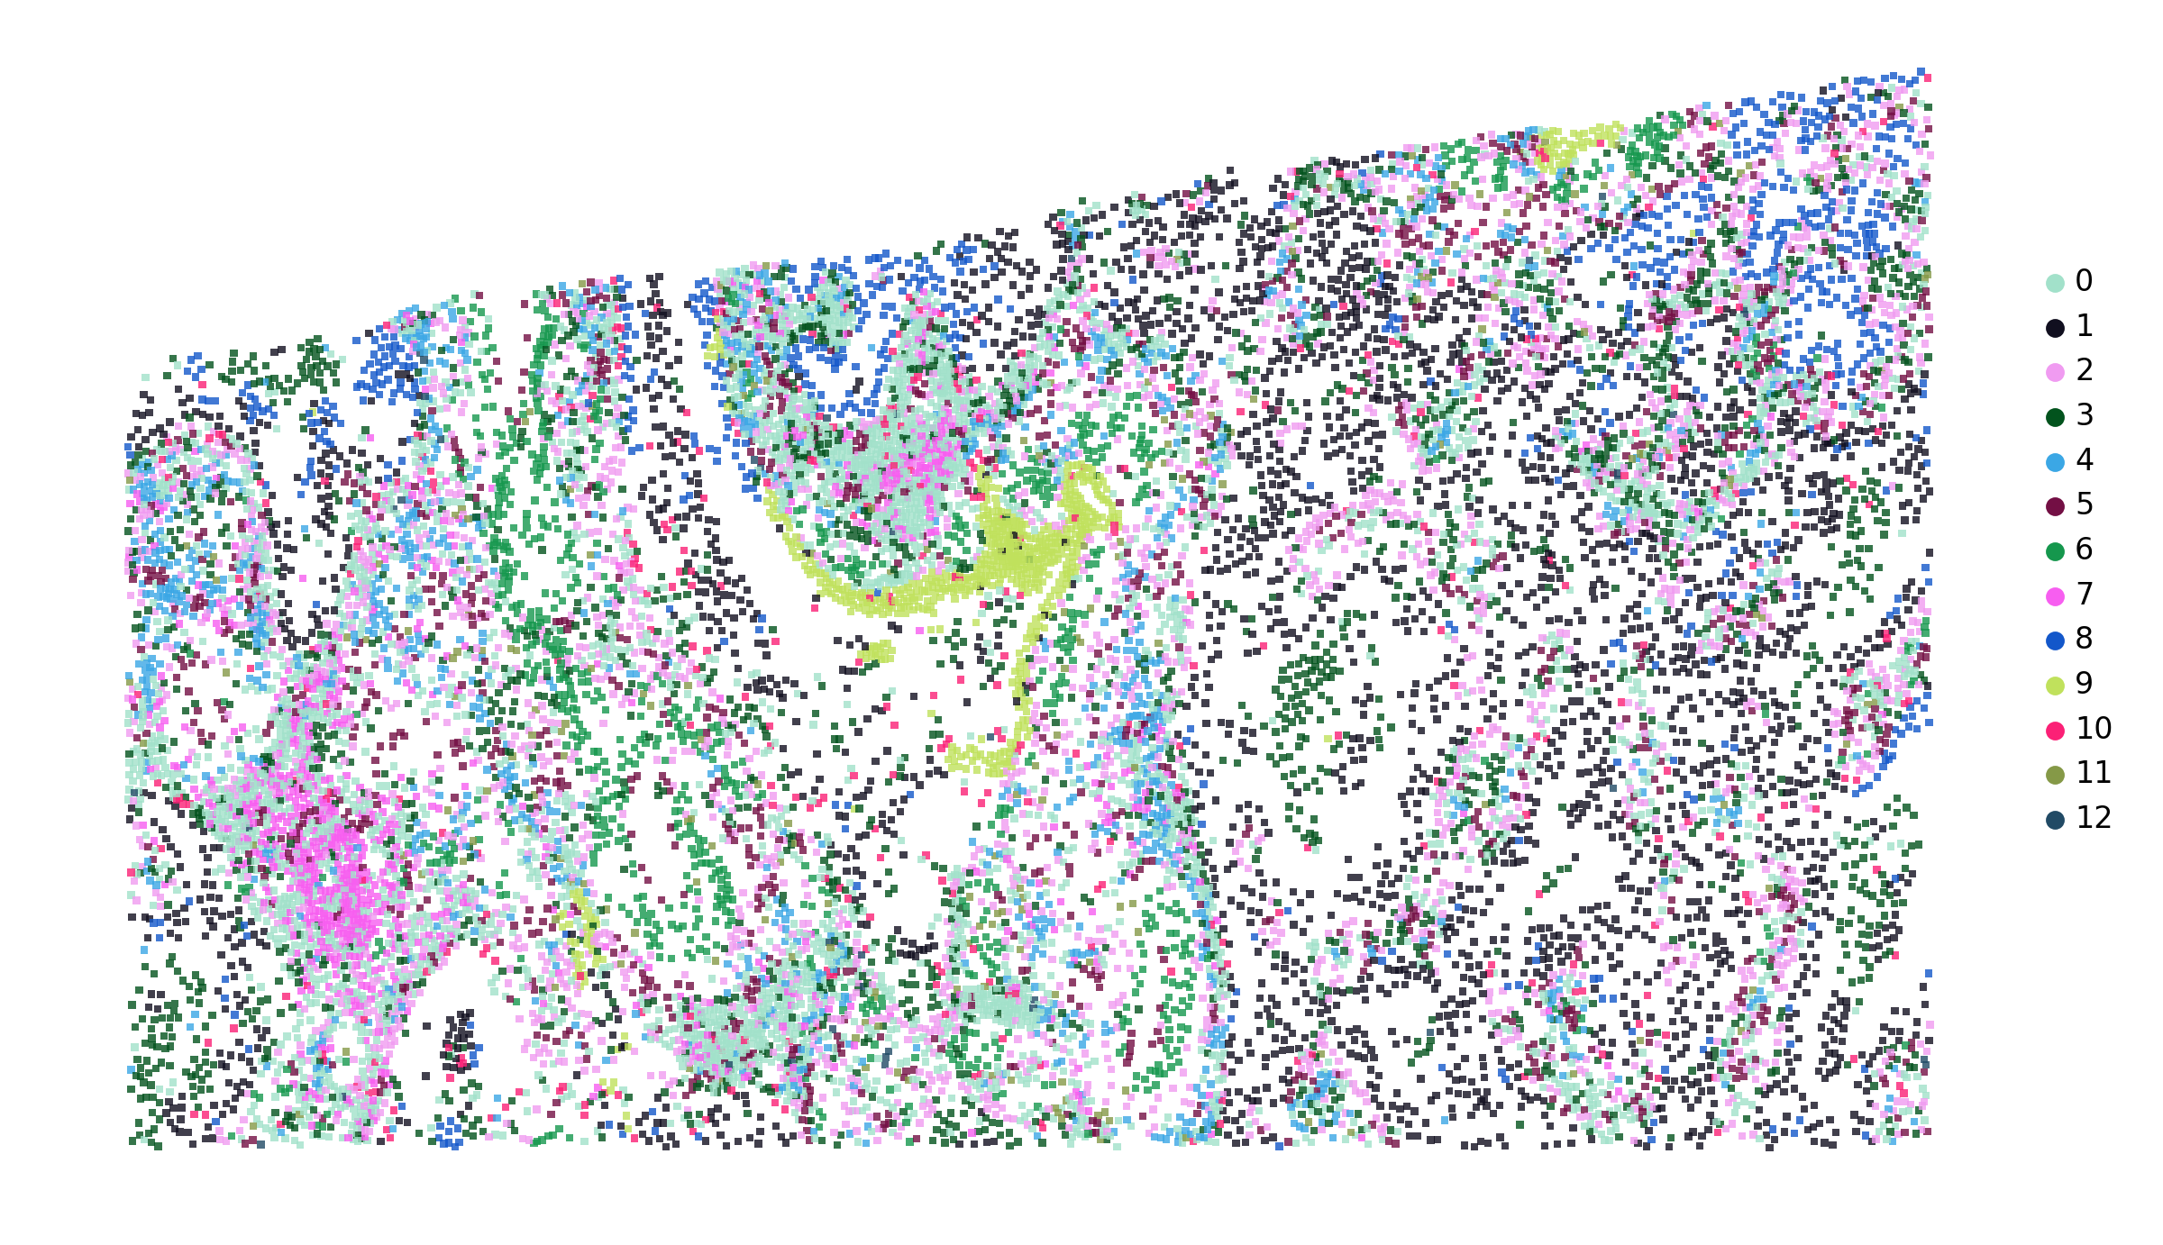
Supplementary Figure S3. Visualization of the SPICEiST clustering results compared to the cell-level, gene expression-based clustering in the Xenium lung cancer dataset with the v1 panel at a resolution of 0.6.
UMAP plots and the spatial distribution of cells illustrate the cell-level embedding and spatial distribution derived from SPICEiST-based analysis (integ; A: UMAP, B: spatial distribution of cells) and cell-level gene expression-based clustering (gex; C: UMAP, D: spatial distribution of cells), respectively. The tissue sample, obtained from patch number 11 is presented, and the four numerical values at the top of the UMAP plot represent the ASW, CHI, DBI, and assortativity coefficient. Each dot in the plot corresponds to a cell, with color indicating the identity of the clusters.

A
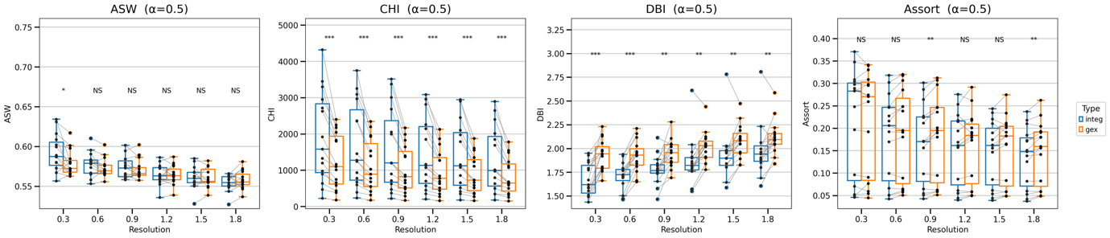
B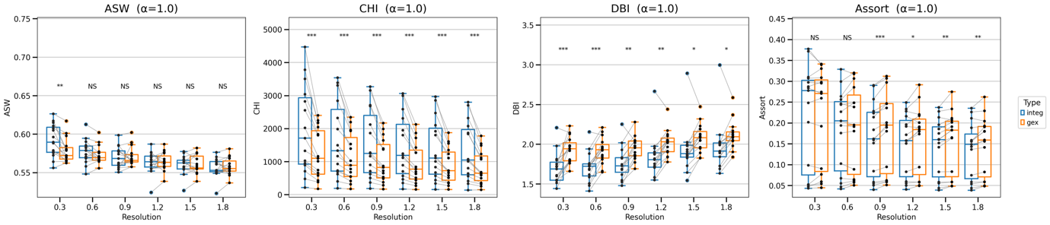
C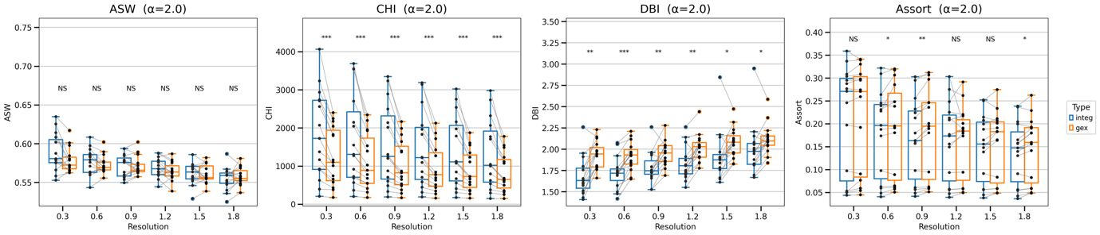
Supplementary Figure S4. Comparison of the SPICEiST (integ) clustering results with those obtained from cell-level gene expression-based (gex) clustering in the Xenium human lung cancer dataset with 5K panel.
The boxplots compare three distinct clustering performance indices: ASW, CHI, DBI, and the assortativity coefficient, across varying resolutions of cell clusters. The alpha weight for the loss was set to (A) 0.50, (B) 1.0, and (C) 2.0 during training.

A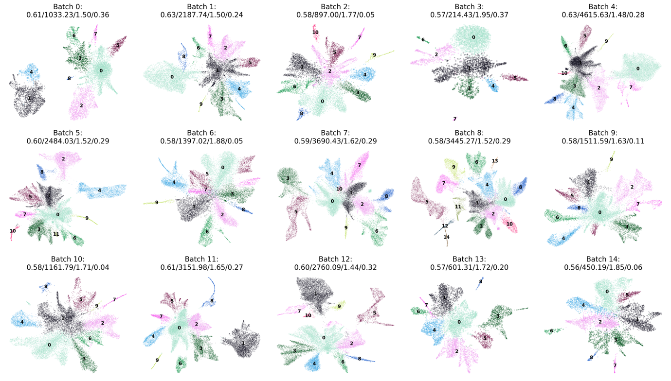

B
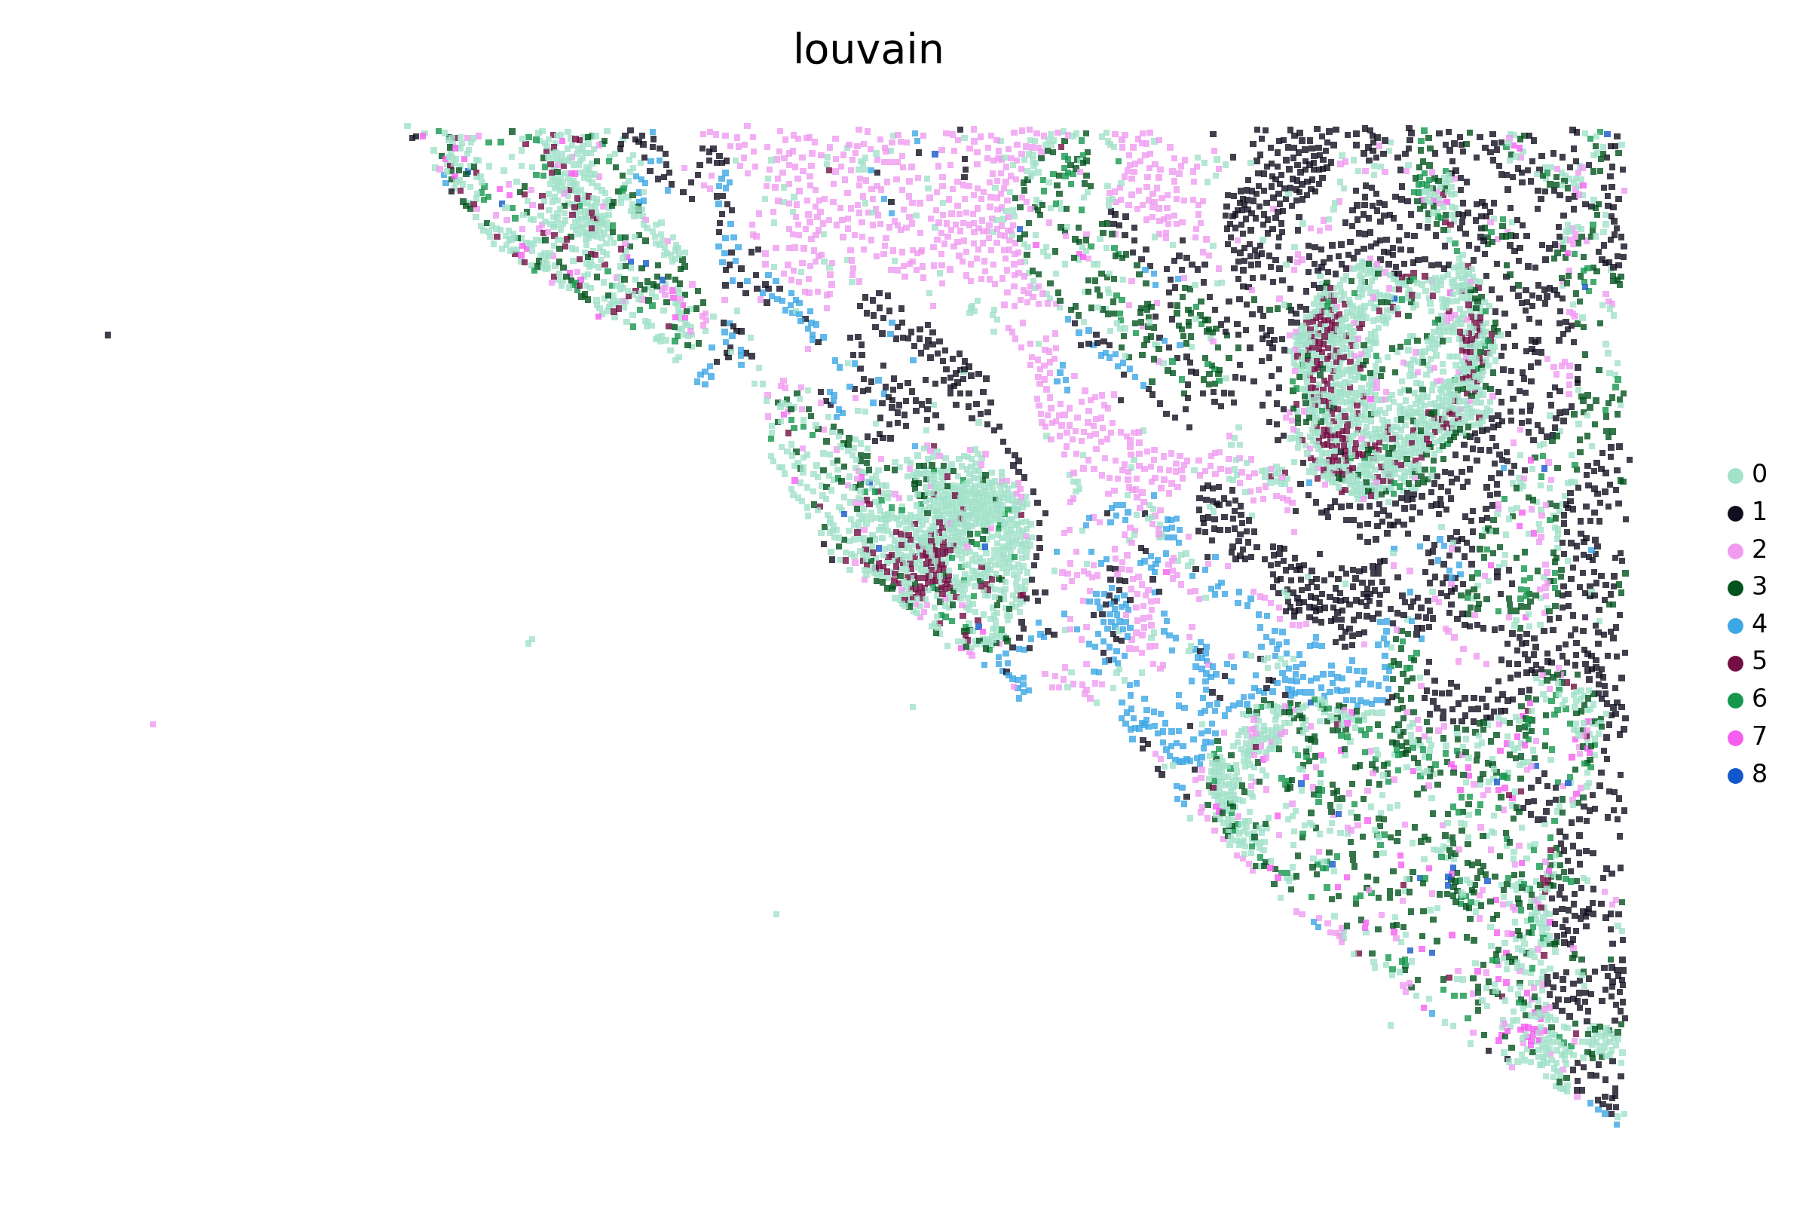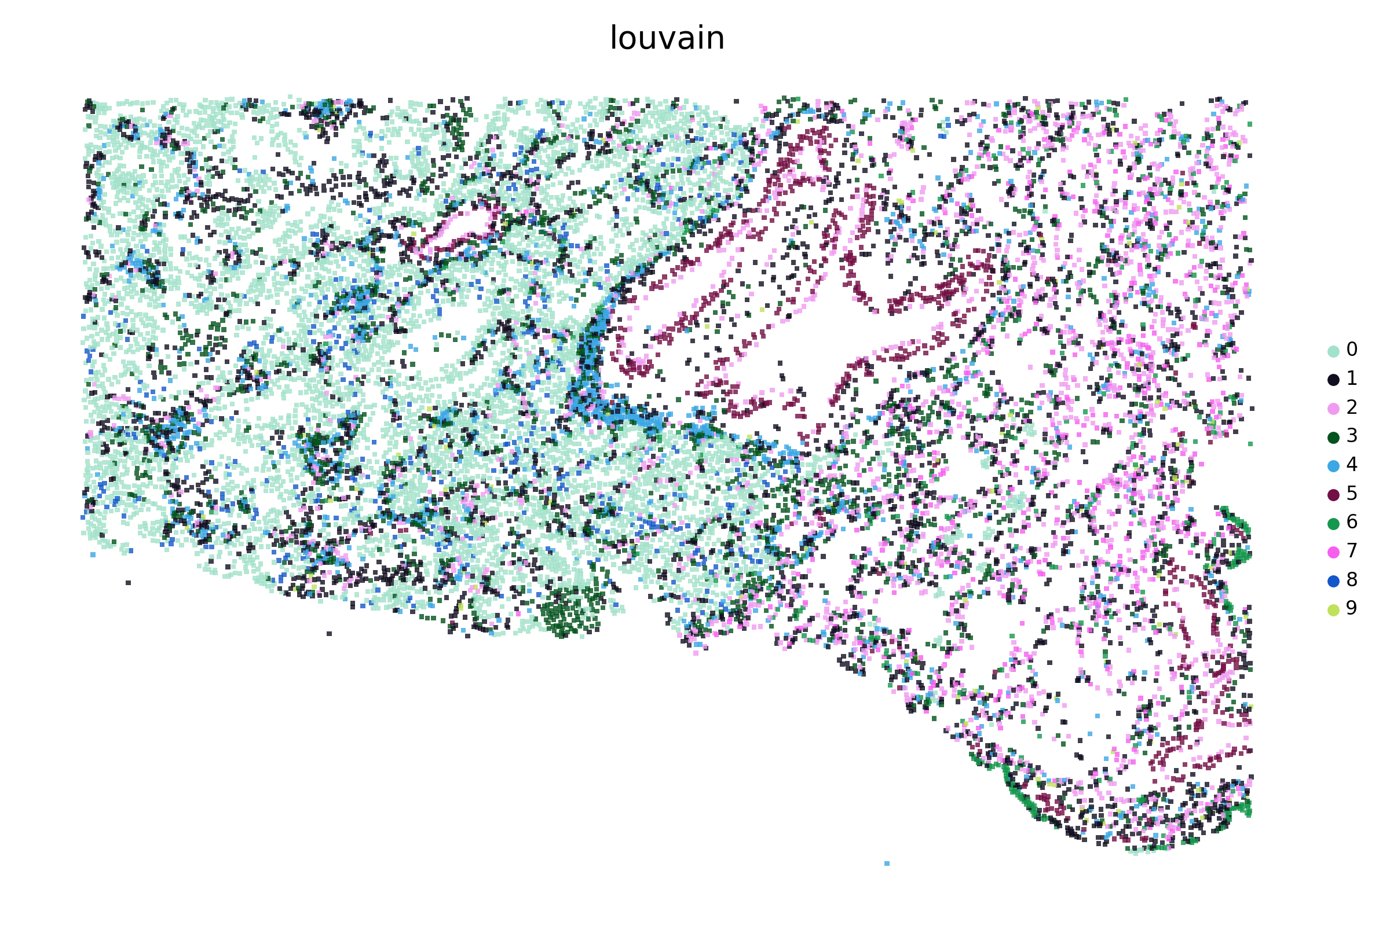
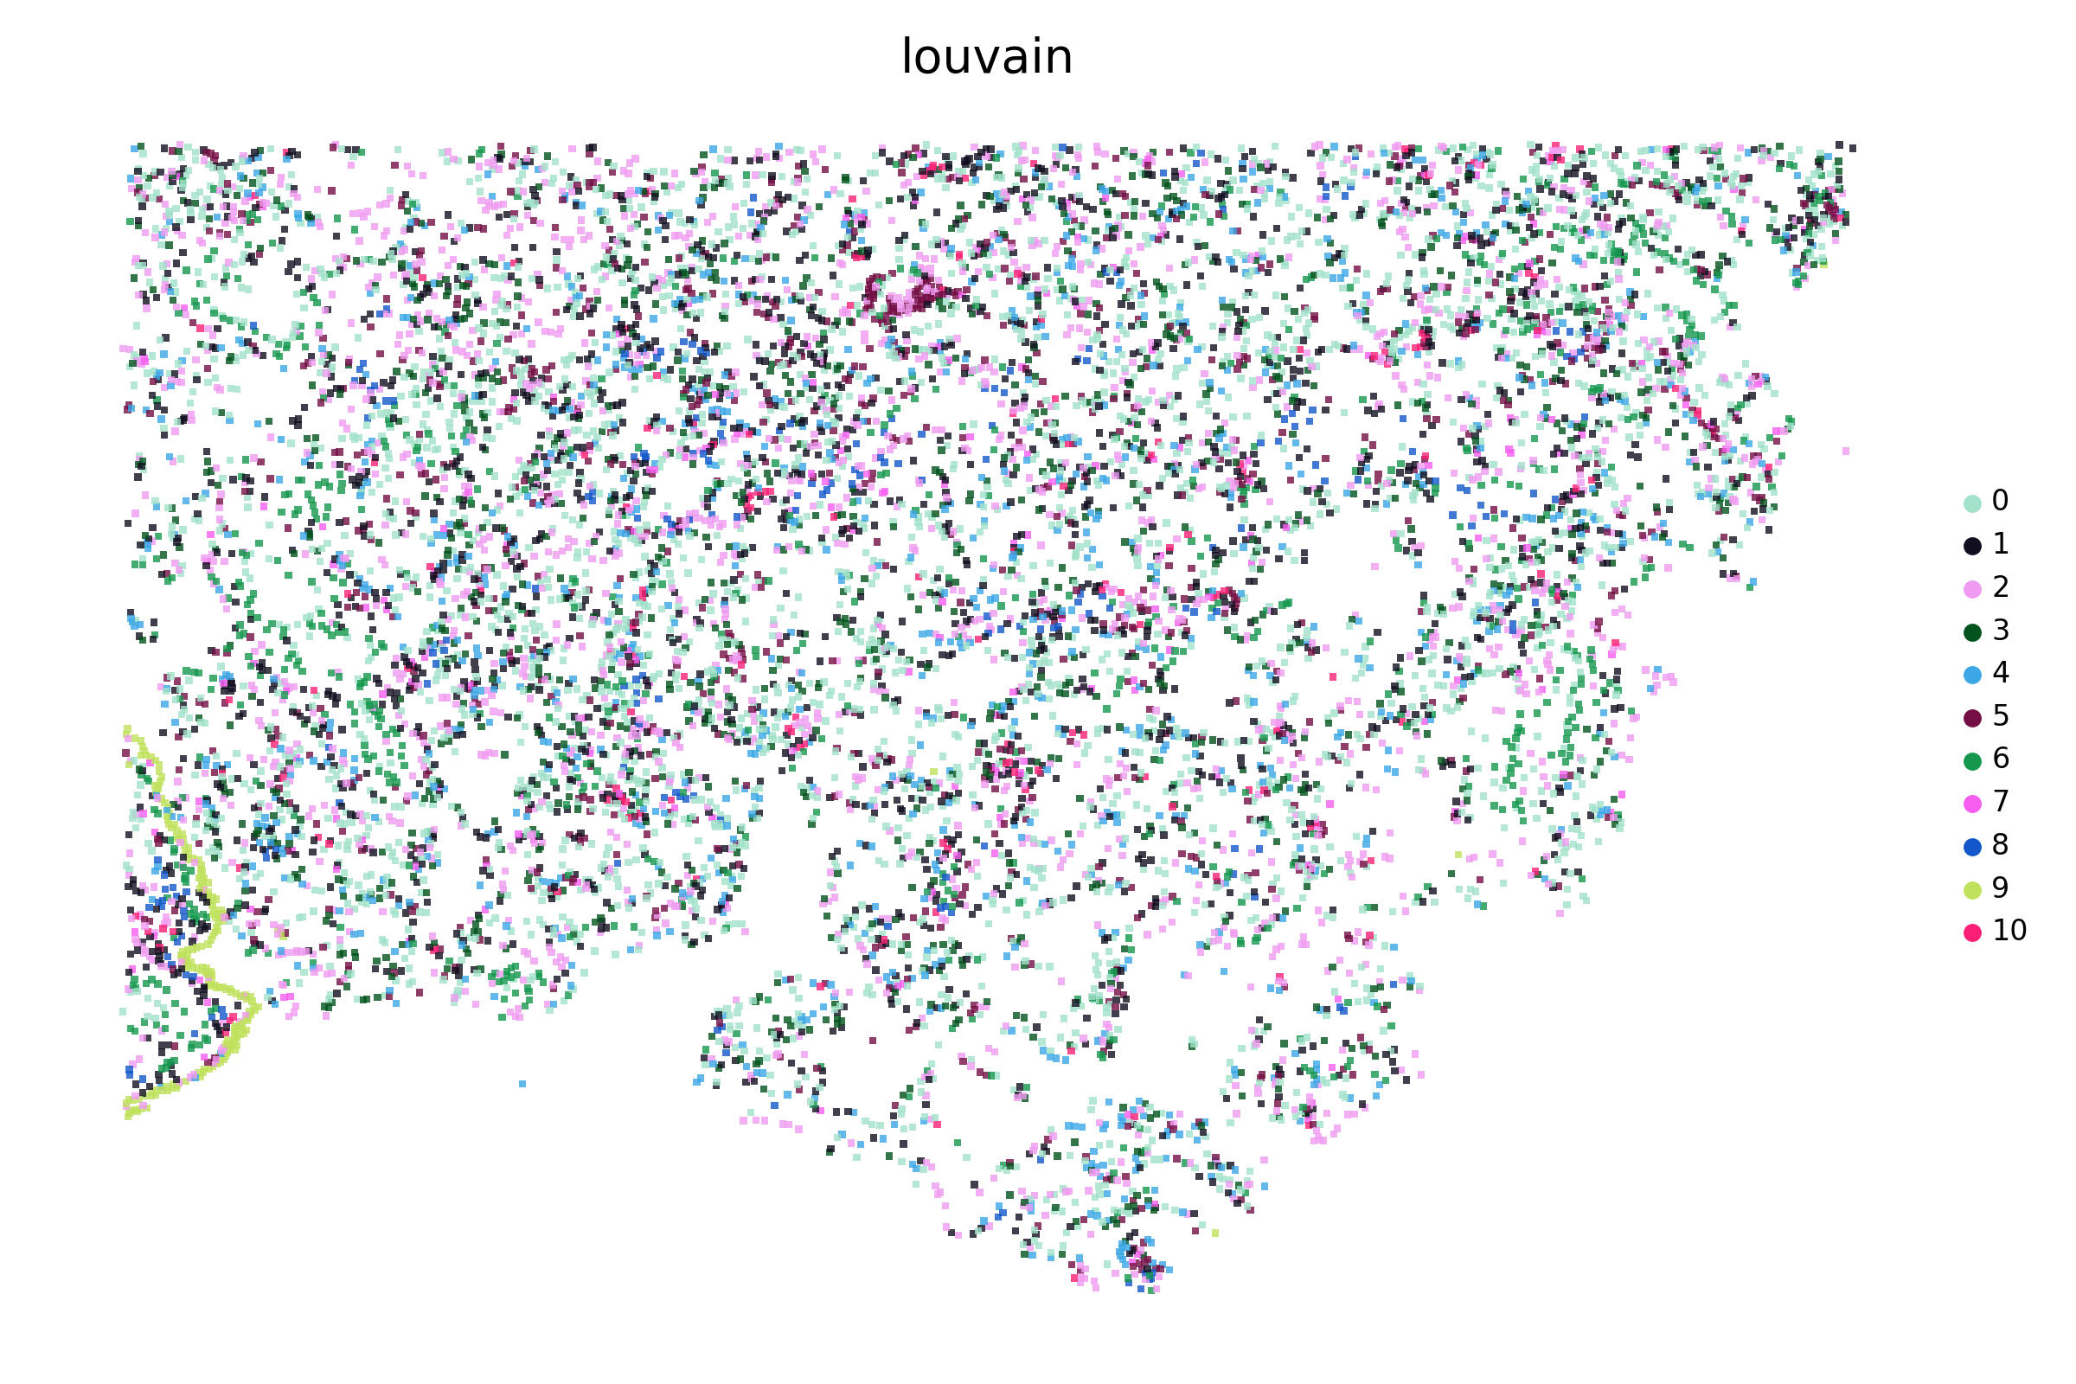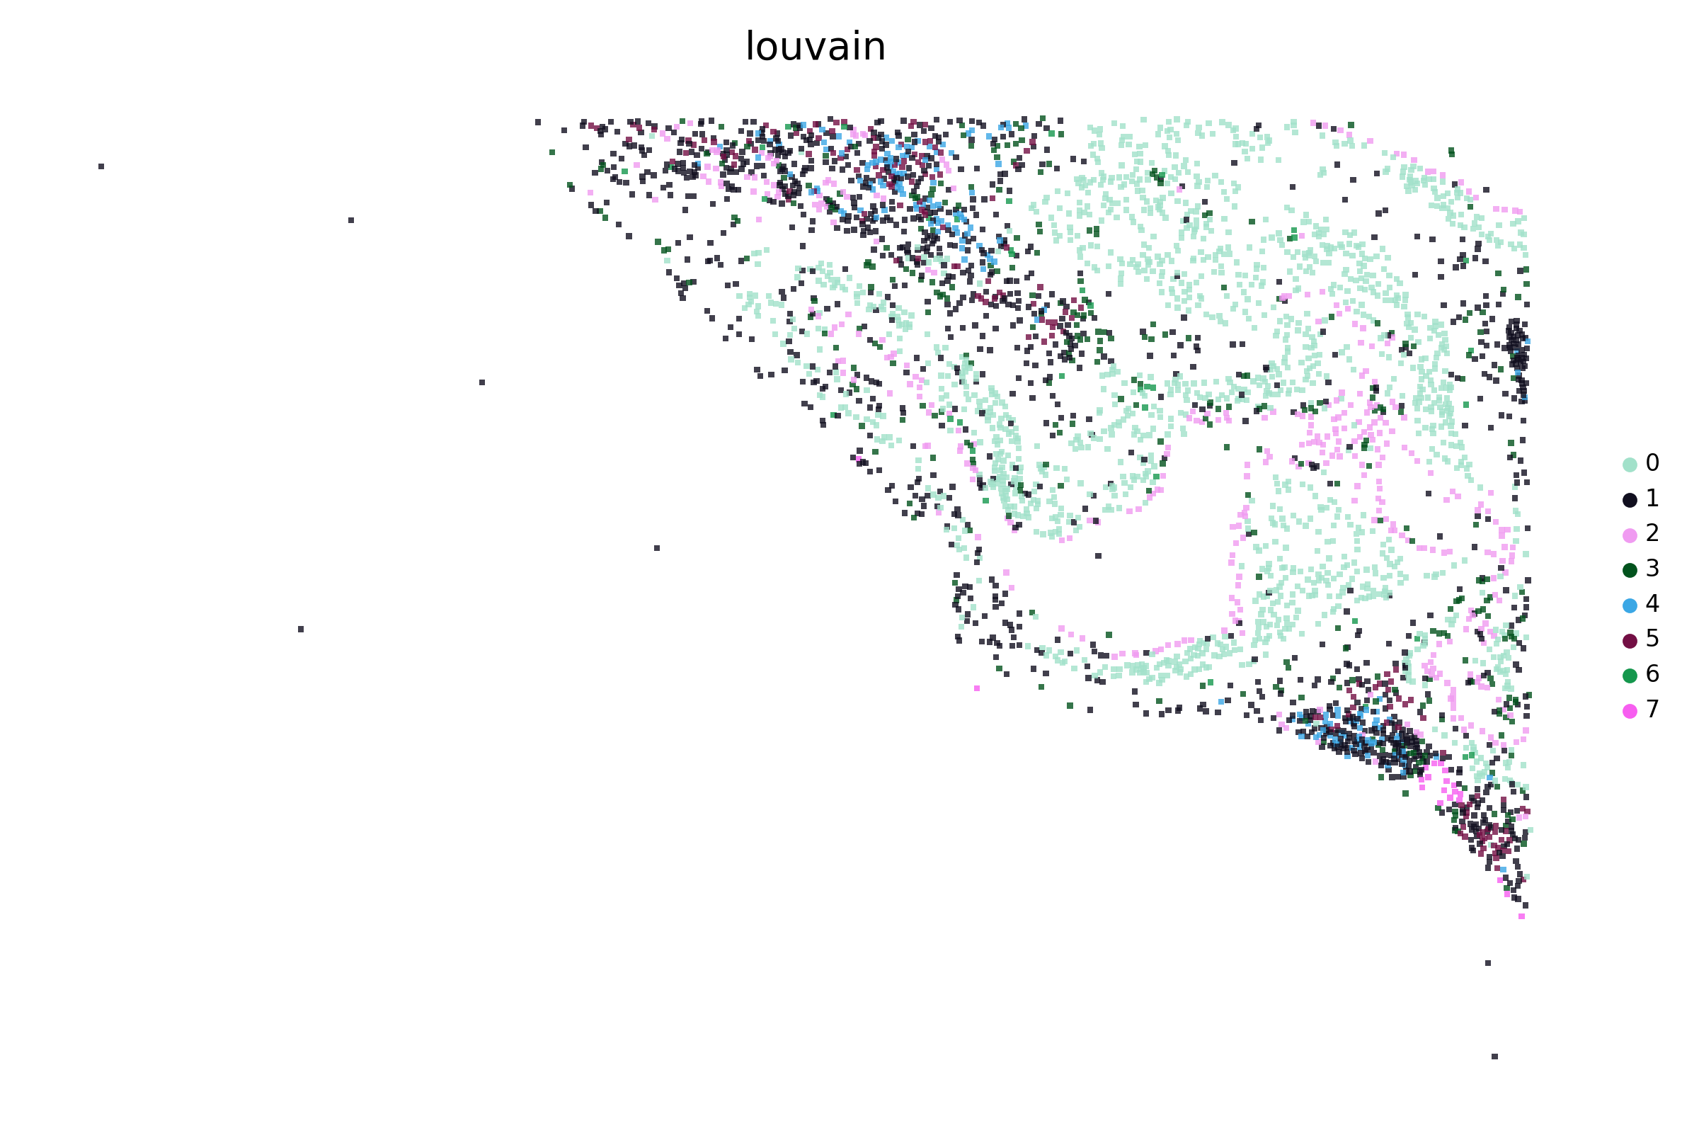
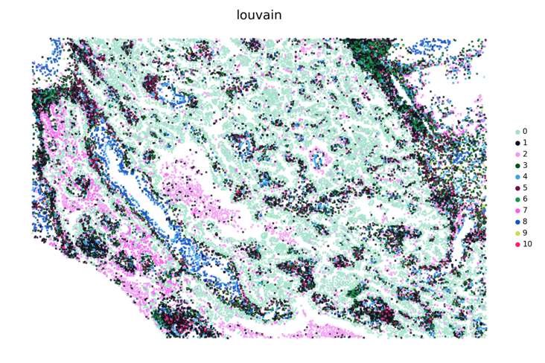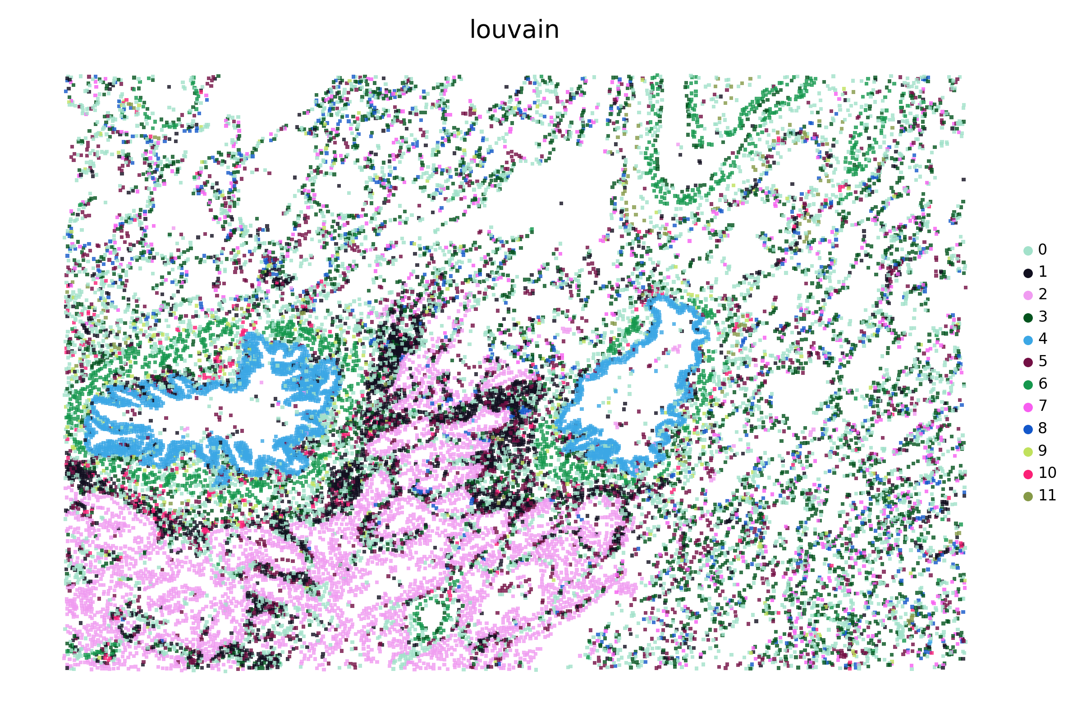
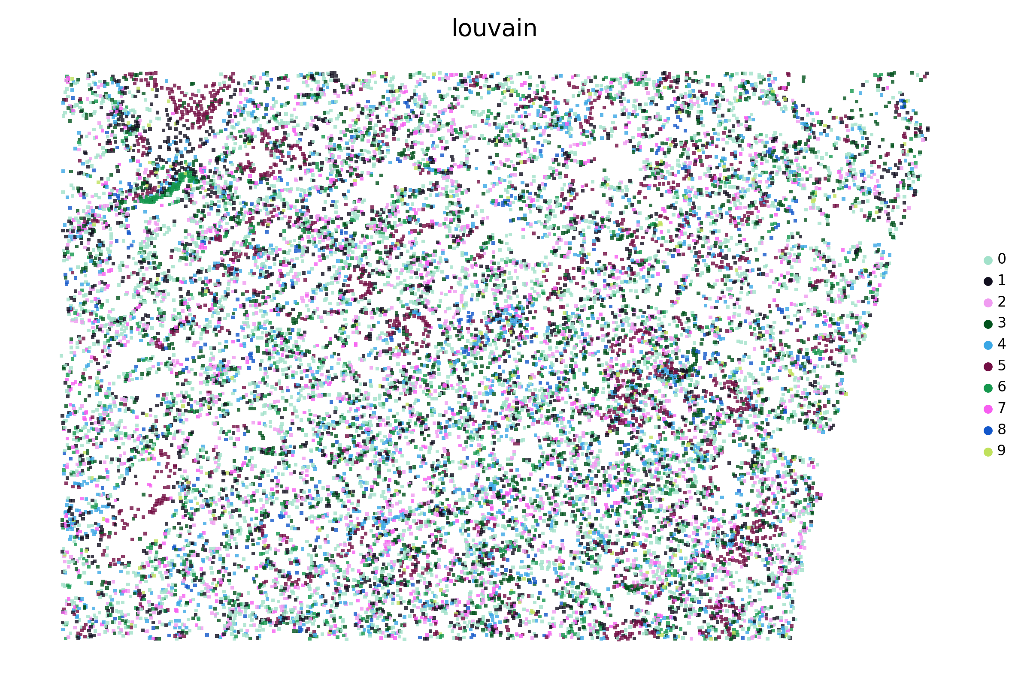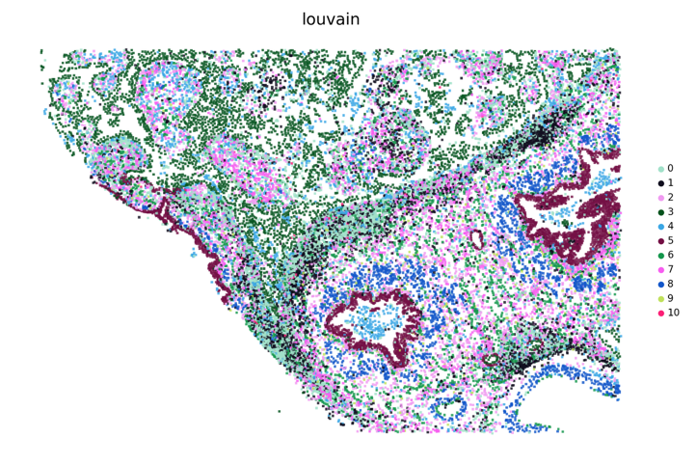
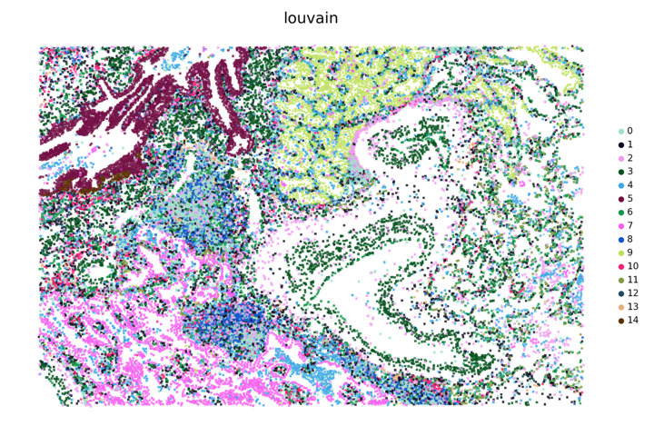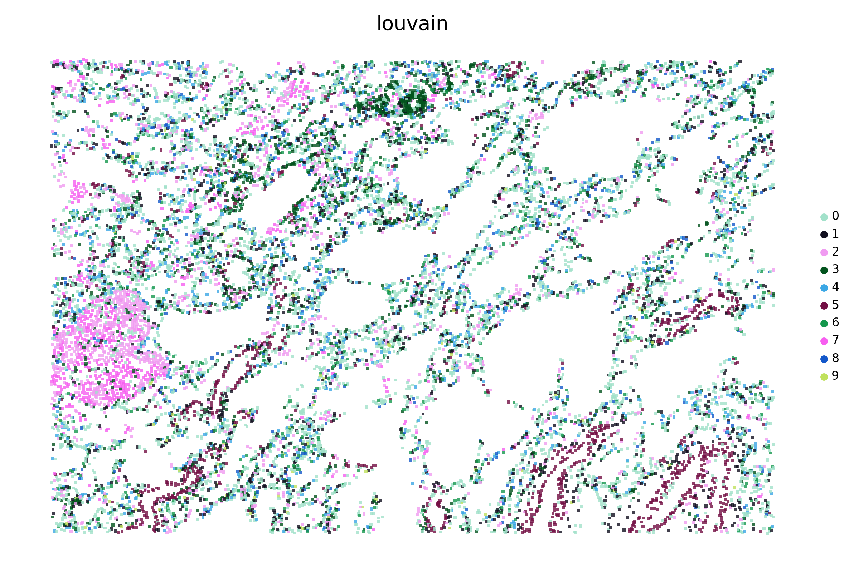
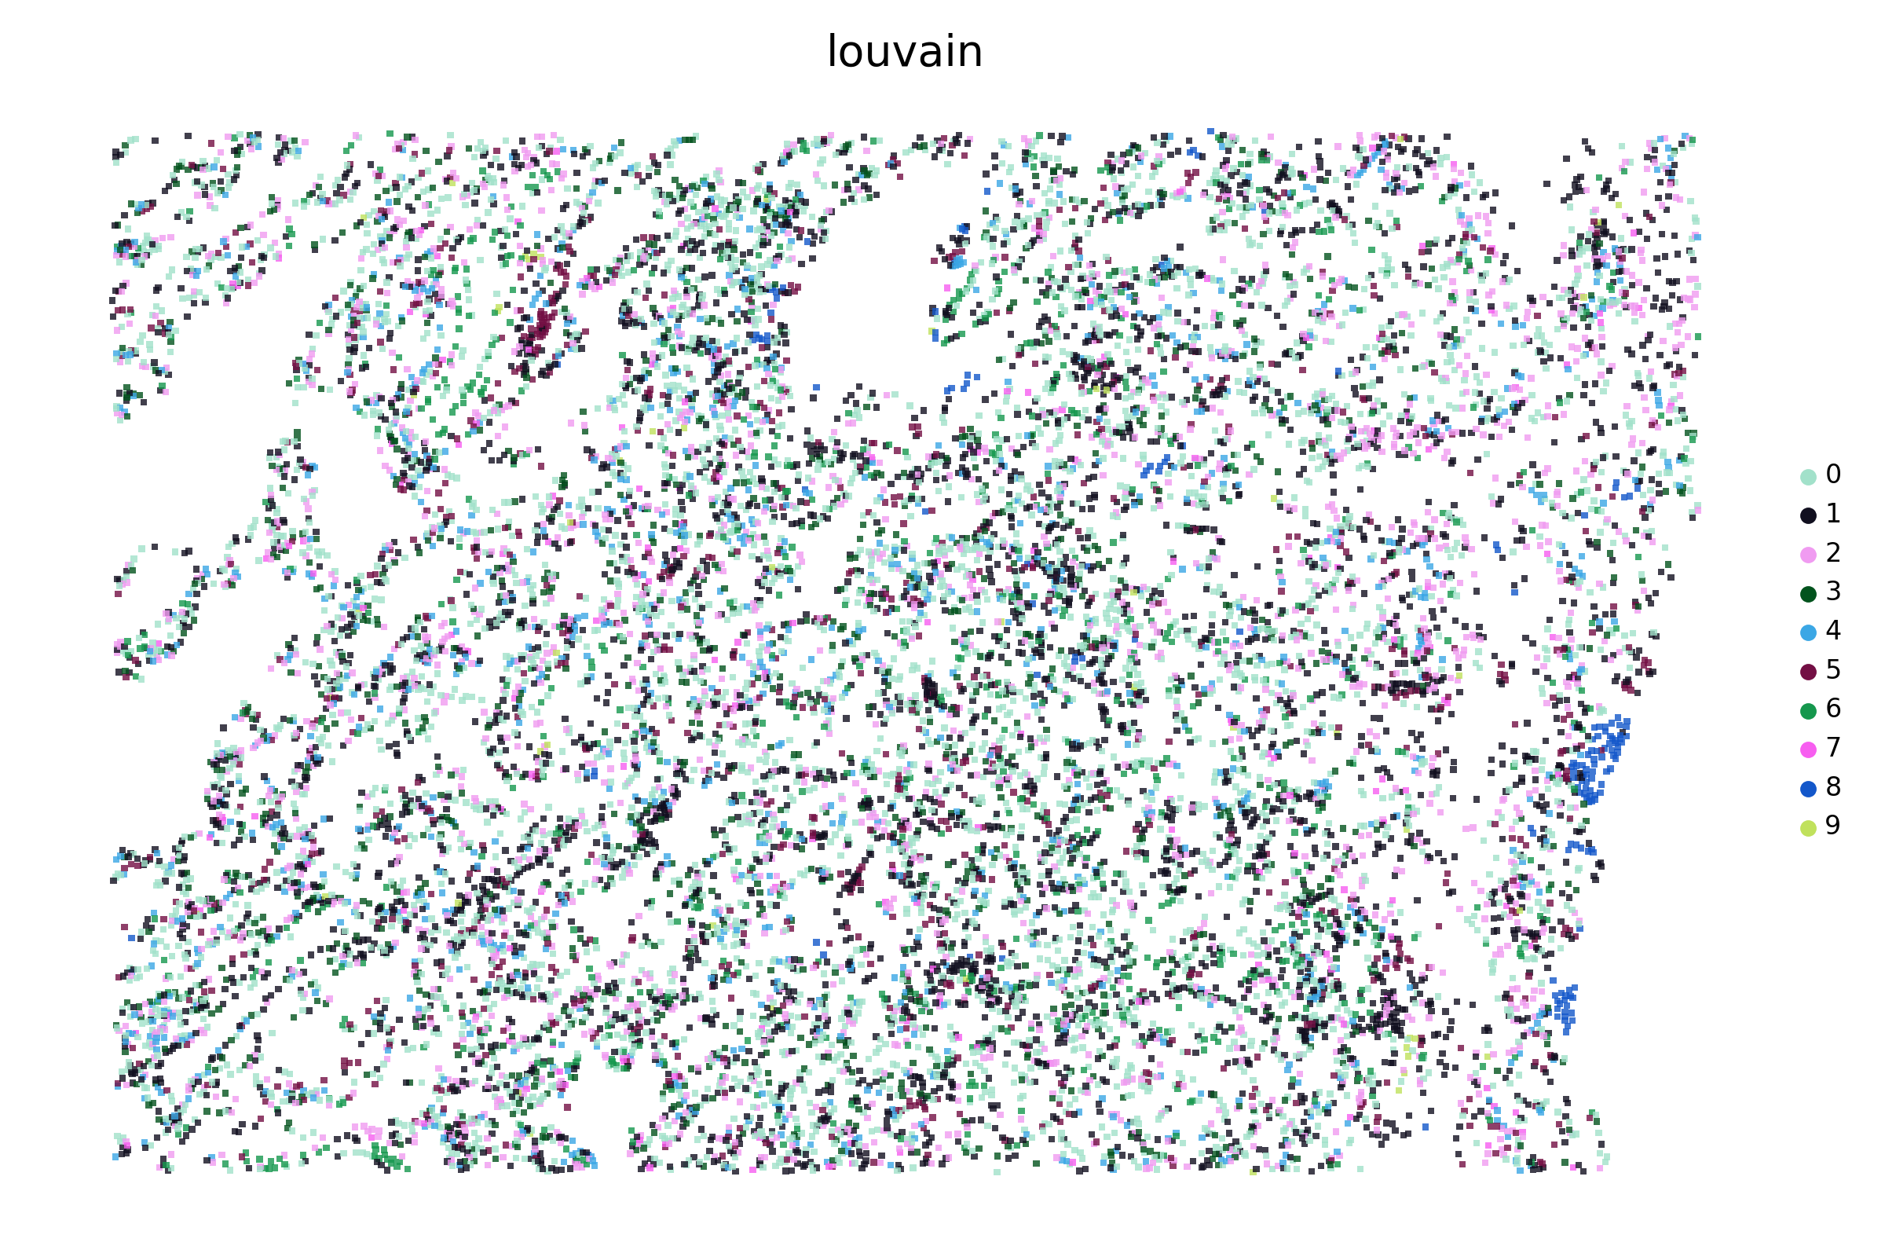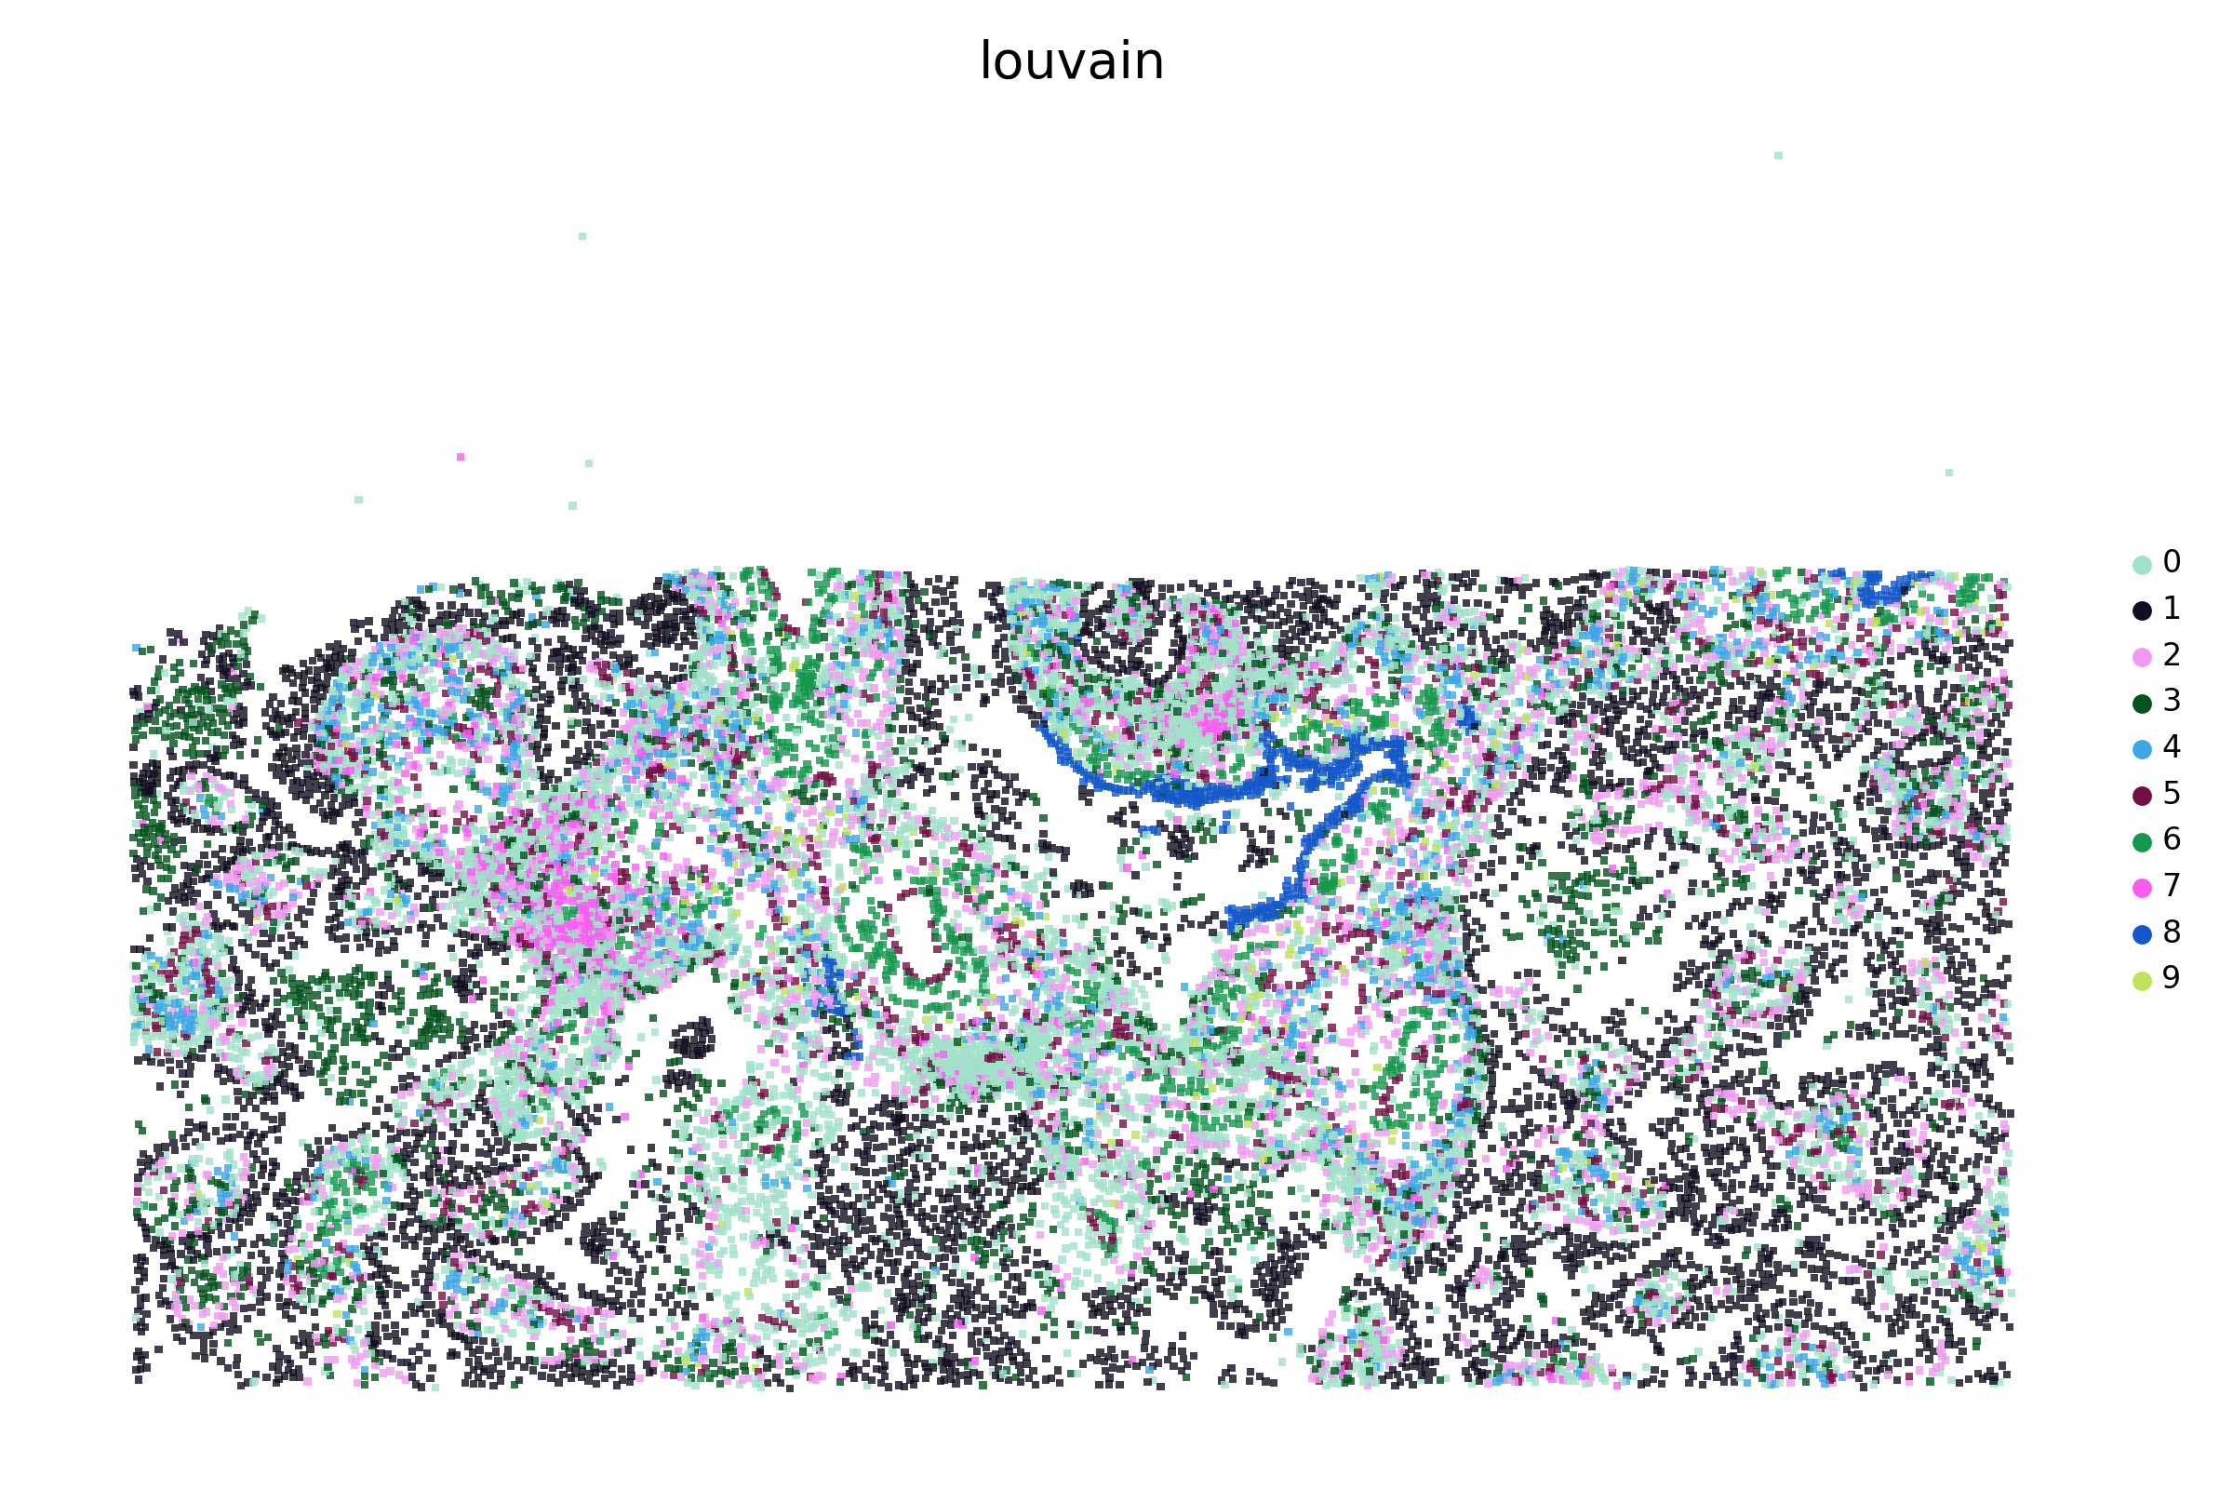
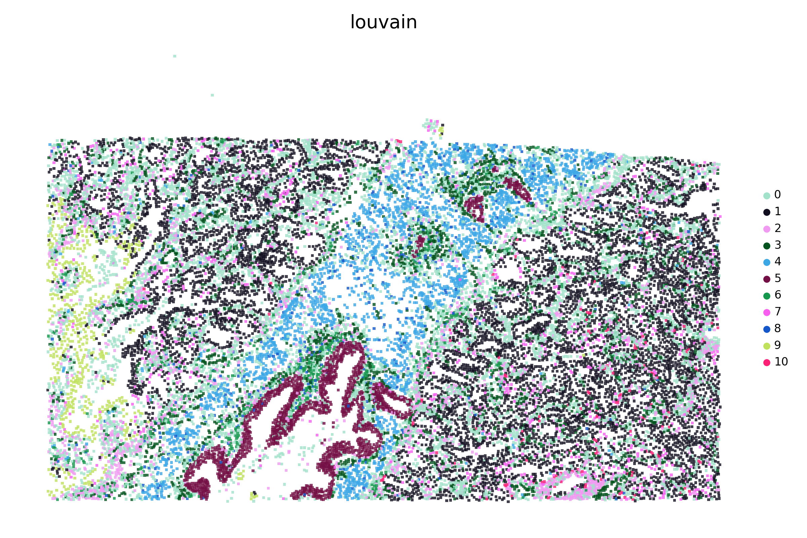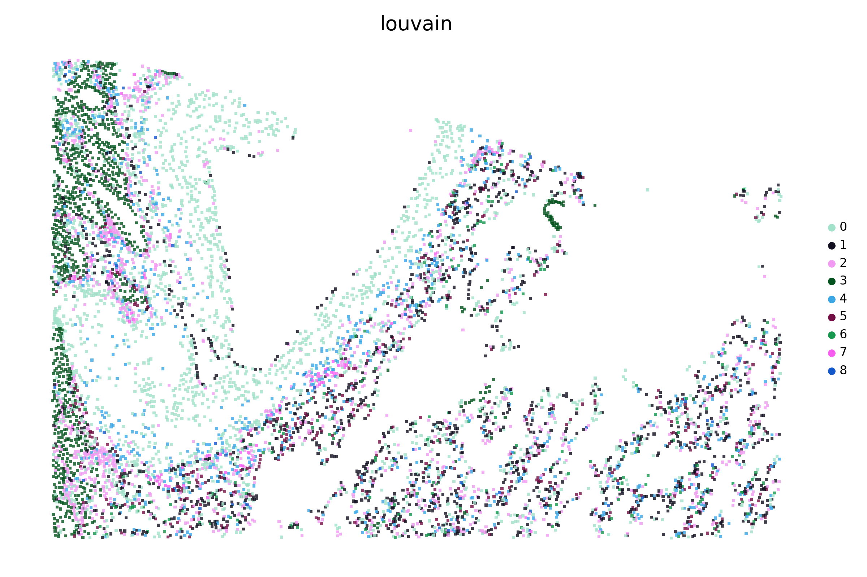
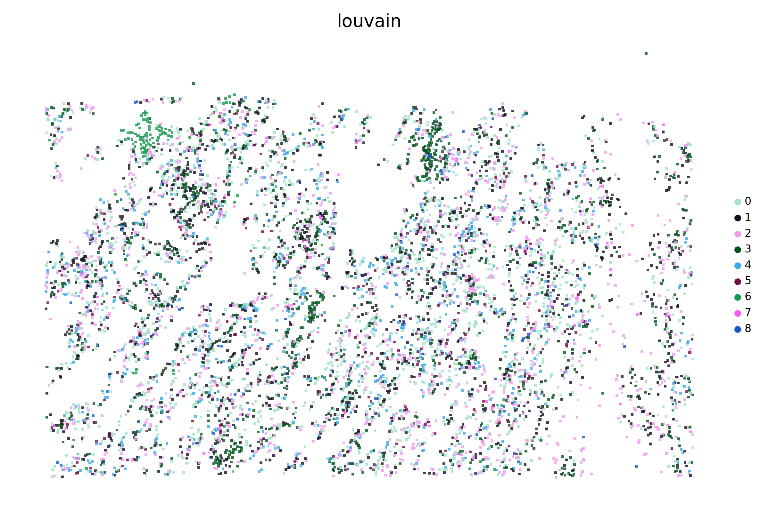
C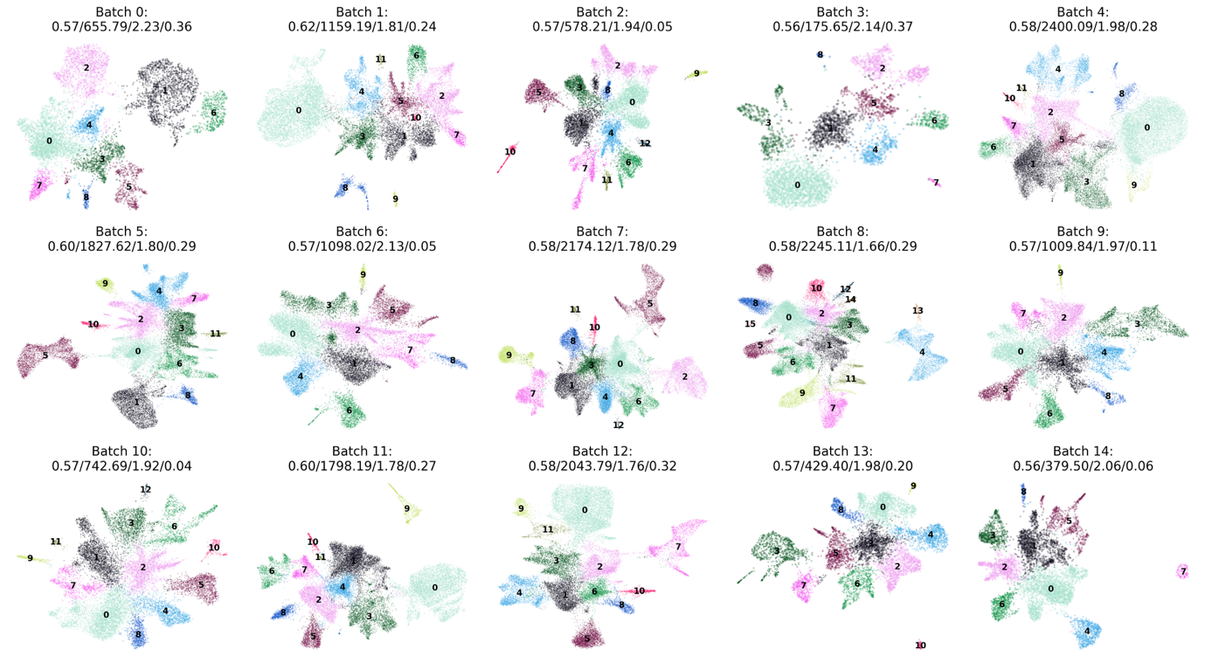
D
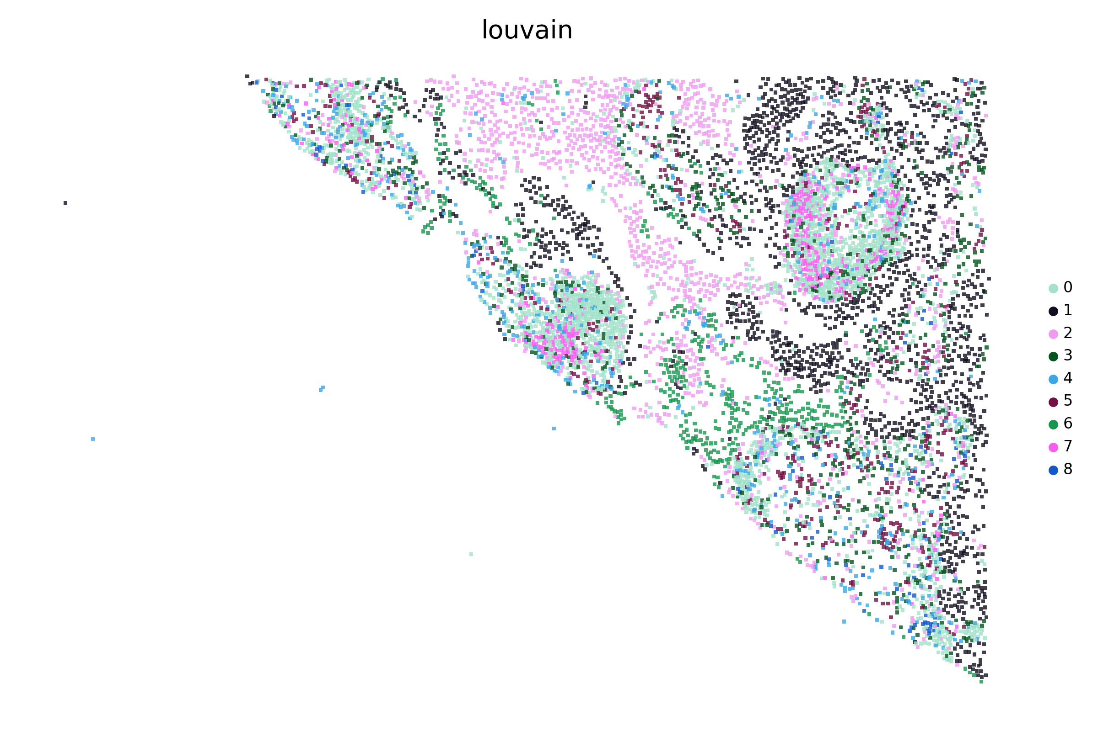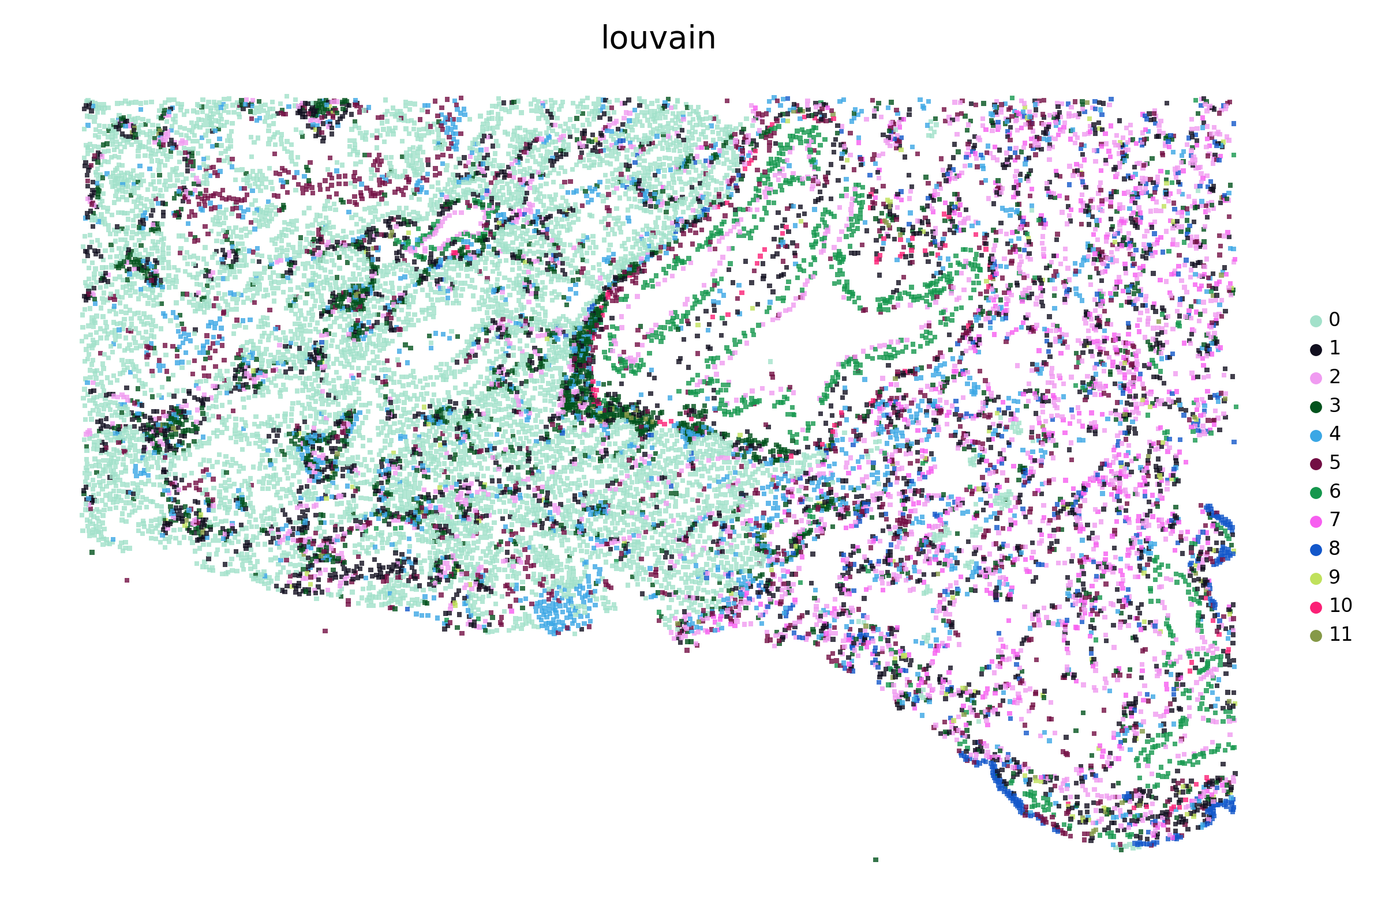
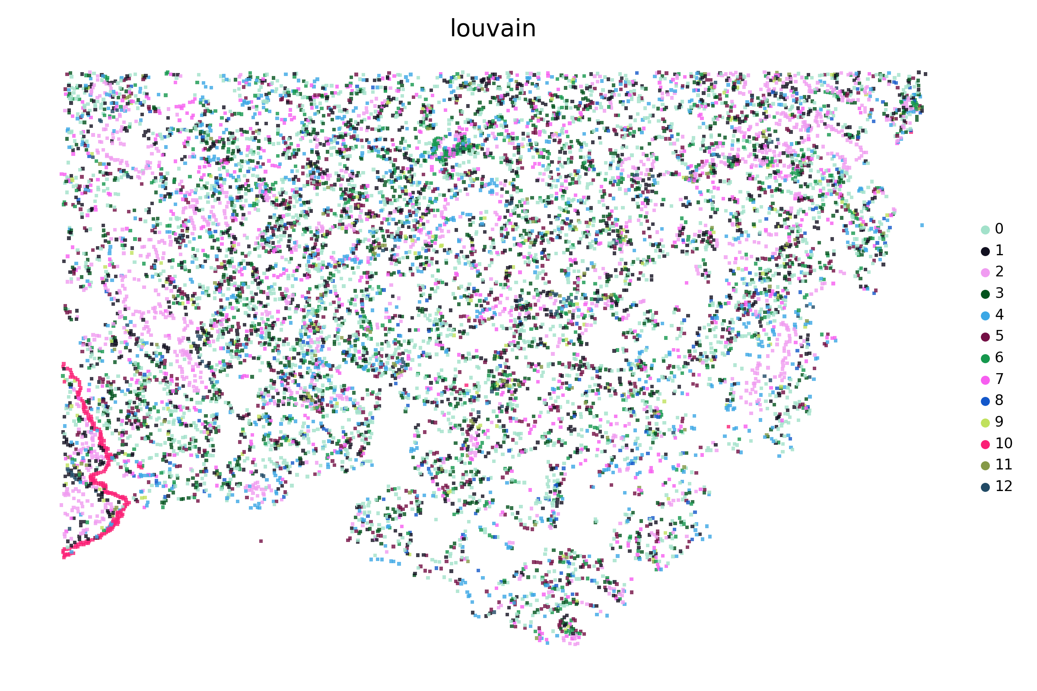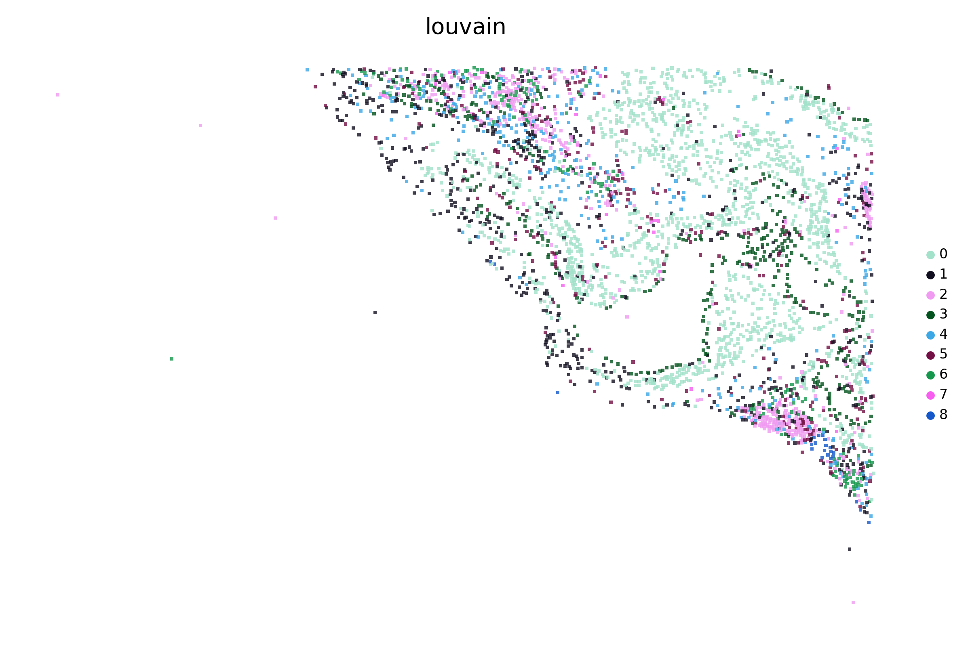
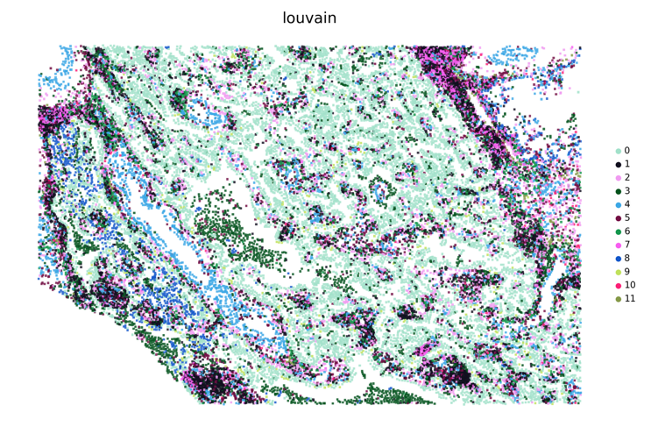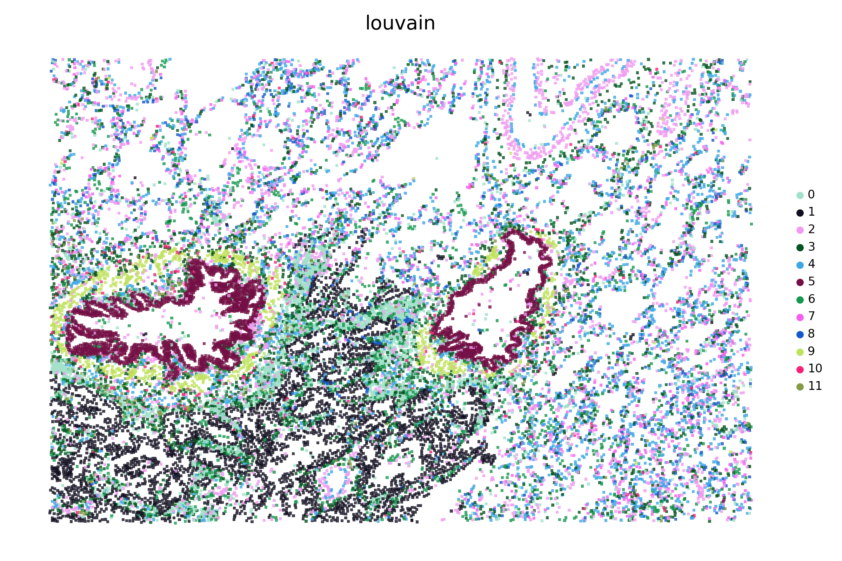
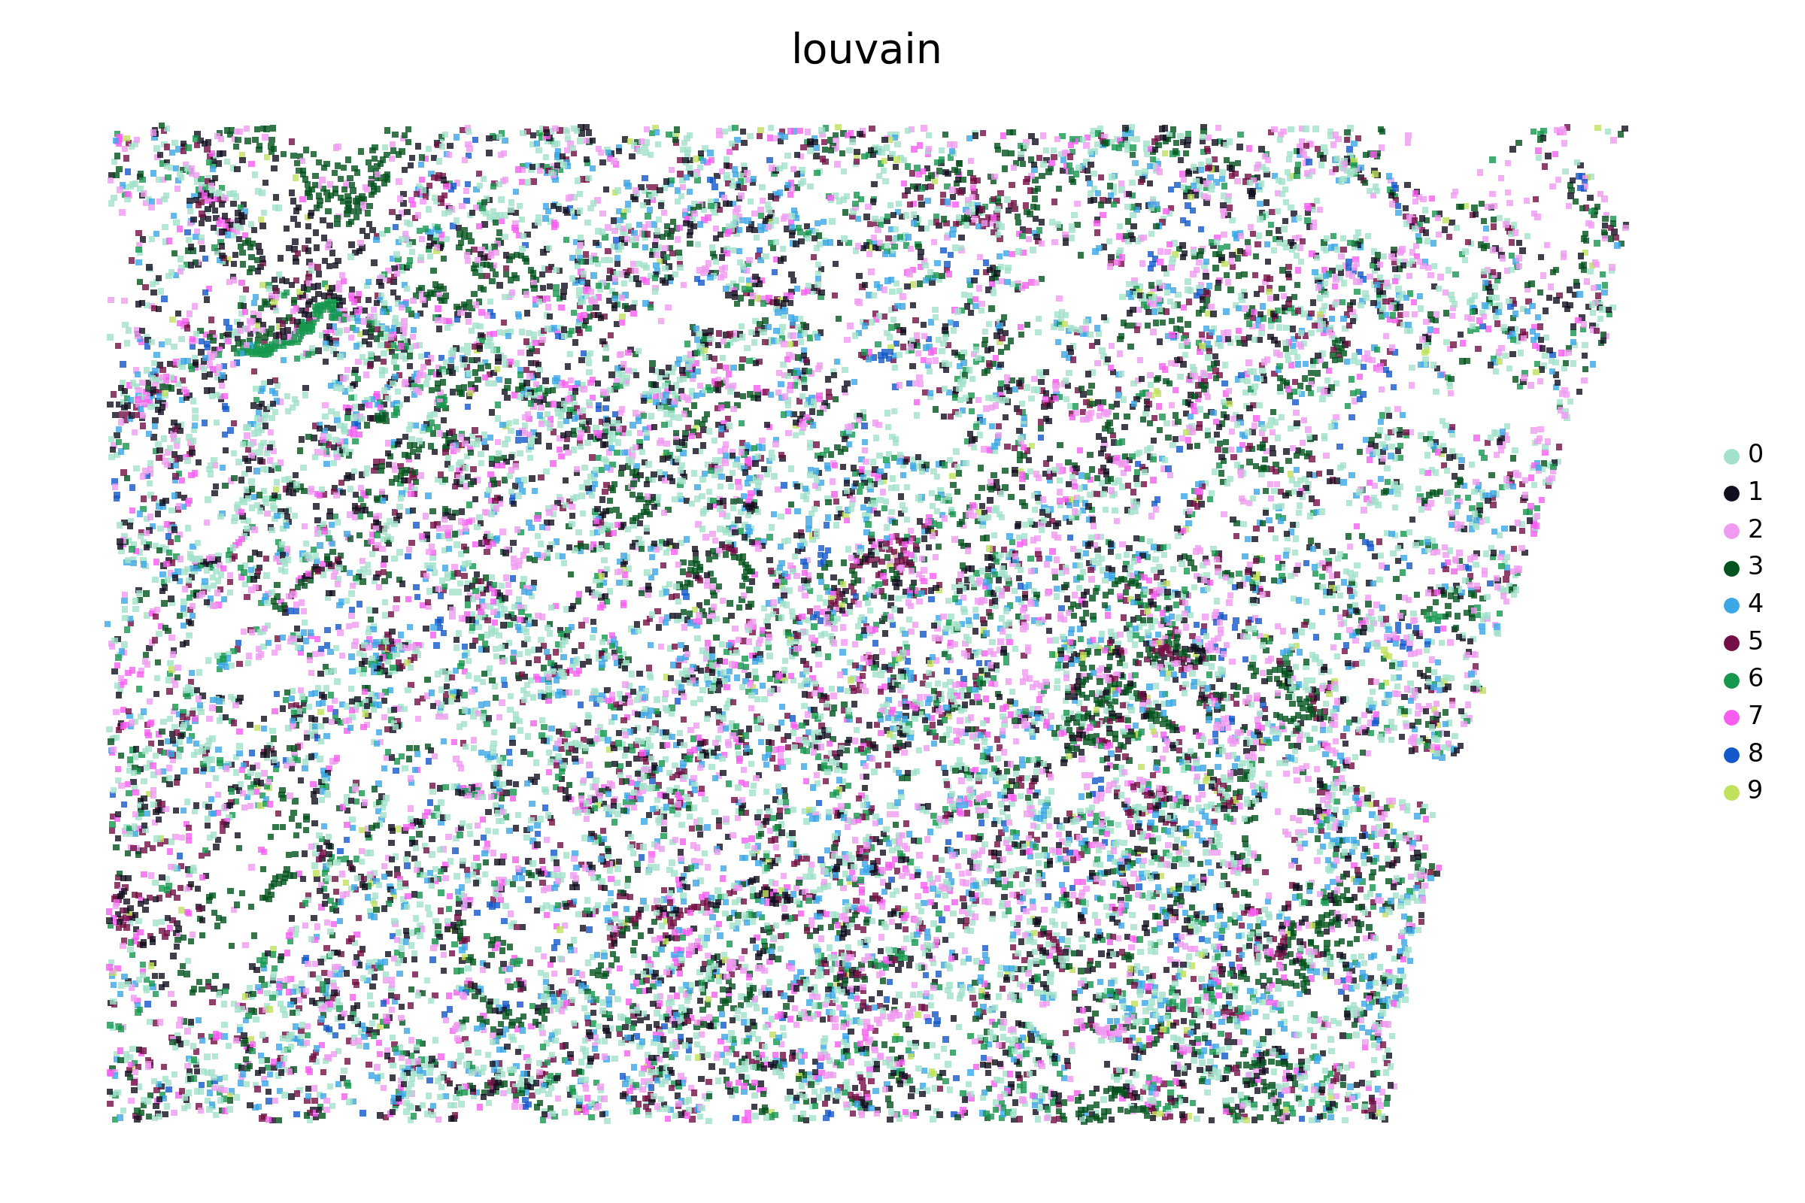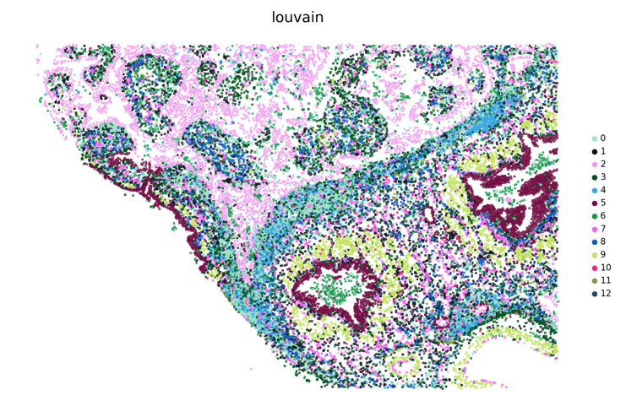
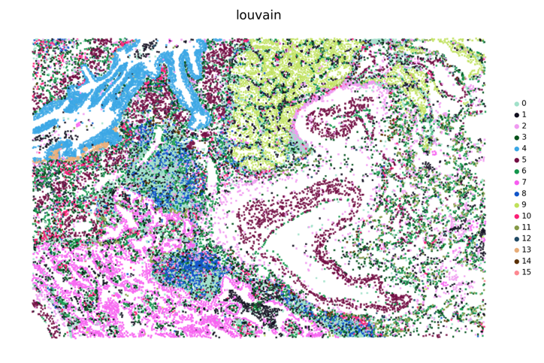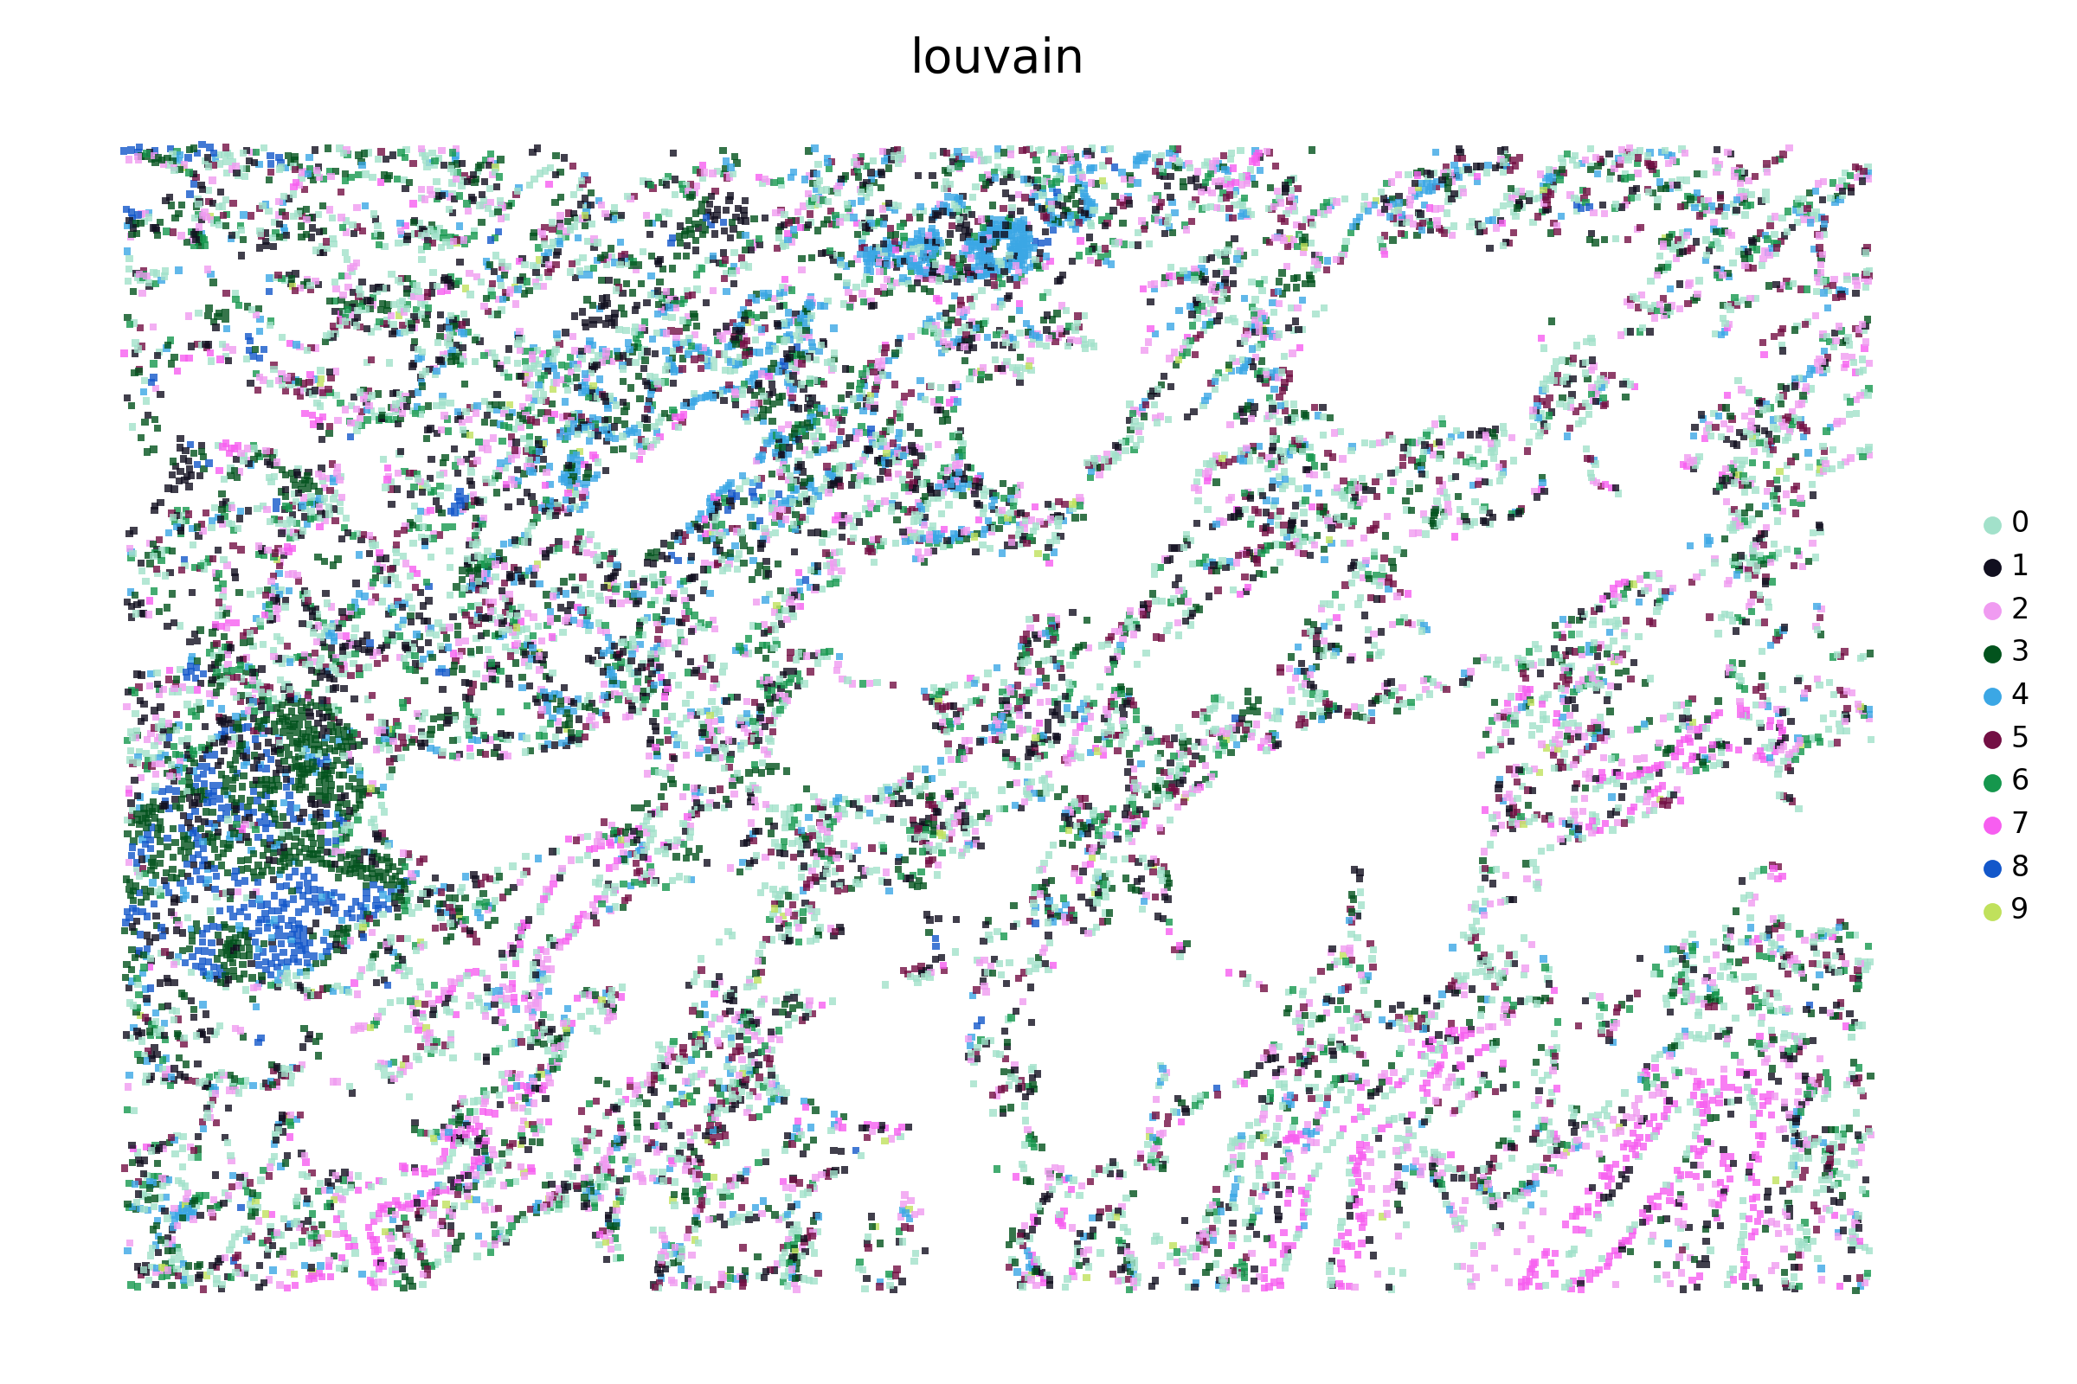
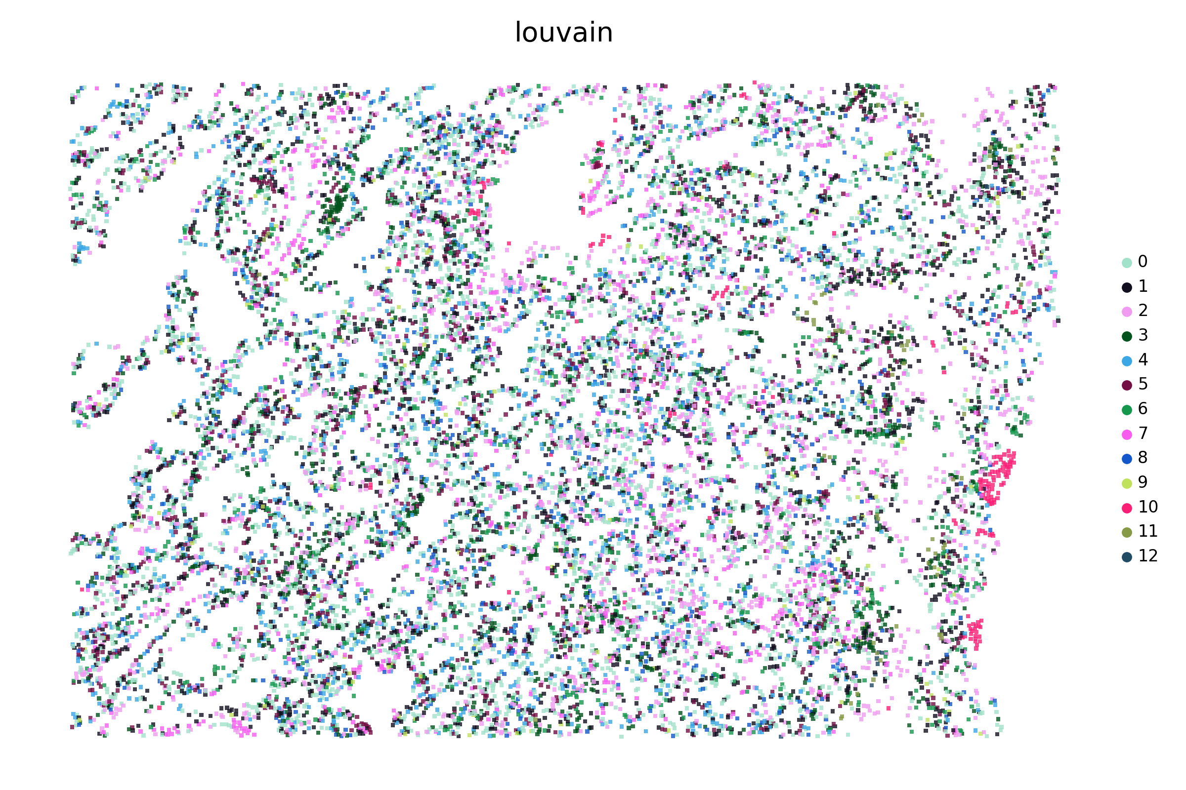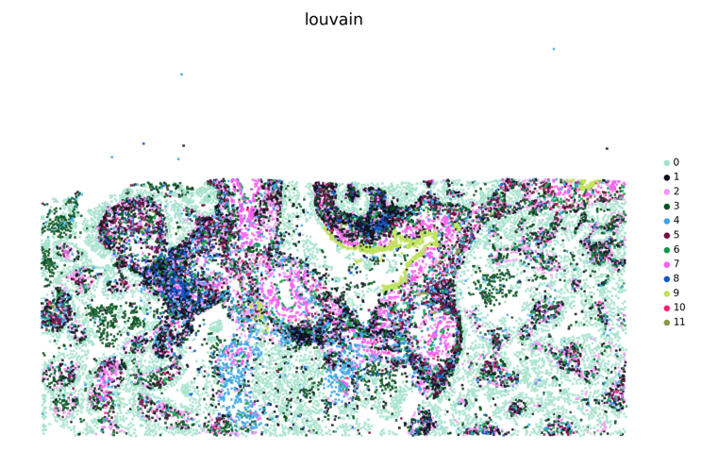
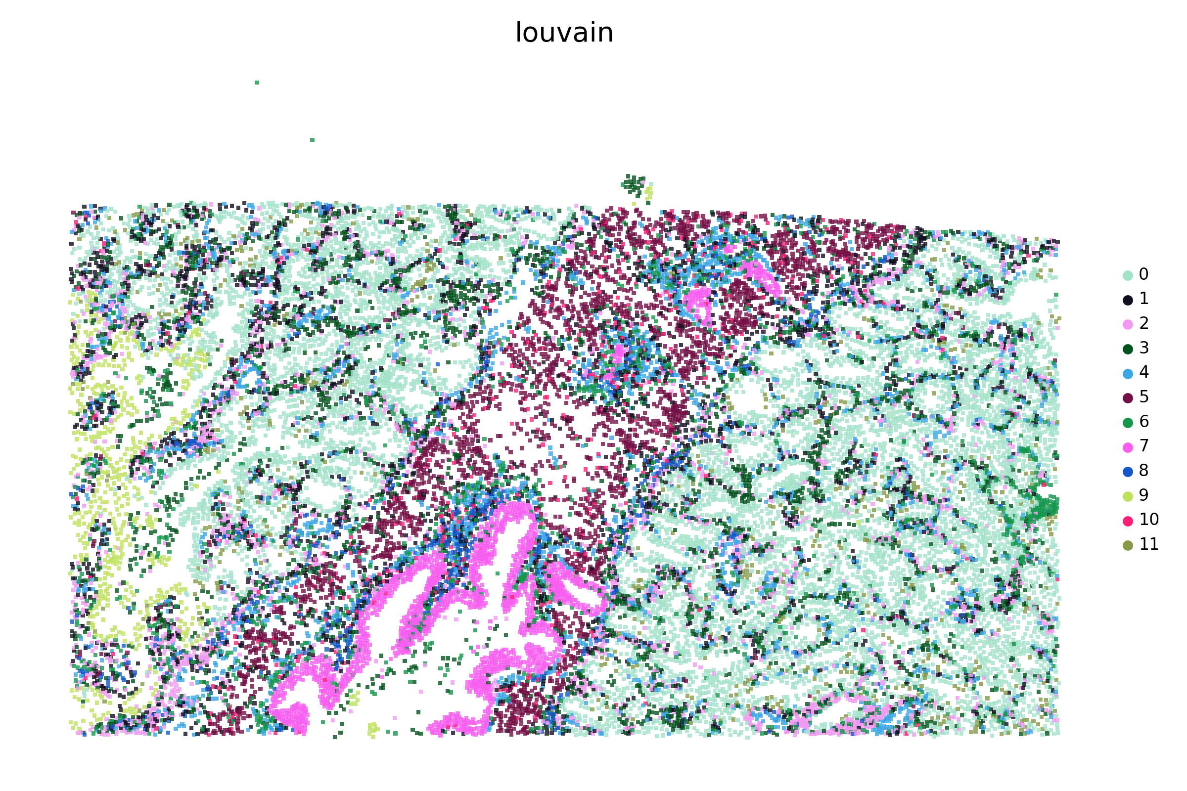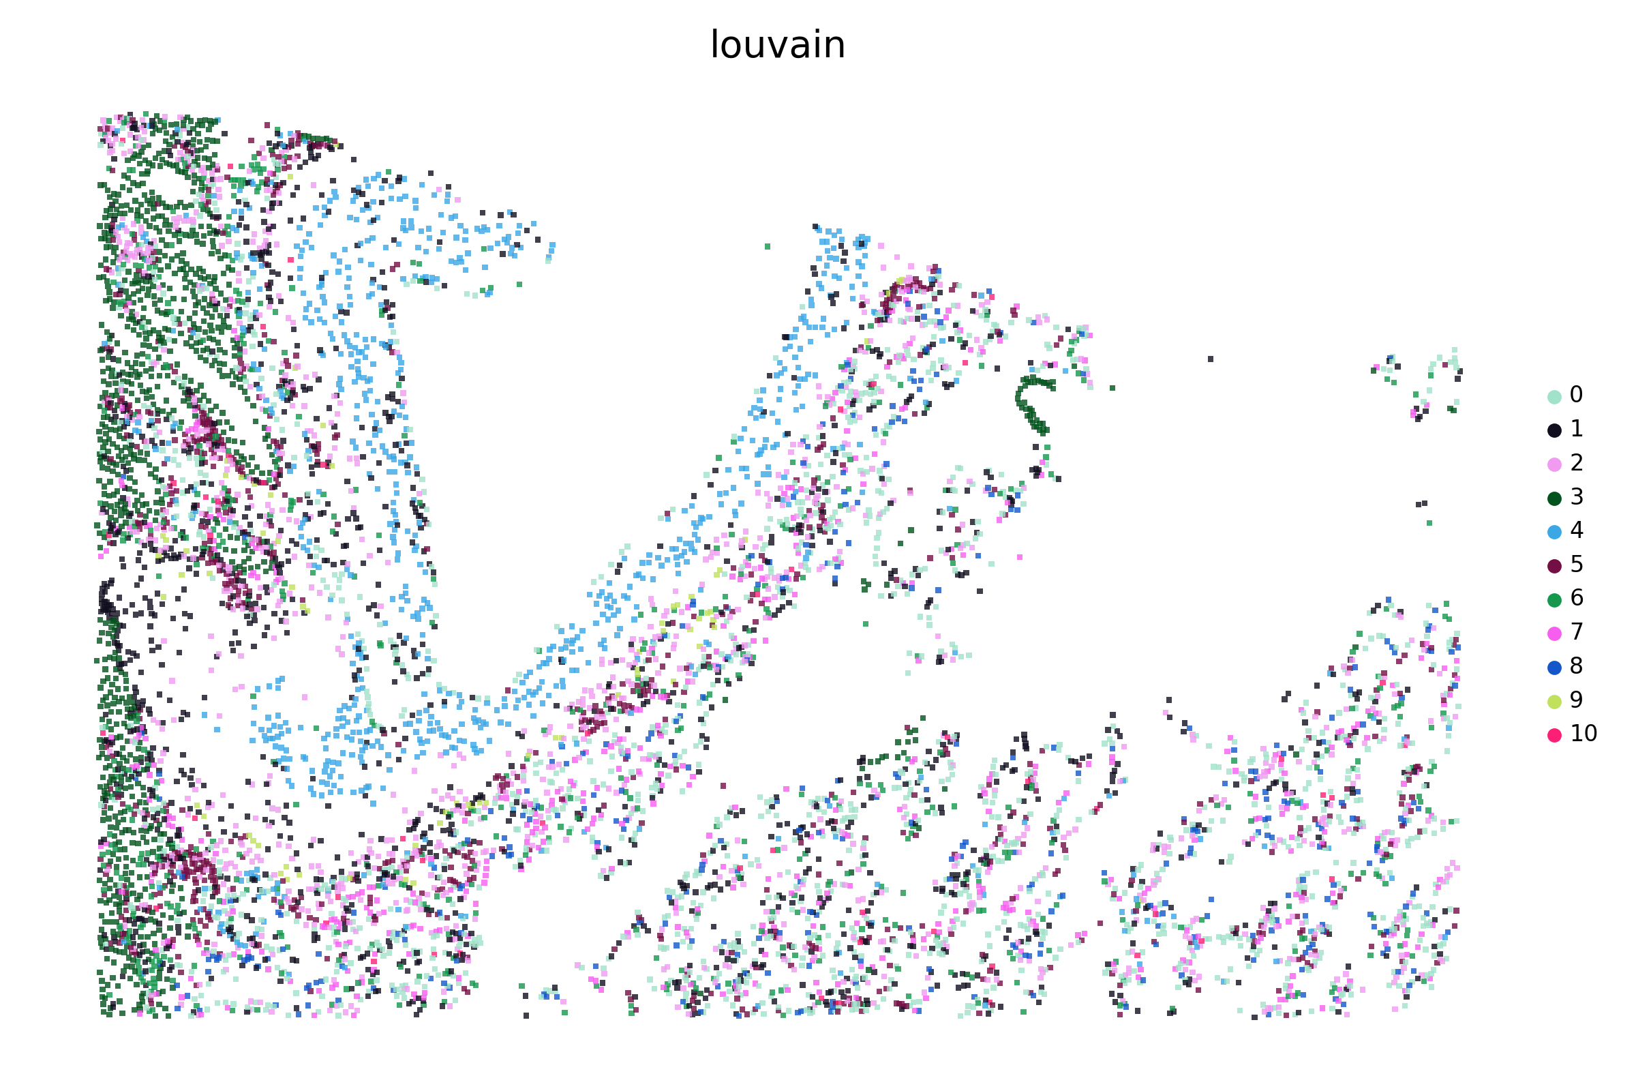
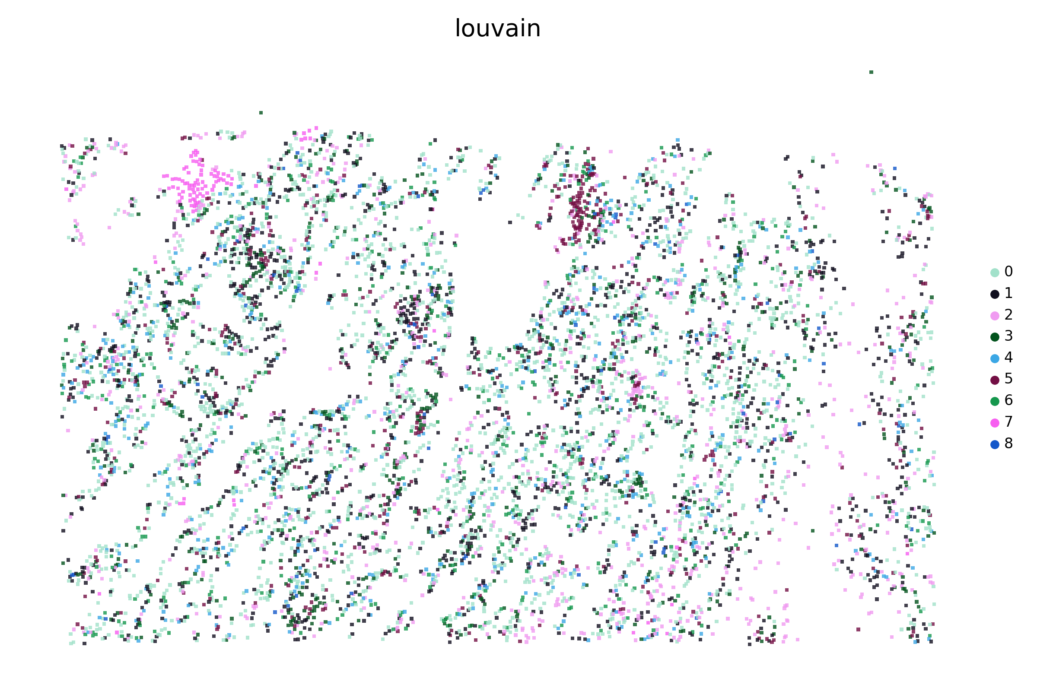
Supplementary Figure S5. Visualization of the SPICEiST clustering results compared to the cell-level, gene expression-based clustering in the Xenium lung cancer dataset with the 5K panel at a resolution of 0.3.
UMAP plots and the spatial distribution of cells illustrate the cell-level embedding and spatial distribution derived from SPICEiST-based analysis (integ; A: UMAP, B: spatial distribution of cells) and cell-level gene expression-based clustering (gex; C: UMAP, D: spatial distribution of cells), respectively. The tissue samples, obtained from patch numbers 0 to 14, are presented serially from left to right and top to bottom. The four numerical values at the top of the UMAP plot represent the ASW, CHI, DBI, and assortativity coefficient. Each dot in the plot corresponds to a cell, with color indicating the identity of the clusters.

A 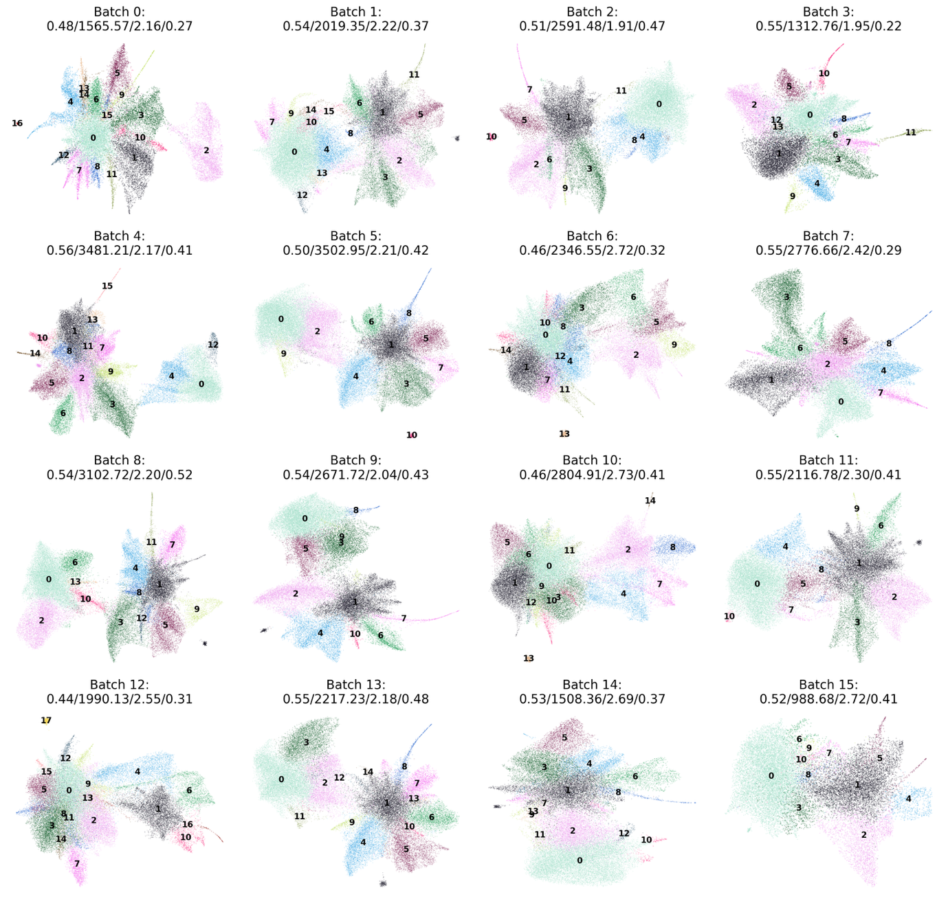

B
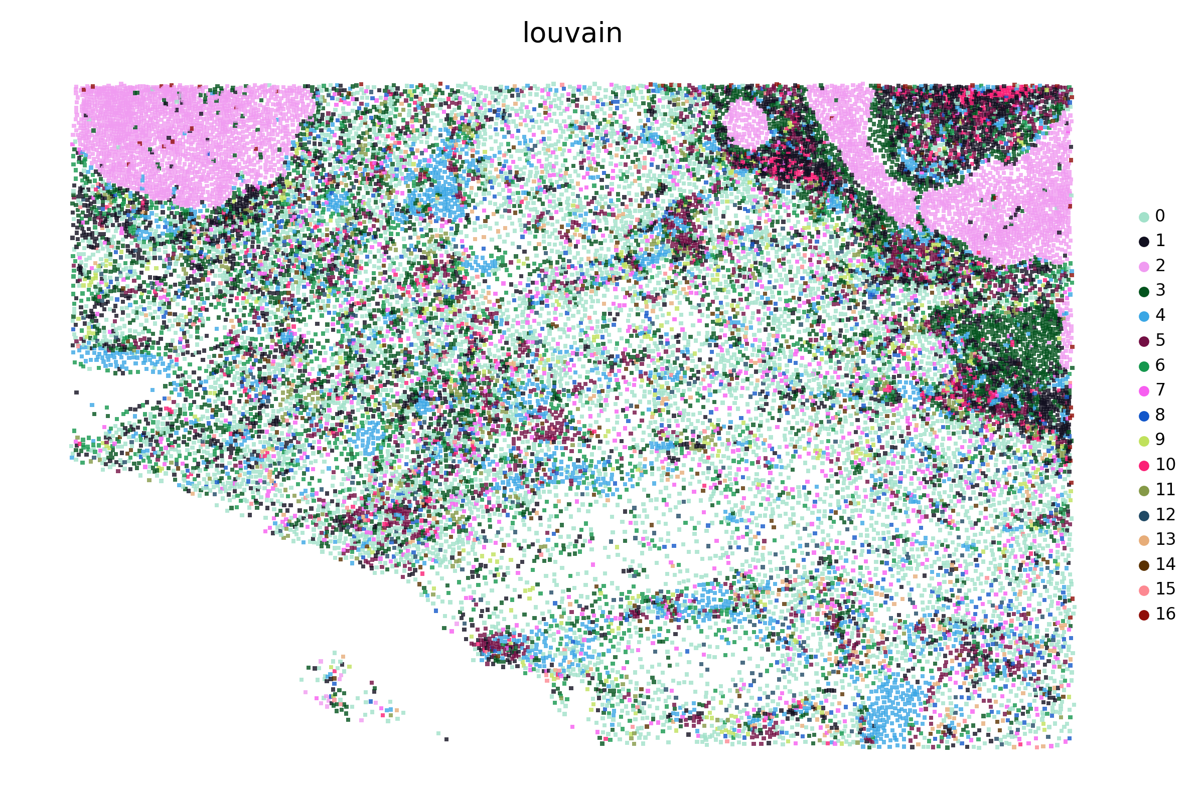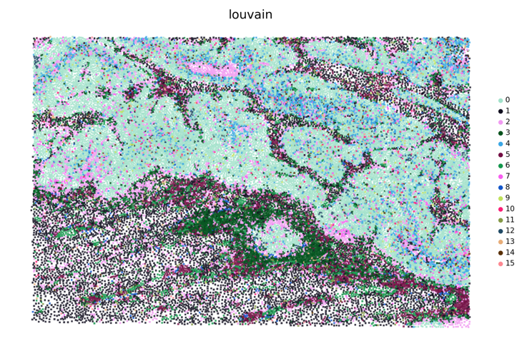
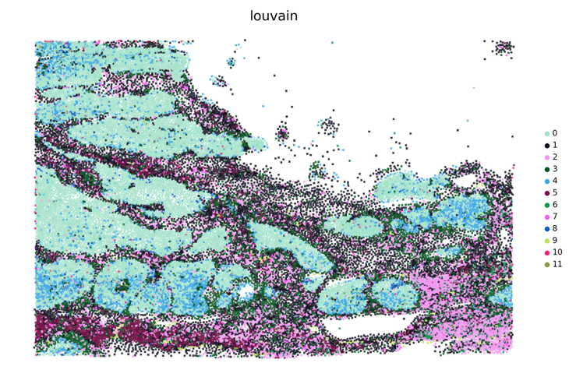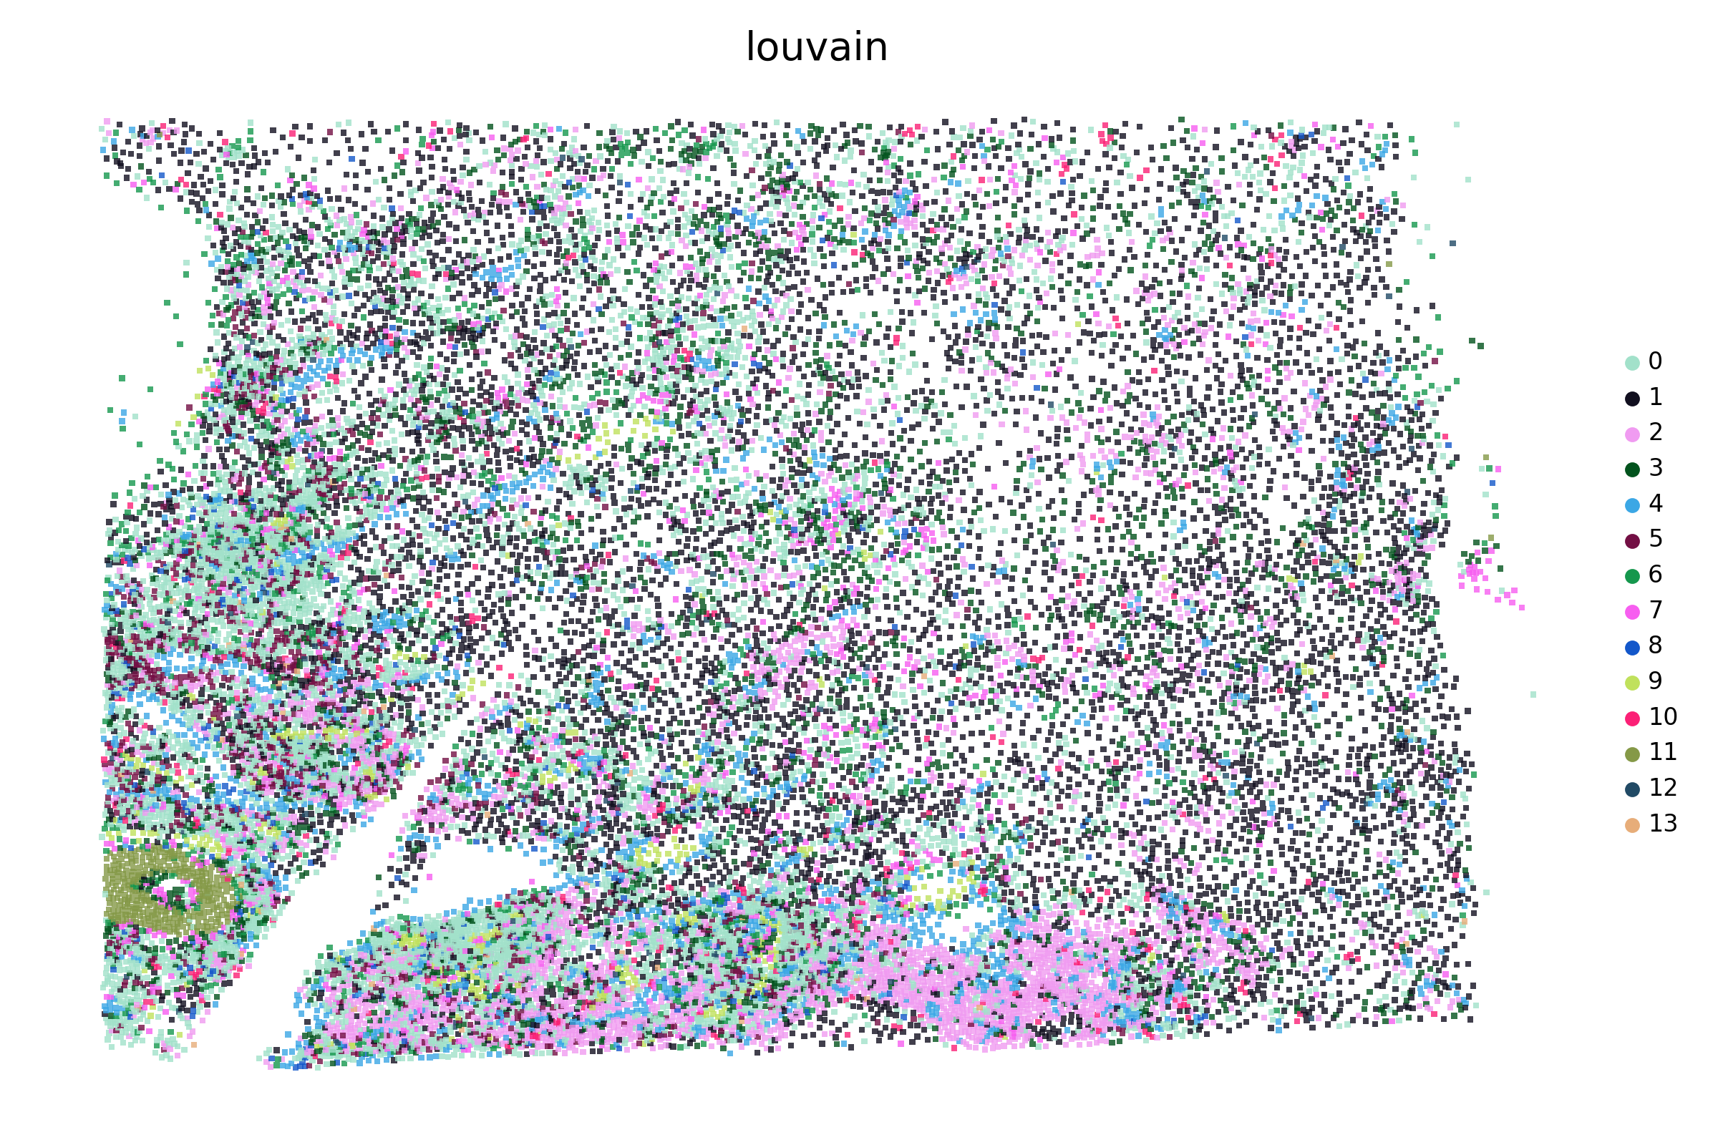
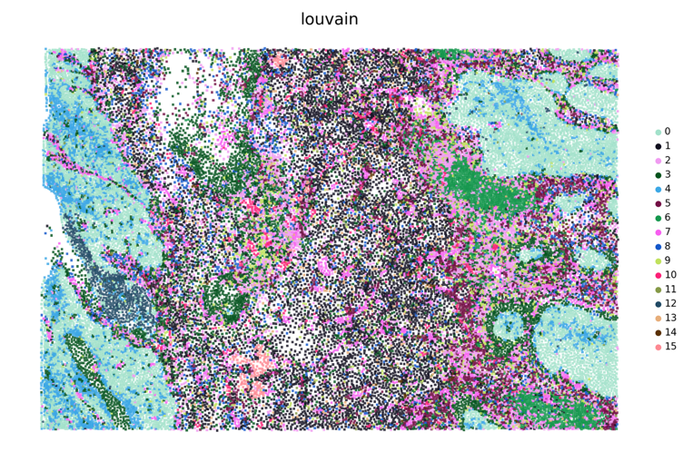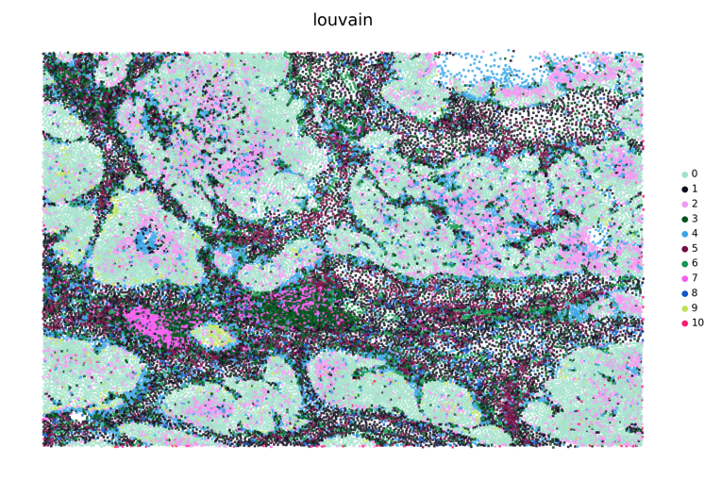
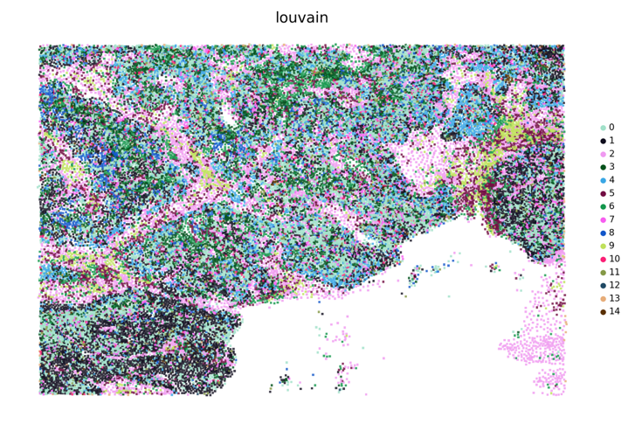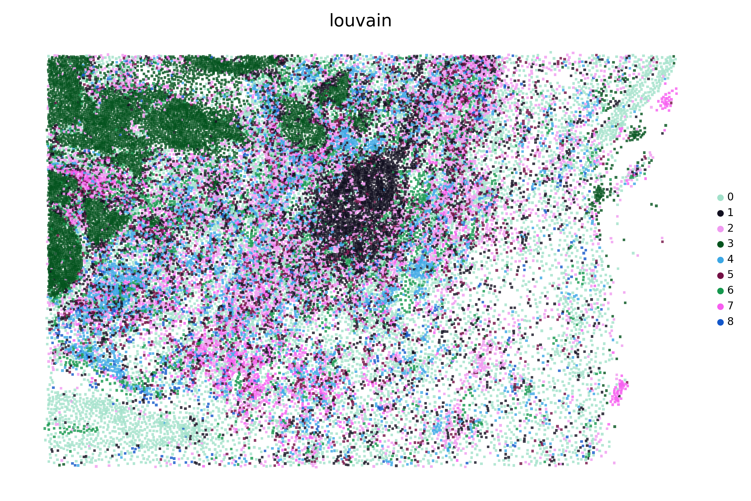
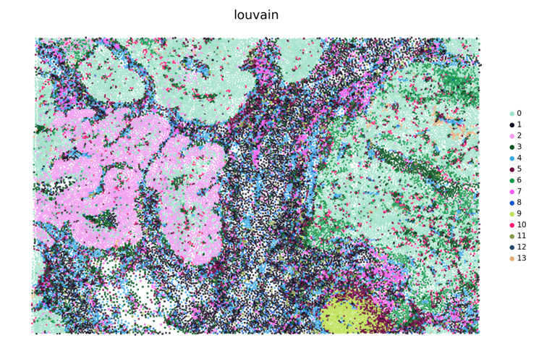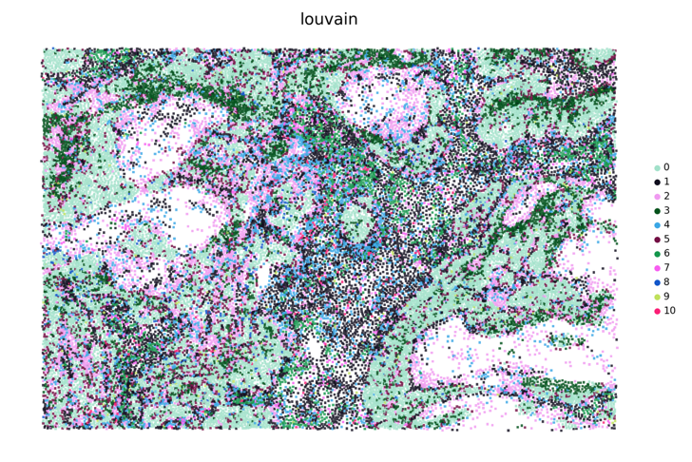
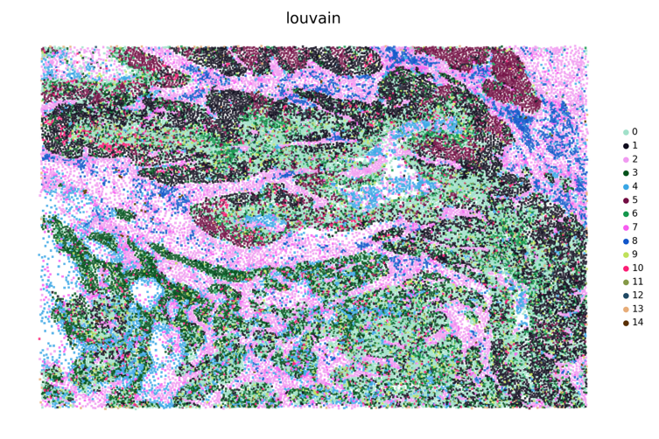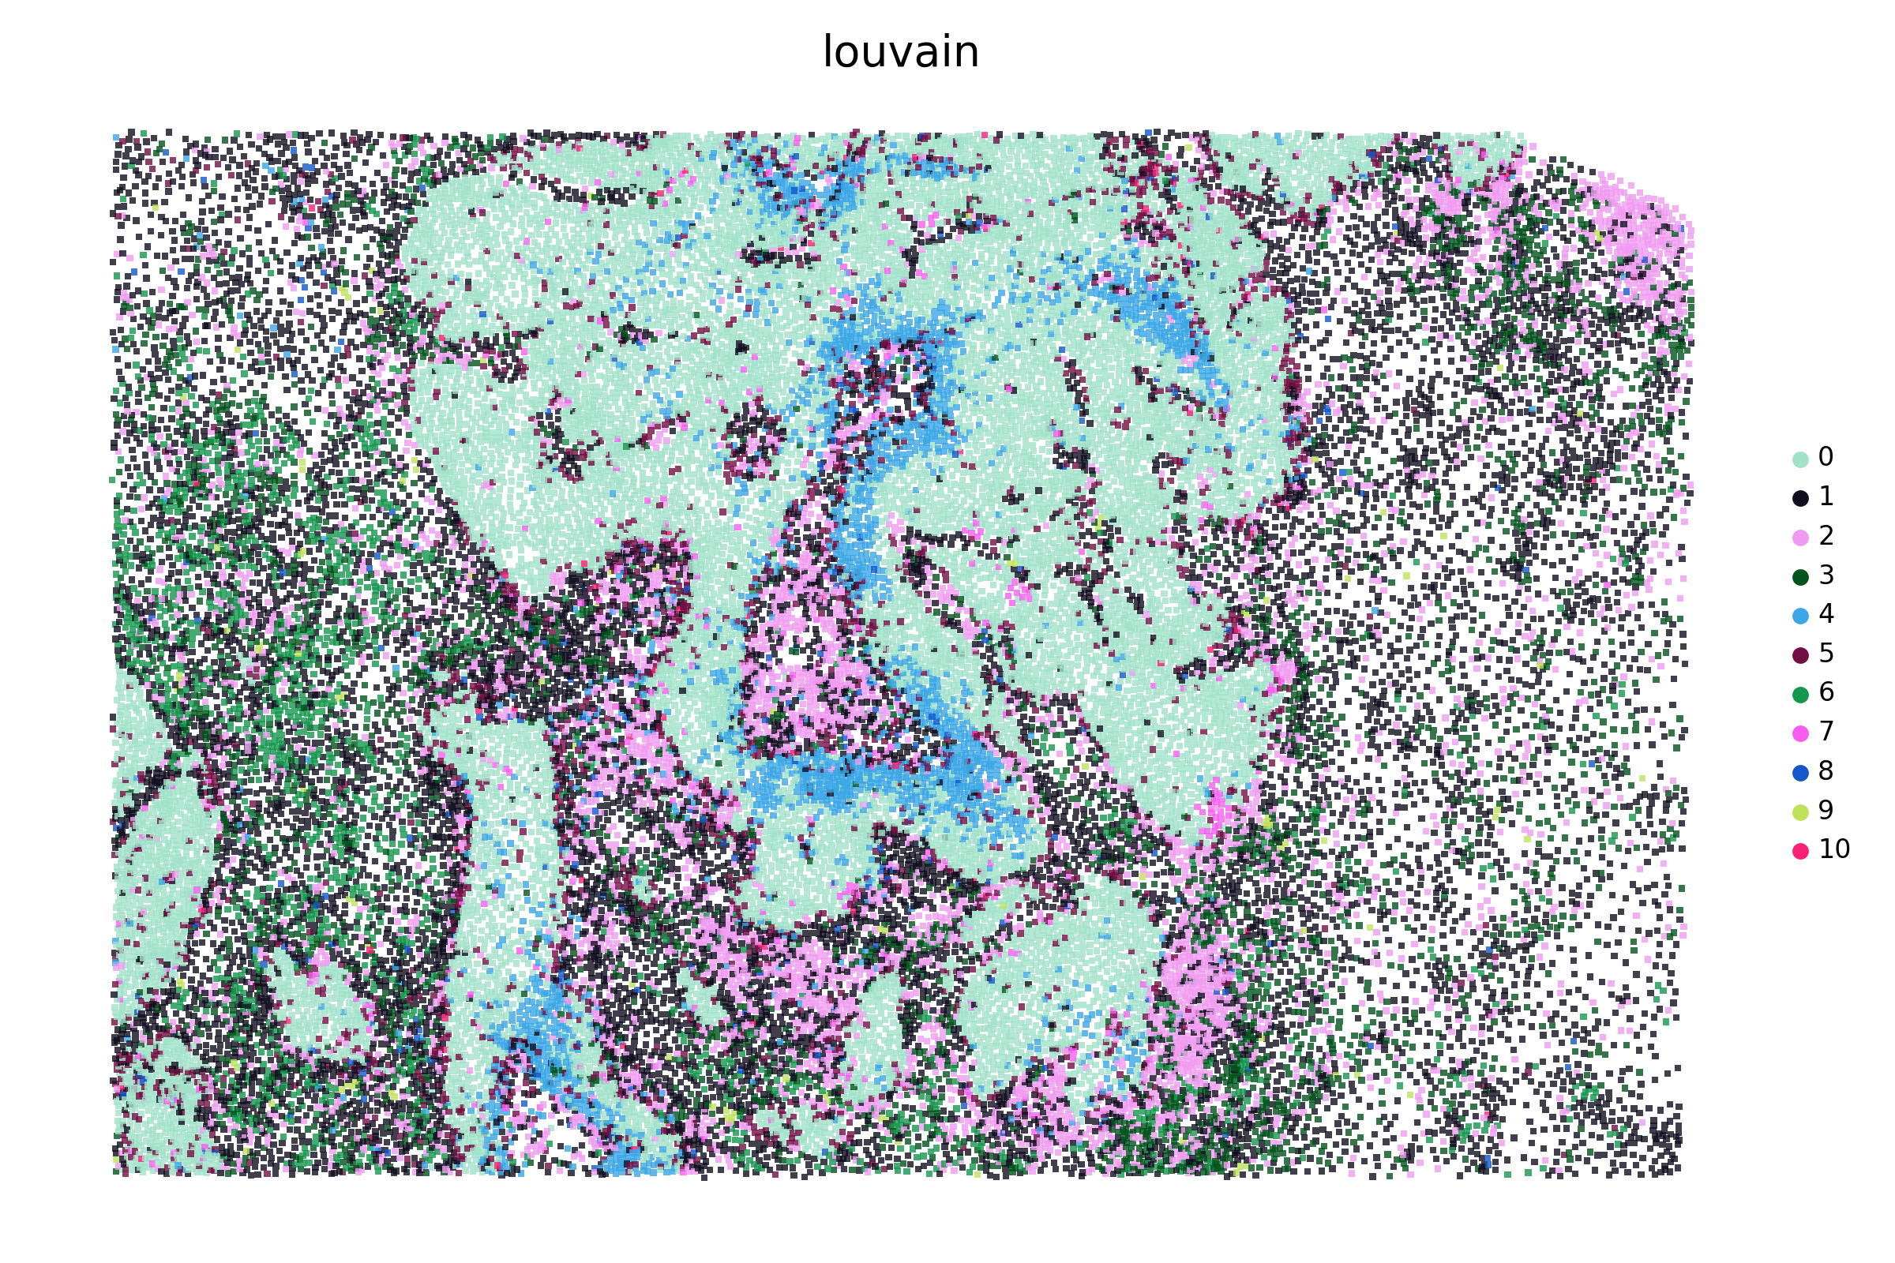
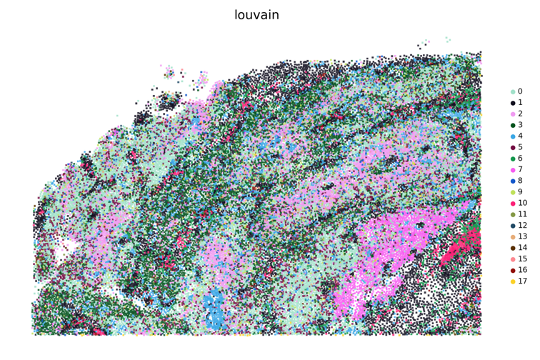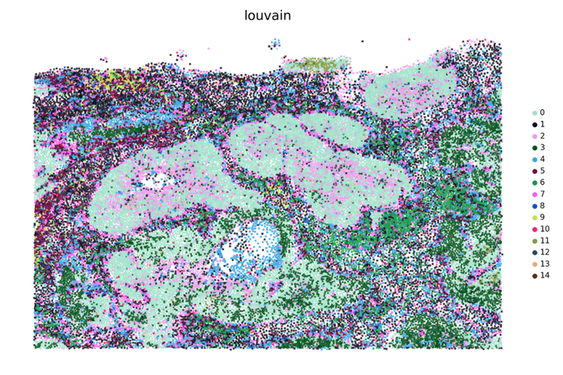
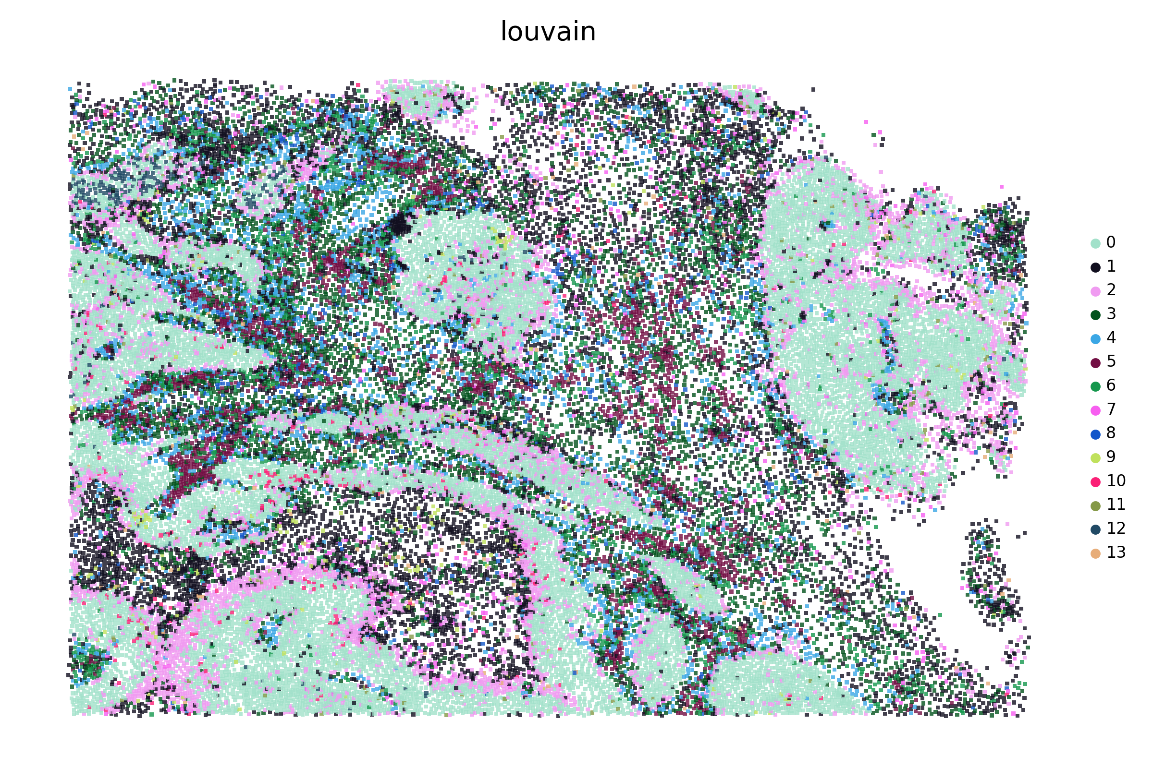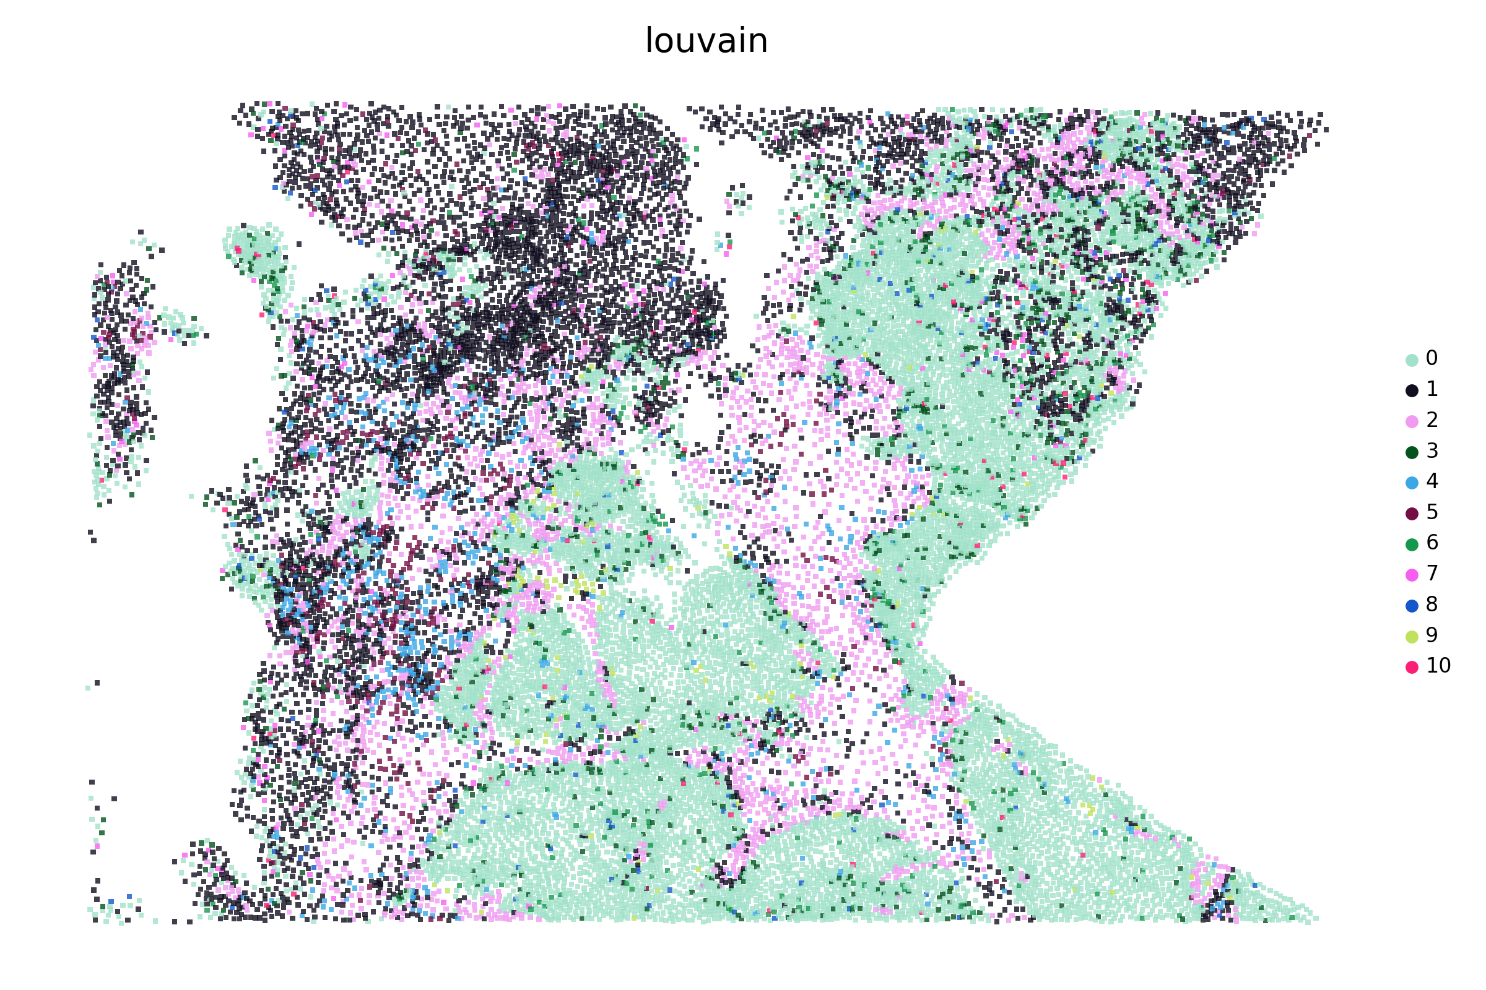
C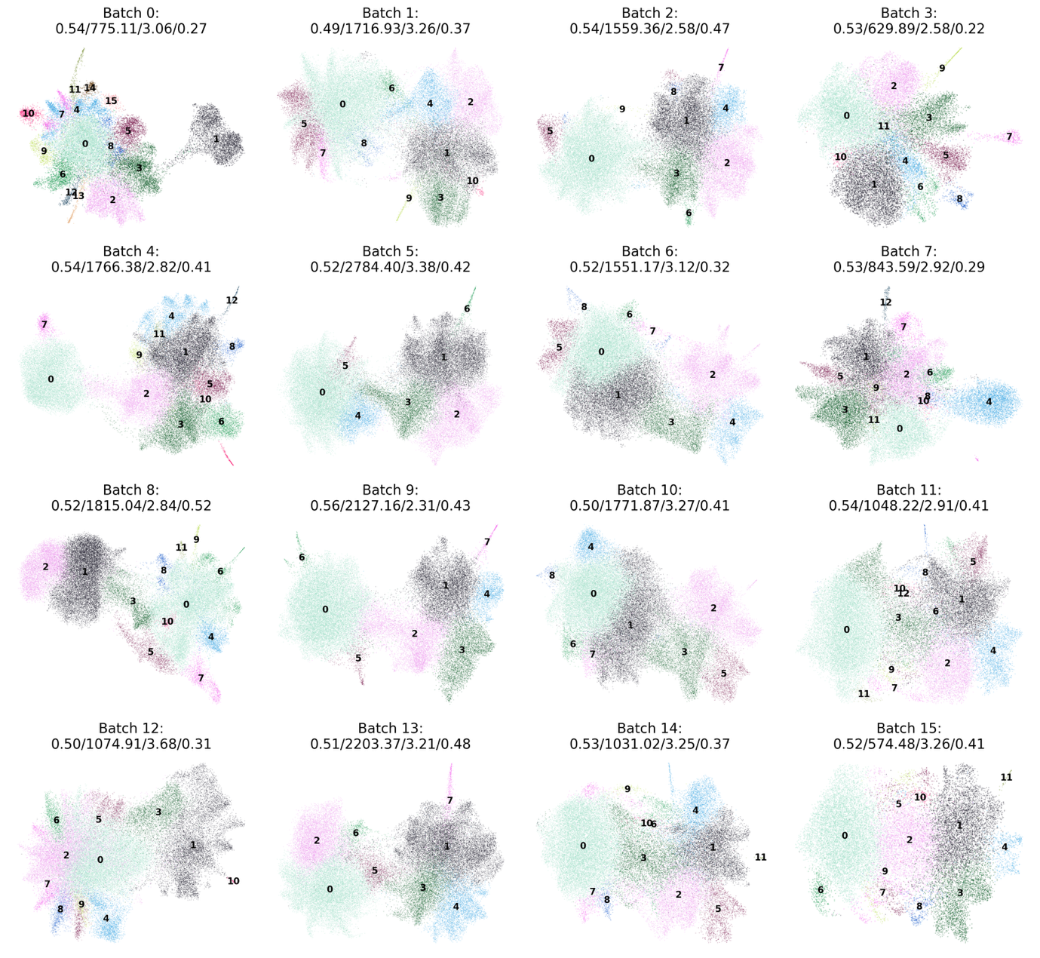

D
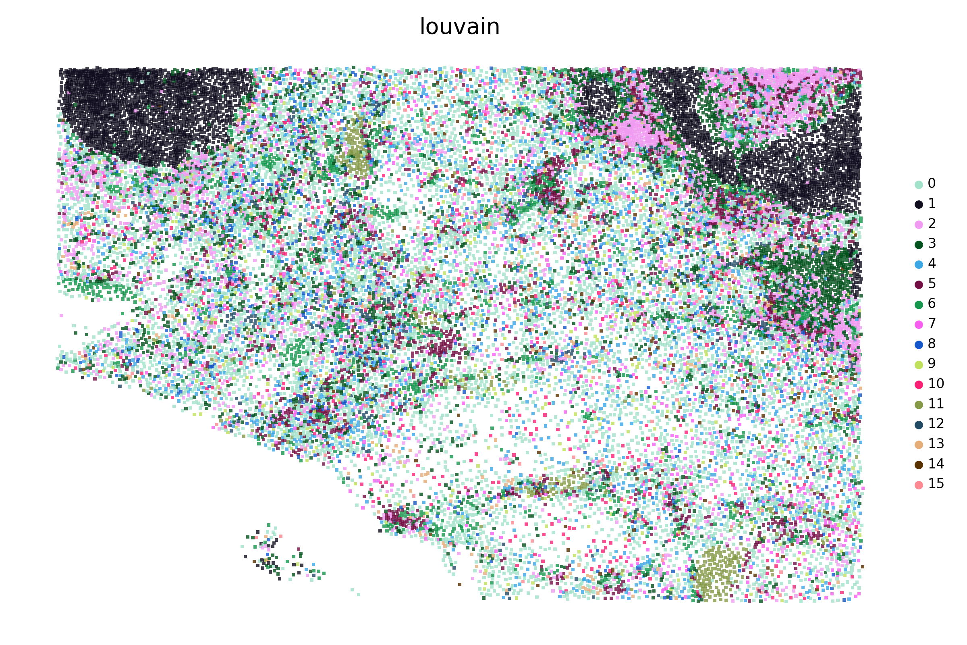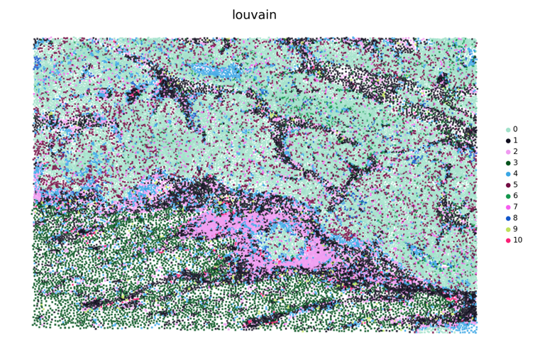
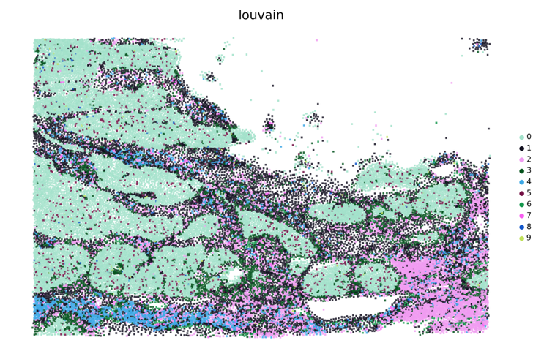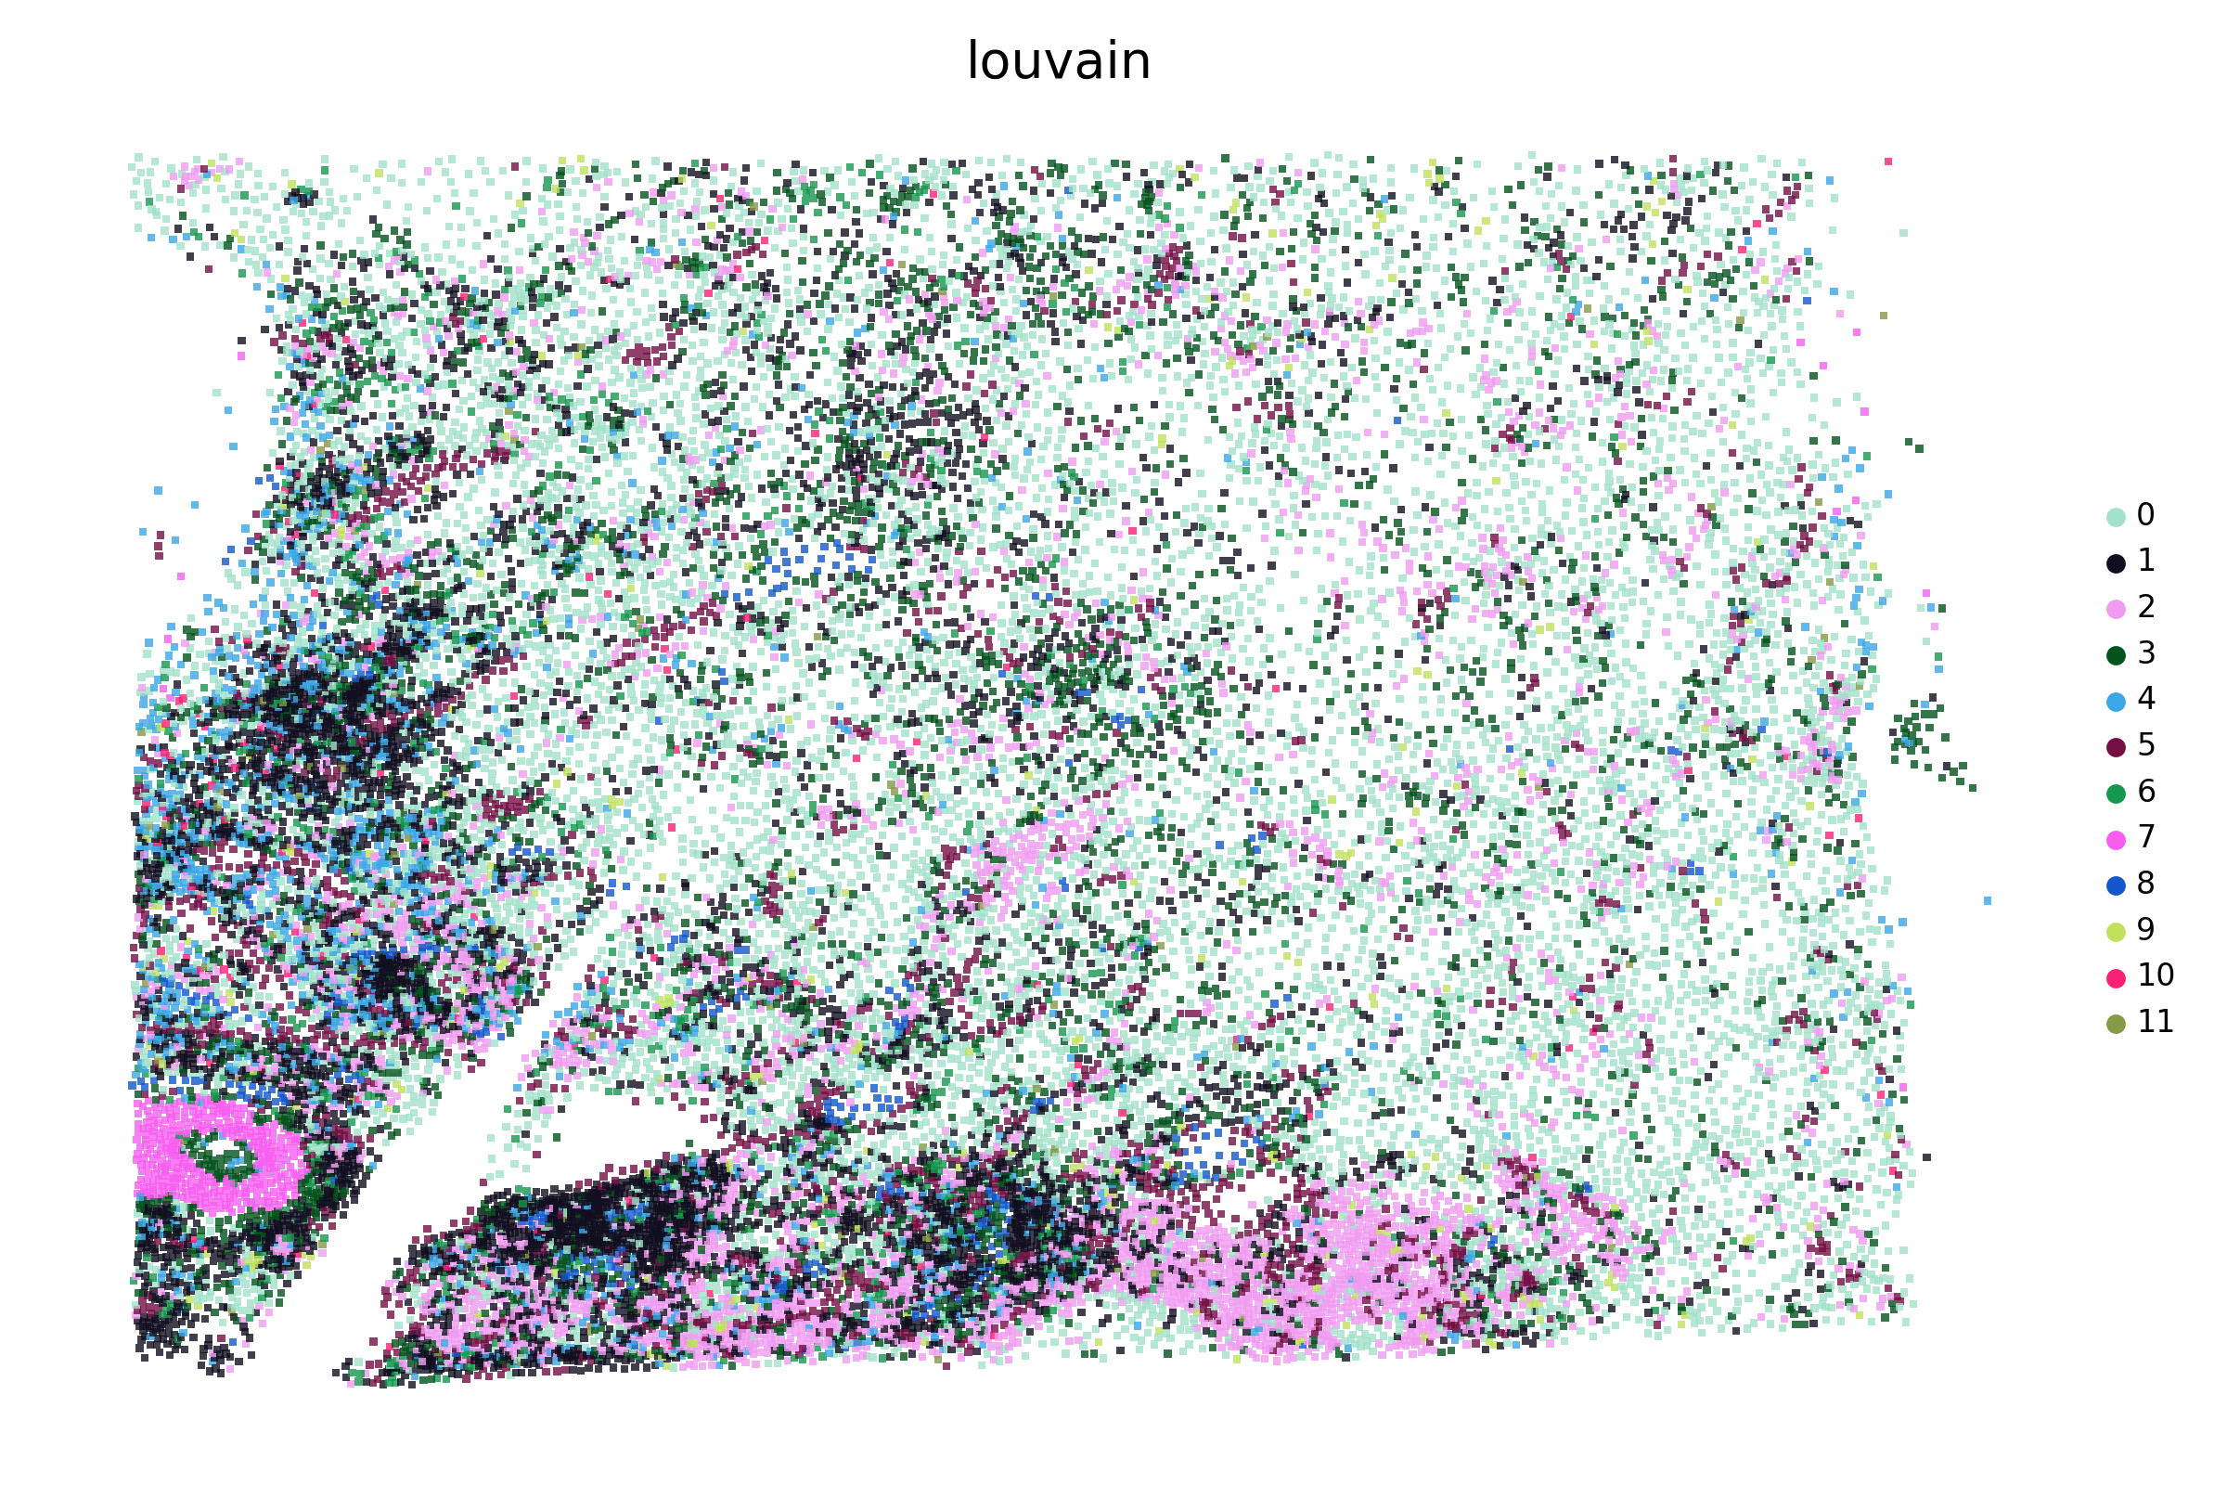
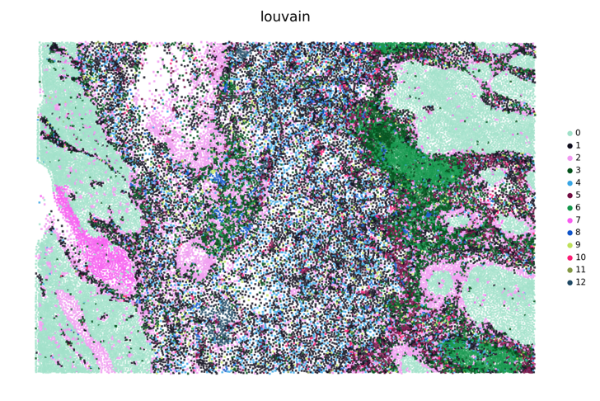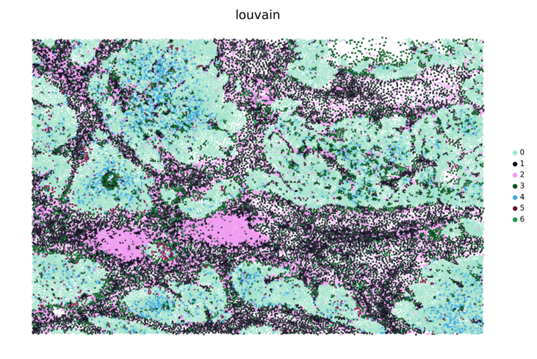
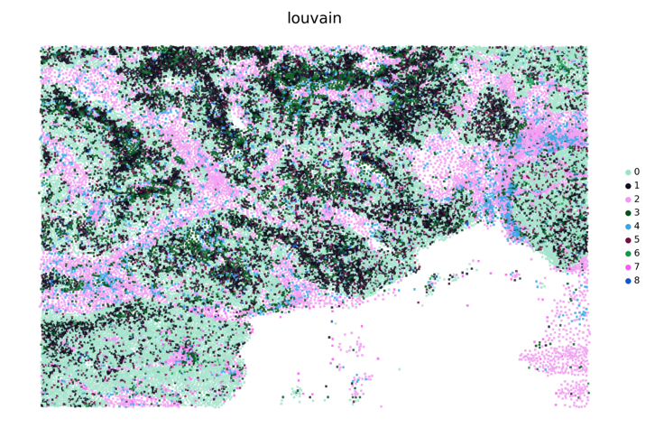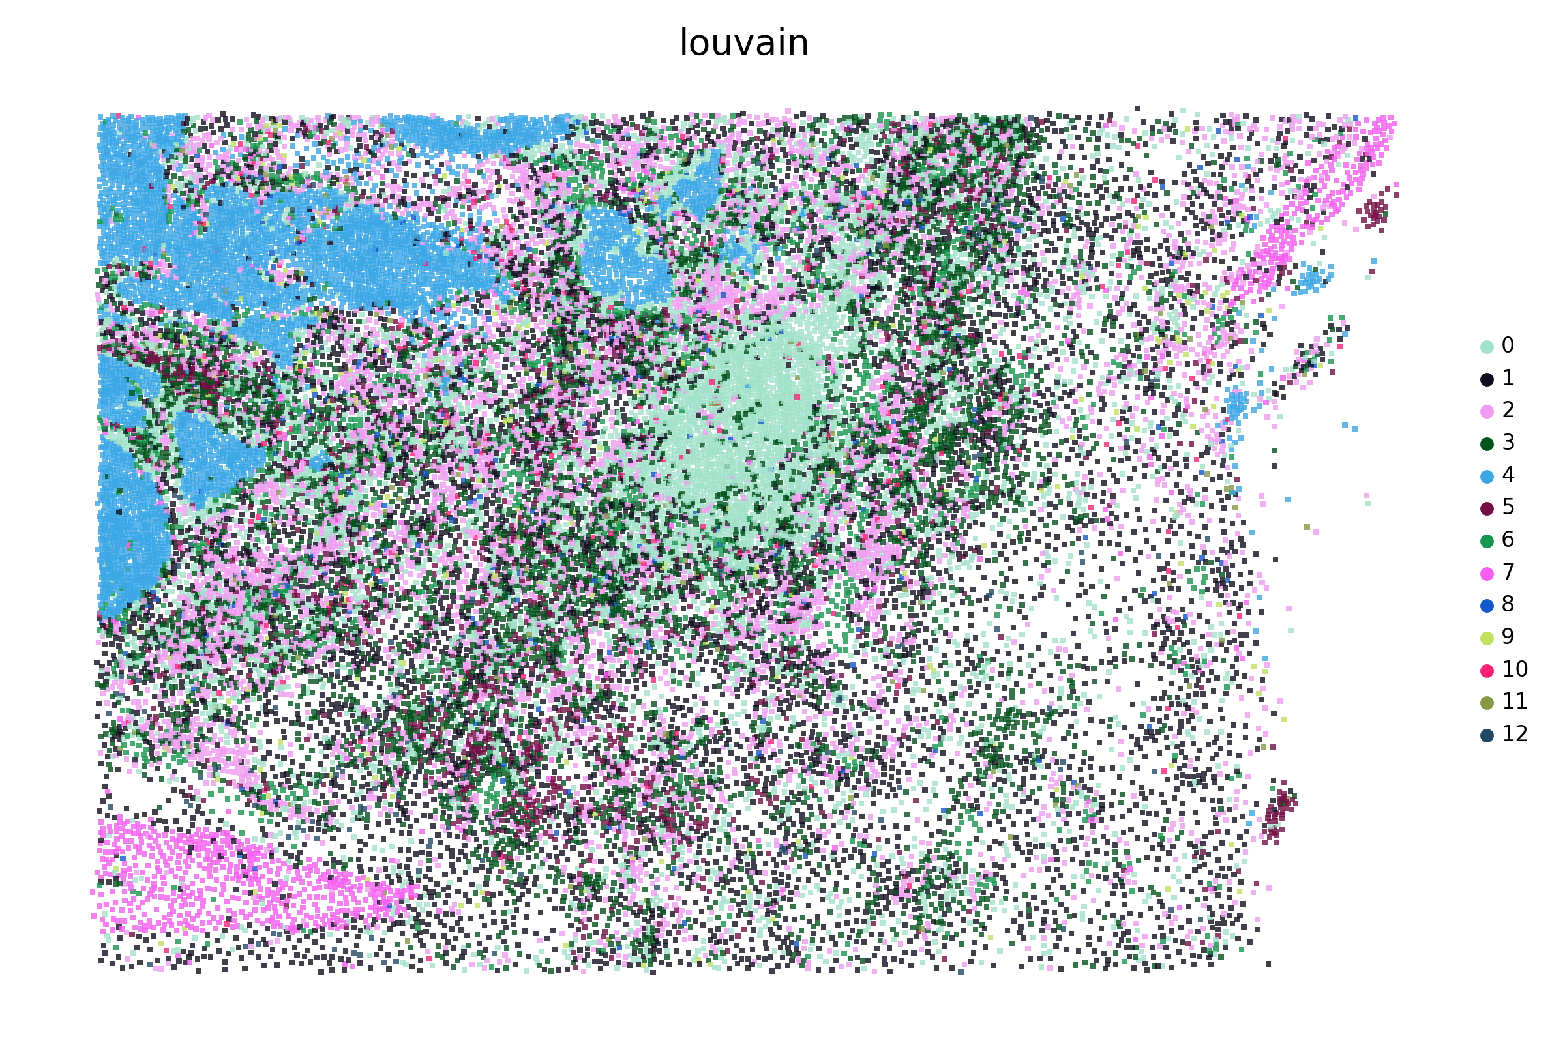
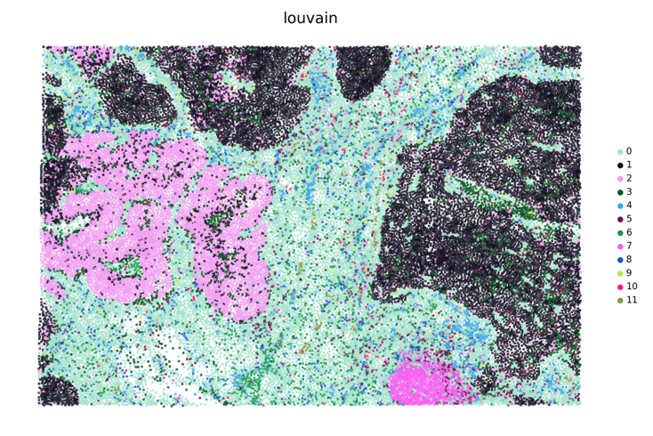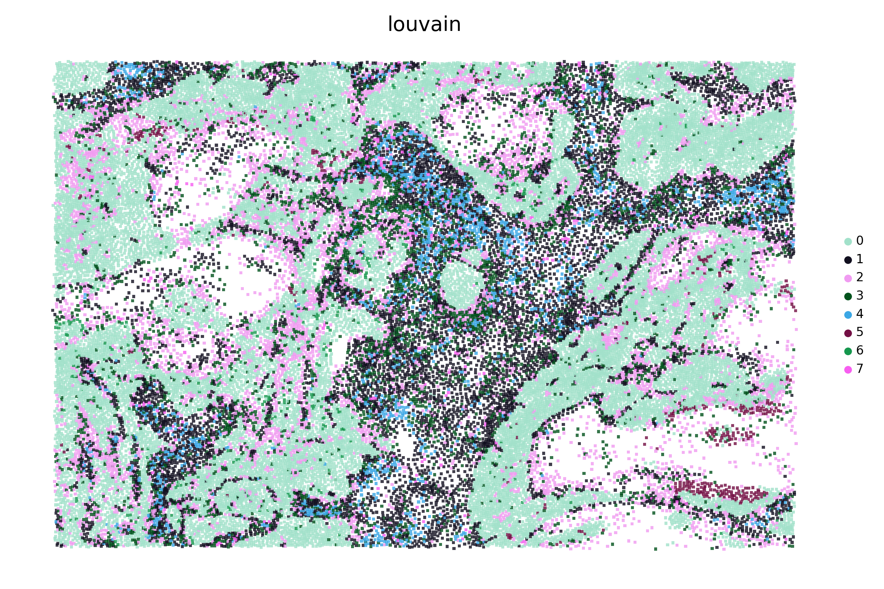
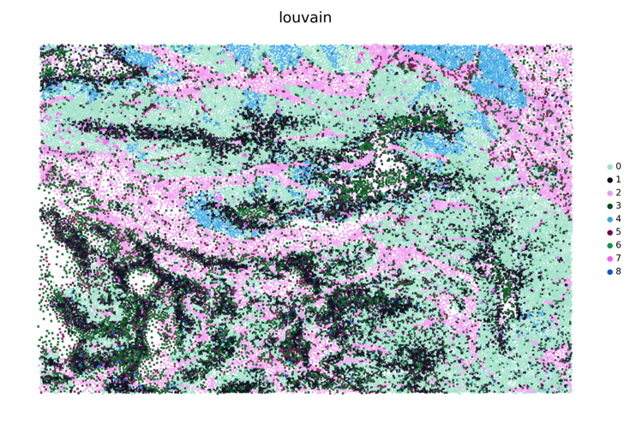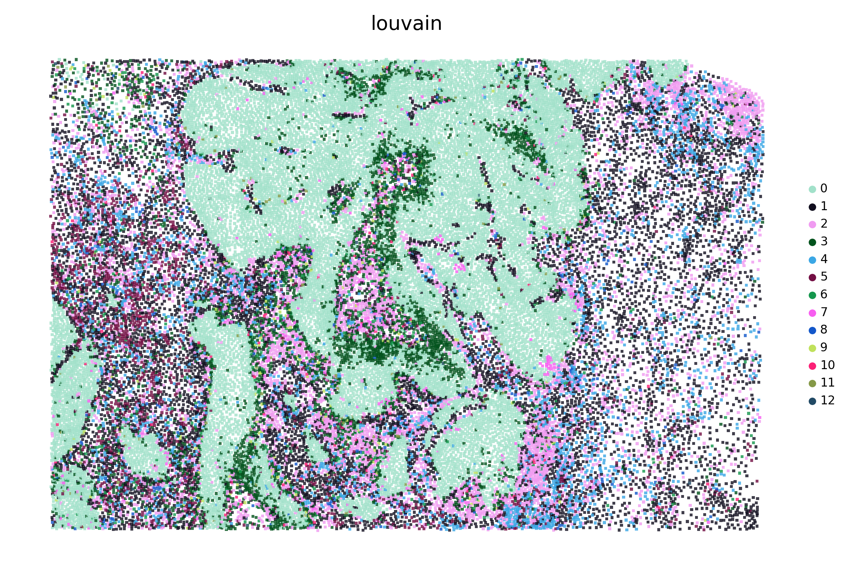
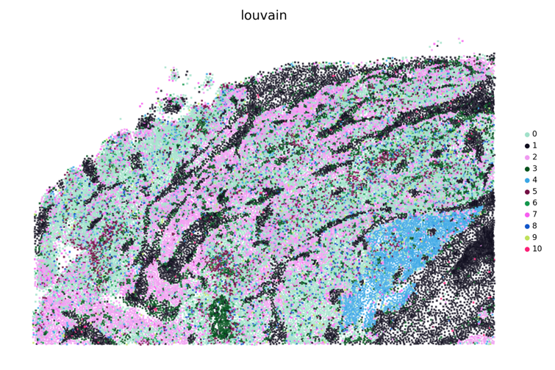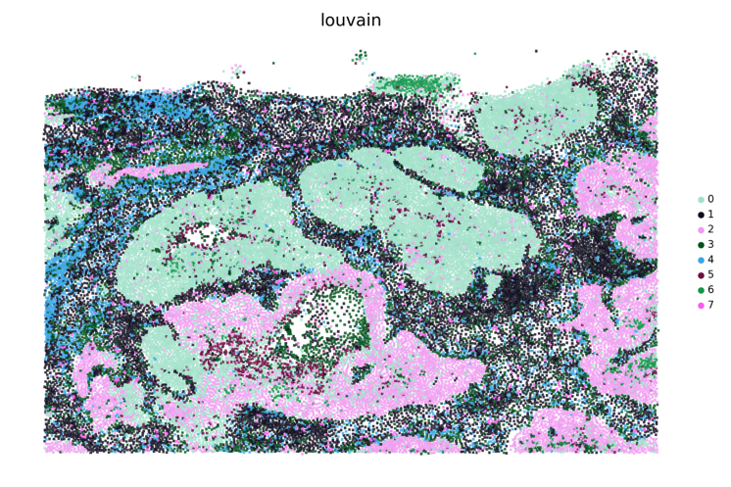
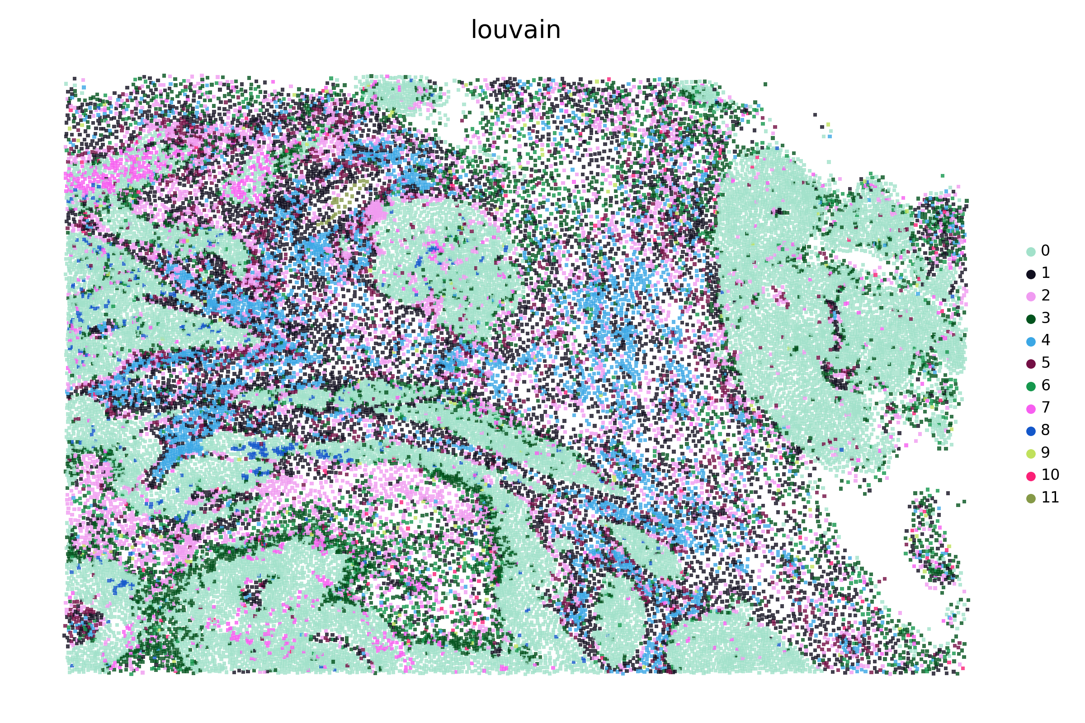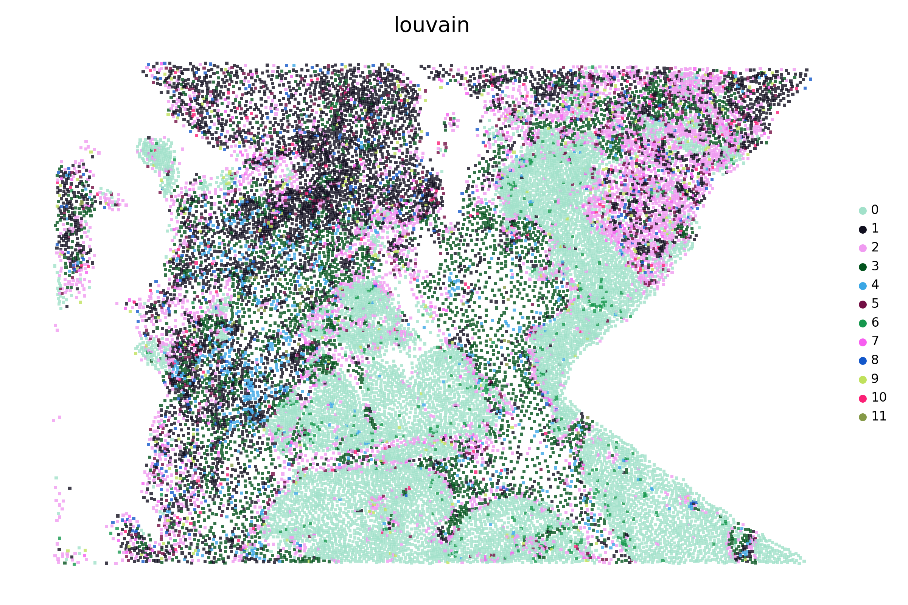
Supplementary Figure S6. Visualization of the SPICEiST clustering results compared to the cell-level, gene expression-based clustering in the Xenium colorectal cancer dataset with the v1 panel at a resolution of 0.6.
UMAP plots and the spatial distribution of cells illustrate the cell-level embedding and spatial distribution derived from SPICEiST-based analysis (integ; A: UMAP, B: spatial distribution of cells) and cell-level gene expression-based clustering (gex; C: UMAP, D: spatial distribution of cells), respectively. The tissue samples, obtained from patch numbers 0 to 15, are presented serially from left to right and top to bottom. The four numerical values at the top of the UMAP plot represent the ASW, CHI, DBI, and assortativity coefficient. Each dot in the plot corresponds to a cell, with color indicating the identity of the clusters.
A
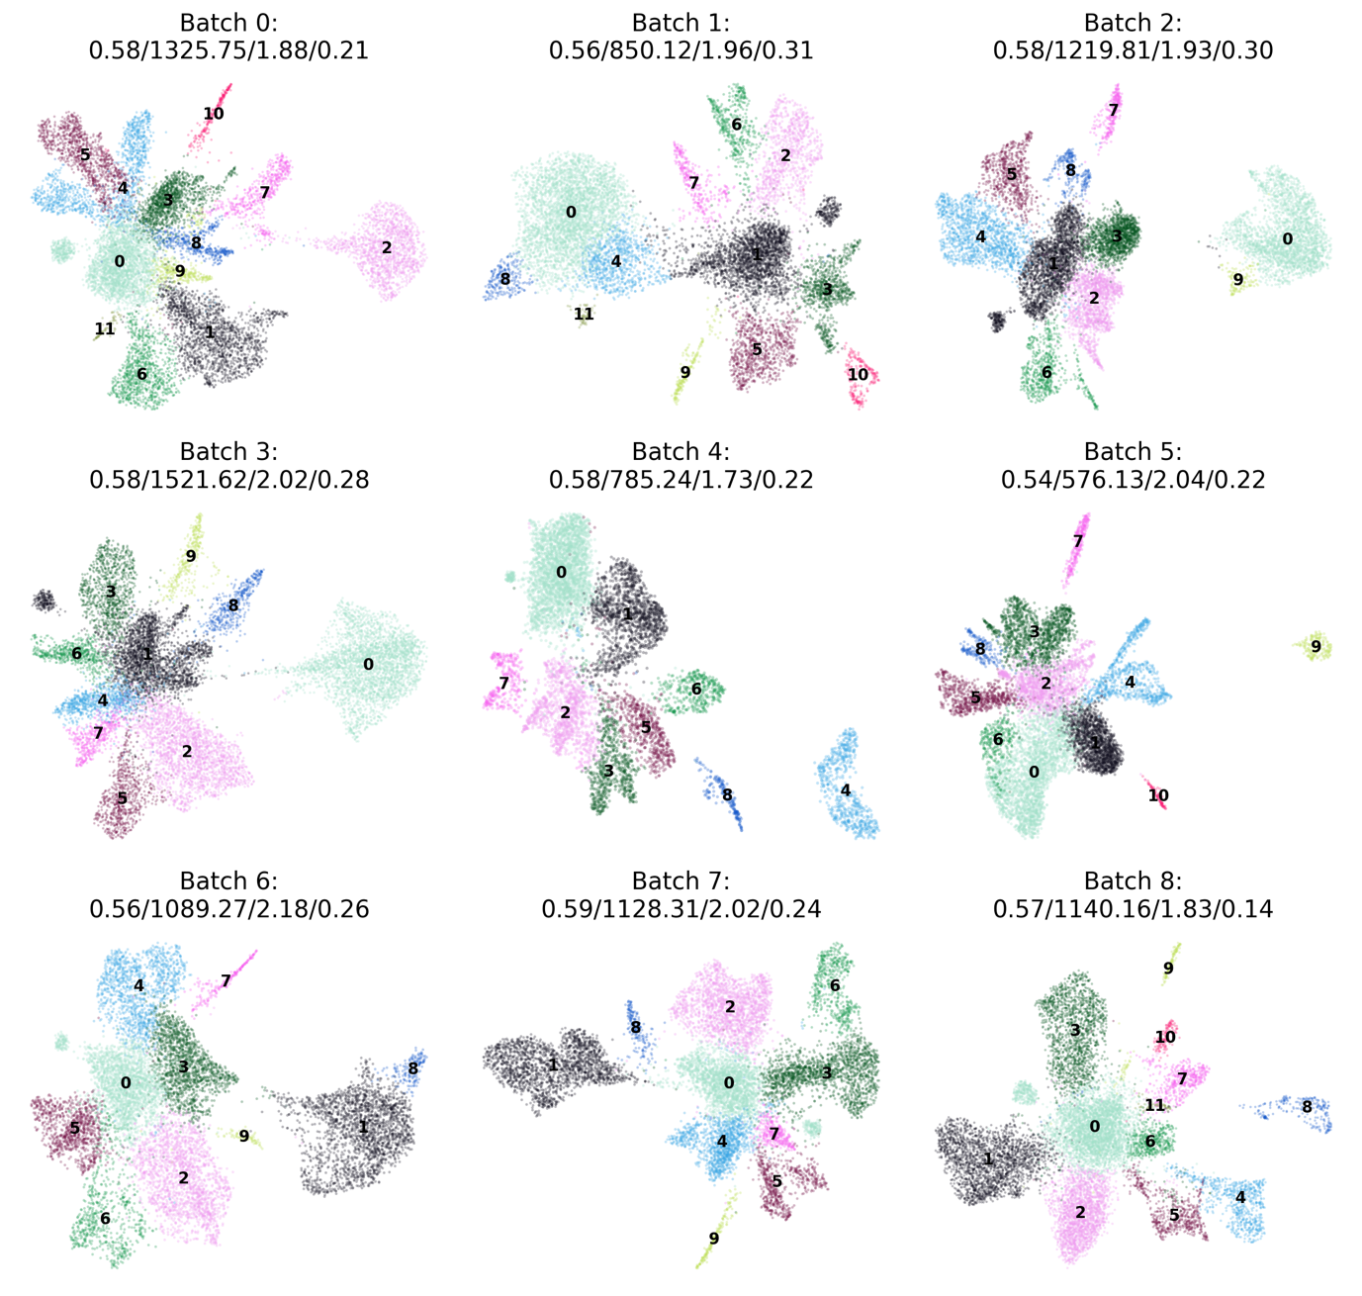
B
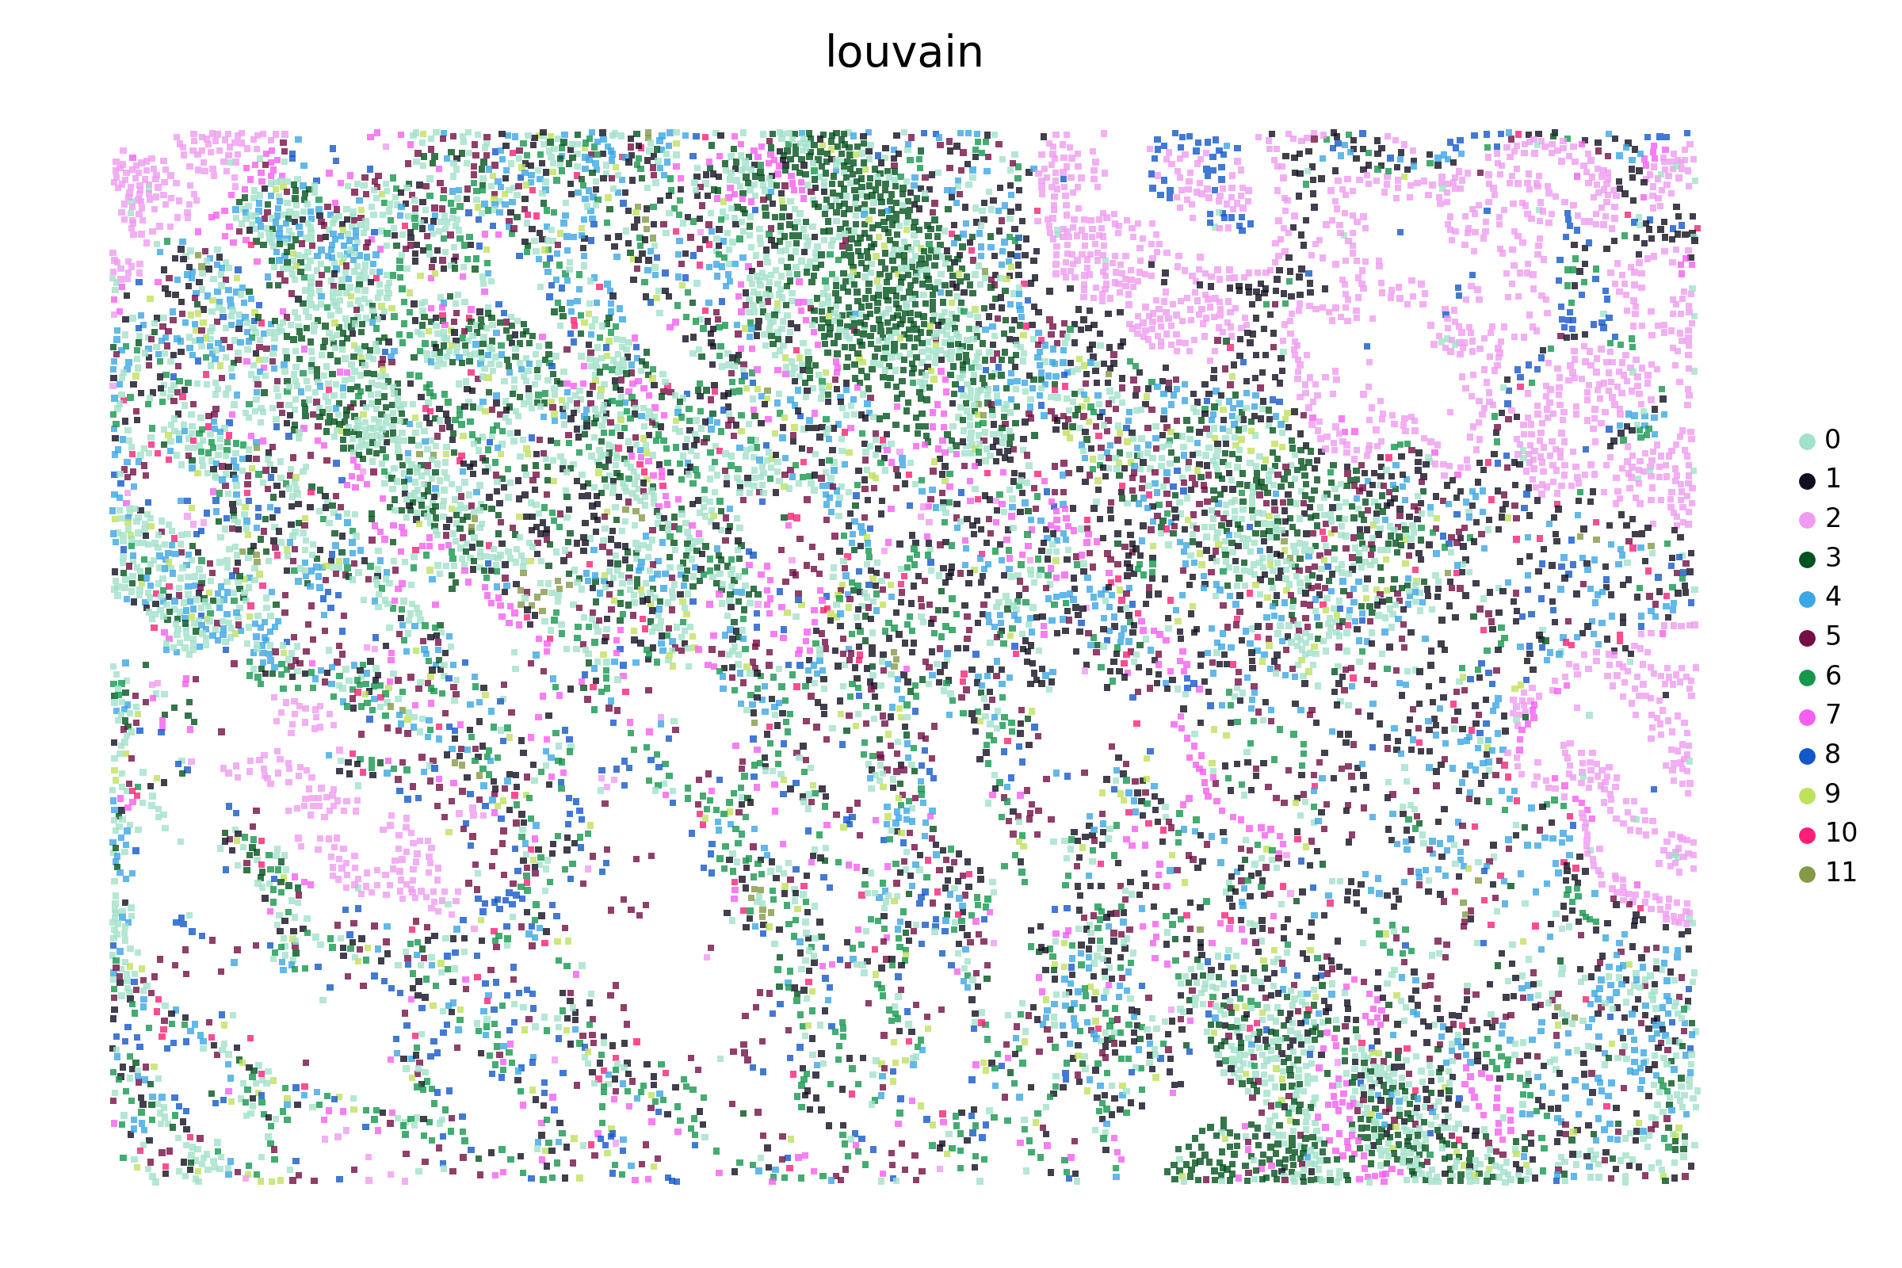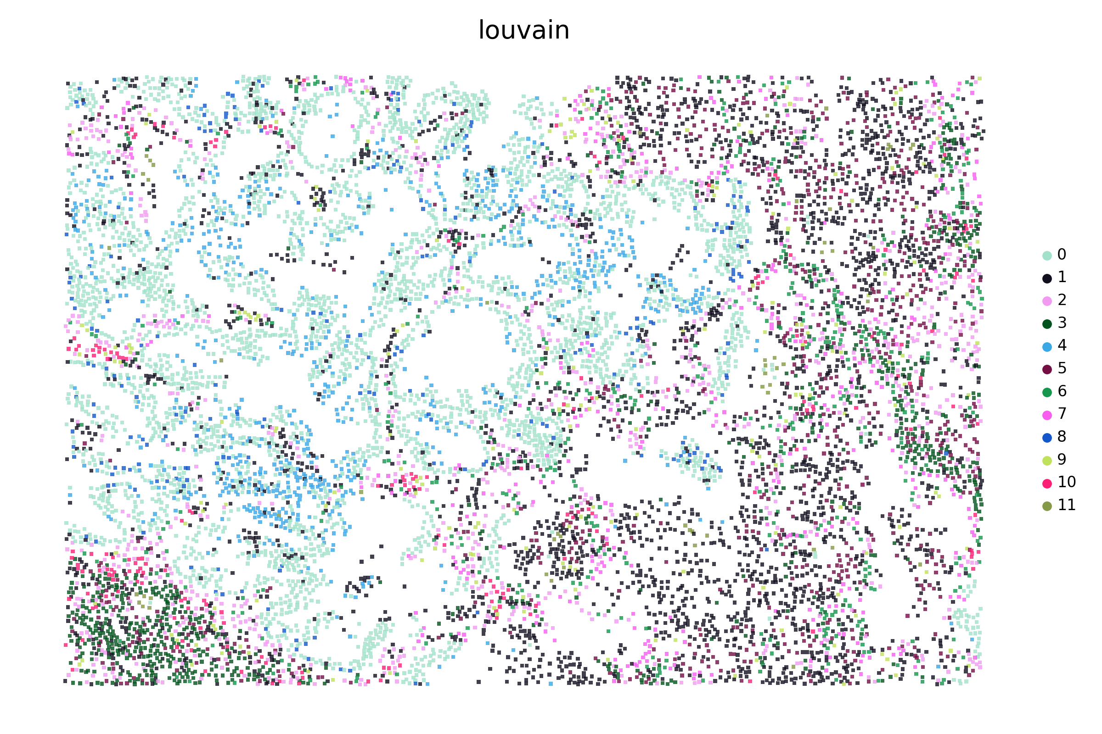
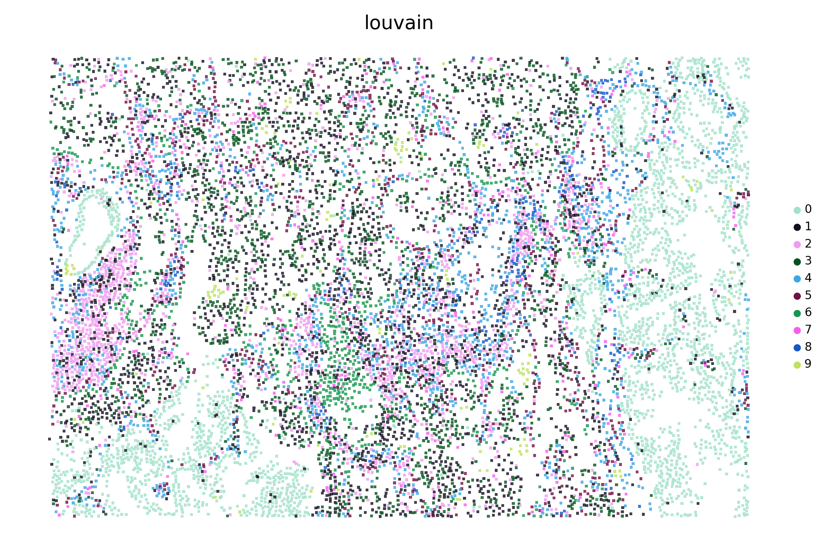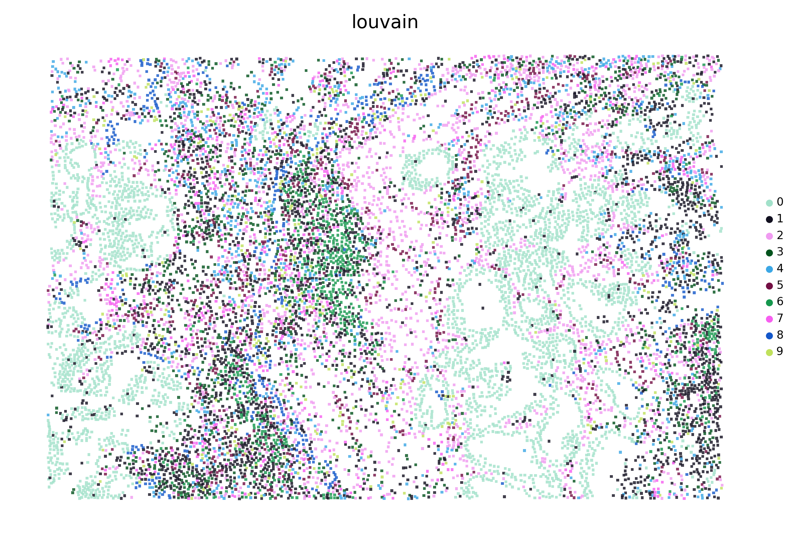
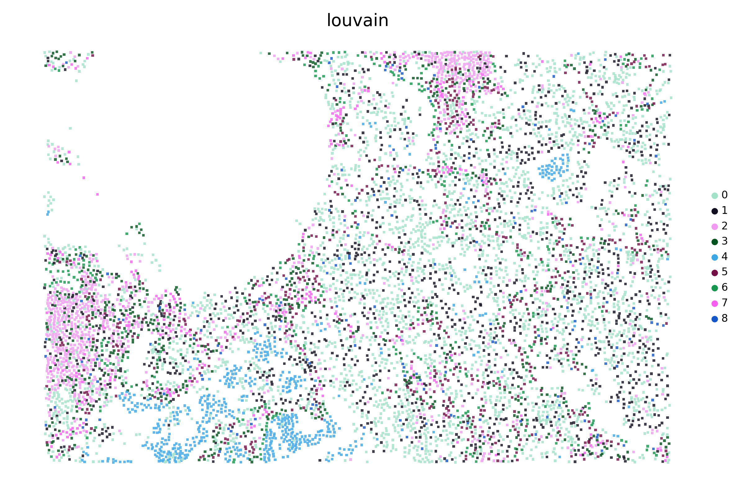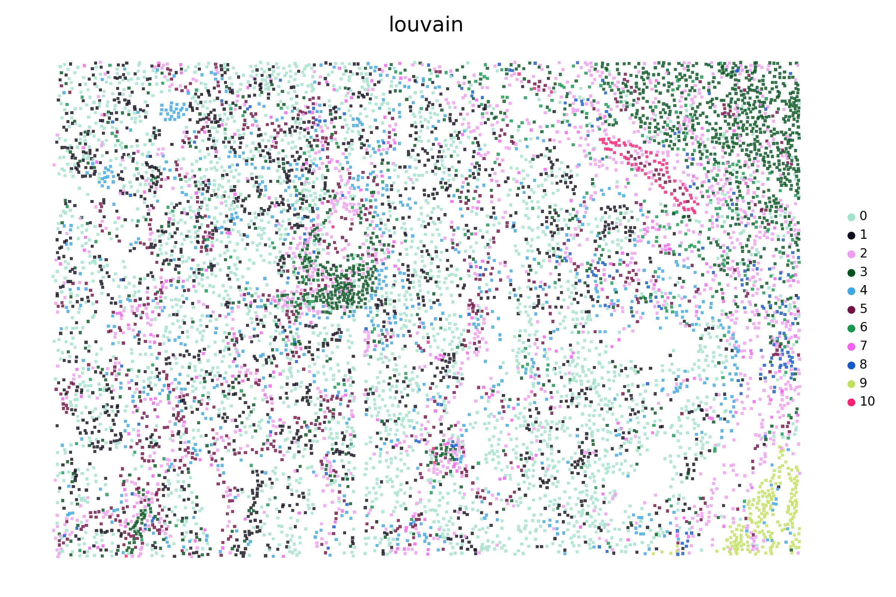
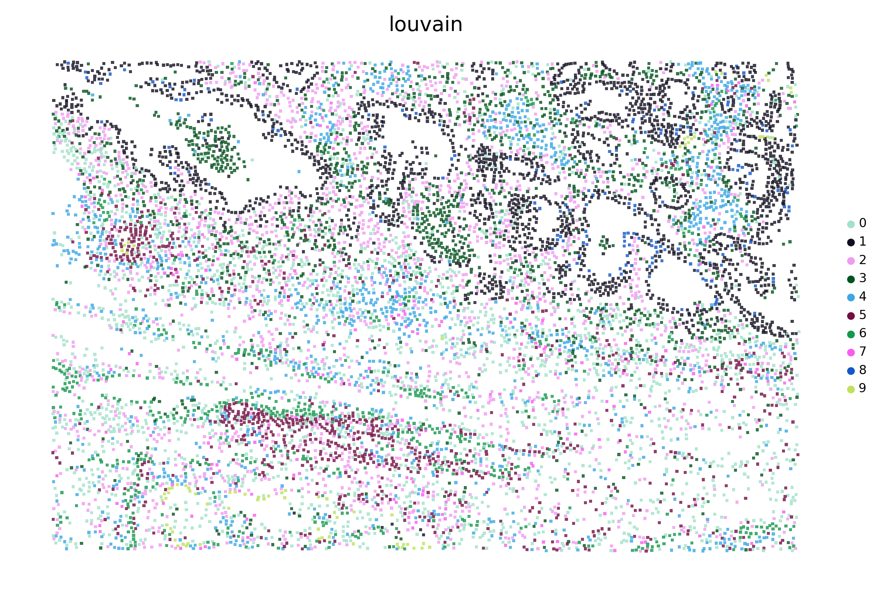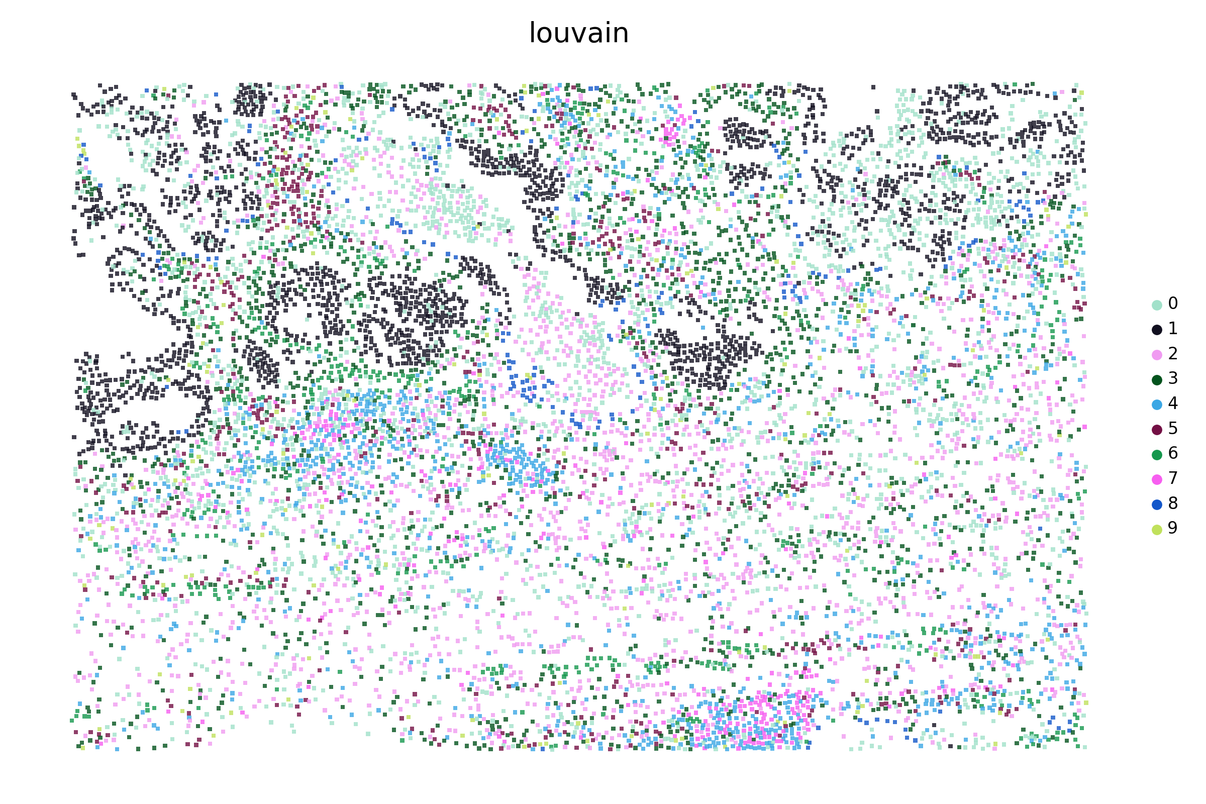
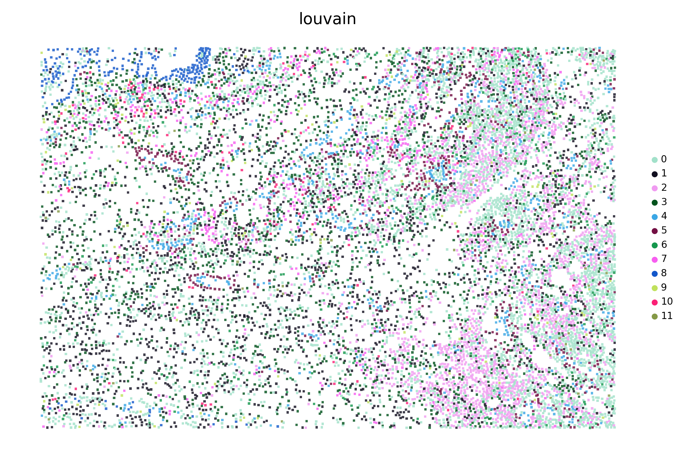
C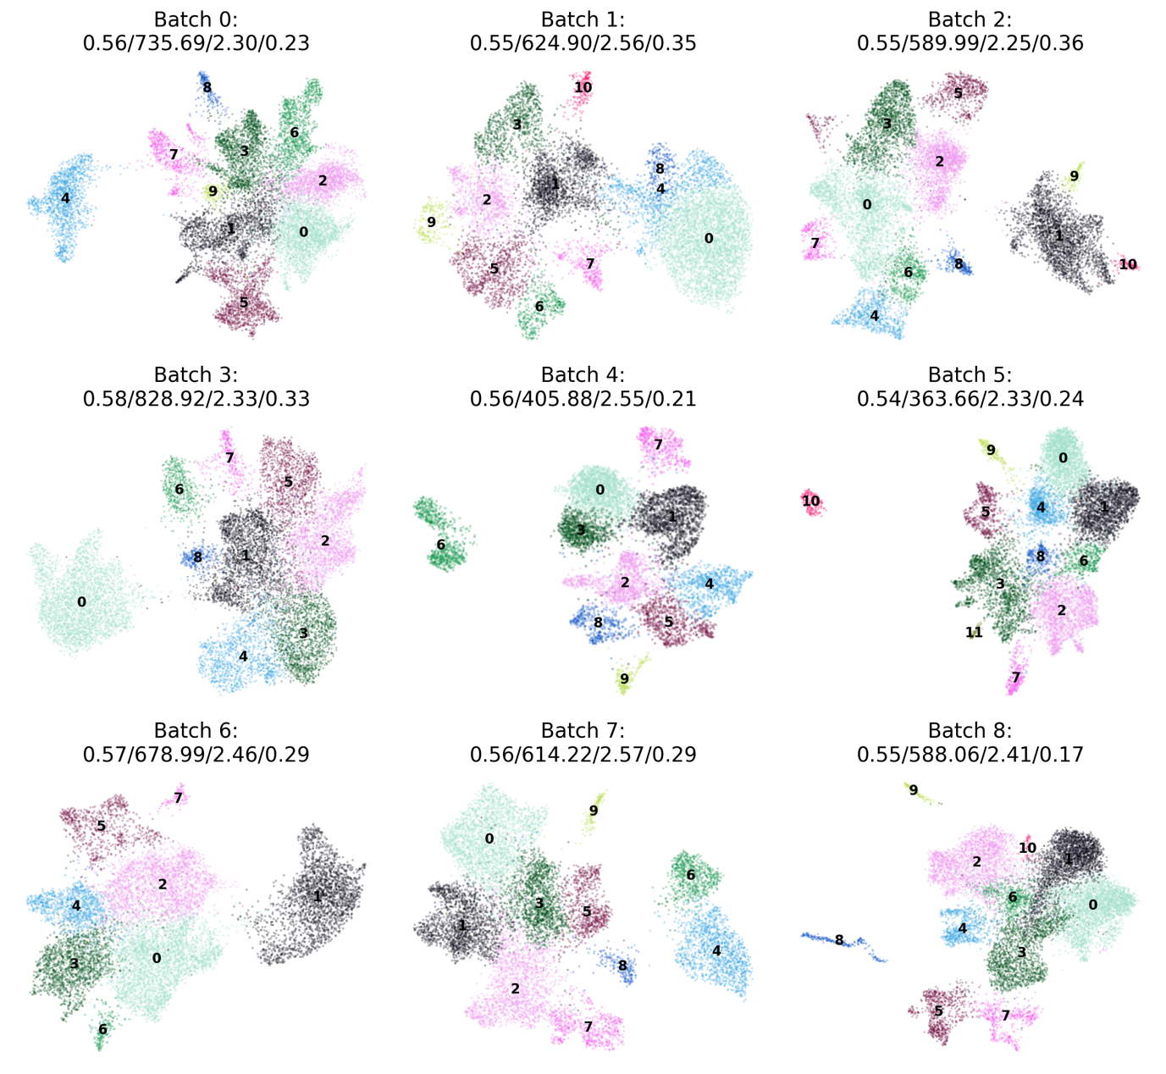

D
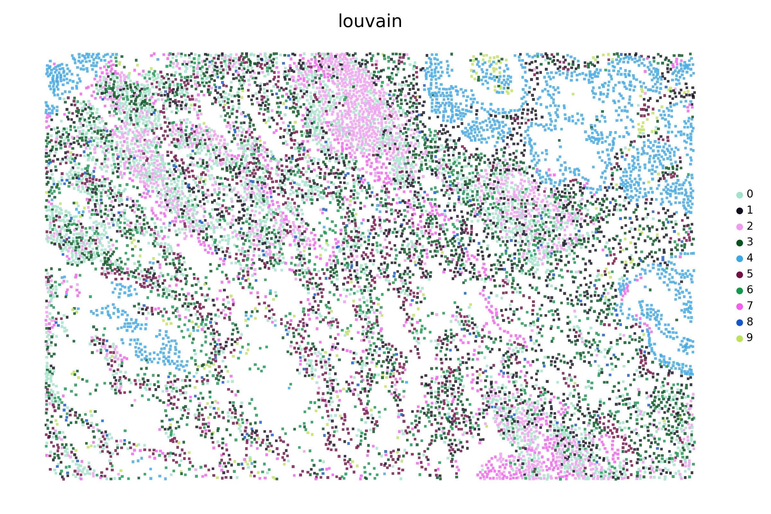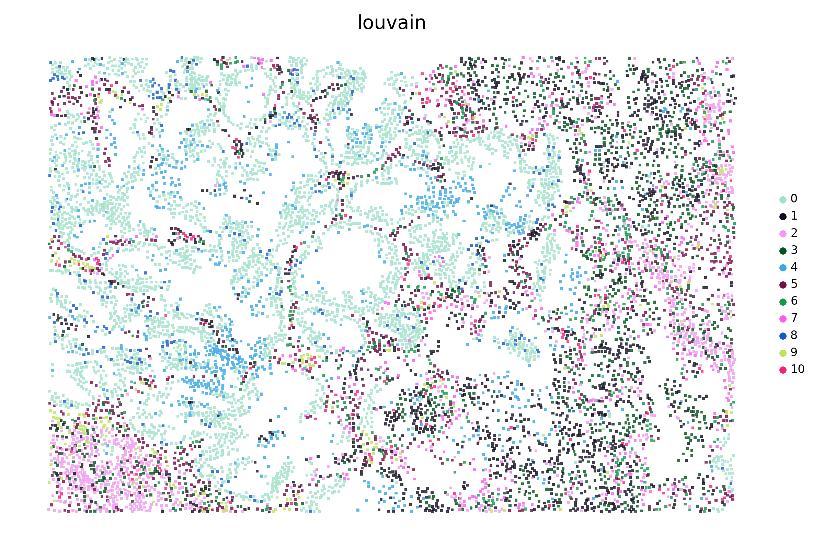
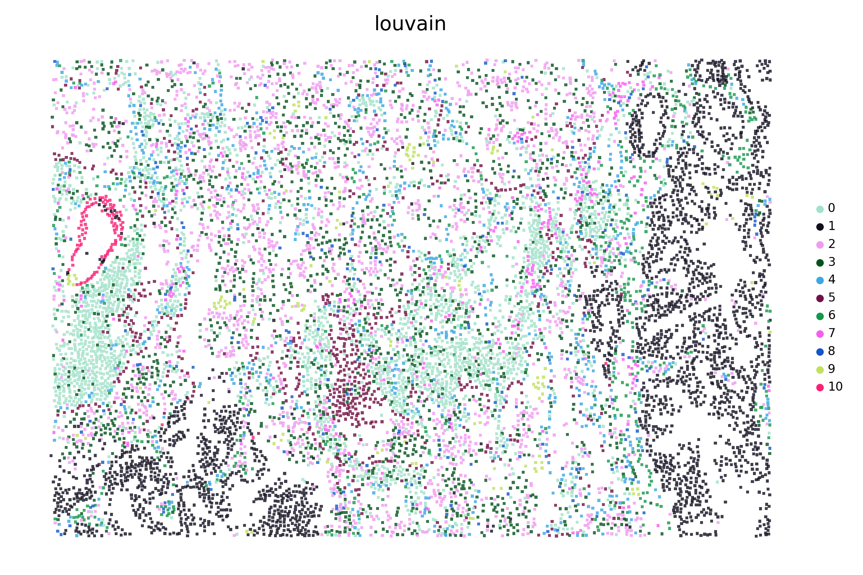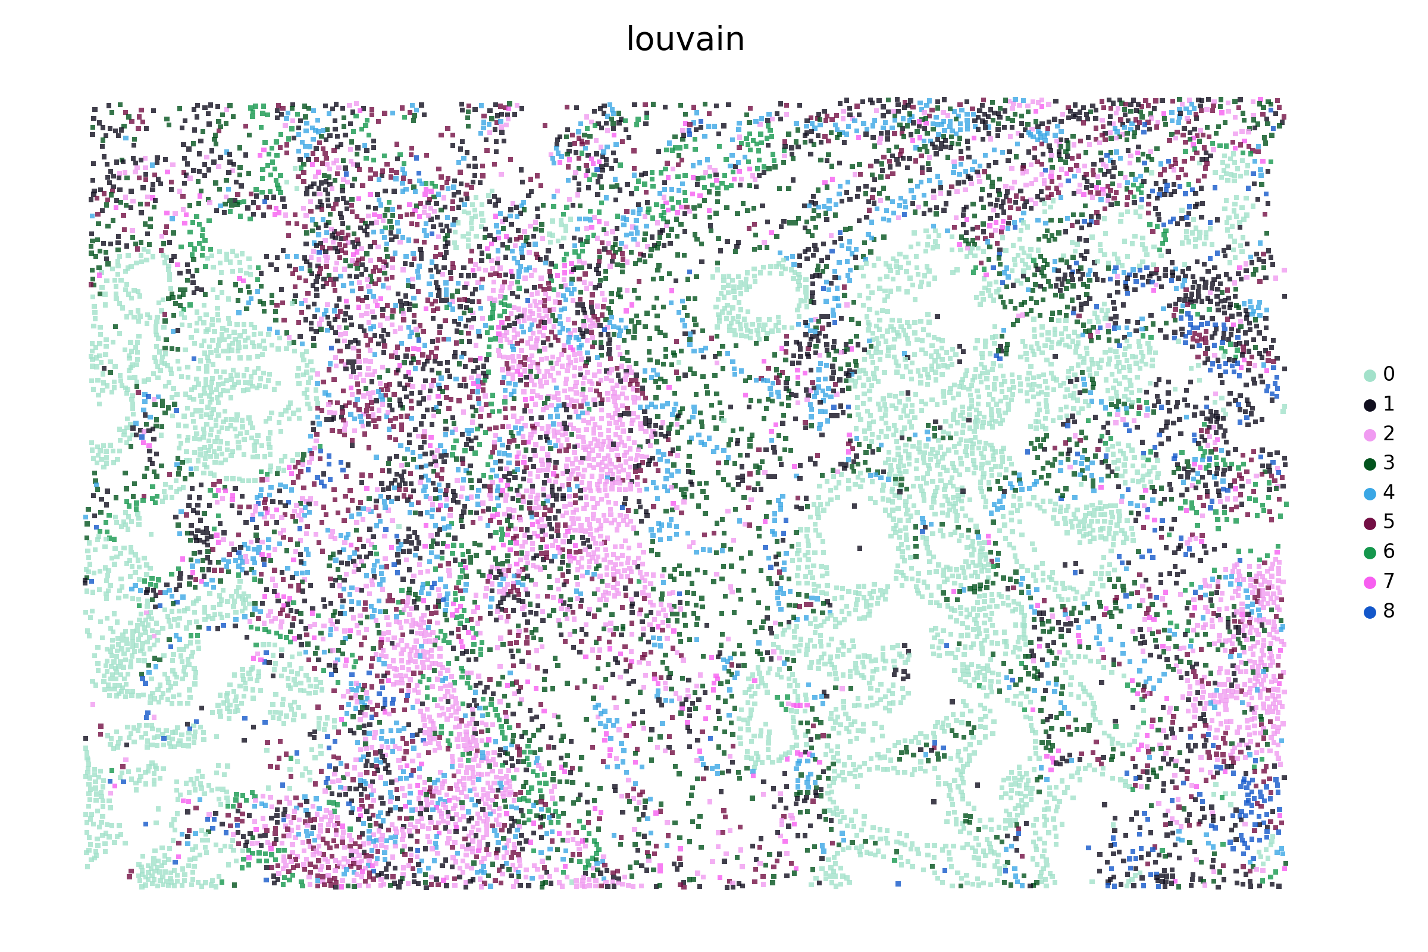
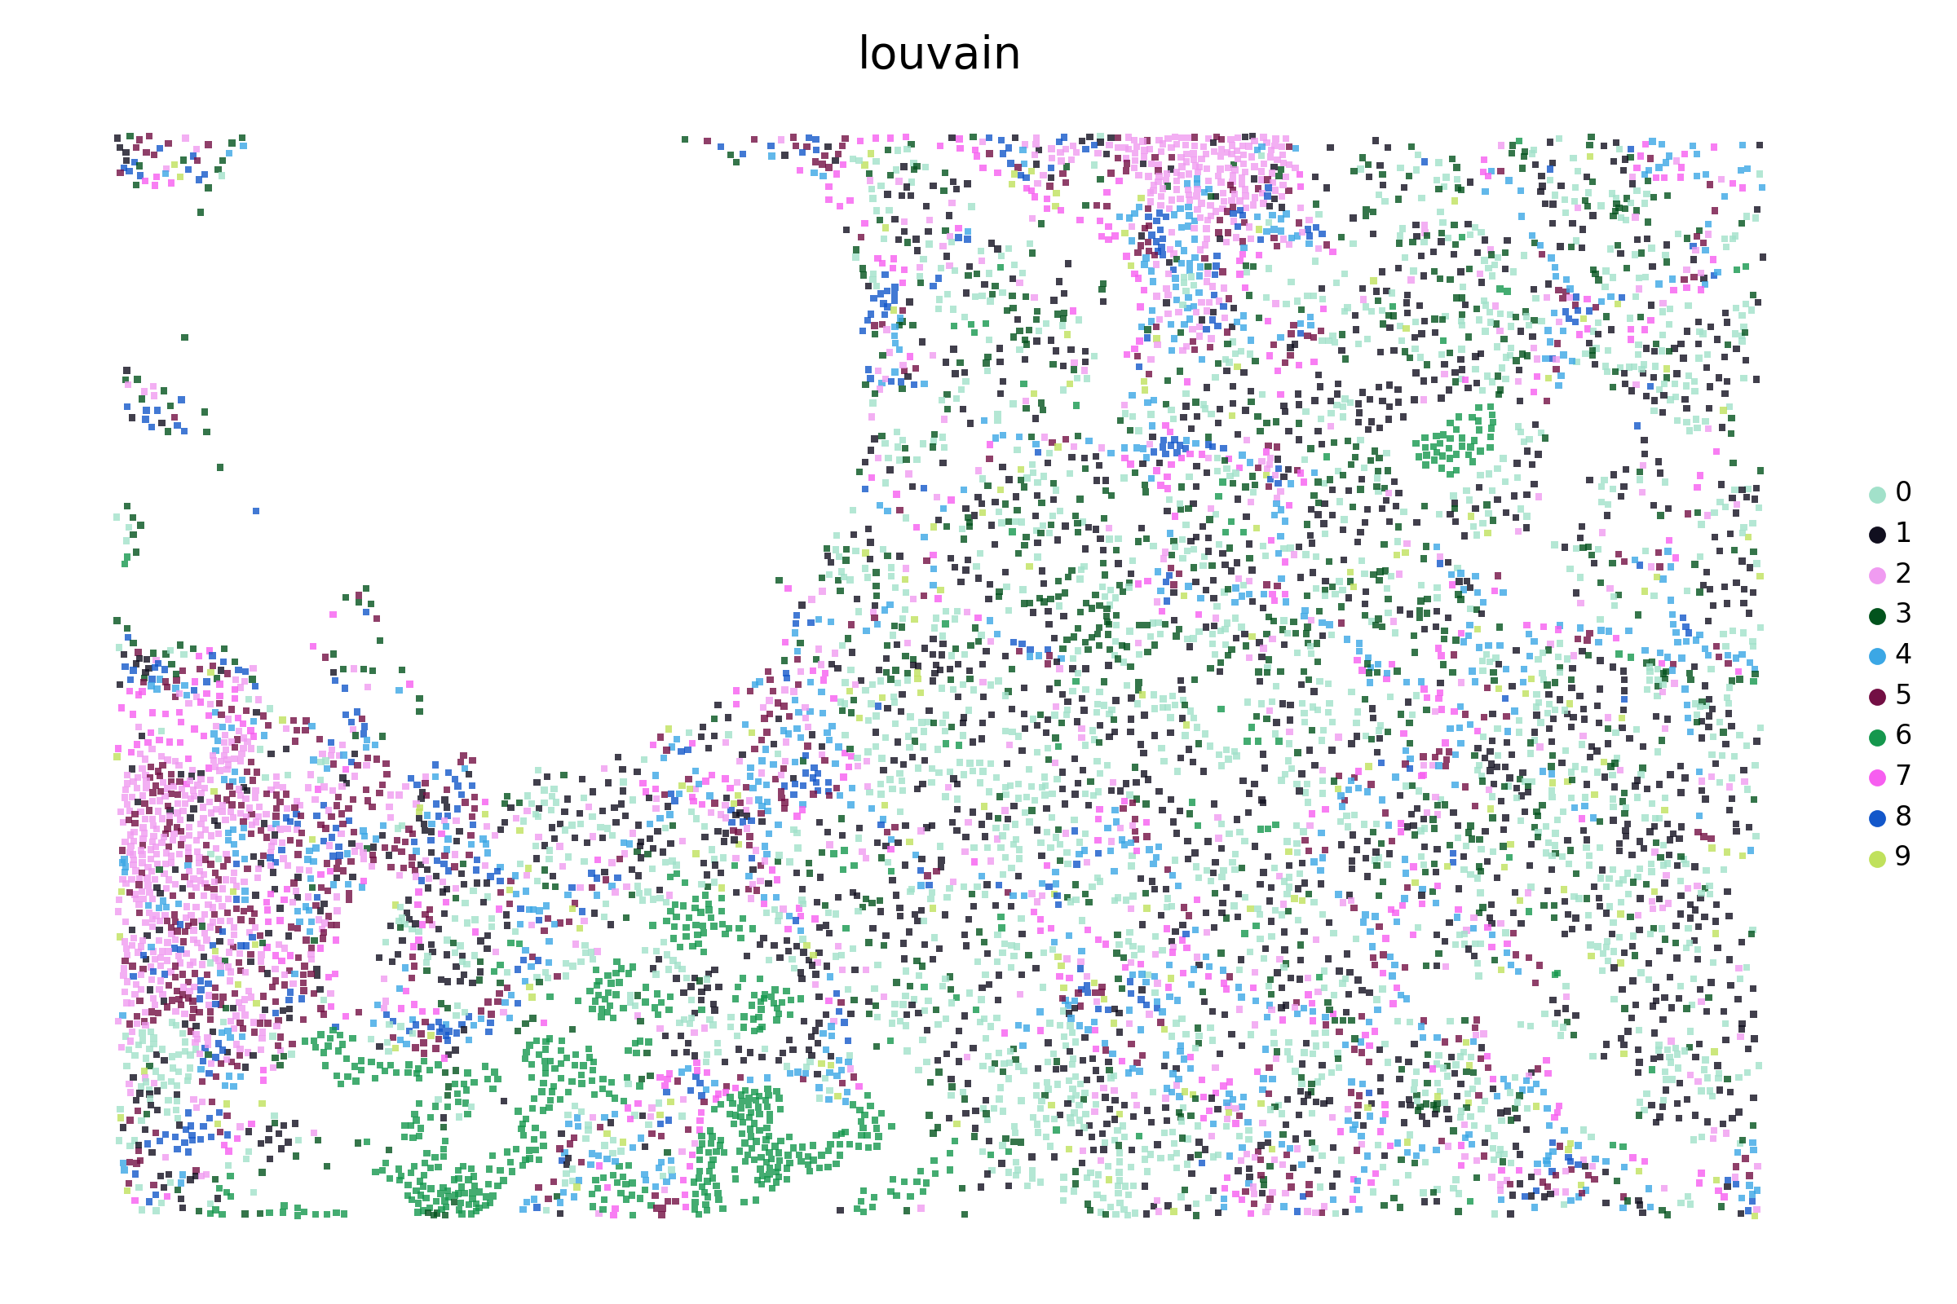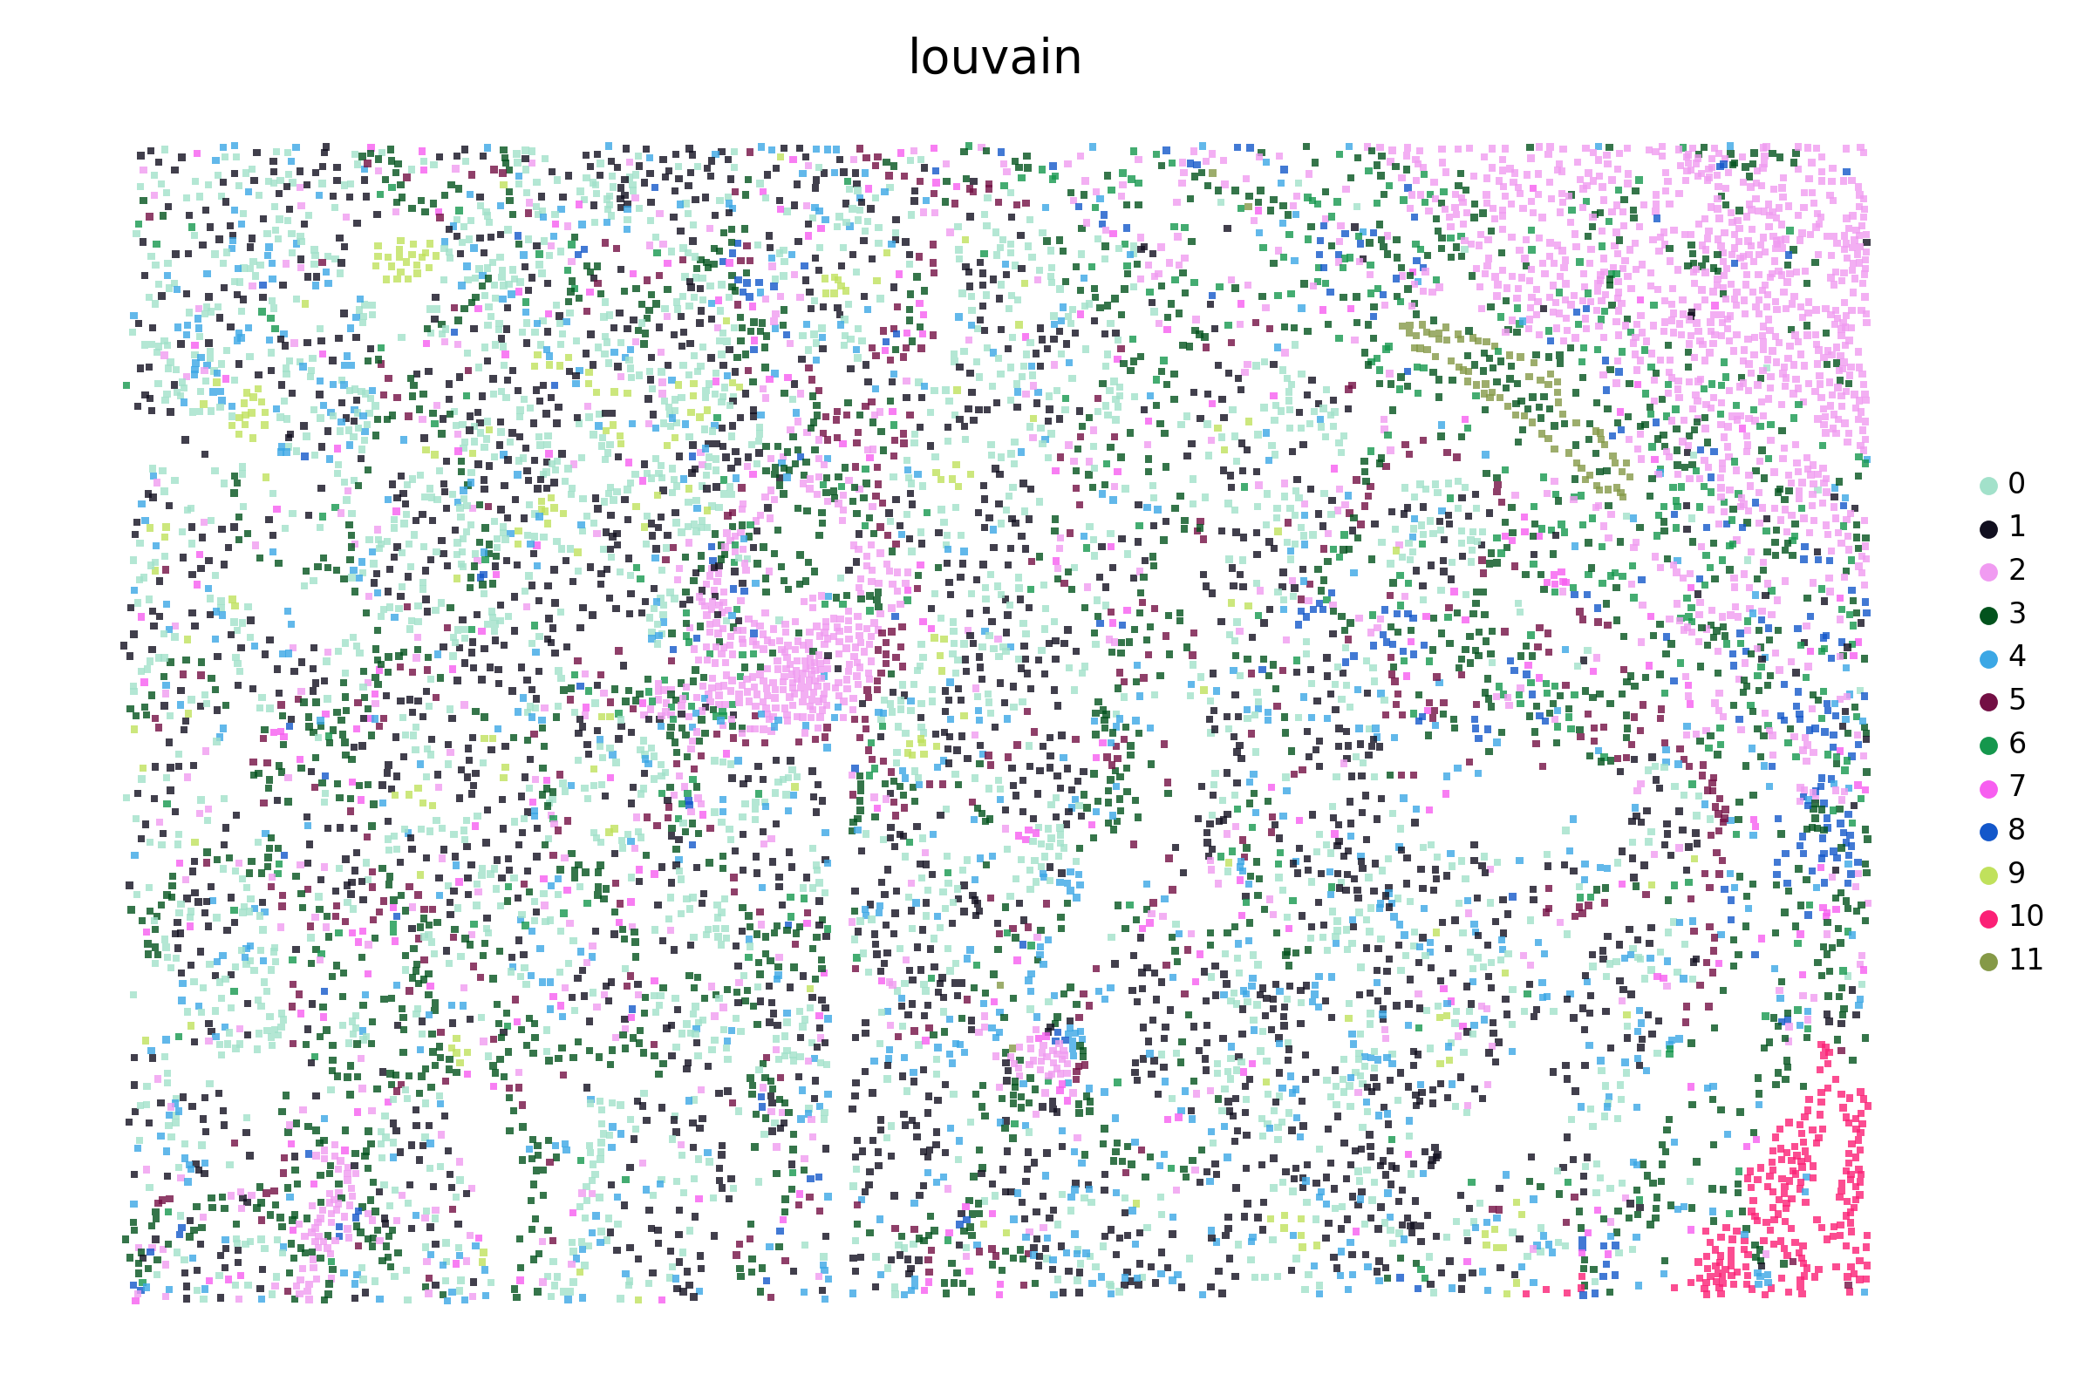
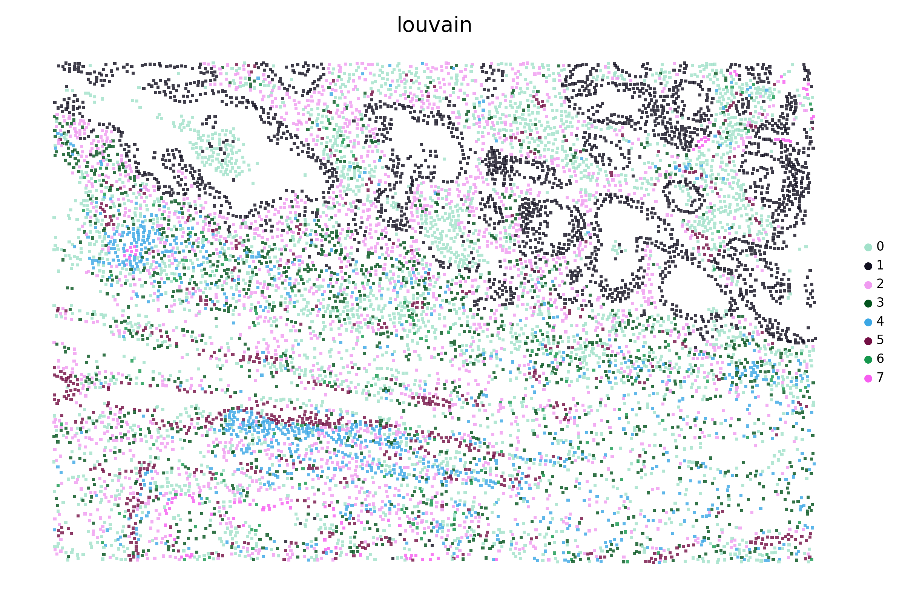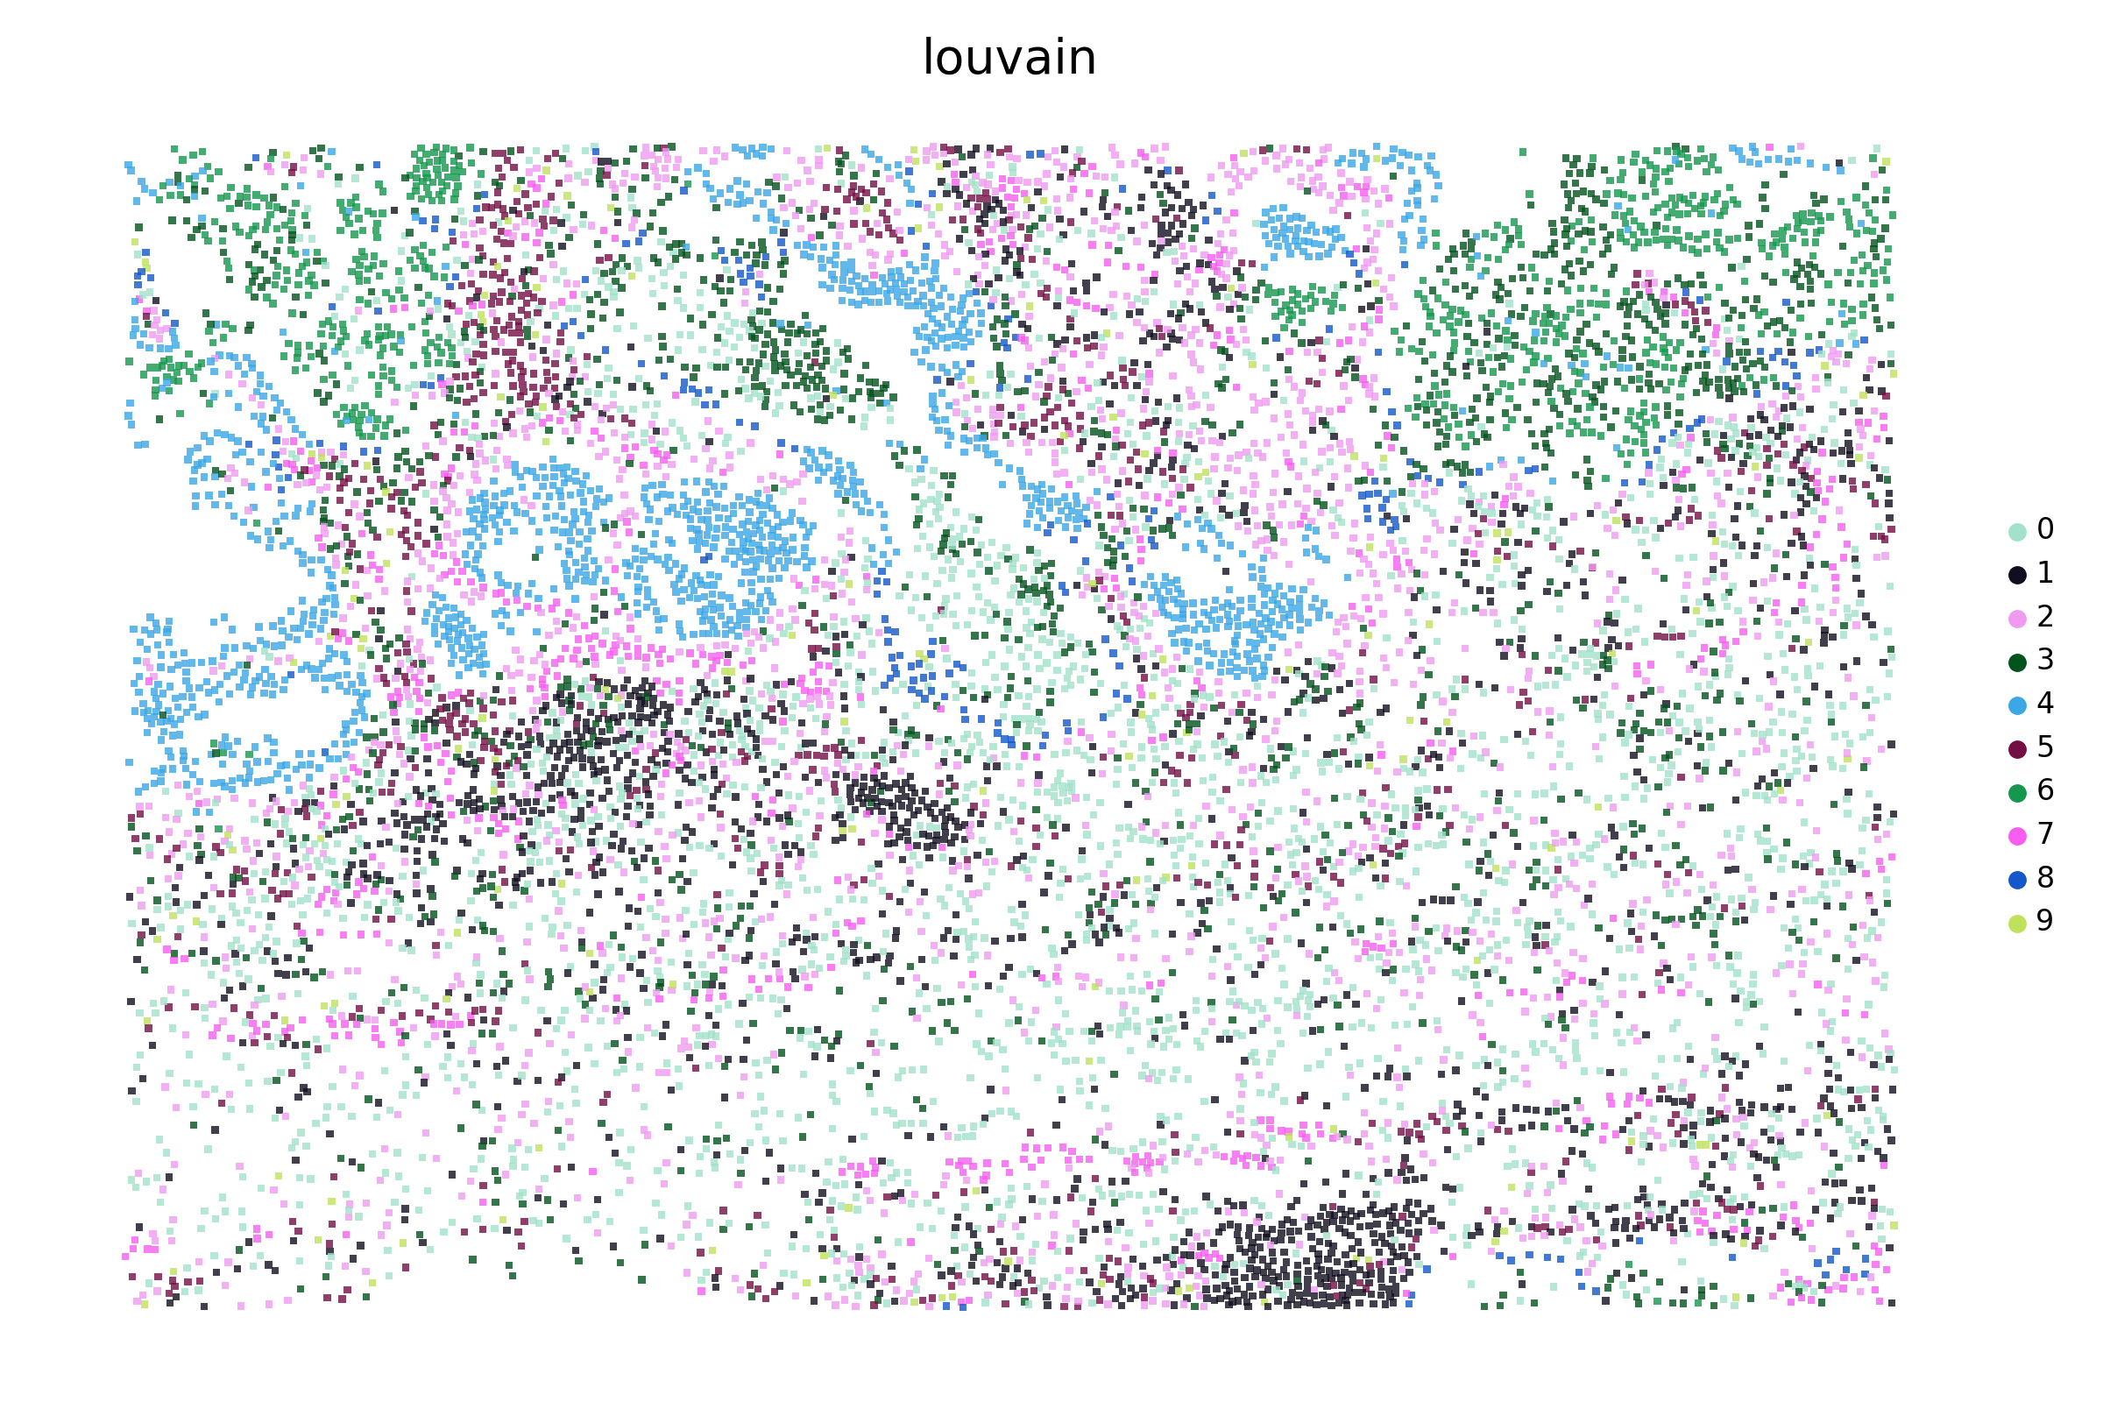
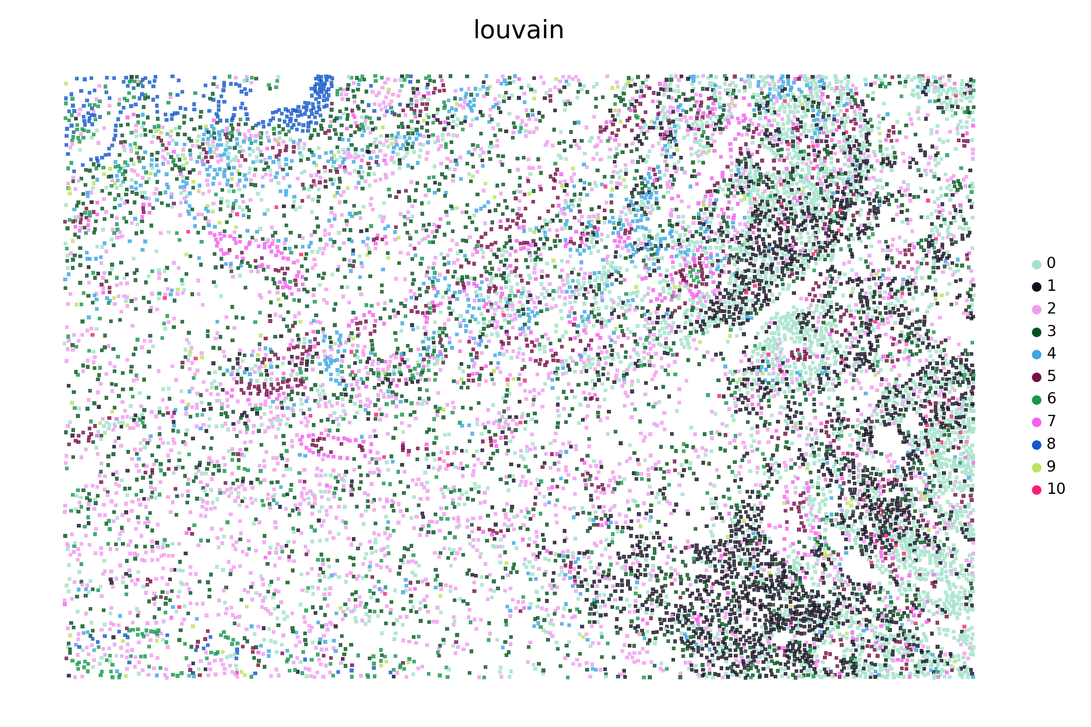
Supplementary Figure S7. Visualization of the SPICEiST clustering results compared to the cell-level, gene expression-based clustering in the CosMx SMI lung cancer dataset at a resolution of 0.6.
UMAP plots and the spatial distribution of cells illustrate the cell-level embedding and spatial distribution derived from SPICEiST-based analysis (integ; A: UMAP, B: spatial distribution of cells) and cell-level gene expression-based clustering (gex; C: UMAP, D: spatial distribution of cells), respectively. The tissue samples, obtained from patch numbers 0 to 8, are presented serially from left to right and top to bottom. The four numerical values at the top of the UMAP plot represent the ASW, CHI, DBI, and assortativity coefficient. Each dot in the plot corresponds to a cell, with color indicating the identity of the clusters.

