Supporting Information
- Supporting Figures

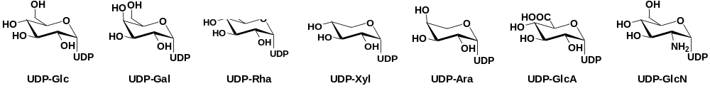
Fig. S1 Sugar donors used in this study.

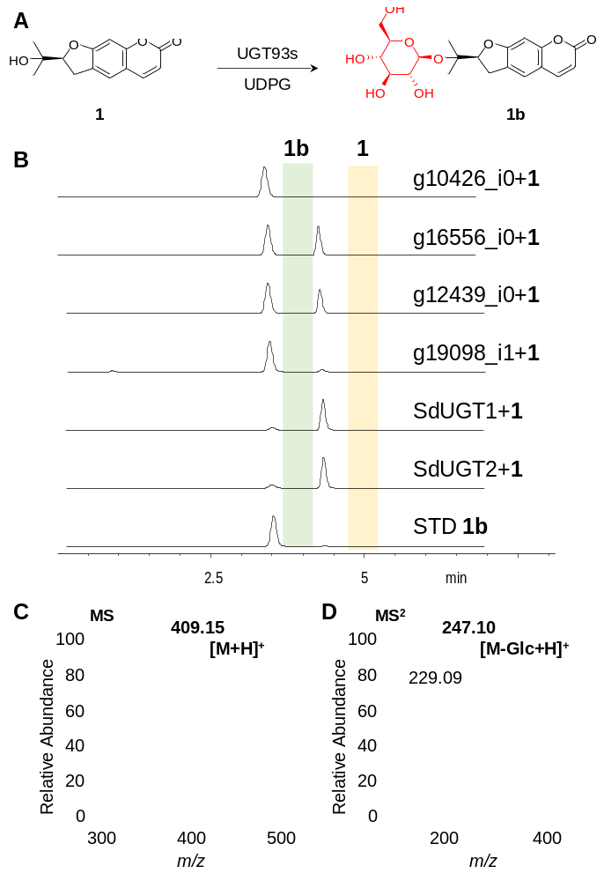
Fig. S2 Catalytic activities of UGT93s toward 1. Shown are the reaction catalyzed by UGT93s (A), the HPLC/UV spectra of the reaction mixture (B, λ=350 nm), as well as the MS (C) and MS/MS (D) spectra of the product 1b.

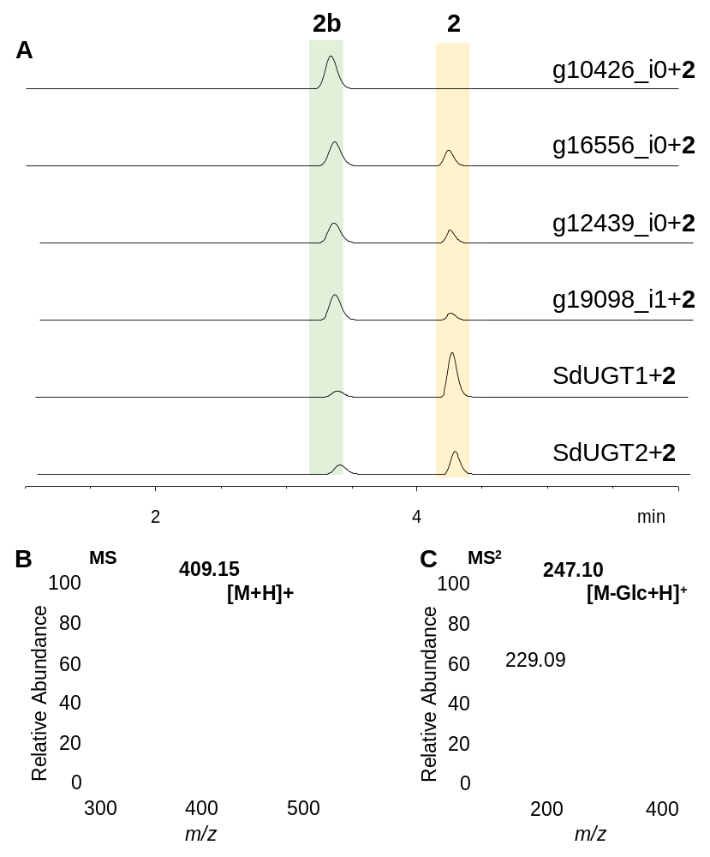
Fig. S3 Catalytic activities of UGT93s toward 2. Shown are the HPLC/UV spectra of the reaction mixture (A, λ=350 nm), as well as the MS (B) and MS/MS (C) spectra of the product 2b.

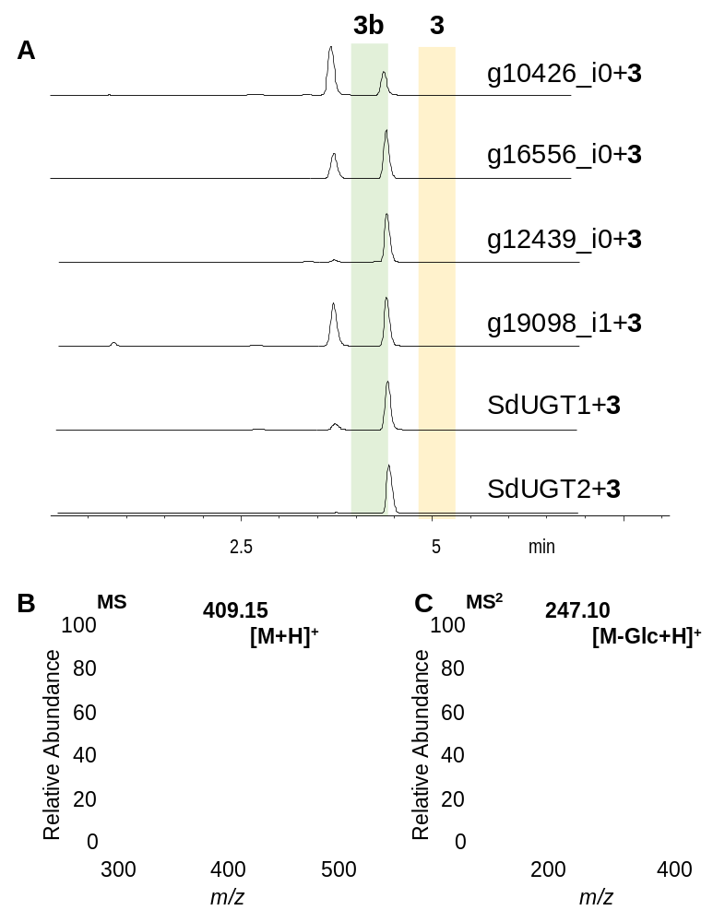
Fig. S4 Catalytic activities of UGT93s toward 3. Shown are the HPLC/UV spectra of the reaction mixture (A, λ=350 nm), as well as the MS (B) and MS/MS (C) spectra of the product 3b.

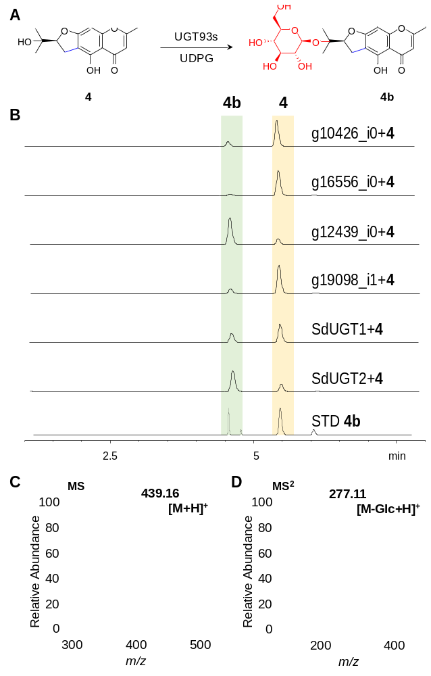
Fig. S5 Catalytic activities of UGT93s toward 4. Shown are the reaction catalyzed by UGT93s (A), the HPLC/UV spectra of the reaction mixture (B, λ=254 nm), as well as the MS (C) and MS/MS (D) spectra of the product 4b.

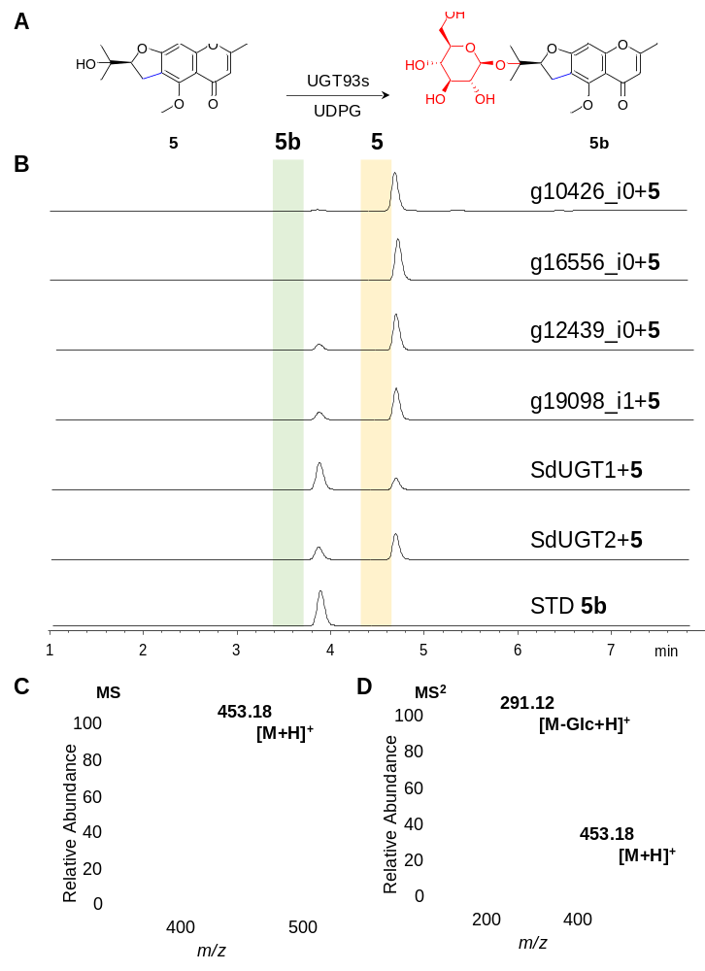
Fig. S6 Catalytic activities of UGT93s toward 5. Shown are the reaction catalyzed by UGT93s (A), the HPLC/UV spectra of the reaction mixture (B, λ=300 nm), as well as the MS (C) and MS/MS (D) spectra of the product 5b.

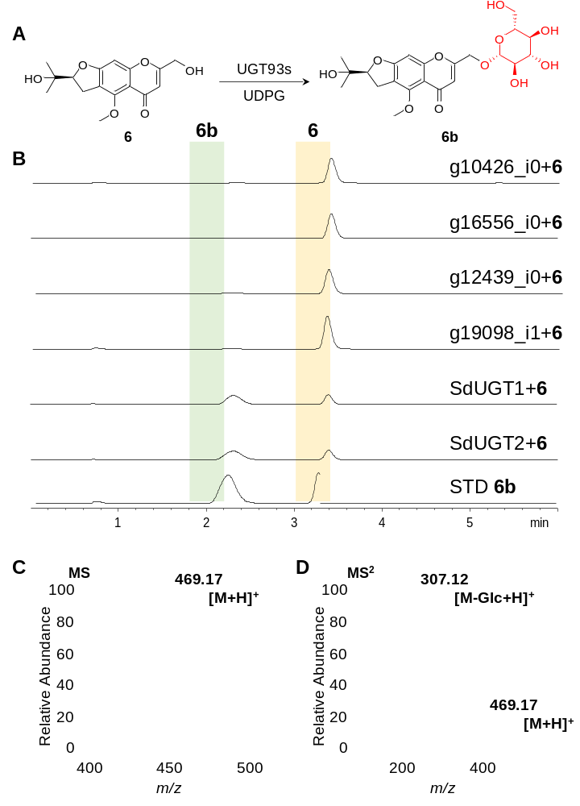
Fig. S7 Catalytic activities of UGT93s toward 6. Shown are the reaction catalyzed by UGT93s (A), the HPLC/UV spectra of the reaction mixture (B, λ=300 nm), as well as the MS (C) and MS/MS (D) spectra of the product 6b.

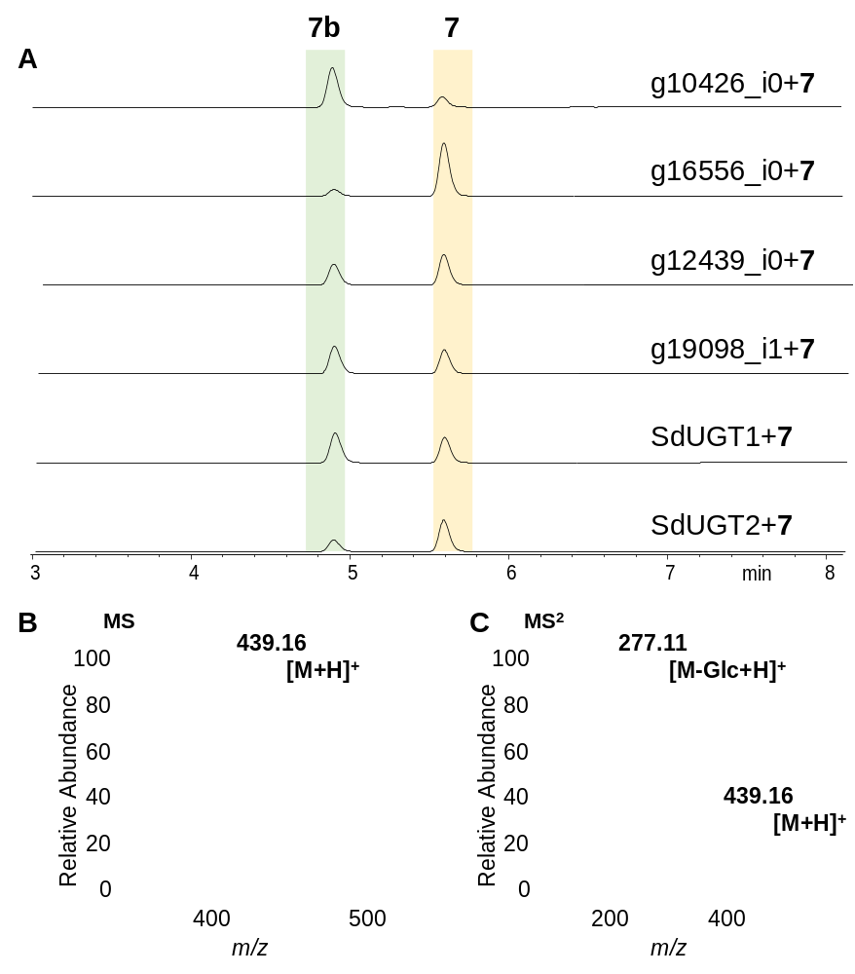
Fig. S8 Catalytic activities of UGT93s toward 7. Shown are the HPLC/UV spectra of the reaction mixture (A, λ=300 nm), as well as the MS (B) and MS/MS (C) spectra of the product 7b.

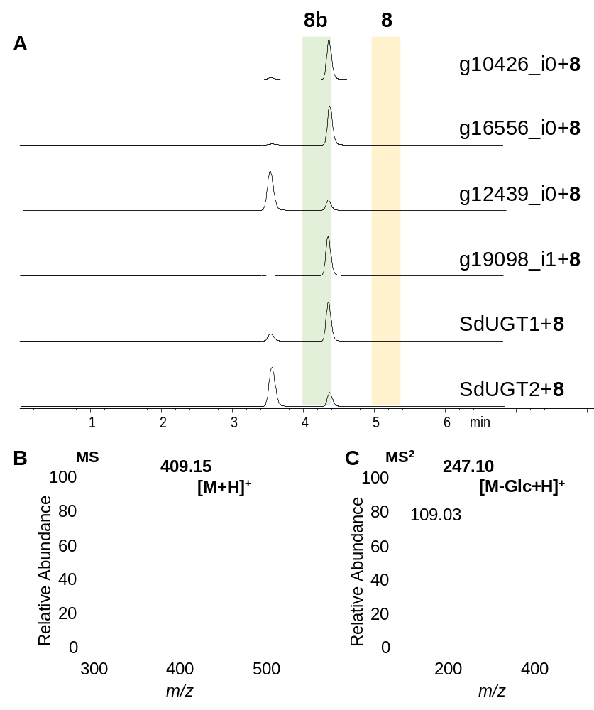
Fig. S9 Catalytic activities of UGT93s toward 8. Shown are the HPLC/UV spectra of the reaction mixture (A, λ=350 nm), as well as the MS (B) and MS/MS (C) spectra of the product 8b.

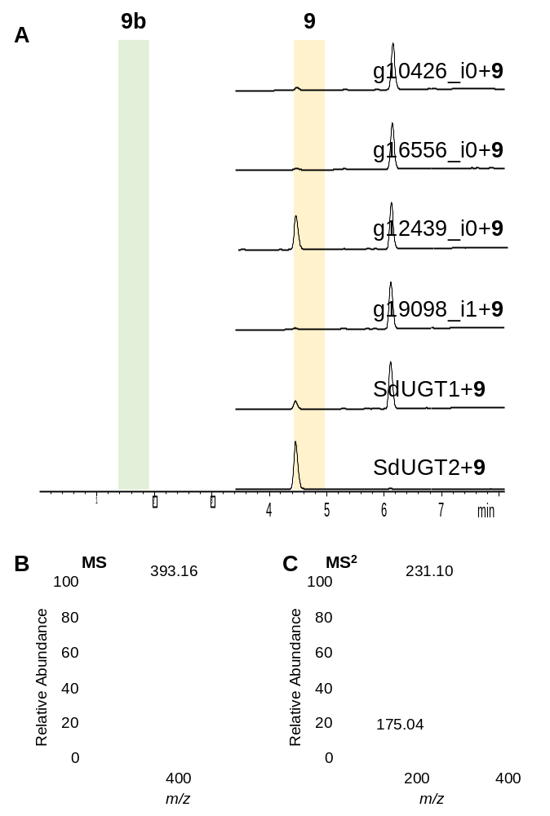
Fig. S10 Catalytic activities of UGT93s toward 9. Shown are the HPLC/UV spectra of the reaction mixture (A, λ=300 nm), as well as the MS (B) and MS/MS (C) spectra of the product 9b.

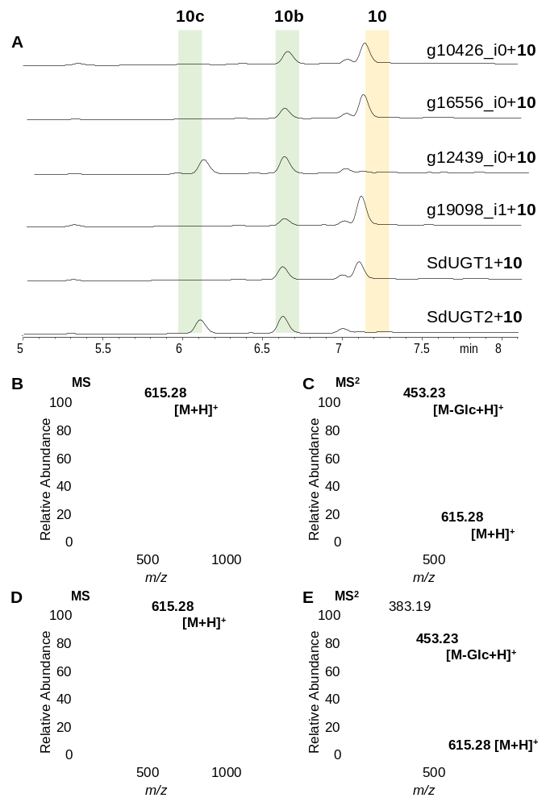
Fig. S11 Catalytic activities of UGT93s toward 10. Shown are the HPLC/UV spectra of the reaction mixture (A, λ=280 nm), as well as the MS (B, D) and MS/MS (C, E) spectra of the product 10b and 10c.

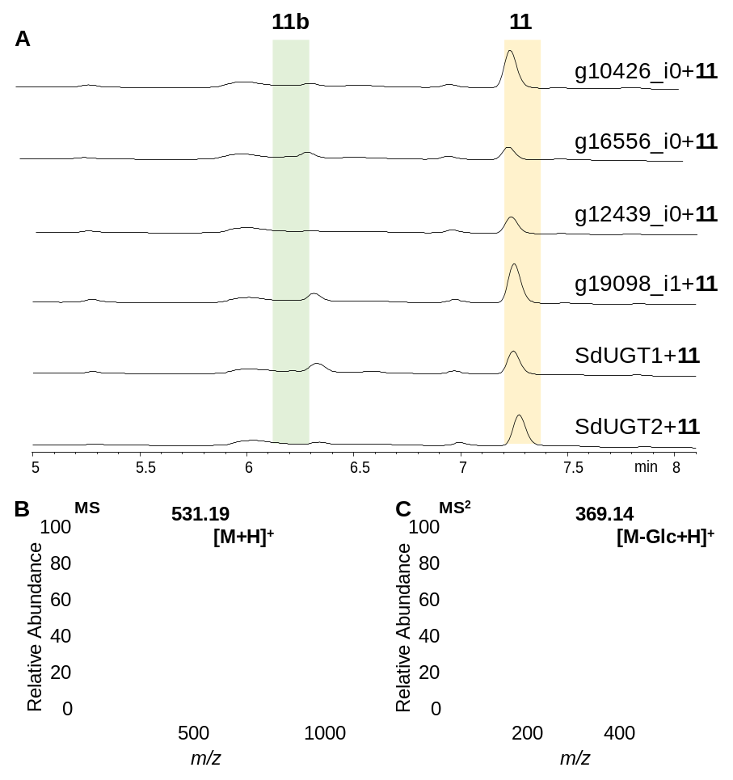
Fig. S12 Catalytic activities of UGT93s toward 11. Shown are the HPLC/UV spectra of the reaction mixture (A, λ=254 nm), as well as the MS (B) and MS/MS (C) spectra of the product 11b.

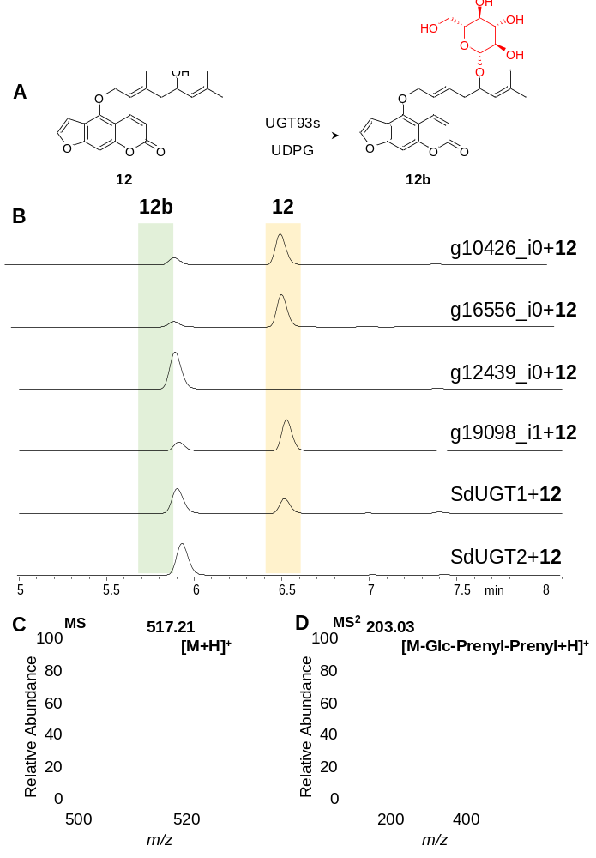
Fig. S13 Catalytic activities of UGT93s toward 12. Shown are the reaction catalyzed by UGT93s (A), the HPLC/UV spectra of the reaction mixture (B, λ=300 nm), as well as the MS (C) and MS/MS (D) spectra of the product 12b.

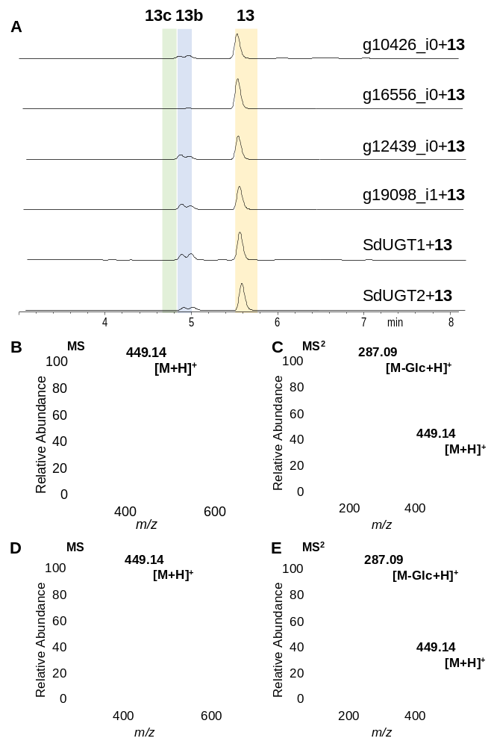
Fig. S14 Catalytic activities of UGT93s toward 13. Shown are the HPLC/UV spectra of the reaction mixture (A, λ=300 nm), as well as the MS (B, D) and MS/MS (C, E) spectra of the product 13b and 13c.

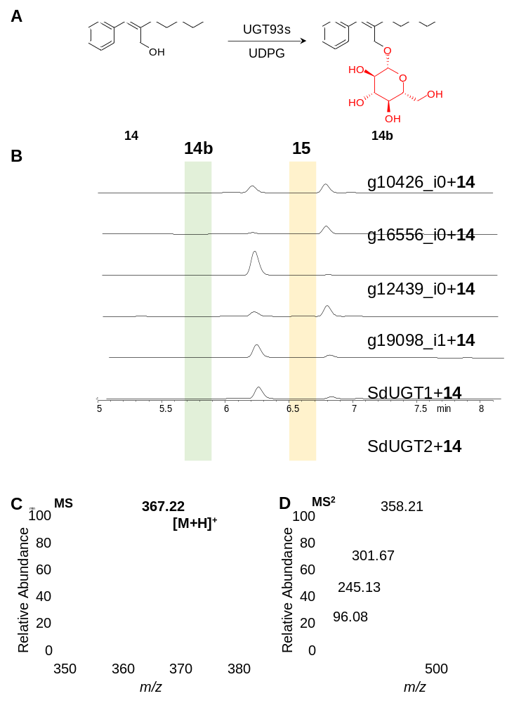
Fig. S15 Catalytic activities of UGT93s toward 14. Shown are the reaction catalyzed by UGT93s (A), the HPLC/UV spectra of the reaction mixture (B, λ=280 nm), as well as the MS (C) and MS/MS (D) spectra of the product 14b.

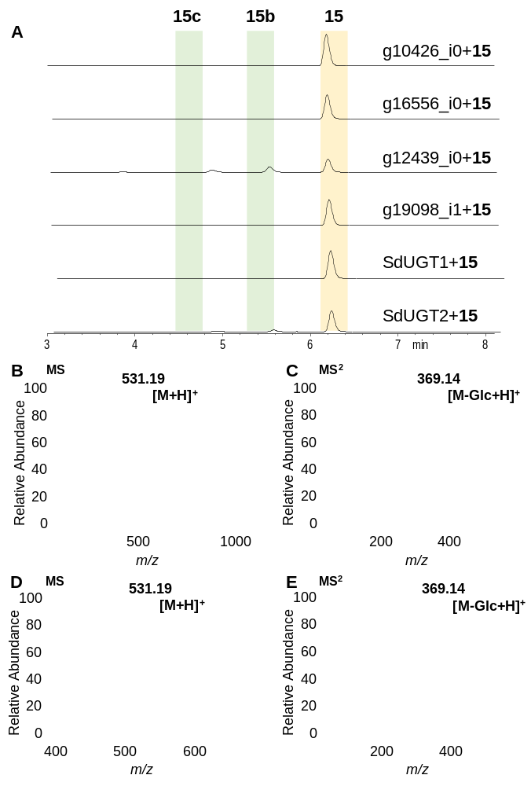
Fig. S16 Catalytic activities of UGT93s toward 15. Shown are the HPLC/UV spectra of the reaction mixture (A, λ=280 nm), as well as the MS (B, D) and MS/MS (C, E) spectra of the product 15b and 15c.

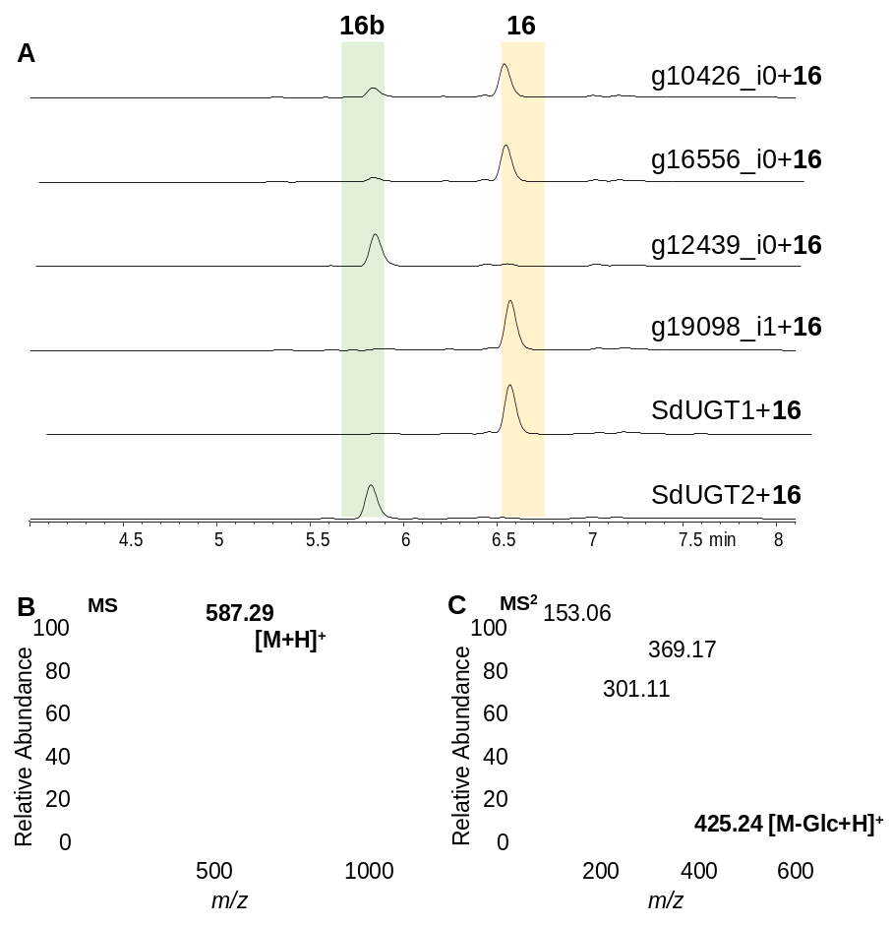
Fig. S17 Catalytic activities of UGT93s toward 16. Shown are the HPLC/UV spectra of the reaction mixture (A, λ=300 nm), as well as the MS (B) and MS/MS (C) spectra of the product 16b.

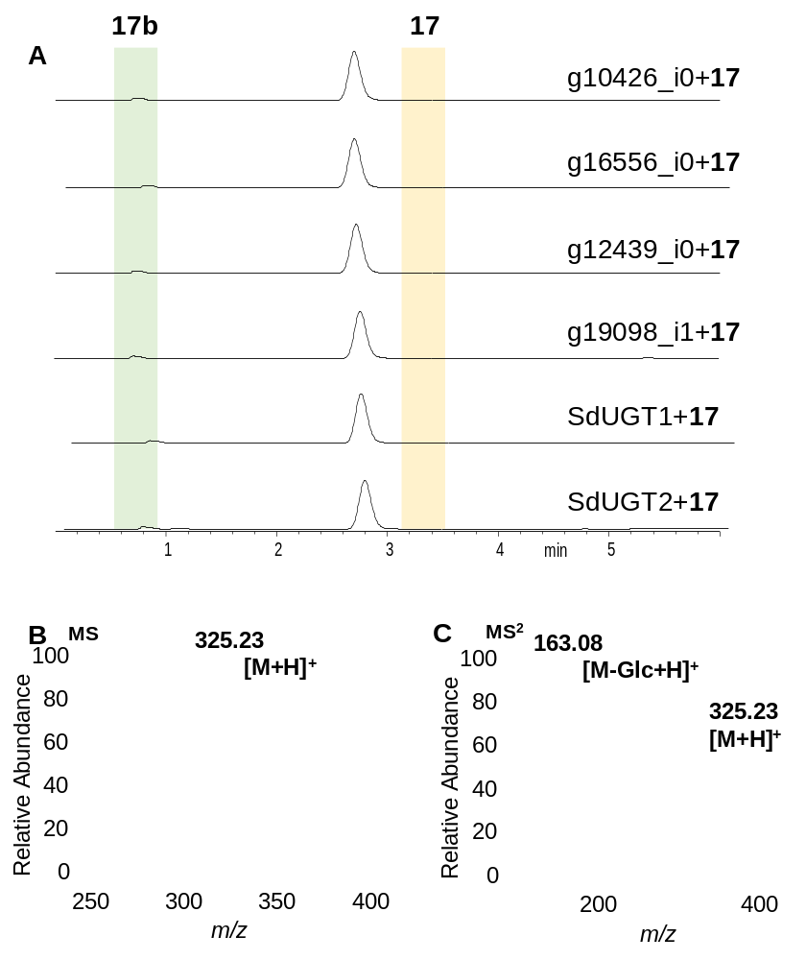
Fig. S18 Catalytic activities of UGT93s toward 17. Shown are the HPLC/UV spectra of the reaction mixture (A, λ=300 nm), as well as the MS (B) and MS/MS (C) spectra of the product 17b.

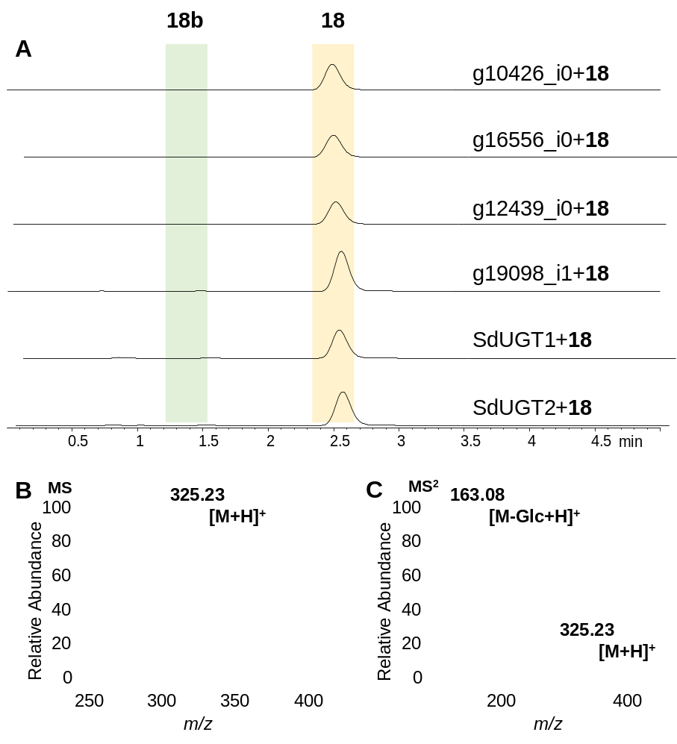
Fig. S19 Catalytic activities of UGT93s toward 18. Shown are the HPLC/UV spectra of the reaction mixture (A, λ=300 nm), as well as the MS (B) and MS/MS (C) spectra of the product 18b.

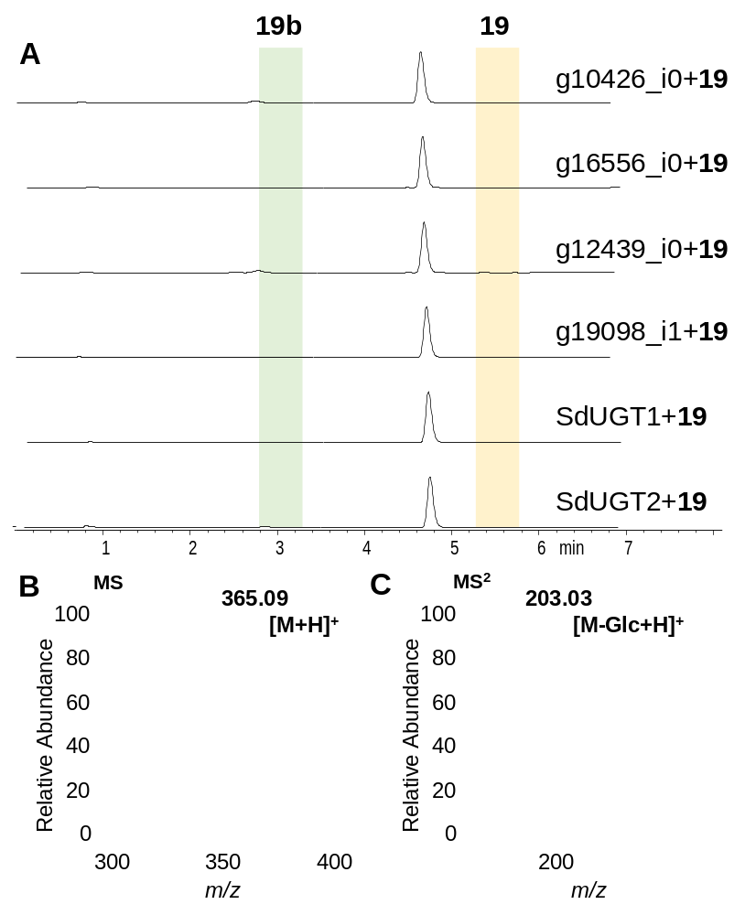
Fig. S20 Catalytic activities of UGT93s toward 19. Shown are the HPLC/UV spectra of the reaction mixture (A, λ=300 nm), as well as the MS (B) and MS/MS (C) spectra of the product 19b.

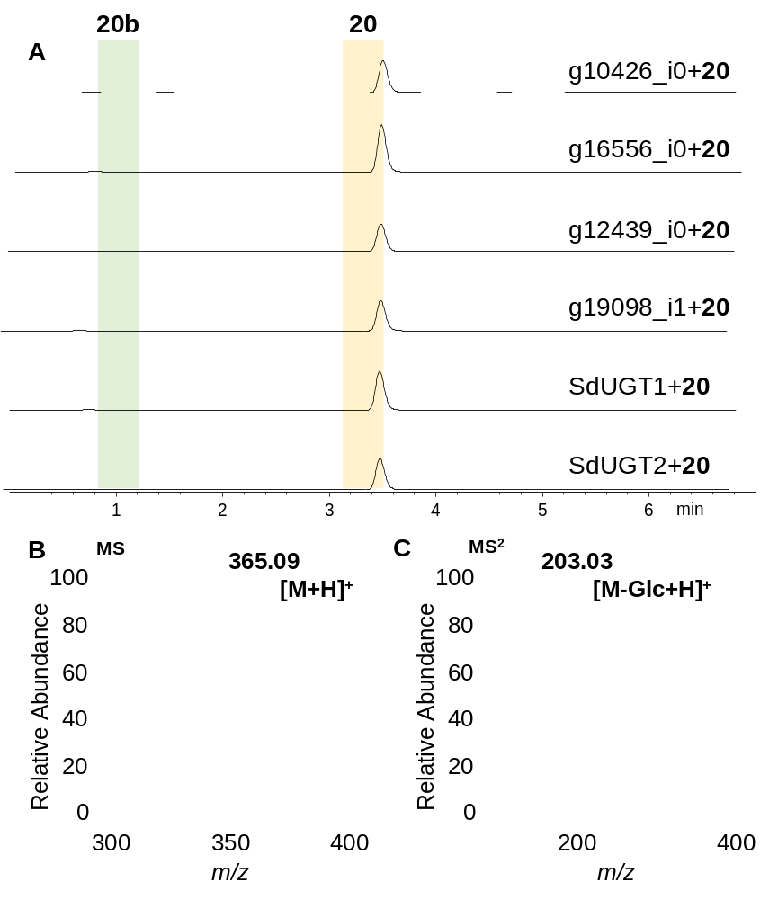
Fig. S21 Catalytic activities of UGT93s toward 20. Shown are the HPLC/UV spectra of the reaction mixture (A, λ=300 nm), as well as the MS (B) and MS/MS (C) spectra of the product 20b.

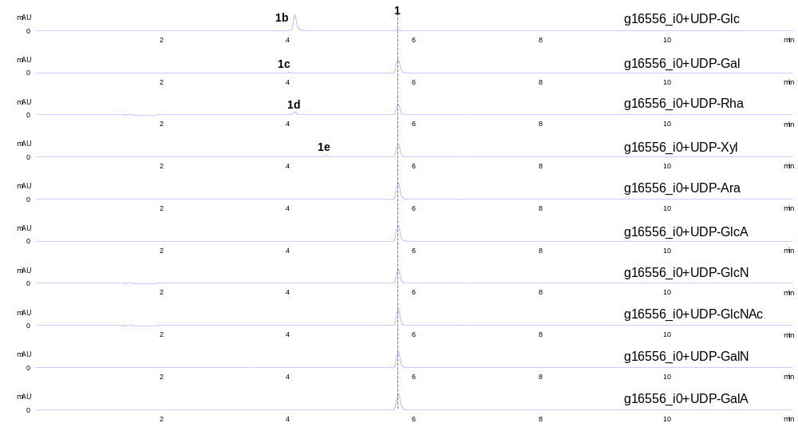
Fig. S22 Catalytic activities of g16556_i0 utilizing different sugar donors. Shown are the HPLC/UV spectra of the reaction mixtures (λ=350 nm).

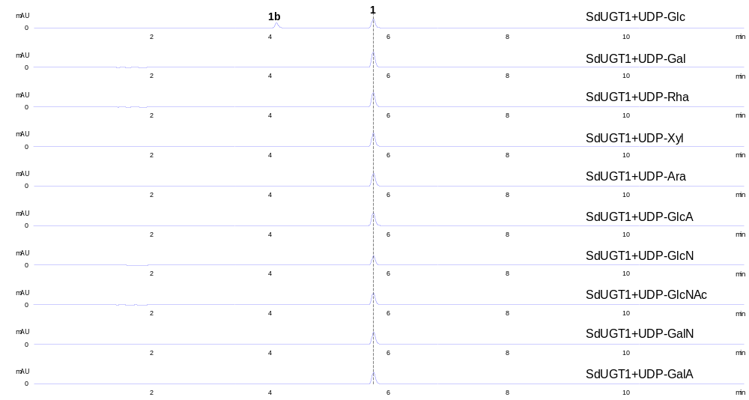
Fig. S23 Catalytic activities of SdUGT1 utilizing different sugar donors. Shown are the HPLC/UV spectra of the reaction mixtures (λ=350 nm).

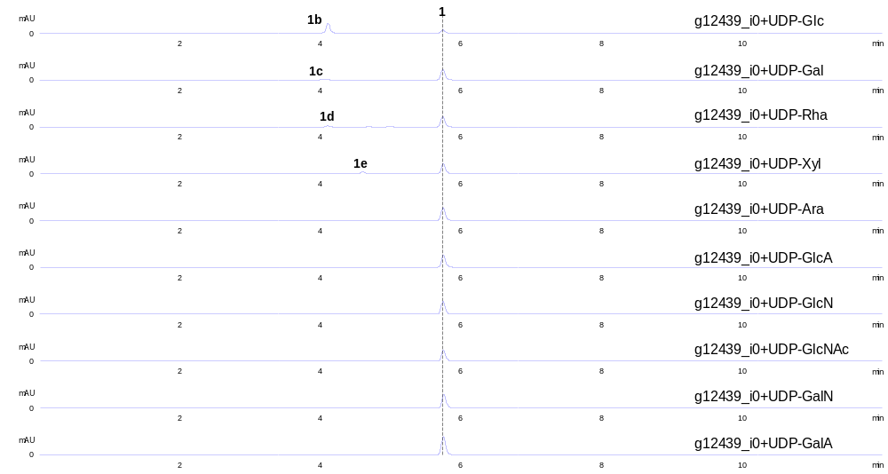
Fig. S24 Catalytic activities of g12439_i0 utilizing different sugar donors. Shown are the HPLC/UV spectra of the reaction mixtures (λ=350 nm).

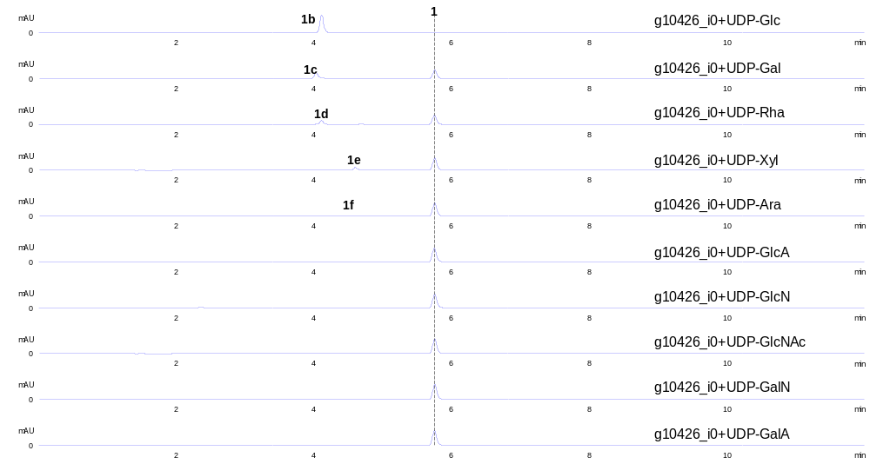
Fig. S25 Catalytic activities of g10426_i0 utilizing different sugar donors. Shown are the HPLC/UV spectra of the reaction mixtures (λ=350 nm).

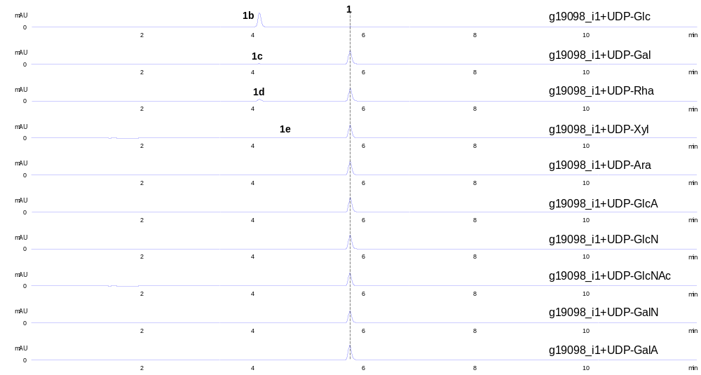
Fig. S26 Catalytic activities of g19098_i1 utilizing different sugar donors. Shown are the HPLC/UV spectra of the reaction mixtures (λ=350 nm).

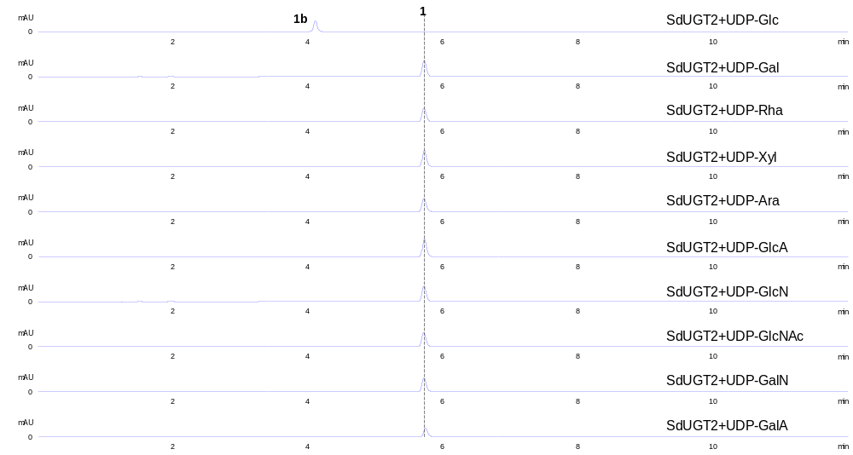
Fig. S27 Catalytic activities of SdUGT2 utilizing different sugar donors. Shown are the HPLC/UV spectra of the reaction mixtures (λ=350 nm).

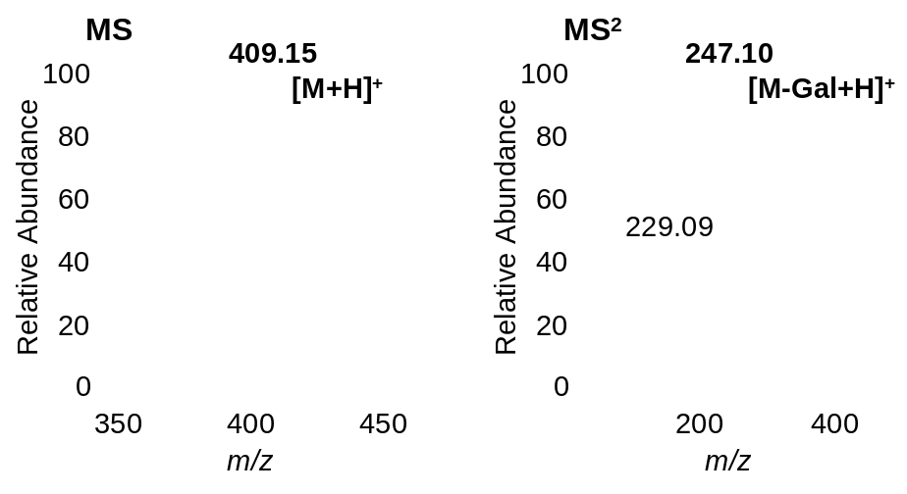
Fig. S28 MS spectra and MS/MS spectra of product 1c.

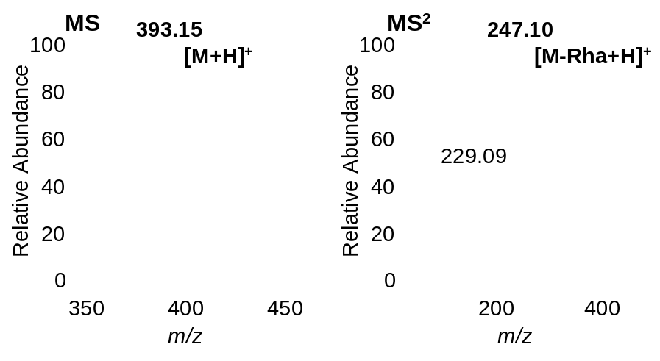
Fig. S29 MS spectra and MS/MS spectra of product 1d.

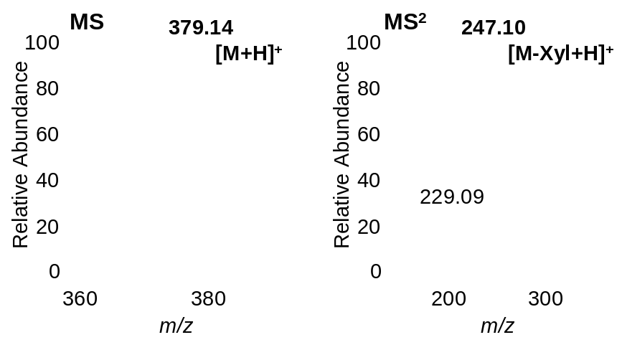
Fig. S30 MS spectra and MS/MS spectra of product 1e.

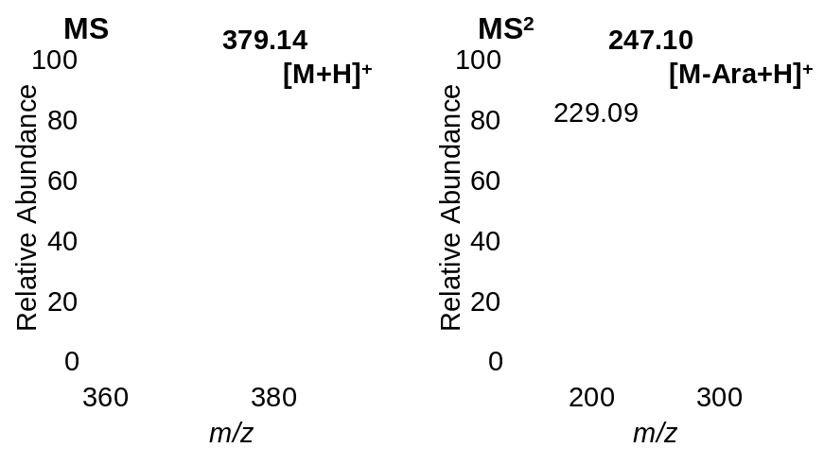
Fig. S31 MS spectra and MS/MS spectra of product 1f.

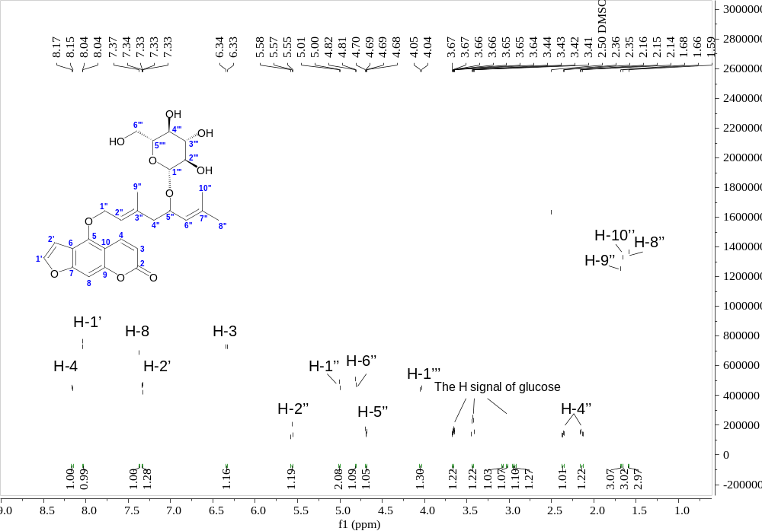
Fig. S32 ¹H NMR spectrum of 12b in DMSO-d₆ (600 MHz).

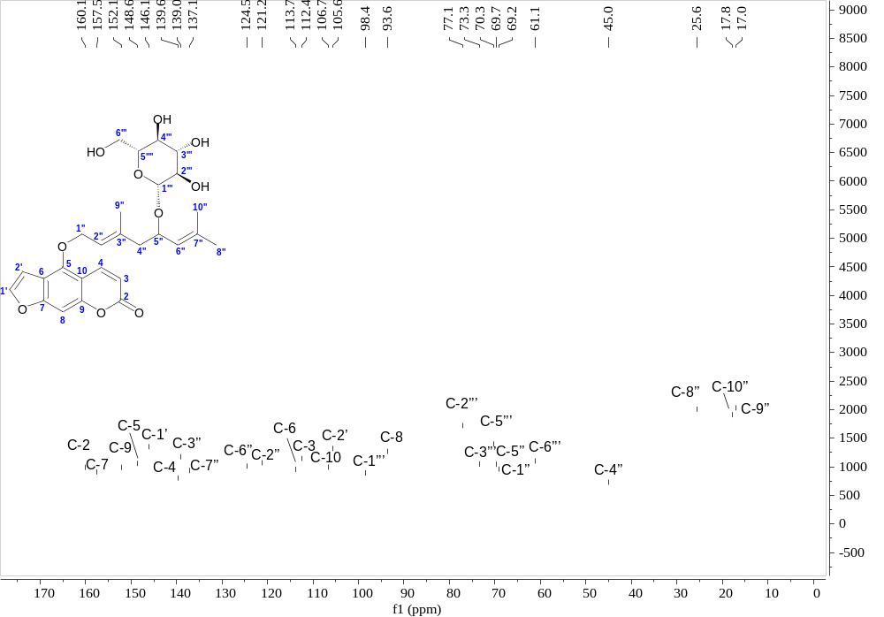
Fig. S33 ¹³C NMR spectrum of 12b in DMSO-d₆ (150 MHz).

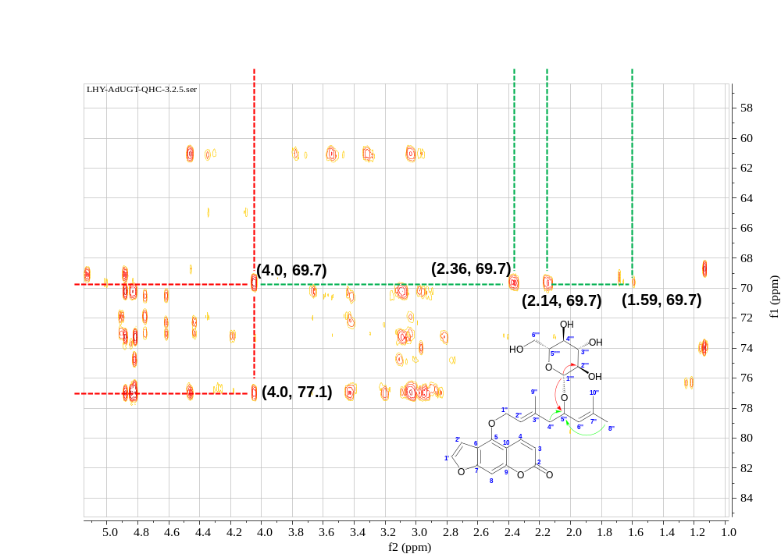
Fig. S34 HMBC spectrum of 12b in DMSO-d₆ (600 MHz).

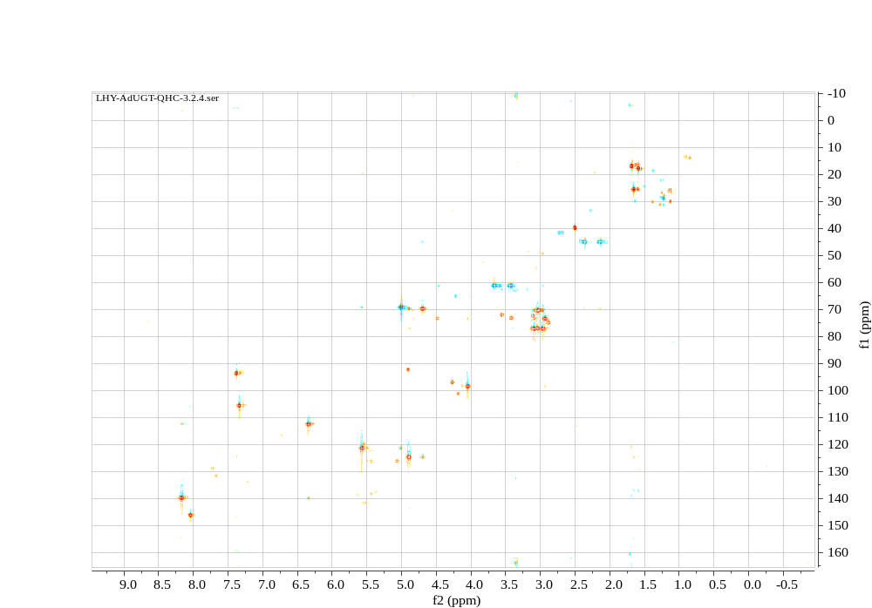
Fig. S35 HSQC spectrum of 12b in DMSO-d₆ (600 MHz).

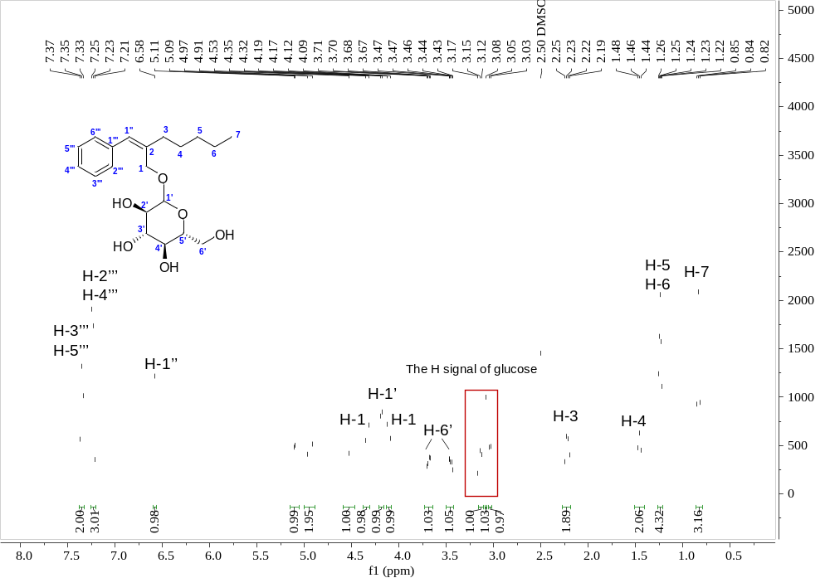
Fig. S36 ¹H NMR spectrum of 14b in DMSO-d₆ (400 MHz).

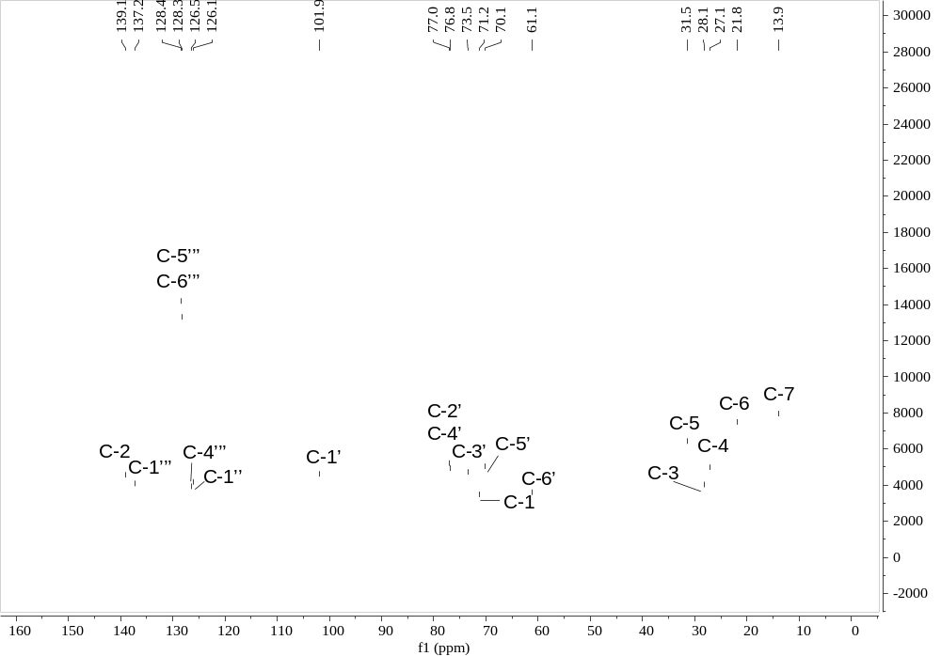
Fig. S37 ¹³C NMR spectrum of 14b in DMSO-d₆ (100 MHz).

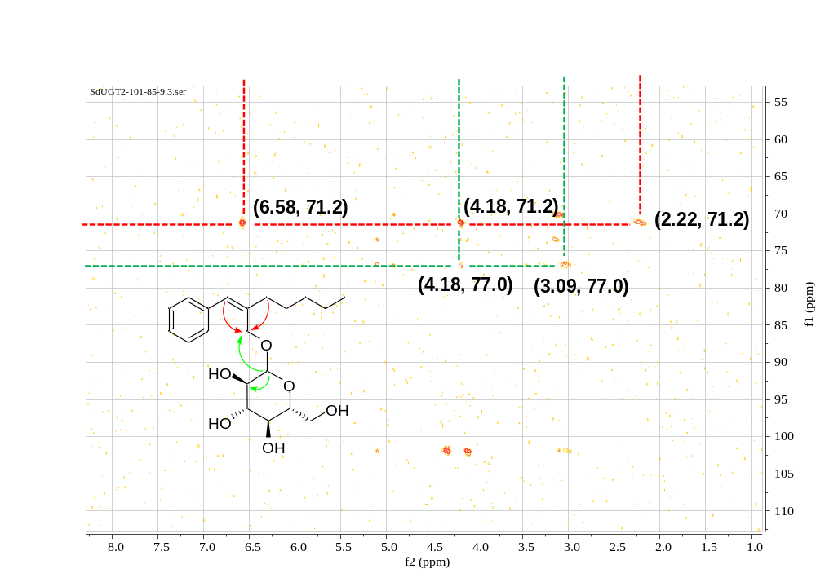
Fig. S38 HMBC spectrum of 14b in DMSO-d₆ (400 MHz).

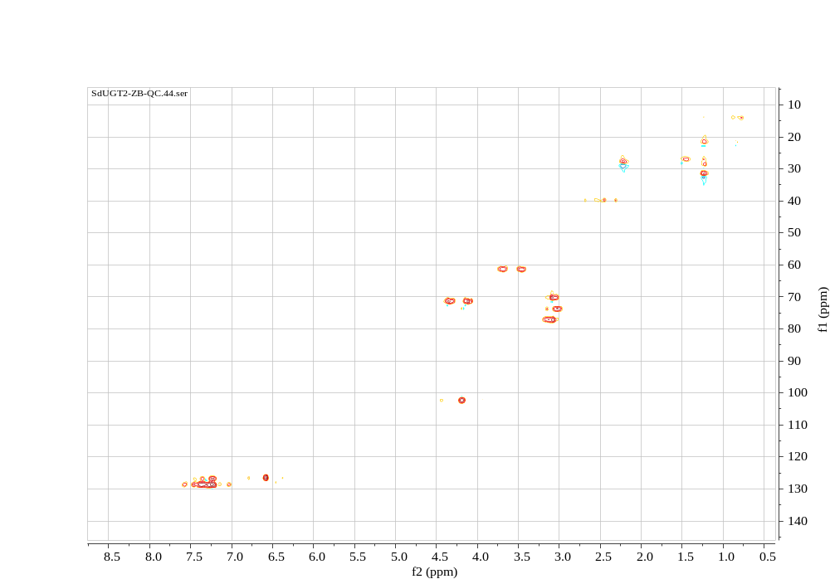
Fig. S39 HSQC spectrum of 14b in DMSO-d₆ (400 MHz).

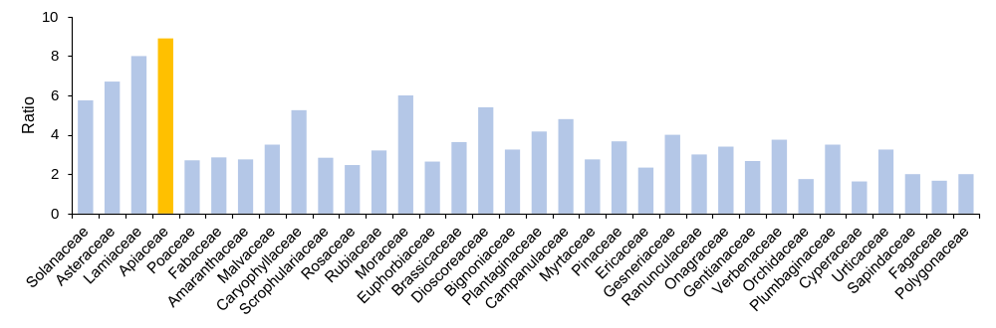
Fig. S40 Distribution of UGT93s in different families. Ratios of UGT93 gene counts to numbers of species in each plant family are shown.

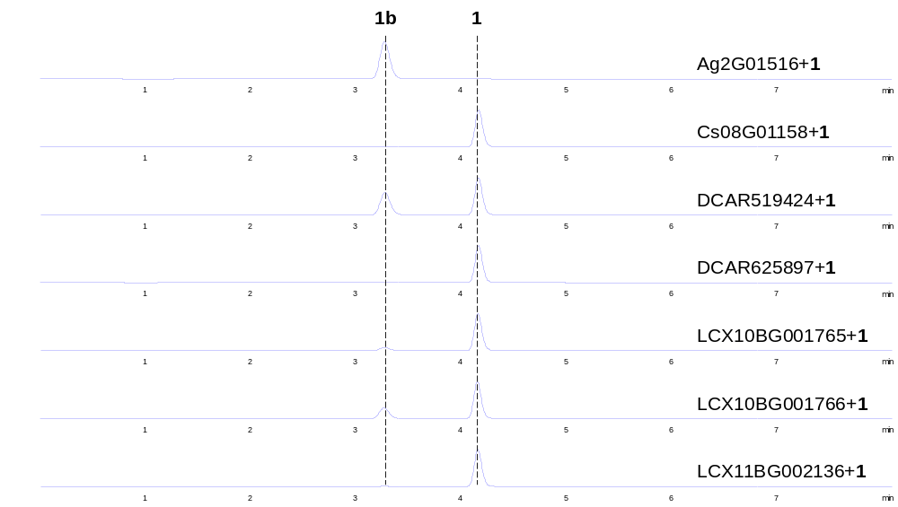
Fig. S41 Catalytic activities of tested UGT93s in Apium graveolens, Coriandrum sativum, Daucus carota and Ligusticum sinense 'Chuanxiong' toward 1. Shown are the HPLC/UV spectra of the reaction mixtures (λ=350 nm).

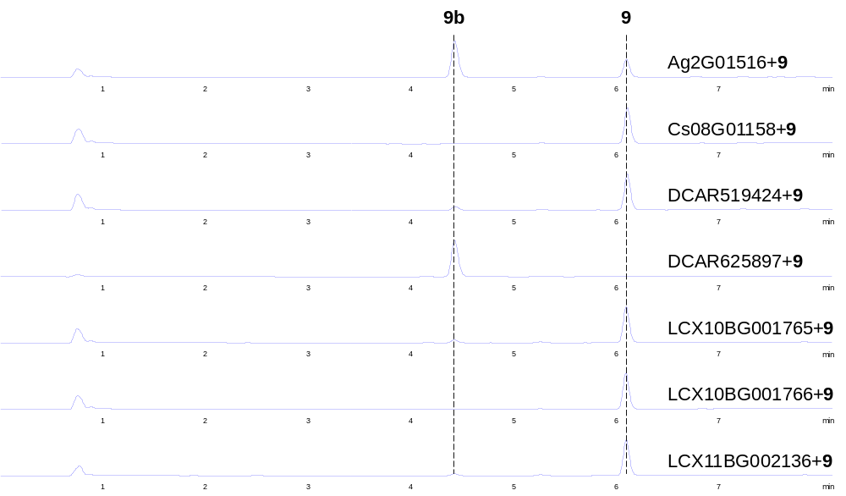
Fig. S42 Catalytic activities of tested UGT93s in Apium graveolens, Coriandrum sativum, Daucus carota and Ligusticum sinense 'Chuanxiong' toward 9. Shown are the HPLC/UV spectra of the reaction mixtures (λ=300 nm).

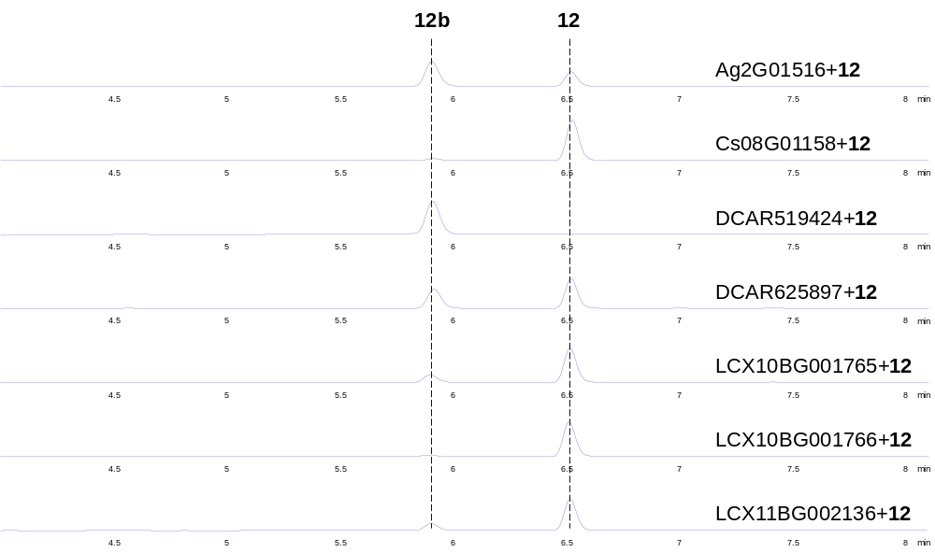
Fig. S43 Catalytic activities of tested UGT93s in Apium graveolens, Coriandrum sativum, Daucus carota and Ligusticum sinense 'Chuanxiong' toward 12. Shown are the HPLC/UV spectra of the reaction mixtures (λ=300 nm).

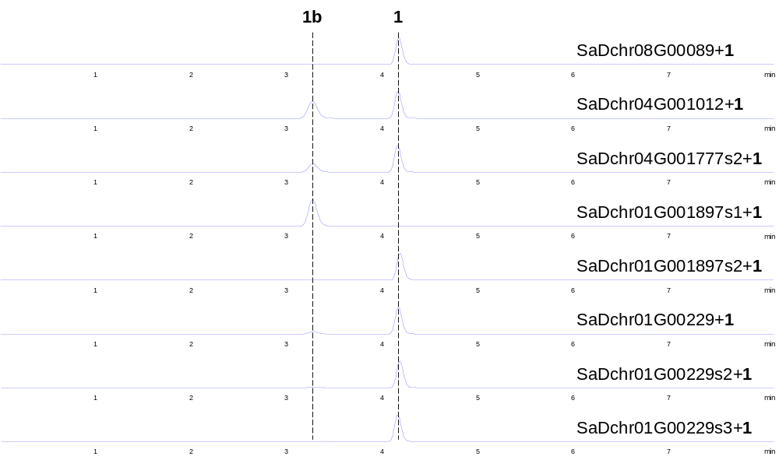
Fig. S44 Catalytic activities of tested UGT93s in Saposhnikovia divaricata toward 1. Shown are the HPLC/UV spectra of the reaction mixtures (λ=350 nm).

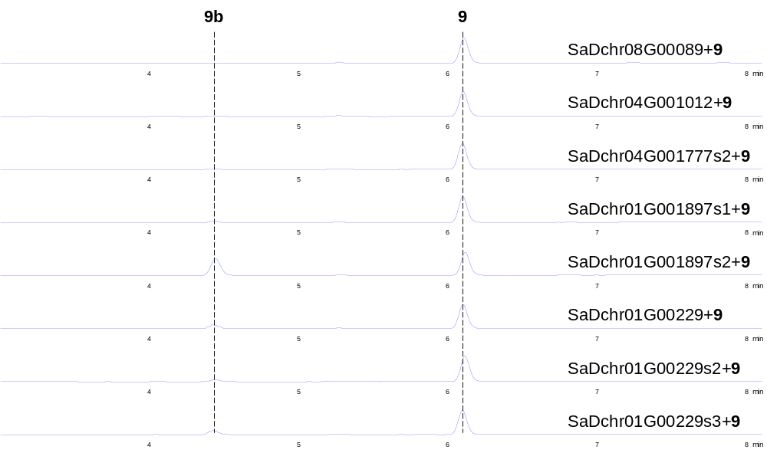
Fig. S45 Catalytic activities of tested UGT93s in Saposhnikovia divaricata toward 9. Shown are the HPLC/UV spectra of the reaction mixtures (λ=300 nm).

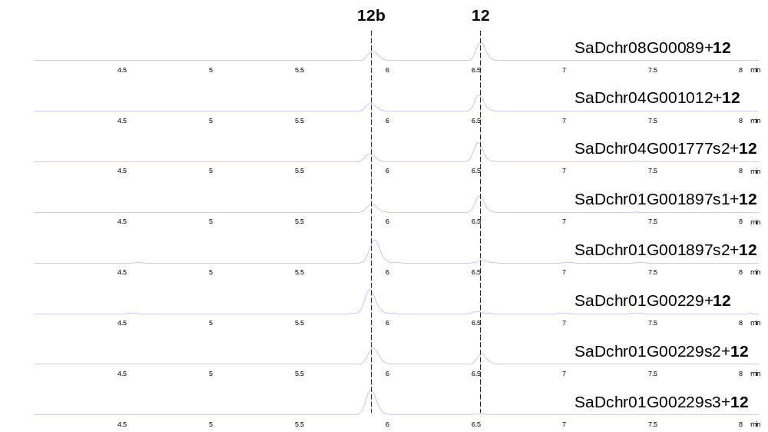
Fig. S46 Catalytic activities of tested UGT93s in Saposhnikovia divaricata toward 12. Shown are the HPLC/UV spectra of the reaction mixtures (λ=300 nm).

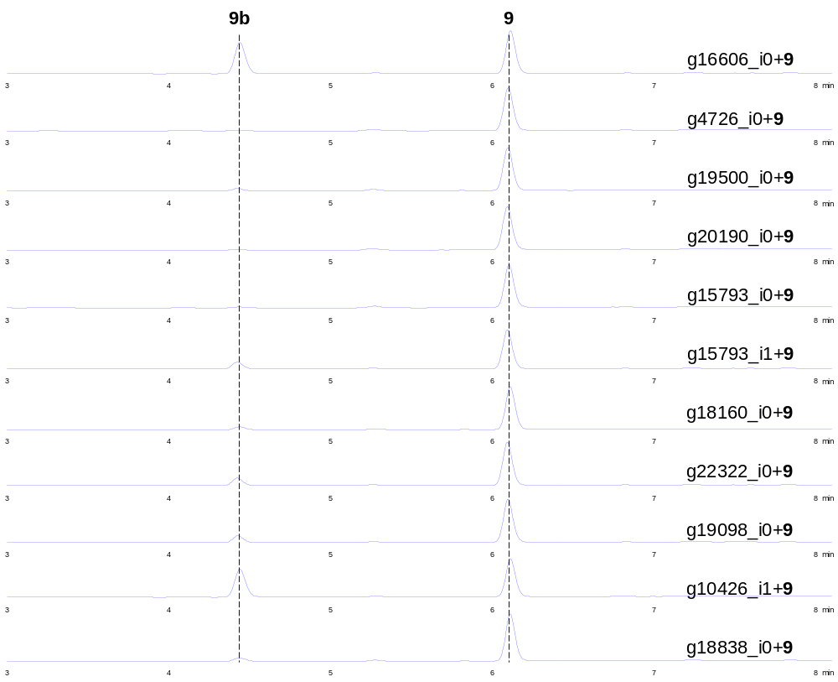
Fig. S47 Catalytic activities of tested UGT93s in Angelica decursiva toward 9. Shown are the HPLC/UV spectra of the reaction mixtures (λ=300 nm).

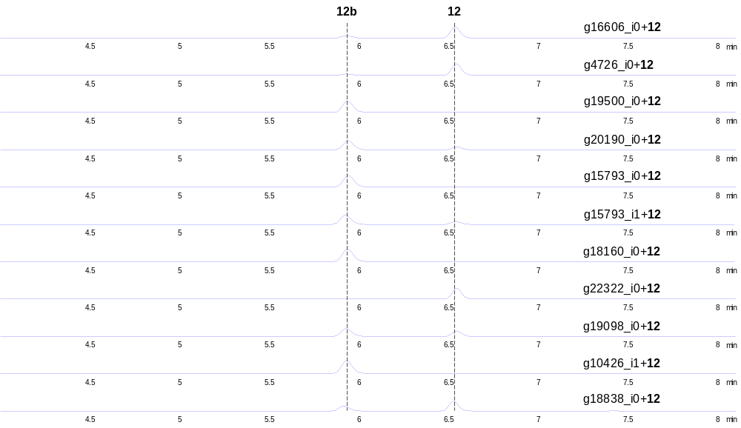
Fig. S48 Catalytic activities of tested UGT93s in Angelica decursiva toward 12. Shown are the HPLC/UV spectra of the reaction mixtures (λ=300 nm).

- Supporting Table
Table S1 PCR primers used in this study
Primer | Sequence (5' to 3')
g18838_i0-F | cagcaaatgggtcgcggatccATGGCAGCCTACAAAAGCAGTG
g18838_i0-R | tgcggccgcaagcttggatccCTAGCGTGTTATGTGCGAGAGAA
g20190_i0-F | cagcaaatgggtcgcggatccATGGCGAAAGACTCTCAAGTATGTG
g20190_i0-R | tgcggccgcaagcttggatccTCATCTAGTAATGTGTGCAACAAACG
g16606_i0-F | cagcaaatgggtcgcggatccATGGCAGAGGATAAACAAGTAGCA
g16606_i0-R | tgcggccgcaagcttggatccTTATTCTCTAGTAATGTGATCAATAAATGAATC
g22322_i0-F | cagcaaatgggtcgcggatccATGTCTAGCAATCATTCCCAAATTAT
g22322_i0-R | tgcggccgcaagcttggatccTTATCTAGAAATGTGAGCTACGAAAGAA
g19500_i0-F | cagcaaatgggtcgcggatccATGGCTAGTCATGATGAAGCAACA
g19500_i0-R | tgcggccgcaagcttggatccCTATCTACGAATGTGAGCAATGAAATC
g18160_i0-F | cagcaaatgggtcgcggatccATGGGTGTGCAAGAAATGCAA
g18160_i0-R | tgcggccgcaagcttggatccCTACCTACATACGTGAGCGATGAAA
g12439_i0-F | cagcaaatgggtcgcggatccATGGGTCTGCAAGCAACTGAA
g12439_i0-R | tgcggccgcaagcttggatccTTACCTACATATATGAGCGATGAAATCA
g4726_i0-F | cagcaaatgggtcgcggatccATGAGCGACGGCAAGGATG
g4726_i0-R | tgcggccgcaagcttggatccTTATCTTCGTATGTGAGCAATGAAATC
g10426_i0-F | cagcaaatgggtcgcggatccATGGCAAAGGACACCCAAGTAA
g10426_i0-R | tgcggccgcaagcttggatccCTAGATCTGAAGATCTGAAGAGAGGAGT
g10426_i1-F | cagcaaatgggtcgcggatccATGGCAAAGGACACCCAAGTAA
g10426_i1-R | tgcggccgcaagcttggatccCTAATTTGATCTTGTAATATGATCGATAAAT
g15793_i0-F | cagcaaatgggtcgcggatccATGGCAAAGGACACCCAAGTAA
g15793_i0-R | tgcggccgcaagcttggatccCTAATTTGATCTTGTAATATGATCGATAAAT
g15793_i1-F | cagcaaatgggtcgcggatccATGGCAAAGGACACCCAAGTAA
g15793_i1-R | tgcggccgcaagcttggatccCTAATTTGATCTTGTAATATGATGGATAAAT
g16556_i0-F | cagcaaatgggtcgcggatccATGGCAAAGGACACCCAAGTAA
g16556_i0-R | tgcggccgcaagcttggatccCTAATTTGACGATCTTGTAATATGATCG
g19098_i0-F | cagcaaatgggtcgcggatccATGGCAAAGGACACCCAAGTAA
g19098_i0-R | tgcggccgcaagcttggatccTTAATTTGATCTTGTAATATGATCGATAAAC
g19098_i1-F | cagcaaatgggtcgcggatccATGGCAAAGGACACCCAAGTAA
g19098_i1-R | tgcggccgcaagcttggatccTTAATTTGATCTTGTAATATGATCGATAAAC
DCAR_625897-F | cagcaaatgggtcgcggatccATGGCTTCTCTTAATAATCACAACCA
DCAR_625897-R | tgcggccgcaagcttggatccTTAAATTCTACTAATGTGAGCGACGA
DCAR_519424-F | cagcaaatgggtcgcggatccATGGCACAAGATAGTCAAGTAACCG
DCAR_519424-R | tgcggccgcaagcttggatccCTAATTCAATCTCATAATATGATCGATAAAC
LCX11BG002136-F | cagcaaatgggtcgcggatccATGGCTTCTGAATCAAAGTCCC
LCX11BG002136-R | tgcggccgcaagcttggatccTTAAATCCTACTAATTTGAGCAATGAAC
LCX10BG001765-F | cagcaaatgggtcgcggatccATGGCAAAAGACACCCAAGTAAC
LCX10BG001765-R | tgcggccgcaagcttggatccCTAATTTGATCTTGTAATATGATTGATAAACG
LCX10BG001766-F | cagcaaatgggtcgcggatccATGGCAAAAGACACCCAAGTAAC
LCX10BG001766-R | tgcggccgcaagcttggatccCTAATCTGATCTTGTAATGTGATCGATAA
Cs08G01158-F | cagcaaatgggtcgcggatccATGGCAAAAGACACCCAAGTGA
Cs08G01158-R | tgcggccgcaagcttggatccCTAATTAGATCTTGTAATGTGATCAATAAACG
Ag2G01516-F | cagcaaatgggtcgcggatccATGGCAATGGACACCCAAGTC
Ag2G01516-R | tgcggccgcaagcttggatccCTAATTTGATCTTGTAATATGATCTATAAACG
SaDchr08G000892-F | cagcaaatgggtcgcggatccATGGCGGCTTCTTACAACGA
SaDchr08G000892-R | tgcggccgcaagcttggatccCTAGTTCAGCAGCAAGAGCTCCA
SaDchr04G001777s2-F | cagcaaatgggtcgcggatccATGTCTAGCAATCATTCCCAAATTAT
SaDchr04G001777s2-R | tgcggccgcaagcttggatccTTATCTAGAAATGTGAGCTACAAAAGAATC
SaDchr01G001897s1-F | cagcaaatgggtcgcggatccATGGCGAAAGACTCTCAAGTATGTG
SaDchr01G001897s1-R | tgcggccgcaagcttggatccTCATCTAGTAATGTGTGCAACAAACG
SaDchr01G002295-F | cagcaaatgggtcgcggatccATGGGTGTTCAGGCGACTGA
SaDchr01G002295-R | tgcggccgcaagcttggatccTTACTTACAGGTGCCGTTCAGAGA
SaDchr01G002295s2-F | cagcaaatgggtcgcggatccATGGCTGAGGACAGCCAGG
SaDchr01G002295s2-R | tgcggccgcaagcttggatccTTAGTTGGAACGAGTGATGTGGTT
SaDchr01G002295s3-F | cagcaaatgggtcgcggatccATGGCGAAAGACAAGACCGTG
SaDchr01G002295s3-R | tgcggccgcaagcttggatccTTATTCACGAGTAACGTGGTCGA
SaDchr04G001012-F | cagcaaatgggtcgcggatccATGGGTGTGCAAGAAATGCAA
SaDchr04G001012-R | tgcggccgcaagcttggatccCTACCTACATACGTGAGCGATGAAA
SaDchr01G001897s2-F | cagcaaatgggtcgcggatccATGAGCAACGACAAAGATGTTGAA
SaDchr01G001897s2-R | tgcggccgcaagcttggatccTTATCTTCGTATGTGAGCAATGAAATC
N0-L140S-F | agcATGTCCAGCGTTGTTCAAGACGTTGCG
N0-L140S-R | CAACGCTGGACATgctAGAGTCGTGGATCAC
N0-V162S-F | agcAGCGCGTTCTCCATCTTTCTG
N0-V162S-R | GGAGAACGCGCTgctAGAGTGGAAAGAGTA
N0-V167S-F | agcTTTCTGTACATCTGGGAGATGATGGGC
N0-V167S-R | GATGTACAGAAAgctGGAGAACGCGCTAAC
N0-I171S-F | agcTGGGAGATGATGGGCAAACCGATCG
N0-I171S-R | CATCATCTCCCAgctGTACAGAAAGATGG
N0-L201S-F | agcAAATTCATCACCTCTCAGCAGGAACAC
N0-L201S-R | GGTGATGAATTTgctAAATTCGGAAGTG
N0-I204S-F | agcACCTCTCAGCAGGAACACCTGAAATTC
N0-I204S-R | CTGCTGAGAGGTgctGAATTTCAGAAATTC
Note: Flanking recombination sequences and mutation sites are shown in lowercase.

Table S2 HPLC and LC/MS methods used in this study.
Method | Instrument | Chromatography HPLC Ccolumn | Mobile phase gradient
A | Agilent HPLC 1260 | Zorbax SB-C18 column (4.6×75 mm, 3.5 μm, Agilent, USA) | 0 min 20% B;  0.5 min 20% B;  4 min 70% B;  5 min 100% B
B | Thermo Fisher Q-Exactive quadrupole Orbitrap mass spectrometer | ACQUITY UPLC BEH C18 column (1.7 µm, 1.0 × 100 mm) | 0 min 20% B;  0.5 min 20% B;  2 min 25% B;  4.5 min 25% B;  6 min 50% B;  7.5 min 50% B;  7.6 min 100% B;  9.6 min 100% B
Note: Solvent A, Water containing 0.1% formic acid; Solvent B, Methanol (Method A) and Acetonitrile (Methods B).
The MS parameters were as follows:
Sheath gas pressure 45 arb, aux gas pressure 10 arb, discharge voltage 4.5 kV, capillary temperature 350°C.
MS1 resolution was set as 70,000 FWHM, AGC target 1*E6, maximum injection time 50 ms, and scan range m/z 100-1,000.
MS2 resolution was set as 17,500 FWHM, AGC target 1*E5, maximum injection time 100 ms, NCE 35.
Table S3 FPKM values of UGTs in Angelica decursiva
Gene_ID | Leaf | Root | Stem
g10426_i0 | 1.27 | 39.54 | 0.13
g10426_i1 | 0.93 | 14.82 | 0.44
g10551_i0 | 2.04 | 7.41 | 2.66
g10717_i1 | 6.70 | 5.07 | 2.03
g10717_i2 | 7.55 | 4.95 | 2.14
g10717_i3 | 3.60 | 30.81 | 4.21
g11360_i0 | 104.98 | 5.45 | 142.92
g1139_i0 | 8.57 | 13.64 | 18.16
g1183_i0 | 1.45 | 0.00 | 1.61
g11927_i0 | 0.00 | 0.46 | 2.36
g12026_i1 | 25.03 | 2.75 | 13.34
g12131_i0 | 13.14 | 0.72 | 15.05
g12131_i1 | 11.56 | 0.66 | 11.16
g12213_i0 | 18.71 | 12.01 | 10.80
g12430_i2 | 1.02 | 9.13 | 0.99
g12439_i0 | 2.45 | 55.77 | 1.31
g12598_i1 | 5.95 | 2.88 | 7.89
g12750_i1 | 3.13 | 31.70 | 8.77
g12757_i0 | 2.29 | 8.63 | 4.70
g12830_i1 | 3.31 | 6.86 | 3.67
g12885_i1 | 17.37 | 0.55 | 6.57
g13077_i0 | 0.10 | 23.67 | 0.75
g13143_i0 | 37.37 | 3.54 | 19.29
g13177_i1 | 1.91 | 37.98 | 1.43
g13246_i1 | 7.42 | 0.09 | 14.08
g13247_i0 | 18.06 | 0.05 | 3.43
g13247_i1 | 18.43 | 0.05 | 3.33
g13264_i0 | 0.50 | 0.05 | 57.05
g13367_i2 | 4.34 | 0.08 | 1.90
g13373_i1 | 1.49 | 6.69 | 0.73
g13373_i2 | 1.25 | 5.46 | 0.57
g13978_i0 | 2.11 | 0.00 | 0.45
g13984_i1 | 40.28 | 3.68 | 13.58
g13988_i0 | 8.38 | 28.67 | 17.59
g14233_i1 | 0.29 | 4.38 | 0.96
g14258_i1 | 6.93 | 7.90 | 1.93
g14380_i0 | 3.86 | 1.42 | 4.78
g14380_i1 | 3.07 | 1.14 | 4.46
g14563_i0 | 26.84 | 1.78 | 64.43
g14563_i2 | 14.83 | 1.25 | 38.28
g14608_i0 | 53.22 | 16.75 | 6.85
g14608_i1 | 21.43 | 8.62 | 1.88
g14608_i2 | 21.48 | 4.75 | 8.16
g14775_i0 | 0.32 | 4.09 | 3.49
g14807_i0 | 30.57 | 42.21 | 29.77
g15100_i0 | 3.29 | 16.69 | 7.67
g15292_i0 | 1.90 | 0.31 | 1.88
g15412_i0 | 56.19 | 27.39 | 33.23
g15412_i1 | 58.21 | 27.86 | 33.81
g15522_i0 | 16.84 | 40.73 | 16.61
g15549_i0 | 2.34 | 6.42 | 14.26
g15768_i0 | 0.85 | 61.74 | 2.72
g15769_i0 | 28.88 | 0.01 | 0.97
g15793_i0 | 5.74 | 12.06 | 6.78
g15793_i1 | 4.72 | 11.67 | 5.23
g15869_i0 | 10.63 | 19.09 | 6.38
g15920_i0 | 1.64 | 1.54 | 1.72
g15986_i0 | 17.61 | 0.29 | 12.35
g16067_i0 | 2.72 | 9.36 | 4.99
g16224_i0 | 16.80 | 0.89 | 0.45
g16365_i0 | 0.91 | 52.76 | 1.21
g16496_i1 | 4.39 | 0.41 | 0.54
g16556_i0 | 52.53 | 58.77 | 22.93
g16606_i0 | 2.31 | 4.81 | 1.03
g16619_i0 | 0.73 | 13.19 | 0.66
g16729_i0 | 1.03 | 0.24 | 4.64
g16729_i1 | 1.22 | 0.64 | 8.58
g16827_i0 | 0.98 | 8.87 | 1.16
g16841_i0 | 4.38 | 11.44 | 12.12
g16841_i1 | 3.80 | 11.59 | 9.73
g16915_i0 | 3.39 | 12.64 | 8.62
g16927_i0 | 0.20 | 13.10 | 0.05
g16927_i1 | 0.47 | 10.90 | 0.05
g1695_i1 | 0.10 | 3.98 | 0.23
g16991_i0 | 0.50 | 27.25 | 5.67
g17077_i0 | 7.44 | 1.68 | 24.19
g17133_i0 | 11.37 | 5.22 | 2.92
g17173_i0 | 1.55 | 4.24 | 6.06
g17175_i0 | 0.75 | 3.58 | 0.36
g17187_i0 | 6.45 | 0.79 | 4.35
g17189_i0 | 4.88 | 0.88 | 3.88
g1718_i2 | 10.58 | 9.22 | 34.64
g17190_i0 | 2.37 | 0.63 | 3.00
g17196_i0 | 5.35 | 11.87 | 7.79
g17369_i0 | 0.42 | 0.58 | 47.81
g17403_i0 | 6.54 | 0.10 | 0.33
g17575_i0 | 0.35 | 10.62 | 0.17
g17664_i0 | 0.00 | 15.08 | 0.00
g17807_i0 | 7.36 | 15.13 | 8.27
g17807_i1 | 6.27 | 12.17 | 4.93
g1782_i0 | 2.30 | 0.00 | 0.14
g1782_i1 | 2.30 | 0.00 | 0.14
g1782_i3 | 2.70 | 0.00 | 0.24
g17880_i0 | 1.14 | 4.66 | 2.83
g18006_i0 | 0.00 | 7.52 | 0.03
g18023_i0 | 5.26 | 0.00 | 0.35
g18132_i0 | 0.82 | 20.18 | 0.33
g18132_i1 | 0.78 | 18.17 | 0.35
g18160_i0 | 0.39 | 3.83 | 0.00
g18311_i0 | 0.56 | 0.89 | 2.40
g18311_i1 | 0.25 | 0.69 | 1.25
g18366_i0 | 7.37 | 0.03 | 3.04
g18452_i0 | 2.31 | 1.30 | 3.31
g18495_i0 | 2.46 | 0.59 | 0.19
g18673_i0 | 1.24 | 18.54 | 0.54
g18738_i0 | 15.72 | 0.24 | 2.28
g18822_i0 | 1.76 | 1.59 | 0.04
g18838_i0 | 0.25 | 0.97 | 0.31
g18955_i0 | 0.00 | 5.44 | 0.00
g18955_i1 | 0.00 | 5.27 | 0.00
g18989_i0 | 70.80 | 0.00 | 33.10
g19098_i0 | 4.99 | 30.83 | 7.23
g19098_i1 | 4.07 | 11.20 | 3.60
g19197_i0 | 4.51 | 3.49 | 4.73
g19197_i1 | 3.28 | 3.55 | 9.10
g19197_i2 | 3.62 | 3.24 | 3.75
g19197_i3 | 1.37 | 1.46 | 4.36
g19500_i0 | 0.00 | 9.47 | 0.58
g19546_i0 | 14.35 | 0.35 | 0.00
g19583_i0 | 1.53 | 3.89 | 1.60
g19856_i0 | 2.13 | 0.45 | 0.48
g20046_i0 | 15.55 | 28.25 | 20.93
g20098_i0 | 0.00 | 20.12 | 0.00
g20190_i0 | 2.00 | 10.21 | 1.77
g20326_i0 | 0.71 | 1.12 | 1.28
g21270_i0 | 0.11 | 0.87 | 0.11
g21610_i0 | 1.11 | 0.00 | 2.02
g22132_i0 | 2.01 | 1.78 | 5.06
g22322_i0 | 2.05 | 0.43 | 0.00
g4409_i2 | 2.54 | 6.10 | 1.58
g4409_i3 | 4.66 | 2.10 | 7.51
g4409_i4 | 11.27 | 1.64 | 2.76
g4409_i5 | 3.81 | 3.70 | 1.99
g4409_i6 | 8.68 | 1.41 | 2.84
g4409_i7 | 3.74 | 1.45 | 2.60
g4409_i8 | 3.01 | 2.21 | 3.15
g4726_i0 | 1.18 | 34.68 | 4.52
g724_i1 | 2.51 | 1.20 | 4.89
g724_i2 | 2.58 | 1.30 | 5.12
g724_i4 | 2.64 | 1.35 | 5.75
g7908_i2 | 14.45 | 81.15 | 11.05
g8747_i0 | 5.11 | 5.24 | 8.99
g8747_i1 | 4.21 | 5.26 | 8.49
g8953_i2 | 57.43 | 3.94 | 30.19
g9424_i0 | 124.28 | 4.25 | 10.09

Table S4 ¹H and ¹³C NMR spectra data for 12b
position | δ_{C}, type | δ_{H} (J in Hz)
2 | 160.1, C
3 | 112.4, CH | 6.34 (1H, d, J = 9.8 Hz)
4 | 139.6, CH | 8.16 (1H, d, J = 9.8 Hz)
5 | 148.6, C
6 | 113.7, C
7 | 157.5, C
8 | 93.6, CH | 7.37(1H, s)
9 | 152.1, C
10 | 106.7, C
1′ | 146.1, CH | 8.04 (2H, d, J = 2.4 Hz)
2′ | 105.6, CH | 7.33(2H, d, J = 2.4 Hz)
1′′ | 69.2, CH₂ | 5.00 (2H, d, J= 6.9 Hz)
2′′ | 121.2, CH | 5.56 (2H, t, J= 6.9 Hz)
3′′ | 139.0, C
4′′ | 45.0, CH₂ | 2.36(1H, dd, J = 13.8, 6.3 Hz), 2.14 (1H, dd, J = 13.8, 7.4 Hz)
5′′ | 69.7, CH | 4.69 (1H, m)
6′′ | 124.5, CH | 4.81 (1H, d, J= 4.8 Hz)
7′′ | 137.1, C
8′′ | 25.6, CH₃ | 1.59 (3H, s)
9′′ | 17.0, CH₃ | 1.68 (3H, s)
10′′ | 17.8, CH₃ | 1.66 (3H, s)
1′′′ | 98.4, CH₂ | 4.04 (2H, d, J= 7.9 Hz)
2′′′ | 77.1, CH | 2.96 (1H, m)
3′′′ | 73.3, CH | 2.92 (1H, m)
4′′′ | 77.1, CH | 3.08 (1H, m)
5′′′ | 70.3, CH | 3.02 (1H, m)
6′′′ | 61.1, CH₂ | 3.42 (1H, m), 3.66 (1H, m)

Table S5 ¹H and ¹³C NMR spectra data for 14b
position | δ_{C}, type | δ_{H} (J in Hz)
1 | 71.2, CH₂ | 4.34 (1H, d, J=13.0 Hz) , 4.10 (1H, d, J=13.0 Hz)
2 | 139.1, C
3 | 28.1, CH₂ | 2.22 (2H, m)
4 | 27.1, CH₂ | 1.46 (2H, m)
5 | 31.5, CH₂ | 1.24 (2H, m)
6 | 21.8, CH₂ | 1.24 (2H,m)
7 | 13.9, CH₃ | 0.84 (3H, t, J = 8.0 Hz)
1′ | 101.9, CH | 4.18 (1H, d, J = 7.7 Hz)
2′ | 77.0, CH | 3.06(1H, m)
3′ | 73.5, CH | 3.02(1H, m)
4′ | 76.8, CH | 3.13(1H, m)
5′ | 70.1, CH | 3.09(1H, m)
6′ | 61.1, CH₂ | 3.69 (1H, dd, J = 11.8, 4.1 Hz), 3.46 (1H, m)
1′′ | 126.1, CH | 6.58 (1H, s)
1′′′ | 137.1, C
2′′′ | 128.4, CH | 7.24 (1H, m)
3′′′ | 128.3, CH | 7.35 (1H, m)
4′′′ | 126.5, CH | 7.24 (1H, m)
5′′′ | 128.3, CH | 7.35 (1H, m)
6′′′ | 128.4, CH | 7.24 (1H, m)

Table S6 Parameters of hydrophobic clusters in N0
Cluster ID | Area | Number of contacts | Contacts/Residue | Area/Residue
0 | 73.58 | 2 | 1 | 36.79
1 | 2273.7 | 59 | 3.69 | 38.54
2 | 2123.21 | 60 | 3.75 | 35.39
3 | 152.26 | 4 | 1.33 | 38.06
4 | 278.81 | 7 | 1.75 | 39.83
5 | 2031.01 | 41 | 2.73 | 49.54
6 | 139.18 | 2 | 1 | 69.59
7 | 78.9 | 2 | 1 | 39.45
8 | 701.9 | 20 | 2.5 | 35.1
9 | 1606.15 | 40 | 2.5 | 40.15
10 | 77.35 | 2 | 1 | 38.67

Table S7 Catalytic activities of N0 and its mutants utilizing 1
Enzyme | Relative Conversion Rate (%) | Error
Wild Type | 100.00 | 1.10
L140S | 32.89 | 0.48
V162S | 5.81 | 0.41
I167S | 151.40 | 2.52
I171S | 106.02 | 1.66
L201S | 72.42 | 6.53
I204S | 0.00 | 0.00
Note: n = 3, three biologically independent samples were tested

Table S8 Catalytic activities of N0 and its mutants utilizing 9
Enzyme | Relative Conversion Rate (%) | Error
Wild Type | 100.00 | 3.85
L140S | 11.12 | 1.09
V162S | 10.91 | 0.27
I167S | 177.60 | 2.44
I171S | 86.23 | 1.27
L201S | 98.71 | 2.64
I204S | 0.00 | 0.00
Note: n = 3, three biologically independent samples were tested

Table S9 Catalytic activities of N0 and its mutants utilizing 12
Enzyme | Relative Conversion Rate (%) | Error
Wild Type | 100.00 | 0.94
L140S | 68.27 | 4.96
V162S | 6.46 | 0.25
I167S | 34.35 | 2.81
I171S | 47.52 | 1.92
L201S | 49.74 | 4.10
I204S | 0.58 | 0.07
Note: n = 3, three biologically independent samples were tested

