Supplemental materials
Table A1. Domains and factors for predicting ADHD in children.
Table A2. Hyperparameters of six machine-learning.
Table A3. Tuned hyper-parameters for six machine-learning.
Table A4. Pairwise comparison of weighted test-set accuracy between XGBoost and alternative models.
Table A5. Permutation sensitivity analysis of prenatal and postnatal feature groups using 10-fold cross-validation.
Table A6. Analysis of the linear correlation distribution between the prenatal and postnatal groups across all features.
Table A7. Univariate logistic regression analysis of the effect of maternal ac on the occurrence of childhood ADHD.
Fig. A1 Feature importance of four machine learning algorithm.
Fig. A2 Global SHAP summary plot illustrating feature importance in the XGBoost model (Exclude sampling weights).
References

Table A1. Domains and factors for predicting ADHD in children
Domain | Variables/Features | Variables derived and processed in the dataset | Description | Value | Datasets of variable sources
Demographic | Gender | AHCSEX00  BHCSEX00 | Cohort Member Sex | 1=Male,  2=Female | mcs1_hhgrid.sav  mcs2_hhgrid.sav
 | Race | ADC06E00  BDC06E00 | Cohort Member Ethnic Group - 6 category Census class | 1=White  2=Mixed  3=Indian  4=Pakistani and Bangladeshi  5=Black or Black British  6=Other Ethnic group (inc. Chinese, Other | mcs1_cm_derived.sav  mcs2_cm_derived.sav
 | Household income quintiles | AOECDUK0  BOECDUK0 | OECD Income Weighted Quintiles (UK Analysis) | 1=Lowest quintile  2=Second quintile  3=Third quintile  4=Fourth quintile  5=Highest quintile | mcs1_family_derived.sav  mcs2_family_derived.sav
 | Mothers academic qualification | APACQU00  BPACQU00 | Mother's Highest Academic qualification | 1=Higher degree  2=First degree  3=Diplomas in higher education  4=A/AS/Slevels  5=O level/GCSE grades A-C  6=GCSE gradesD-G  7=Other academic qualifications  8=None of these qualifications | mcs1_parent_interview  mcs2_parent_interview
Prenatal Factors | Premature | DERLT00 | One of the perinatal complications: whether preterm (<37 weeks) | 1=Premature  0=Not Premature | mcs1_cm_derived
 | Low weight | ADBWGT00  BDBWGT00 | One of the perinatal complications: whether the birth weight is low birth weight (<2500g). | 1=Low weight  0=Not Low weight | mcs1_cm_derived  mcs2_cm_derived
 | Prenatal depression | APILWM0A  APILWM0B  APILWM0C  APILWM0D  APILWM0E | Type of illness/problem during pregency: Depression or mental illness | 1=Prenatal depression  0=Not Prenatal depression | mcs1_parent_interview
 | Prenatal eclampsia | APILWM0A  APILWM0B  APILWM0C  APILWM0D  APILWM0E | Type of illness/problem during pregency: Raised blood pressure, pre/eclampsia | 1=Prenatal eclampsia  0=Not Prenatal eclampsia | mcs1_parent_interview
 | Prenatal epilepsy | APILWM0A  APILWM0B  APILWM0C  APILWM0D  APILWM0E | Type of illness/problem during pregency: Neurological problems:epilepsy | 1=Prenatal epilepsy  0=Not Prenatal epilepsy | mcs1_parent_interview
 | Prenatal Suspected Slow Growth | APILWM0A  APILWM0B  APILWM0C  APILWM0D  APILWM0E | Type of illness/problem during pregency:Suspected slow growth of baby | 1=Suspected Growth Abnormality  0=Not Suspected Growth Abnormality | mcs1_parent_interview
 | Multiple pregnancy | APILWM0A  APILWM0B  APILWM0C  APILWM0D  APILWM0E | Type of illness/problem during pregency:Pregancy diagnosed as twins, triplets | 1=Twin pregnancy  0=Not Twin pregnancy | mcs1_parent_interview
 | Threatened miscarriage | APILWM0A  APILWM0B  APILWM0C  APILWM0D  APILWM0E | Type of illness/problem during pregency: threatened miscarriage or Bleeding | 1=Threatened miscarriage  0=Not Threatened miscarriage | mcs1_parent_interview
 | Prenatal asthma | APILWM0A  APILWM0B  APILWM0C  APILWM0D  APILWM0E | Type of illness/problem during pregency: Asthma, hay fever, eczema etc | 1=Prenatal asthma  0=Not Prenatal asthma | mcs1_parent_interview
 | Prenatal persistent vomiting | APILWM0A  APILWM0B  APILWM0C  APILWM0D  APILWM0E | Type of illness/problem during pregency:persistent vomiting | 1=Prenatal persistent vomiting  0=Not Prenatal persistent vomiting | mcs1_parent_interview
 | Prenatal non-trivial infections | APILWM0A  APILWM0B  APILWM0C  APILWM0D  APILWM0E | Type of illness/problem during pregency:Non-trivial infections | 1=Prenatal non-trivial infections  0=Not Prenatal non-trivial infections | mcs1_parent_interview
 | Prenatal smoking | APSMTY00  APCIPR00  APSMCH00 | Prenatal smoking was inferred by 4 factors: smoked in last 2 years, Number of cigarettes smoked per day before preg, Changed number smoked during pregnancy, and Number smoked per day after change | 1=Yes  0=No | mcs1_parent_interview
 | Prenatal drinking | PDROF00 | Frequency of alcohol consumption during pregnancy | 1=Everyday  2=5-6 times perweek  3=3-4times perweek  4=1-2times perweek  5=1-2times permonth  6=Less than once a month  7=Never | mcs1_parent_interview
 | Age group | ADDAGB00  BDDAGB00 | Respondent age at birth of CM (grouped) | 1=12 to 19  2=20 to 29  3=30 to 39  4=40 plus | mcs1_parent_derived mcs2_parent_derived
 | Prepregnancy BMI | APHECM00  APWTBF00  APWBST00  APWBLB00  APWBKG00 | Body Mass Index (BMI) was calculated from the mother’s height and weight before pregnancy | Numeric | mcs1_parent_interview
Early maternal parenting style | Mother-child Conflicts | BPPIAN00  BPPIAR00  BPPIBD00  BPPIPT00  BPPISM00  BPPIST00  BPPIUC0 | The conflict score in mother-child relationships (from CPRS [1]). | Numeric | mcs2_parent_cm_derived
 | Mother-child positive relationship | BPPIAW00  BPPIBP00  BPPICO00  BPPIET00  BPPISE00  BPPISI00  BPPIVA00 | The positive mother-child relationship score in the Pianta scale (from CPRS [1]). | Numeric | mcs2_parent_cm_derived
 | Breastfeeding | ACBFEV00  BPBFEA00 | Whether the person was breastfed? | 1=Yes  2=No | mcs1_parent_cm_interview  mcs2_parent_cm_interview
 | Postpartum depression | APDIFC0A  APDIFC0B  APDIFC0C  APDIFC0D  APDIFC0E | Postpartum depression in the first nine months. | 1=Yes  0=No | mcs1_parent_interview
 | Regular bedtimes | BPBERE00 | Children has regular bedtimes | 1=Never or almost never  2=Sometimes  3=Usually  4=Always | mcs2_parent_cm_derived
 | Regular eat | BPMERE00 | Whether CM eats at regular times | 1=Never or almost never  2=Sometimes  3=Usually  4=Always | mcs2_parent_cm_derived
 | Single parent | BPFCIN00 | Classify 'Married, 1st and only marriage' and 'Remarried, 2nd or later marriage' as non-single parent, and classify 'Legally separated,' 'Single never married,' 'Divorced,' and 'Widowed' as single parent. | 1=Yes  0=No | mcs2_parent_interview
Child environmental exposure | Media | BPTVHO00 | Hours a day child watches tv/videos | 1=Not at all  2=Up to one hour  3=More than 1 hour,less than 3 hours  4=Or,more than 3hours | mcs2_parent_cm_derived
 | Injury | BPACCA00 | Number of accidents or injuries | Numeric | mcs2_parent_cm_derived
 | Secondhand smoke | APSMKR00  BPSMKR00 | Whether anyone smokes in the same room as CM | 1=Yes  2=No | mcs1_parent_interview  mcs2_parent_interview
Early child cognitive and behavioral development | Suspected social delay | ACSMIL00  ACWAVE00  ACNODS00  ACGIVE00  ACARMS00 | Social and communication skills involve the ability to interact with others, assessing whether there are suspicions of delayed social and communication development (from DDST [2]) | 1=Yes  0=No | mcs1_parent_cm_derived
 | Suspected fine motor delay | ACHAND00  ACGRAB00  ACPICK00  ACPTOY00 | Fine motor skills refer to the ability to control smaller body parts, checking for suspicions of delayed fine motor development (from DDST [2]) | 1=Yes  0=No | mcs1_parent_cm_derived
 | Suspected gross motor delay | ACSITU00  ACSTAN00  ACWALK00  ACMOVE00 | Gross motor skills refer to the ability to control large body parts, assessing whether there are suspicions of delayed motor development (from DDST [2]) | 1=Yes  0=No | mcs1_parent_cm_derived
 | Mood | APHAPN00  APUNFA00  APBRUS00  APFEED00  APINJU00 | The Mood assesses the infant’s emotional responses in various situations, particularly the expression of pleasantness and calmness (From CITS [3]) | Numeric | mcs1_parent_cm_derived
 | Approach | APBATH00  APWARY00  APBSHY00 | The Approach measures the infant's response to new stimuli or strangers, reflecting their openness or avoidance behavior (From CITS [3]) | Numeric | mcs1_parent_cm_derived
 | Adaptability | APFRET00  APSLEE00  APMILK00 | The Adaptability evaluates the infant’s ability to adjust to new situations, environments, or changes, demonstrating their adaptability (From CITS [3]) | Numeric | mcs1_parent_cm_derived
 | Regularity | APSLTI00  APNAPS00  APSOFO00 | The Regularity focuses on the consistency of the infant’s daily routines, particularly the stability of feeding, sleeping, and activity patterns (From CITS [3]) | Numeric | mcs1_parent_cm_derived
 | Cry | APFUBS00  APFUAS00  APCRYS00 | The Cry measures the frequency and intensity of the infant’s crying when experiencing discomfort or unmet needs (From CITS [3]) | Numeric | mcs1_parent_cm_derived
 | Naming vocabulary | BDSRCP00 | Naming vocabulary - percentile (from BAS [4]) | Numeric | mcs2_cm_cognitive_assessment
 | School readiness composit | BDBASP00 | School readiness composite percentile (from BBCS-R [5]) | Numeric | mcs2_cm_cognitive_assessment
 | Independence-Self Regulation | BDCSBI00 | Independence-Self Regulation assesses an individual's ability to autonomously manage their behavior and emotions in daily life, including self-control, organization, and completing tasks independently (from CSBQ [6-7]) | Numeric | mcs2_cm_derived
 | Emotional-Dysregulation | BDCSBE00 | Emotional-Dysregulation assesses the intensity or maladaptiveness of emotional responses, such as extreme mood swings or difficulty controlling emotions in stressful situations (from CSBQ [6-7]) | Numeric | mcs2_cm_derived
 | Emotional Symptoms | BEMOTION | Emotional Symptoms assesses emotional distress, such as anxiety, depression, and irritability (from SDQ [8]) | Numeric | mcs2_cm_derived
 | Conduct problems | BCONDUCT | Conduct problem measures behavioral issues, such as aggression, defiance, and disruptive behavior (from SDQ [8]) | Numeric | mcs2_cm_derived
 | Peer problems | BPEER | Peer problem assesses issues in social interactions, such as isolation, rejection, or difficulty relating to others (from SDQ [8]) | Numeric | mcs2_cm_derived
 | Prosocial Behaviour | BPROSOC | Prosocial Behaviour focuses on positive social behaviors, such as helping others, sharing, and cooperation (from SDQ [8]) | Numeric | mcs2_cm_derived
Notes. CM refer to cohort member, CPRS refer to Child-Parent Relationship Scale, DDST refer to Denver Developmental Screening Test, CITS refer to Carey Infant Temperament Scale, BAS refer to The British Ability Scales, BBCS-R refer to The Bracken Basic Concept Scale – Revised, CSBQ refer to Child Social Behaviour Questionnaire, SDQ refer to Strengths and Difficulties Questionnaire.

Table A2. Hyperparameters of six machine-learning
RandomForest | n_estimators ∈{200,400,600,800,1000}  max_depth ∈{None,20,40,60,80}  max_features ∈{sqrt,log2}  min_samples_split ∈{2,8,15,30}  min_samples_leaf ∈{1,3,5}  bootstrap ∈{True,False}
SVM | C ∈{0.01,0.1,1,10,100,1e3,1e4,1e5}  gamma ∈{scale,auto,1e-4,1e-3,1e-2,0.1,1,10}  tol ∈{1e-6,1e-5,1e-4,1e-3}  class_weight ∈{ class_weights, 'balanced'}  shrinking ∈{True,False}
LightGBM | n_estimators ∈{200,600,1000,1400}  learning_rate ∈{0.01,0.05,0.1}  num_leaves ∈{31,63,127}  max_depth ∈{–1,10,20}；  subsample ∈{0.6,0.8,1.0}  colsample_bytree ∈{0.7,1.0}  reg_alpha ∈{0.0,0.1}
KNN | n_neighbors ∈{3,7,11,15,19,23,27}  weights ∈{uniform,distance}  metric ∈{euclidean,manhattan,chebyshev,cosine}  leaf_size ∈{20,40,60}  algorithm ∈{auto,kd_tree,ball_tree}  p ∈{1,2}
XGBoost | n_estimators ∈{400,800,1200}  learning_rate ∈{0.01,0.1}  max_depth ∈{6,10,14}  min_child_weight ∈{1,5}  subsample,colsample_bytree ∈{0.7,1.0}  gamma ∈{0.0,0.1}  reg_alpha ∈{0.0,0.1}  reg_lambda ∈{1,3}
MLP | hidden_layer_sizes ∈{(64,),(128,),(256,),(128,64),(256,128),(256,128,64)}  activation ∈{relu,tanh}  solver ∈{adam,lbfgs,sgd}  alpha ∈{1e-5,1e-4,1e-3}  learning_rate_init ∈{1e-4,1e-3,1e-2}  batch_size ∈{64,128,256}。

Table A3. Tuned hyper-parameters for six machine-learning
Model | Hyper-parameter | Value
RandomForest | n_estimators | 800
 | min_samples_split | 15
 | min_samples_leaf | 5
 | class_weight | {0:0.514167188478397,1:18.146408839779006}
 | n_jobs | 1
 | random_state | 42
SVM | C | 1000
 | gamma | 0.0001
 | tol | 1.00E-06
 | probability | TRUE
 | class_weight | balanced
 | random_state | 42
LightGBM | learning_rate | 0.01
 | n_estimators | 200
 | subsample | 0.6
 | num_leaves | 63
 | reg_alpha | 0.1
 | class_weight | {0:0.514167188478397, 1:18.146408839779006}
 | random_state | 42
KNN | n_neighbors | 15
 | metric | cosine
 | p | 1
 | leaf_size | 20
XGBoost | n_estimators | 800
 | learning_rate | 0.1
 | eval_metric | logloss
 | scale_pos_weight | 0.028334377
 | random_state | 42
MLP | hidden_layer_sizes | (256, 128, 64)
 | activation | tanh
 | solver | sgd
 | learning_rate_init | 0.01
 | alpha | 0.001
 | batch_size | 64

Table A4. Pairwise comparison of weighted test-set accuracy between XGBoost and alternative models
Comparator Model | Weighted Accuracy | Raw p-value | Holm-adjusted p-value
RandomForest | 0.0208 | 0.4795 | 0.9156
SVM | 0.0172 | 0.4083 | 0.9156
LightGBM | 0.1038 | 0.0031 | 0.0155
KNN | 0.0362 | 0.1666 | 0.6664
MLP | 0.0181 | 0.3052 | 0.9156

Table A5. Permutation sensitivity analysis of prenatal and postnatal feature groups using 10-fold cross-validation
Model | Original AUC | ΔAUC pregnancy | ΔAUC Postnatal | ΔAUC Demographic
XGBoost | 0.8505 | 0.0068 | 0.2352 | 0.0306
SVM | 0.8729 | 0.0254 | 0.18 | 0.0492

Table A6. Analysis of the linear correlation distribution between the prenatal and postnatal groups across all features
Count | Mean | Std | Min | 25% | 50% | 75% | Max
442 | 0.03 | 0.037 | 0 | 0.007 | 0.018 | 0.037 | 0.341
Notes. Std refers to Standard Deviation,

Table A7. Univariate logistic regression analysis of the effect of Mothers academic qualification on the occurrence of childhood ADHD.
Variable | Coefficient | SE | OR | LL | UL | z | p-value
Constant | -4.072 | 0.177 | 0.017 | 0.012 | 0.024 | -23.078 | <0.001
MA | 0.128 | 0.038 | 1.136 | 1.055 | 1.224 | 3.382 | 0.001
Notes. MA refers to Mothers academic qualification, SE refers to Standard error, OR refers to Odds ratio, LL refers to Lower limit of 95 % confidence interval, UL refers to Upper limit of 95 % confidence interval

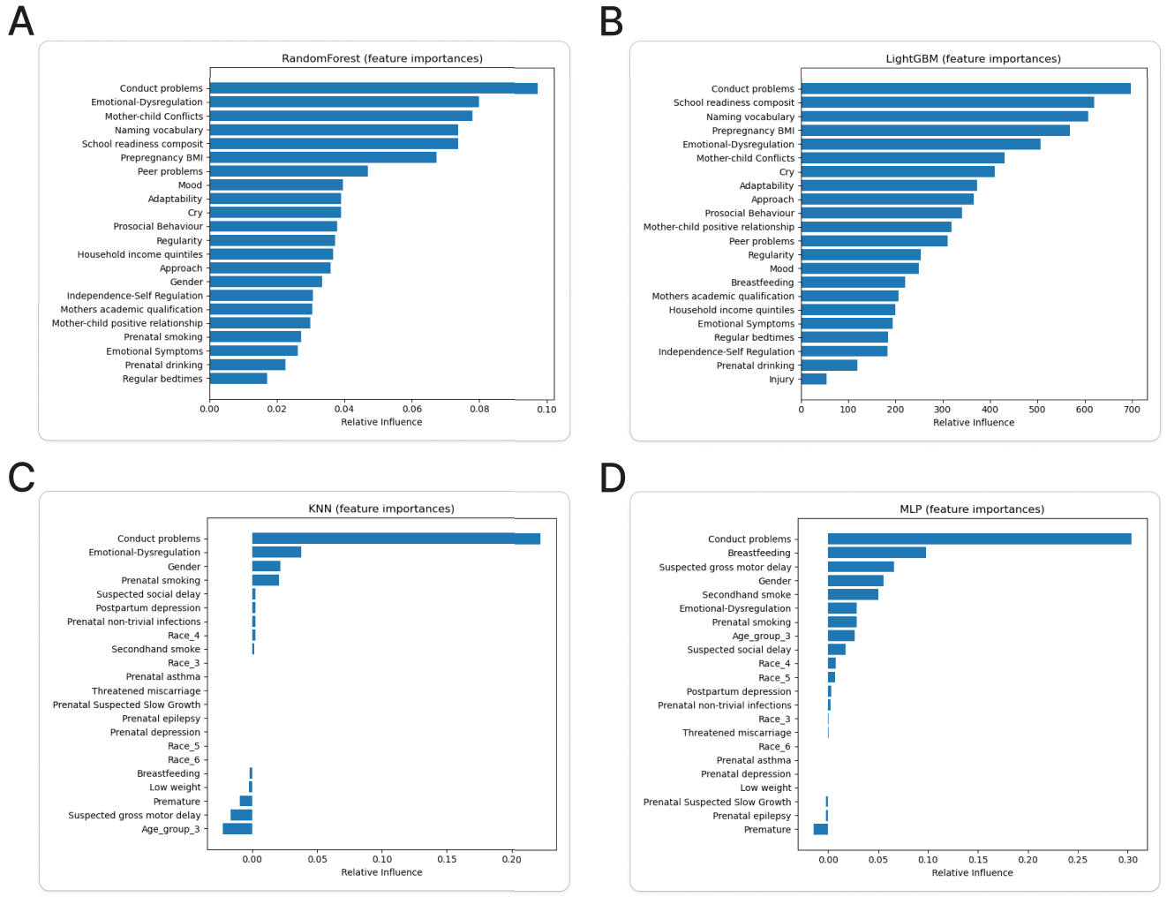
Fig.A1 Feature importance of four machine learning algorithm. (A) Random Forest feature importance, (B) lightGBM feature importance, (C) KNN feature importance, (D) MLP feature importance.

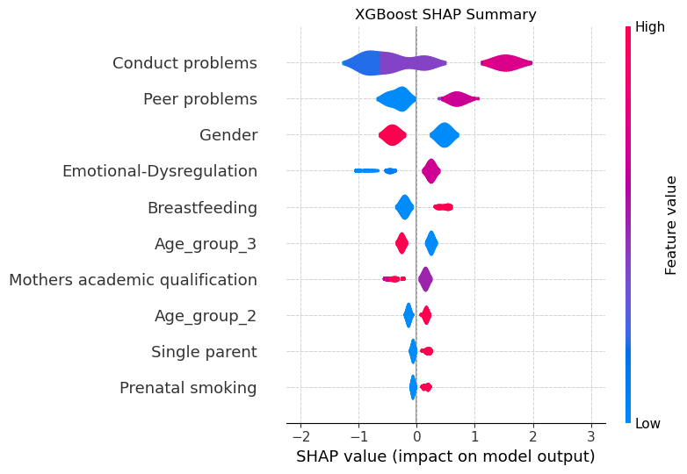Fig.A2 Global SHAP summary plot illustrating feature importance in the XGBoost model (Exclude sampling weights)

References
- Pianta RC (1992) Child–Parent Relationship Scale. University of Virginia.
- Frankenburg WK, Dodds JB (1967) The Denver Developmental Screening Test. The Journal of Pediatrics 71:181–191. https://doi.org/10.1016/s0022-3476(67)80070-2
- Carey C, McDevitt SC (1997) Infant Temperament Questionnaire. Department of Educational Psychology, Temple University, Philadelphia
- Elliott CD, Smith P, McCulloch K (1997) British Ability Scales. Technical Manual, London: Nelson
- Bracken BA (1998) Bracken Basic Concept Scale— Revised. TX: Psychological Corporation, San Antonio
- Sammons P, Sylva S, Melhuish E, et al (2004) The Effective Provision of Pre-school Education (EPPE) Project: Technical Paper 11: The continuing effect of pre-school education at age 7 years. London: Institute of Education.
- Melhuish E, Hanna K, Quinn L, et al (2004) The Effective Pre-school Provision in Northern Ireland Project, Technical Paper 11: Pre-school Experience and Social/Behavioural Development at the End of Year 3 of Primary School. Belfast, N.I.: Stranmillis University Press.
- Goodman R (1997) The Strengths and Difficulties Questionnaire: A Research Note. Journal of Child Psychology and Psychiatry 38:581–586. https://doi.org/10.1111/j.1469-7610.1997.tb01545.x

