Supplementary materials for “A Binomial Random-Walk Framework Quantifying Molecular Collision-Induced Fluctuations in Inertial-Range Eddy Formation”

I Supplementary Methods
This Supplementary Methods section documents the data files, statistical procedures, surrogate constructions, resampling parameters, heteroskedasticity rules, outlier policy, unit conventions, and the minimal verification steps required for a reader to reproduce the summary numbers without rerunning the full simulations. All machine readable CSV blocks referenced below are included in the Supplementary Data section and are named explicitly.

I-A Data and Primary Statistics
- Files included in Supplementary Data):
  - transfer_summary_per_seed.csv — one row per seed with columns: seed_id, amplitude, integrated_transfer_J_per_kg (ΔE), optional per_seed_variance, optional n_timesteps.
  - transfer_summary_clean.csv — ensemble summary with columns: seed_id (ensemble id), amplitude, mean_integrated (ensemble mean ΔE), ci_lo, ci_hi (bootstrap 95% percentile CI), p_boot_ge0, p_perm_ge0, n_seeds, notes.
  - per_seed_variances.csv — grouped variance summary with columns: group_label, amplitude, n_seeds, variance_across_seeds, std_across_seeds, min_integrated_transfer, max_integrated_transfer.
  - robustness_summary.csv — short scaffold listing checks, parameter variants, figure refs, and qualitative outcome.
- Primary reported quantity: ensemble mean of final integrated transfer ΔE (units: J kg⁻¹). Ensemble means reported in the manuscript correspond to arithmetic means of the per-seed ΔE values in transfer_summary_per_seed.csv.
- Conversion to Kolmogorov-scale rms velocity reported in the text: $u_{rms}=\sqrt{\left(2ΔE\right)}$. Reported $u_{rms}$ values are converted to mm s⁻¹ by multiplying meters per second by 1000. Inline formula (used throughout):
$$u_{\text{rms}}=1000×\sqrt{2ΔE} \text{(mm }{\text{s}}^{-1}).$$

I-B Resampling and Inference Procedures
- Bootstrap:
  - Method: resampling with replacement of the N seeds within each ensemble, computing the ensemble mean for each resample.
  - Parameters: B = 5,000 resamples; random seed = 42.
  - CI: percentile method reporting the 2.5th and 97.5th percentiles of the resampled means as the 95% CI (ci_lo, ci_hi).
  - One-sided bootstrap probability reported: p_boot_ge0 = fraction of bootstrap resampled means ≥ 0.
- Permutation:
  - Method: label permutation test applied to raw per-seed ΔE values to test the one-sided hypothesis mean ≥ 0.
  - Parameters: B = 10,000 permutations.
  - For groups with heteroskedasticity (see below) a studentized permutation statistic is computed and reported; raw and studentized permutation p-values are both provided when studentization is used.
- Reporting convention:
- For each ensemble I report: ensemble mean ± 95% bootstrap percentile CI, p_boot_ge0, and p_perm_ge0. The manuscript cites both resampling p-values where appropriate.

I-C Surrogate Data Constructions
Surrogates are constructed per seed and then aggregated into surrogate ensembles with the same nominal N as the true ensembles unless an alternate N is specified (documented next to the surrogate results).
- Phase randomized:
  - Procedure: compute Fourier transform of the per-seed time series, replace each mode’s phase with a uniform random phase in 0,2π) independently per mode, preserve the original modal amplitudes, inverse transform to produce the surrogate time series. Thus, surrogates preserve spectral amplitude envelope but remove coherent phase relationships.
- Shuffled:
  - Procedure: fully randomize (permute) the time index within each seed, preserving the marginal amplitude distribution but destroying temporal correlation and coherent cumulative drift.
- Upsampled:
  - Procedure: generate surrogate time series that preserve the amplitude PDF while weakening temporal correlations via resampling and interpolation; when upsampling changes sample count this is noted explicitly (e.g., upsampled ensemble at A=3×10⁻⁹ used n=256; see Results).
- Implementation notes:
  - Surrogate algorithms preserve the same post-processing pipeline used for true ensembles (integration endpoints, normalization) so reported ΔE values are directly comparable.

I-D Heteroskedasticity, studentization, and outlier policy
- Variance reporting:
  - Across-seed dispersion is reported as variance_across_seeds, the population variance computed with ddof=0 over per-seed ΔE values. std_across_seeds is the square root of this variance. Units: variance (J kg⁻¹)², std J kg⁻¹.
- Studentized permutation trigger:
  - If the ratio of the larger group variance to the smaller group variance exceeds 1.20 (i.e., >20% imbalance), then a studentized permutation statistic is computed and the studentized permutation p-value is reported alongside the raw permutation p-value. This rule is applied to comparisons that motivate studentized testing in the manuscript; both values are provided for transparency.
- Outlier policy:
  - All per-seed ΔE values are retained in the primary analyses and included verbatim in transfer_summary_per_seed.csv. Seeds identified as extreme (ΔE ≥ 10× median absolute deviation) are inspected and documented; sensitivity checks excluding extreme seeds were performed and summarized in the robustness section (Table S3 / robustness_summary.csv). The supplement provides the sensitivity note and the numerical effect on ensemble mean when excluding the top one, two, and three largest-magnitude seeds.

I-E Reproducibility and Verification
- Machine-readable CSV blocks:
  - The Supplement contains full ASCII CSV blocks for transfer_summary_per_seed.csv, transfer_summary_clean.csv, per_seed_variances.csv, and robustness_summary.csv. Each block is labeled with its filename. Numeric formatting uses plain ASCII scientific notation (no unicode characters).
- Minimal verification script:
  - A small script verify_summaries.py is provided as a code block in the Supplement. Usage (one-line):
python verify_summaries.py transfer_summary_per_seed.csv transfer_summary_clean.csv per_seed_variances.csv
  - The script recomputes per-amplitude ensemble means, population variance, std, and min/max and prints them for side-by-side comparison with the pasted ensemble summary. It is intended to allow a reader to confirm that the pasted CSV blocks are internally consistent with the tables in the Supplement.
- README paragraph for reviewers (included in the Supplement): copy each CSV block into a plain text file with the exact filename above, save verify_summaries.py, and run the usage line. The output should match the table entries in Tables S1 and S2.

I-F Physical Constants and Unit Conventions
The production runs used a kinematic viscosity $ν=5.0×{10}^{-7}$ m² s⁻¹ (from run manifests) and for conversion purposes I use a mean dissipation rate $ε=1.0×{10}^{-6}$m² s⁻³. The Kolmogorov time scale is $τ_{K}=\sqrt{ν/ϵ}=0.7071067812$ s. Reported rms velocities at the Kolmogorov scale are computed from the integrated transfer ΔE by $u_{\text{rms}}=\sqrt{2ΔE}$ (m s⁻¹) and presented in mm s⁻¹ by multiplying by 1000; example conversions for ΔE = 1e-35, 1e-34, 1e-33 J kg⁻¹ are 4.472e-15, 1.414e-14, and 4.472e-14 mm s⁻¹ respectively. u and eps were taken from the analysis manifest (analysis_results/manifest.json) and are recorded in transfer_summary.json for provenance.
{"physical_constants": {"nu_mean_m2_per_s": 5.0e-7, "eps_mean_m2_per_s3": 1.0e-6, "tauK_s": 0.7071067811865476 } }

I-G Energy-budget Estimate and LLNS Mapping (Order of Magnitude)
I provide here a compact, dimensionally consistent mapping from microscopic (collision-induced) stress fluctuations to an equivalent energy-injection rate per unit mass at a chosen coarse-graining length scale $l$. The mapping uses the standard Landau–Lifshitz fluctuating-hydrodynamics form for the stress covariance as the continuum limit of molecular stress fluctuations; it, therefore, furnishes an independent continuum bound against which the measured integrated transfers $ΔE$ (Section IV-B) may be compared (see Landau & Lifshitz [1]; Fox & Uhlenbeck [2] for standard presentations of fluctuating hydrodynamics and stochastic hydrodynamic forces).
The fluctuating stress tensor $σ_{ij}^{R}\left(x,t\right)$ in the Landau–Lifshitz framework satisfies, in the isotropic approximation,
$$\left\langle σ_{ij}^{R}\left(x,t\right)σ_{kl}^{R}\left(x^{'},t^{'}\right)\right\rangle =2k_{B}TμS_{ijkl}δ\left(x-x^{'}\right)δ\left(t-t^{'}\right)$$
( 1)
where $k_{B}$ is Boltzmann's constant, $T$ temperature, $μ$ dynamic viscosity, and $S_{ijkl}$ is the symmetric isotropic fourth-rank tensor. The stochastic body force per unit mass entering the momentum equation is $f_{i}=ρ^{-1}∂_{j}σ_{ij}^{R}$ [1,2].
Replacing the delta correlations by coarse-grained averages over a control volume $ΔV∼l^{3}$ and time window $Δt ∼ τ$ yields the estimate
$$Var\left(σ\right)∼\left(2k_{B}Tμ\right)/\left(l^{3}τ\right),$$
( 2)
so that
$σ_{rms}∼\sqrt{\left(2k_{B}Tμ/\left(l^{3}τ\right)\right)}$.
( 3)
Taking a spatial derivative over length $l$ gives a force per unit volume of order $σ_{rms}/l$, hence a force per unit mass
$f_{rms}∼\left(σ_{rms}\right)/\left(ρl\right)=\left(1/ρ\right)\sqrt{\left(2k_{B}Tμ/\left(l^{5}τ\right)\right)}$.
( 4)
For a forcing with correlation time $∼ τ$, an order-of-magnitude estimate for the mean energy injection rate per unit mass at scale $l$ is
$P_{l}∼{f_{rms}}^{2}τ=\left(2k_{B}Tμ\right)/\left(ρ^{2}l^{5}\right)$.
( 5)
Equation (5) has units J kg⁻¹ s⁻¹ (W kg⁻¹). A dimensional check gives $\left[k_{B}T\right]\left[μ\right]/\left({\left[ρ\right]}^{2}{\left[l\right]}^{5}\right)$→ m² s⁻³. Note the explicit $τ$ cancels in (5) under the white-noise / coarse-grained approximation; the dominant scale dependence is $∝l^{-5}$.
Evaluate equation (5) at the Kolmogorov length $η={\left(ν^{3}/ε\right)}^{1/4}$. Using $ν=5.0×{10}^{-7}$ m² s⁻¹ and $ε=1.0×{10}^{-6}$ m² s⁻³ (Section I-F) yields$η≈5.946×{10}^{-4}$m, $τ_{η}≈0.7071$ s.
For a numerical example, I use $k_{B}=1.380649×{10}^{-23}$ J K⁻¹, $T ≈ 300$ K, $μ=νρ$:
Air: $ρ ≈ 1.2$ kg m⁻³, $μ≈6.0×{10}^{-7}$ Pa·s → $P_{η}≈4.6×{10}^{-11}$ W kg⁻¹, $P_{η}/ε≈4.6×{10}^{-5}$.
Water: $ρ ≈ 1000$kg m⁻³, $μ≈5.0×{10}^{-4}$Pa·s → $P_{η}≈5.6×{10}^{-14}$ W kg⁻¹, $P_{η}/ε≈5.6×{10}^{-8}$.
These continuum LLNS estimates show that thermal/stochastic forcing at the viscous cutoff is non-zero but typically $≪ε$ for macroscopic turbulent flows.
The ensemble means in IV-B correspond to integrated energy per unit mass $ΔE$ (J kg⁻¹). Interpreting $ΔE$ as energy delivered on time scale $∼τ_{η}$ gives mean power $≈ΔE/τ_{η}$. For the amplitudes reported in IV-B:
$ΔE/τ_{η}{\left.​\right|}_{A=1×{10}^{-8}}≈1.34×{10}^{-35}$ W kg⁻¹, $ΔE/τ_{η}{\left.​\right|}_{A=3×{10}^{-9}}≈7.35×{10}^{-36}$ W kg⁻¹.
These values are many orders of magnitude smaller than both ε and the LLNS continuum bound $P_{η}$ above (e.g. $P_{η}/\left(ΔE/τ_{η}\right)∼{10}^{24}$ for air with the parameters used here).
Interpretation and implications.
Equation (5) provides an independent continuum reference for the available thermal forcing per unit mass at scale $l$; it is non-zero but, for macroscopic turbulence, small relative to $ε$. The measured $ΔE$ in my surrogate/spectral experiments is extremely small in energetic terms (far below $ε$), which shows that the direct energetic contribution of the particular surrogate realizations reported here is negligible. That fact does not contradict the paper’s central claim that molecular collisions set a finite lower bound on perturbation amplitude: amplitude growth can be exponential while energy scales with amplitude squared. Hence, a minute initial amplitude can be amplified by finite-time chaotic/transient growth into a macroscopic amplitude even when the instantaneous molecular power is much smaller than $ε$.
To make this explicit, define the required energy amplification factor $G_{E}=ε/\left(ΔE/τ_{η}\right)$ and the corresponding amplitude amplification $G_{u}=\sqrt{\left(G_{E}\right)}$. Using $A=1×{10}^{-8}$ as an example gives $G_{E}≈7.44×{10}^{28}$ and $G_{u}≈2.73×{10}^{14}$. With a heuristic finite-time Lyapunov rate $λ∼1/τ_{η}$ $(≈1.414$s⁻¹ for $τ_{η}≈0.7071$s), the time required for amplitude amplification by $G_{u}$ is
$t≈\left(1/λ\right)ln\left(G_{u}\right)=\left(1/\left(2λ\right)\right)ln\left(G_{E}\right)≈23.5$ s $≈33τ_{η}$.
This numerical example illustrates that enormous energy amplification factors correspond to moderate durations of sustained exponential amplitude growth; whether such growth occurs depends on the flow’s Lyapunov/finite-time amplification dynamics and persistence, not on energetic parity alone.
Caveats and recommended diagnostics.
Equation (5) is an order-of-magnitude estimate: it assumes isotropic coarse-graining, neglects $O(1)$ tensor prefactors, and uses $l=η$ for concreteness. Because $P_{l}∝l^{-5}$, the estimate is extremely sensitive to the chosen coarse-graining length. The heuristic $λ∼1/τ_{η}$ is illustrative; actual finite-time Lyapunov spectra and transient growth rates depend on mean shear, geometry and boundary conditions and may be quenched by nonlinear effects. To substantiate amplification claims I recommend either (i) transient-growth or Lyapunov-spectrum calculations for representative flows, (ii) shell-model or low-dimensional simulations demonstrating amplification, or (iii) DNS/MD coupling that injects thermal noise consistent with equation (5) and measures ensuing amplification. A small sensitivity table/plot of $P_{l}/ε$ versus $l/η\left(l∈η/10,η/3,η,3η,10η\right)$ is recommended; the $l^{-5}$ scaling makes that sensitivity explicit.
Conclusion
Use equation (5) as the canonical continuum reference for available thermal forcing per unit mass at scale $l$ when comparing microscopic/mesoscopic seed amplitudes to continuum energy budgets. The numerical examples above show molecular/thermal forcing is non-zero but energetically minute; the question of practical significance for macroscopic turbulence, therefore, reduces to whether and how rapidly dynamical amplification mechanisms can convert that small amplitude into large observable fluctuations.

II Supplementary Figures
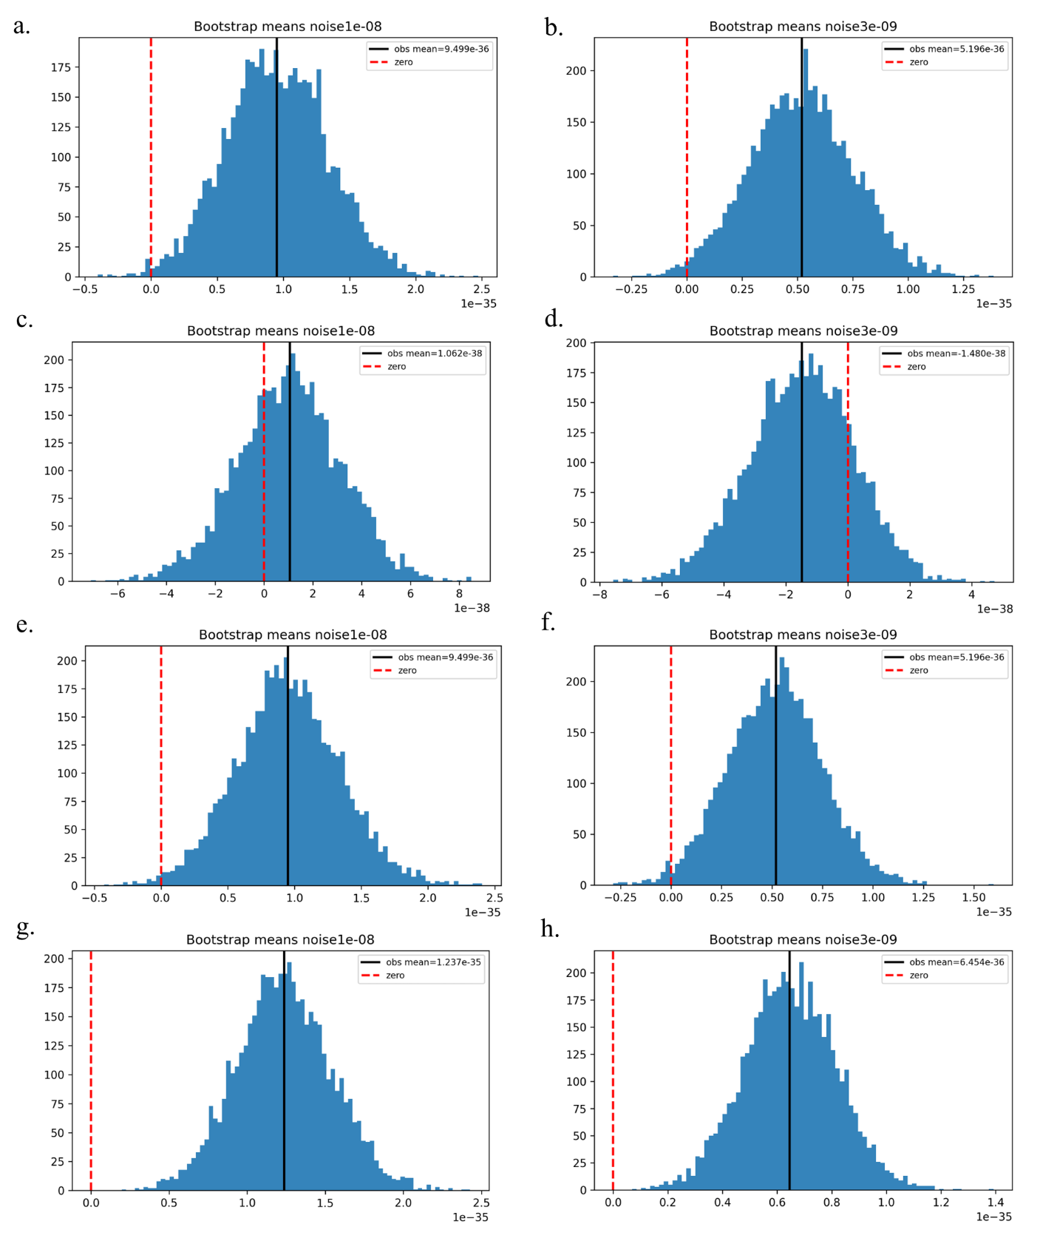
Supplementary Figure S1 — Bootstrap distributions
Figure S1a-S1b: Bootstrap histograms of resampled mean integrated transfer for true ensembles (A = 1×10⁻⁸ and A = 3×10⁻⁹). Solid black lines mark observed means; dashed red lines mark zero. Figure S1c–S1h: Bootstrap histograms for each surrogate class (phase-randomized, shuffled, upsampled) at both amplitudes (left to right), showing distributional collapse or small positive biases as appropriate. Panel note: Per seed values and resampling parameters (number of bootstrap replicates, random seeds) are available in Supplementary Data.
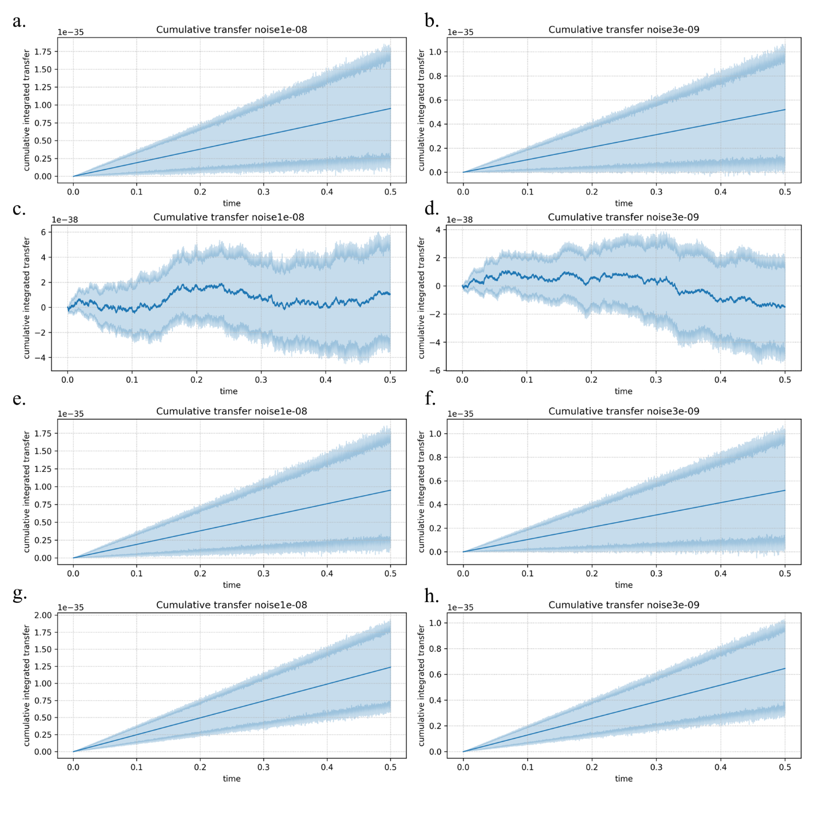
Supplementary Figure S2 — Cumulative integrated transfer trajectories
Figure S2a-S2b: Full cumulative integrated transfer time series for true ensembles (A = 1×10⁻⁸ and A = 3×10⁻⁹). Solid lines = ensemble means; shaded regions = 95% bootstrap CIs. Figure S2c–S2h: Corresponding cumulative trajectories for each surrogate class and amplitude (left to right), showing near-zero fluctuations for phase-randomized surrogates and weak drifts for shuffled/upsampled surrogates. Panel note: Time axis and integration endpoint are identical across panels for direct comparison.
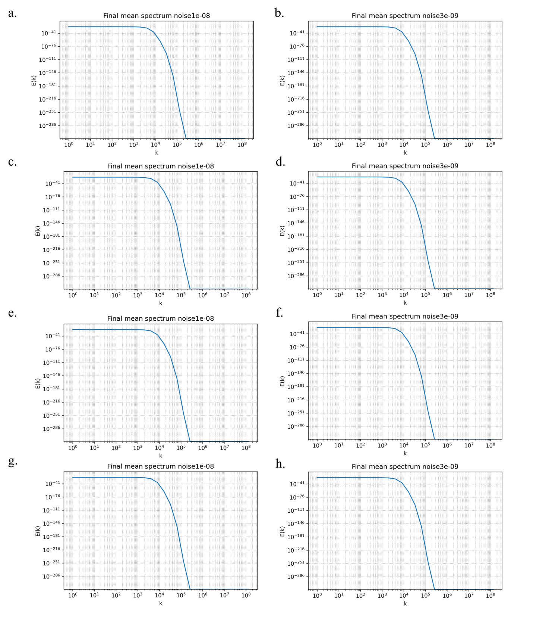
Supplementary Figure S3 — Final mean spectra
Figure S3a: Final mean energy spectrum E(k) for true ensembles at A = 1×10⁻⁸ (log–log). The spectrum shows the expected steep decay with no spurious peaks. Figure S3b: Final mean energy spectrum E(k) for true ensembles at A = 3×10⁻⁹ (log–log). Figure S3c–S3h: Final mean spectra for surrogate ensembles (all classes and amplitudes) demonstrating that surrogate procedures preserve amplitude envelopes but disrupt phase/temporal structure. Panel note: Spectral diagnostics confirm that positive integrated transfer in the true ensembles is not driven by spectral artifacts.

III Supplementary Tables
seed_id | amplitude | integrated_transfer_J_per_kg
noise1e-08_seed001 | 1e-08 | 1.4336133221767937e-35
noise1e-08_seed002 | 1e-08 | -2.3170051471286182e-35
noise1e-08_seed003 | 1e-08 | 4.9637990575696145e-35
noise1e-08_seed004 | 1e-08 | 3.0383268956283779e-35
noise1e-08_seed005 | 1e-08 | 3.3296329683437351e-36
noise1e-08_seed006 | 1e-08 | 2.3034597258723207e-36
noise1e-08_seed007 | 1e-08 | -3.9666465514036159e-36
noise1e-08_seed008 | 1e-08 | 5.5367959408505814e-35
noise1e-08_seed009 | 1e-08 | -5.8405947474985929e-37
noise1e-08_seed010 | 1e-08 | 5.0833448796845584e-35

seed_id | amplitude | integrated_transfer_J_per_kg
noise3e-09_seed001 | 3e-09 | 1.4827413611750836e-35
noise3e-09_seed002 | 3e-09 | -4.7984963970560302e-35
noise3e-09_seed003 | 3e-09 | -2.1377625345050818e-36
noise3e-09_seed004 | 3e-09 | 9.3653991556206243e-36
noise3e-09_seed005 | 3e-09 | -5.5241540545474660e-36
noise3e-09_seed006 | 3e-09 | 1.5345101689342758e-35
noise3e-09_seed007 | 3e-09 | 2.6352801116546882e-35
noise3e-09_seed008 | 3e-09 | -1.7718448988864065e-37
noise3e-09_seed009 | 3e-09 | 8.0933103118942516e-36
noise3e-09_seed010 | 3e-09 | 2.3862605645863072e-35
Table S1. Per-seed integrated transfer ΔE (J kg⁻¹), first 10 rows per amplitude; full per-seed CSV available in the Supplementary Data repository.
group_label | amplitude | n_seeds | variance_across_seeds | std_across_seeds | min_integrated_transfer | max_integrated_transfer
true_ensembles | 1e-08 | 128 | 1.928859e-69 | 4.391878e-35 | -1.240243e-34 | 1.866304e-34
true_ensembles | 3e-09 | 128 | 7.022369e-70 | 2.649975e-35 | -9.369563e-35 | 1.054719e-34
Table S2. Per‑seed integrated‑transfer summary by amplitude. variance_across_seeds is the population variance across seeds (ddof=0) with units (J kg⁻¹)²; std_across_seeds is its square root (J kg⁻¹); min_integrated_transfer and max_integrated_transfer are the minimum and maximum per‑seed ΔE (J kg⁻¹).
check_name | parameter_variant | figure_ref | qualitative_conclusion_preserved
integration_endpoint | +25% | Fig.S2a | yes
bootstrap_B | 2000 | FigS1b | yes
Table S3. Robustness checks summary. Each row lists the analysis change tested, the parameter variant used, the figure panel showing the diagnostic, and whether the qualitative conclusion (positive ensemble mean ΔE) was preserved.

IV Supplementary Data

IV-A verify_summaries.py
#!/usr/bin/env python3
# verify_summaries.py
# Usage:
# python verify_summaries.py transfer_summary_per_seed.csv transfer_summary_clean.csv per_seed_variances.csv
#
# Reads:
# - transfer_summary_per_seed.csv with headers: seed_id,amplitude,integrated_transfer_J_per_kg
# - transfer_summary_clean.csv with headers including key,n_seeds,mean_integrated,ci_lo,ci_hi,p_boot_ge0,p_perm_ge0
# - per_seed_variances.csv with headers including group_label,amplitude,variance_across_seeds,std_across_seeds,min_integrated_transfer,max_integrated_transfer
#
# Prints computed stats per amplitude and shows values from the provided summaries for quick comparison.

import sys
import csv
import math
from collections import OrderedDict

def read_per_seed(path):
groups = OrderedDict()
with open(path, newline='', encoding='utf-8') as f:
r = csv.reader(f)
hdr = next(r)
# tolerant header lookup
try:
amp_i = hdr.index('amplitude')
val_i = hdr.index('integrated_transfer_J_per_kg')
except ValueError:
# fallback to fixed indices
amp_i = 1
val_i = 2
for row in r:
if not row or len(row) <= val_i:
continue
amp = row[amp_i].strip()
try:
v = float(row[val_i].strip())
except:
continue
groups.setdefault(amp, []).append(v)
return groups

def read_ensemble_summary(path):
summary = {}
with open(path, newline='', encoding='utf-8') as f:
r = csv.DictReader(f)
for row in r:
# support both 'amplitude' and 'key' identifiers
amp = row.get('amplitude', '').strip() or row.get('key', '').strip()
if not amp:
continue
summary[amp] = row
return summary

def read_variances(path):
varsum = {}
with open(path, newline='', encoding='utf-8') as f:
r = csv.DictReader(f)
for row in r:
amp = row.get('amplitude','').strip()
if not amp:
continue
varsum[amp] = row
return varsum

def compute_stats(vals):
n = len(vals)
mean = sum(vals)/n if n>0 else float('nan')
var = sum((x-mean)**2 for x in vals)/n if n>0 else float('nan') # population variance ddof=0
std = math.sqrt(var) if var>=0 else float('nan')
mn = min(vals) if n>0 else float('nan')
mx = max(vals) if n>0 else float('nan')
return {'n':n,'mean':mean,'var':var,'std':std,'min':mn,'max':mx}

def fmt(x, sig=6):
try:
return f"{x:.6e}"
except:
return str(x)

def compare_field(computed, provided, tol_rel=1e-12, tol_abs=0.0):
if provided is None or provided=='':
return "MISSING"
try:
p = float(provided)
except:
return f"NONNUM({provided})"
c = computed
diff = abs(c-p)
tol = max(tol_abs, tol_rel * max(abs(c), abs(p), 1.0))
return "OK" if diff <= tol else f"MISMATCH (computed {fmt(c)} vs provided {fmt(p)})"

def main(args):
if len(args) < 3:
print("Usage: python verify_summaries.py transfer_summary_per_seed.csv transfer_summary_clean.csv per_seed_variances.csv")
sys.exit(1)
per_seed_path = args[0]
ensemble_path = args[1]
var_path = args[2] if len(args)>2 else None

groups = read_per_seed(per_seed_path)
ensemble = read_ensemble_summary(ensemble_path)
variances = read_variances(var_path) if var_path else {}

amps = list(groups.keys())
if not amps:
print("No amplitudes found in per-seed file.")
sys.exit(1)

for amp in amps:
vals = groups[amp]
stats = compute_stats(vals)
print(f"Amplitude: {amp}")
print(f" computed n = {stats['n']}")
print(f" computed mean = {fmt(stats['mean'])}")
e = ensemble.get(amp)
if e:
print(f" ensemble mean (summary) = {e.get('mean_integrated') or e.get('mean_integrated', '') or e.get('mean')}")
else:
print(" ensemble summary: NONE")
# variance/std/min/max
print(f" computed variance_across_seeds = {fmt(stats['var'])}")
print(f" computed std_across_seeds = {fmt(stats['std'])}")
print(f" computed min_integrated_transfer = {fmt(stats['min'])}")
print(f" computed max_integrated_transfer = {fmt(stats['max'])}")
v = variances.get(amp)
if v:
print(f" summary variance_across_seeds = {v.get('variance_across_seeds')}")
print(f" summary std_across_seeds = {v.get('std_across_seeds')}")
print(f" summary min_integrated_transfer = {v.get('min_integrated_transfer')}")
print(f" summary max_integrated_transfer = {v.get('max_integrated_transfer')}")
# tolerance check for numeric fields
print(" checks:")
print(" variance ->", compare_field(stats['var'], v.get('variance_across_seeds',None)))
print(" std ->", compare_field(stats['std'], v.get('std_across_seeds',None)))
print(" min ->", compare_field(stats['min'], v.get('min_integrated_transfer',None), tol_rel=1e-10))
print(" max ->", compare_field(stats['max'], v.get('max_integrated_transfer',None), tol_rel=1e-10))
else:
print(" per-seed variances summary: NONE")
print("-"*72)

if __name__ == "__main__":
main(sys.argv[1:])

IV-B transfer_summaries.json
{
"noise1e-08": {
"n_seeds": 128,
"mean_integrated": 9.498756219223147e-36,
"ci_lo": 2.0570422702004013e-36,
"ci_hi": 1.7174201194684506e-35,
"p_boot_ge0": 0.9936,
"p_perm_ge0": 1.0,
"per_seed_integrated_sample": [
1.4336133221767937e-35,
-2.3170051471286182e-35,
4.963799057569614e-35,
3.038326895628378e-35,
3.329632968343735e-36,
2.3034597258723207e-36,
-3.966646551403616e-36,
5.536795940850581e-35,
-5.840594747498593e-37,
5.083344879684558e-35
]
},
"noise3e-09": {
"n_seeds": 128,
"mean_integrated": 5.19631133665915e-36,
"ci_lo": 6.367470632733544e-37,
"ci_hi": 9.80663533243143e-36,
"p_boot_ge0": 0.988,
"p_perm_ge0": 1.0,
"per_seed_integrated_sample": [
1.4827413611750836e-35,
-4.79849639705603e-35,
-2.1377625345050818e-36,
9.365399155620624e-36,
-5.524154054547466e-36,
1.5345101689342758e-35,
2.635280111654688e-35,
-1.7718448988864065e-37,
8.093310311894252e-36,
2.3862605645863072e-35
]
},
"_physical_constants": {
"nu_mean_m2_per_s": 5e-07,
"eps_mean_m2_per_s3": 1e-06,
"tauK_s": 0.7071067811865476
}
}

IV-D transfer_summary_clean.csv
key,n_seeds,mean_integrated,ci_lo,ci_hi,p_boot_ge0,p_perm_ge0
noise1e-08,128,9.498756219223147e-36,2.0570422702004013e-36,1.7174201194684506e-35,0.9936,1.0
noise3e-09,128,5.19631133665915e-36,6.367470632733544e-37,9.80663533243143e-36,0.988,1.0

IV-E per_seed_variances.csv
group_label,amplitude,n_seeds,variance_across_seeds,std_across_seeds,min_integrated_transfer,max_integrated_transfer
true_ensembles,1e-08,128,1.928859e-69,4.391878e-35,-1.240243e-34,1.866304e-34
true_ensembles,3e-09,128,7.022369e-70,2.649975e-35,-9.369563e-35,1.054719e-34

IV-F robustness_summary.csv
check_name,parameter_variant,figure_ref,qualitative_conclusion_preserved
integration_endpoint,+25%,Fig.S2a,yes
bootstrap_B,2000,Fig.S1b,yes

IV-G transfer_summary_per_seed.csv
seed_id,amplitude,integrated_transfer_J_per_kg
noise1e-08_seed001,1e-08,1.4336133221767937e-35
noise1e-08_seed002,1e-08,-2.3170051471286182e-35
noise1e-08_seed003,1e-08,4.9637990575696145e-35
noise1e-08_seed004,1e-08,3.0383268956283779e-35
noise1e-08_seed005,1e-08,3.3296329683437351e-36
noise1e-08_seed006,1e-08,2.3034597258723207e-36
noise1e-08_seed007,1e-08,-3.9666465514036159e-36
noise1e-08_seed008,1e-08,5.5367959408505814e-35
noise1e-08_seed009,1e-08,-5.8405947474985929e-37
noise1e-08_seed010,1e-08,5.0833448796845584e-35
noise1e-08_seed011,1e-08,-2.7168178760927832e-36
noise1e-08_seed012,1e-08,-2.0720786338336865e-35
noise1e-08_seed013,1e-08,5.2038990128107409e-35
noise1e-08_seed014,1e-08,-8.0331606682992889e-36
noise1e-08_seed015,1e-08,-7.4013704403403375e-36
noise1e-08_seed016,1e-08,-1.2224666876103325e-35
noise1e-08_seed017,1e-08,-2.0198556122269350e-35
noise1e-08_seed018,1e-08,-7.0618102701283033e-36
noise1e-08_seed019,1e-08,1.0731625201398345e-34
noise1e-08_seed020,1e-08,3.8948005105449822e-35
noise1e-08_seed021,1e-08,1.8898016374674789e-35
noise1e-08_seed022,1e-08,-3.1224570196304513e-35
noise1e-08_seed023,1e-08,-8.0382278451533553e-35
noise1e-08_seed024,1e-08,3.5970328272169674e-35
noise1e-08_seed025,1e-08,-3.2724947335590548e-36
noise1e-08_seed026,1e-08,1.1795976282319967e-35
noise1e-08_seed027,1e-08,-6.0970364236954010e-35
noise1e-08_seed028,1e-08,-5.6331983116896928e-36
noise1e-08_seed029,1e-08,2.9088198123623838e-35
noise1e-08_seed030,1e-08,-1.2402425844942920e-34
noise1e-08_seed031,1e-08,-2.3568632778945773e-35
noise1e-08_seed032,1e-08,2.9326284226897952e-35
noise1e-08_seed033,1e-08,8.4531515833468416e-35
noise1e-08_seed034,1e-08,5.0571794884997550e-35
noise1e-08_seed035,1e-08,2.3742300126424852e-35
noise1e-08_seed036,1e-08,2.4871476237340289e-35
noise1e-08_seed037,1e-08,-4.0845163699795139e-36
noise1e-08_seed038,1e-08,3.2195675511338045e-35
noise1e-08_seed039,1e-08,6.4009473428734633e-36
noise1e-08_seed040,1e-08,-8.1534729343436445e-37
noise1e-08_seed041,1e-08,3.6771048128417183e-36
noise1e-08_seed042,1e-08,-1.4543387422571080e-35
noise1e-08_seed043,1e-08,-2.5369489863551194e-36
noise1e-08_seed044,1e-08,-5.6078845629361703e-35
noise1e-08_seed045,1e-08,2.9190429846737199e-35
noise1e-08_seed046,1e-08,-3.5411934165679334e-37
noise1e-08_seed047,1e-08,-2.2865382982549801e-35
noise1e-08_seed048,1e-08,1.1066290264342690e-34
noise1e-08_seed049,1e-08,6.8028364768507385e-35
noise1e-08_seed050,1e-08,3.7464513969301146e-35
noise1e-08_seed051,1e-08,-1.5604088916129799e-35
noise1e-08_seed052,1e-08,1.5227617207727163e-35
noise1e-08_seed053,1e-08,2.9512278307820743e-35
noise1e-08_seed054,1e-08,-1.0327812839554455e-36
noise1e-08_seed055,1e-08,9.0905298342915163e-36
noise1e-08_seed056,1e-08,-1.2166053035108894e-35
noise1e-08_seed057,1e-08,-2.0209021616380933e-35
noise1e-08_seed058,1e-08,2.6978706010932094e-35
noise1e-08_seed059,1e-08,-6.3010412931316170e-37
noise1e-08_seed060,1e-08,2.4369699936487296e-35
noise1e-08_seed061,1e-08,-9.2044464245241385e-36
noise1e-08_seed062,1e-08,4.7411131809411534e-35
noise1e-08_seed063,1e-08,-6.8266081233005227e-35
noise1e-08_seed064,1e-08,1.8664182201234255e-35
noise1e-08_seed065,1e-08,5.6042723493203518e-35
noise1e-08_seed066,1e-08,1.3695358660694398e-35
noise1e-08_seed067,1e-08,5.3237497661893724e-36
noise1e-08_seed068,1e-08,1.3096437928820601e-35
noise1e-08_seed069,1e-08,2.5989754082830464e-35
noise1e-08_seed070,1e-08,9.4669528955679987e-35
noise1e-08_seed071,1e-08,-3.6214995001617936e-36
noise1e-08_seed072,1e-08,8.8362518552806456e-35
noise1e-08_seed073,1e-08,-1.3771743193824905e-35
noise1e-08_seed074,1e-08,-2.6659322509595969e-36
noise1e-08_seed075,1e-08,-1.9808738299262560e-36
noise1e-08_seed076,1e-08,1.9843033895859477e-35
noise1e-08_seed077,1e-08,-5.8203531773222415e-36
noise1e-08_seed078,1e-08,4.3270782118142550e-36
noise1e-08_seed079,1e-08,-2.5977287534679002e-35
noise1e-08_seed080,1e-08,9.8193423405223821e-35
noise1e-08_seed081,1e-08,1.0241272792591661e-35
noise1e-08_seed082,1e-08,-1.7758318426636401e-35
noise1e-08_seed083,1e-08,6.9072239773641638e-35
noise1e-08_seed084,1e-08,1.1760583858997480e-35
noise1e-08_seed085,1e-08,3.0054312585305201e-35
noise1e-08_seed086,1e-08,1.9979537286006797e-35
noise1e-08_seed087,1e-08,-7.5061750342919671e-35
noise1e-08_seed088,1e-08,5.7703085342276717e-36
noise1e-08_seed089,1e-08,1.5934180556318848e-34
noise1e-08_seed090,1e-08,1.5211972017515414e-35
noise1e-08_seed091,1e-08,5.6479282531887003e-36
noise1e-08_seed092,1e-08,1.9226252754199911e-36
noise1e-08_seed093,1e-08,-4.0667218768835691e-37
noise1e-08_seed094,1e-08,-1.3797904282282977e-36
noise1e-08_seed095,1e-08,-3.0499557184304148e-35
noise1e-08_seed096,1e-08,-2.4253838593557434e-35
noise1e-08_seed097,1e-08,-1.3383181123161397e-35
noise1e-08_seed098,1e-08,-5.2250046953442818e-35
noise1e-08_seed099,1e-08,-1.3193960605385506e-35
noise1e-08_seed100,1e-08,4.1619345558515522e-35
noise1e-08_seed101,1e-08,1.4011715041231278e-36
noise1e-08_seed102,1e-08,-3.2743882235031117e-35
noise1e-08_seed103,1e-08,5.1131146613689372e-35
noise1e-08_seed104,1e-08,-8.1563863327697162e-35
noise1e-08_seed105,1e-08,1.2350278968572333e-35
noise1e-08_seed106,1e-08,-3.0176120792827650e-36
noise1e-08_seed107,1e-08,1.5076946378167079e-34
noise1e-08_seed108,1e-08,-2.2631453208863172e-35
noise1e-08_seed109,1e-08,-5.6792657251980638e-36
noise1e-08_seed110,1e-08,-6.7966247350879130e-36
noise1e-08_seed111,1e-08,1.8663037996002021e-34
noise1e-08_seed112,1e-08,2.5919003329217516e-36
noise1e-08_seed113,1e-08,2.2684947604186129e-37
noise1e-08_seed114,1e-08,1.3100234440920719e-35
noise1e-08_seed115,1e-08,3.5629215714056498e-35
noise1e-08_seed116,1e-08,-3.1755200174688716e-35
noise1e-08_seed117,1e-08,2.4751505649515064e-35
noise1e-08_seed118,1e-08,3.3683528380841204e-36
noise1e-08_seed119,1e-08,1.7808095810233071e-36
noise1e-08_seed120,1e-08,-8.8587684230153002e-36
noise1e-08_seed121,1e-08,-5.7448594401985126e-36
noise1e-08_seed122,1e-08,-3.0283087746255065e-35
noise1e-08_seed123,1e-08,-2.8577403202857334e-35
noise1e-08_seed124,1e-08,3.9741052880947702e-35
noise1e-08_seed125,1e-08,6.1292461221995847e-37
noise1e-08_seed126,1e-08,-1.8319984815993554e-35
noise1e-08_seed127,1e-08,1.0783986387217002e-35
noise1e-08_seed128,1e-08,-5.9817472239767413e-35
noise3e-09_seed001,3e-09,1.4827413611750836e-35
noise3e-09_seed002,3e-09,-4.7984963970560302e-35
noise3e-09_seed003,3e-09,-2.1377625345050818e-36
noise3e-09_seed004,3e-09,9.3653991556206243e-36
noise3e-09_seed005,3e-09,-5.5241540545474660e-36
noise3e-09_seed006,3e-09,1.5345101689342758e-35
noise3e-09_seed007,3e-09,2.6352801116546882e-35
noise3e-09_seed008,3e-09,-1.7718448988864065e-37
noise3e-09_seed009,3e-09,8.0933103118942516e-36
noise3e-09_seed010,3e-09,2.3862605645863072e-35
noise3e-09_seed011,3e-09,6.1727180081771680e-36
noise3e-09_seed012,3e-09,-3.9137026214476821e-35
noise3e-09_seed013,3e-09,-9.5802537319864377e-36
noise3e-09_seed014,3e-09,-1.4961537535375687e-35
noise3e-09_seed015,3e-09,5.8203715003875627e-36
noise3e-09_seed016,3e-09,-5.0814990853596992e-35
noise3e-09_seed017,3e-09,-3.5288919140889975e-35
noise3e-09_seed018,3e-09,-4.1702414731613120e-36
noise3e-09_seed019,3e-09,2.0240076828195070e-35
noise3e-09_seed020,3e-09,3.9566173331897204e-35
noise3e-09_seed021,3e-09,1.8316843257837639e-35
noise3e-09_seed022,3e-09,-8.1740967361700628e-36
noise3e-09_seed023,3e-09,4.2463638747181650e-35
noise3e-09_seed024,3e-09,8.9430726831131773e-37
noise3e-09_seed025,3e-09,-1.8456641559415060e-35
noise3e-09_seed026,3e-09,2.4315572118164363e-35
noise3e-09_seed027,3e-09,-2.5731363623404392e-36
noise3e-09_seed028,3e-09,-2.9068673702422412e-36
noise3e-09_seed029,3e-09,2.5250776508058531e-35
noise3e-09_seed030,3e-09,-5.9757036841506224e-36
noise3e-09_seed031,3e-09,-2.1068211294714332e-36
noise3e-09_seed032,3e-09,-1.6174296941097981e-35
noise3e-09_seed033,3e-09,-2.7733805241853477e-35
noise3e-09_seed034,3e-09,5.6063807657336622e-36
noise3e-09_seed035,3e-09,-7.3813216868387528e-36
noise3e-09_seed036,3e-09,-7.5876597460840319e-36
noise3e-09_seed037,3e-09,-5.5452287990719114e-35
noise3e-09_seed038,3e-09,-3.7292089052208731e-36
noise3e-09_seed039,3e-09,4.2215081371751303e-35
noise3e-09_seed040,3e-09,2.3872848547676641e-35
noise3e-09_seed041,3e-09,-6.4523140258575418e-36
noise3e-09_seed042,3e-09,2.2125419130267335e-35
noise3e-09_seed043,3e-09,2.1583737685323508e-35
noise3e-09_seed044,3e-09,2.3871666588786601e-35
noise3e-09_seed045,3e-09,1.2891407396098321e-36
noise3e-09_seed046,3e-09,1.4056726043124733e-35
noise3e-09_seed047,3e-09,-1.1035265734171627e-35
noise3e-09_seed048,3e-09,2.2514510221076542e-35
noise3e-09_seed049,3e-09,-1.2510665181923286e-35
noise3e-09_seed050,3e-09,-9.3695625949562719e-35
noise3e-09_seed051,3e-09,-2.5816756098497086e-36
noise3e-09_seed052,3e-09,-3.2762934889924024e-35
noise3e-09_seed053,3e-09,2.5284900925392309e-36
noise3e-09_seed054,3e-09,1.4119206776833293e-35
noise3e-09_seed055,3e-09,6.6811214731814118e-35
noise3e-09_seed056,3e-09,-3.3341157342756784e-35
noise3e-09_seed057,3e-09,2.0653291775200835e-35
noise3e-09_seed058,3e-09,8.5074141209203270e-37
noise3e-09_seed059,3e-09,5.3263143853938058e-35
noise3e-09_seed060,3e-09,1.3037283433772349e-35
noise3e-09_seed061,3e-09,-8.5455705321556413e-37
noise3e-09_seed062,3e-09,3.7579713827721952e-35
noise3e-09_seed063,3e-09,-4.5787050883607738e-36
noise3e-09_seed064,3e-09,-1.3033676403853207e-35
noise3e-09_seed065,3e-09,-1.4340763498544621e-35
noise3e-09_seed066,3e-09,-8.7759416912895983e-36
noise3e-09_seed067,3e-09,7.3488343476686104e-36
noise3e-09_seed068,3e-09,1.5910604487753238e-35
noise3e-09_seed069,3e-09,-5.0090369651606057e-35
noise3e-09_seed070,3e-09,-2.2111658219485951e-35
noise3e-09_seed071,3e-09,9.4026976349627000e-36
noise3e-09_seed072,3e-09,2.7220235694031046e-35
noise3e-09_seed073,3e-09,1.4144634330043747e-35
noise3e-09_seed074,3e-09,2.4650933975397239e-36
noise3e-09_seed075,3e-09,8.9477503216510034e-36
noise3e-09_seed076,3e-09,4.1011136413356517e-36
noise3e-09_seed077,3e-09,1.1756196313332338e-35
noise3e-09_seed078,3e-09,1.2851537487872430e-35
noise3e-09_seed079,3e-09,4.0087362980933887e-35
noise3e-09_seed080,3e-09,7.9133950696217115e-36
noise3e-09_seed081,3e-09,-1.2173653706371602e-35
noise3e-09_seed082,3e-09,-6.6995785633626956e-37
noise3e-09_seed083,3e-09,2.8333831976906079e-36
noise3e-09_seed084,3e-09,-1.7264987234061815e-37
noise3e-09_seed085,3e-09,7.3900742609380116e-37
noise3e-09_seed086,3e-09,1.2713077965248396e-36
noise3e-09_seed087,3e-09,3.1857799419044633e-35
noise3e-09_seed088,3e-09,-6.9926277744241129e-36
noise3e-09_seed089,3e-09,1.3420084191424150e-36
noise3e-09_seed090,3e-09,-2.5294412915291210e-36
noise3e-09_seed091,3e-09,1.0547192645559059e-34
noise3e-09_seed092,3e-09,-6.9858976207734331e-36
noise3e-09_seed093,3e-09,-2.3884755884128384e-35
noise3e-09_seed094,3e-09,1.1843435031435516e-35
noise3e-09_seed095,3e-09,-7.6183187456408217e-36
noise3e-09_seed096,3e-09,1.6461999480652192e-35
noise3e-09_seed097,3e-09,2.7093975052020212e-36
noise3e-09_seed098,3e-09,7.2307539065336847e-36
noise3e-09_seed099,3e-09,8.0765894866302694e-36
noise3e-09_seed100,3e-09,4.8205475958945373e-35
noise3e-09_seed101,3e-09,1.9136949835876613e-35
noise3e-09_seed102,3e-09,-2.1069921008823423e-35
noise3e-09_seed103,3e-09,9.4375600615946289e-36
noise3e-09_seed104,3e-09,3.8066696120503456e-36
noise3e-09_seed105,3e-09,4.6363523598358503e-36
noise3e-09_seed106,3e-09,7.3388347688800452e-36
noise3e-09_seed107,3e-09,-4.6256583562385238e-36
noise3e-09_seed108,3e-09,4.0136815503701023e-35
noise3e-09_seed109,3e-09,1.8174552561574273e-35
noise3e-09_seed110,3e-09,1.1852401302482784e-35
noise3e-09_seed111,3e-09,2.9671552313849966e-35
noise3e-09_seed112,3e-09,4.2506989945476083e-35
noise3e-09_seed113,3e-09,9.9987264916830891e-35
noise3e-09_seed114,3e-09,1.3590026966267281e-35
noise3e-09_seed115,3e-09,7.2882141434393504e-35
noise3e-09_seed116,3e-09,3.6346915550267731e-36
noise3e-09_seed117,3e-09,6.9372749466820409e-36
noise3e-09_seed118,3e-09,-2.1251641209548009e-35
noise3e-09_seed119,3e-09,1.7485508880024999e-35
noise3e-09_seed120,3e-09,3.1837118985865532e-35
noise3e-09_seed121,3e-09,8.9628715064597212e-36
noise3e-09_seed122,3e-09,7.5214262703862119e-36
noise3e-09_seed123,3e-09,-2.0007448733519331e-35
noise3e-09_seed124,3e-09,-5.7817977875334005e-36
noise3e-09_seed125,3e-09,-3.6810882311169833e-36
noise3e-09_seed126,3e-09,2.1722549731174399e-36
noise3e-09_seed127,3e-09,-4.3376469413190662e-36
noise3e-09_seed128,3e-09,-3.7662956782090396e-35
References
- [1] Landau, L. D., Lifshitz, E. M. Fluid Mechanics, 2nd edition, Course of Theoretical Physics, Vol. 6. Elsevier, Oxford (1959).
- [2] Fox, R. O., Uhlenbeck, G. E. Contributions to non-equilibrium thermodynamics. I. Theory of hydrodynamical fluctuations. Physics of Fluids 13, 1893–1902 (1970). https://doi.org/10.1063/1.1693183

