APPENDIX A
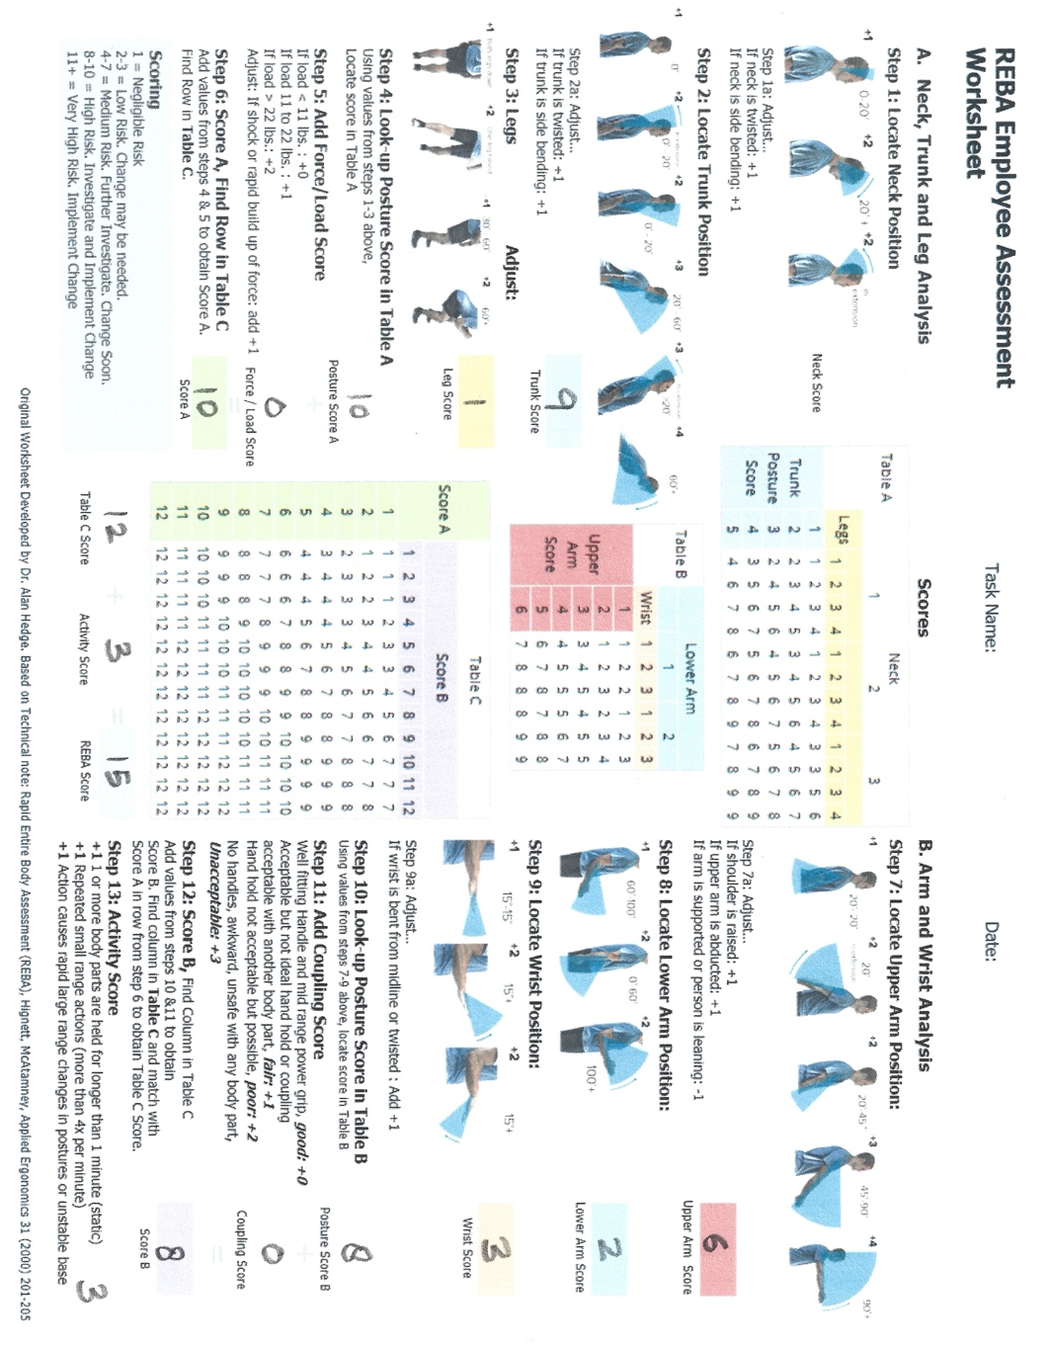

APPENDIX B
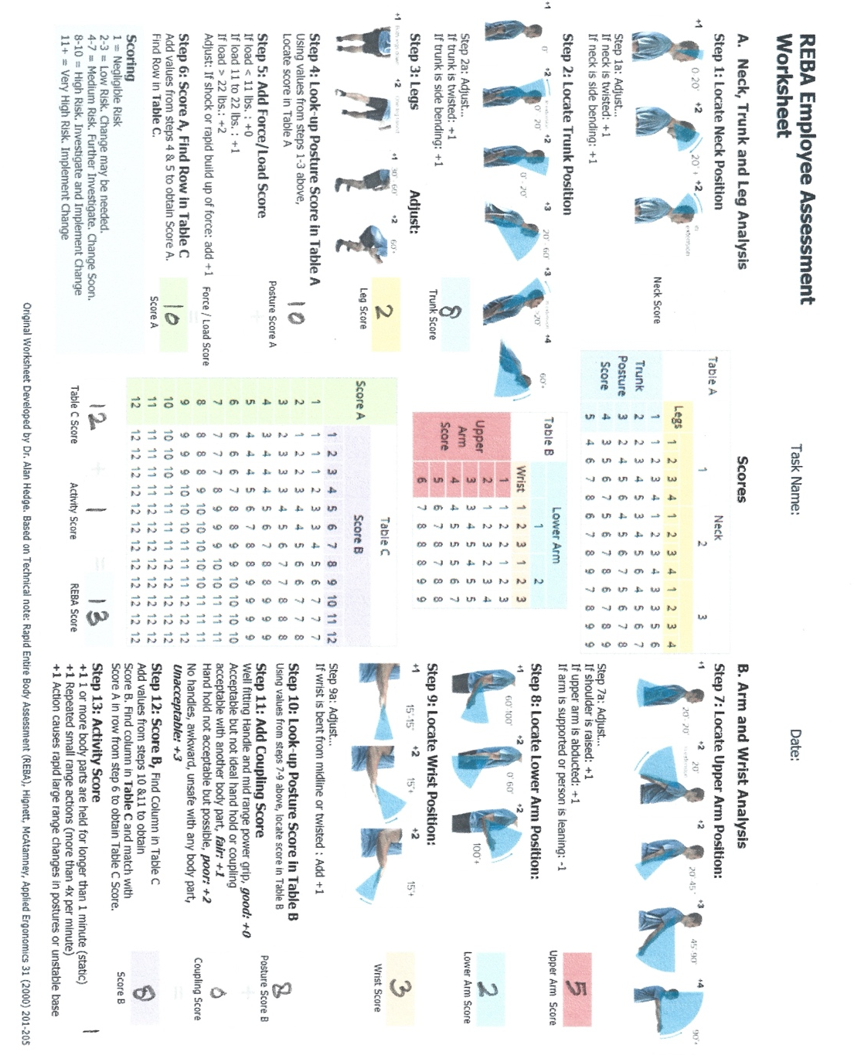

APPENDIX C

APPENDIX D

Score | Level of MSD Risk
1 | Negligible risk, no action required
2 – 3 | Low risk, change may be needed
4 – 7 | Medium risk, further investigation, change soon
8 - 10 | High risk, Investigate and implement change
11+ | Very High risk, implement change

