Supporting Information for
A Novel Mechanism for Intermediate Intra-Slab Earthquakes: Crustal Dense Block Controls in the 2020–2024 San Pedro Seismic Sequence, Chile

Contents of this file

Figure S1 to S4

Tables S1 to S2

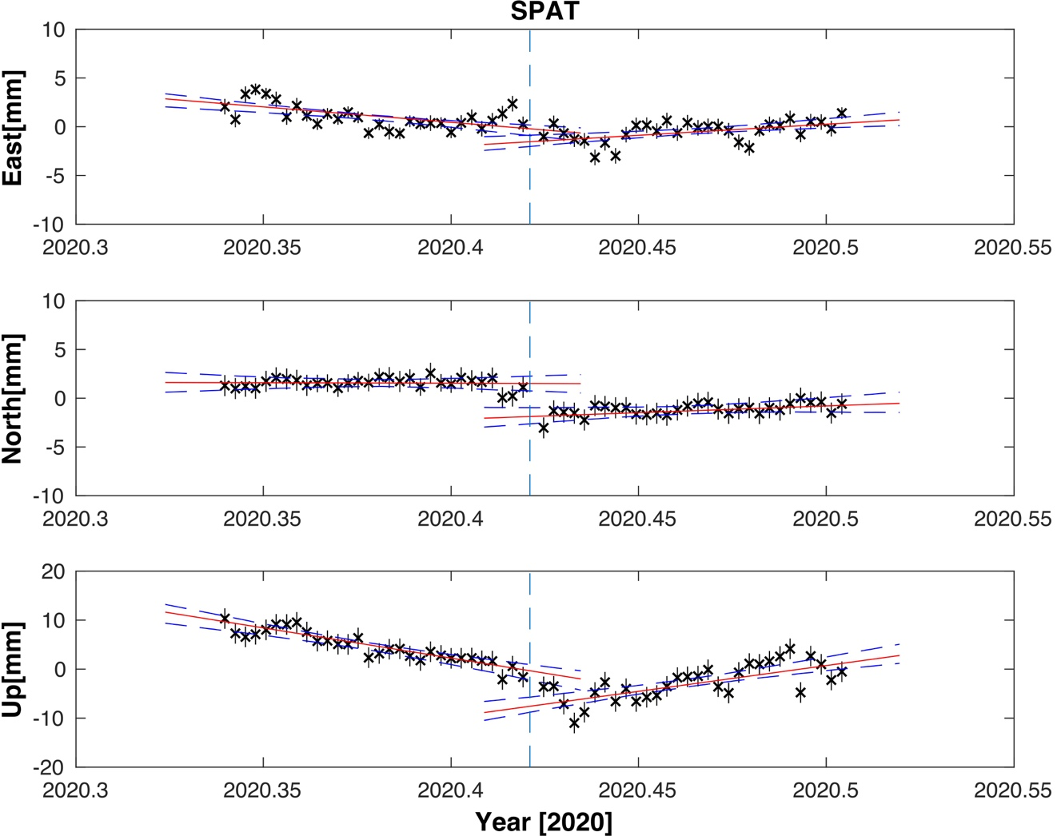
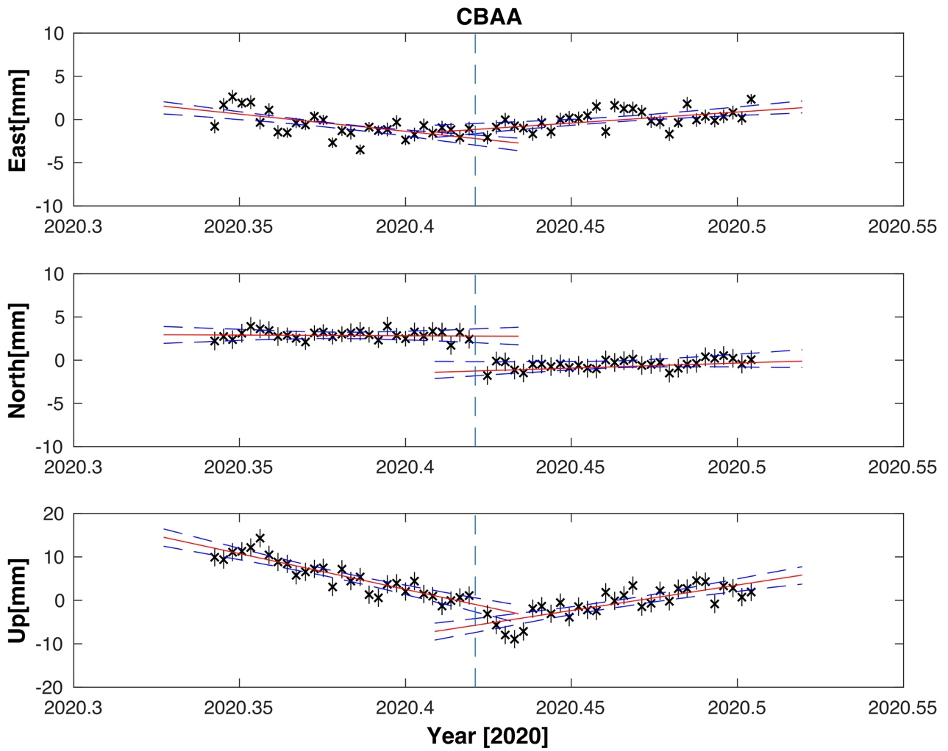
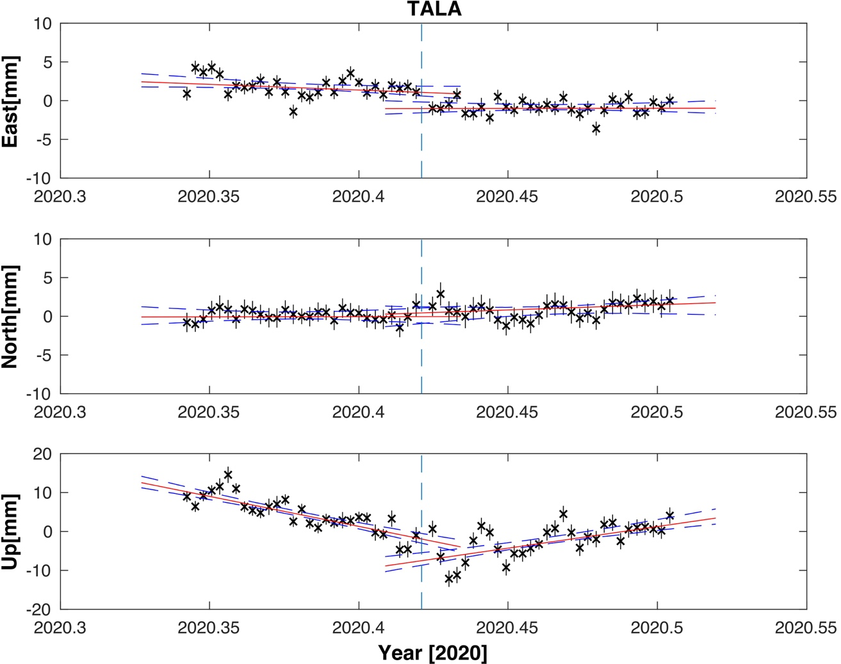
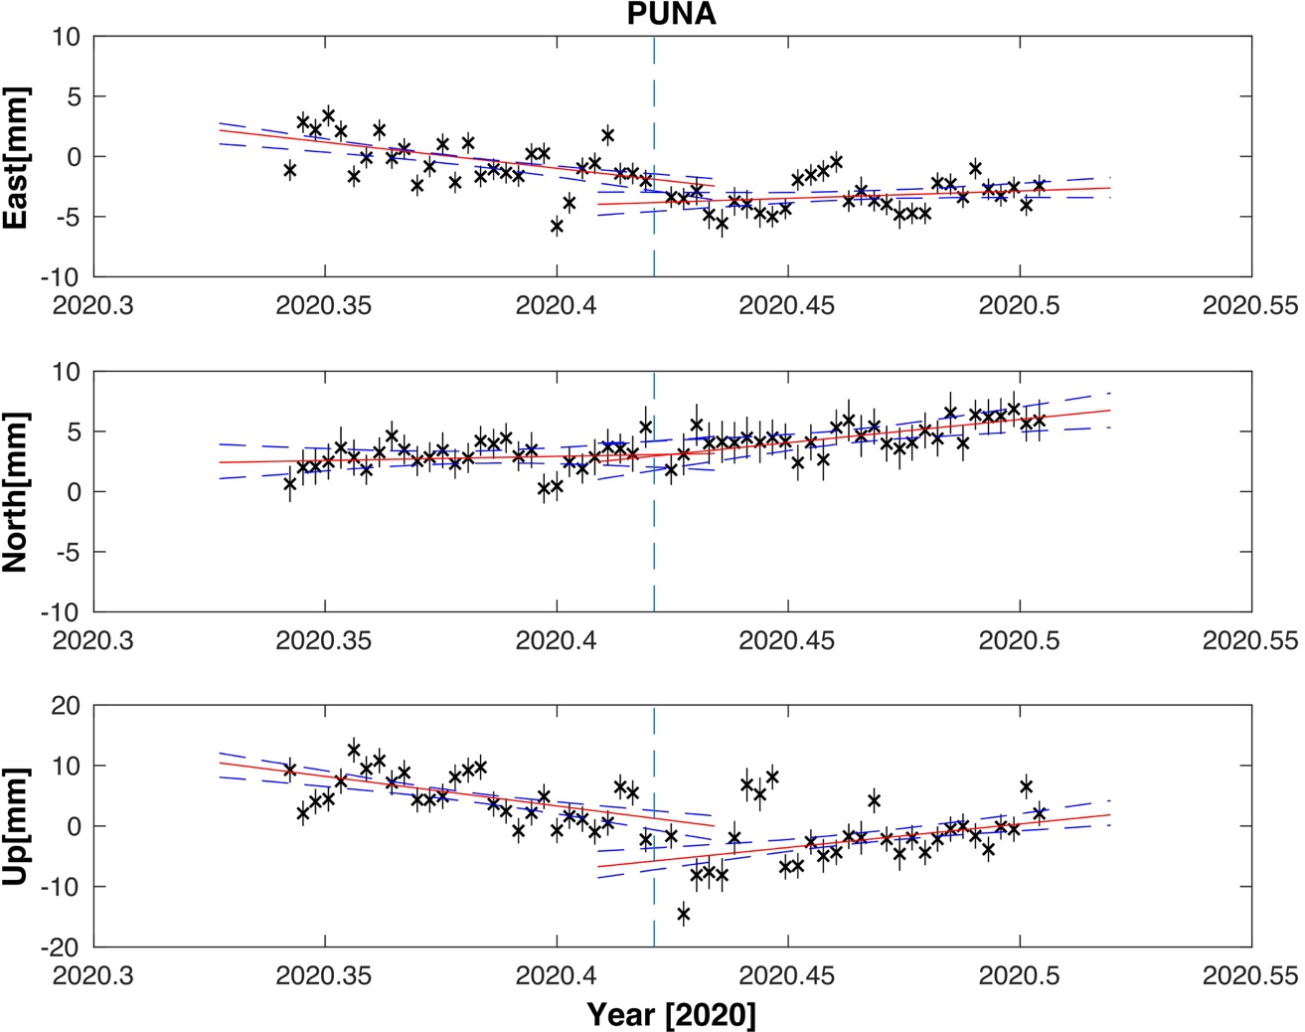
Figure S1: Figures are shown all the GPS time series 30 -days before and 30-days later the San Pedro Earthquake June 3, 2020 repeatability with errors, which we used to represent the East North and vertical deformation.

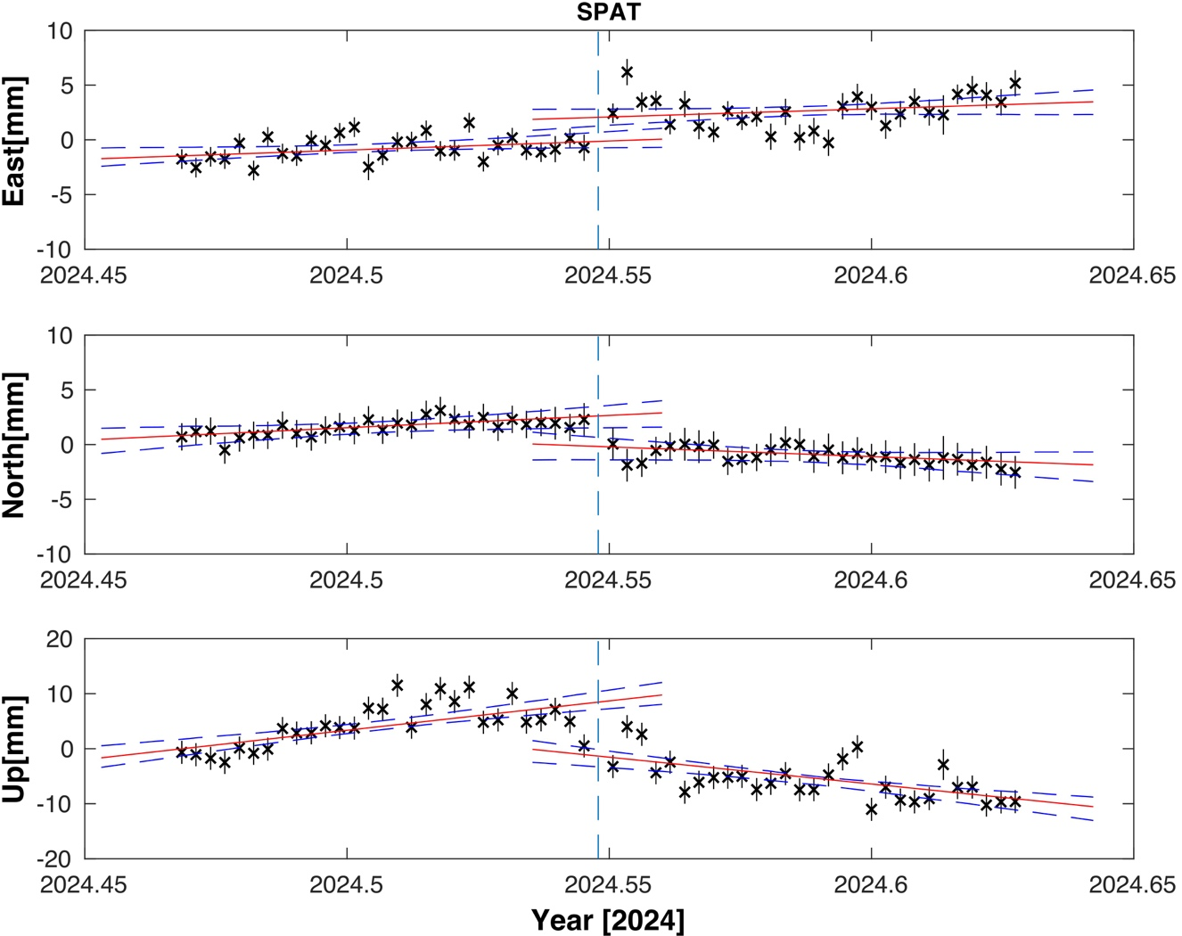
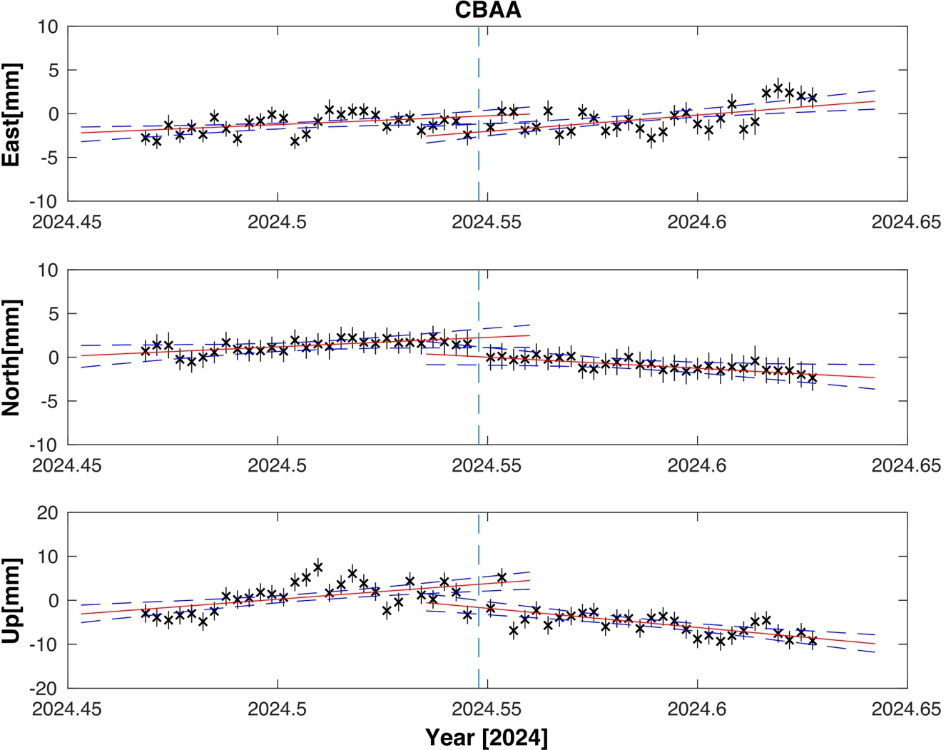
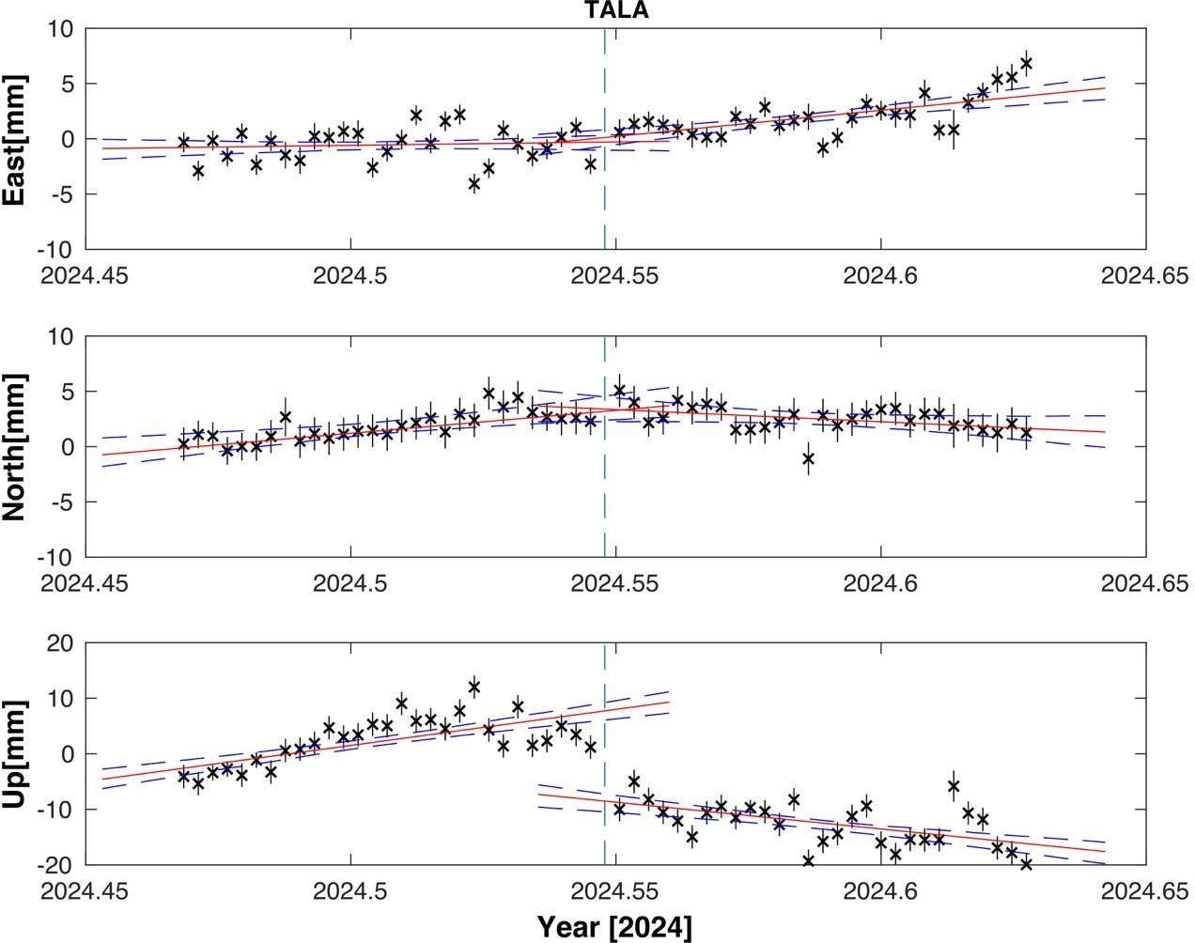
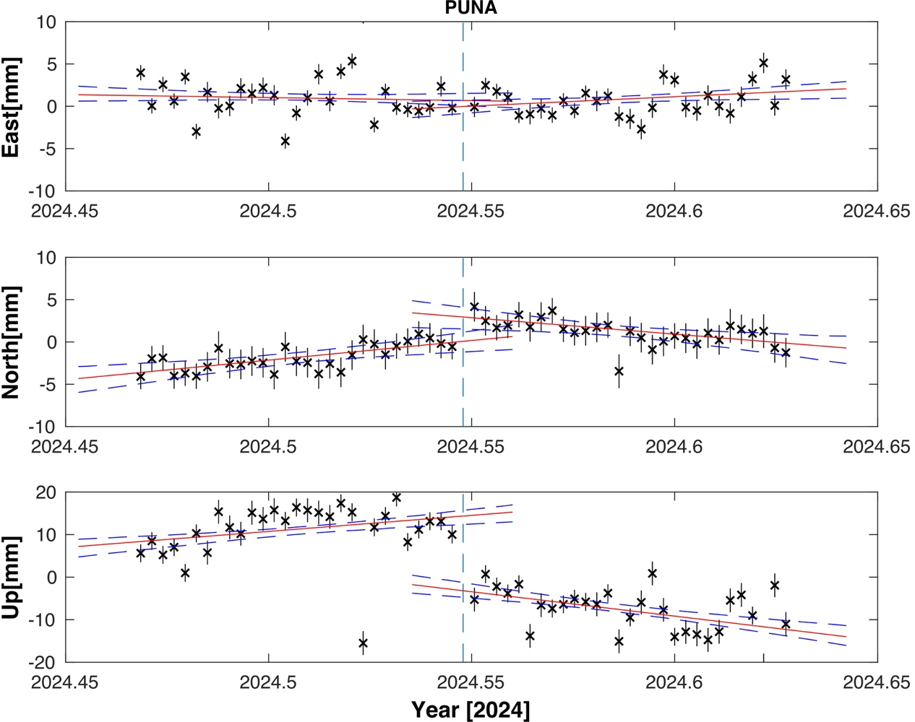

Figure S2: Figures are shown all the GPS time series 30 -days before and 30-days later the San Pedro Earthquake July 19, 2024 repeatability with errors, which we used to represent the East North and vertical deformation.

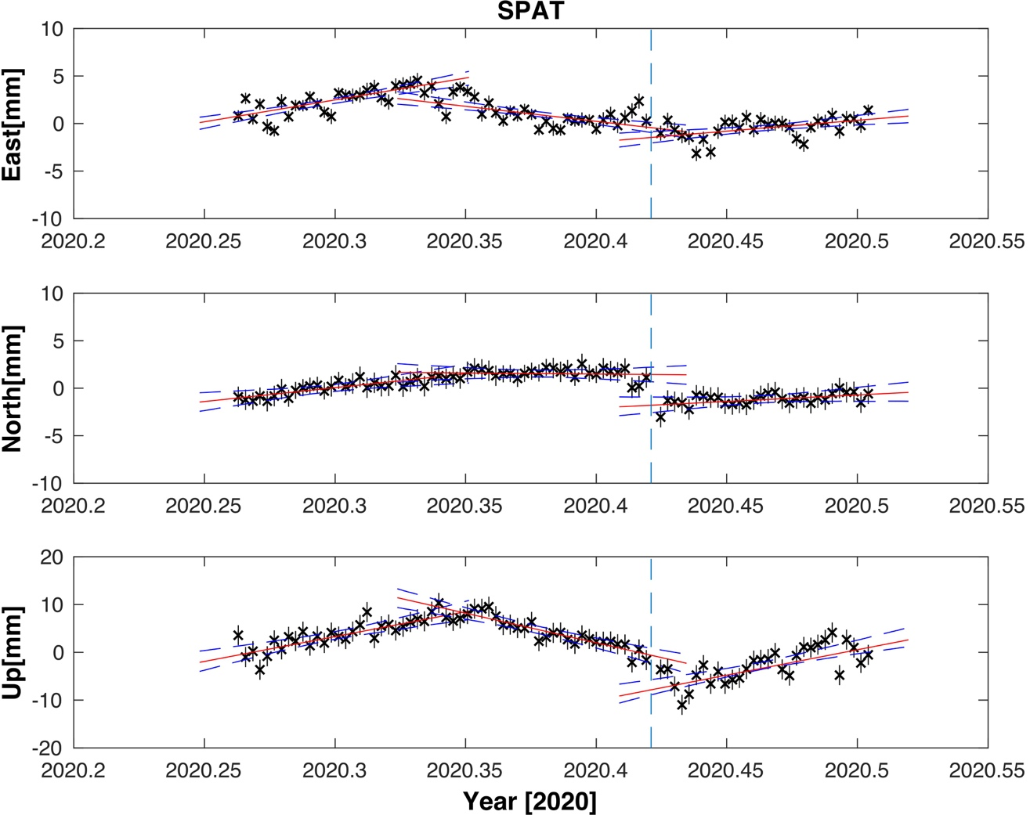
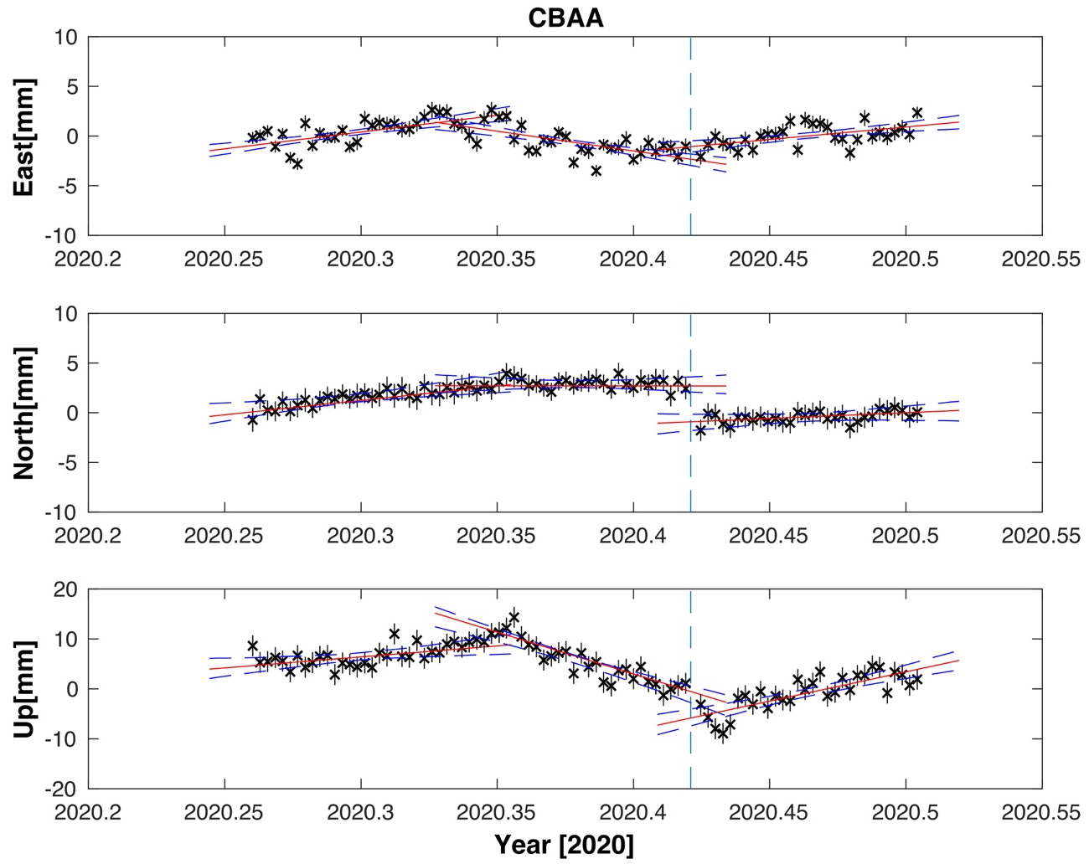
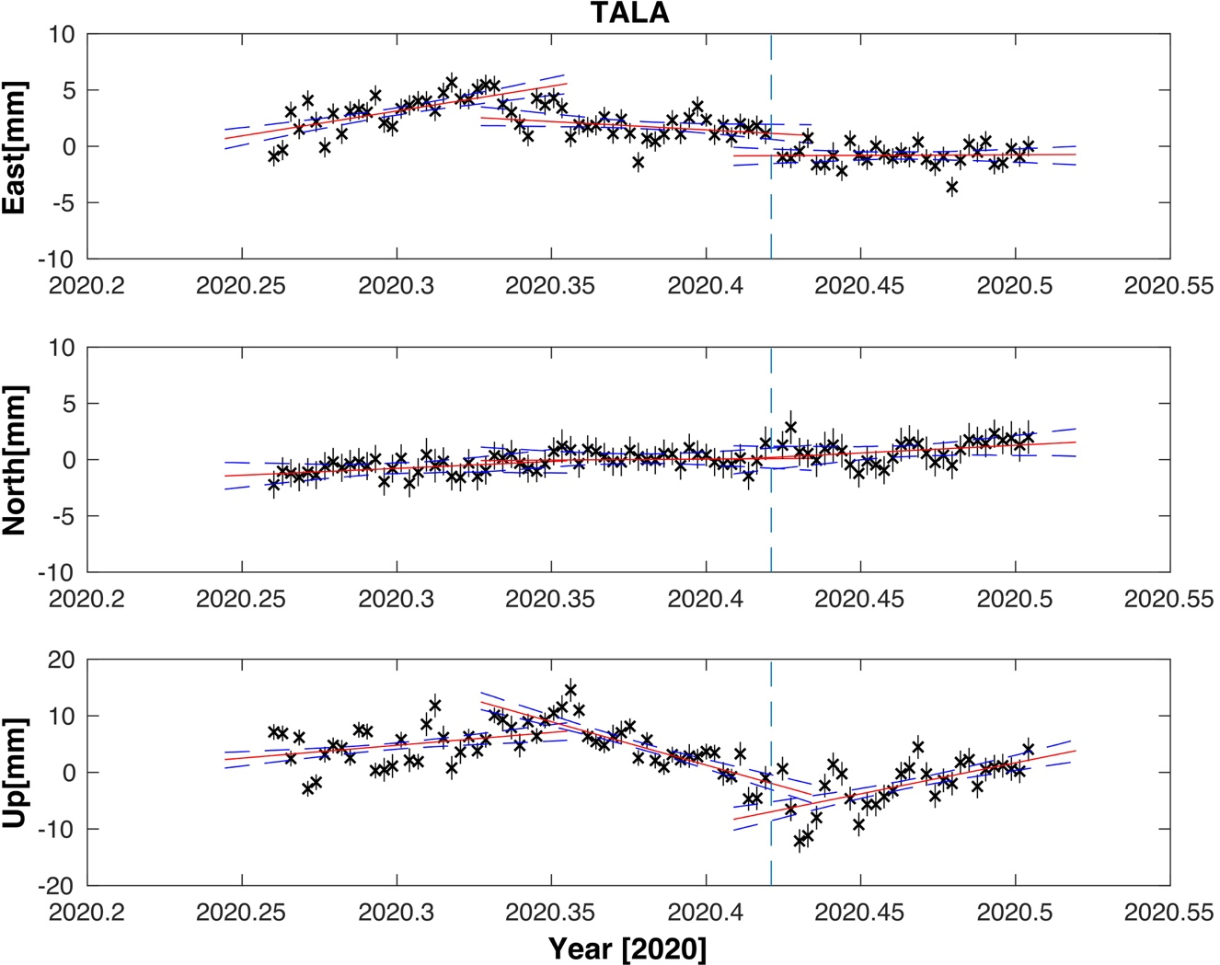
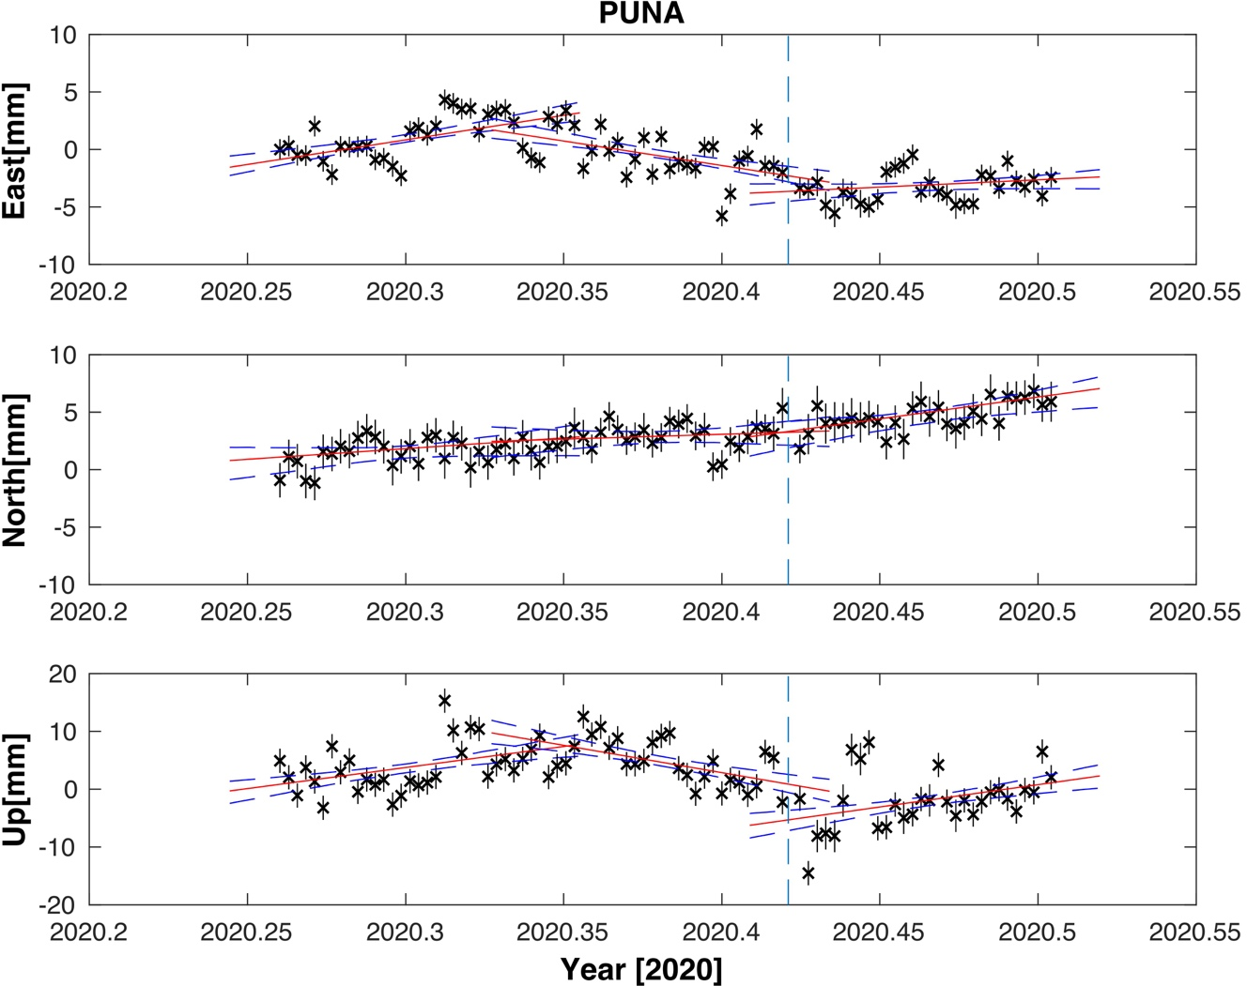
Figure S3: Figures are shown all the GPS time series 60 -days before and 30-days later the San Pedro Earthquake June 3, 2020 repeatability with errors, which we used to represent the East North and vertical deformation.

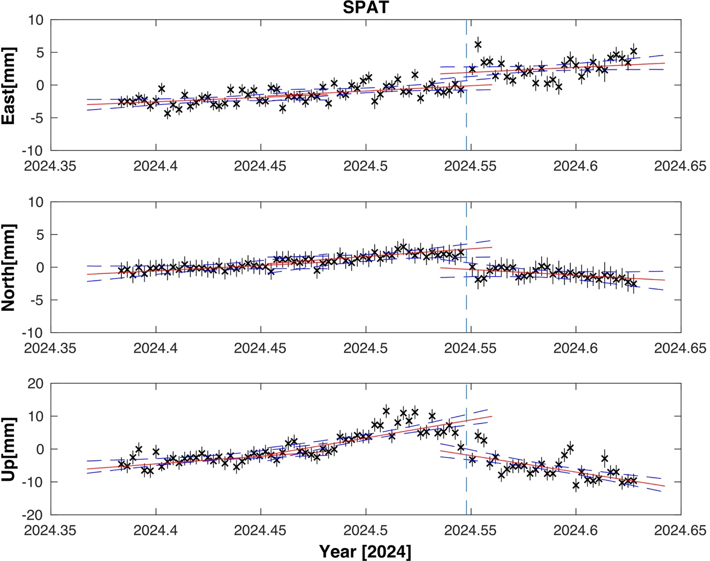
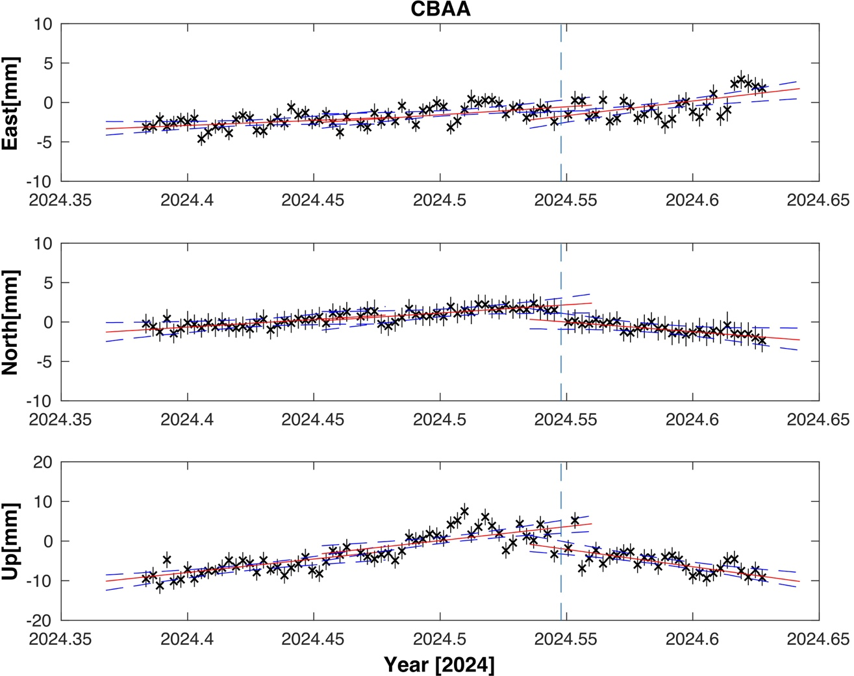
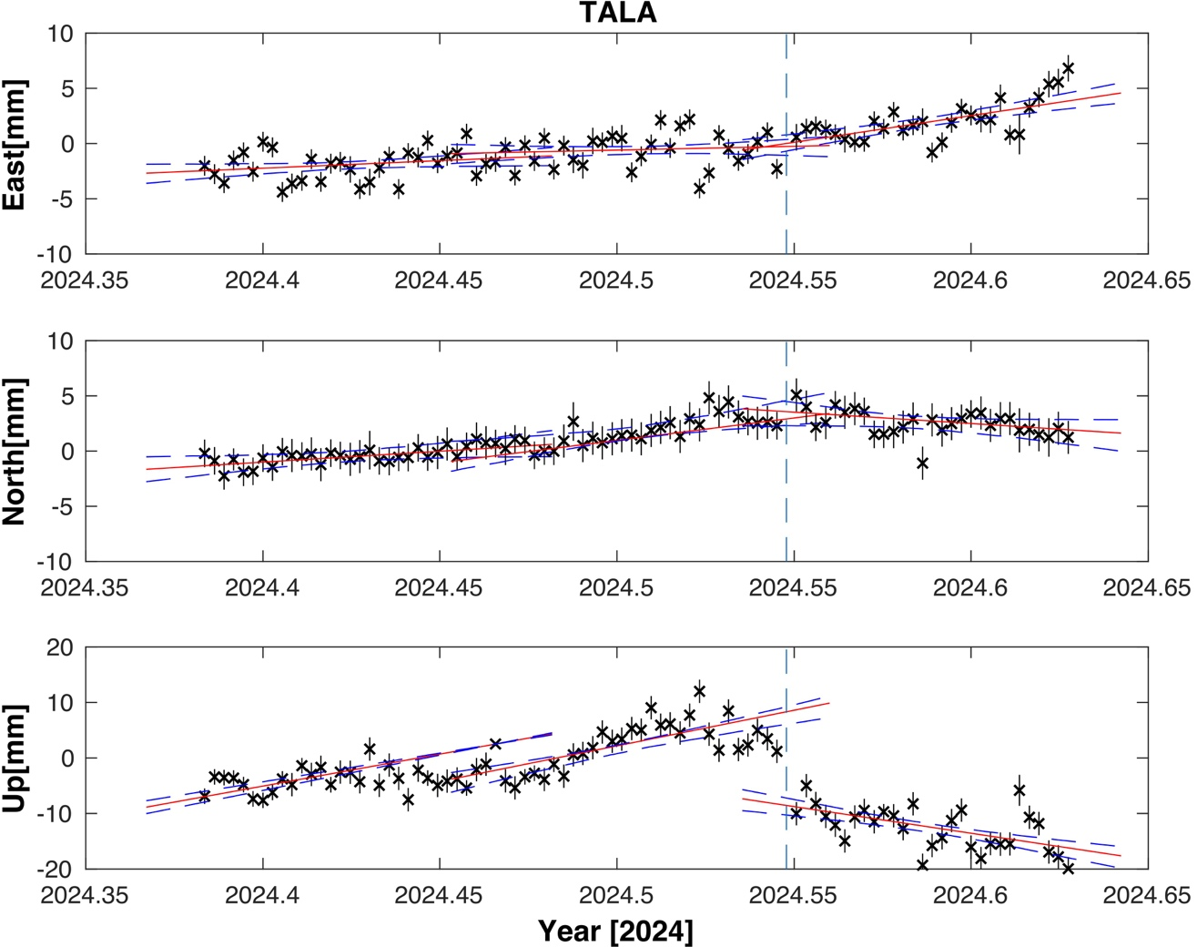
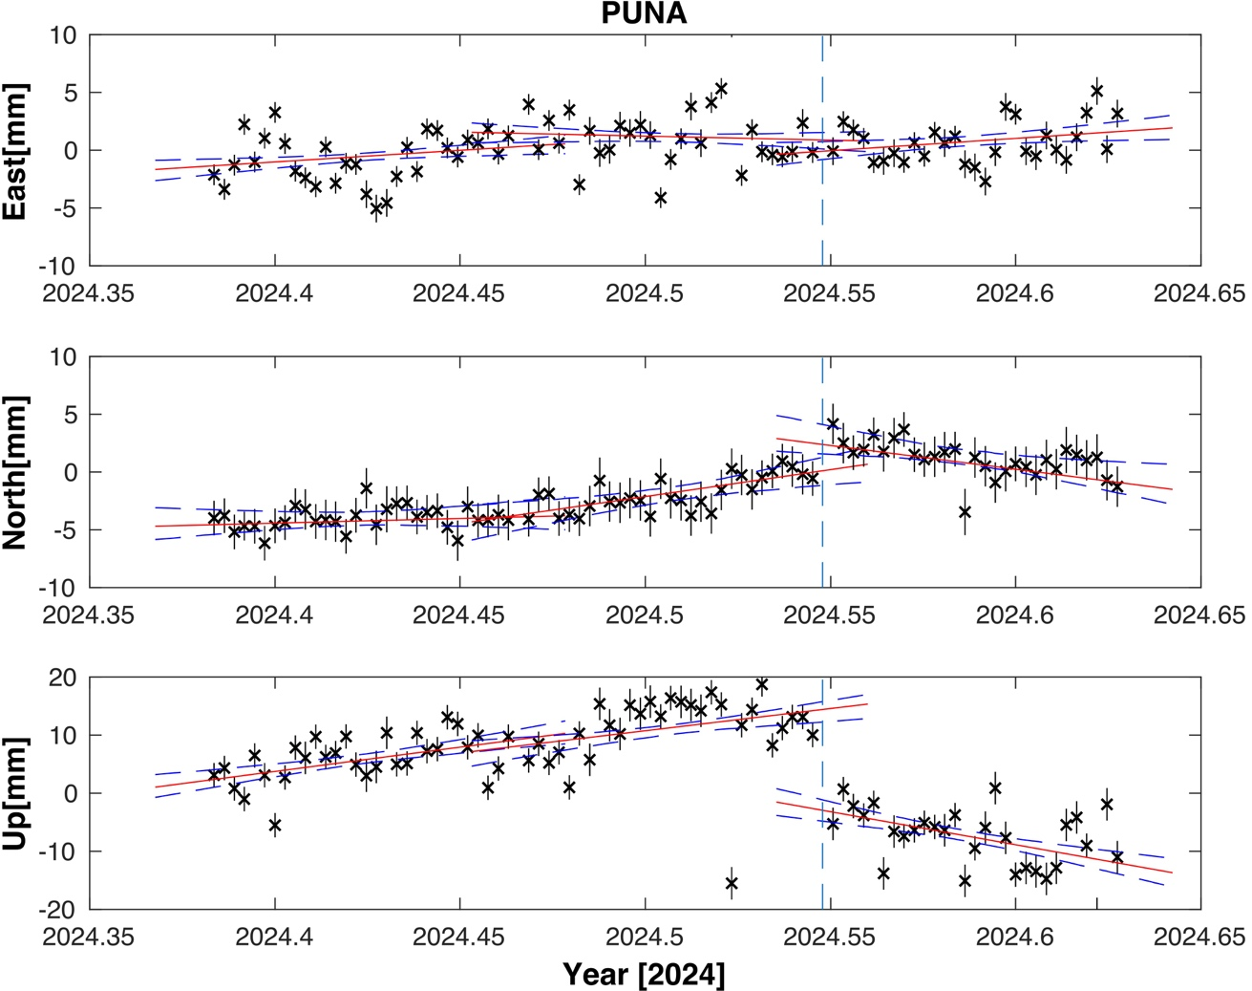
Figure S4: Figures are shown all the GPS time series 60 -days before and 30-days later the San Pedro Earthquake July 19, 2024 repeatability with errors, which we used to represent the East North and vertical deformation.

Table S1: Distance from the epicentre of the San Pedro earthquake June 3, 2020
Sites Name | Longitude | Latitude | Distance(Km)
CBAA | -68.5481 | -22.6464 | 82
SPAT | -68.3588 | -23.0421 | 50
TALA | -67.8975 | -23.3112 | 81
PUNA | -67.8418 | -23.4897 | 87

Table S2: Distance from the epicentre of the San Pedro earthquake July 19, 2024
Sites Name | Longitude | Latitude | Distance(Km)
CBAA | -68.5481 | -22.6464 | 80
SPAT | -68.3588 | -23.0421 | 39
TALA | -67.8975 | -23.3112 | 21
PUNA | -67.8418 | -23.4897 | 40

