Table 1: Population Counts, Detailed Asian Groups 2010 and 2020

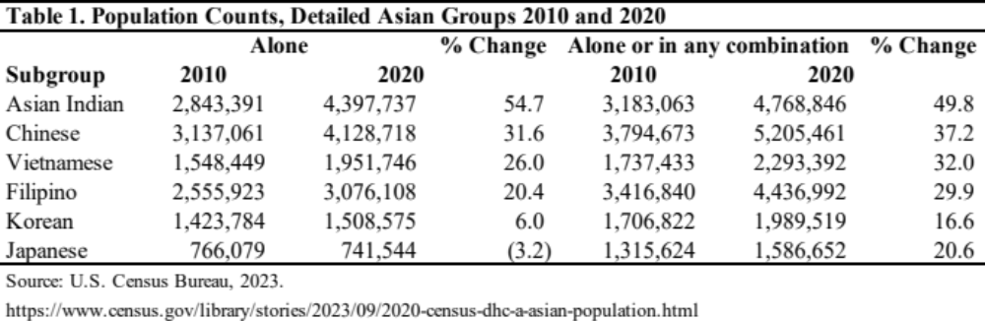
Per the U.S. Census Bureau, the race alone population represents the minimum number of people who identified as that group. It includes those who reported only one response, such as only Fijian. The race alone or in any combination population represents the maximum number of people who identified as that group. It includes those who reported only one response, such as Fijian, and those who reported multiple responses, such as Fijian and Japanese or Fijian and Black or African American.

Table 2(a): Summary Statistics for Individual with One Asian Indian Parent

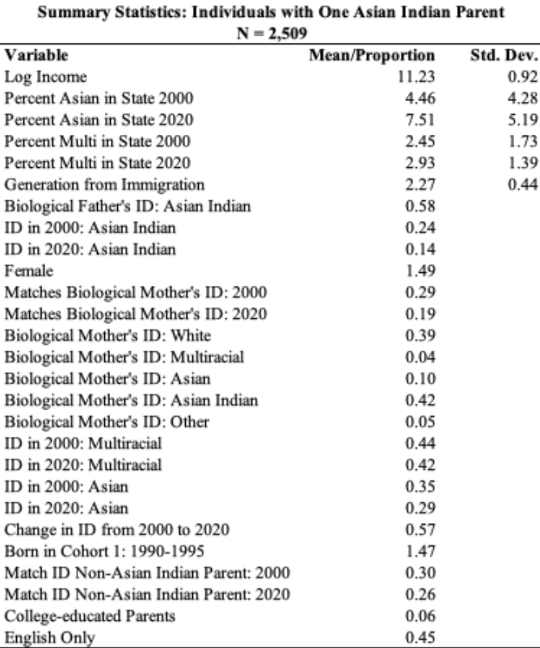

Table 2(b)*: Summary Statistics for Individuals with an Asian Indian and a White Parent

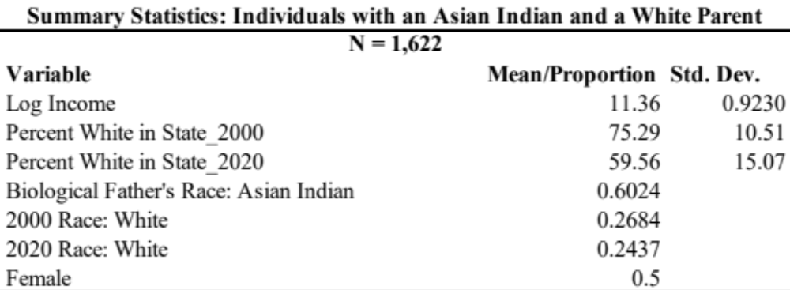
*This sample is a subset of the larger sample.

Table 3: Results of Logit Regression Models Analyzing Identification as Multiracial

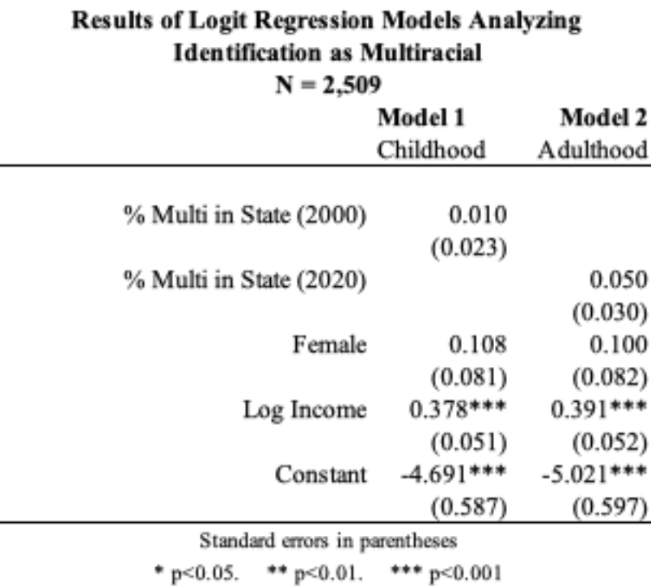

Table 4: Results of Logit Regression Models Analyzing Identification as Asian

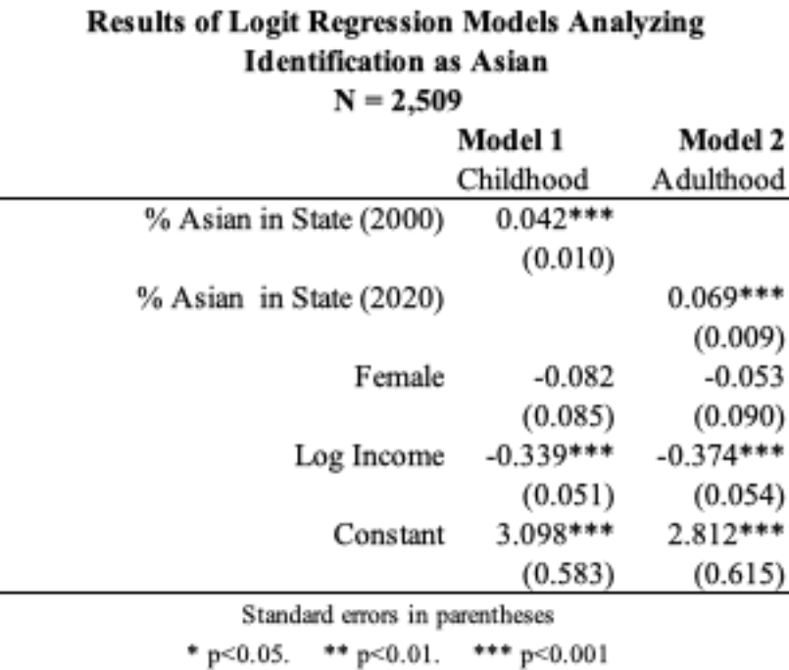

Table 5: Results of Logit Regression Models Analyzing Identification at White

