Supplemental Tables and Figures

Table S1. Separate spreadsheet

Table S2. Modified Leach grading of adhesions
Severity of adhesion
No adhesion | 0
Filmy avascular | 1
Vascular opaque | 2
Cohesive attachment | 3

Table S3. Verhofstad scale for grading of histologic changes
Score | Necrosis | PMNs | Lymphocytes | Macrophages | Oedema | ME | SML
0 | None | Normal number | Normal number | Normal number | None | Normal glandular | Good bridging
1 | Small patches | Slight increase | Slight increase | Slight increase | Some | Normal cubic | Average bridging
2 | Some patches | Marked infiltration | Marked infiltration | Marked infiltration | Marked | Incomplete cubic | Poor bridging
3 | Massive | Massive infiltration | Massive infiltration | Massive infiltration | Severe | Absent | No bridging
PMNs = Polymorphonuclear cells
ME = Mucosal epithelium
SML = Submucosal muscular layer

Table S4. Separate spreadsheet

Table S5. Separate spreadsheet

Figure S1
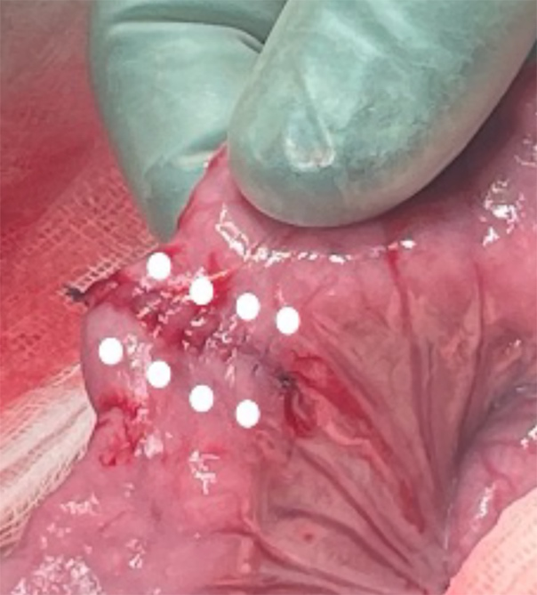
Figure S1. Anastomotic injections sites. White dots indicate the predefined sites for subserosal injections of aethoxysklerol, anti-MFAP4 or control treatments in a surgical anastomosis. Eight out of a total of 16 deposits are shown.

Figure S2
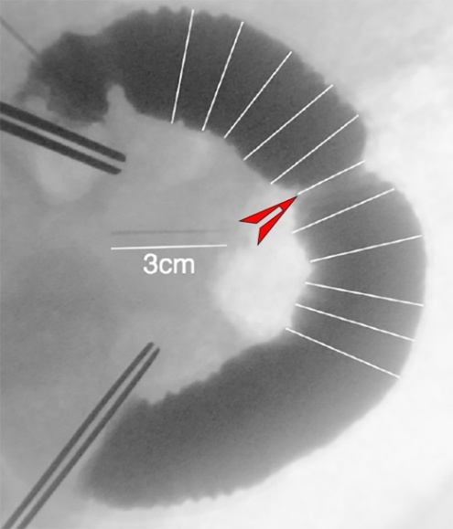
Figure S2. Radiological image of anastomosis used for assessment of anastomotic index. Representative wound contraction (red arrow head). A needle is used as scale (3 cm white bar).

Figure S3
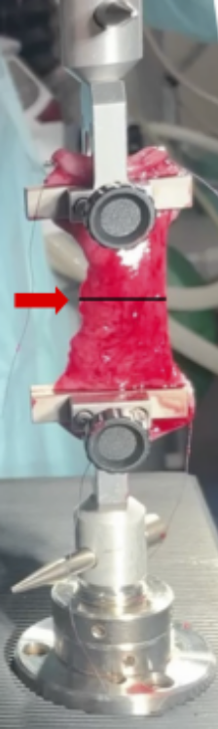
Figure S3. Maximal anastomotic tensile strength test. The red arrow indicates the anastomotic line. The position of the clamps was in a distance of 6 cm with the anastomosis placed in the center. The segment was gradually stretched at a constant deformation rate of 15 mm/min until rupture occurred.

Figure S4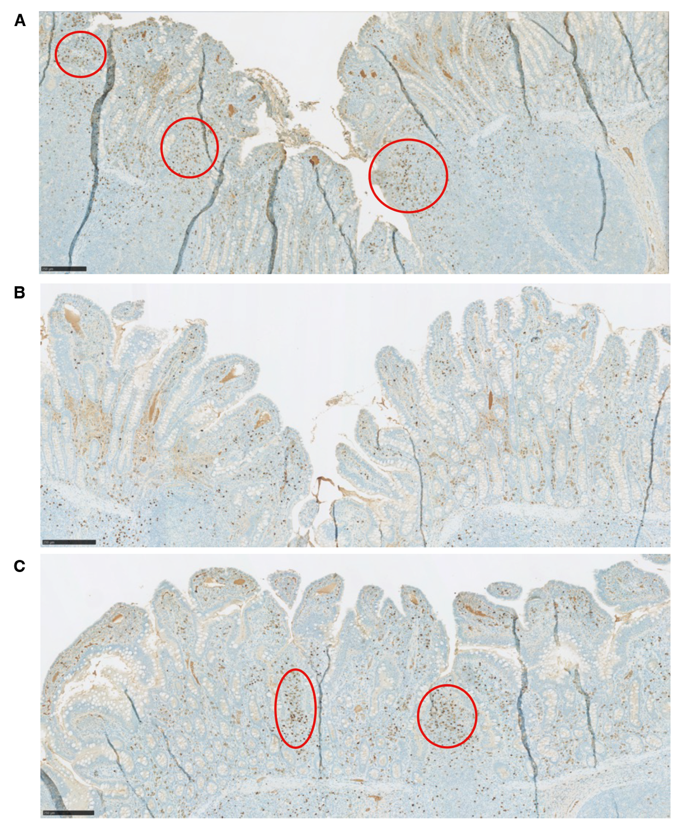
Figure S4. Regulatory T-cells in anastomotic lamina propria in different treatment groups. Representative FOXP3-stained tissue sections from (A) anakinra-, (B) vehicle-, and (C) anti-MFAP4-treated anastomoses. Red circles show areas enriched in FOXP3-positive cells. Anakinra, vehicle and anti-MFAP4 were locally injected 14-days post-surgery in the 28-days study.
Bars are 250 µm.

