Supplementary Material
The role of broadleaved hedgerows and landscape composition for biodiversity conservation in a pine plantation context
Nattan Platª, Eric Allan^{bc}, Severin Jouveauª, Olivier Bonnardª, Jean-Baptiste Rivoalª, Jennifer Duditª, Tom Barlierª, Yohan Charbonnier^{d}, Mathieu Sannier^{d}, Irene Garcia-Celada^{d}, Inge van Halderª & Hervé Jactelª
Affiliations:
ªUniversity of Bordeaux, INRAE, BIOGECO, 69 route d’Arcachon 33610, Cestas, France
nattan.plat@hotmail.com; severin.jouveau@inrae.fr ; olivier.bonnard@inrae.fr ; jean-baptiste.rivoal@inrae.fr ; jennifer.dudit@inrae.fr ; tom.barlier@inrae.fr ; inge.van-halder@inrae.fr; herve.jactel@inrae.fr
^{b}Institute for Plant Sciences (IPS), University of Bern, Bern, Switzerland
^{c}Centre for Development and Environment, University of Bern, Bern, Switzerland
eric.allan@unibe.ch
^{d}Ligue pour la Protection des Oiseaux, Bourrou, France
yohan.charbonnier@lpo.fr
ORCID number of the authors:
Nattan Plat: 0009-0002-8272-8013 Eric Allan: 0000-0001-9641-9436
Inge van Halder: 0000-0003-3244-4338 Hervé Jactel: 0000-0002-8106-5310
Tom Barlier: 0009-0005-7854-3122
Corresponding author: Nattan Plat, +33638390540, nattan.plat@hotmail.com

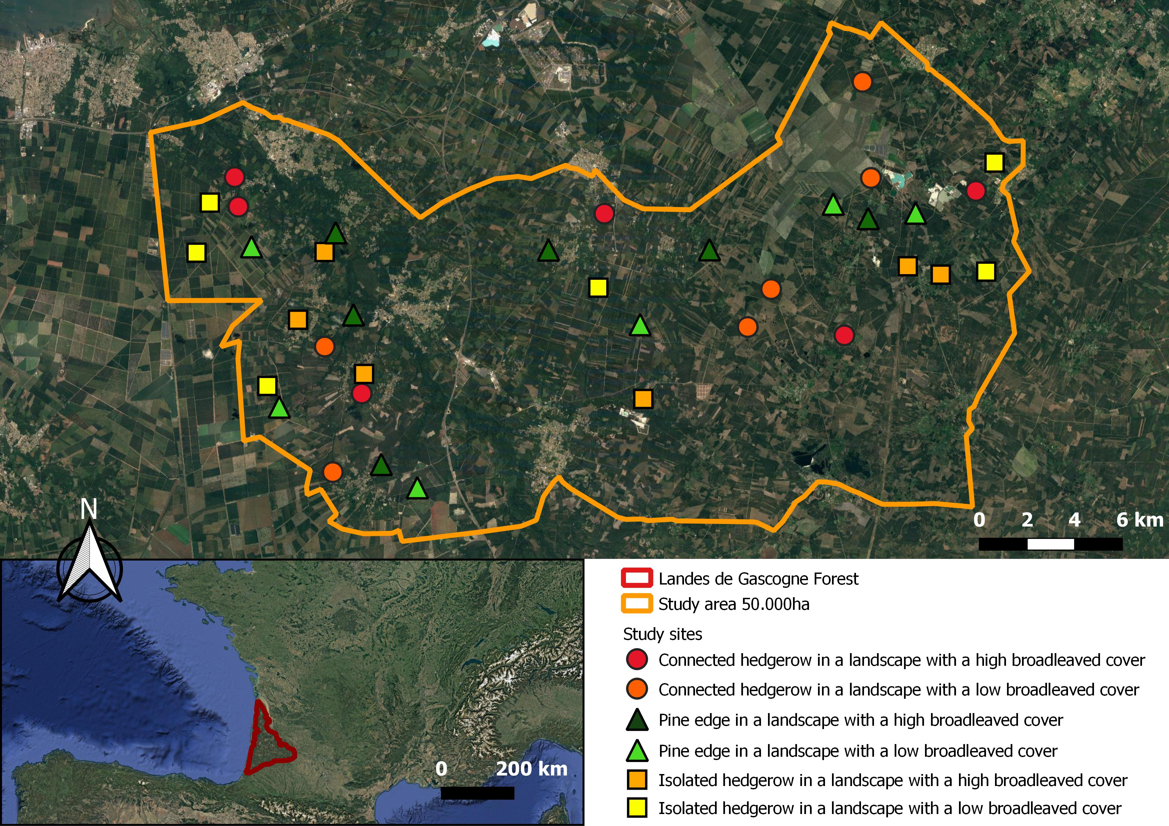
Figure S1 : Map of the study area (50 000ha). Circles, triangles and squares show the location of study sites and the corresponding modalities. Bottom left map shows the location of the “Landes de Gascogne Forest” in southwest Europe. The background map comes from Google Map (Google Maps, 2025).

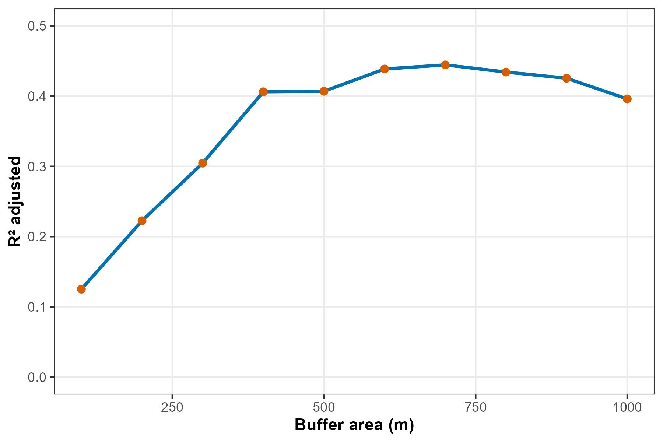
Figure S2: Correlation between buffer area and R² adjusted. Each red point correspond to one of the 10 linear models using multidiversity as a response variable, with broadleaved cover measured at buffer distances ranging from 100 m to 1000 m in 100 m increments as explanatory variable.

Table S1: Summary of LM testing the correlation between the broadleaved cover in a 500m buffer and the broadleaved cover in buffers from 400 to 1000m. Significant variables are indicated in bold. Sample size was n=36 sites.
Response variable | Predictors | x2 | Df | Coeff. ± SE | P | R² adj
Broadleaved cover in a 500m buffer | Broadleaved cover in a 400m buffer | 2773 | 1 | 1.14 ± 0.04 | <0.001 | 0.94
Broadleaved cover in a 500m buffer | Broadleaved cover in a 600m buffer | 2858 | 1 | 0.97 ± 0.02 | <0.001 | 0.97
Broadleaved cover in a 500m buffer | Broadleaved cover in a 700m buffer | 2701 | 1 | 0.98 ± 0.05 | <0.001 | 0.92
Broadleaved cover in a 500m buffer | Broadleaved cover in a 800m buffer | 2500 | 1 | 0.97 ± 0.07 | <0.001 | 0.84
Broadleaved cover in a 500m buffer | Broadleaved cover in a 900m buffer | 2320 | 1 | 0.97 ± 0.08 | <0.001 | 0.78
Broadleaved cover in a 500m buffer | Broadleaved cover in a 1000m buffer | 2234 | 1 | 0.99 ± 0.09 | <0.001 | 0.75

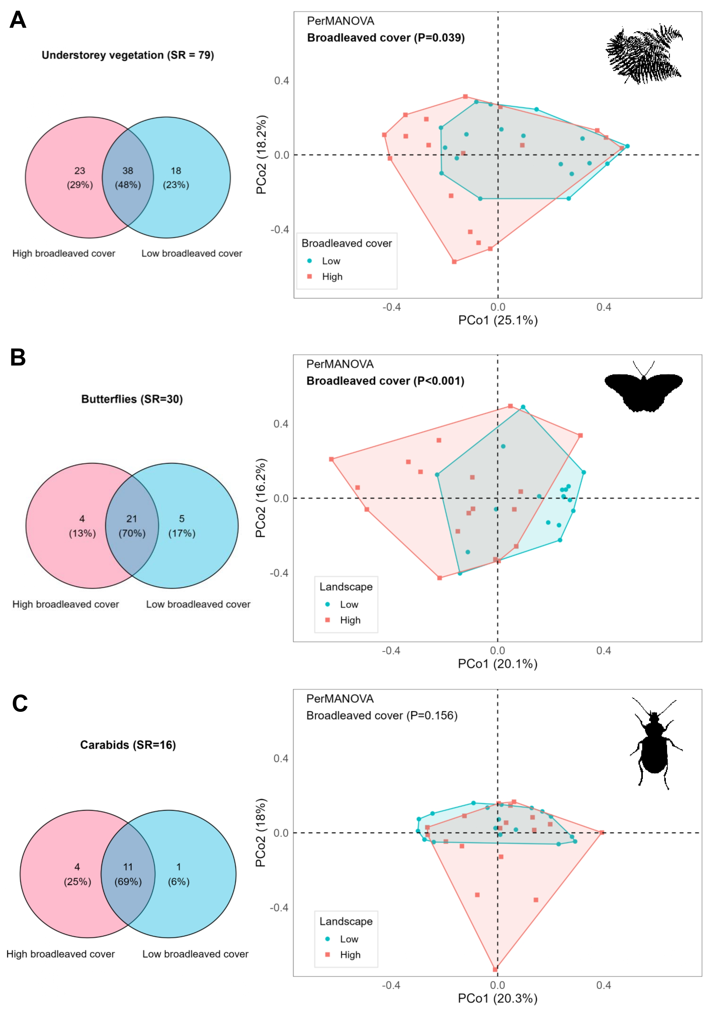
Figure S3 : Venn diagrams showing species presence in each broadleaved cover modality and PCoA showing difference between study sites communities depending on broadleaved cover modality and for (A) understorey vegetation, (B) butterflies, (C) carabids, (D) spiders, (E) birds and (F) reptiles. Significant differences in community composition were tested using PerMANOVAs. Communities are based on Bray Curtis dissimilarity matrix with Hellinger transformation. Sample size was n=36 sites.
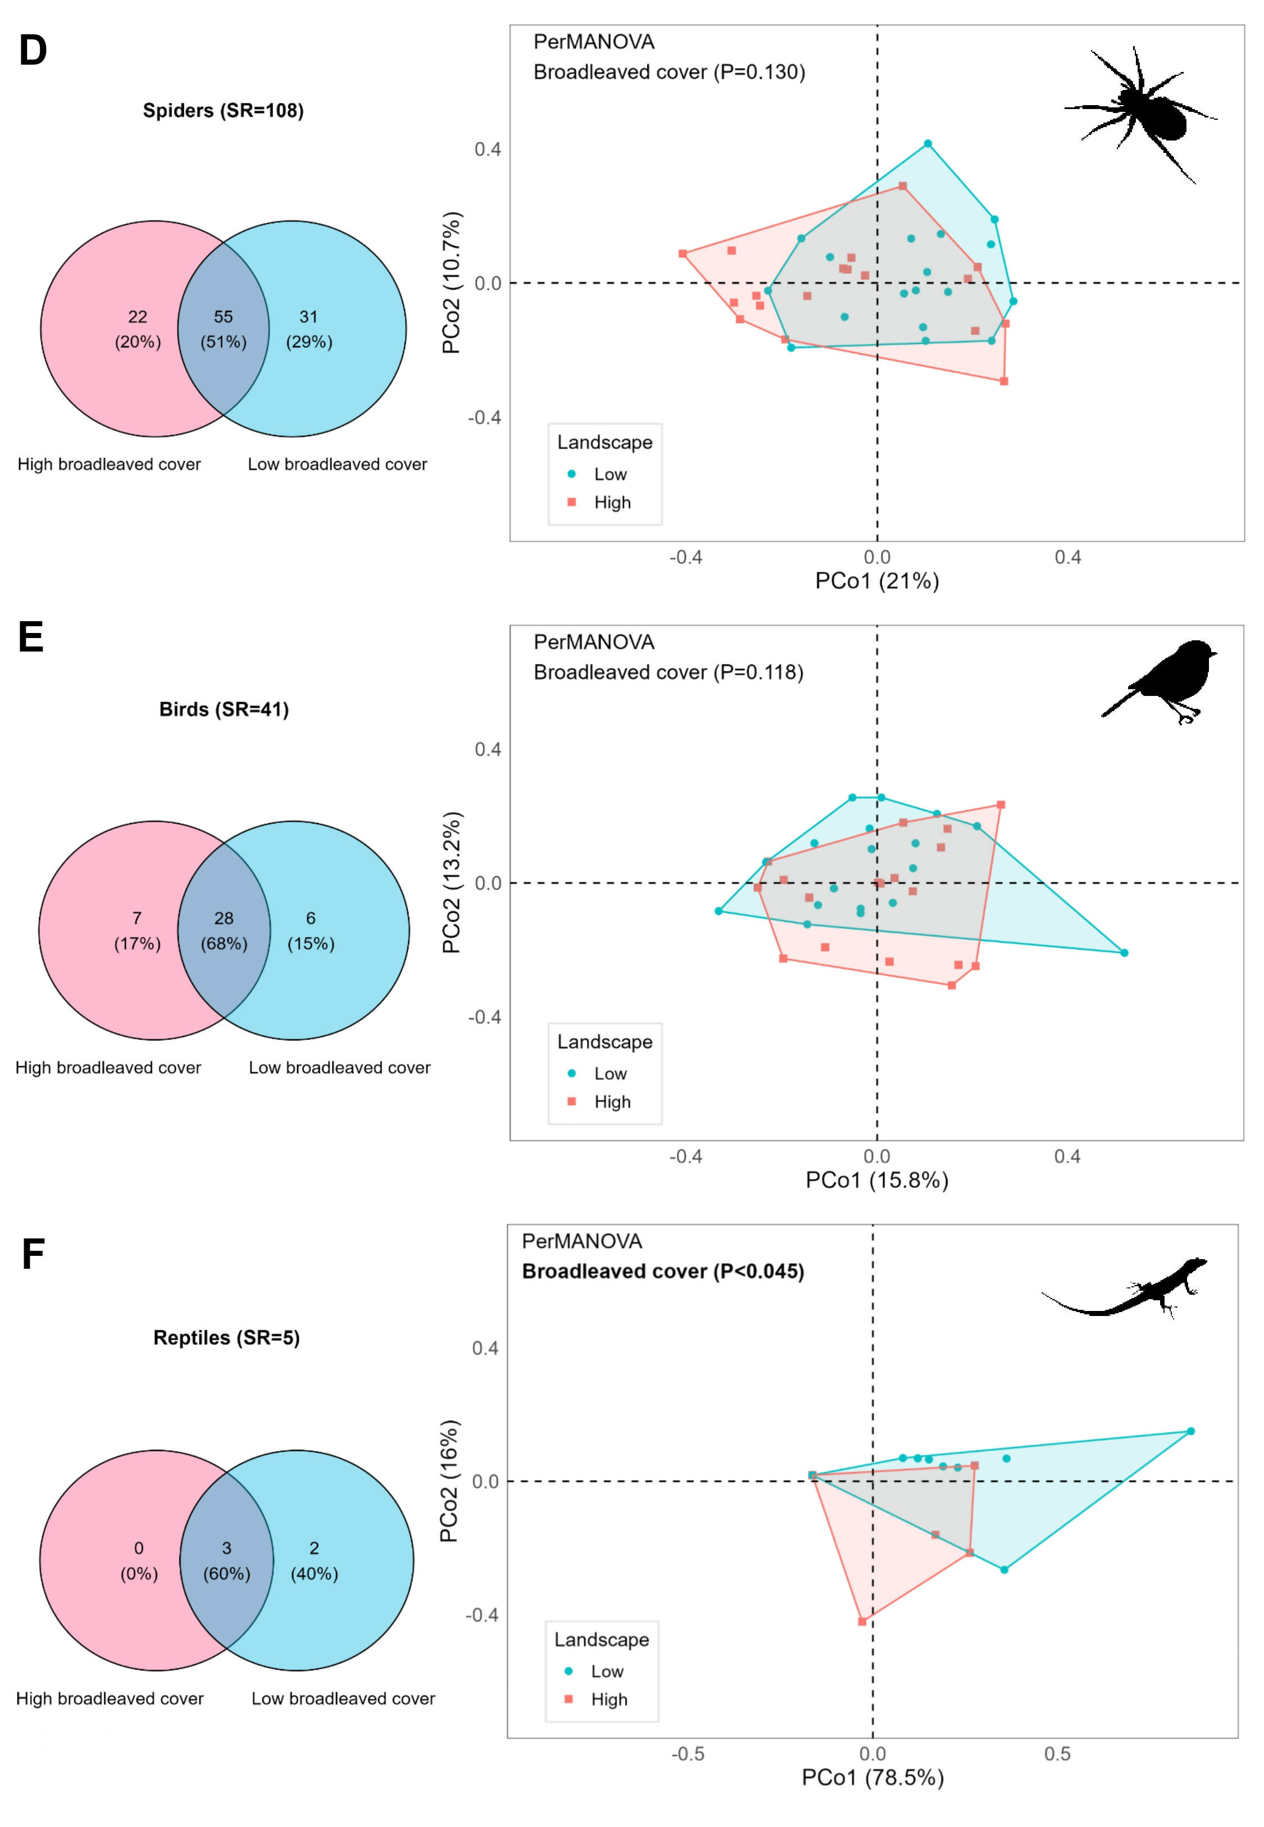

Table S2 : List of species identified in the Living Lab based on a multi-taxonomic sampling (6 groups) of 36 study sites.
Group | Genus | Species | Forest species | Redlist Category | Dominance
Bird | Anthus | trivialis | 0 | Least Concern | Locally dominant
Bird | Columba | palumbus | 0 | Least Concern | Locally dominant
Bird | Dendrocopos | major | 1 | Least Concern | Locally dominant
Bird | Dryocopus | martius | 1 | Least Concern | Locally dominant
Bird | Hirundo | rustica | 0 | Least Concern | Locally dominant
Bird | Lophophanes | cristatus | 1 | Least Concern | Locally dominant
Bird | Luscinia | megarhynchos | 0 | Least Concern | Locally dominant
Bird | Parus | major | 0 | Least Concern | Locally dominant
Bird | Phoenicurus | phoenicurus | 0 | Least Concern | Rare
Bird | Picus | viridis | 0 | Least Concern | Locally dominant
Bird | Regulus | ignicapilla | 1 | Least Concern | Locally dominant
Bird | Streptopelia | decaocto | 0 | Least Concern | Locally dominant
Bird | Sylvia | atricapilla | 0 | Least Concern | Locally dominant
Bird | Turdus | merula | 0 | Least Concern | Locally dominant
Bird | Turdus | philomelos | 1 | Least Concern | Locally dominant
Bird | Turdus | viscivorus | 1 | Least Concern | Locally dominant
Bird | Upupa | epops | 0 | Least Concern | Locally dominant
Bird | Aegithalos | caudatus | 0 | Least Concern | Rare
Bird | Alauda | arvensis | 0 | Least Concern | Rare
Bird | Buteo | buteo | 0 | Least Concern | Rare
Bird | Certhia | brachydactyla | 1 | Least Concern | Rare
Bird | Corvus | corone | 0 | Least Concern | Rare
Bird | Curruca | undata | 0 | Near Threatened | Rare
Bird | Cyanistes | caeruleus | 0 | Least Concern | Rare
Bird | Garrulus | glandarius | 0 | Least Concern | Rare
Bird | Hippolais | polyglotta | 0 | Least Concern | Rare
Bird | Locustella | naevia | 0 | Least Concern | Rare
Bird | Lullula | arborea | 0 | Least Concern | Rare
Bird | Phasianus | colchicus | 0 | Least Concern | Rare
Bird | Phylloscopus | bonelli | 1 | Least Concern | Rare
Bird | Pica | pica | 0 | Least Concern | Rare
Bird | Prunella | modularis | 0 | Least Concern | Rare
Bird | Pyrrhula | pyrrhula | 1 | Least Concern | Rare
Bird | Sitta | europaea | 1 | Least Concern | Rare
Bird | Streptopelia | turtur | 0 | Vulnerable | Rare
Bird | Sylvia | communis | 0 | Least Concern | Rare
Bird | Cuculus | canorus | 0 | Least Concern | Regionally dominant
Bird | Erithacus | rubecula | 1 | Least Concern | Regionally dominant
Bird | Fringilla | coelebs | 0 | Least Concern | Regionally dominant
Bird | Phylloscopus | collybita | 1 | Least Concern | Regionally dominant
Bird | Troglodytes | troglodytes | 1 | Least Concern | Regionally dominant
Butterfly | Argynnis | paphia | 1 | Least Concern | Rare
Butterfly | Coenonympha | arcania | 0 | Least Concern | Rare
Butterfly | Celastrina | argiolus | 0 | Least Concern | Rare
Butterfly | Coenonympha | oedippus | 0 | Near Threatened | Locally dominant
Butterfly | Coenonympha | pamphilus | 0 | Least Concern | Locally dominant
Butterfly | Euphydryas | aurinia | 0 | Least Concern | Locally dominant
Butterfly | Gonepteryx | rhamni | 0 | Least Concern | Locally dominant
Butterfly | Hipparchia | semele | 0 | Least Concern | Rare
Butterfly | Lasiommata | megera | 0 | Least Concern | Rare
Butterfly | Limenitis | reducta | 1 | Least Concern | Rare
Butterfly | Melitaea | athalia | 0 | Least Concern | Rare
Butterfly | Minois | dryas | 0 | Least Concern | Locally dominant
Butterfly | Pararge | aegeria | 1 | Least Concern | Rare
Butterfly | Quercusia | quercus | 1 | Least Concern | Rare
Butterfly | Thymelicus | sylvestris | 0 | Vulnerable | Rare
Butterfly | Aricia | agestis | 0 | Least Concern | Rare
Butterfly | Brintesia | circe | 0 | Least Concern | Rare
Butterfly | Cupido | argiades | 0 | Least Concern | Rare
Butterfly | Colias | crocea | 0 | Least Concern | Rare
Butterfly | Heteropterus | morpheus | 0 | Least Concern | Rare
Butterfly | Lampides | boeticus | 0 | Least Concern | Rare
Butterfly | Melanargia | galathea | 0 | Least Concern | Rare
Butterfly | Satyrium | ilicis | 1 | Least Concern | Rare
Butterfly | Ochlodes | sylvanus | 0 | Least Concern | Rare
Butterfly | Polyommatus | icarus | 0 | Least Concern | Rare
Butterfly | Pieris | napi | 0 | Least Concern | Rare
Butterfly | Vanessa | atalanta | 0 | Least Concern | Rare
Butterfly | Lycaena | phlaeas | 0 | Least Concern | Regionally dominant
Butterfly | Maniola | jurtina | 0 | Least Concern | Regionally dominant
Butterfly | Pyronia | tithonus | 0 | Least Concern | Regionally dominant
Carabid | Abax | parallelepipedus | 1 | NA | Locally dominant
Carabid | Amara | Spp. | 0 | NA | Rare
Carabid | Carabus | granulatus | 1 | NA | Rare
Carabid | Carabus | nemoralis | 0 | NA | Locally dominant
Carabid | Harpalus | rubripes | 0 | NA | Rare
Carabid | Harpalus | rufipalpis | 0 | NA | Locally dominant
Carabid | Harpalus | smaragdinus | 0 | NA | Rare
Carabid | Notiophilus | bigutattus | 0 | NA | Locally dominant
Carabid | Pterostichus | gallega | 1 | NA | Locally dominant
Carabid | Synuchus | vivalis | 1 | NA | Rare
Carabid | Nebria | salina | 0 | NA | Rare
Carabid | Notiophilus | germinyi | 0 | NA | Rare
Carabid | Paranchus | albipes | 0 | NA | Rare
Carabid | Poecilus | versicolor | 1 | NA | Rare
Carabid | Carabus | problematicus | 1 | NA | Locally dominant
Carabid | Carabus | violaceus purpuracens | 1 | NA | Landscape dominant
Reptile | Hierophis | viridiflavus | 0 | Least Concern | Rare
Reptile | Natrix | helvetica | 0 | Least Concern | Rare
Reptile | Vipera | aspis | 0 | Vulnerable | Rare
Reptile | Lacerta | bilineata | 0 | Least Concern | Rare
Reptile | Podarcis | muralis | 0 | Least Concern | Regionally dominant
Spider | Alopecosa | pulverulenta | 0 | NA | Locally dominant
Spider | Atypus | affinis | 0 | NA | Locally dominant
Spider | Aulonia | albimana | 0 | NA | Locally dominant
Spider | Bassaniodes | robustus | 0 | NA | Rare
Spider | Callilepis | schuszteri | 0 | NA | Rare
Spider | Civizelotes | civicus | NA | NA | Locally dominant
Spider | Drassyllus | villicus | 0 | NA | Rare
Spider | Gnaphosa | alpica | NA | NA | Locally dominant
Spider | Haplodrassus | silvestris | 1 | NA | Locally dominant
Spider | Haplodrassus | umbratilis | 1 | NA | Rare
Spider | Pardosa | hortensis | 0 | NA | Rare
Spider | Pardosa | proxima | NA | NA | Locally dominant
Spider | Pardosa | Sp | NA | NA | Rare
Spider | Saitis | barbipes | NA | NA | Locally dominant
Spider | Scotina | celans | 0 | NA | Locally dominant
Spider | Titanoeca | quadriguttata | 0 | NA | Rare
Spider | Trachyzelotes | pedestris | 0 | NA | Locally dominant
Spider | Trichoncus | hackmani | 0 | NA | Locally dominant
Spider | Trochosa | terricola | 0 | NA | Locally dominant
Spider | Zelotes | aeneus | 0 | NA | Locally dominant
Spider | Zelotes | apricorum | 0 | NA | Locally dominant
Spider | Zelotes | gallicus | NA | NA | Locally dominant
Spider | Zora | spinimana | 0 | NA | Locally dominant
Spider | Aelurillus | v-insignitus | 0 | NA | Rare
Spider | Agroeca | brunnea | 1 | NA | Rare
Spider | Agroeca | inopina | NA | NA | Rare
Spider | Agroeca | proxima | 0 | NA | Rare
Spider | Agyneta | fuscipalpus | NA | NA | Rare
Spider | Agyneta | rurestris | 0 | NA | Rare
Spider | Agyneta | saxatilis | 0 | NA | Rare
Spider | Alopecosa | albofasciata | NA | NA | Rare
Spider | Anyphaena | accentuata | 1 | NA | Rare
Spider | Aphantaulax | trifasciata | NA | NA | Rare
Spider | Arctosa | figurata | 0 | Near Threatened | Rare
Spider | Centromerus | sylvaticus | 0 | NA | Rare
Spider | Ceratinella | scabrosa | 1 | NA | Rare
Spider | Cercidia | prominens | 0 | NA | Rare
Spider | Clubiona | comta | 1 | NA | Rare
Spider | Cozyptila | blackwalli | 1 | NA | Rare
Spider | Crustulina | guttata | 0 | NA | Rare
Spider | Diplostyla | concolor | 0 | NA | Rare
Spider | Drassodes | cupreus | 0 | NA | Rare
Spider | Drassodes | lapidosus | 0 | NA | Rare
Spider | Drassodes | pubescens | 0 | NA | Rare
Spider | Drassyllus | praeficus | 0 | NA | Rare
Spider | Drassyllus | pusillus | 0 | NA | Rare
Spider | Dysdera | erythrina | 0 | NA | Rare
Spider | Dysdera | fuscipes | NA | Endangered | Rare
Spider | Enoplognatha | thoracia | NA | NA | Rare
Spider | Euophrys | frontalis | 0 | NA | Rare
Spider | Euryopis | flavomaculata | 0 | NA | Rare
Spider | Evarcha | arcuata | 0 | NA | Rare
Spider | Haplodrassus | signifer | 0 | NA | Rare
Spider | Heliophanus | cupreus | 0 | NA | Rare
Spider | Heliophanus | tribulosus | NA | NA | Rare
Spider | Hogna | radiata | NA | NA | Rare
Spider | Iberina | candida | NA | NA | Rare
Spider | Kishidaia | conspicua | 1 | NA | Rare
Spider | Liocranoeca | striata | 1 | NA | Rare
Spider | Liocranum | rupicola | 0 | NA | Rare
Spider | Micaria | fulgens | 0 | NA | Rare
Spider | Microneta | viaria | 1 | NA | Rare
Spider | Ozyptila | atomaria | 0 | NA | Rare
Spider | Ozyptila | praticola | 1 | NA | Rare
Spider | Palliduphantes | alutacius | 1 | NA | Rare
Spider | Palliduphantes | pallidus | 0 | NA | Rare
Spider | Parapelecopsis | nemoralioides | NA | NA | Rare
Spider | Pelecopsis | parallela | 0 | NA | Rare
Spider | Peponocranium | ludicrum | NA | NA | Rare
Spider | Phlegra | fasciata | 0 | NA | Rare
Spider | Pholcomma | gibbum | 1 | NA | Rare
Spider | Phrurolithus | festivus | 0 | NA | Rare
Spider | Phrurolithus | minimus | 0 | NA | Rare
Spider | Piratula | hygrophila | 0 | NA | Rare
Spider | Pisaura | mirabilis | 0 | NA | Rare
Spider | Pocadicnemis | jacksoni | NA | NA | Rare
Spider | Pocadicnemis | juncea | 0 | NA | Rare
Spider | Pocadicnemis | pumila | 0 | NA | Rare
Spider | Robertus | mediterraneus | NA | NA | Rare
Spider | Scotophaeus | nanoides | NA | NA | Rare
Spider | Scotina | palliardii | 0 | NA | Rare
Spider | Talavera | inopinata | NA | NA | Rare
Spider | Tenuiphantes | flavipes | 0 | NA | Rare
Spider | Tenuiphantes | spiniger | NA | NA | Rare
Spider | Tenuiphantes | tenuis | 0 | NA | Rare
Spider | Tenuiphantes | zimmermanni | 1 | NA | Rare
Spider | Thanatus | sabulosus | 0 | NA | Rare
Spider | Theonina | cornix | 0 | NA | Rare
Spider | Theonoe | minutissima | 0 | NA | Rare
Spider | Trochosa | spinipalpis | 0 | NA | Rare
Spider | Walckenaeria | acuminata | 0 | NA | Rare
Spider | Walckenaeria | atrotibialis | 0 | NA | Rare
Spider | Walckenaeria | cucullata | 1 | NA | Rare
Spider | Walckenaeria | furcillata | 1 | NA | Rare
Spider | Walckenaeria | languida | NA | NA | Rare
Spider | Wiehlea | calcarifera | NA | NA | Rare
Spider | Xerolycosa | nemoralis | 0 | NA | Rare
Spider | Xysticus | erraticus | 0 | NA | Rare
Spider | Xysticus | kempeleni | 0 | NA | Rare
Spider | Xysticus | kochi | 0 | NA | Rare
Spider | Zelotes | erebeus | 0 | NA | Rare
Spider | Zelotes | latreillei | 0 | NA | Rare
Spider | Zelotes | patrensis | NA | NA | Rare
Spider | Zodarion | fuscum | NA | NA | Rare
Spider | Zodarion | machadoi | NA | NA | Rare
Spider | Zora | nemoralis | 1 | NA | Rare
Spider | Pardosa | lugubris | 0 | NA | Regionally dominant
Spider | Zodarion | italicum | 0 | NA | Regionally dominant
Understorey vegetation | Agrostis | capillaris | 0 | NA | Rare
Understorey vegetation | Calluna | vulgaris | 0 | Least Concern | Locally dominant
Understorey vegetation | Castanea | sativa | 1 | Least Concern | Locally dominant
Understorey vegetation | Crataegus | monogyna | 0 | Least Concern | Locally dominant
Understorey vegetation | Avenella | flexuosa | 0 | NA | Locally dominant
Understorey vegetation | Erica | cinerera | 0 | NA | Locally dominant
Understorey vegetation | Erica | scoparia | 0 | NA | Locally dominant
Understorey vegetation | Fraxinus | excelsior | 0 | Near Threatened | Rare
Understorey vegetation | Hedera | helix | 0 | Least Concern | Locally dominant
Understorey vegetation | Ilex | aquifolium | 1 | Least Concern | Locally dominant
Understorey vegetation | Lonicera | periclymenum | 0 | NA | Locally dominant
Understorey vegetation | Phytolacca | americana | 0 | NA | Rare
Understorey vegetation | Prunus | serotina | 0 | NA | Locally dominant
Understorey vegetation | Pseudarrhenaterum | longifolium | 0 | NA | Locally dominant
Understorey vegetation | Frangula | alnus | 0 | Least Concern | Locally dominant
Understorey vegetation | Rubus | fruticosus | 0 | Least Concern | Locally dominant
Understorey vegetation | Ulex | europaeus | 0 | Least Concern | Locally dominant
Understorey vegetation | Ulex | minor | 0 | Least Concern | Locally dominant
Understorey vegetation | Acer | negundo | 0 | NA | Rare
Understorey vegetation | Aira | caryphyllea | 0 | NA | Rare
Understorey vegetation | Aira | praecox | 0 | NA | Rare
Understorey vegetation | Alnus | glutinosa | 0 | Least Concern | Rare
Understorey vegetation | Anthoxanthum | odoratum | 0 | NA | Rare
Understorey vegetation | Arbutus | unedo | 0 | Least Concern | Rare
Understorey vegetation | Arenaria | montana | 0 | NA | Rare
Understorey vegetation | Aster | sp | 0 | NA | Rare
Understorey vegetation | Betula | pendula | 0 | Least Concern | Rare
Understorey vegetation | Betula | pubescens | 0 | Least Concern | Rare
Understorey vegetation | Calystegia | sepium | 0 | NA | Rare
Understorey vegetation | Carex | arenaria | 0 | NA | Rare
Understorey vegetation | Carex | sylvatica | 1 | NA | Rare
Understorey vegetation | Chenopodium | sp | 0 | NA | Rare
Understorey vegetation | Cistus | lasianthus | 0 | NA | Rare
Understorey vegetation | Cytisus | hirsutus | 0 | NA | Rare
Understorey vegetation | Danthonia | decumbens | 0 | NA | Rare
Understorey vegetation | Erica | tetralix | 0 | NA | Rare
Understorey vegetation | Erigeron | canadensis | 0 | NA | Rare
Understorey vegetation | Eupatorium | cannabium | 0 | NA | Rare
Understorey vegetation | Galium | aparine | 0 | Least Concern | Rare
Understorey vegetation | Holcus | lanatus | 0 | NA | Rare
Understorey vegetation | Holcus | mollis | 0 | NA | Rare
Understorey vegetation | Hypericum | humifusum | 0 | NA | Rare
Understorey vegetation | Hypochaeris | radicata | 0 | NA | Rare
Understorey vegetation | Jasione | montana | 0 | NA | Rare
Understorey vegetation | Juncus | bulbosus | 0 | Least Concern | Rare
Understorey vegetation | Juncus | effusus | 0 | Least Concern | Rare
Understorey vegetation | Lapsana | communis | 0 | NA | Rare
Understorey vegetation | Lobelia | urens | 0 | NA | Rare
Understorey vegetation | Luzula | multiflora | 0 | NA | Rare
Understorey vegetation | Lysimachia | vulgaris | 0 | Least Concern | Rare
Understorey vegetation | Melampyrum | pratense | 1 | NA | Rare
Understorey vegetation | Omalotheca | sylvatica | 0 | Least Concern | Rare
Understorey vegetation | Osmunda | regalis | 1 | Least Concern | Rare
Understorey vegetation | Polygonatum | multiflorum | 1 | NA | Rare
Understorey vegetation | Polypodium | vulgare | 0 | Least Concern | Rare
Understorey vegetation | Populus | tremula | 0 | Least Concern | Rare
Understorey vegetation | Potentilla | erecta | 0 | Least Concern | Rare
Understorey vegetation | Prunus | spinosa | 0 | Least Concern | Rare
Understorey vegetation | Pyrus | cordata | 1 | NA | Rare
Understorey vegetation | Quercus | rubra | 0 | NA | Rare
Understorey vegetation | Ranunculus | repens | 0 | Least Concern | Rare
Understorey vegetation | Robinia | pseudoacacia | 0 | NA | Rare
Understorey vegetation | Rubia | peregrina | 0 | NA | Rare
Understorey vegetation | Ruscus | aculeatus | 1 | Least Concern | Rare
Understorey vegetation | Salix | atrocinerea | 0 | Least Concern | Rare
Understorey vegetation | Senecio | sylvaticus | 1 | NA | Rare
Understorey vegetation | Simethis | mattiazzi | 0 | NA | Rare
Understorey vegetation | Solidago | virgaurea | 0 | Least Concern | Rare
Understorey vegetation | Sonchus | asper | 0 | NA | Rare
Understorey vegetation | Sonchus | oleraceus | 0 | NA | Rare
Understorey vegetation | Sorbus | domestica | 0 | Least Concern | Rare
Understorey vegetation | Stellaria | holostea | 0 | NA | Rare
Understorey vegetation | Dioscorea | communis | 1 | Least Concern | Rare
Understorey vegetation | Teucrium | scorodonia | 0 | Least Concern | Rare
Understorey vegetation | Tuberaria | gutata | 0 | NA | Rare
Understorey vegetation | Viola | sp | 0 | NA | Rare
Understorey vegetation | Molinia | caerulea | 0 | NA | Regionally dominant
Understorey vegetation | Pteridium | aquilinium | 0 | NA | Regionally dominant

