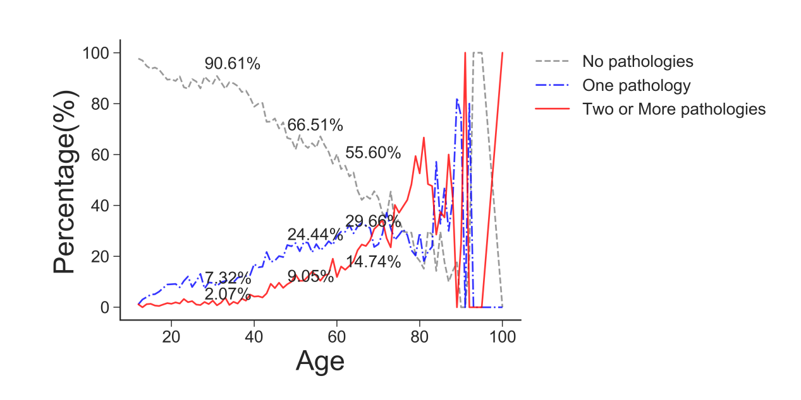
Suppl 1. Prevalence of chronic diseases at different ages.

Suppl.2 Logistic regression analysis of chronic disease risk factors in middle-aged and young people.
Factor | OR | P.value
Age | 1.01(1.01-1.01) | P<0.001
Gender | 1.02(1.01-1.04) | P <0.001
Residence | 0.98(0.97-1.00) | 0.04
Education | 0.97(0.96-0.99) | 0.001
Marital status | 1.01(0.99-1.02) | 0.34
Smoking | 1.01(0.99-1.03) | 0.15
Drinking | 0.99(0.98-1.01) | 0.24
Income | 1.04(1.02-1.05) | P <0.001
PHQ_9 | 1.01(1.01-1.02) | P <0.001
Sugary drinks | 0.98(0.97-1.00) | 0.01

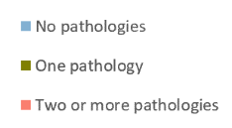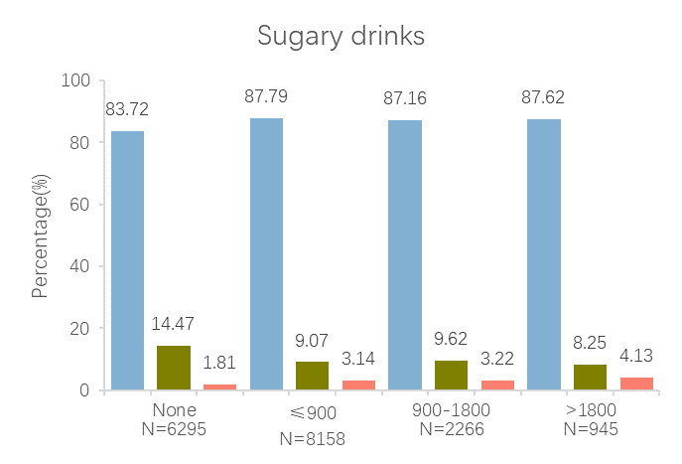
Suppl. 3 Association of sugary drinks with chronic disease risk in the middle-aged and young population.

