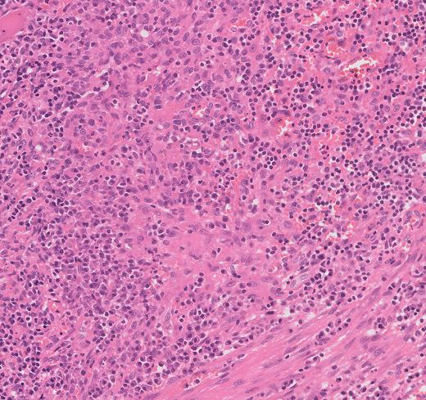

Figure S1: Lymph node biopsy (hematoxylin-eosin stain) showing non-necrotising epithelioid histiocytic granulomas.

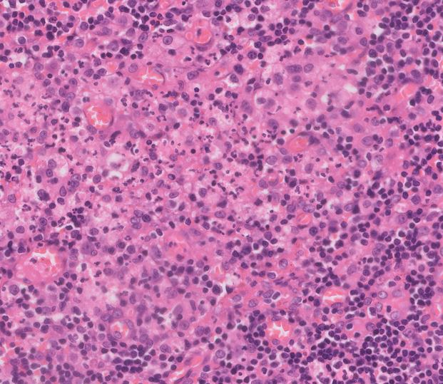

Figure S2: Lymph node biopsy (hematoxylin-eosin stain) showing plump histiocytic aggregates with central areas of neutrophils.

