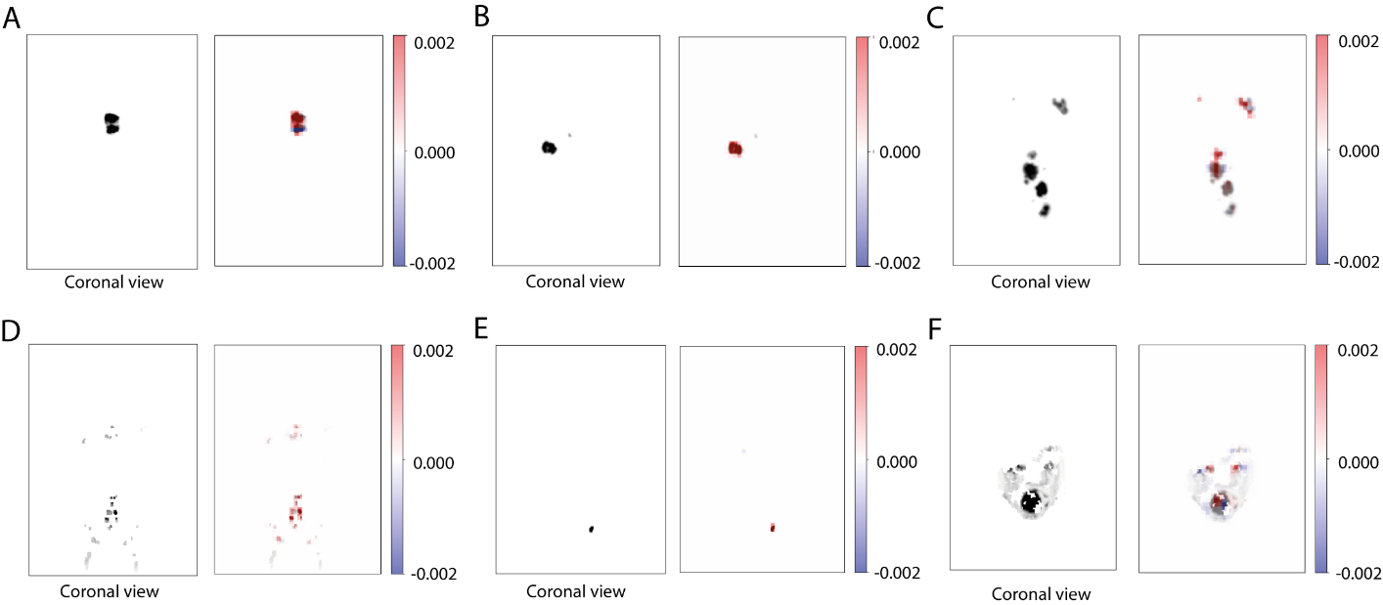

Supplemental Figure 1. Coronal views of six different patient’s lesion-only scans and their corresponding occlusion map heatmaps for the L-PET3D-CNN model. (A–C) represent three patients with clearly localized tumors, categorized as straightforward cases. (D–F) depict three patients with no distinct tumor masses, classified as complex cases. In (D), the tumor is infiltrating the bone. In (E), a full enlarged bladder is observed. In (F), the tumor shows extensive bowel/peritoneal infiltration with ill-defined borders. Regions in red have the strongest contribution to the model’s prediction.

