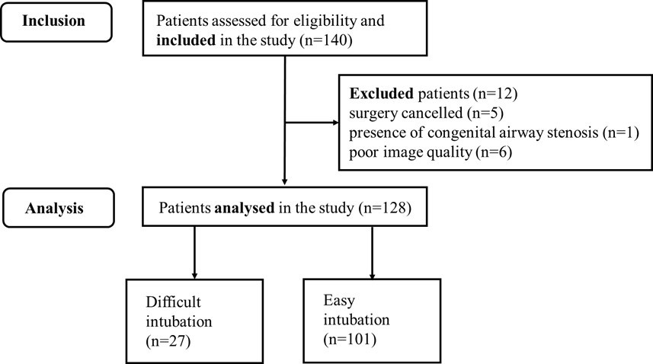
eFigure 5. A flow chart of patients included in the study

