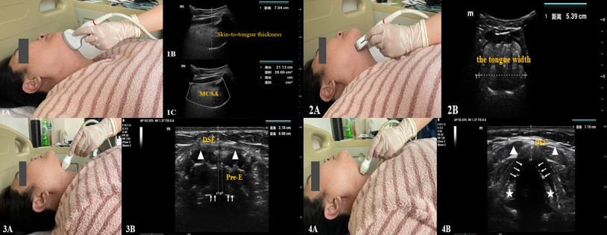
eFigure 1. (A)The convex array probe was placed under the chin in the midsagittal plane. (B) White dashed line: skin-to-tongue thickness. Skin-to-tongue thickness of one patient was 7.04 cm. (C)White curved area: midsagittal cross-sectional area (MCSA) of the tongue. The MCSA of the tongue of one patient was 28.00 cm².
eFigure 2. (A)The convex array probe was placed transversely under the chin to obtain an entire tongue outline. (B)White dashed line: tongue width. The tongue width of one patient was 5.39 cm.
eFigure 3. (A)The linear probe was placed transversely at the level of thyrohyoid membrane. (B)White dashed line on the left: distance from the skin to the epiglottis (DSE). White dashed line on the right: depth of the pre-epiglottic space (Pre-E). The DSE of one patient was 2.18 cm, and the Pre-E of one patient was 0.98 cm.
Solid arrow: air-mucosal interface, triangles: strap muscles (thyrohyoid muscles).
eFigure 4. (A)The linear probe was placed transversely at the level of thyroid cartilage. (B)White dashed line: distance from the skin to the vocal cords (DSV). The DSV of one patient was 1.10 cm.
Solid arrow: vocal cords; stars: arytenoid cartilage; triangles: strap muscles.

