Design and Synthesis of Novel Indolinone Aurora B Kinase Inhibitors Based on Fragment-Based Drug Discovery (FBDD)

Baoxing Xie^{a,b} , Miaomiao Shi^{a,b}, Dan Tangª, Shan Yangª, Lifei Nieª, Chao Niu^{a, b∗}

ª State Key Laboratory Basis of Xinjiang Indigenous Medicinal Plants Resource Utilization, and the Key Laboratory of Chemistry of Plant Resources in Arid Regions Xinjiang Technical Institute of Physics and Chemistry, Chinese Academy of Sciences;Urumqi 830011, Xinjiang, China.
^{b} University of Chinese Academy of Science, Beijing 10004 , China.

Contents
1. Pharmacophore generation 4
2. Suzuki Coupling Reaction Condition Screening 6
3. Molecular dynamics simulation (MD) 0
4. The NMR Spectra of Intermediates 1
4. The NMR Spectra of target compounds 15

Figure S1. The FBDD strategy for the indolone-based Aurora B inhibitors 3
Figure S2. The ROC curves for Pharmacophore_07 (left) and Pharmacophore_09 (right) 4
Figure S3. The schematic diagrams of Pharmacophore_07 (left) and Pharmacophore_09 (right) 4
Figure S4. The inhibition rate of 3-17a to 3-17n and 3-19 on Aurora A 0

Table S1. The ten pharmacophore models validated for active and inactive compounds 3
Table S2. The optimization of the Suzuki reaction 5

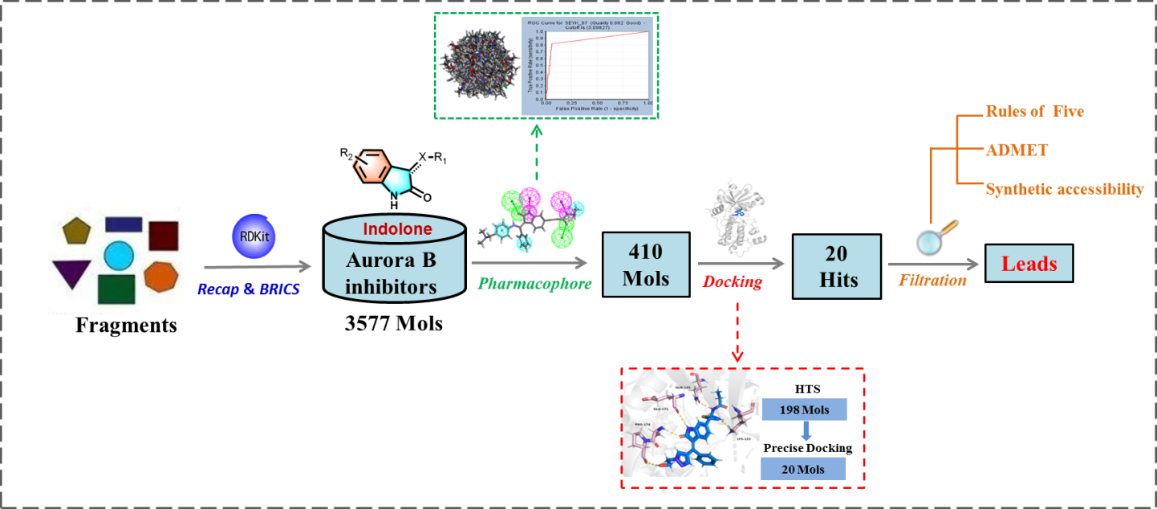
Figure S1. The FBDD strategy for the indolone-based Aurora B inhibitors

1. Pharmacophore generation
Test Set Construction. We extracted 22 known Aurora B-targeted active molecules from the Binding DB database (http://www.bindingdb.org/). Additionally, based on strict screening criteria such as Lipinski's rule and molecular fingerprint analysis, we selected 662 inactive molecules from the ZINC drug library to ensure they possessed certain drug-like properties and exhibited structural similarity to the active molecules (Jaccard Index > 0.5). These active and inactive molecules served as the test set for pharmacophore screening and validation.
Method for Generation and Validation. The pharmacophore models were generated using the Receptor-Ligand Pharmacophore Generation module in Discovery Studio 2019. First, in the "Receptor-Ligand Pharmacophore Generation" panel, the "Input Receptor" was set to the processed protein (5EYK), and the "Input Ligand" was set to the processed original ligand. "Validation" was set to True, with "Active Ligands" assigned as the 22 active molecules from the test set and "Inactive Ligands" as the 662 inactive molecules. The parameters for pharmacophore construction were configured as follows: maximum hydrogen bond distance of 3.0, maximum hydrophobic distance of 5.5, maximum exclusion volume distance of 5.0, and maximum feature distance of 2.0. The process was then executed. This method incorporated two validation approaches during pharmacophore model generation: the "Validation" operation in the workflow parameter settings and the Selectivity Scoring settings (default parameters) under the expanded "Advanced" options. The former evaluates the model's ability to distinguish active from inactive compounds by constructing a "decoy set" using known active and inactive molecules, while the latter assesses the selectivity of the pharmacophore model, with higher scores indicating greater selectivity.
Results and Discussion. Through the above procedure, a total of ten pharmacophore models were generated. The selectivity score of these pharmacophores was 11.635. Using active molecules to construct the decoy set and inactive compounds for validation, the models' ability to differentiate active and inactive compounds was tested. The validation results of the ten pharmacophore models for active and inactive compounds are analyzed in Table S1. Sensitivity (SE) and specificity (SP) were used to measure the models' capability to identify active and inactive molecules, respectively. Higher scores for both metrics indicate stronger discriminative ability of the model.
Table S1. The ten pharmacophore models validated for active and inactive compounds
Pharmacophore | Total Actives | Total  Inactives | True  Positives | True Negatives | False Positives | False Negatives | Sensitivity | Specificity
Pharmacophore_1 | 22 | 662 | 15 | 376 | 286 | 7 | 0.68182 | 0.56798
Pharmacophore_2 | 22 | 662 | 16 | 589 | 73 | 6 | 0.72727 | 0.88973
Pharmacophore_3 | 22 | 662 | 13 | 579 | 83 | 9 | 0.59091 | 0.87462
Pharmacophore_4 | 22 | 662 | 14 | 620 | 42 | 8 | 0.63636 | 0.93659
Pharmacophore_5 | 22 | 662 | 14 | 625 | 37 | 8 | 0.63636 | 0.94411
Pharmacophore_6 | 22 | 662 | 17 | 589 | 73 | 5 | 0.77273 | 0.88973
Pharmacophore_7 | 22 | 662 | 18 | 623 | 39 | 4 | 0.81818 | 0.94109
Pharmacophore_8 | 22 | 662 | 17 | 539 | 123 | 5 | 0.77273 | 0.81420
Pharmacophore_9 | 22 | 662 | 16 | 612 | 50 | 6 | 0.72727 | 0.92447
Pharmacophore_10 | 22 | 662 | 18 | 405 | 257 | 4 | 0.81818 | 0.61178

The Receiver Operating Characteristic (ROC) curve is used to evaluate the diagnostic accuracy of binary classification tasks, where the x-axis represents the false positive rate (FPR), and the y-axis represents the true positive rate (TPR). The area under the curve (AUC, denoted as Quality) reflects the overall performance of the model. This value must be greater than 0.5, with higher values indicating stronger discriminative ability of the model. Among the pharmacophore models, Pharmacophore_07 and Pharmacophore_09 were identified as the best-performing models and were selected for further screening of the enumerated compound library. The Figure S2 displayed the ROC curves for Pharmacophore_07 and Pharmacophore_09. The Pharmacophore_07 consisted of two hydrogen bond acceptors (green), two hydrogen bond donors (pink), two hydrophobic centers (light blue), and exclusion volumes (gray). The Pharmacophore_09 contains one hydrogen bond acceptor, two hydrogen bond donors, three hydrophobic centers, and exclusion volumes (Figure S3).

Figure S2. The ROC curves for Pharmacophore_07 (left) and Pharmacophore_09 (right)
Figure S3. The schematic diagrams of Pharmacophore_07 (left) and Pharmacophore_09 (right)

2. Suzuki Coupling Reaction Condition Screening
Table S2. The optimization of the Suzuki reaction
Entry | Base/catalyst | Amount | Solvent | Yield%
1 | Na₂CO₃/Pd(PPh₄)₃ | 3/0.05 | Acetonitrile(80ºC) | N.R.
2 | N2_{a}CO₃/Pd(PPh₄)₃ | 3/0.05 | 1,4-dioxane:H₂O/4:1(105 ºC) | Trace
3 | Na₂CO₃/Pd(PPh₃)₄ | 4/0.05 | THF:H₂O/4:1 (66 ºC) | N.R.
4 | CsCO₃/Pd(dppf)Cl₂ | 3/0.05 | 1,4-dioxane: H₂O/4:1(105 ºC) | 34
5 | TMOSK/Pd-P(t-Bu)₃-G₃ | 3/0.05 | THF (66 ºC) | N.R.
6 | K₂CO₃/Pd₂(dba)₃ | 3/0.05 | 1,4-dioxane: H₂O/4:1(105 ºC) | N.R.
7 | K₂CO₃/Pd(OAc)₂/Xhos | 3/0.05/0.05 | 1,4-dioxane:H₂O/4:1(105 ºC) | Trace
8 | K₂CO₃/Pd(dppf)Cl₂ | 3/0.05 | 1,4-dioxane:H₂O/4:1(105 ºC) | 45
9 | K₂CO₃/Pd(PPh₃)₄ | 3/0.05 | Acetonitrile(80 ºC) | N.R.
10 | K₂CO₃/Pd(PPh₃)₄ | 3/0.05 | 1,4-dioxane: H₂O/4:1(105 ºC) | 70
11 | K₂CO₃/Pd(PPh₃)₄ | 3/0.05 | 1,4-dioxane:H₂O/2:1(105 ºC) | Trace
12 | K₂CO₃/PdCl₂(PPh₃)₂ | 3/0.05 | 1,4-dioxane:H₂O/4:1(105 ºC) | Trace
13 | K₂CO₃/Pd(PPh₃)₄/KF | 3/0.05/0.05 | 1,4-dioxane:H₂O/4:1(105 ºC) | 9
14 | K₂CO₃/Pd(PPh₃)₄/CuI | 3/0.05/0.05 | 1,4-dioxane:H₂O/4:1(105 ºC) | 15

3. Molecular dynamics simulation (MD)
In this study, we employed Gromacs 2022.3, a leading molecular dynamics simulation software in the industry, to conduct a comprehensive simulation of the protein-ligand complexes obtained through molecular docking. The preprocessing of small molecules during the simulation process is crucial as it ensures the accuracy and reliability of the simulation. To this end, we used AmberTools22 to add the GAFF force field to the small molecules and employed Gaussian 16W for hydrogenation operations and RESP charge calculations of the small molecules. These operations not only optimize the molecular geometry but also ensure the accuracy of charge distribution, providing a solid foundation for subsequent simulations.
The selection of simulation conditions is also a key aspect of the simulation process. We chose a static temperature of 300K and constant pressure (1 Bar) as the simulation environment because these conditions are close to the actual environment within the body, which helps us to simulate the dynamic behavior of molecules more realistically. In terms of force field selection, we adopted Amber99sb-ildn, which has been widely validated and is considered to accurately describe the dynamics of biomolecules. Additionally, we selected the Tip3p water model to simulate the solvent environment and added an appropriate number of Na⁺ ions to neutralize the total charge of the simulation system, ensuring the stability and accuracy of the simulation.
In this simulation process, we first performed energy minimization of the system using the steepest descent method to eliminate possible conformational stresses and unreasonable geometric structures. Subsequently, we carried out isothermal-isochoric ensemble (NVT) and isothermal-isobaric ensemble (NPT) equilibrations, each with 100,000 steps, a coupling constant of 0.1 ps, and a duration of 100 ps, to ensure the stability of the system in terms of temperature and pressure. Finally, we conducted free molecular dynamics simulation, which lasted for 50,000,000 steps with a step size of 2 fs, totaling 100 nanoseconds, to fully capture the dynamic behavior of the system.
To deeply analyze the simulation results, we calculated a series of important physical quantities, including the RMSD (root-mean-square deviation), RMSF (root-mean-square fluctuation), Rg (radius of gyration) values and hydrogen bonds of the complex. These physical quantities provide rich information about the structural stability, flexibility, and solvent accessibility of the complex. Furthermore, we utilized the Gibbs free energy landscape and MM/GBSA methods to assess the binding energy and thermodynamic stability between the small molecules and protein receptors.
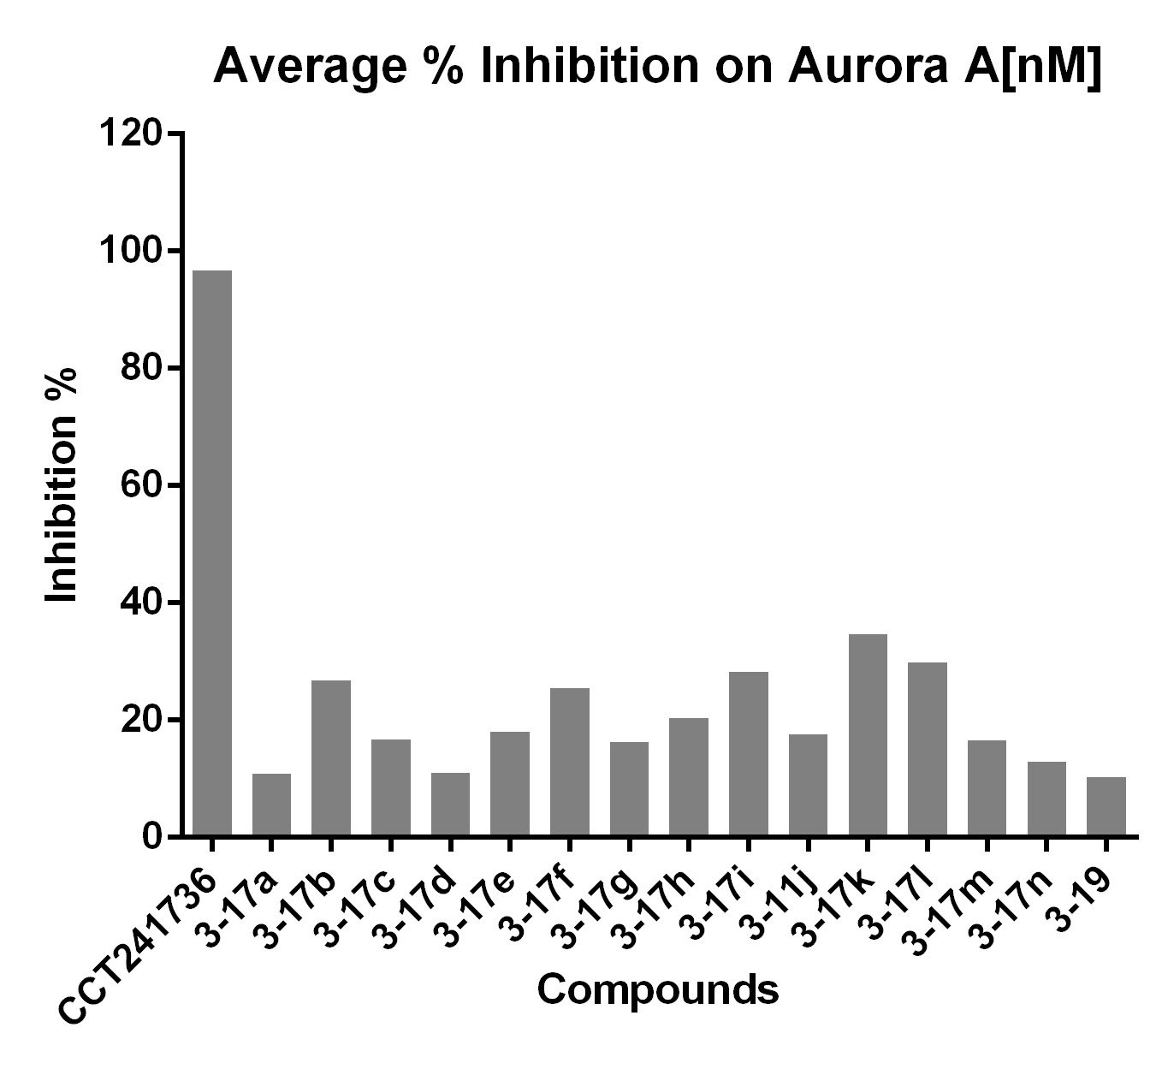
Figure S4. The inhibition rate of 3-17a to 3-17n and 3-19 on Aurora A

4. The NMR Spectra of Intermediates
The ¹H and ¹³C spectra of 3-3a
3-3a

The ¹H and ¹³C spectra of 3-3b
3-3b
The ¹H and ¹³C spectra of 3-3c
3-3c

The ¹H and ¹³C spectra of 3-3d
3-3d

The ¹H and ¹³C spectra of 3-3e
3-3e

The ¹H and ¹³C spectra of 3-3f
3-3f

The ¹H and ¹³C spectra of 3-3g
3-3g

The ¹H and ¹³C spectra of 3-6a
3-6a

The ¹H and ¹³C spectra of 3-6b
3-6b

The ¹H and ¹³C spectra of 3-9
3-9

The ¹H and ¹³C spectra of 3-11
3-11

The ¹H and ¹³C spectra of 3-14
3-14

The ¹H and ¹³C spectra of 3-16
3-16

4. The NMR Spectra of target compounds

The ¹H and ¹³C spectra of 3-17a
3-17a

The ¹H and ¹³C spectra of 3-17b
3-17b

The ¹H and ¹³C spectra of 3-17c
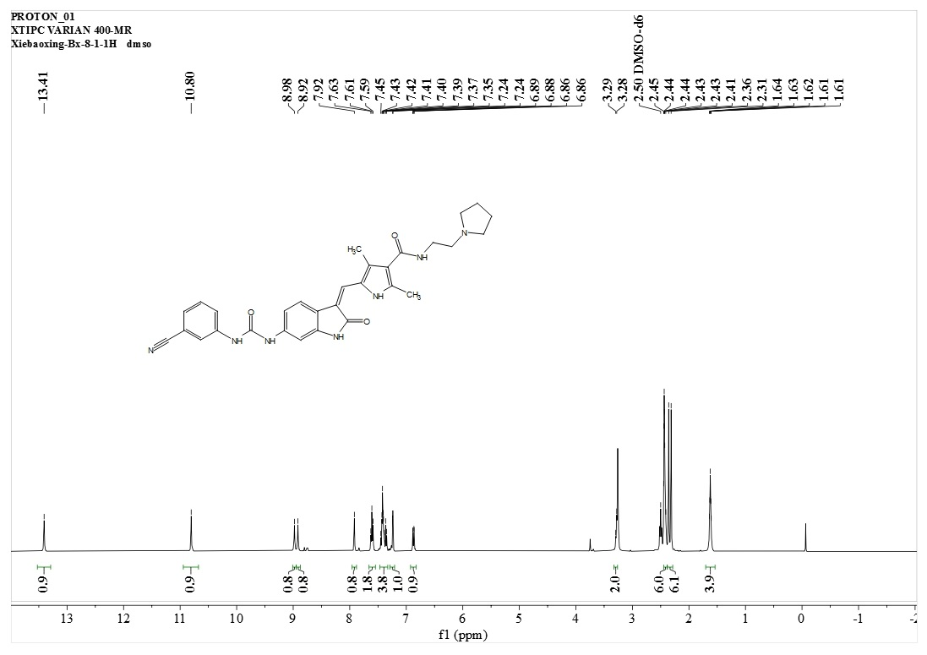
3-17c

The ¹H and ¹³C spectra of 3-17d
3-17d

The ¹H and ¹³C spectra of 3-17e
3-17e

The ¹H and ¹³C spectra of 3-17f
3-17f
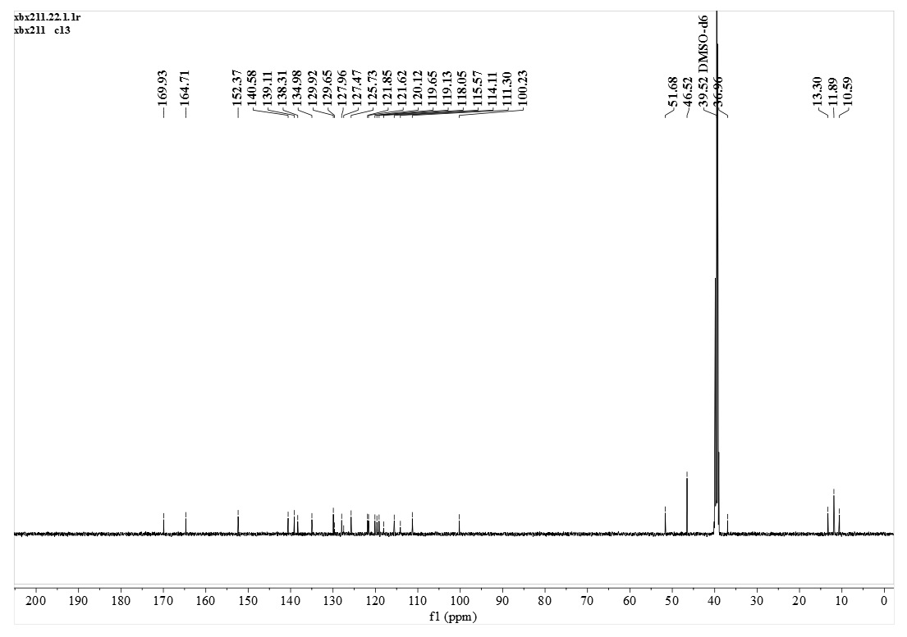

The ¹H and ¹³C spectra of 3-17g
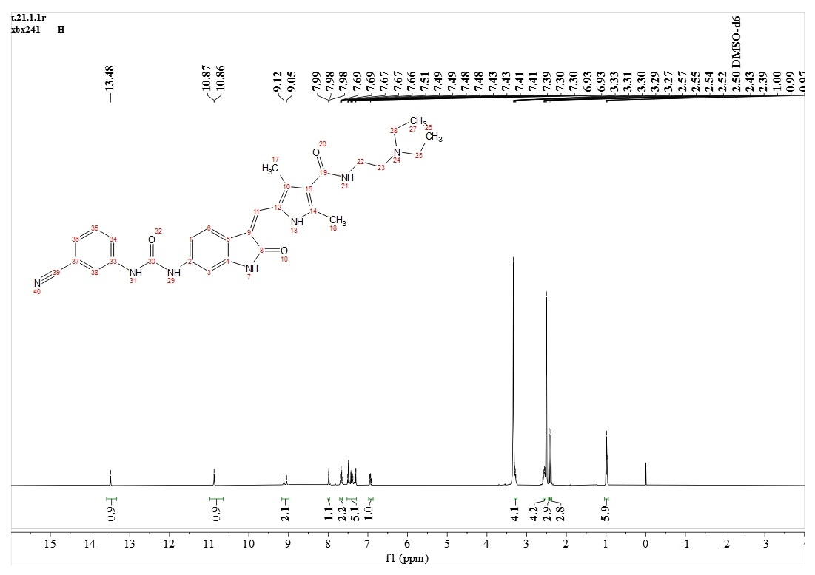
3-17g

The ¹H and ¹³C spectra of 3-17h
3-17h

The ¹H and ¹³C spectra of 3-17i
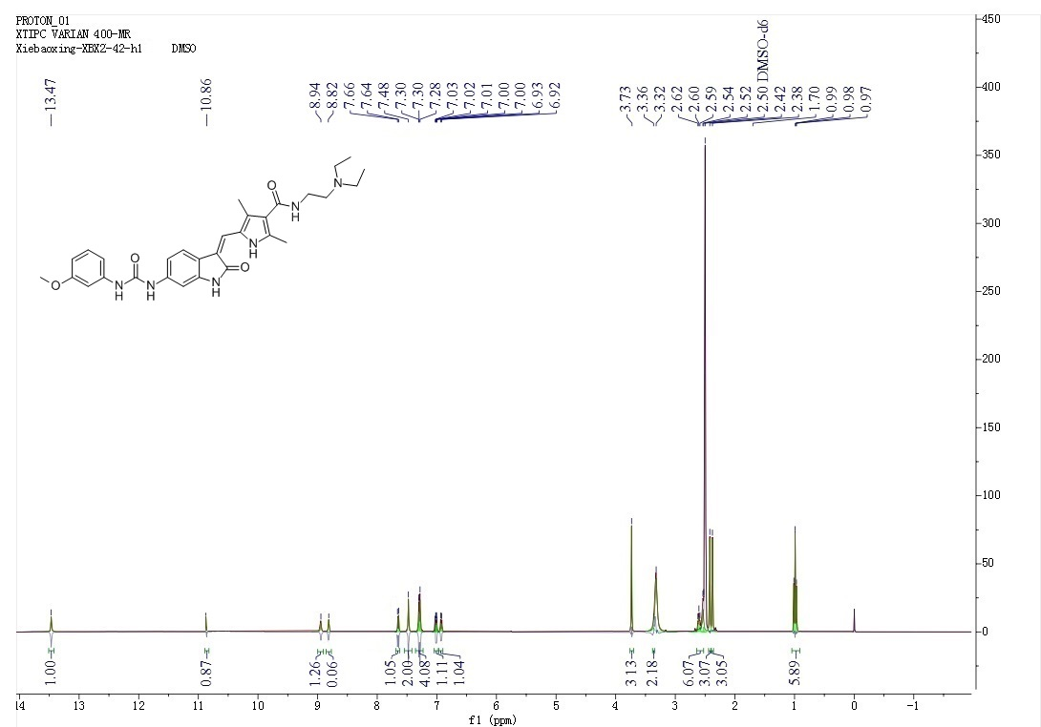
3-17i
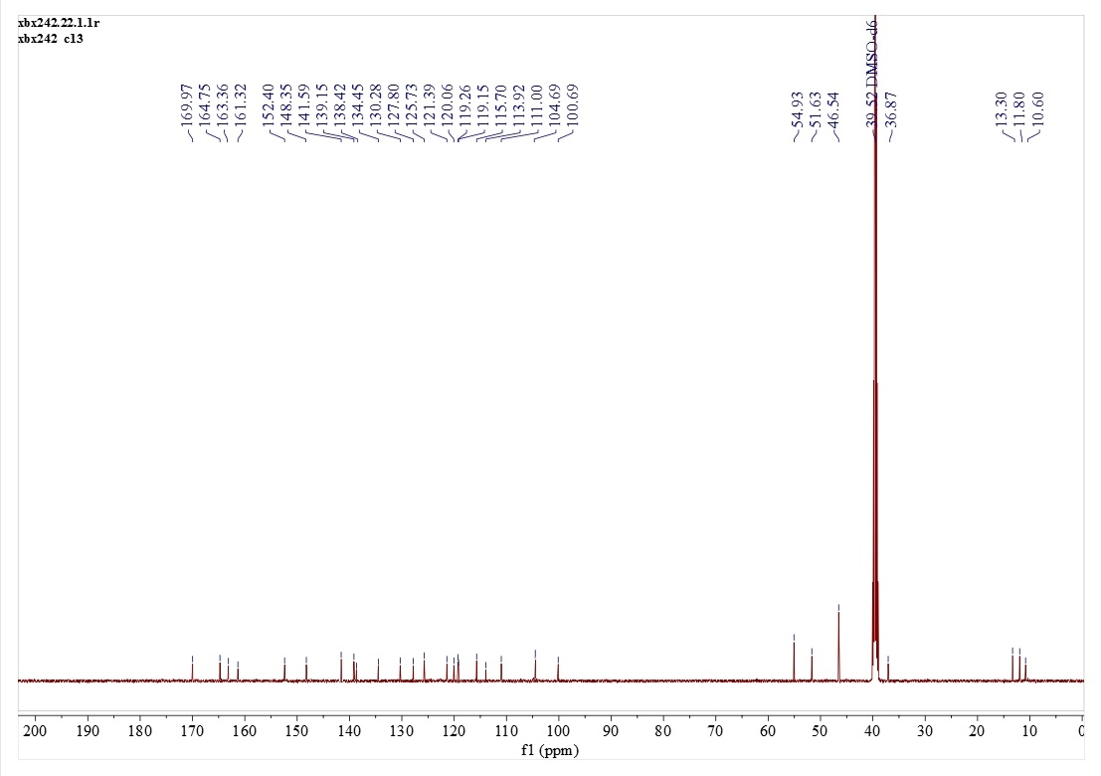

The ¹H and ¹³C spectra of 3-17j
3-17j
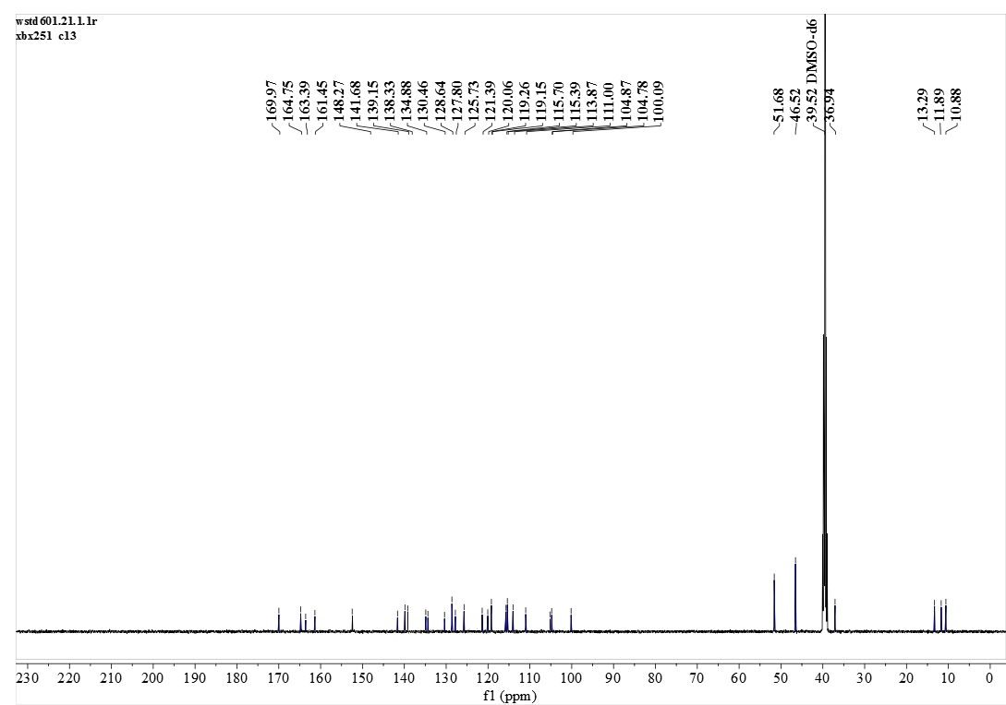

The ¹H and ¹³C spectra of 3-17k
3-17k
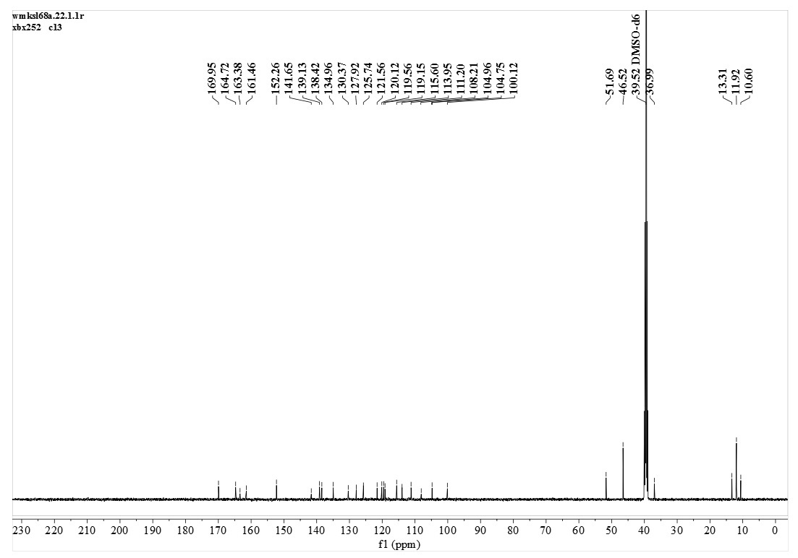

The ¹H and ¹³C spectra of 3-17l
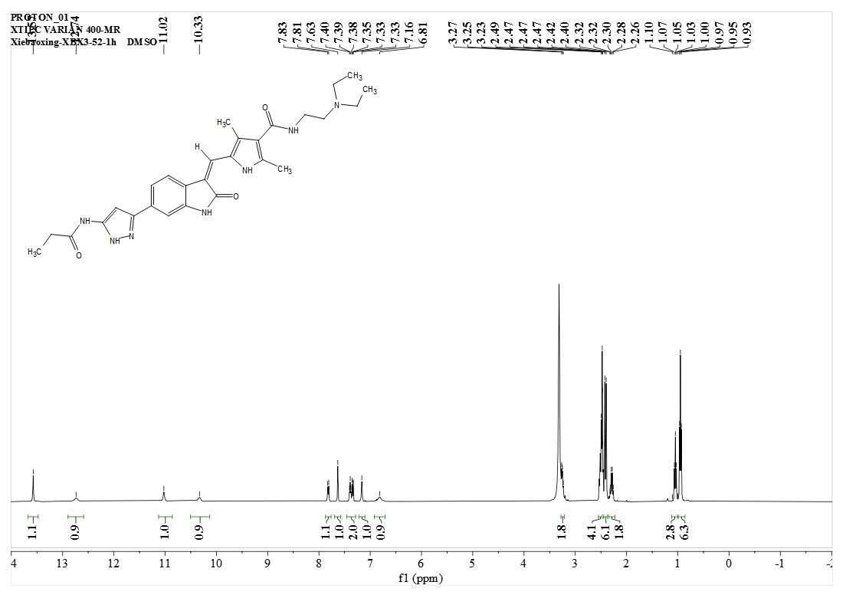
3-17l

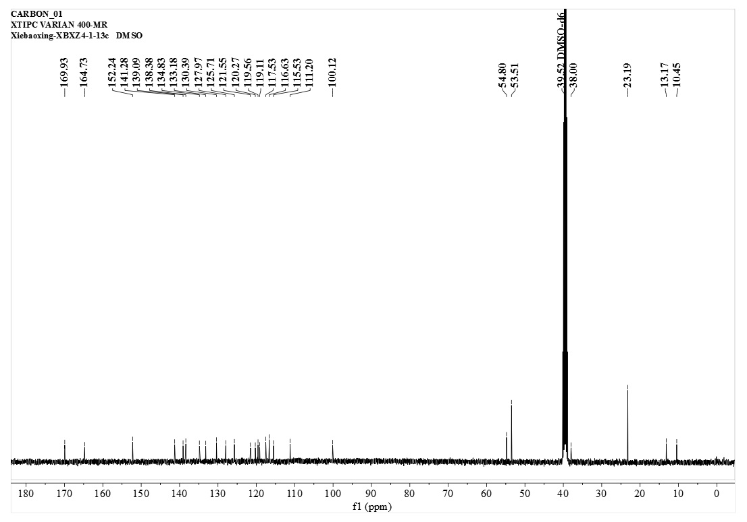

The ¹H and ¹³C spectra of 3-17m
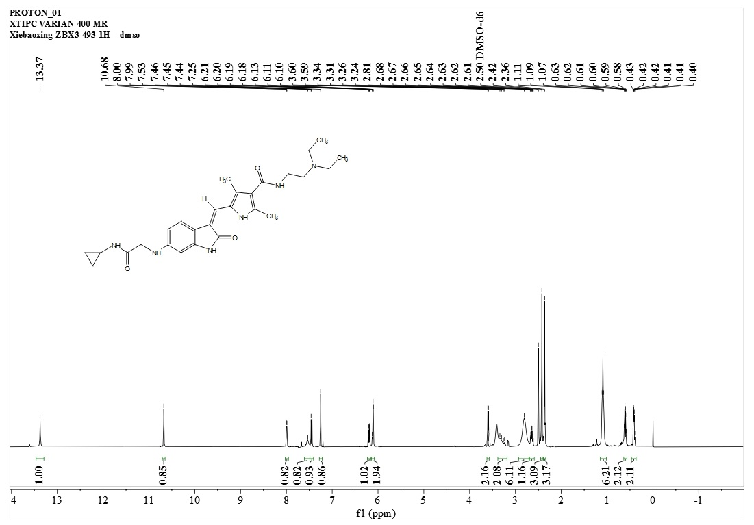
3-17m
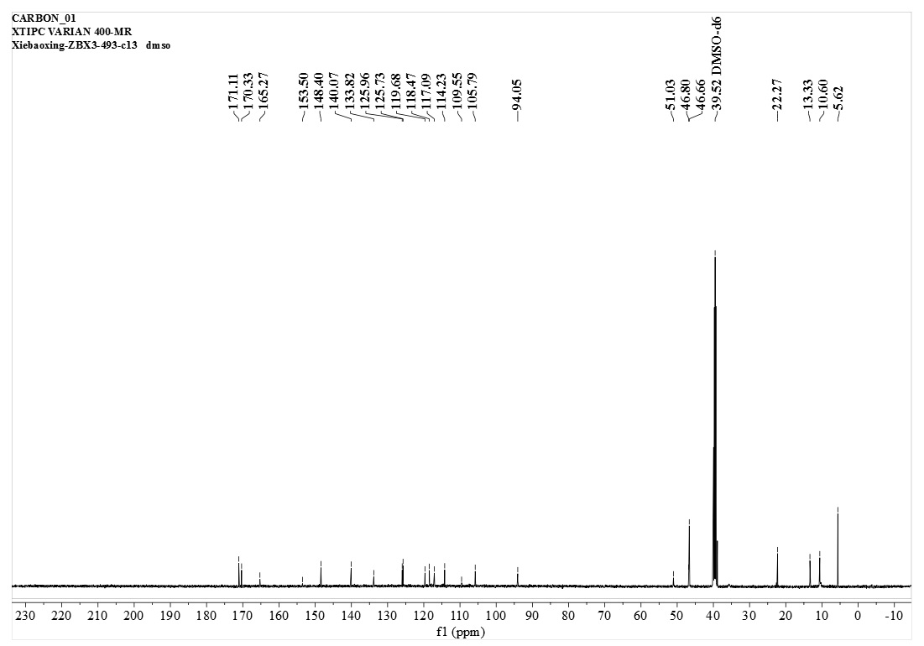

The ¹H and ¹³C spectra of 3-17n
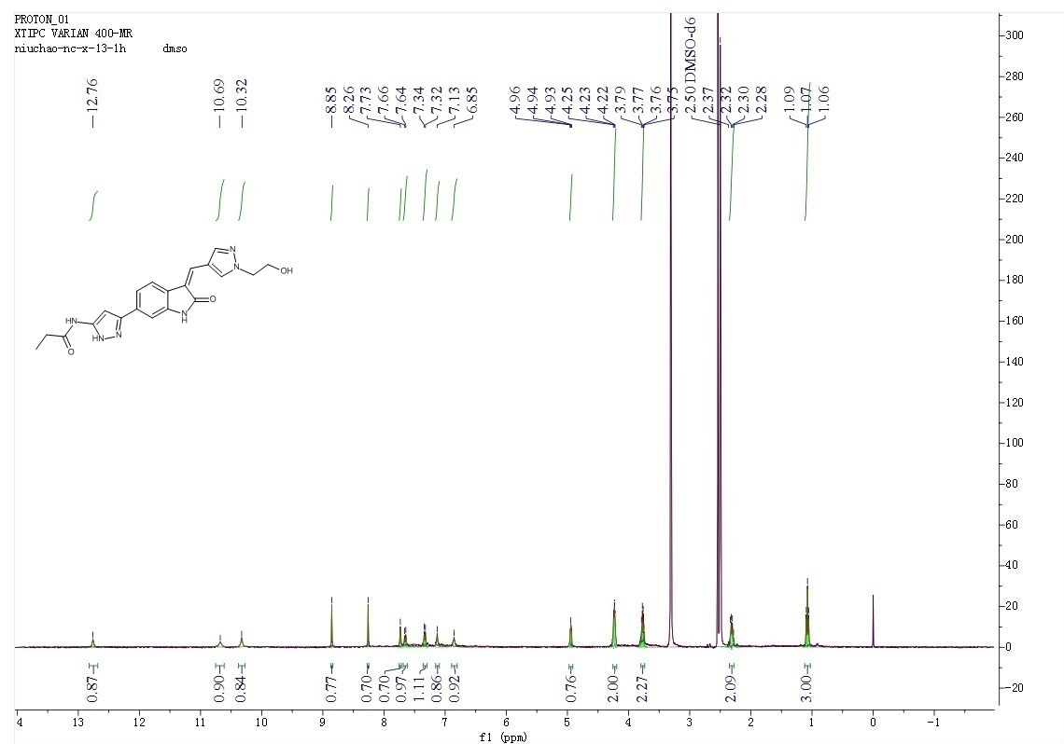
3-17n
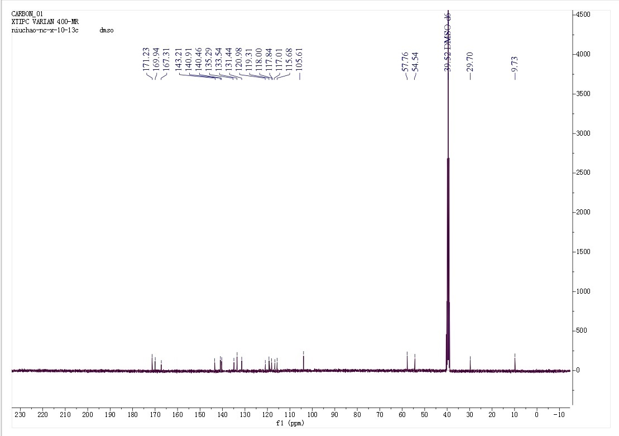
The ¹H and ¹³C spectra of 3-19
3-19

∗ Corresponding author. E-mail address: niuchao@ms.xjb.ac.cn

