Appendix
Fig. 5.To verify the correlations between various features and suicidal ideation (target), we constructed a visualized heatmap using Dataset C. Red colors indicate stronger positive correlations, blue colors indicate stronger negative correlations, and white areas suggest weak or no correlation. The figure reveals significant correlations between multiple features and suicidal ideation. Acoustic features such as "spectral_centroid", "spectral_bandwidth" ,and "zero-crossing rate" exhibit varying degrees of correlation with suicidal ideation. This may imply that there is an association between suicidal ideation and individual vocal features. When an individual harbors suicidal ideation, differences may exist in vocal features such as the frequency distribution center (reflected by spectral centroid), frequency range distribution (spectral bandwidth), and the frequency of zero crossings in the voice signal (zero-crossing rate) compared to those without suicidal ideation [34]. This could be due to psychological states affecting vocal cord control and the fluency of speech expression, thereby manifesting as correlations in acoustic features [35]. Scores for autobiographical memory specificity and its subdivisions (positive, neutral, and negative cue words) show positive correlations with suicidal ideation, while overgeneralization scores show negative correlations. These findings align with previous research on autobiographical memory and suicidal ideation[11].
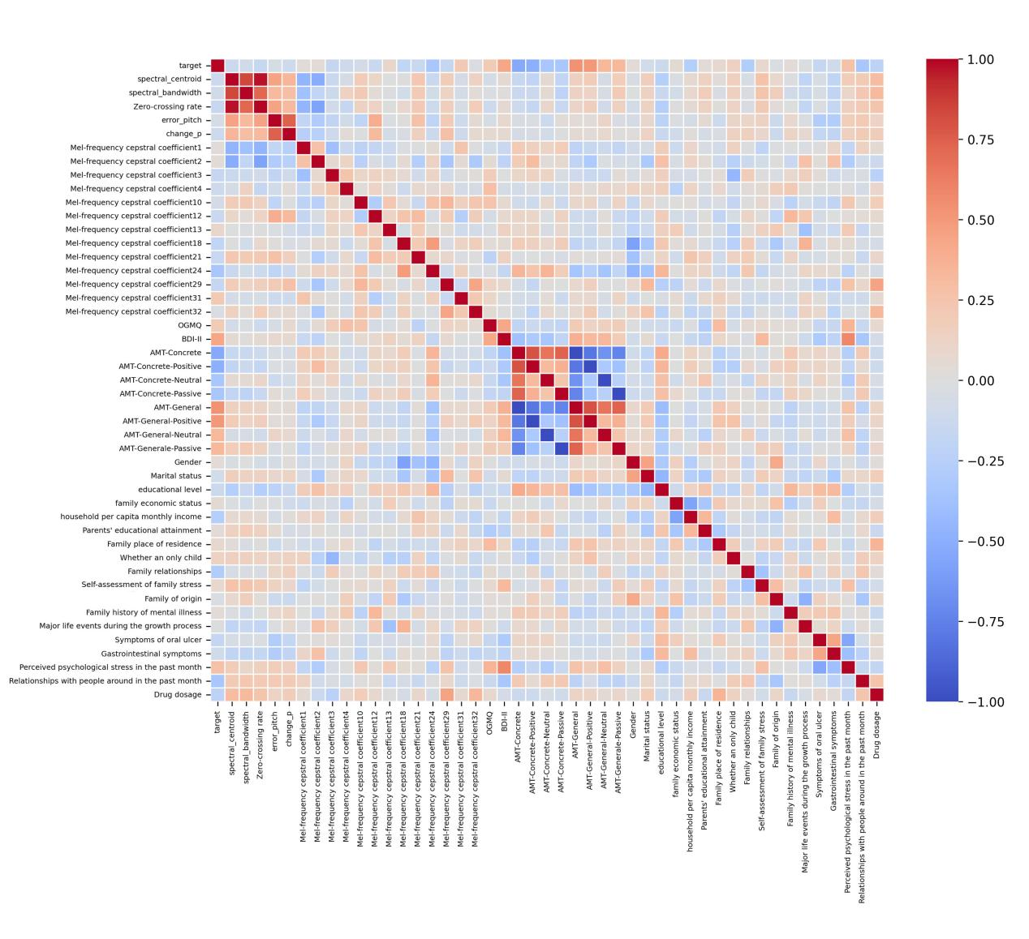
Fig. 5.Heatmap of Feature Correlations with Suicidal Ideation

