Gut Microbiome Dysbiosis in Hepatocellular Carcinoma Patients with Persistent HCV Viremia versus Viral Clearance: A Cross-Sectional Study
Hany R. Hashem¹ †, Tasnem Yehia² †, Marwa Azab², Ali Abdellah², Ibrahim A. Amin³, Mohammed Ramadan³*
Table S1. Statistical Summary of Classification Error Rates
Group | Mean Error | Min Error | Max Error | Std. Dev.
Overall | 0.208 | 0.103 | 0.300 | 0.059
Control | 0.110 | 0.053 | 0.196 | 0.041
RHCC | 0.254 | 0.165 | 0.349 | 0.051
THCC | 0.309 | 0.205 | 0.398 | 0.055
The control group had the lowest average error and least variability, indicating high classification accuracy. The THCC group had the highest average error, suggesting that classification was the most challenging. The overall error decreased and stabilized as the number of trees increased, indicating model convergence. Annotations highlight key points such as the lowest errors and convergence behavior.

Table S2. Microbiome Stratification by Enterotyping in HCC
Enterotype | Key Genera (Mean Relative Abundance %) | Group Association | Significant Features
ET-R (Relapse-associated) | 1. Asteroleplasma  2. uncultured Succinivibrionaceae  3. Succinivibrio  4. Treponema 2  5. uncultured bacterium Clostridiales vadinBB60 | RHCC | • Highest Asteroleplasma (KW p=0.009)  • Elevated LPS-producers  • Depleted SCFA-generators
ET-T (Treatment-associated) | 1. Prevotella 9  2. Bifidobacterium  3. Ruminococcaceae UCG-002  4. Parabacteroides  5. Ruminococcaceae UCG-014 | THCC | • Intermediate Prevotella 9 levels  • Partial Ruminococcaceae recovery  • Reduced Asteroleplasma
ET-C (Control-associated) | 1. Faecalibacterium  2. Bacteroides  3. Megasphaera  4. Prevotella 2  5. Subdoligranulum | Control | • Highest Bacteroides (KW p=0.041)  • Balanced SCFA-producers  • Lowest pathogenic genera

Figure S1. Bacterial diversity analysis: Alpha diversity
Rarefaction curves demonstrating observed amplicon sequence variants (ASVs) across sequencing depths for (A) healthy versus diseased samples and (B) different disease statuses (Control/THCC/RHCC). Curves represent individual samples. The dashed vertical line indicates the rarefaction depth (27,119 reads) used for downstream analyses.
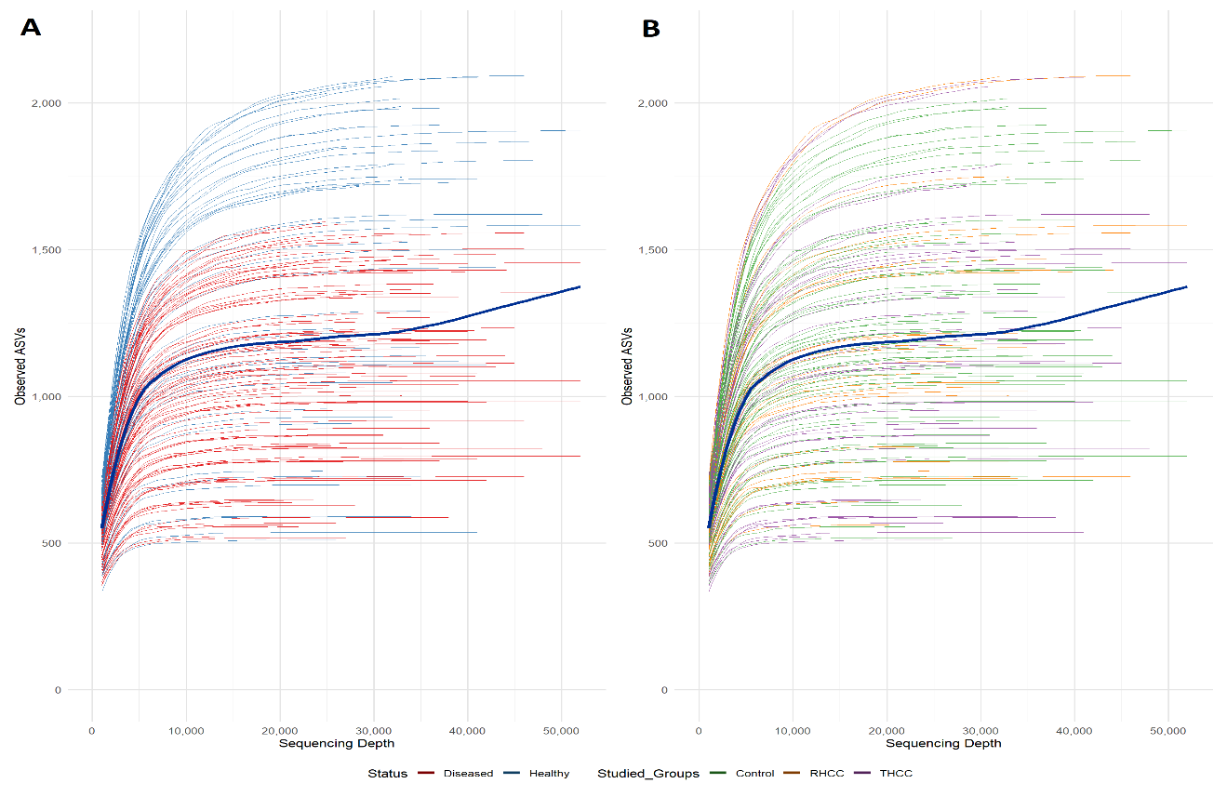
Figure S1. Variable-Length Rarefaction Curves Showing Microbial Diversity by Health and Diseased status

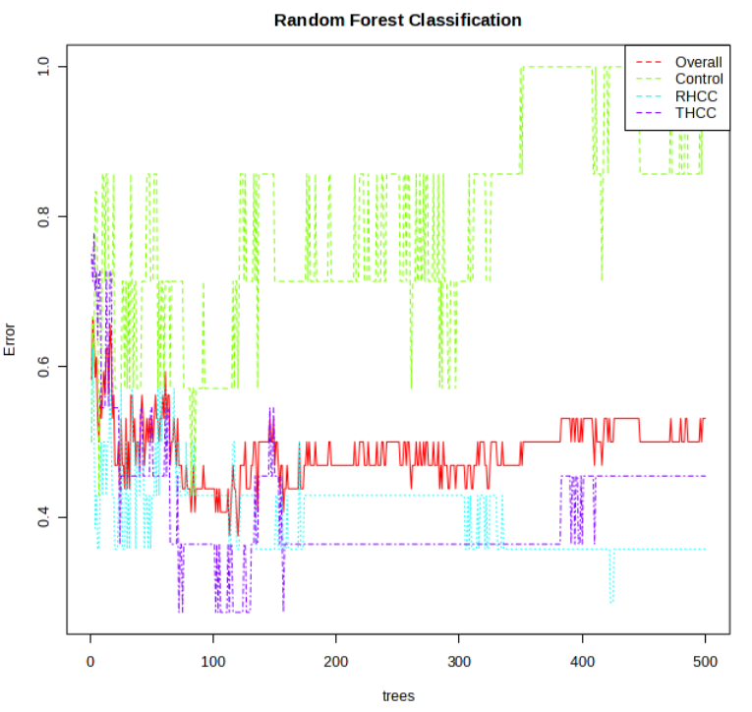
Figure S2. RF classification illustrates how the classification error rate changes as the number of trees in the RF model increases (from 0-500). As the number of trees increases, the error rates for all groups generally decrease, indicating improved model performance with more trees. The overall error stabilizes at a lower level, suggesting good general classification performance. The Control group appears to have the lowest error, indicating that it is the easiest to classify. The RHCC and THCC groups have higher error rates, possibly because of overlapping features or more complex patterns.

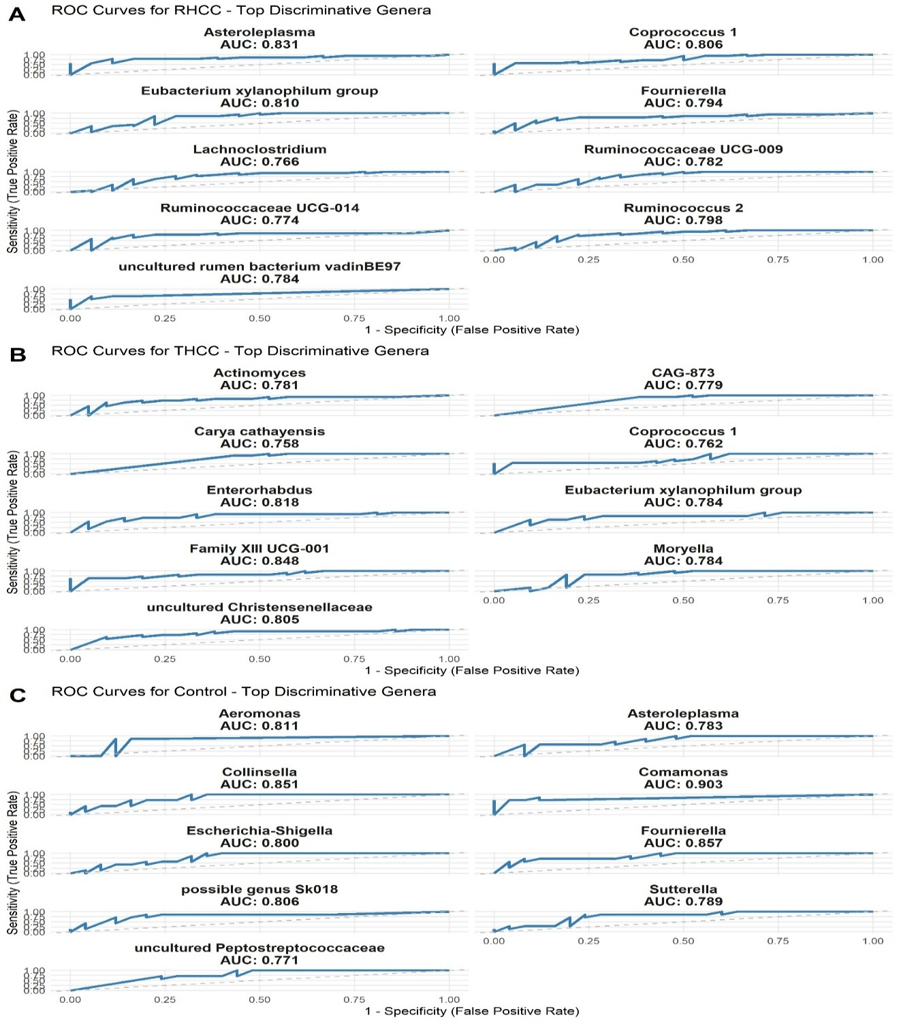
Figure S3. ROC Curves for Top Discriminative Bacterial Genera Across RHCC, THCC, and Control Groups
This figure displays Receiver Operating Characteristic (ROC) curves for the most discriminative bacterial genera identified in three clinical groups: RHCC (A), THCC (B), and Control (C). Each subplot illustrates the diagnostic performance of a specific genus, with sensitivity plotted against 1-specificity. The Area Under the Curve (AUC) values are provided to quantify the classification accuracy of each genus in distinguishing between groups. Genera such as Asteroeplasma, Enterorhabdus, and Coprococcus_1 demonstrated high discriminative power across different comparisons.

