Supplementary File1
Molecular interactions of antibody CR3022 with 7 different structurally changed RBD variants. Hydrogen bonds are depicted in green dashed lines and hydrophobic contacts are indicated by the red brick.

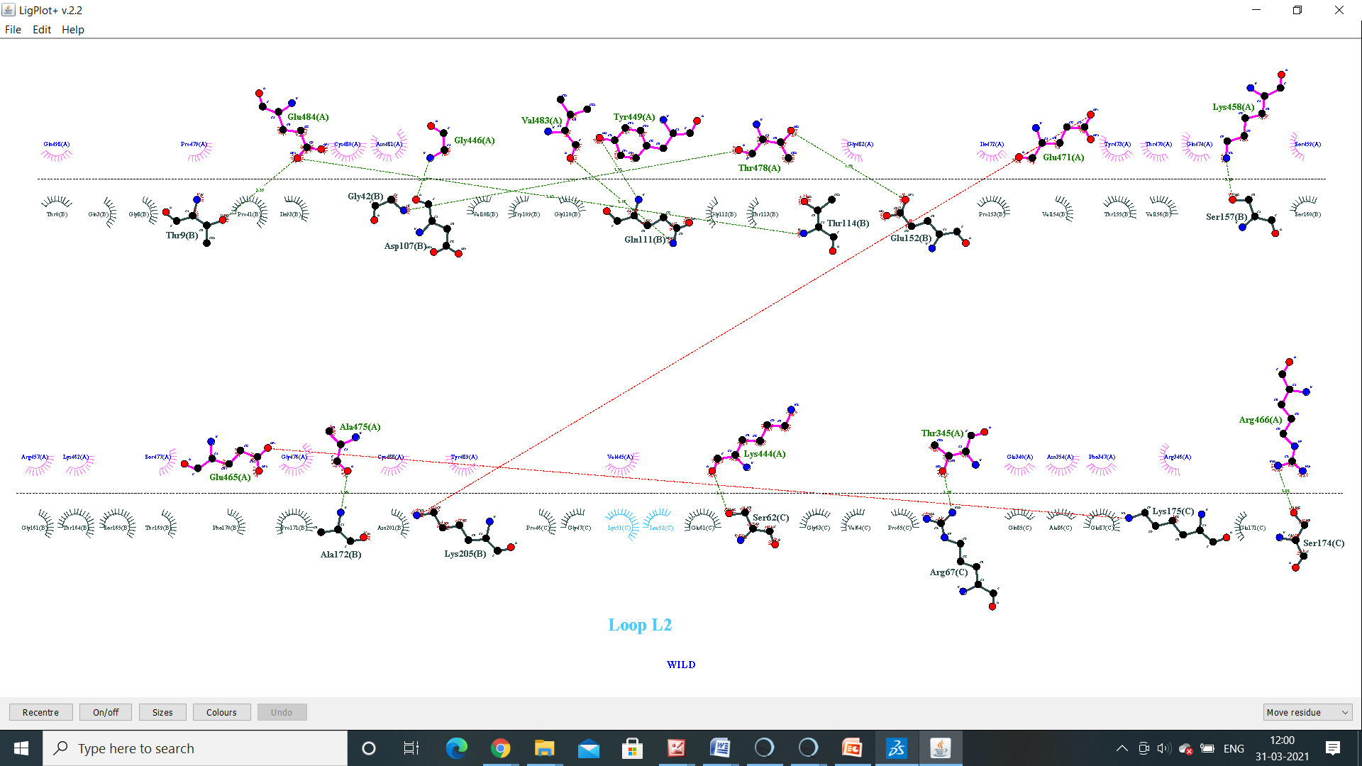
Spike wild
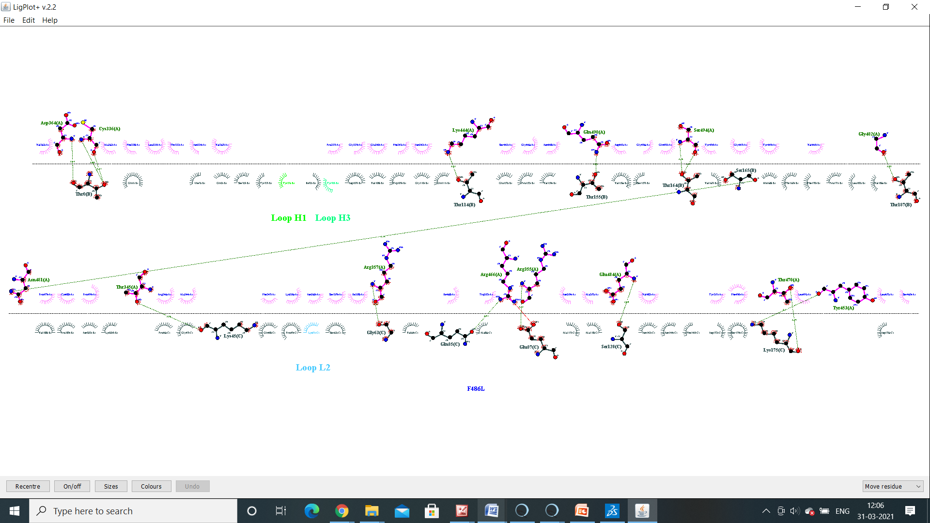
F486L

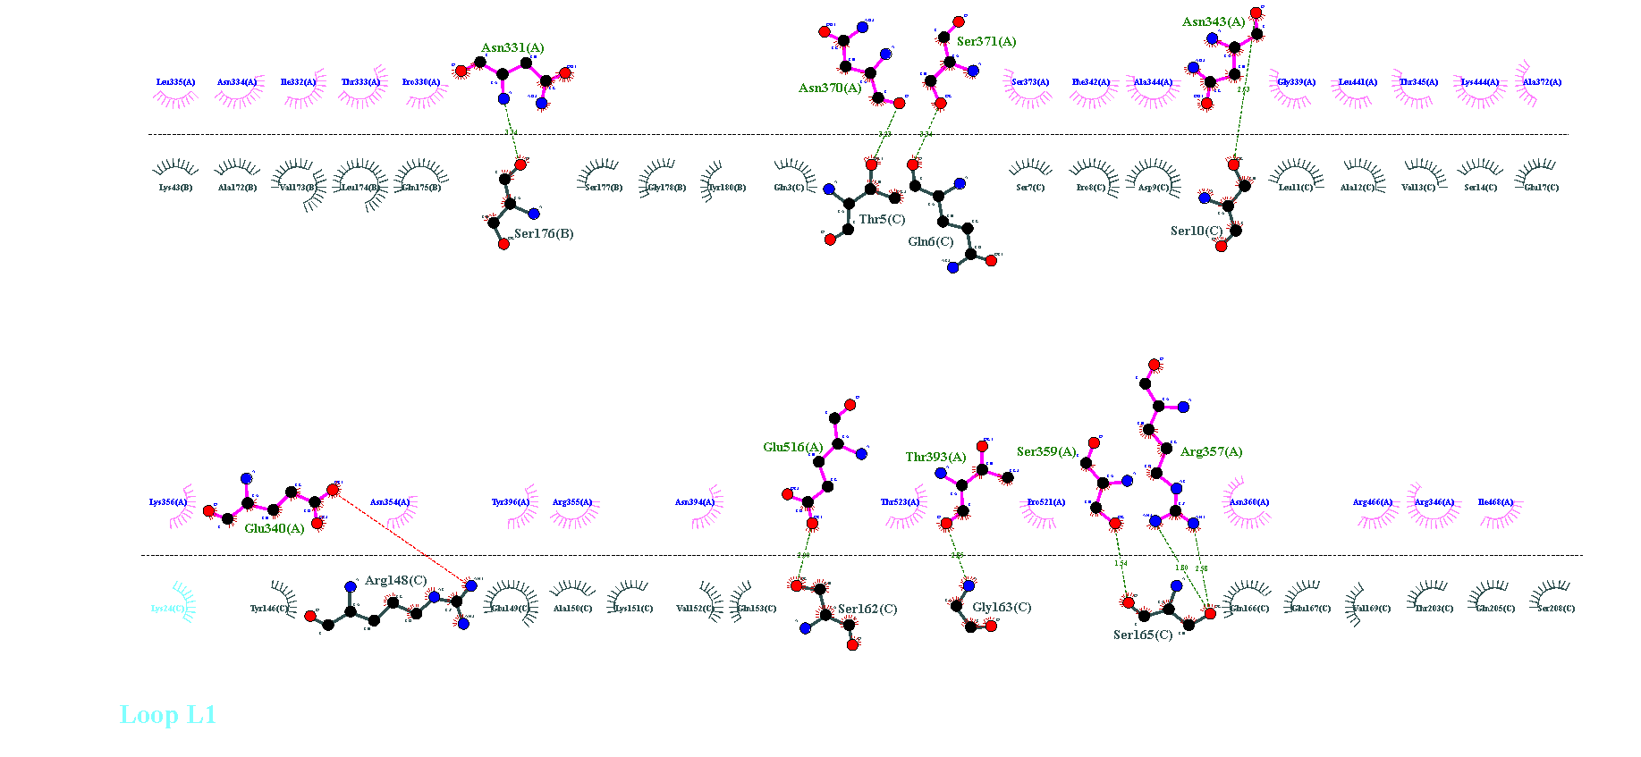
Q493N
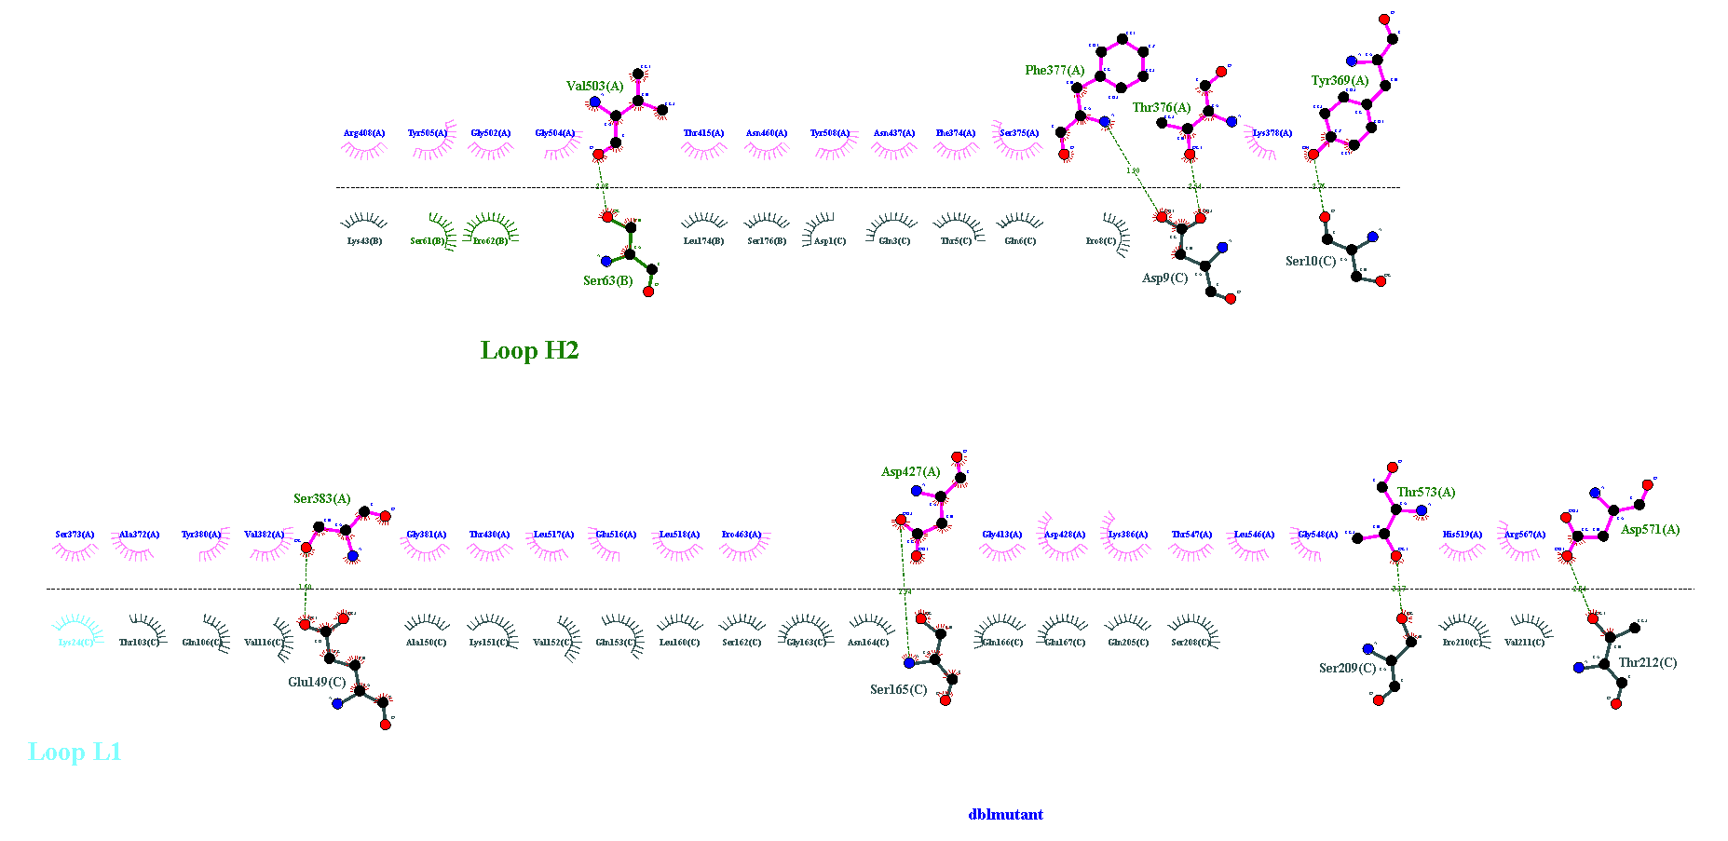
B.1.617’strain
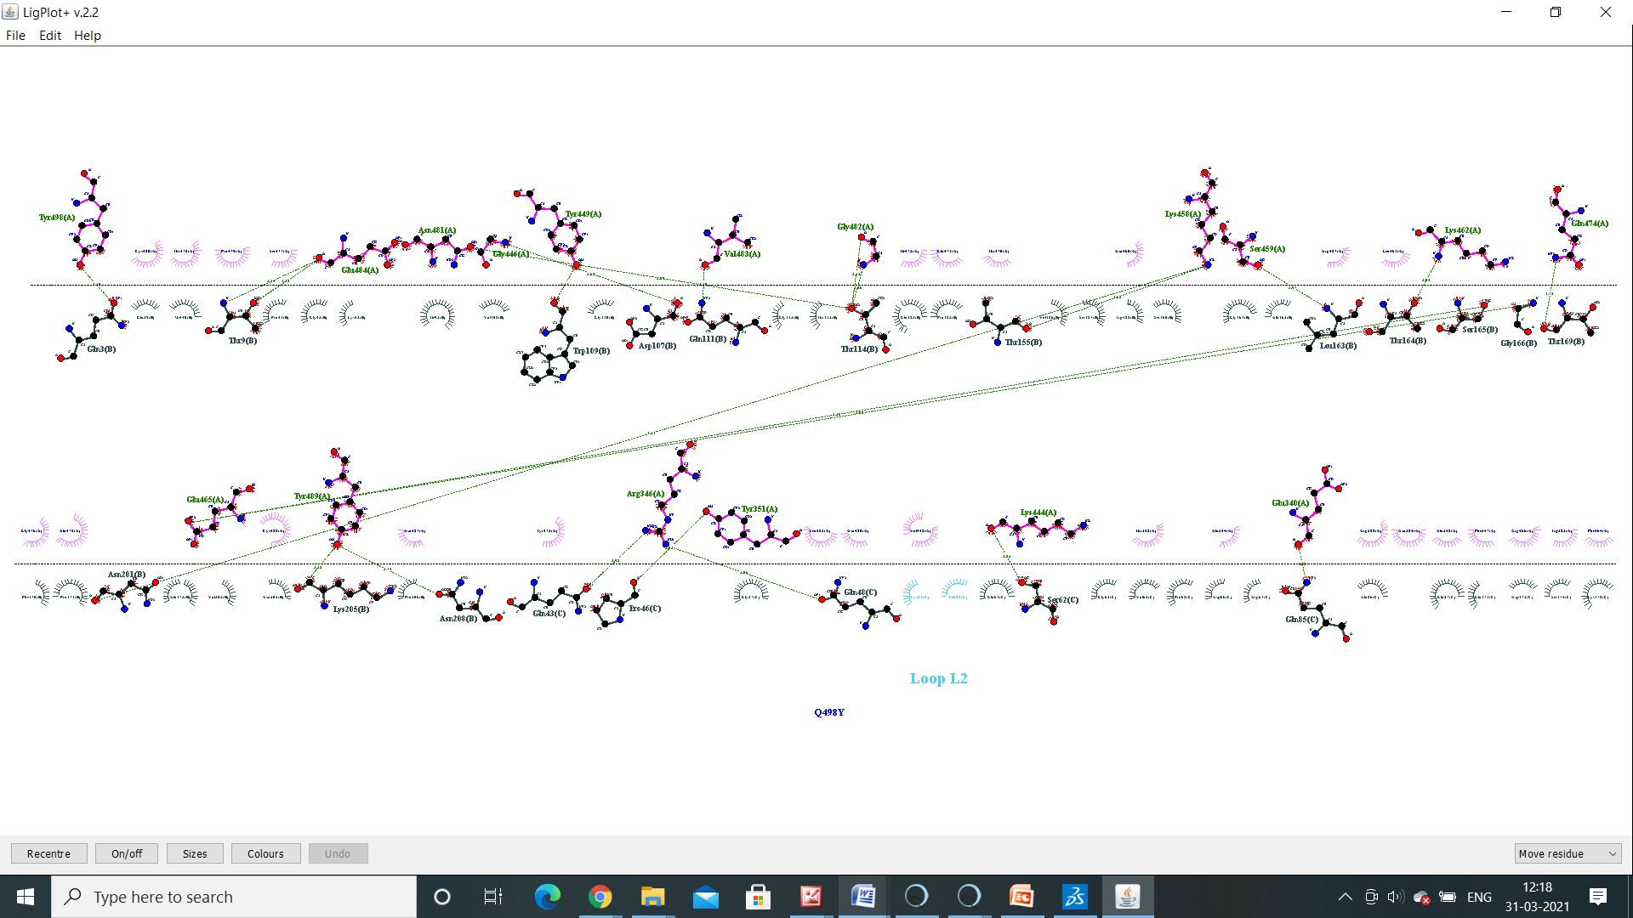
Q498Y
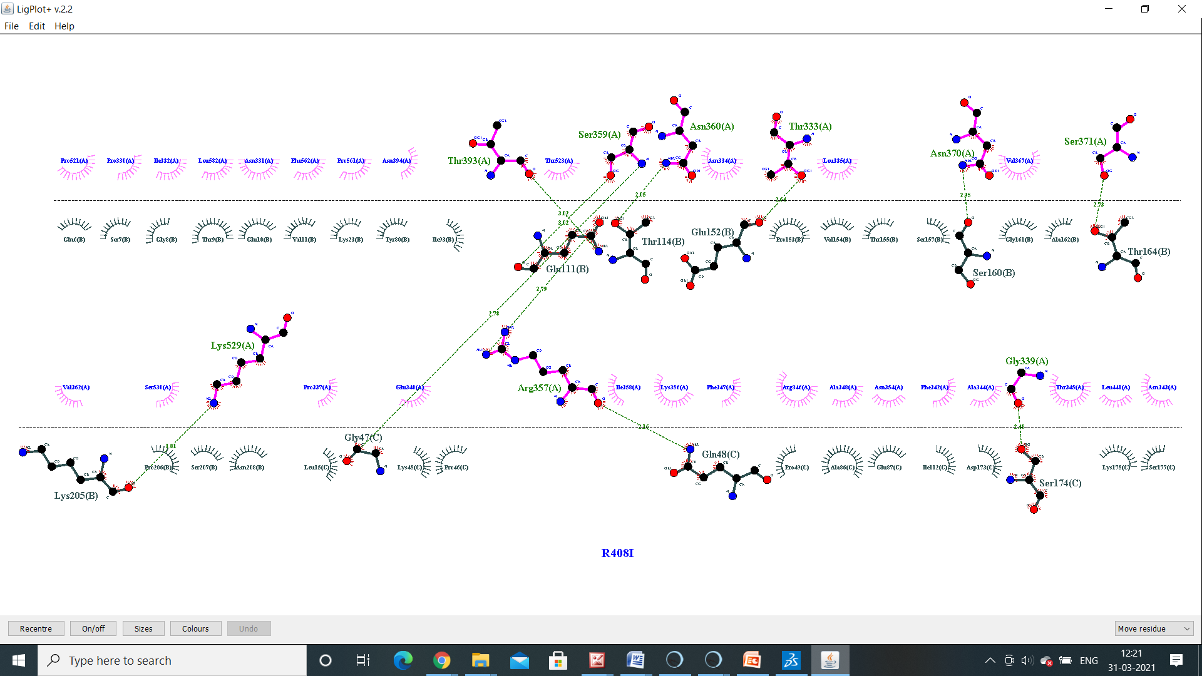
R408I
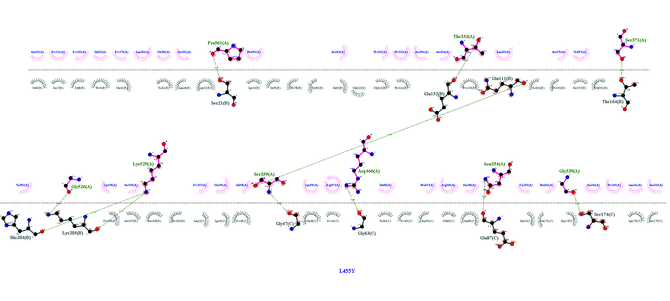
L455Y
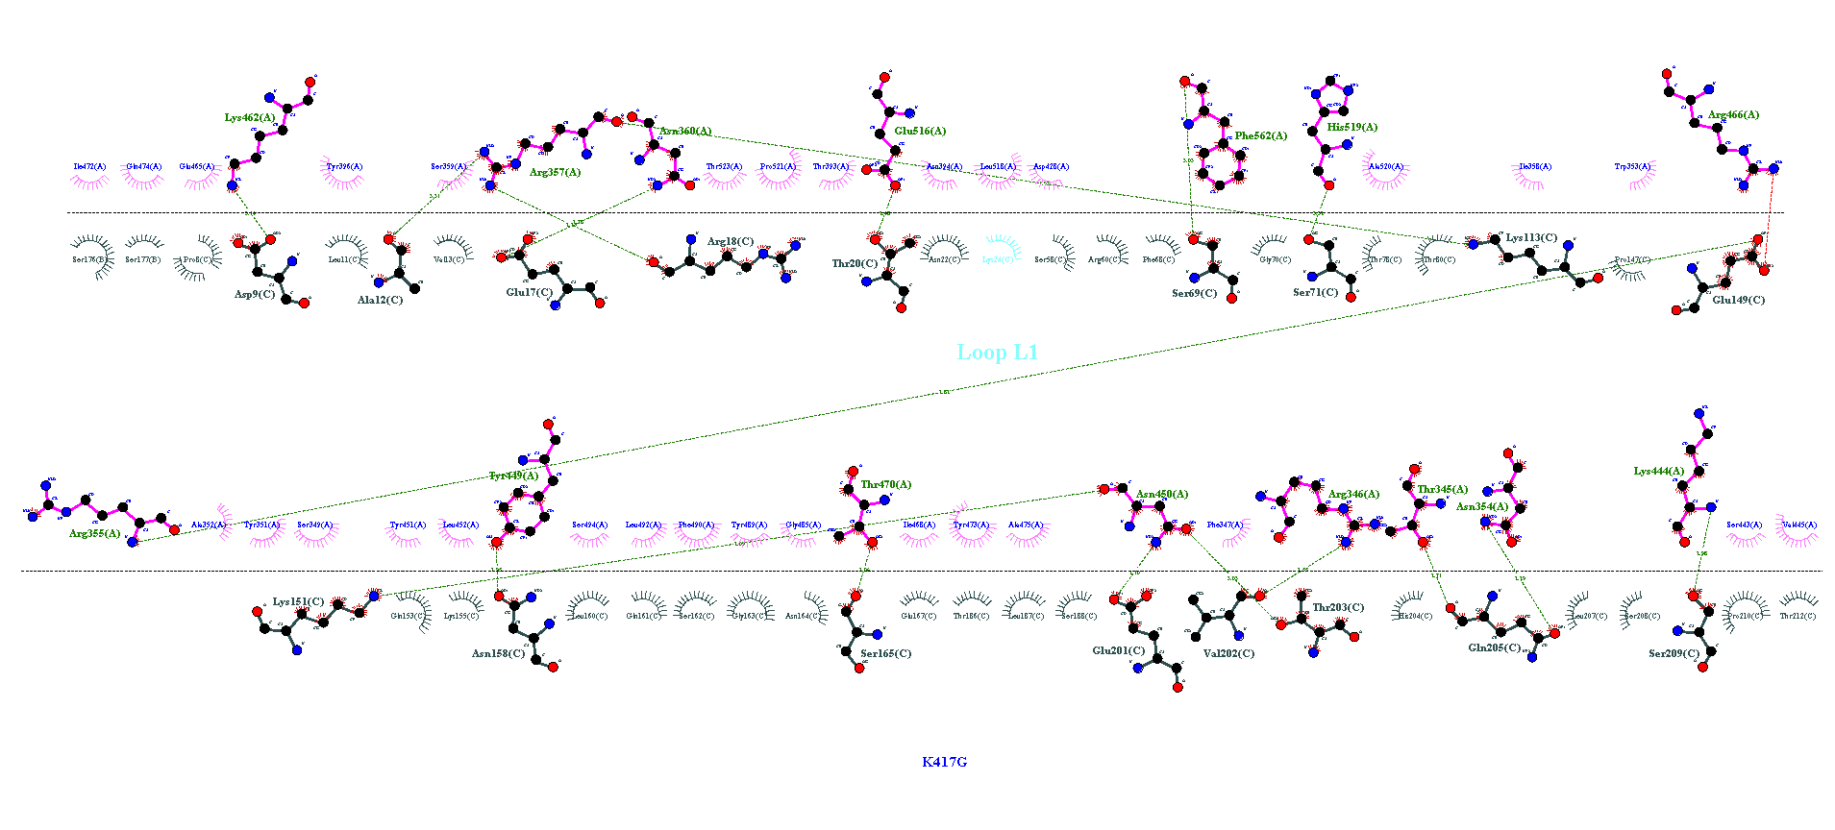
K417G
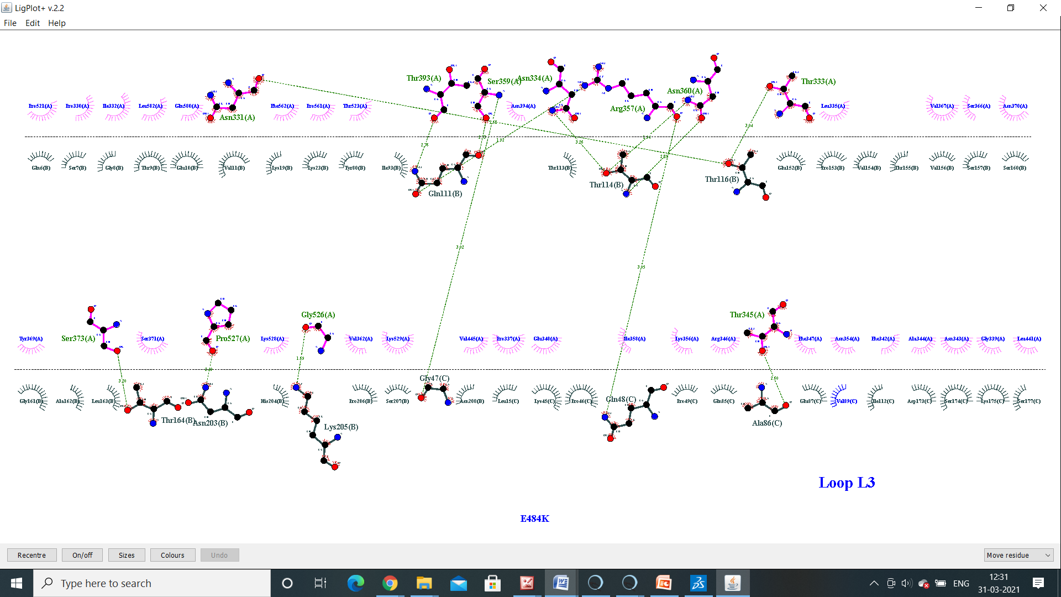
E484K

ACE2 – RBD Variants
Molecular interaction of ACE2 (6ACG) with 7 different RBD Variants which have structural changes in RBD region. Hydrogen bonds showed in green dashed lines and hydrophobic contacts indicated by the red brick

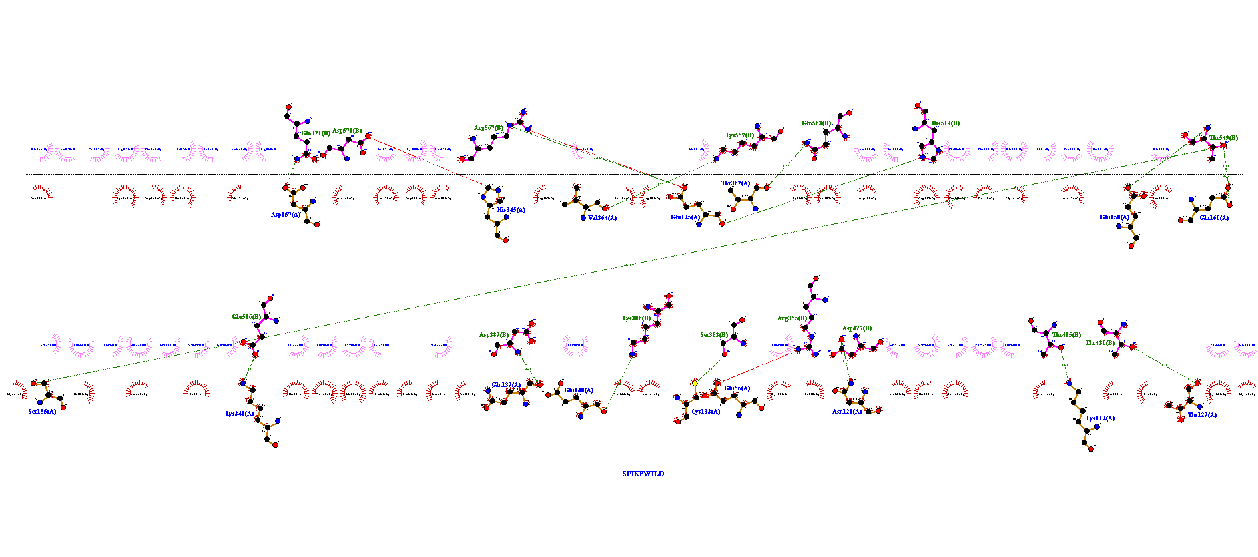
Spike Wild
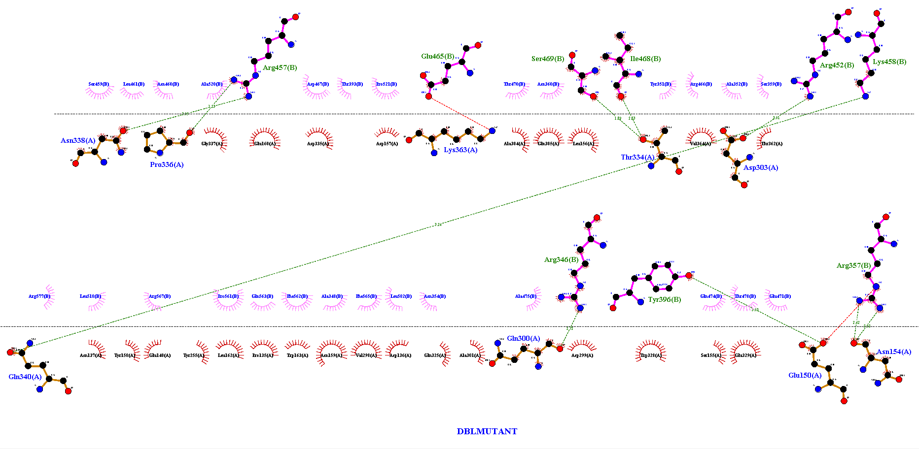
B.1.617’strain

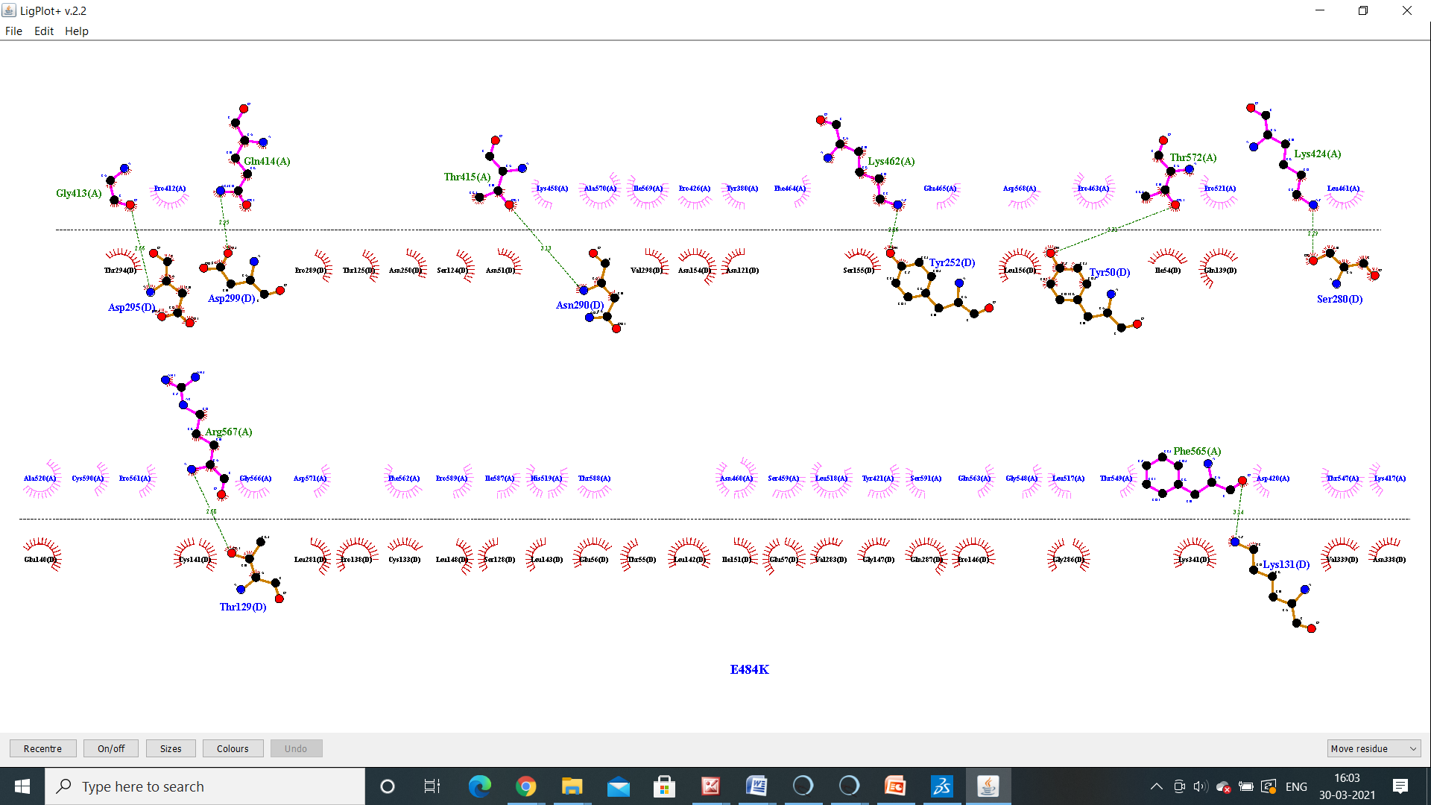
E484k
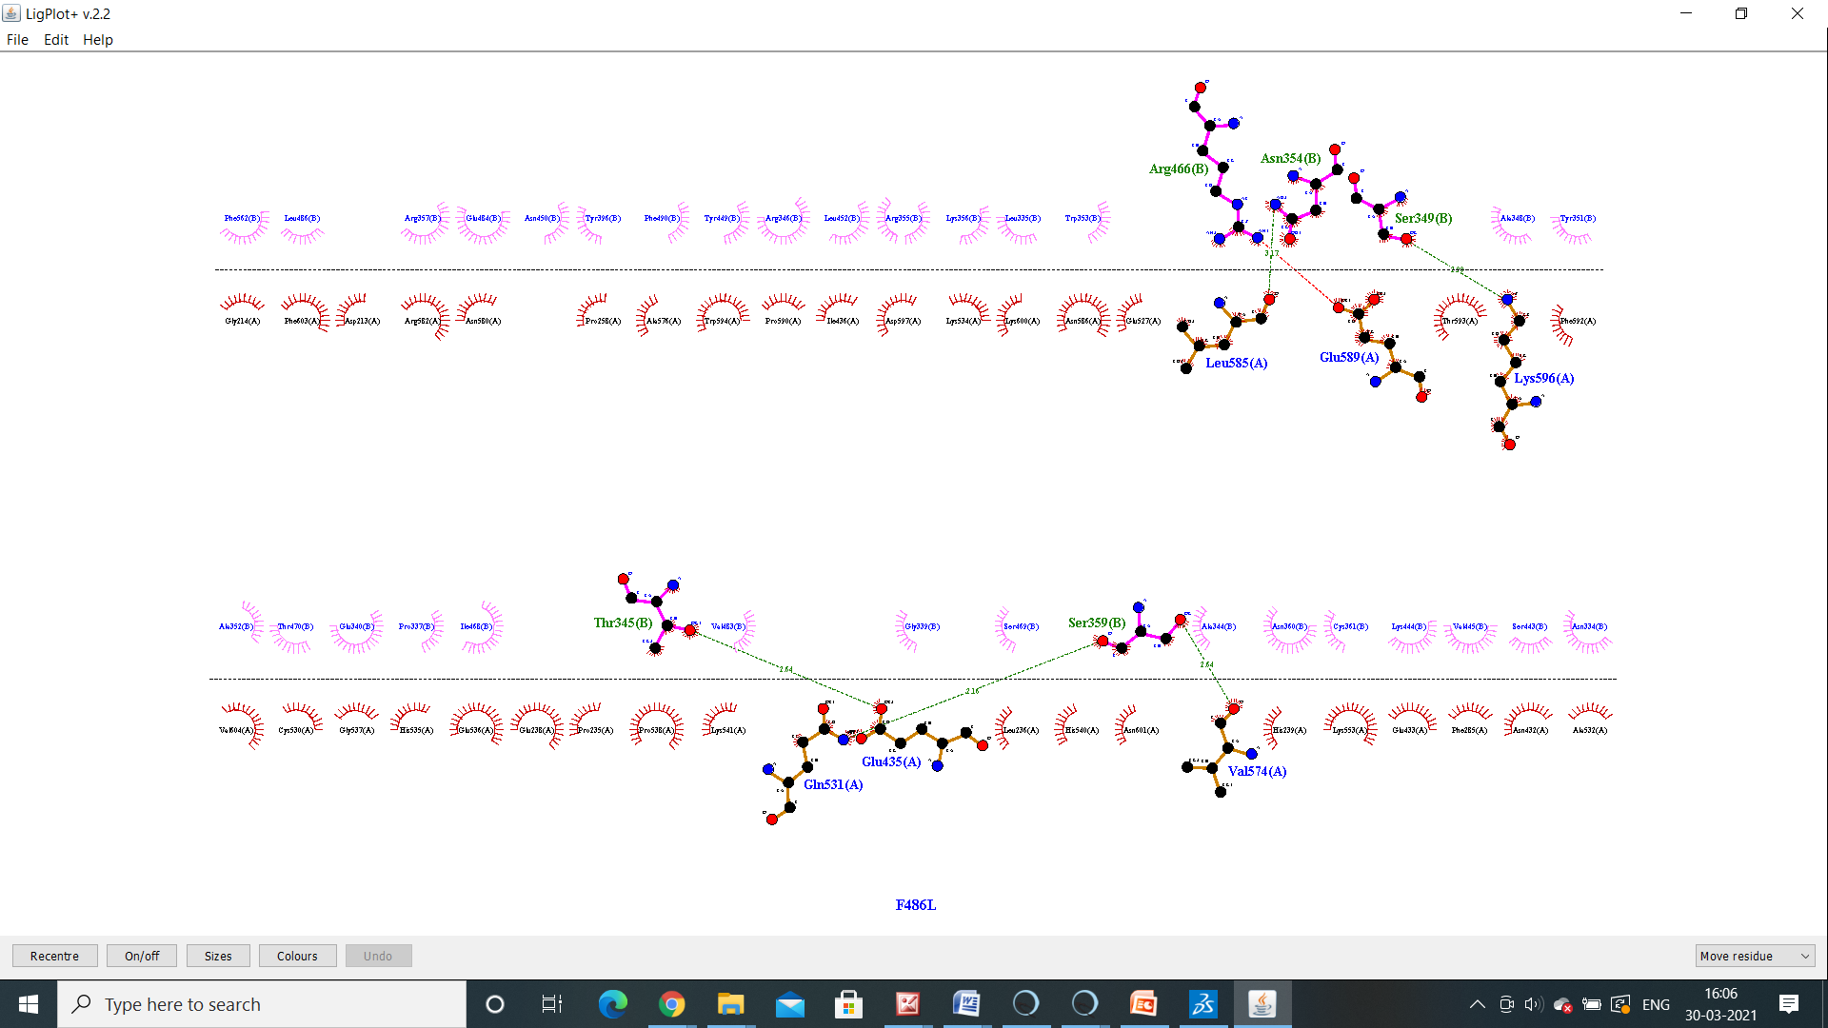
F486L
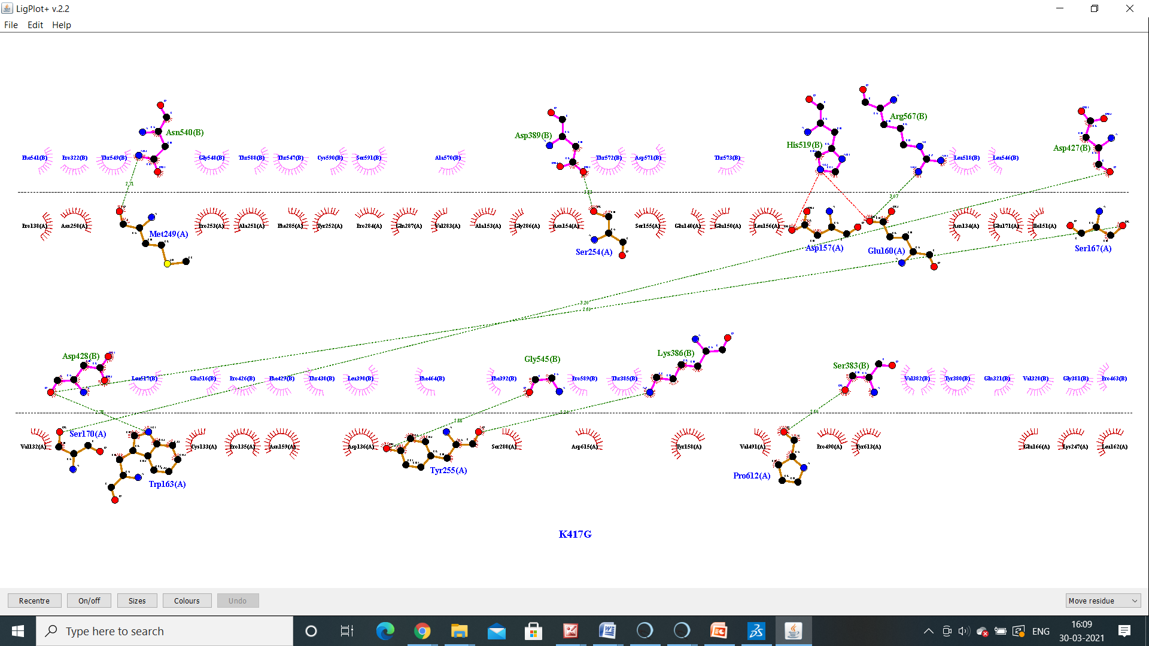
K417G
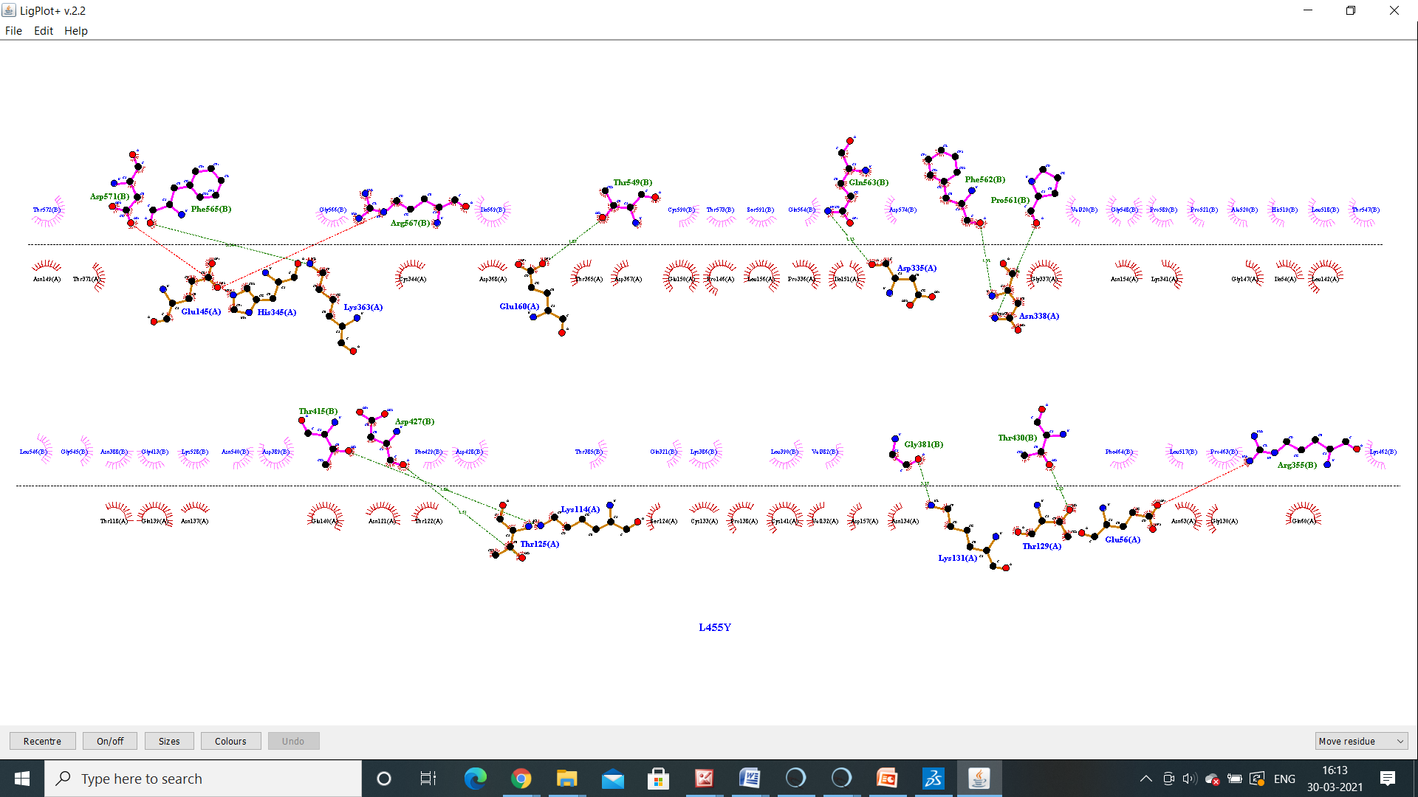
L455Y

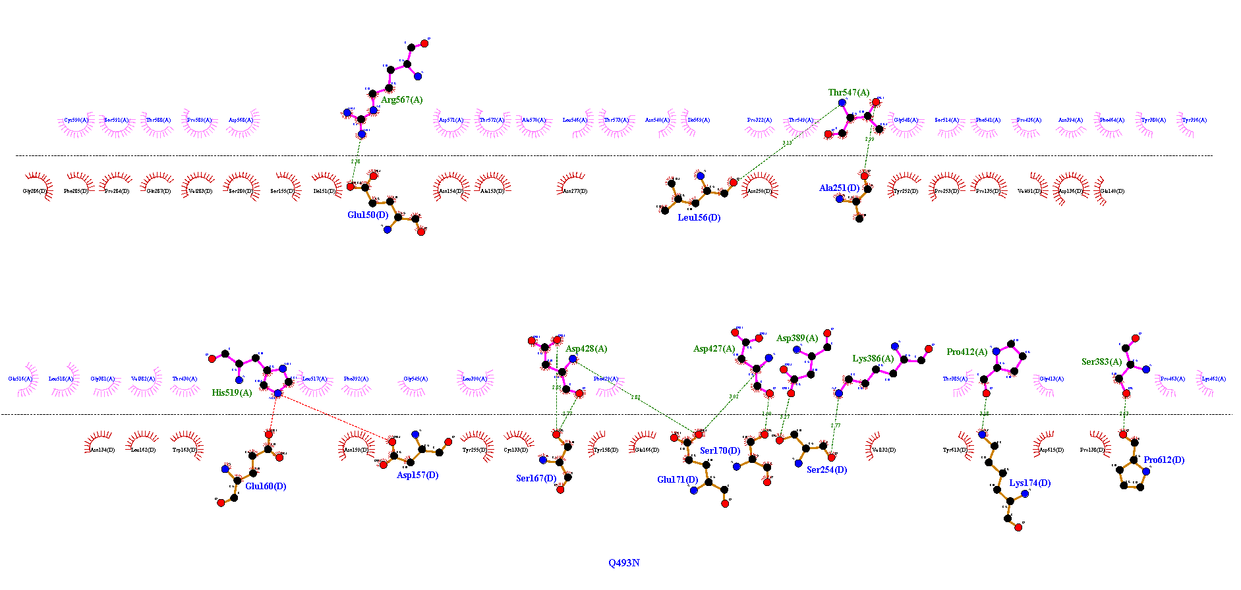
Q493N

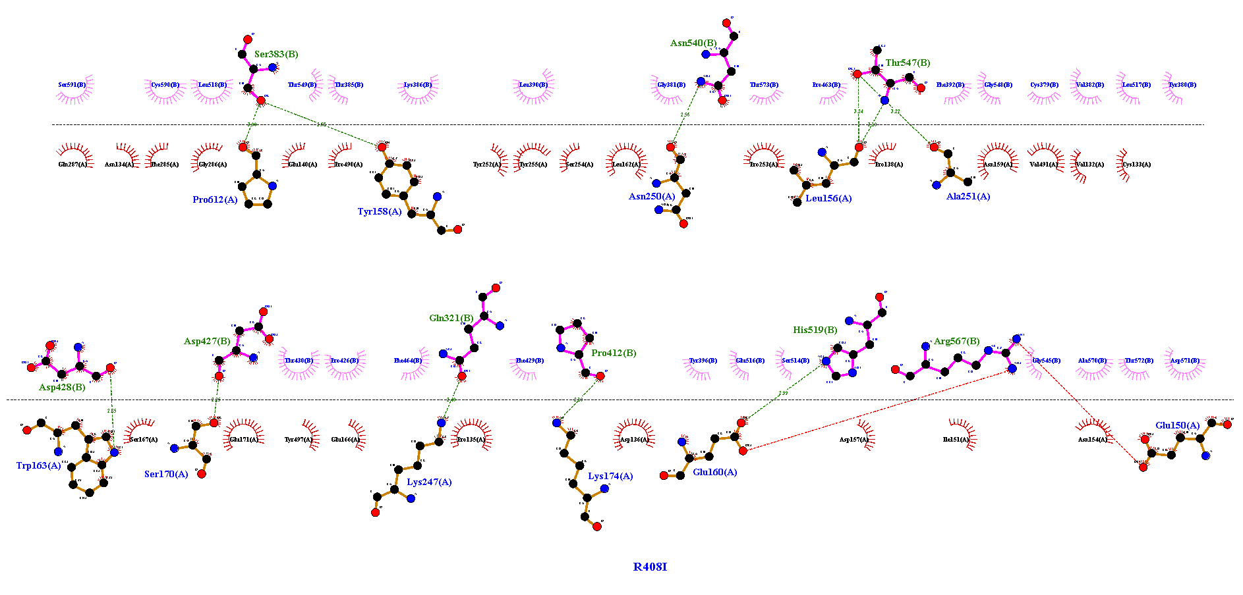
R408I

