Direct Aspiration vs. Partial and Complete Stent Retriever Retraction in Stroke: Influence of Collateral Flow on Recanalization and Embolic Risk

Magda Jablonska^{1,3}, Jiahui Li^{2,3}, Riccardo Tiberi^{2,3}, Eder Ariel Paredes Cruz^{3,4}, Marc Ribo^{2,3}

¹ 2-nd Department of Radiology, Medical University of Gdansk, Gdansk, Poland
² Stroke Unit, Vall d’Hebron University Hospital, Barcelona, Spain
³ Stroke Research, Vall d’Hebron Research Institute, Barcelona, Spain
⁴ Autonomous University of Barcelona, Barcelona, Spain

Corresponding author:
Marc Ribo
Stroke Unit, Neurology, Vall d’Hebron University Hospital, Barcelona, Spain
Hospital Vall d’Hebron, Passeig de la Vall d’Hebron Barcelona 119-129, Spain
E-mail: marcriboj@hotmail.com

 | OVERALL % | PCM % | GCM % | P VALUE
TICI 2b-3
SOFT CLOT | 71,7 | 63,3 | 80 | 0.043*
STIFF CLOT | 65,8 | 63,3 | 68,3 | 0.564
TICI 2c-3
SOFT CLOT | 71,7 | 63,3 | 80 | 0.10*
STIFF CLOT | 24,2 | 15 | 33,3 | 0.019*

Supplemental material 1. Recanalization rates (TICI 2b-3 and TICI 2c-3) for PCM and GCM based on clot type.

 | OVERALL % | Complete SR retraction technique % | Partial SR retraction technique % | Direct aspiration %
TICI 2b-3
OVERALL | 68,8 | 90 | 52,5 | 63,7
PCM
TOTAL | 63,3 | 82,5 | 50 | 57,5
SOFT CLOT | 63,3 | 90 | 45 | 55
STIFF CLOT | 63,3 | 75 | 55 | 60
GCM
TOTAL | 74,2 | 97,5 | 55 | 70
SOFT CLOT | 80 | 100 | 60 | 80
STIFF CLOT | 68,3 | 95 | 50 | 60
TICI 2c-3
OVERALL | 23,8 | 25 | 15 | 31,3
PCM
TOTAL | 14,2 | 12,5 | 5 | 25
SOFT CLOT | 13,3 | 10 | 5 | 25
STIFF CLOT | 15 | 15 | 5 | 25
GCM
TOTAL | 33,3 | 37,5 | 25 | 37,5
SOFT CLOT | 33,3 | 35 | 30 | 35
STIFF CLOT | 33,3 | 40 | 20 | 40

Supplemental material 2. Revascularization outcomes based on thrombectomy techniques and clot characteristics.

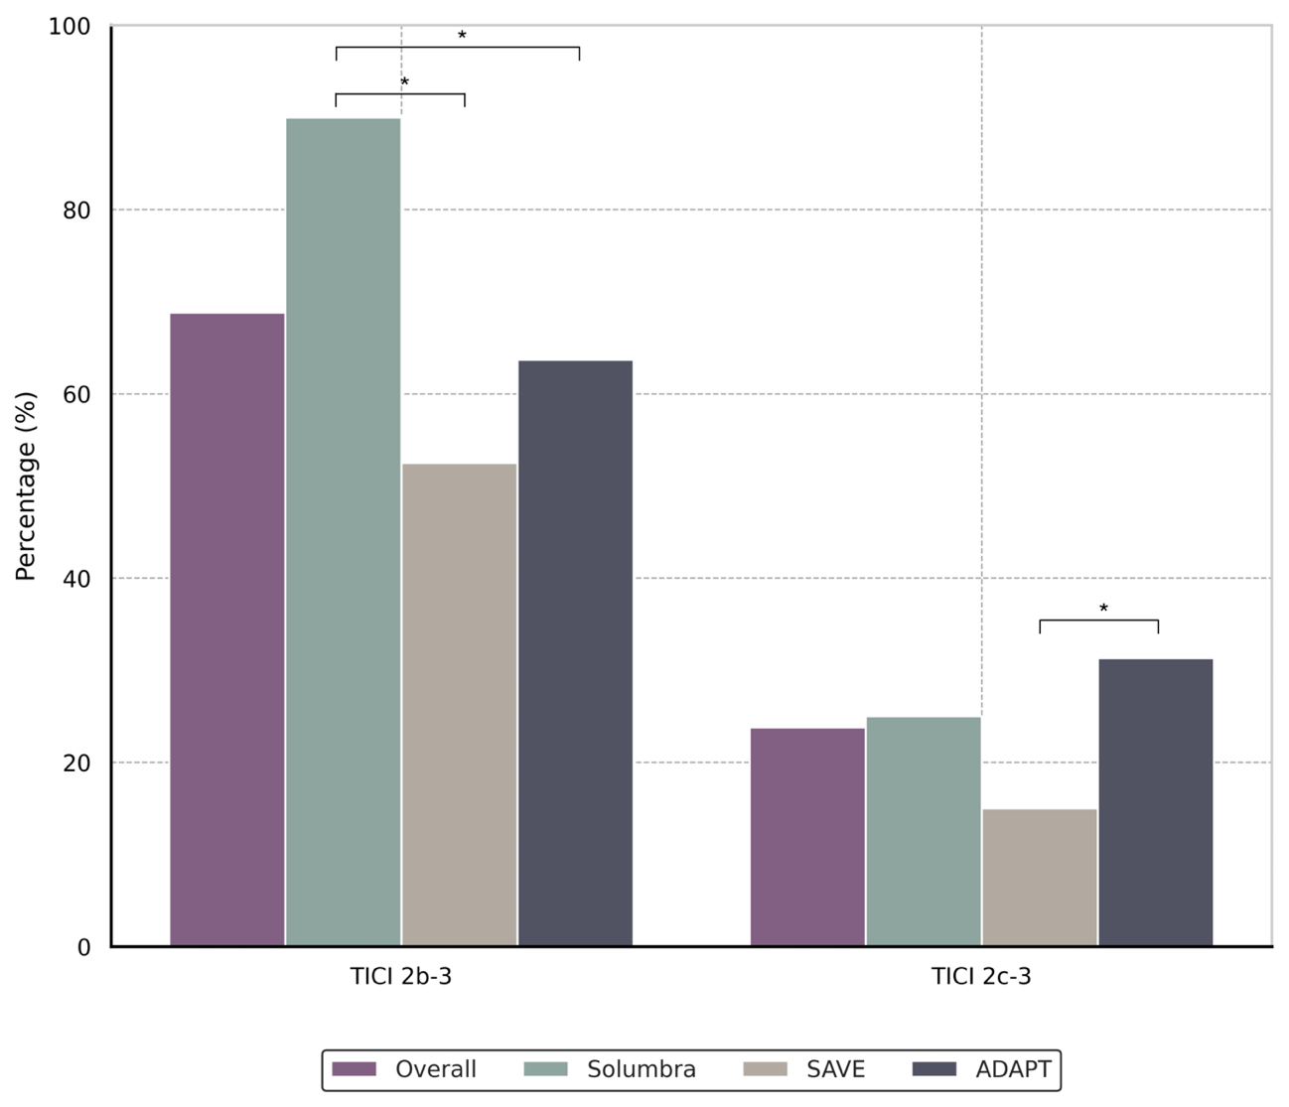

Supplemental material 3. Comparison of overall substantial and complete recanalization rates across complete and partial stent retriever retraction and direct aspiration techniques.

