Sup. Fig.1: Post-MD MMGBSA calculations of top hit compounds in equilibrium phase of simulation. The final 100 ns interval was selected as it corresponded to the equilibrium phase of the simulation, characterized by minimal structural fluctuations, thereby indicating system stabilization and convergence.

Sup. Fig.2: Per Residue energy decomposition of top hit compounds

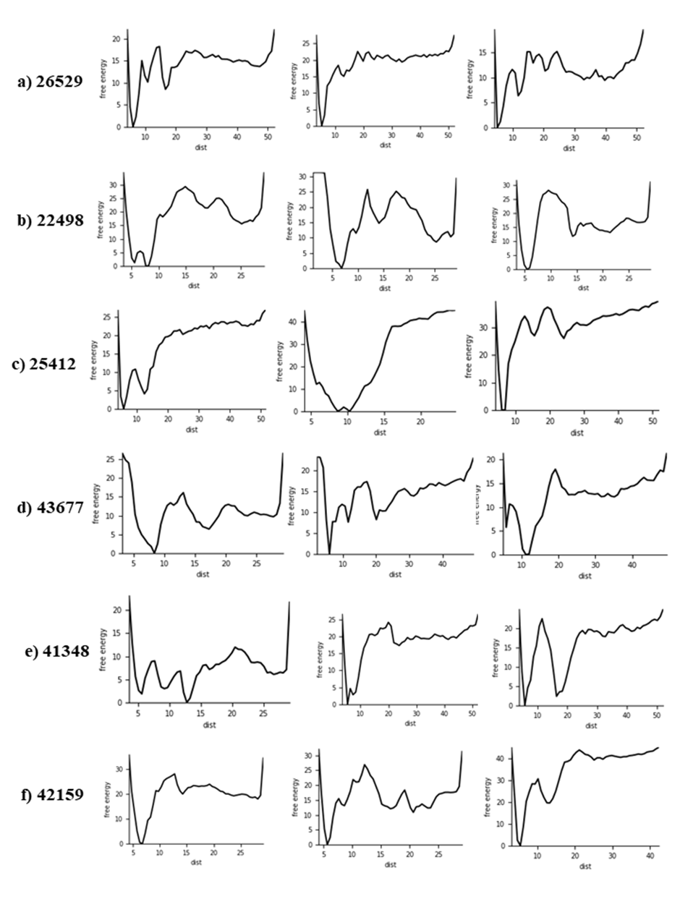
Sup. Fig. 3: Metadynamics simulation and free energy landscape of triplicate runs of top hit compounds

Sup. Table 1: SASA (${(Å)}^{2}$) values of top hit compounds complexed with LasR

SASA | Docked | 1st Run | 2nd run | 3rd run
26529 | 8576.17 | 8710.41 | 8711.52 | 8925.32
25412 | 8643.93 | 8390.27 | 8981.18 | 9029.08
22498 | 8447.90 | 8546.10 | 9051.40 | 8931.14
43677 | 8641.07 | 8684.57 | 9004.78 | 8549.58
41348 | 8644.08 | 9610.72 | 8737.26 | 8702.07
42159 | 8582.12 | 9172.05 | 9416.37 | 8921.11
OHN | 8644.22 | 8893.49 | 8799.35 | 8838.62

Sup. Table 2: Toxicity values of top 20 hit compounds
Compounds | Hepatotoxicity | Nephrotoxicity | Neurotoxicity | Cardiotoxicity | Cytotoxicity | Carcinogenicity | BBB Barrier | Immunotoxicity | LD50(mg kg-1)/Class
26529 | Inactive | Inactive | Active | Inactive | Inactive | Inactive | Active | Inactive | 1500/4
26529 | 0.63 | 0.57 | 0.83 | 0.89 | 0.56 | 0.56 | 0.62 | 0.99 | 1500/4
22498 | Active | Inactive | Active | Inactive | Inactive | Inactive | Active | Inactive | 600/4
22498 | 0.58 | 0.53 | 0.67 | 0.75 | 0.72 | 0.51 | 0.83 | 0.99 | 600/4
25412 | Inactive | Active | Inactive | Inactive | Inactive | Active | Active | Inactive | 550/4
25412 | 0.52 | 0.64 | 0.55 | 0.62 | 0.79 | 0.55 | 0.81 | 0.97 | 550/4
43677 | Inactive | Inactive | Inactive | Inactive | Inactive | Active | Active | Active | 728/4
43677 | 0.62 | 0.59 | 0.58 | 0.79 | 0.51 | 0.61 | 0.8 | 0.82 | 728/4
41348 | Inactive | Inactive | Active | Inactive | Inactive | Active | Active | Inactive | 1000/4
41348 | 0.52 | 0.58 | 0.76 | 0.88 | 0.86 | 0.59 | 0.89 | 0.99 | 1000/4
42159 | Inactive | Inactive | Active | Inactive | Inactive | Active | Active | Inactive | 1600/4
42159 | 0.62 | 0.54 | 0.78 | 0.91 | 0.61 | 0.53 | 0.71 | 0.97 | 1600/4

Sup. Table 3: Post-MD MMGBSA calculations of top hit compounds in equilibrium phase of simulation in final 100 ns interval of 2nd and 3rd run (energy values in kcal/mol)

Parameters | dG_Bind energy | Coulomb energy | Covalent energy | Lipophilic energy | Solv_GB energy | vdW energy
Control rep 2 | -78.97 | -23.9 | 2.56 | -24.67 | 26.46 | -57.55
Control rep 3 | -85.28 | -24.61 | 2.68 | -26.4 | 25.14 | -58.7
26529 rep 2 | -104.47 | -76.99 | 4.5 | -32.46 | 60.33 | -53.38
26529 rep 3 | -92.1 | -64.34 | 0.06 | -24.24 | 56.24 | -56.88
41348 rep 2 | -75.84 | -14.88 | 1.02 | -18.18 | 18.03 | -52.27
41348 rep 3 | -75.77 | -14.88 | 1.01 | -18.18 | 18.1 | -52.27
42159 rep 2 | -59.74 | -47.25 | 3.32 | -17.11 | 45.67 | -42.64
42159 rep 3 | -77.28 | -47.99 | 2.18 | -19.78 | 51.34 | -58.87
43677 rep 2 | -81.23 | -12.4 | 3.8 | -23.93 | 13.47 | -58.55
43677 rep 3 | -90.78 | -16.52 | 4.09 | -27.15 | 12.44 | -57.61
25412 rep 2 | -79.33 | -28.76 | 7.72 | -27.32 | 25.87 | -50.13
25412 rep 3 | -83.94 | -21.33 | 1.81 | -30.94 | 23.6 | -48.88
22498 rep 2 | -80.06 | -11.38 | 4.86 | -28.24 | 21.7 | -60.27
22498 rep 3 | -69.42 | -16.56 | 3.36 | -26.6 | 29.43 | -54.72

