A Comparative Analysis of Optical Properties of Silver Nanoparticles Synthesized Using Two Plant Extracts:
Getachew Tizazu¹*, Habtamu Mengesha² and Abera Senay¹
¹Department of Physics, Bahir Dar University, Bahir Dar, Ethiopia
²Ethiopian Institute of Textile and Fashion Technology, Bahir Dar , Ethiopia

- Silver nanoparticle synthesis
To synthesize silver nanoparticles, 0.509 g of silver nitrate (AgNO₃) was accurately weighed and dissolved in 500 mL of deionized water in a 1000 mL volumetric flask to prepare a 6 mM stock solution. From this stock, lower concentrations (1 mM, 2 mM, and 4 mM) were prepared using serial dilution according to the dilution formula (C₁V₁ = C₂V₂).
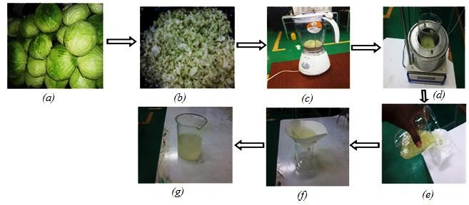
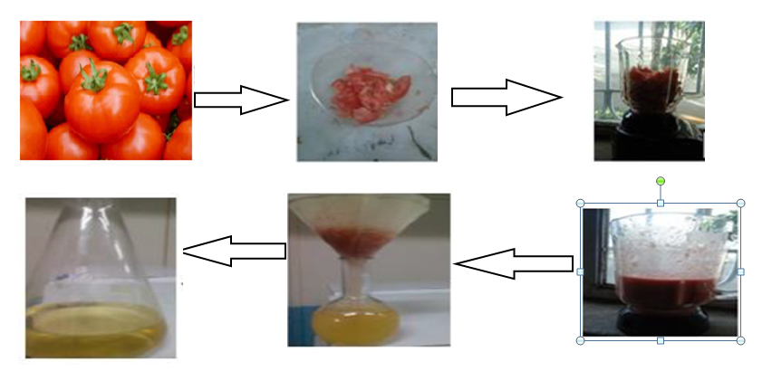

Figure: s1. The procedure of preparation of the extracts a) tomatoes extracted and b) cabbage extract
To examine the effect of reaction time, silver nanoparticles were synthesized at the three time intervals mentioned above, allowing us to assess how prolonged exposure to the reducing agent influences nanoparticle formation and properties. In parallel, the concentration of the extract was varied by adjusting the volume ratio of silver nitrate solution to plant extract using four different ratios: 24:4, 20:4, 12:4, and 8:4 (v/v), where the first value represents the volume of silver nitrate solution and the second the volume of plant extract in milliliters. The reaction mixtures were allowed to proceed under ambient conditions, and the formation of silver nanoparticles was monitored visually (through color change) and using UV-Visible spectroscopy to assess the influence of these variables on nanoparticle size, concentration, and optical characteristics.
Table s2: Table of silver nanoparticles synthesis with varying mixing ratio of extract to aqueous silver nitrate solution and reaction time with samples from 1a through 1d, 2a through 2d, 3a through 3d, 4a through 4d and 5a through 5d are made.

Sample | Conc. of LE  (ml) | Conc. Of AgNO₃  (ml) | Volume ratio of  Extract: AgNO₃ | Time (Hrs.)
1a | 5 | 25 | 1:5
1b | 5 | 50 | 1:10
 |  |  |  | 2
1c | 5 | 75 | 1:15
1d | 5 | 100 | 1:20
2a | 5 | 25 | 1:5
2b | 5 | 50 | 1:10
 |  |  |  | 18
2c | 5 | 75 | 1:15
2d | 5 | 100 | 1:20
3a | 5 | 25 | 1:5
3b | 5 | 50 | 1:10
 |  |  |  | 24
3c | 5 | 75 | 1:15
3d | 5 | 100 | 1:20
4a | 5 | 25 | 1:5
4b | 5 | 50 | 1:10
4c | 5 | 75 | 1:15 | 48
4d | 5 | 100 | 1:20

Table s3 the ratio of mixing tomato extract and AgNO₃ solution.
Sample | Tomato extract | AgNO₃ solution  (0.509 g/500 ml) | Volume ratio of  Extrac:AgNO₃ | Time in hour
1 | 4 ml | 8ml | 1:2 | 4 | 12 | 24
2 | 4 ml | 12ml | 1:3 | 4 | 12 | 24
3 | 4 ml | 16ml | 1:4 | 4 | 12 | 24
4 | 4 ml | 20ml | 1:5 | 4 | 12 | 24
5 | 4 ml | 24ml | 1:6 | 4 | 12 | 24

To investigate the influence of reaction time on the properties of silver nanoparticles, synthesis was carried out at different durations: 4 hours, 12 hours, and 24 hours. These time intervals were selected to monitor the evolution of nanoparticle formation and changes in their optical characteristics over time. In addition to reaction time, the concentration of the reducing agent—cabbage leaf extract—was also varied to assess its impact on nanoparticle synthesis.
The extract-to-metal precursor ratio was systematically modified, with extract volumes adjusted in the following ratios relative to the silver ion solution: 24:4, 20:4, 12:4, and 8:4 (v/v). These variations were aimed at identifying the optimal extract concentration required for effective reduction and stabilization of silver nanoparticles. By analyzing both reaction time and extract concentration, a comprehensive understanding of their combined effects on nanoparticle size, shape, distribution, and optical properties was achieved.
- Characterization Techniques
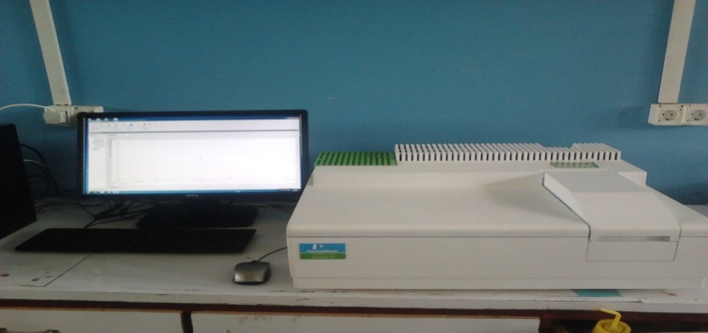
The synthesized silver nanoparticles were characterized using UV-Visible spectroscopy, which measures the change in light intensity after interaction with a sample relative to the initial incident intensity. For this study, the optical properties of silver nanoparticles were determined using a double beam Lambda 35 UV-Vis spectrophotometer (PerkinElmer, USA). This technique is based on the Beer-Lambert Law, which relates absorbance to the concentration, path length, and absorption coefficient of the sample. The absorbance A(λ)A(\lambda)A(λ) is defined as A(λ)=log⁡(I0/I)A(\lambda) = \log(I_0/I)A(λ)=log(I0​/I), where I0I_0I0​ is the intensity of the incident light and III is the transmitted intensity. UV-Vis spectroscopy provides valuable information about the chemical composition, thickness, and optical properties of the material. It is widely used to analyze solutions due to the fact that many molecules absorb light in the ultraviolet and visible regions. In this method, a beam of light is passed through a sample, and the amount of absorbed light at different wavelengths is recorded. By scanning across a range of wavelengths and measuring the absorbance at each point, an absorbance versus wavelength graph is generated using appropriate software. After the addition of AgNO₃ to the plant extract, the resulting colloidal solution was scanned across a wavelength range of 300–800 nm. Absorbance spectra were recorded at different time intervals over a 24-hour period to monitor the evolution of nanoparticle formation.

Figure s2. UV-visible Spectrophotometry
- Antibacterial test

Table s3 shows information on the materials and bacterial strains used in the antimicrobial testing. The bacterial strains used were obtained from Bahir Dar University Natural Science College Microbiology Laboratory, Bahir Dar (Ethiopia). They were clinical isolates and are used as international reference standards for disc susceptibility assessment of many antibiotics.
Table s4: The materials and bacterial strains used for the antimicrobial testing of the lab- synthesized silver nanoparticles

Materials Used | Bacterial Strains
Nutrient broth media | Escherichia coli (gram –)
Mueller Hinton agar | Staphylococcus aureus (gram +)
0.85% saline solution | Pseudomonas aeruginosa (gram –)
McFarland standard solution | Proteus vulgaris (gram -)
Petri dish
Test tube

- Testing the Active Concentration of Bacterial Colony

The bacteria colony for the test was prepared by growing each bacterial strain in nutrient broth (which is prepared by dissolving 18 g of nutrient broth in 1 liter of distilled water and sterilized by autoclaving at 121 ⁰C for 15 minutes) for 24 hours. Then the bacteria colony was inoculated in 0.85 % saline solution, prepared by dissolving 85 g sodium chloride in 1 liter distilled water. The effective concentration of the bacterial colony was evaluated by comparing the turbidity of the 24 hour grown active bacterial colony in saline solution with 0.5 McFarland standard (prepared by mixing 0.05 mL of 1.175% barium chloride dihydrate (BaCl₂•2H₂O), with 9.95 mL of 1% sulfuric acid (H₂SO₄)).
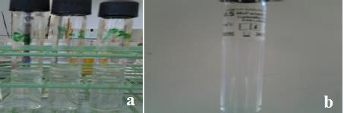

Figure s3: (a) Four bacterial suspensions in 0.85 % saline solution and (b) McFarland standard solution

Preparation of Mueller Hinton Agar Plate

The Mueller Hinton agar plate was prepared by pouring the agar (which is prepared by dissolving 38 g of Mueller Hinton agar in 1 L of distilled water and sterilized by autoclaving at 15 lbs. pressure at 121 ⁰C for 15 minutes) on the petri dish uniformly without it forming any bubbles and allowing it to solidify at room temperature.

Bacteria

In order to achieve an understanding of antimicrobial effect of silver nanoparticles, knowledge about the structure of bacteria is needed. In particular, the bacterial membrane and the contained proteins are of special interest, because the silver has to react with it in order to penetrate the bacteria. Bacteria are unicellular microscopic organisms which consist of one compartment containing all the elements of the cell, including DNA. They are in overall divided in two main groups; gram positive and gram negative, which refers to two different types of membranes. The gram positive bacteria have a thick mesh-like shell consisting of peptidoglycan, which protects the single bilayer phospholipid membrane. The gram negative bacteria have a thin layer of peptidoglycan enclosed by two bilayers of phospholipid [70]. In order for the bacteria to interact with the surroundings they have integrated proteins in the membrane. Each of these proteins has a specific use. Some are so-called ion channels that allow ions to move in or out of the cell by diffusion. Others are proteins that transport molecules by consumption of energy in the form of ATP.

Furthermore there is a third type of membrane proteins consisting of three subtypes. The first of these is the so called uniporters where an already thermodynamically favorable reaction is enhanced by allowing molecules to migrate through a membrane from high concentration towards low. This means that the uniporters actually allow a substance that cannot penetrate the phospholipid membranes by diffusion, to enter the cell using the catalyzing properties of the protein. The last two of the three is the so called cotransporters which work by using the energy of a thermodynamical favorable migration of substrate such as ions to catalyze the transport of another substrate against its concentration gradient [38].

- Representative python code

- Python code for the determination of size from Mie equation ( Johnson and Christy Optical data)
- # -*- coding: utf-8 -*-
- """
- Created on Sun Apr 13 16:55:27 2025

- @author: Getachew
- """
- import numpy as np
- import pandas as pd
- import matplotlib.pyplot as plt
- from scipy.special import spherical_jn, spherical_yn
- from scipy.interpolate import interp1d
- import os

- # Load or create Johnson and Christy data file
- jc_filename = "Ag_Johnson_Christy.csv"
- if not os.path.exists(jc_filename):
- jc_data = """Wavelength (nm),n,k
- 300,0.27,3.25
- 310,0.29,3.47
- 320,0.31,3.73
- 330,0.33,4.01
- 340,0.35,4.34
- 350,0.37,4.69
- 360,0.39,5.08
- 370,0.42,5.50
- 380,0.44,5.95
- 390,0.47,6.43
- 400,0.50,6.93
- 410,0.52,7.45
- 420,0.55,7.97
- 430,0.58,8.49
- 440,0.61,9.01
- 450,0.63,9.52
- 460,0.66,10.0
- 470,0.68,10.5
- 480,0.70,10.9
- 490,0.72,11.3
- 500,0.74,11.6
- 510,0.76,11.9
- 520,0.78,12.2
- 530,0.80,12.4
- 540,0.82,12.6
- 550,0.84,12.8
- 560,0.86,12.9
- 570,0.88,13.1
- 580,0.90,13.2
- 590,0.92,13.3
- 600,0.94,13.4
- 610,0.96,13.4
- 620,0.98,13.5
- 630,1.00,13.5
- 640,1.02,13.5
- 650,1.04,13.5
- 660,1.06,13.5
- 670,1.08,13.4
- 680,1.10,13.3
- 690,1.12,13.2
- 700,1.14,13.1
- 710,1.16,13.0
- 720,1.18,12.8
- 730,1.20,12.6
- 740,1.22,12.4
- 750,1.24,12.2
- 760,1.26,12.0
- 770,1.28,11.7
- 780,1.30,11.5
- 790,1.32,11.2
- 800,1.34,11.0"""
- with open(jc_filename, "w") as f:
- f.write(jc_data)

- # Load Johnson and Christy data
- data = pd.read_csv(jc_filename)
- wl_data = data["Wavelength (nm)"].values
- n_data = data["n"].values
- k_data = data["k"].values
- eps_data = (n_data + 1j * k_data) ** 2

- # Interpolation of dielectric function
- eps_real_interp = interp1d(wl_data, eps_data.real, kind='cubic', fill_value='extrapolate')
- eps_imag_interp = interp1d(wl_data, eps_data.imag, kind='cubic', fill_value='extrapolate')

- # Mie theory functions
- def psi(n, z):
- return z * spherical_jn(n, z)

- def dpsi(n, z):
- return spherical_jn(n, z) + z * spherical_jn(n, z, derivative=True)

- def xi(n, z):
- return z * (spherical_jn(n, z) + 1j * spherical_yn(n, z))

- def dxi(n, z):
- return (spherical_jn(n, z, derivative=True) + 1j * spherical_yn(n, z, derivative=True)) + \
- (spherical_jn(n, z) + 1j * spherical_yn(n, z)) / z

- def mie_coeffs(m, x, N):
- an = []
- bn = []
- for n in range(1, N+1):
- mx = m * x
- psi_mx = psi(n, mx)
- dpsi_mx = dpsi(n, mx)
- psi_x = psi(n, x)
- dpsi_x = dpsi(n, x)
- xi_x = xi(n, x)
- dxi_x = dxi(n, x)

- a = (m * psi_mx * dpsi_x - psi_x * dpsi_mx) / (m * psi_mx * dxi_x - xi_x * dpsi_mx)
- b = (psi_mx * dpsi_x - m * psi_x * dpsi_mx) / (psi_mx * dxi_x - m * xi_x * dpsi_mx)

- an.append(a)
- bn.append(b)
- return np.array(an), np.array(bn)

- def mie_Qs(m, x, N=50):
- an, bn = mie_coeffs(m, x, N)
- n = np.arange(1, N+1)
- Qext = (2 / x**2) * np.sum((2*n + 1) * np.real(an + bn))
- Qsca = (2 / x**2) * np.sum((2*n + 1) * (np.abs(an)**2 + np.abs(bn)**2))
- Qabs = Qext - Qsca
- return Qext, Qsca, Qabs

- # User input
- try:
- user_radius_nm = float(input("Enter the radius of the silver nanoparticle (in nm): "))
- except ValueError:
- print("Invalid input. Please enter a number.")
- exit()

- radius = user_radius_nm * 1e-9 # Convert to meters
- n_medium = 1.5 # Refractive index of water
- wavelengths = np.linspace(400, 500, 10000) # Increased resolution in target range
- Qabs_spectrum = []

- # Calculate Q_abs
- for wl in wavelengths:
- eps = eps_real_interp(wl) + 1j * eps_imag_interp(wl)
- m = np.sqrt(eps) / n_medium
- x = 2 * np.pi * n_medium * radius / (wl * 1e-9)
- _, _, Qabs = mie_Qs(m, x)
- Qabs_spectrum.append(Qabs)

- # Resonance detection
- Qabs_spectrum = np.array(Qabs_spectrum)
- peak_index = np.argmax(Qabs_spectrum)
- resonance_wavelength = wavelengths[peak_index]
- max_Qabs = Qabs_spectrum[peak_index]

- # Output results
- print(f"\nResonance wavelength for radius {user_radius_nm:.2f} nm is {resonance_wavelength:.2f} nm")
- print(f"Maximum absorbance (Q_abs) = {max_Qabs:.3f}")

- # Plot
- plt.figure(figsize=(8, 5))
- plt.plot(wavelengths, Qabs_spectrum, label=f'Radius = {user_radius_nm:.1f} nm')
- plt.axvline(resonance_wavelength, color='red', linestyle='--', label=f'Resonance λ = {resonance_wavelength:.2f} nm')
- plt.xlabel("Wavelength (nm)")
- plt.ylabel("Q_abs (Absorbance)")
- plt.title(f"Absorbance Spectrum | Radius: {user_radius_nm:.1f} nm | Resonance: {resonance_wavelength:.2f} nm")
- plt.grid(True)
- plt.legend()
- plt.tight_layout()
- plt.show()

2. Python code for the determination of size from Mie equation ( Drude model )
# -*- coding: utf-8 -*-
"""
Created on Fri Jun 6 14:44:44 2025

@author: Getachew
"""
import numpy as np
import pandas as pd

def solve_quadratic(a, b, c):
"""Solve quadratic equation a*x^2 + b*x + c = 0 and return the positive real root if exists."""
discriminant = b**2 - 4*a*c
if discriminant < 0:
return np.nan
root1 = (-b + np.sqrt(discriminant)) / (2*a)
root2 = (-b - np.sqrt(discriminant)) / (2*a)
# Return the positive root
return root1 if root1 > 0 else (root2 if root2 > 0 else np.nan)

# Prompt user for resonance wavelength
l = float(input("Enter the resonance wavelength (in nm): "))

# Equation 1: l = 391.8 + 0.1737*(2R) + 0.008175*(2R)^2
# Solve 0.008175*(2R)^2 + 0.1737*(2R) + (391.8 - l) = 0
D1 = solve_quadratic(0.008175, 0.1737, 391.8 - l)
R1 = D1 / 2 if not np.isnan(D1) else np.nan

# Equation 2: 2R = 0.78*l - 266
D2 = 0.78 * l - 266
R2 = D2 / 2 if D2 > 0 else np.nan

# Equation 3: l = 397 + 0.00958*(2R)^2
# Solve 0.00958*(2R)^2 + (397 - l) = 0
D3 = solve_quadratic(0.00958, 0, 397 - l)
R3 = D3 / 2 if not np.isnan(D3) else np.nan

# Equation 4: l = 0.11*(2R)^2 + 89.88*(2R) + 17.775
# Solve 0.11*(2R)^2 + 89.88*(2R) + (17.775 - l) = 0
D4 = solve_quadratic(0.11, 89.88, 17.775 - l)
R4 = D4 / 2 if not np.isnan(D4) else np.nan

# Create results table
data = {
"Equation": ["Eq1", "Eq2", "Eq3", "Eq4"],
"2R (nm)": [D1, D2, D3, D4],
"R (nm)": [R1, R2, R3, R4]
}
df = pd.DataFrame(data)

# Display results
print("\nNanoparticle Size Estimates (from resonance wavelength):")
print(df.to_string(index=False, float_format="%.2f"))

