Supplementary Information

The Energy Equity Gap: Unveiling Hidden Energy Poverty
Shuchen Cong^{1,#}, Destenie Nock^{1, 2, #}, Yueming (Lucy) Qiu³, Bo Xing⁴

¹Department of Engineering and Public Policy, Carnegie Mellon University, PA, USA
²Department of Civil and Environmental Engineering, Carnegie Mellon University, PA, USA
³School of Public Policy, University of Maryland College Park, College Park, MD, USA
⁴Department of Forecasting, Resource Planning and Development, Salt River Project, Tempe, AZ, USA
#Corresponding author. Destenie Nock: dnock@andrew.cmu.edu.
Supplemental Information Figures

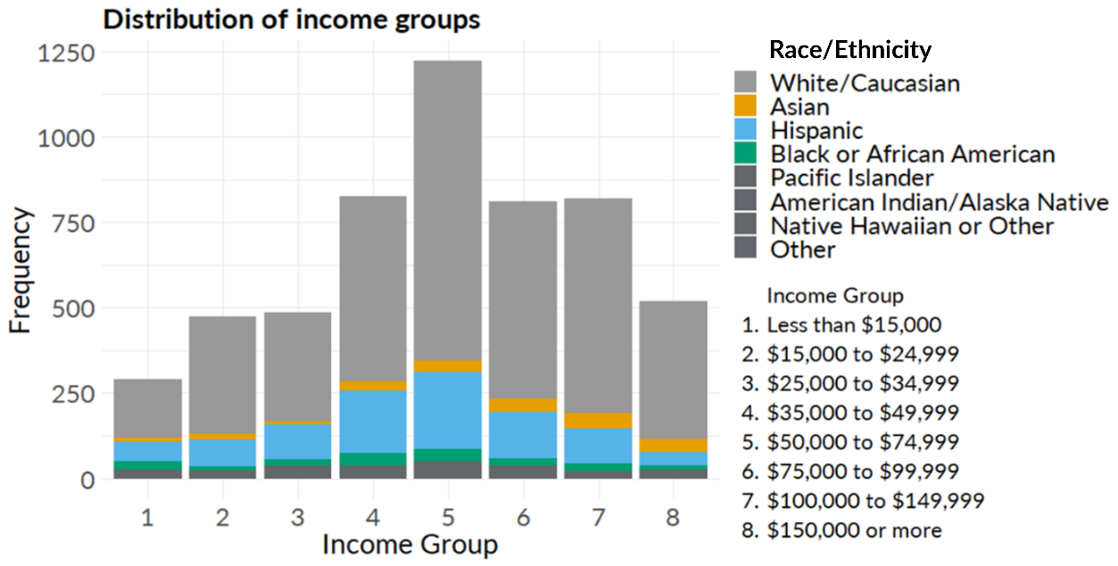
Figure S1. Racial and ethnic distribution by income group within our sample from Arizona.

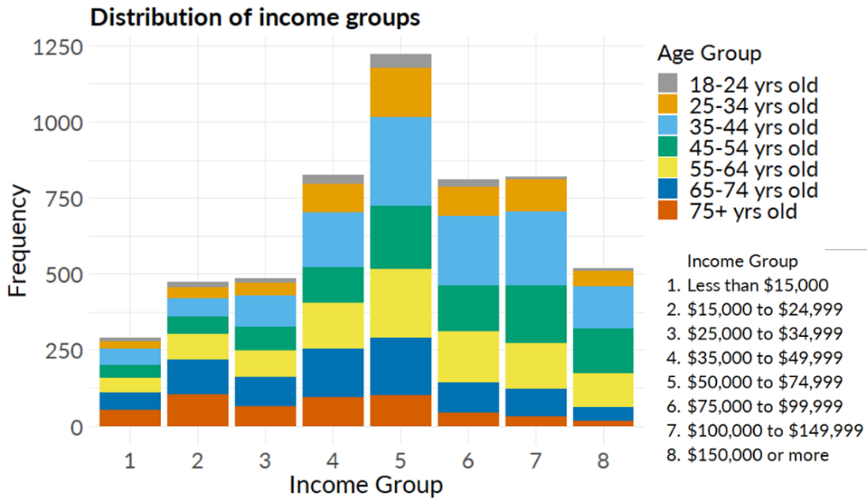
Figure S2. Age distribution by income group within the dataset.

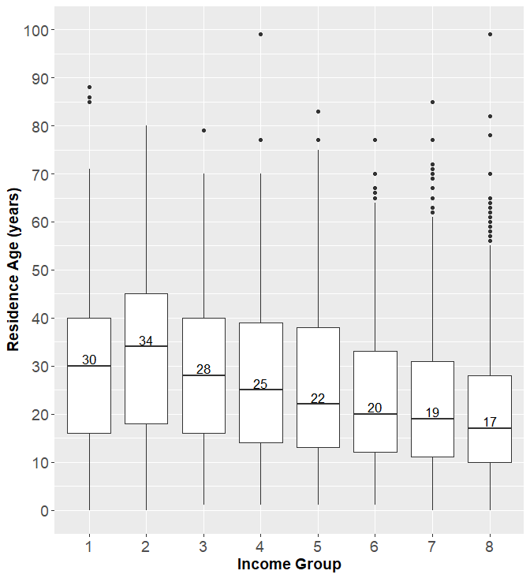
Figure S3. Residence age distribution by income group within the dataset. We note that lower income groups tend to have older residences.

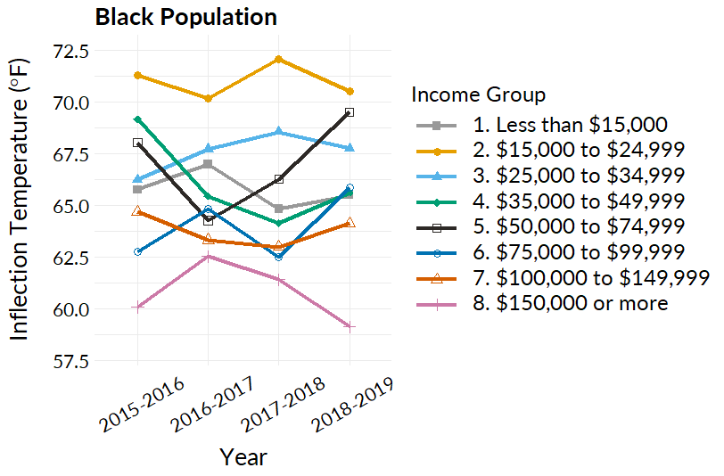
Figure S4. Energy equity gap by ethnicity: Black population
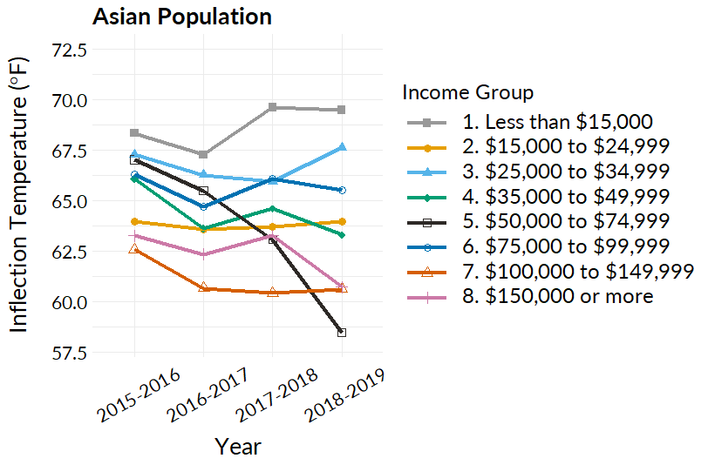
Figure S5. Energy equity gap by ethnicity: Asian population

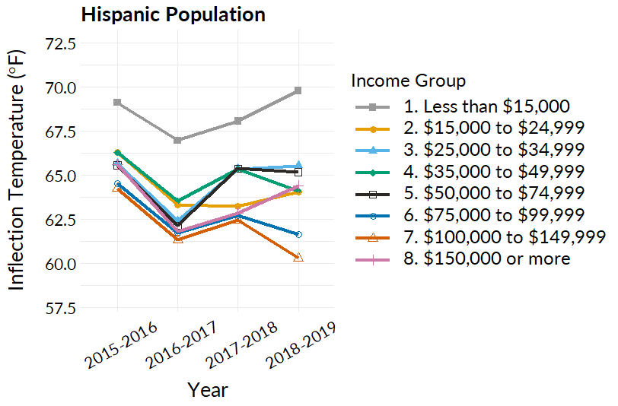
Figure S6. Energy equity gap by ethnicity: Hispanic population
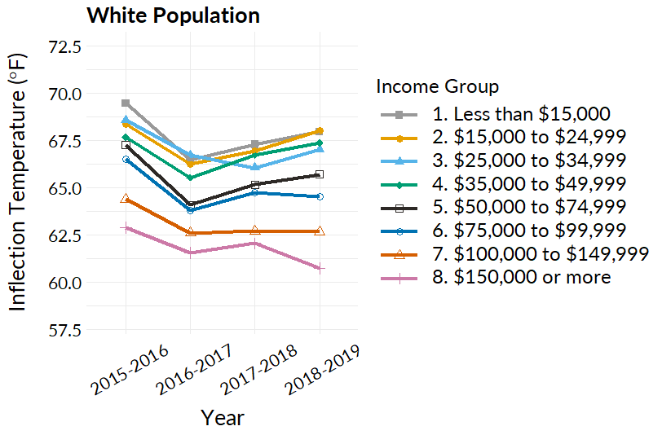
Figure S7. Energy equity gap by ethnicity: White population

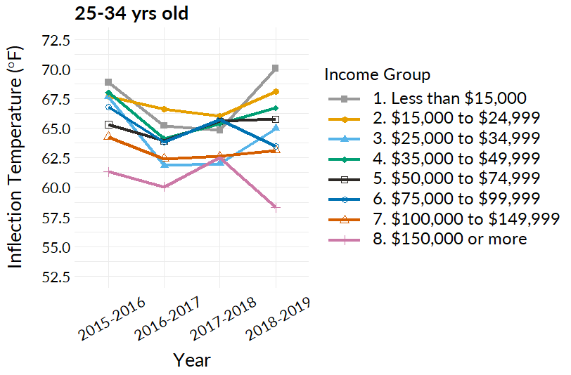
Figure S8. Energy equity gap by age group: 25-34 yrs old

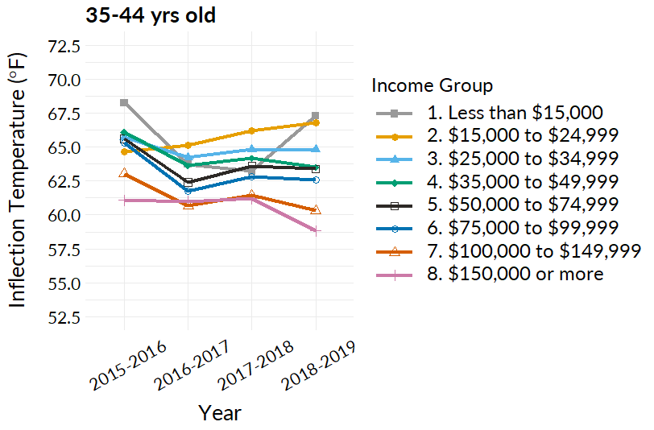
Figure S9. Energy equity gap by age group: 35-44 yrs old

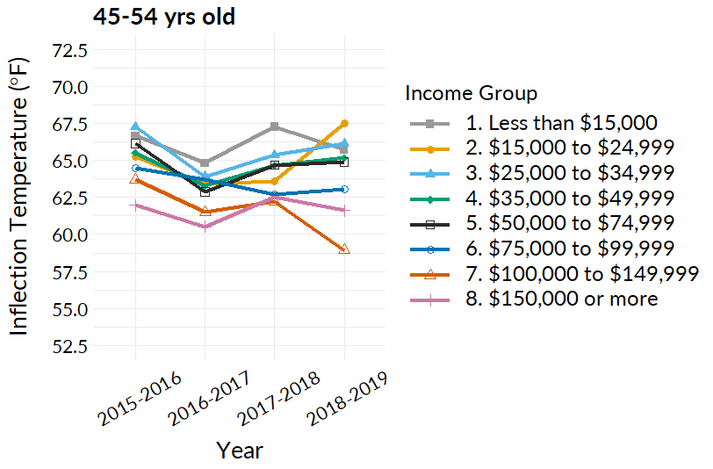
Figure S10. Energy equity gap by age group: 45-54 yrs old

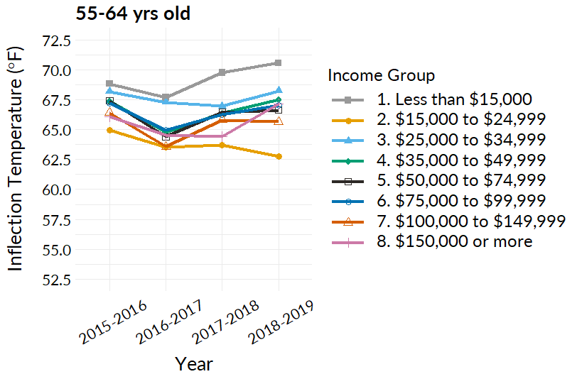
Figure S11. Energy equity gap by age group: 55-64 yrs old

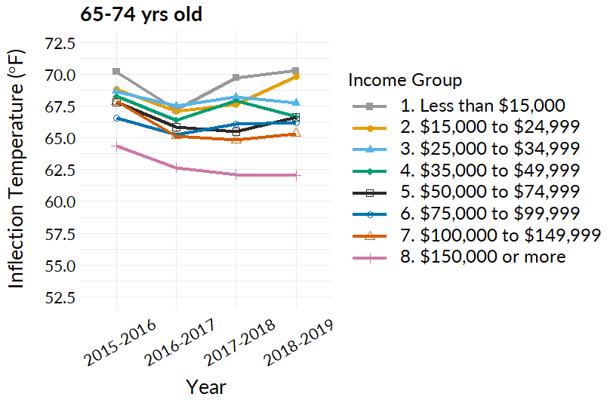
Figure S12. Energy equity gap by age group: 65-74 yrs old
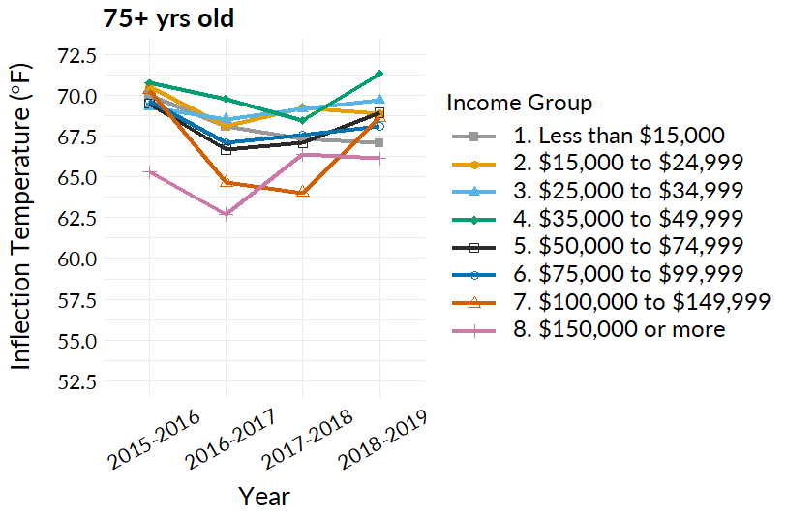
Figure S13. Energy equity gap by age group: 75+ yrs old

Supplemental Information Note: preferences versus inequities
Our objective is to provide utility companies with a method to identify energy-limiting behavior in different demographic groups. The electricity utility company we collaborated with collected electricity consumption data at the household level, but do not have information on electricity consumption by appliance. When it comes to comfortable temperature preferences across different groups of people and culture, the lack of thermostat and detailed survey data for the households in this study makes preference difficult to gauge. We acknowledge that there will be varying electricity consumption preferences across different demographics, but we note that preferences are influenced by a number of factors (e.g., perceived amount of spending available, body mass index, preferred climate, etc.). In our distinctions we see a wide variation within income groups (Figures 5b and 5d) as well as most racial, ethnicity and age groups. However, when investigating the groups as a whole, we find low income groups are as a whole wait longer to start using AC systems in the summer (i.e., higher inflection temperatures. We have investigated preferences of AC consumption across ethnicity and age groups. For example, Figures 5a and 5c illustrate the potential difference in inflection temperature preference between ethnicity and age groups, where Black and Asian groups may be less tolerant of heat, therefore have lower inflection temperatures overall. Similar with age groups, younger groups may prefer colder temperatures and older groups may prefer slightly warmer temperatures. Figures 5b and 5d illustrate the inequality within each ethnicity and age group, where Black and young households display the highest amount of inequality.

