Supplementary Information
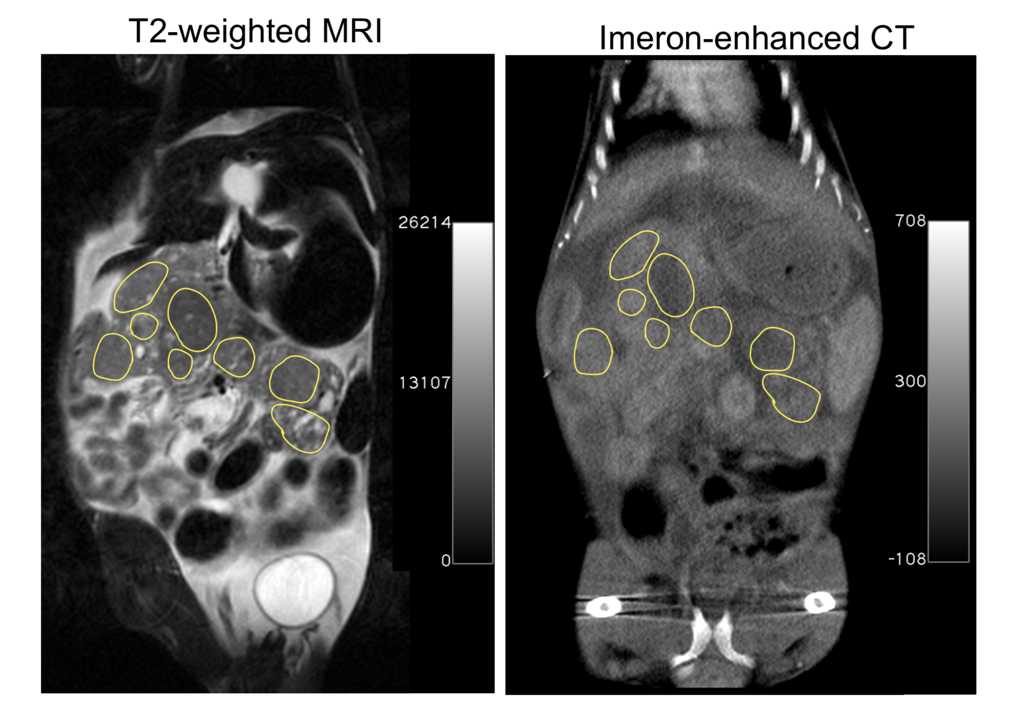
Suppl. Fig. 1. Coronal T2w MRI (left) and CE-µCT (right) images obtained within the first 63 seconds after CA injection of the same anatomical region showing high tumor heterogeneity. Manually placed ROIs are indicated as overlay.

