A Proteomics-Driven Machine Learning Tool for Distinguishing ET from pre-PMF
Qing Wen^{1, 2, *}, Ting Sun^{1, 2, *} , Dandan Yu^{1, 2}, Mankai Ju^{1, 2}, Xiaofan Liu^{1, 2}, Huiyuan Li^{1, 2}, Rongfeng Fu^{1, 2}, Wei Liu^{1, 2}, Feng Xue^{1, 2}, Huan Dong^{1, 2}, Xinyue Dai^{1, 2}, Wentian Wang^{1, 2}, Ying Chi^{1, 2}, Renchi Yang^{1, 2}, Yunfei Chen ^{1, 2} and Lei Zhang ^{1, 2, 3}
¹ State Key Laboratory of Experimental Hematology, National Clinical Research Center for Blood Diseases, Haihe Laboratory of Cell Ecosystem, Tianjin Key Laboratory of Gene Therapy for Blood Diseases, CAMS Key Laboratory of Gene Therapy for Blood Diseases, Institute of Hematology & Blood Diseases Hospital, Chinese Academy of Medical Sciences & Peking Union Medical College, Tianjin 300020, China.
² Tianjin Institutes of Health Science, Tianjin 301600, China.
³ School of Population Medicine and Public Health, Chinese Academy of Medical Sciences and Peking Union Medical College, Beijing 100730, China.
* Qing Wen and Ting Sun contributed equally as co-first authors.
Correspondence
Lei Zhang and Yunfei Chen, State Key Laboratory of Experimental Hematology, National Clinical Research Center for Blood Diseases, Haihe Laboratory of Cell Ecosystem, Institute of Hematology & Blood Diseases Hospital, Chinese Academy of Medical Sciences & Peking Union Medical College, Tianjin Key Laboratory of Gene Therapy for Blood Diseases, CAMS Key Laboratory of Gene Therapy for Blood Diseases, Tianjin 300020, China.
Email: zhanglei1@ihcams.ac.cn and chenyunfei@ihcams.ac.cn

Supplementary Methods
1. Protein Extraction and LC-MS/MS Workflow
Bone marrow FFPE tissue sections (5 μm thick) were deparaffinized with xylene and rehydrated through a graded ethanol series. Protein extraction was performed using pressure cycling technology with lysis buffer (8 M urea, 1% SDS, protease inhibitor cocktail), followed by reduction with 10 mM DTT (56°C for 30 minutes) and alkylation with 20 mM iodoacetamide (30 minutes in the dark). Protein concentration was measured using a BCA assay. Tryptic digestion was performed overnight at 37°C using sequencing-grade modified trypsin at a 1:50 enzyme-to-protein ratio. Peptides were desalted using C18 cartridges and dried under vacuum. The dried peptides were reconstituted in 0.1% formic acid prior to LC-MS/MS analysis. Peptides were separated using an EASY-nLC 1200 system and analyzed on a Q Exactive HF-X mass spectrometer (Thermo Fisher Scientific) in data-independent acquisition (DIA) mode with a 120-minute gradient. Fixed isolation window widths of 8 m/z were used for MS/MS acquisition.

2. DIA Data Processing and Normalization
Raw DIA data were processed using Spectronaut (Biognosys AG, v15) with directDIA workflow. The default settings were applied for peptide identification and quantification. Protein-level intensities (I_{ij}) were extracted from Spectronaut output.
To account for sample-specific intensity variation, intra-sample normalization was performed. Specifically, for each protein j in sample i, its normalized abundance Rij was computed by dividing its raw intensity by the median intensity of all proteins in that sample:
R_{ij} = I_{ij}/Median (I_{j})
where R_{ij} denotes the normalized abundance of protein j in sample i, and Median (Ii) represents the median intensity across all proteins in sample i.

3. Differential Expression and Enrichment Analysis
Differential expression analysis between ET and pre-PMF was performed using Wilcoxon rank-sum test. Proteins with |log2FC| > 0.58 and p < 0.05 were considered differentially expressed. GO and KEGG enrichment analysis was performed using the "clusterProfiler" package (v4.6.2) in R. Significance of enrichment was calculated using p-values to determine whether DEPs were statistically overrepresented in specific functional categories compared to the total protein background (i.e., all identified proteins).The reference database was org.Hs.eg.db (human genome annotation).

4. Machine Learning: Nested Cross-Validation and Feature Selection
Model construction and evaluation were performed using nested 5-fold cross-validation. The outer loop was used to evaluate model performance, and the inner loop was used for feature selection and hyperparameter tuning. (1) Clinical model: included age, WBC, and LDH (fixed features from cohort 1). (2) Proteomic model: included all DEPs from cohort 2, with feature selection performed within each training fold. Within each fold, candidate protein features were ranked by mean decrease in Gini index using the randomForest package (v4.7-1.1). The top-ranked proteins were further refined using SVM-RFE (caret + e1071 packages), and optimal subsets were selected based on maximum cross-validated accuracy. After model evaluation, the two-step feature selection pipeline (random forest + SVM-RFE) was applied to the entire dataset in cohort 2 to construct a final 9-protein classifier. This panel was used for downstream interpretation and subgroup analysis only. The same machine learning framework was independently applied within the JAK2V617F and CALR mutation subgroups to identify subgroup-specific discriminatory proteins.

Table S1 The baseline characteristics of ET and pre-PMF in cohort 2
Characteristics | ET (n = 64) | pre-PMF (n = 21) | p value
Male patients, n (%) | 27 (42.2) | 9 (42.9) | 0.957
Age (years), median (range) | 54.48±10.86 | 60.29±10.09 | 0.034
Age＞60 years, n (%) | 22 (34.4) | 13 (61.9) | 0.026
Leukocytes (×10⁹/L), median (range) | 9.32±3.11 | 11.66±6.14 | 0.106
Leukocytes >10×10⁹/L, n (%) | 17 (26.6) | 10 (47.6) | 0.072
Hemoglobin (g/L), median (range) | 137.5±21.59 | 118.24±21.33 | 0.001
Hemoglobin < 120g/L, n (%) | 10 (15.9) | 11 (52.4) | 0.001
Platelets, (×10⁹/L), median (range) | 780.37±282.72 | 1184.33±497.49 | 0.002
Platelets > 450×10⁹/L, n (%) | 58 (92.1) | 21 (100.0) | 0.325
ALT (U/L), median (range) | 22.54±13.83 | 24.62±19.14 | 0.593
AST (U/L), median (range) | 23.24±7.47 | 23.82±8.07 | 0.765
LDH (U/L), median (range) | 244.61±84.36 | 290.05±84.78 | 0.038
LDH >247 U/L, n (%) | 22 (34.4) | 14 (66.7) | 0.009
Glucose (mmol/L), median (range) | 5.1±1.1 | 5.16±0.95 | 0.815
Crea (umol/L), median (range) | 63.19±13.9 | 61.16±12.1 | 0.552
Karyotype (abnormal/normal), n | 1/52 (1.9) | 2/14 (12.5) | 0.185
Palpable splenomegaly, n (%) | 19/8 (70.4) | 7/4 (63.6) | 0.391
Driver mutations
JAK2V617F | 41 (64.1) | 10 (47.6) | 0.327
CALR | 13 (20.3) | 8 (38.1)
MPL | 1 (1.6) | 0 (0)
Negative | 9 (14.1) | 3 (14.3)
Nondriver mutations
Epigenetic regulation
DNMT3A, n (%) | 7 (10.9) | 2 (9.5) | 1.000
TET2, n (%) | 6 (9.4) | 5 (23.8) | 0.130
ASXL1, n (%) | 8 (12.5) | 2 (9.5) | 1.000
KMT2D, n (%) | 4 (6.3) | 4 (19.0) | 0.099
Transcription factors
TP53, n (%) | 1 (1.6) | 1 (4.8) | 0.435
RNA splicing
SF3B1, n (%) | 2 (3.1) | 1 (4.8) | 1.000
ZRSR2, n (%) | 3 (4.7) | 2 (9.5) | 0.593
SRSF2, n (%) | 1 (1.6) | 1 (4.8) | 0.435
U2AF1, n (%) | 1 (1.6) | 0 (0) | 1.000
Signaling pathway
NRAS, n (%) | 0 (0) | 0 (0) | NA
SH2B3, n (%) | 0 (0) | 1 (4.8) | 0.247
Others
NF1, n (%) | 1 (1.6) | 0 (0) | 1.000
NFE2, n (%) | 0 (0) | 0 (0) | NA
Abbreviation: ET, Essential Thrombocythemia; pre-PMF, pre-fibrotic Primary Myelofibrosis; ALT, Alanine Aminotransferase; AST, Aspartate Aminotransferase; LDH, Lactate Dehydrogenase; Crea, Creatinine; DNA2, Deoxyribonuclease 2; JAK2V617F, Janus Kinase 2; CALR, Calreticulin; MPL, Myeloproliferative Leukemia Virus Oncogene; DNMT3A, DNA Methyltransferase 3 Alpha; TET2, Tet Methylcytosine Dioxygenase 2; ASXL1, Additional Sex Combs-Like 1; KMT2D, Lysine Methyltransferase 2D; SF3B1, Splicing Factor 3B Subunit 1; TP53, Tumor Protein 53; NRAS, Neuroblastoma RAS Viral Oncogene Homolog; SH2B3, SH2B Adaptor Protein 3; NF1, Neurofibromin 1; NFE2, Nuclear Factor Erythroid 2.

Table S2 The baseline characteristics of JAK2⁺ ET and pre-PMF in cohort 2
Characteristics | ET (n = 41) | pre-PMF (n = 10) | p value
Male patients, n (%) | 20 (48.8) | 6 (60.0) | 0.726
Age (years), median (range) | 54.9±10.86 | 62.6±8.57 | 0.043
Age＞60 years, n (%) | 15 (36.6) | 7 (70.0) | 0.079
Leukocytes (×10⁹/L), median (range) | 9.72±3.1 | 13.71±5.35 | 0.046
Leukocytes >10×10⁹/L, n (%) | 13 (31.7) | 7 (70.0) | 0.036
Hemoglobin (g/L), median (range) | 141.68±20.74 | 121±25.95 | 0.01
Hemoglobin < 120g/L, n (%) | 3 (7.5) | 5 (50.0) | 0.005
Platelets, (×10⁹/L), median (range) | 736.58±260.06 | 954.3±401.04 | 0.04
Platelets > 450×10⁹/L, n (%) | 37 (90.2) | 10 (100.0) | 0.573
ALT (U/L), median (range) | 22.17±13.65 | 26.07±23.68 | 0.494
AST (U/L), median (range) | 22.74±7.54 | 24.17±8.68 | 0.605
LDH (U/L), median (range) | 234.85±80.11 | 310.7±105.74 | 0.017
LDH >247 U/L, n (%) | 14 (34.1) | 8 (80.0) | 0.013
Glucose (mmol/L), median (range) | 5.08±1.27 | 5.11±0.8 | 0.944
Crea (umol/L), median (range) | 66.01±14.85 | 63.85±12.64 | 0.675
Karyotype (abnormal/normal), n | 1/37 | 2/6 | 0.058
Palpable splenomegaly, n (%) | 6 (14.6) | 2 (20.0) | 0.367
Driver mutations
JAK2 burden | 29.58±22.03 | 40.85±25.57 | 0.166
Nondriver mutations
Epigenetic regulation
DNMT3A, n (%) | 5 (12.2) | 1 (10.0) | 1.000
TET2, n (%) | 5 (12.2) | 2 (20.0) | 0.612
ASXL1, n (%) | 7 (17.1) | 1 (10.0) | 1.000
KMT2D, n (%) | 3 (7.3) | 3 (30.0) | 0.081
Transcription factors
TP53, n (%) | 0 (0) | 1 (10.0) | 0.196
RNA splicing
SF3B1, n (%) | 2 (4.9) | 1 (10.0) | 0.488
ZRSR2, n (%) | 3 (7.3) | 0 (0) | 1.000
SRSF2, n (%) | 1 (2.4) | 0 (0) | 1.000
U2AF1, n (%) | 0 (0) | 0 (0) | NA
Signaling pathway
NRAS, n (%) | 0 (0) | 0 (0) | NA
SH2B3, n (%) | 0 (0) | 1 (10.0) | 0.196
Others
NF1, n (%) | 1 (2.4) | 0 (0) | 1.000
NFE2, n (%) | 0 (0) | 0 (0) | NA
Abbreviation: ET, Essential Thrombocythemia; pre-PMF, pre-fibrotic Primary Myelofibrosis; ALT, Alanine Aminotransferase; AST, Aspartate Aminotransferase; LDH, Lactate Dehydrogenase; Crea, Creatinine; DNA2, Deoxyribonuclease 2; JAK2, Janus Kinase 2; CALR, Calreticulin; MPL, Myeloproliferative Leukemia Virus Oncogene; DNMT3A, DNA Methyltransferase 3 Alpha; TET2, Tet Methylcytosine Dioxygenase 2; ASXL1, Additional Sex Combs-Like 1; KMT2D, Lysine Methyltransferase 2D; SF3B1, Splicing Factor 3B Subunit 1; TP53, Tumor Protein 53; NRAS, Neuroblastoma RAS Viral Oncogene Homolog; SH2B3, SH2B Adaptor Protein 3; NF1, Neurofibromin 1; NFE2, Nuclear Factor Erythroid 2.

Table S3 The baseline characteristics of CARL⁺ ET and pre-PMF in cohort 2
Characteristics | ET (n = 13) | pre-PMF (n = 8) | p value
Male patients, n (%) | 4 (30.8) | 2 (25.0) | 1.000
Age (years), median (range) | 53.23±13.13 | 58.75±13.17 | 0.362
Age＞60 years, n (%) | 4 (30.8) | 5 (62.5) | 0.203
Leukocytes (×10⁹/L), median (range) | 8.52±3.45 | 9.02±3.95 | 0.767
Leukocytes >10×10⁹/L, n (%) | 3 (23.1) | 2 (25.0) | 1.000
Hemoglobin (g/L), median (range) | 126.75±20.06 | 120±11.98 | 0.406
Hemoglobin < 120g/L, n (%) | 5 (38.5) | 4 (50.0) | 0.673
Platelets, (×10⁹/L), median (range) | 958.67±367.35 | 1201±329.41 | 0.143
Platelets > 450×10⁹/L, n (%) | 11 (91.7) | 8 (100.0) | 1.000
ALT (U/L), median (range) | 27.25±17.39 | 17.75±7.32 | 0.126
AST (U/L), median (range) | 27.06±8.26 | 21.48±6.9 | 0.138
LDH (U/L), median (range) | 286.25±116.56 | 250.53±55.93 | 0.436
LDH >247 U/L, n (%) | 4 (30.8) | 3 (37.5) | 1.000
Glucose (mmol/L), median (range) | 5.28±0.84 | 5.07±1.21 | 0.664
Crea (umol/L), median (range) | 59.18±12.04 | 57.75±10.87 | 0.793
Karyotype (abnormal/normal), n | 0/10 | 0/6 | 1.000
Palpable splenomegaly, n (%) | 2 (15.4) | 1 (12.5) | 0.237
Driver mutations
CARL burden | 30.9±16.42 | 40.34±15.11 | 0.204
Nondriver mutations
Epigenetic regulation
DNMT3A, n (%) | 1 (7.7) | 0 (0) | 1.000
TET2, n (%) | 1 (7.7) | 3 (37.5) | 0.253
ASXL1, n (%) | 1 (7.7) | 0 (0) | 1.000
KMT2D, n (%) | 1 (7.7) | 0 (0) | 1.000
Transcription factors
TP53, n (%) | 1 (7.7) | 0 (0) | 1.000
RNA splicing
SF3B1, n (%) | 0 (0) | 0 (0) | NA
ZRSR2, n (%) | 0 (0) | 2 (25.0) | 0.133
SRSF2, n (%) | 0 (0) | 0 (0) | NA
U2AF1, n (%) | 1 (7.7) | 0 (0) | 1.000
Signaling pathway
NRAS, n (%) | 0 (0) | 0 (0) | NA
SH2B3, n (%) | 0 (0) | 0 (0) | NA
Others
NF1, n (%) | 0 (0) | 0 (0) | NA
NFE2, n (%) | 0 (0) | 0 (0) | NA
Abbreviation: ET, Essential Thrombocythemia; pre-PMF, pre-fibrotic Primary Myelofibrosis; ALT, Alanine Aminotransferase; AST, Aspartate Aminotransferase; LDH, Lactate Dehydrogenase; Crea, Creatinine; DNA2, Deoxyribonuclease 2; JAK2, Janus Kinase 2; CALR, Calreticulin; MPL, Myeloproliferative Leukemia Virus Oncogene; DNMT3A, DNA Methyltransferase 3 Alpha; TET2, Tet Methylcytosine Dioxygenase 2; ASXL1, Additional Sex Combs-Like 1; KMT2D, Lysine Methyltransferase 2D; SF3B1, Splicing Factor 3B Subunit 1; TP53, Tumor Protein 53; NRAS, Neuroblastoma RAS Viral Oncogene Homolog; SH2B3, SH2B Adaptor Protein 3; NF1, Neurofibromin 1; NFE2, Nuclear Factor Erythroid 2.

Table S4 Performance metrics of nested cross-validation based on proteomic, clinical, and combined features for distinguishing ET from pre-PMF
Model | Accuracy | Sensitivity | Specificity | F1
Protein | 0.812 | 0.476 | 0.922 | 0.556
Clinical | 0.729 | 0 | 0.969 | NA
Combined | 0.8 | 0.524 | 0.891 | 0.564
Abbreviations: ET: essential thrombocythemia; pre-PMF: pre-fibrotic primary myelofibrosis; AUC: area under the curve; CV: cross-validation; F1: F1 score (harmonic mean of precision and sensitivity); Sensitivity: true positive rate; Specificity: true negative rate.

Table S5 List of the 9 selected proteins used for SVM-RFE model construction
Uniprot ID | Gene Symbol | log2FC | p-value | Full Protein Name
Q8IW93 | ARHGEF19 | 0.702 | 0.004 | Rho guanine nucleotide exchange factor 19
E9PSG1 | CAST | 0.607 | 0.000 | Calpastatin
R4GMN3 | SFTPA2 | 5.504 | 3.094E-06 | Surfactant protein A2
C9JNG9 | COL6A3 | 1.272 | 0.002 | Collagen type VI alpha 3 chain
P12074 | COX6A1 | -1.622 | 8.168E-06 | Cytochrome c oxidase subunit 6A1
P51530 | DNA2 | 2.017 | 2.697E-06 | DNA replication ATP-dependent helicase/nuclease DNA2
Q8TCC3 | MRPL30 | -0.586 | 0.000 | Large ribosomal subunit protein uL30m
Q9NY97 | B3GNT2 | -1.860 | 0.013 | N-acetyllactosaminide beta-1,3-N-acetylglucosaminyltransferase 2
Q96Q06 | PLIN4 | 0.702 | 0.004 | Perilipin-4

Figure S1 Receiver operator characteristic curves analysis of age (A), WBC (B), LDH (C) and combined age, WBC, and LDH (D) in distinguishing ET from pre-PMF in cohort 2.
WBC, white blood cell; LDH, lactate dehydrogenase; ET, essential thrombocythemia; Pre-PMF, prefibrotic primary myelofibrosis; AUC, area under the curve.

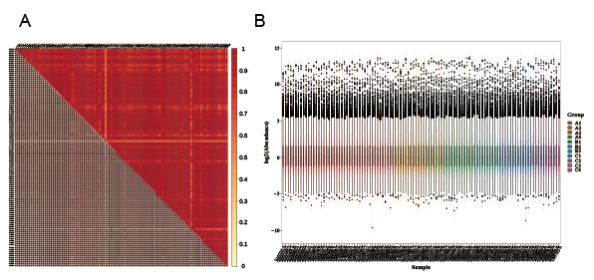
Figure S2 Protein expression data quality control: sample correlation matrix (A) and sample-wise intensity distribution (B).

Figure S3 Heatmap of differentially expressed proteins in ET and pre-PMF patients. (A) Heatmap showing the clustering of ET and pre-PMF groups based on proteomic expression; (B) Heatmap of JAK2+ subgroups (ET vs. pre-PMF) with hierarchical clustering; (C) Heatmap of CALR+ subgroups (ET vs. pre-PMF) showing distinct protein expression patterns.
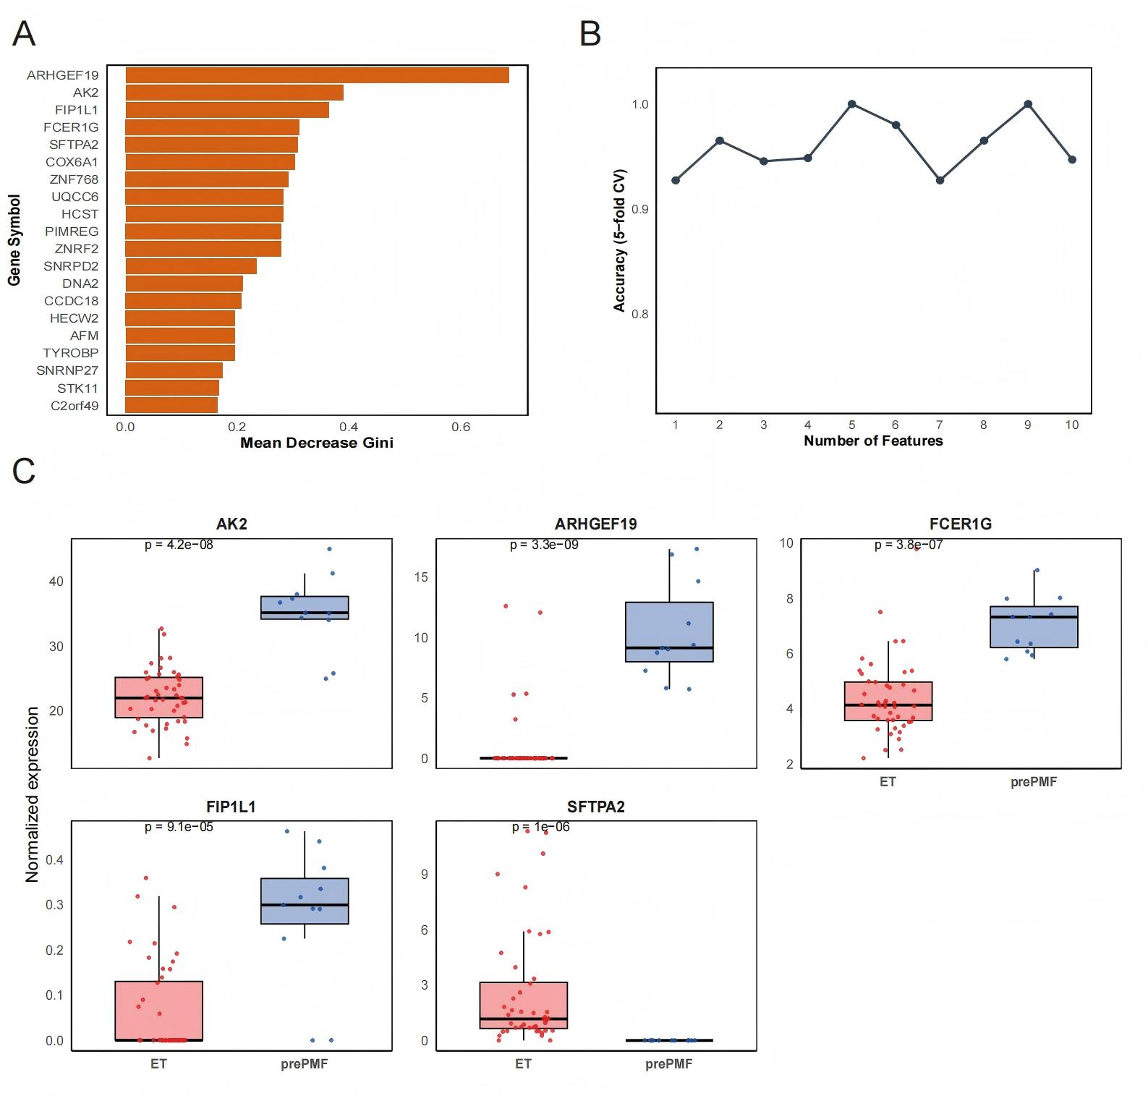
Figure S4 Identification of diagnostic protein markers in the JAK2V617F+ subgroup. (A) Top 20 most important proteins ranked by Mean Decrease Gini using random forest in the JAK2V617F+ subgroup; (B) SVM-RFE feature selection curve showing the classification accuracy across different numbers of protein features; (C) Expression profiles of the top 5 selected proteins (AK2, ARHGEF19, FCER1G, FIP1L1, and SFTPA2) showing significant differences between ET and pre-PMF (Wilcoxon test).

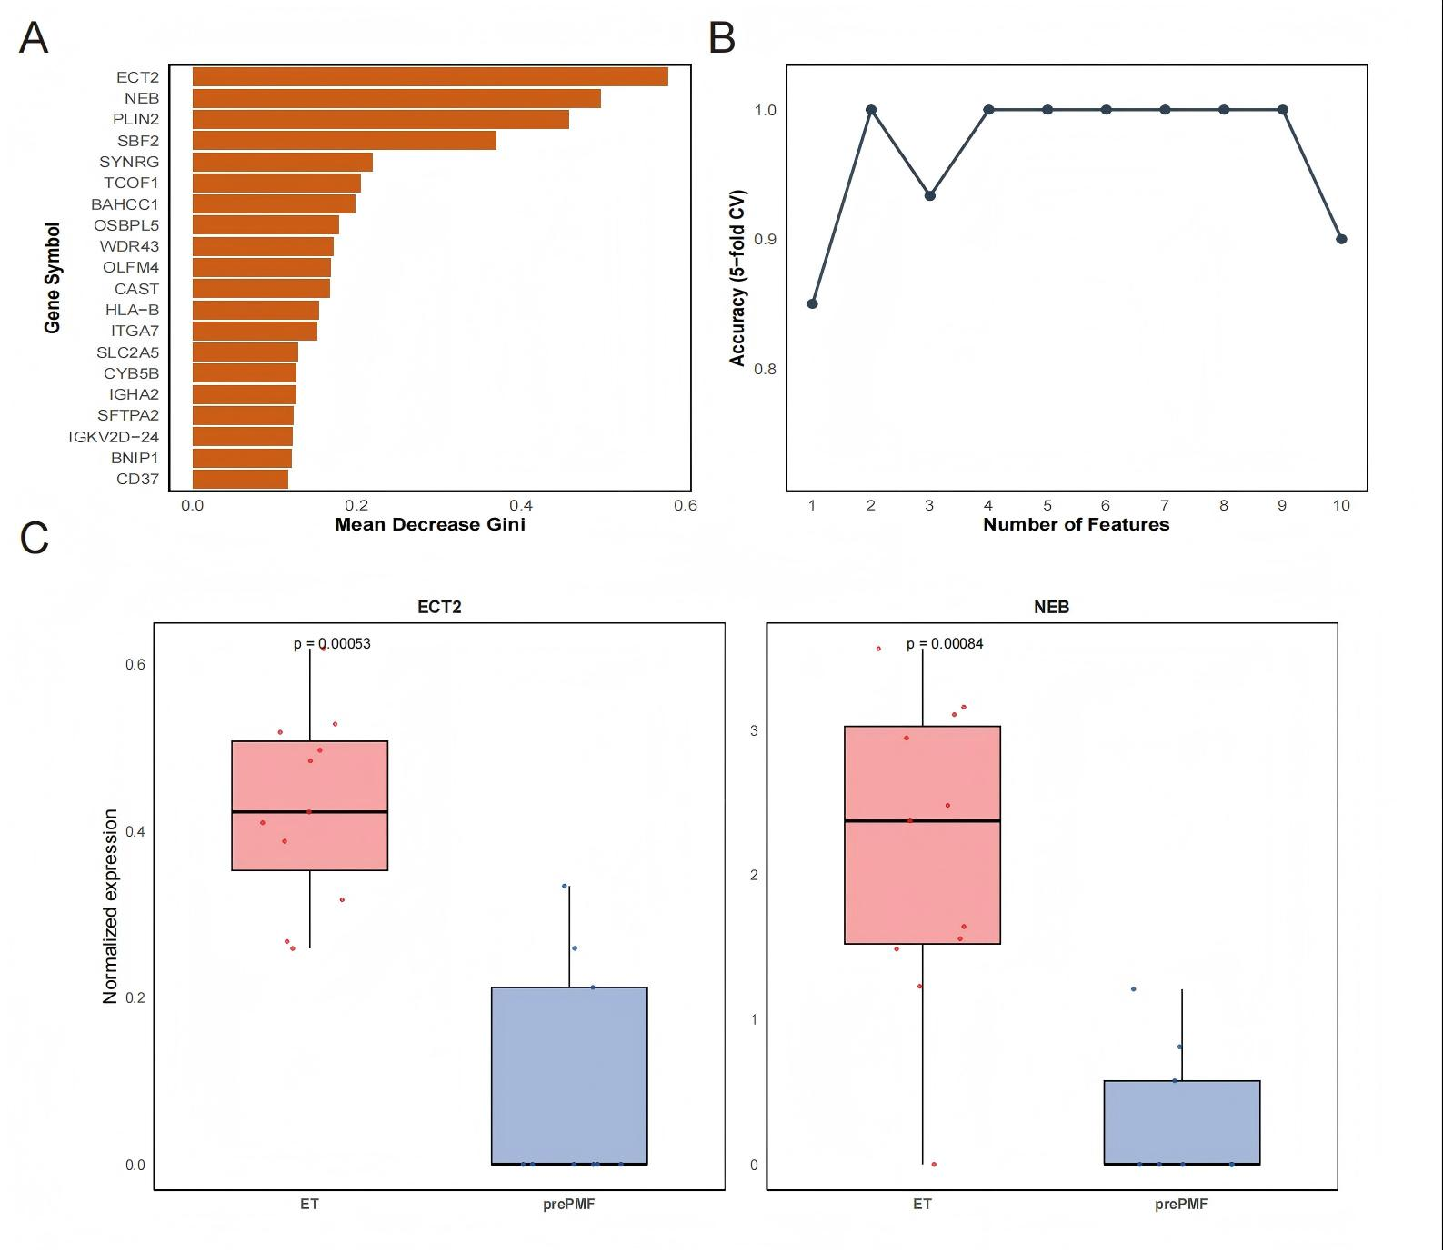
Figure S5 Identification of diagnostic protein markers in the CALR+ subgroup. (A) Top 20 most important proteins ranked by Mean Decrease Gini using random forest in the CALR+ subgroup; (B) SVM-RFE feature selection curve showing 5-fold cross-validation accuracy across different numbers of protein features; (C) Expression comparison of the top 2 selected proteins (ECT2 and NEB) between ET and pre-PMF in the CALR+ subgroup (Wilcoxon test).

