SUPPLEMENT
SNPs associated with Metabolic Disorders Disrupt Structural Properties of DNA G-Quadruplexes in Regulatory Regions relevant during Tumor Development

Angelika Lahnsteiner^{1,2*}, Victoria Ellmer^{1,2}, Esther Schönauer^{2,3}, Markus Wiederstein⁴, Angela Risch^{1,2}

¹Division of Cancer (Epi-)Genetics, Department of Biosciences and Medical Biology, Center for Tumor Biology and Immunology (CTBI), Paris Lodron University Salzburg, Austria
²Cancer Cluster Salzburg, Austria
³Division of Structural Biology, Department of Biosciences and Medical Biology, Center for Tumor Biology and Immunology (CTBI), Paris Lodron University Salzburg, Austria
⁴Division of Protein Bioinformatics, Department of Biosciences and Medical Biology, Center for Tumor Biology and Immunology (CTBI), Paris Lodron University Salzburg, Austria

*Corresponding author
angelika.lahnsteiner@plus.ac.at

University of Salzburg
Hellbrunnerstraße 34
5020 Salzburg
Austria

Content
1. Supplementary Methods 2
2. Supplementary Figures 3
3. References 12

Supplementary Methods

  - Oligos used for CD spectra:
SNP ID | Oligo | length [bp] | c[µM]
rs2855804_T | AGGGGTCTGGAGGGGAGTGGGATGGAGGG | 29 | 5,00
rs2855804_C | GGGGGTCTGGAGGGGAGTGGGATGGAGGG | 29 | 5,00
rs2277844_G | GGGGTTCAGGGGAGAAACTCAGGGTCGAAGCTGGGGTCCCTGGGG | 45 | 5,00
rs2277844_A | GGGGTTCAAGGGAGAAACTCAGGGTCGAAGCTGGGGTCCCTGGGG | 45 | 5,00
MYC | GGCCGACTCAGAGGAGGGGTGGAAGGGGTGGGAGGGGTGGGAGG  GGTATTCGCGGGGAGGGCCCAAGGG | 69 | 5,00

  - Luciferase reporter assay oligos
SNP ID | Oligo
rs2855804_T_top | tcagATGCATAGGGGTCTGGAGGGGAGTGGGATGGAGGGAAGCTTtact
rs2855804_T_bottom | agtaAAGCTTCCCTCCATCCCACTCCCCTCCAGACCCCTATGCATctga
rs2855804_C_top | tcagATGCATGGGGGTCTGGAGGGGAGTGGGATGGAGGGAAGCTTtact
rs2855804_C_bottom | agtaAAGCTTCCCTCCATCCCACTCCCCTCCAGACCCCCATGCATctga

Supplementary Figures

Supplement Figure 1. Bar plot showing shared and unique G4-SNPs identified by pqsfinder [1] and G4Hunter [2].

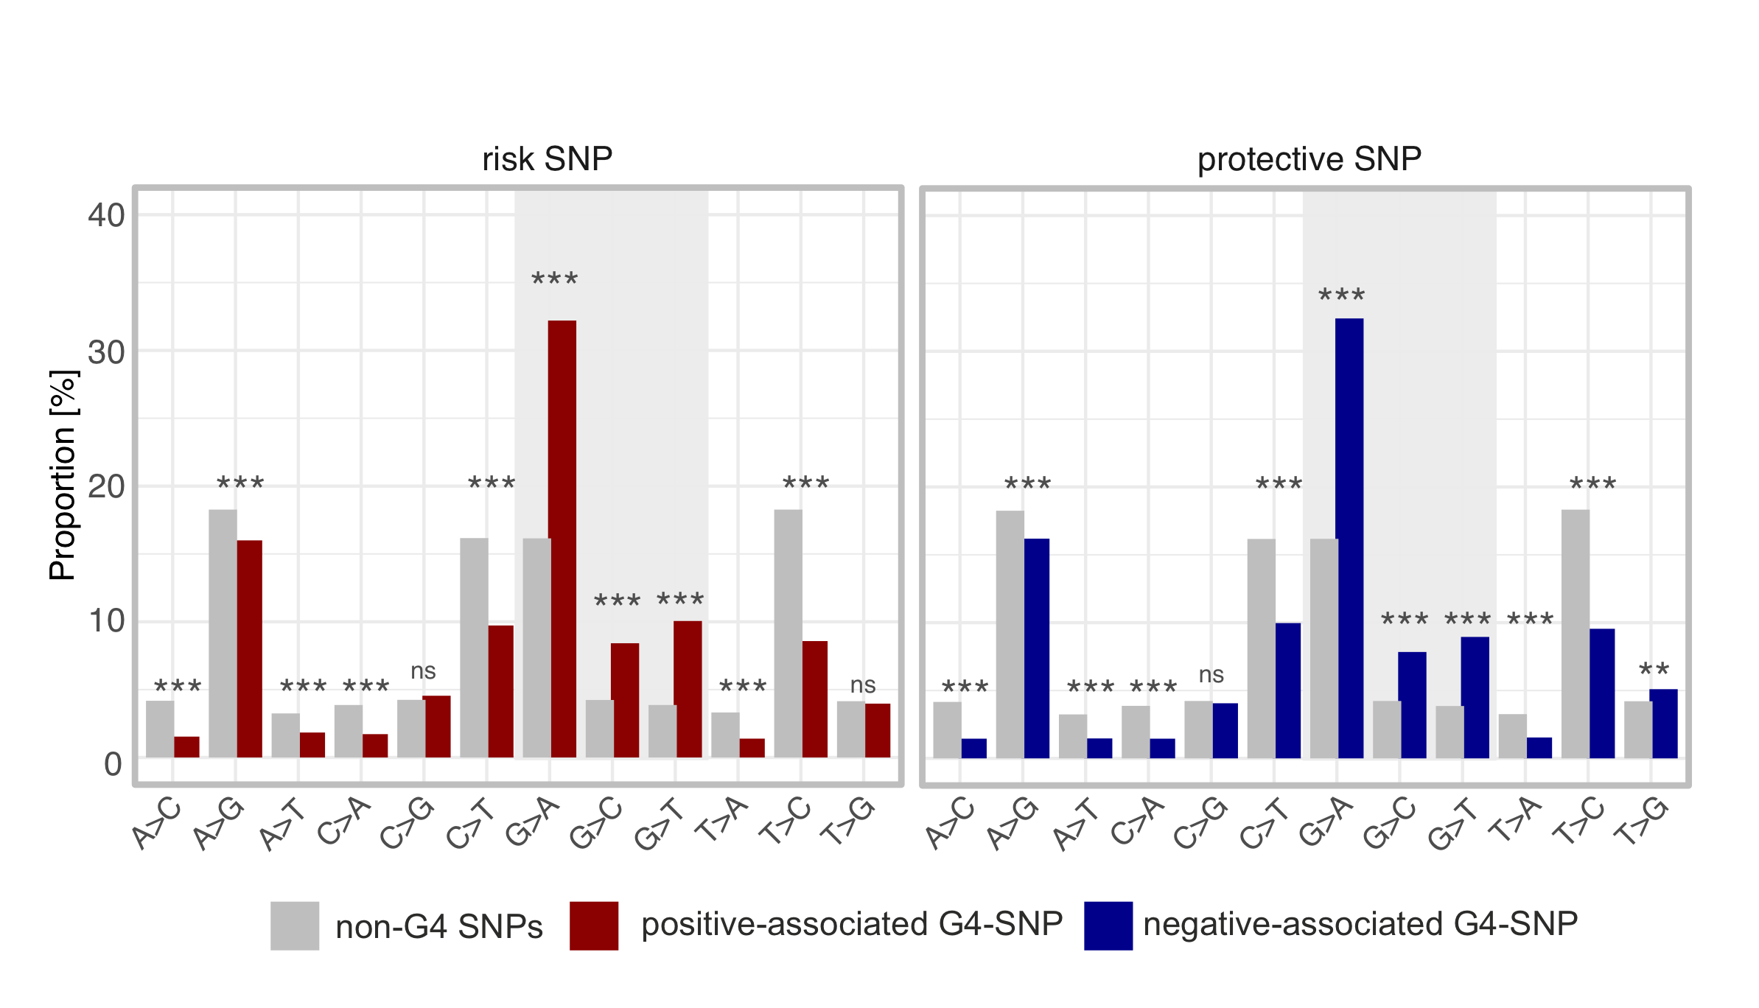
Supplement Figure 2. G4-SNP substitution direction for G4hunter [2] G4-SNPs. Distribution of nucleotide variants overlapping with G4s for risk (left panel) and protective (right panel) G4-SNPs compared to SNPs located outside of G4s (non-G4 SNPs). The grey-highlighted region marks the substitutions highly enriched in G4 motifs. Benjamini Hochberg adjusted Fisher´s exact test; **** p<0.0001, *** p<0.001, ** p<0.01 and * p<0.05.

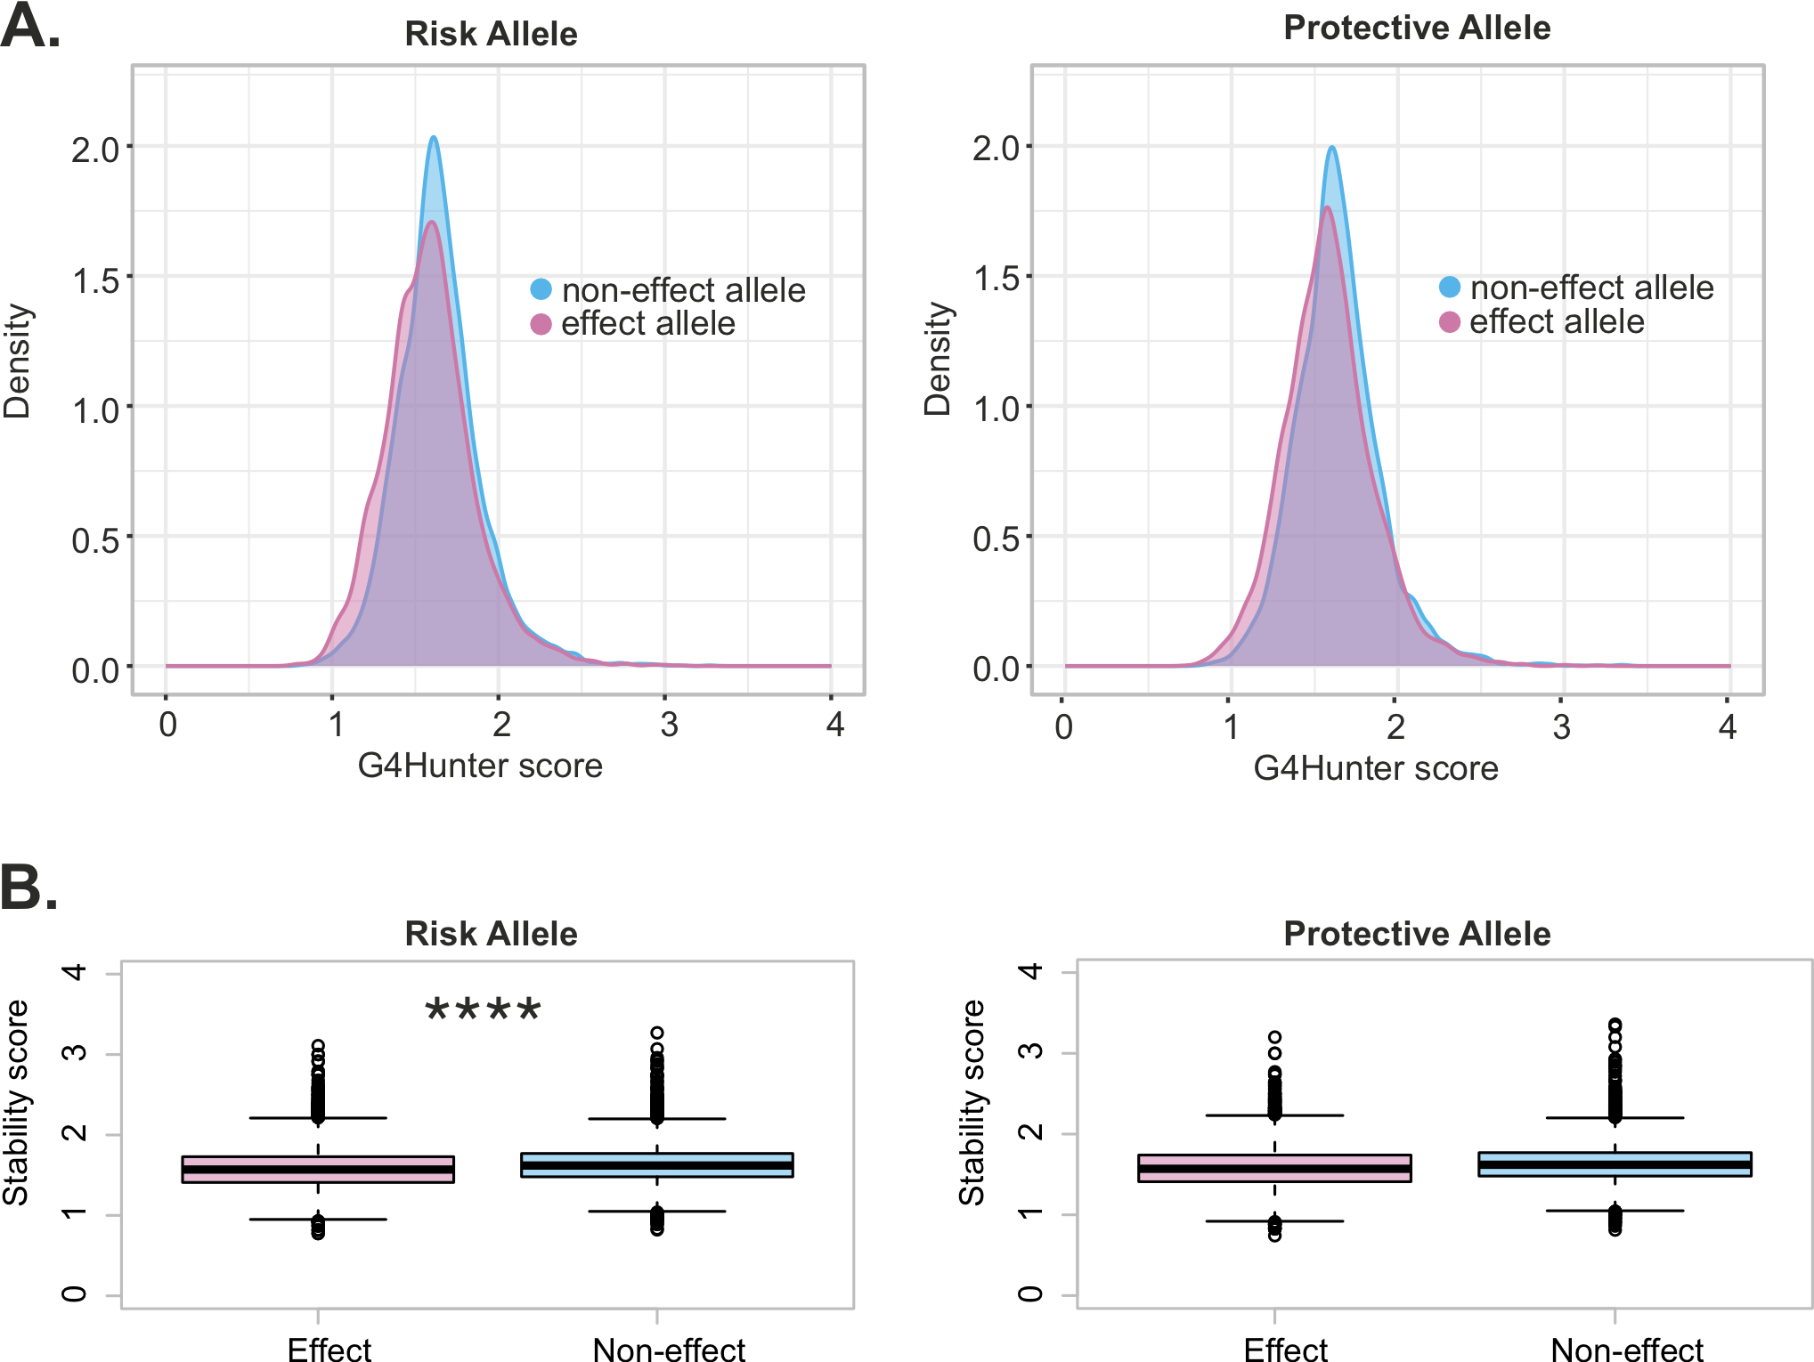

Supplement Figure 3. MetD-associated SNPs and their effect on G4hunter-predicted G4 stability. A. Density plots showing G4 stability scores for G4 motifs containing the effect allele (red) versus the non-effect allele (blue) for risk and protective SNPs for G4hunter. B. Boxplot indicate significantly reduced stability scores of G4-SNPs of effect alleles compared to non-effect alleles for risk and protective variants (Wilcoxon rank sum tests). **** p<2e-16

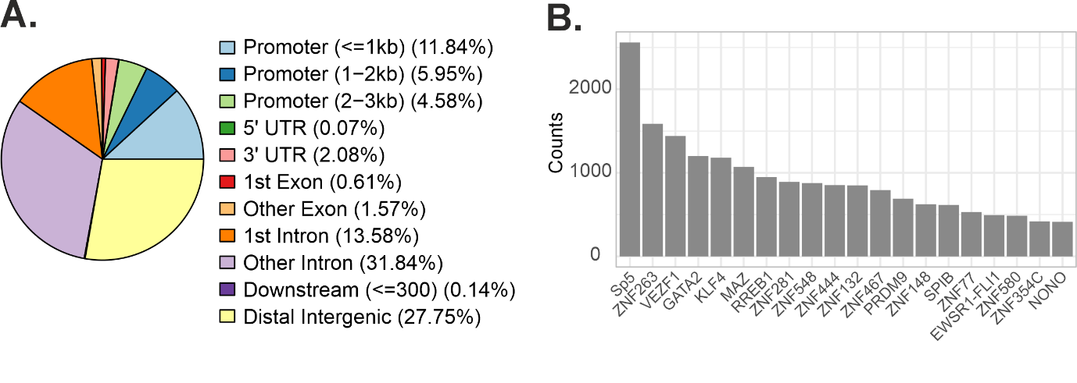

Supplement Figure 4. Annotation of G4Hunter-predicted G4-SNPs. A. Annotation with genomic regions. B. Overlap with transcription factor binding motifs from JASPAR database [3].

Supplement Figure 5. Alternative promoters in MICB. The MICB genomic region is shown in the UCSC Genome Browser [4] using the hg38 chromosome assembly. G4 motifs predicted by pqsfinder [1] are indicated as black lines. rs2855804 is marked as yellow line. Transcript isoforms, UCSC-annotated promoters (light blue rectangles), and CpG islands (green rectangles) are also displayed. Additionally, regulatory elements from ENCODE (cCREs) [5] are shown, including promoters (red rectangles), proximal enhancers (yellow rectangles), and distal enhancers (orange rectangles). Alternative promoters identified by Demircioglu et al. [6] are depicted as red lines spanning the entire graph.

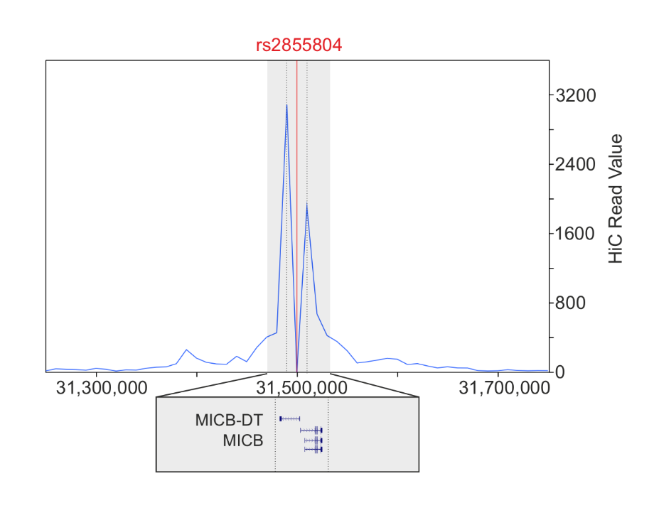
Supplement Figure 6. HiC contact points of MICB rs2855804 G4-SNP. HiC read peaks were detected for position chr6:31,479,587 and chr6:31,519,587 and visualized in 3D Genome Browser [7].

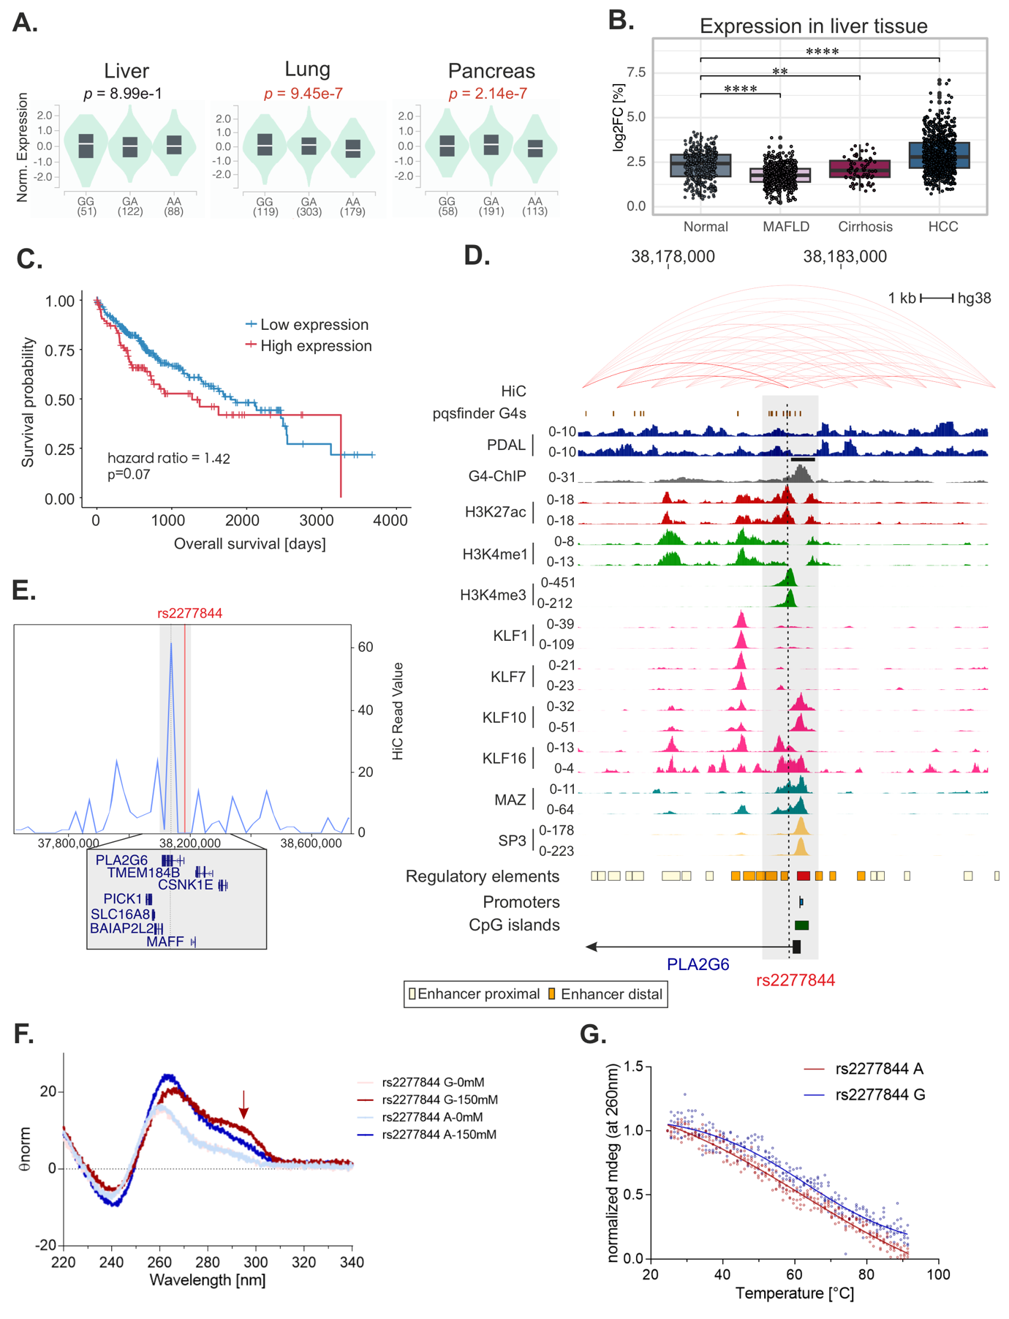

Supplement Figure 7. Molecular characterization of the rs2277844 G/A G4-SNP in intron 1 of PLA2G6. A. PLA2G6 expression correlated with the genotype of the G4-SNP rs2277844. The destabilizing T allele is associated with increased expression in three different tissues. Data were obtained from the GTEx database [8]. p-values were adjusted for multiple testing using false discovery rate correction. B. PLA2G6 expression decreased in metabolic-associated fatty liver disease (MAFLD) but then increases in more severe disease stages until the formation of hepatocellular carcinoma (HCC). Data were obtained from GepLiver database [9]. Wilcoxon rank sum test with Benjamini Hochberg (BH) adjusted p-values. C. Elevated PLA2G6 expression was associated with lower overall survival, albeit only borderline significant. Data were obtained from TCGA [10]. Log rank test was used to assess statistical significance. D. The G4-SNP was detected slightly upstream of a PDAL-Seq footprint (blue) as well as a G4-ChIP-seq peak (grey) [37] in HEK293 cells. Enrichment of H3K27ac (red) and H3K4me3 (green), but not with H3K4me1 was observed, consistent with promoter activity. The G4-SNP is located within an annotated regulatory region as depicted by the UCSC-annotated enhancer-proximal region [4] (dark orange rectangles). KLF10, KLF16, MAZ and slightly upstream also SP3 binding was observed. Hi-C contacts reveal interactions with other genomic locations. E. HiC read peaks were detected for position chr22:38,161,507 (dotted line) for rs2277844, albeit the signal intensity was very low. F. CD spectra of the effect allele (G) and the non-effect allele (A) demonstrated parallel G4 formation in a K⁺ concentration-dependent manner. The effect allele G caused a slight topological change to a hybrid structure, visible as an increased peak at 295 nm. G. CD melt curve analysis showed a slight increase in stability for the effect allele (G) versus the non-effect allele (A) with a ΔT of 0.57°C, albeit not significant (p=0.365, Welch two sample t-test). **** p<0.0001, *** p<0.001, ** p<0.01 and * p<0.05

A.
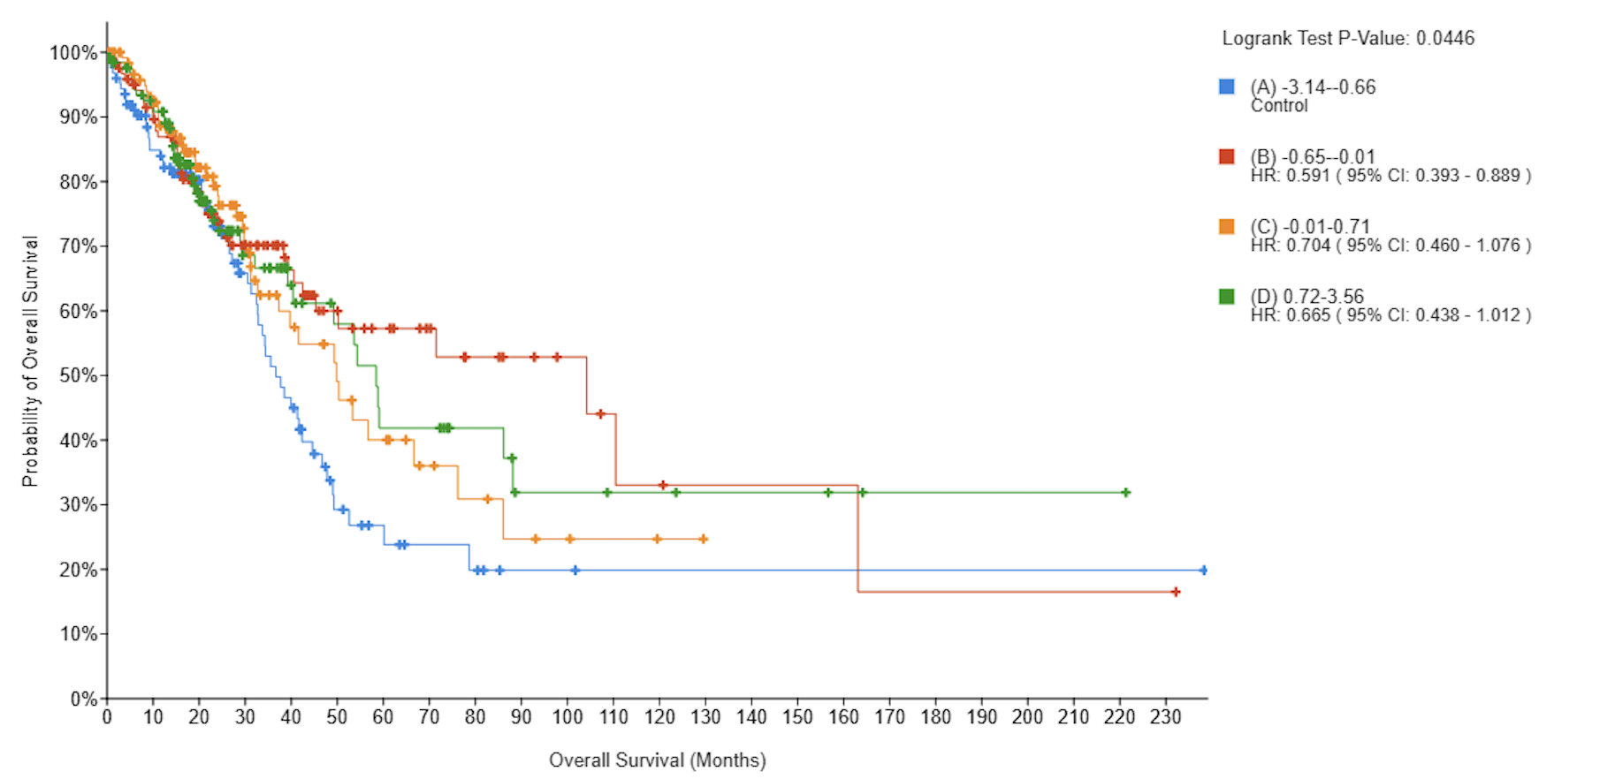

B.
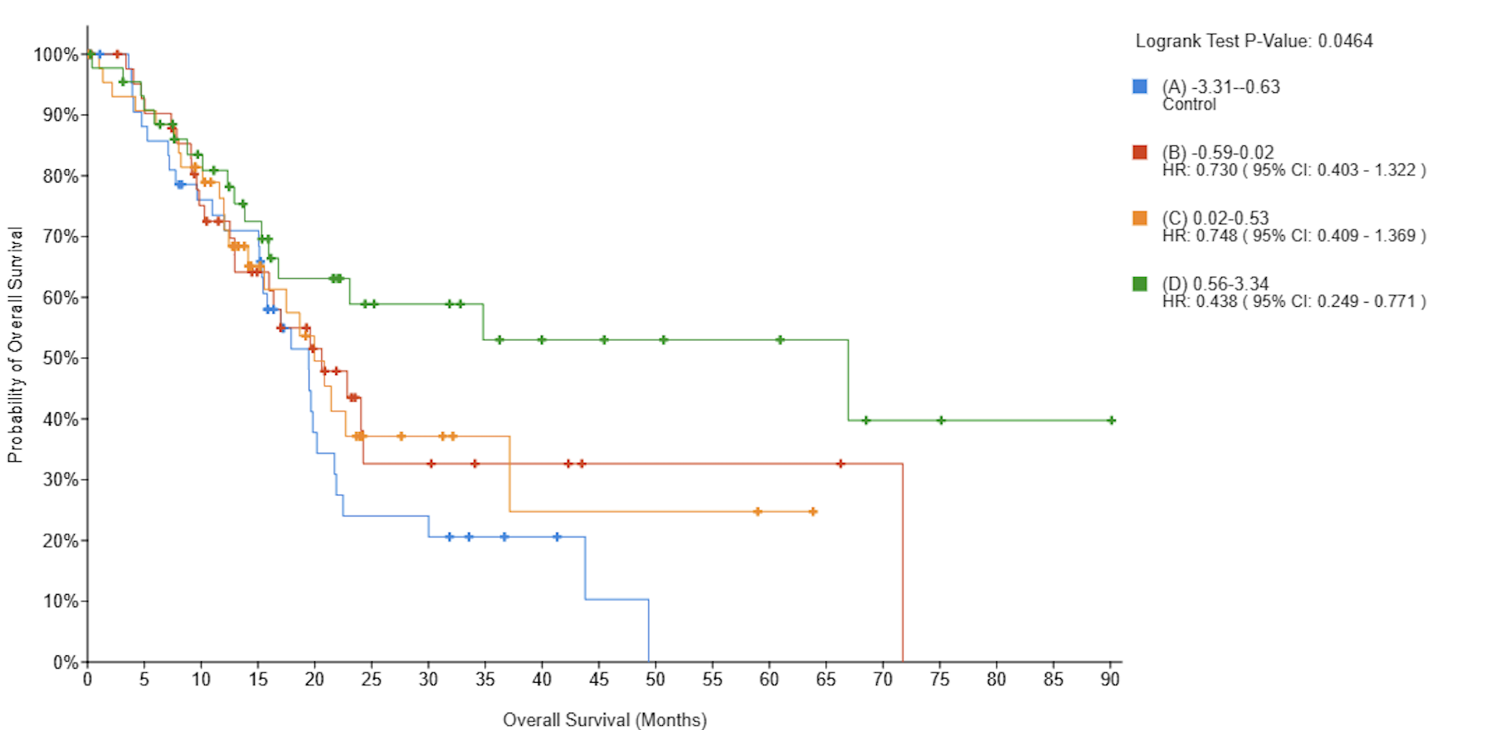

Supplement Figure 8. Overall survival correlating with PLA2G6 expression. Kaplan Meier plots show significant reduced overall survival of A. lung and B. pancreas cancer patients with low expression of PLA2G6. Log rank test was used to assess significance.

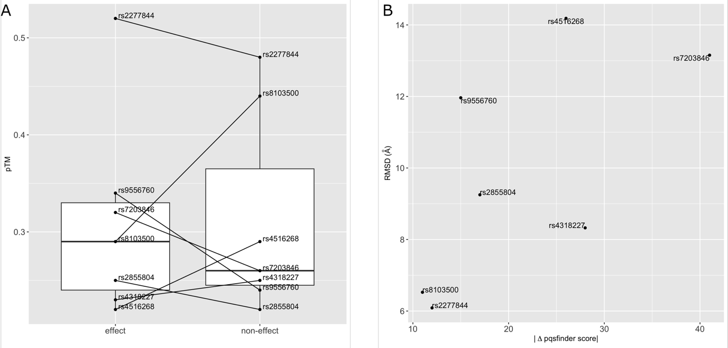

Supplement Figure 9. Model characteristics of AlphaFold 3 predictions. A. Distributions of confidence (pTM) scores of structure models generated by AlphaFold 3 for G4 motifs harboring effect (left) and non-effect (right) alleles. B. Structure similarity of model pairs (effect/non-effect) depending on the difference in their pqsfinder scores.

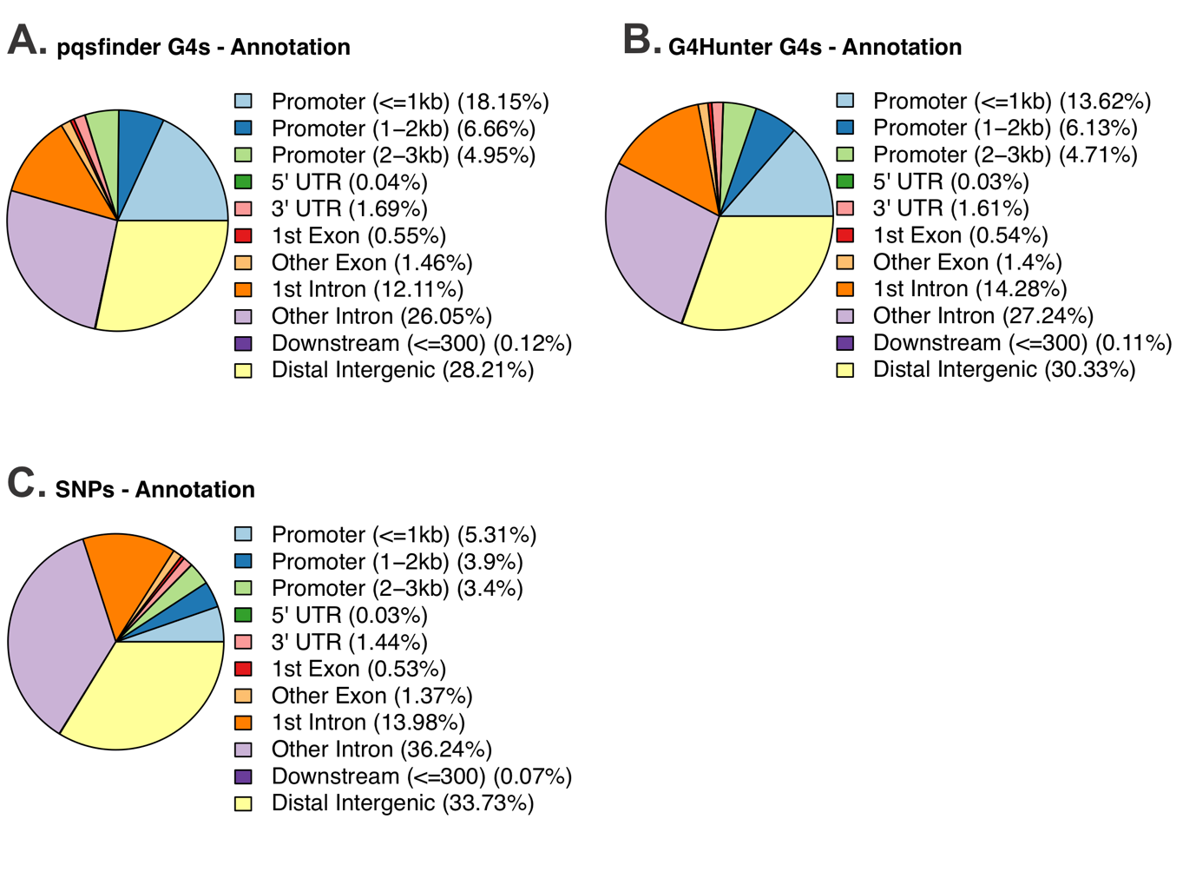
Supplement Figure 10. Genomic annotation of G4 motifs and SNPs. This figure shows the annotation of G4s predicted by A. pqsfinder [1] and by B. G4hunter [2]. C. Shows the annotation of the whole SNP dataset used for the analysis [11].

References
1. Hon, J., et al., pqsfinder: an exhaustive and imperfection-tolerant search tool for potential quadruplex-forming sequences in R. Bioinformatics, 2017. 33(21): p. 3373-3379.
2. Bedrat, A., L. Lacroix, and J.L. Mergny, Re-evaluation of G-quadruplex propensity with G4Hunter. Nucleic Acids Res, 2016. 44(4): p. 1746-59.
3. Rauluseviciute, I., et al., JASPAR 2024: 20th anniversary of the open-access database of transcription factor binding profiles. Nucleic Acids Res, 2024. 52(D1): p. D174-D182.
4. Perez, G., et al., The UCSC Genome Browser database: 2025 update. Nucleic Acids Res, 2025. 53(D1): p. D1243-D1249.
5. Ernst, J. and M. Kellis, Chromatin-state discovery and genome annotation with ChromHMM. Nat Protoc, 2017. 12(12): p. 2478-2492.
6. Demircioglu, D., et al., A Pan-cancer Transcriptome Analysis Reveals Pervasive Regulation through Alternative Promoters. Cell, 2019. 178(6): p. 1465-1477 e17.
7. Wang, Y., et al., The 3D Genome Browser: a web-based browser for visualizing 3D genome organization and long-range chromatin interactions. Genome Biol, 2018. 19(1): p. 151.
8. Consortium, G.T., The Genotype-Tissue Expression (GTEx) project. Nat Genet, 2013. 45(6): p. 580-5.
9. Li, Z., et al., GepLiver: an integrative liver expression atlas spanning developmental stages and liver disease phases. Sci Data, 2023. 10(1): p. 376.
10. Cancer Genome Atlas Research, N., et al., The Cancer Genome Atlas Pan-Cancer analysis project. Nat Genet, 2013. 45(10): p. 1113-20.
11. Park, S., et al., Multivariate genomic analysis of 5 million people elucidates the genetic architecture of shared components of the metabolic syndrome. Nat Genet, 2024. 56(11): p. 2380-2391.

