Supplementary Information
Study 2: Additional Preregistered Hypotheses
In addition to the hypotheses considered in the text, our preregistration for Study 2 considered three long-shot hypotheses that were rejected or only partially supported by the data.
H1: “The choice rates in all supersets will reflect the original CE.”
H2: “The choice rates in Superset 140 will reflect the original CE.”
These hypotheses build on a generalization of the analysis by Spektor et al. (2021), implying that the original compromise effect will emerge when options are presented in a precise numerical format. This hypothesis is rejected by the observation of a weak reversed compromise effect in Superset 8 (CE = –.024), and a significant reversed compromise effect in Superset 140 (CE = –.226).
H3: “The choice rates in Superset 8 will reflect a reversed CE.” This expectation stemmed from the results of Study 1. It was rejected since no significant effect was observed in Superset 8 this time (CE = –.02, t(405) = –.51, p = .6082, Cohen’s d = –.052).

Study 3: Additional Preregistered Hypotheses
The pre-registered hypotheses for Study 3 considered the possibility of both original and reversed compromise effects, particularly concerning the influence of experience. The main text focused on the observed pattern (weak initial CE, reversed CE with experience).
H1a: "The choice rates in the first trial will reflect the original compromise effect (as in Simonson, 1989)." This hypothesis was partially supported. The compromise effect was observed in the first trial, albeit small and non-significant (CE = .07, t(139), p = .404, Cohen’s d = .142), as shown in Figure 3 of the paper.
H2a: "The choice rates over trials 2 to 100 will reflect the original compromise effect." This hypothesis was rejected. Choice rates over trials 2-100 showed a significant reversed compromise effect (CE = –.12, t(196) = –2.74, p = .0067, Cohen’s d = –.393), as presented in Figure 3 of the paper.

Data
The dataset of studies 1, 2 and 3 (n = 964, CloudResearch), containing 38103 rows, is available at https://github.com/niyazmukh/si_the_coexistence_ce_and_reversed_ce . The dataset in the .csv format contains the following columns, A to M: study (numbered 1 to 3), age, gender, id (participant id), trial order (the order in which the decision was made by the participant), problem (see below), trial (1 to 100), trial time, selected option, option order 1 to 3 (relevant to study 1), attention.
Supersets are mapped via problem numbers such as the odd number corresponds to set ABC, and even number corresponds to set BCD:
- Study 1: Superset8 sets ABC and BCD are problems 1 and 2 respectively.
- Study 2: Superset8 (1 and 2), Superset22 (3 and 4), Superset140 (5 and 6).
- Study 3: Superset 22 (1 and 2).

Additional figures
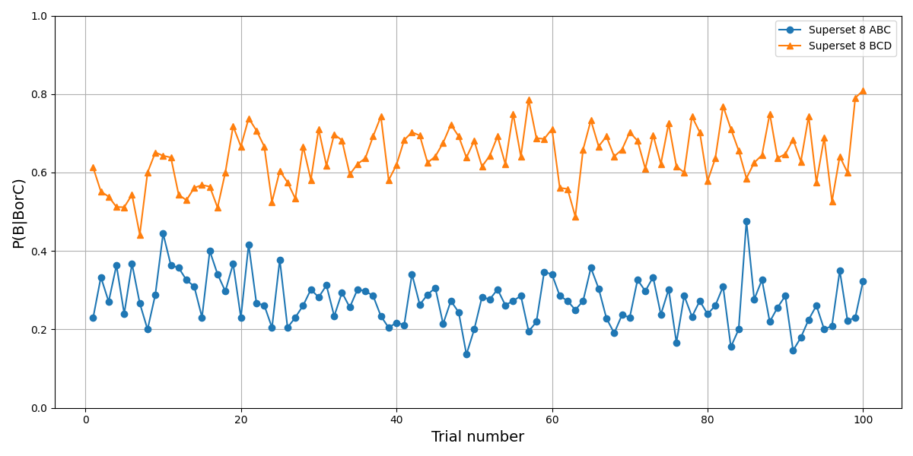Figure A. The choice rate of option B over C, P(B|BorC), in Study 1, as a function of time by choice set.

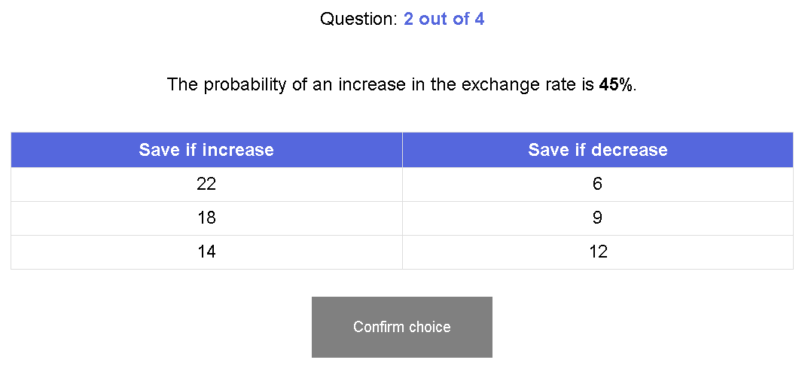Figure B. Visual representation of Superset 22.

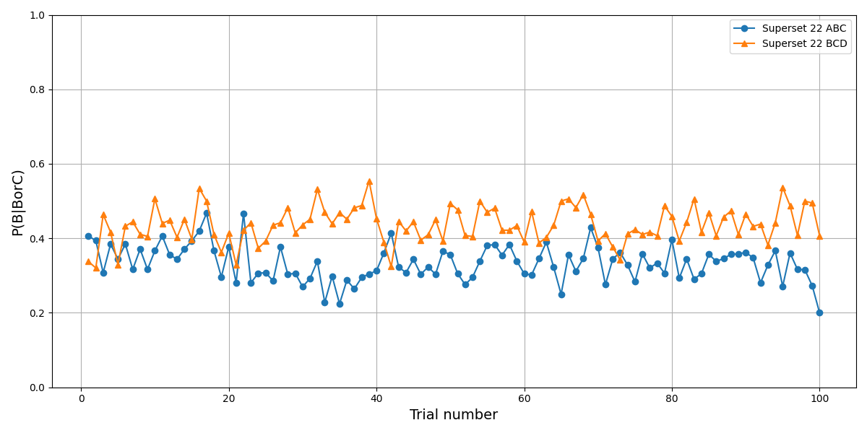Figure C. The choice rate of option B over C, P(B|BorC), in Study 3, as a function of time by the choice set.

