Supplementary Information

Resolving sampling and population-size biases in domestication genomics supports a South Asian origin of walnuts

Cai-Jin Chen¹, Xiao-Xu Pang^{1,2}, Ya-Mei Ding¹, Wei-Ping Zhang¹, Yang Yang¹, Jie Liu^{3,4}, Anush Nersesyan⁵, Bo-Wen Zhang¹, Susanne S. Renner^{6*}, Da-Yong Zhang^{1*} & Wei-Ning Bai^{1*}
¹Ministry of Education Key Laboratory for Biodiversity Science and Ecological Engineering, College of Life Sciences, Beijing Normal University, Beijing 100875, China
²College of Ecology, Lanzhou University, Lanzhou 730000, China
³CAS Key Laboratory for Plant and Biodiversity of East Asia, Kunming Institute of Botany, Chinese Academy of Sciences, Kunming, Yunnan, China
⁴Germplasm Bank of Wild Species, Kunming Institute of Botany, Chinese Academy of Sciences, Kunming, Yunnan, China
⁵A. Takhtajyan Institute of Botany, Yerevan, Armenia
⁶Department of Biology, Washington University, Saint Louis, MO 63130, USA
*Corresponding authors: srenner@wustl.edu; zhangdy@bnu.edu.cn; baiwn@bnu.edu.cn

This PDF file includes:
Supplementary Figures 1 to 3

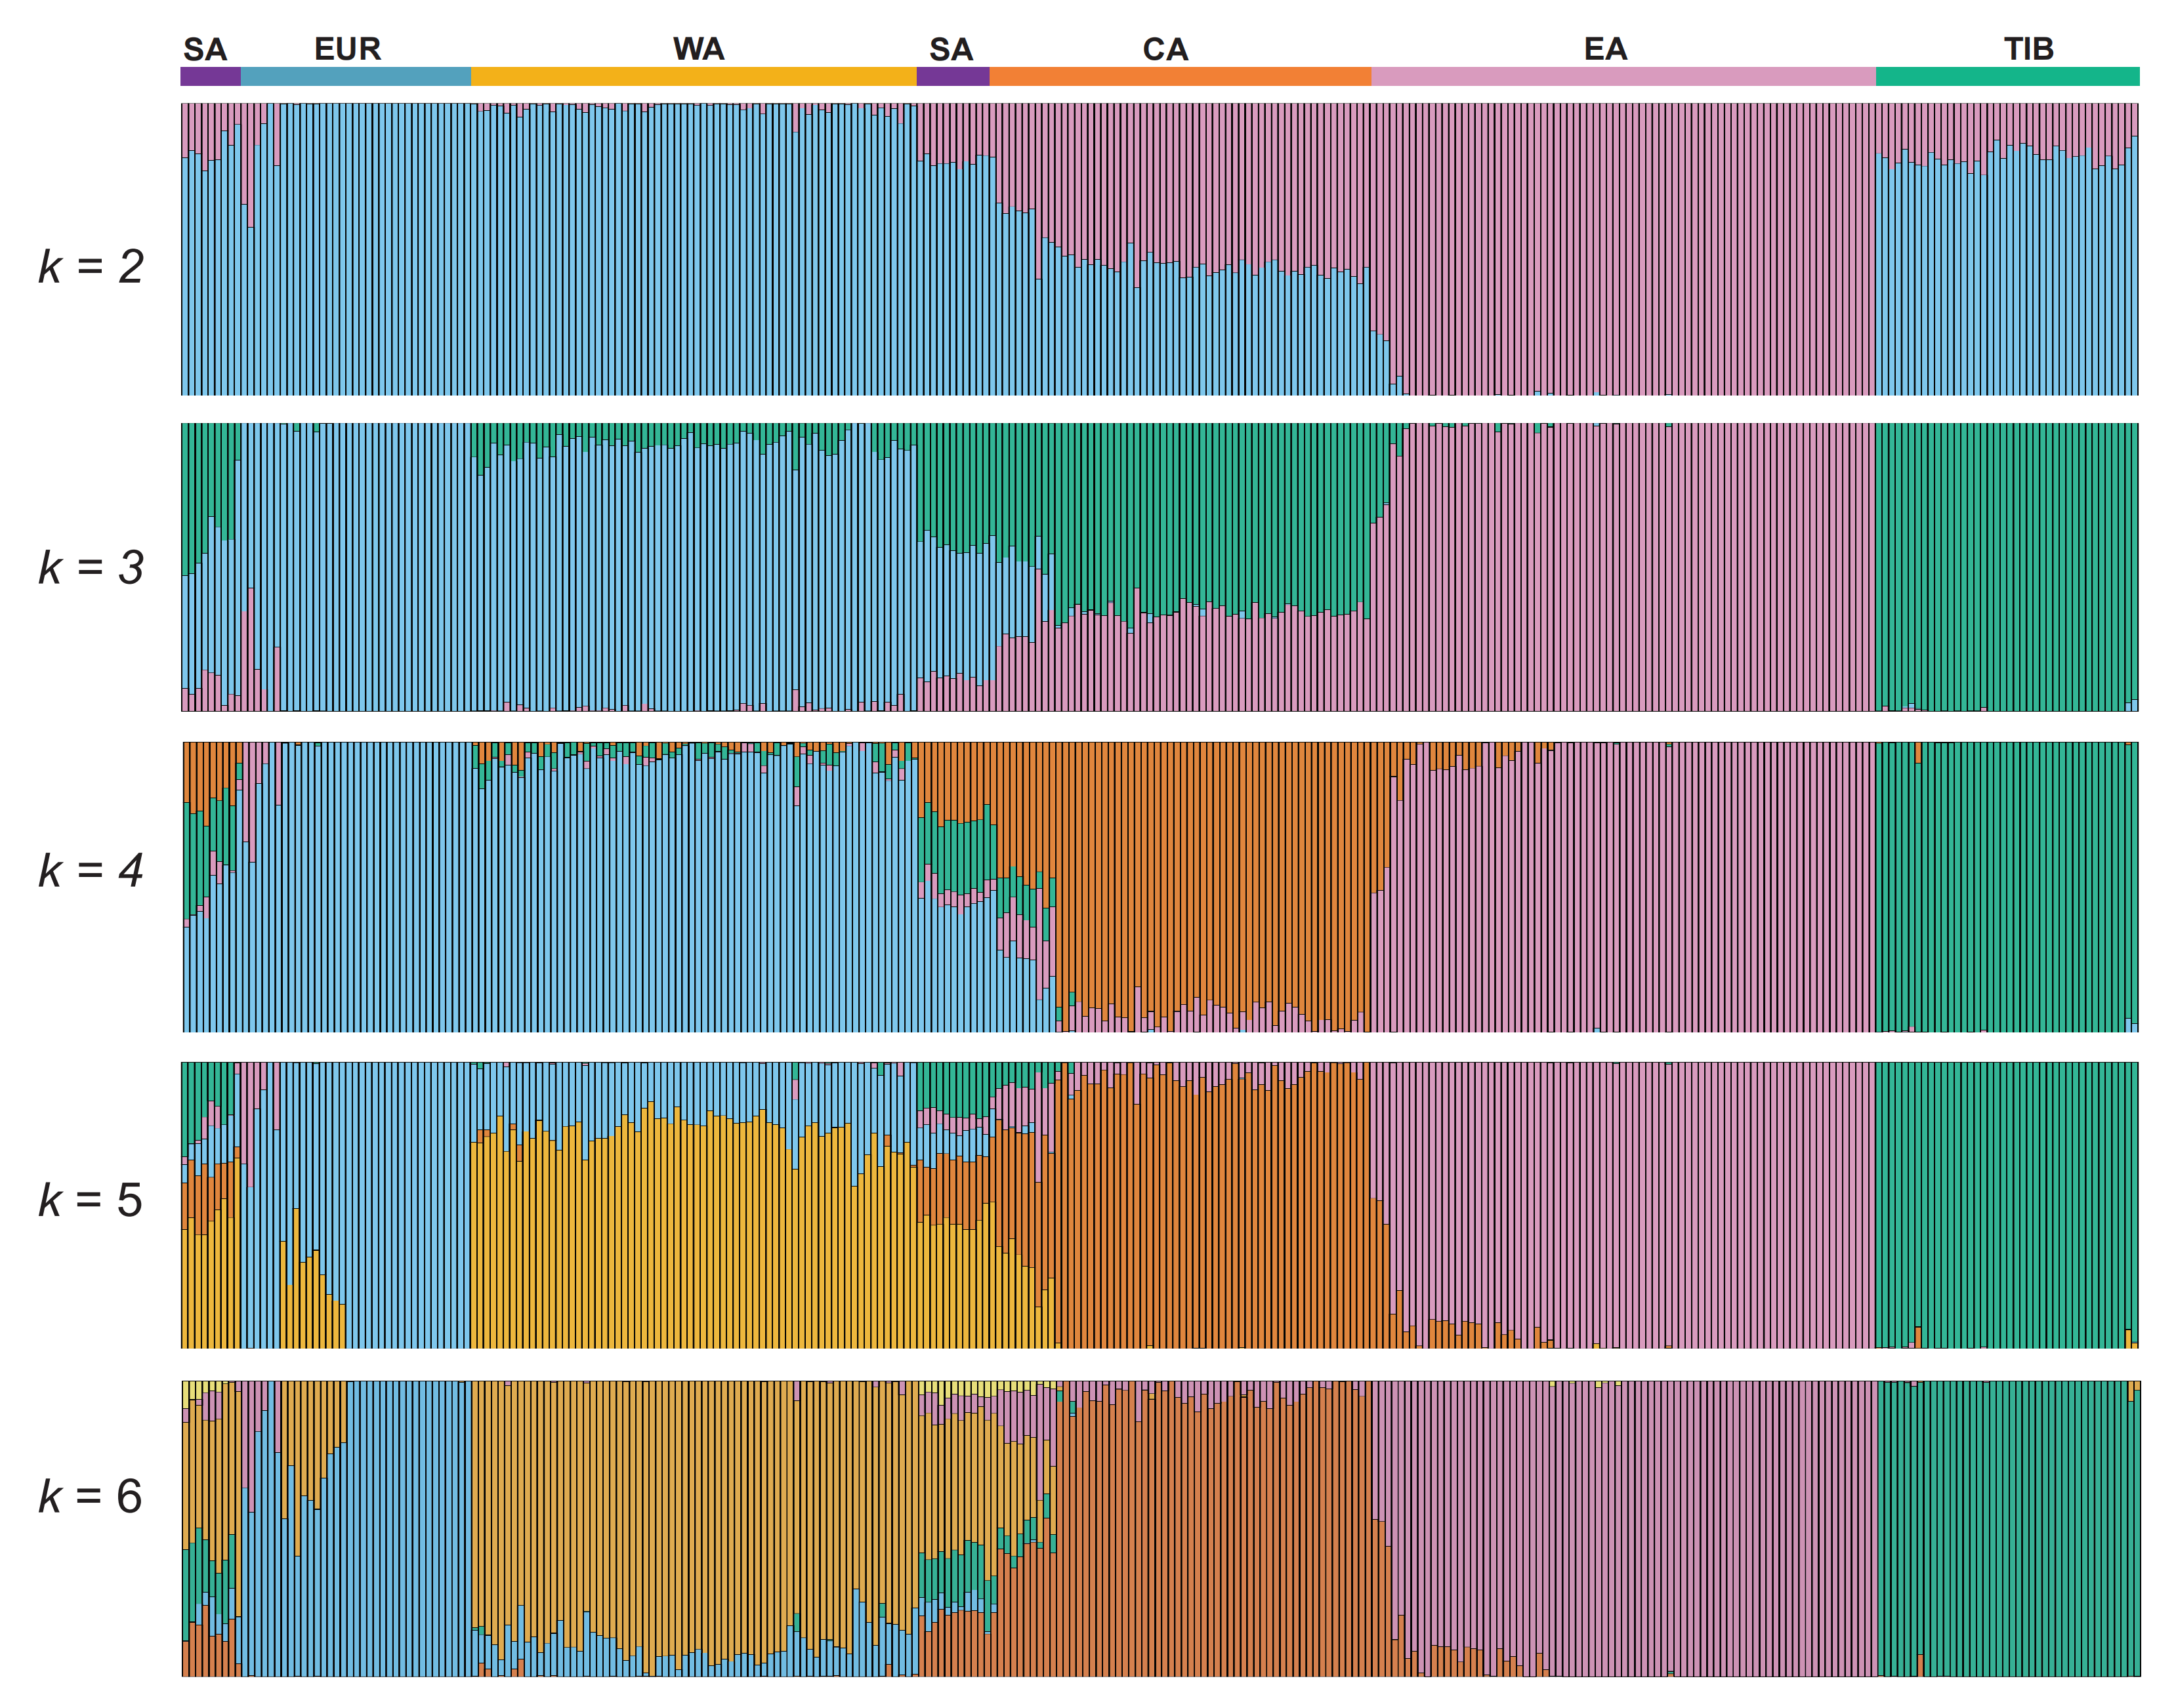
Supplementary Figure 1. Population structure analysis 298 individuals of Juglans regia. Genetic structure inferred using STRUCTURE v.2.3.4 (Pritchard et al. 2000) with ParamSet2 (the alternative ancestry prior (POPALPHA = 1), a small ALPHA value (ALPHA = 0.25), and uncorrelated allele frequency model (FREQSCORR = 0)). The y-axis represents the q value, and the x-axis shows each individual. Color coding: Europe (EUR, blue), West Asia (WA, yellow), Central Asia (CA, orange), East Asia (EA, pink), Tibet (TIB, green), and South Asia (SA, purple).

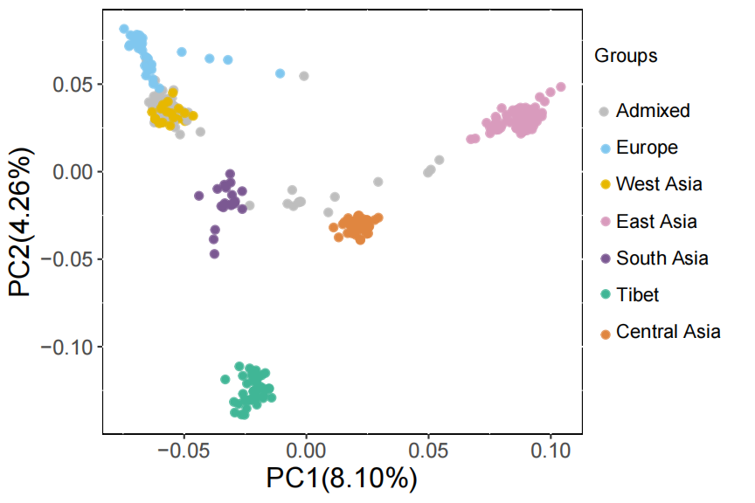
Supplementary Figure 2. A principal component analysis (PCA) of 298 individuals of Juglans regia.

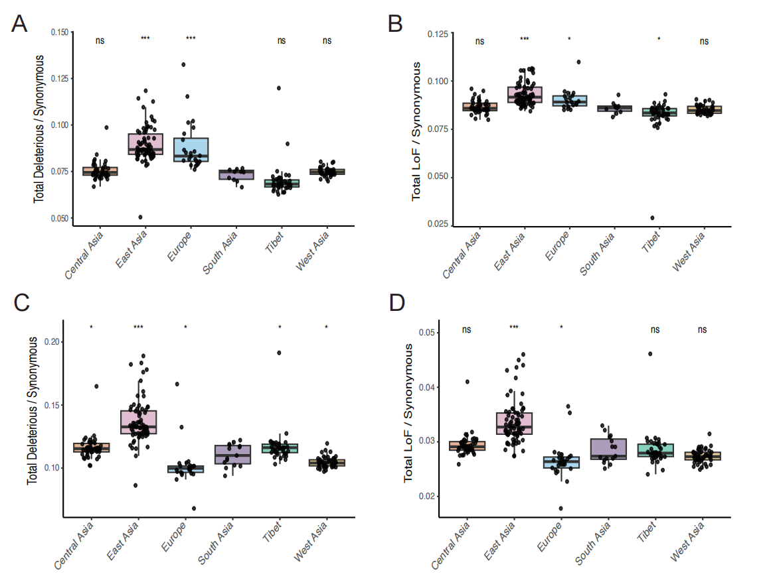
Supplementary Figure 3. Mutational load, and loss-of-function (LoF) variants were analyzed in six groups of Juglans regia using the Tibetan reference genome (A-B) (Zhang et al. 2020) and Chandler 2.0 reference genome (C-D) (Marrano et al. 2020). The ratios of derived deleterious variants (A, C) and LoF variants (B, D) to synonymous variants were calculated for each individual. p-values were derived using t-tests comparing each group to “South Asia”, with significance levels indicated as “***” p < 0.001, “**” p < 0.01, “*” p < 0.05, “ns” p > 0.05.

