Graphical Abstract
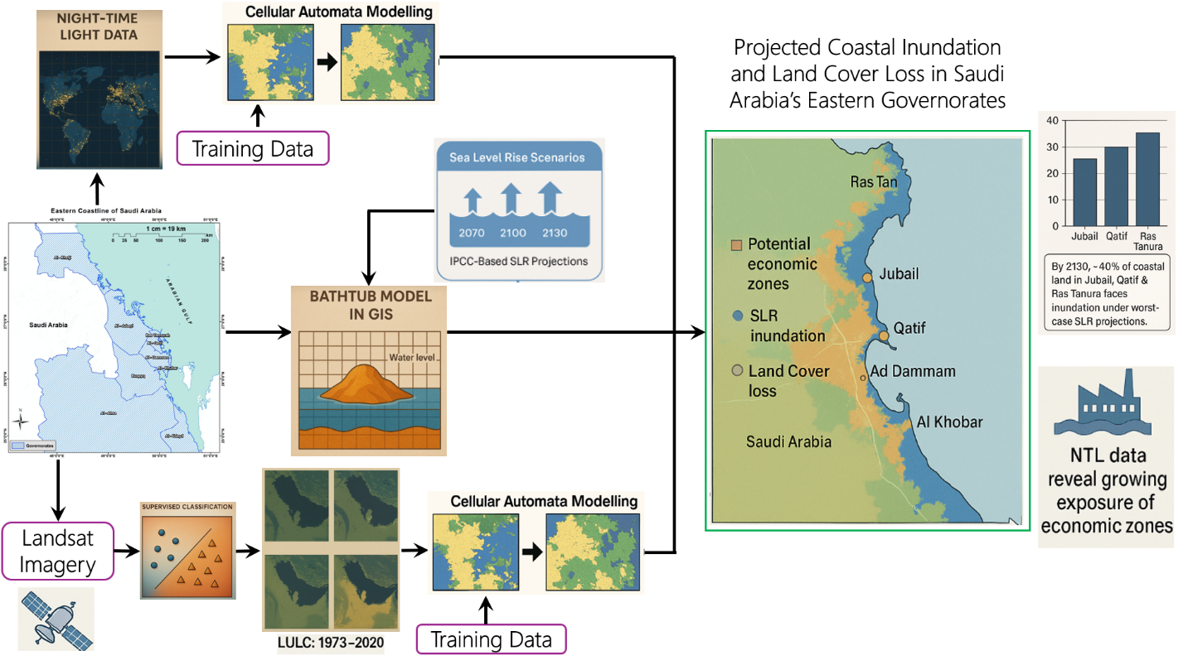
Graphical Abstract Description: The graphical abstract provides a visual and textual summary of a study focused on the potential consequences of sea level rise (SLR) on the coastal regions of the western Arabian Gulf, particularly along the Saudi Arabian coastline. On the left side, the image outlines the key objectives of the research, including forecasting sea level rise effects on major coastal cities, analyzing historic shoreline changes, and examining the implications of SLR on future land use, land cover (LULC), and economic zones. A small inset map highlights the geographical scope of the study, showing vulnerable coastal areas in Saudi Arabia. The center of the image emphasizes the methodology, which includes gathering technical data, performing geoprocessing operations, and simulating predictive models to assess risk levels. On the right side, the results and implications are presented: significant coastal belt alteration is expected, and cities such as Jubail, Qatif, and Ras Tanura are identified as high-risk zones under worst-case scenarios. Additionally, economic hubs like Ad Dammam and Al Qatif face severe inundation risks. The study underscores the urgency of proactive planning and adaptive strategies to address the anticipated ecological and economic challenges. Overall, the image integrates scientific analysis, spatial modeling, and policy-relevant findings to highlight the critical need for regional preparedness in the face of climate-induced sea level rise.

