Supplementary Information for A Physics-Informed Foundation Model for
Real-Time High-Fidelity Structural Dynamics

1. AI-Driven Structural Design and Automated Finite Element Model Generation
We introduce an automated pipeline for structural design and finite element model generation, integrating generative modeling, computer vision, and code-compliant optimization. The process begins with user-defined constraints—floor area, number of stories, functional zones, and seismic intensity—which are encoded into spatial prompts. These are processed by the Flux backbone, a rectified flow generative model augmented with ControlNet for conditioning, and fine-tuned into three specialized variants: ArchiFlux, StructFlux, and BeamFlux.
ArchiFlux synthesizes architectural layouts with semantic segmentation; StructFlux infers column and wall configurations; BeamFlux completes beam networks based on connectivity requirements. The models operate hierarchically, ensuring alignment between architectural intent and structural logic. Over 270,000 layouts were generated using a dataset of annotated plans and trained with RGB-encoded labels representing structural classes.
Post-processing converts color-encoded images into vectorized primitives via skeletonization, topological reconstruction, and chromatic classification. Structural elements are extracted as polylines, classified, and assembled into connected graphs.
These layouts are transformed into reinforced concrete finite element models through a rules-based design engine incorporating Chinese seismic codes^{1,2}. Member dimensions, reinforcement ratios, and detailing are assigned analytically and filtered by strength, ductility, and drift criteria. Models failing code checks undergo a multi-stage optimization, adjusting geometry, materials, and configuration. Seismic compliance is verified through nonlinear time-history analysis. Persistent violations lead to rejection, while compliant designs are archived with full geometric, material, and seismic metadata. This pipeline enables high-throughput generation of code-compliant, structurally realistic models for large-scale simulation and learning. The entire generative workflow is schematically illustrated in Supplementary Figure 1.
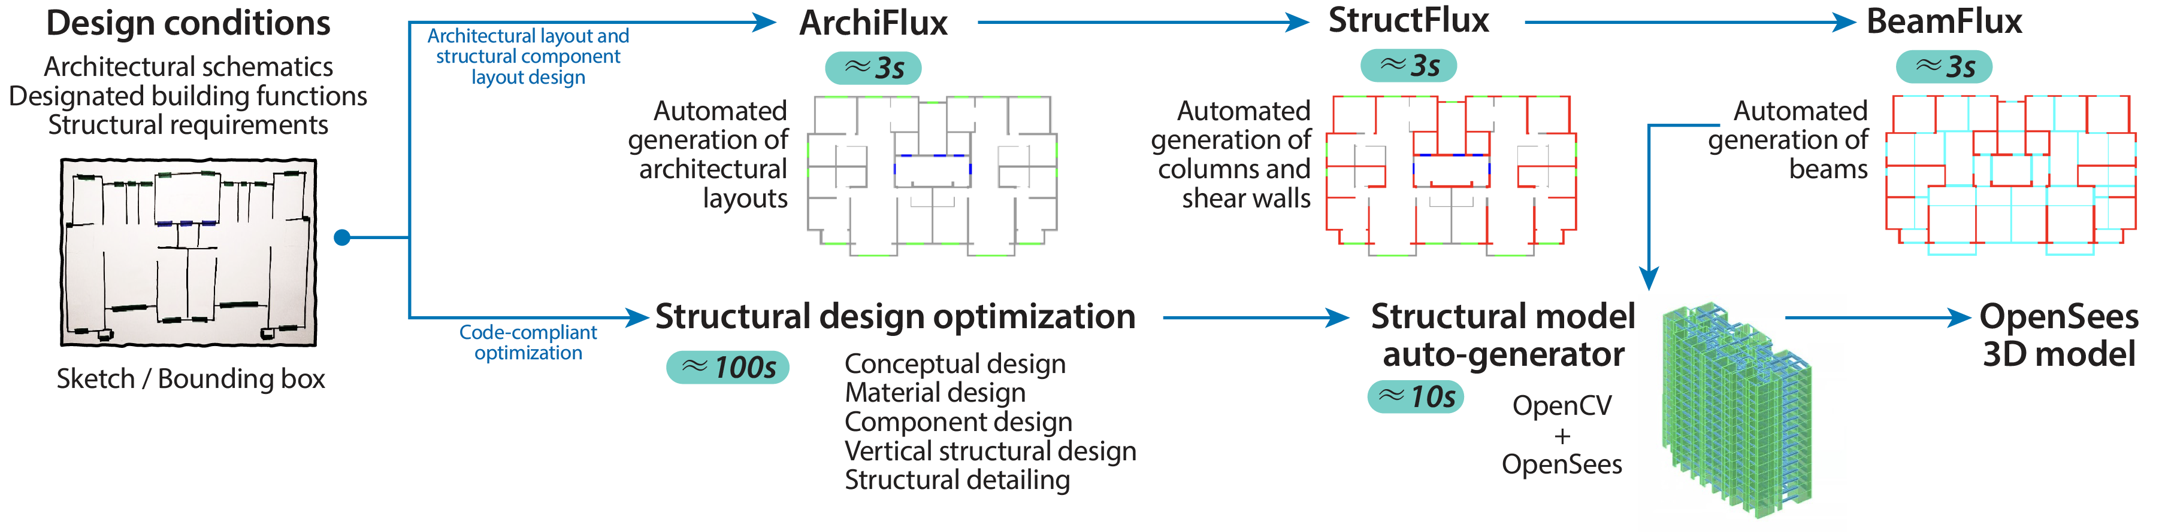
Supplementary Figure 1 | Schematic overview of the automated generative workflow for structural design and finite element model construction.

1.1 Generation of Architectural Floor Plans and Structural Layouts Using Flux and ControlNet
This section presents the architectural framework and training strategy used to implement a generative structural design pipeline comprising the latent-diffusion backbone (Flux), its spatial conditioning extension (ControlNet), and three task-specific variants—ArchiFlux, StructFlux, and BeamFlux. Together, these models enable hierarchical structural layout synthesis, from schematic floor plan generation to detailed member-level configuration, using a compact expert-labelled dataset of architectural drawings. The generated layouts support the development of 270,000 structurally valid building models, which form the basis of all subsequent nonlinear finite-element simulations.

1.1.1 Rectified flow formulation of Flux
Let $x_{t}∈R^{C×H×W}$ denote the latent representation of a floor plan image at continuous time $t∈\left[0,1\right]$. In Flux model, synthesis is posed as a rectified flow problem rather than a denoising-diffusion process. A single noise sample $x_{t}∼N(0,I)$ is transported to the data manifold at $t$=0 by integrating the ordinary differential equation
$$\frac{dx_{t}}{dt}=v_{θ}\left(x_{t},t,c\right), x_{t=1}∼N(0,I)$$ | (1)
where $v_{θ}$ is a conditional velocity field parameterized by $θ$ and driven by conditioning information $c$ (text embeddings, spatial priors, or layout constraints)³.
Flux is trained with the flow-matching loss, which aligns the predicted velocity with a reference velocity $\overline{v}(x_{t},t)$ derived from probability-flow theory:
$$L_{FM}=E_{t∼U\left[0,1\right],x_{0}∼p_{data}}{\left\|v_{θ}\left(x_{t},t,c\right)-\overline{v}(x_{t},t)\right\|}_{2}^{2}$$ | (2)
where $x_{t}$ is obtained by analytically sampling along the reference flow connecting $x_{1}$ and $x_{0}$. No denoiser or $β_{t}$ variance schedule is required.
At test time, images are generated by discretizing Equation (1) with a fixed-step forward-Euler solver:
$$x_{t-∆t}=x_{t}-∆tv_{θ}\left(x_{t},t,c\right), ∆t=\frac{1}{N}$$ | (3)
where $N$ is typically 10–50. Classifier-free guidance is applied by evaluating both conditional and unconditional velocities and linearly combining them to modulate prompt fidelity. This rectified-flow formulation eliminates the diffusion forward process and the noise-prediction objective altogether, enabling Flux 1 to achieve high-resolution, text-conditioned image synthesis with an order-of-magnitude fewer function evaluations than conventional denoising-diffusion models.

1.1.2 The model architecture of Flux
The generative core of Flux is a high-capacity Transformer architecture, FluxTransformer2D, which models conditional vector fields over compressed latent spatial grids. The network operates on a resolution of 64 × 64 latent patches, each corresponding to a 16×16 region in pixel space, and adopts a U-Net-style topology with deep hierarchical attention, parameter-efficient normalization, and cross-modal conditioning mechanisms. The model architecture consists of three principal stages—input embedding, a dual-stream encoder, and a single-stream fusion block—all implemented using transformer layers augmented with convolutional projections and residual attention.
Latent patch embedding: The input latent tensor $x_{t}∈R^{C×H×W}$, typically initialized from standard Gaussian noise at $t$=1, is first passed through a 1×1 convolutional projection layer that maps it into a 64-channel token space. This serves as the initial representation for subsequent attention-based processing.
Dual-stream encoder: The first stage comprises 19 Transformer blocks, each composed of residual self-attention and feedforward layers, collectively referred to as double stream blocks. Spatial positional encoding is implemented using rotary positional embedding⁴ (RoPE) over a canonical patch grid (16,56,56), which is critical for maintaining alignment constraints and local symmetry—particularly important in structured design tasks such as architectural layout synthesis.
Single-stream fusion: To facilitate interaction between visual latents and textual conditions, the second stage consists of 38 Transformer blocks that integrate the image stream with textual embeddings via cross-attention. Prior to fusion, textual embeddings from CLIP⁵ (ViT-L/14) and T5⁶ encoders are projected into a shared 768-dimensional space and concatenated along the sequence dimension. Cross-modal joint attention is then computed over the fused sequence, with a model-wide joint embedding dimension of 4096.
Each Transformer block comprises a 24-head self-attention mechanism with 128-dimensional heads, followed by a feedforward network using SwiGLU⁷ activation and a 4× expansion ratio (≈8192 units). RMSNorm⁸ is applied after both attention and multi-layer perceptron (MLP) layers to ensure stable optimization and efficient gradient propagation at scale.

1.1.3 Spatial conditioning with ControlNet
To guide the generative process with structured spatial constraints, a ControlNet⁹ module is integrated at each resolution stage. This mechanism adds a parallel, trainable path to the Flux backbone, enabling fine-grained control without modifying the original network weights. Specifically, a frozen encoder $F_{locked}$ is combined with a trainable duplicate $F_{train}$, modulated through a zero-initialized 1×1 convolution layer $W_{0}$:
$$y=F_{locked}\left(x_{t}\right)+W_{0}*F_{train}(s)$$ | (4)
where $s$ represents the spatial condition input (e.g., zoning boundaries or element masks). At inference, classifier-free guidance is used to adjust conditioning strength:
$$ε_{θ}^{cfg}=ε_{θ}(x_{t},∅,t)+g\left[ε_{θ}\left(x_{t},c,t\right)-ε_{θ}(x_{t},∅,t)\right]$$ | (5)
with $g$ controlling the trade-off between fidelity and constraint adherence.

1.1.4 Hierarchical domain adaptation: ArchiFlux, StructFlux, and BeamFlux
A core methodological contribution of this work is the hierarchical adaptation of the Flux rectified-flow model for automated structural layout generation, realised through three task-specific variants: ArchiFlux, StructFlux, and BeamFlux. These models were fine-tuned from a shared Flux.1 backbone using a domain-specific dataset comprising 232 semantically annotated architectural drawings at 1024 × 1024 resolution. Each drawing encodes six structural and architectural categories via a fixed colour mapping: white (background), grey (infill walls), red (columns or shear walls), blue (beams), green (windows), and dark blue (doors).
Fine-tuning was performed using the ControlNet, which attaches a zero-initialised conditioning branch to the frozen backbone of Flux. Each model was trained for 100 epochs using the AdamW optimiser (learning rate 5×10⁻⁵, batch size 4, mixed-precision). To preserve hierarchical consistency, earlier-stage models were frozen during the training of downstream variants.
ArchiFlux generates multi-class architectural floor plans from binary input masks representing building footprints.
StructFlux takes the output of ArchiFlux as input and predicts the spatial arrangement of vertical load-bearing components, including columns and shear walls.
BeamFlux receives the StructFlux layout and outputs the complete beam network defining the gravity-load system.
Each model was trained under consistent settings and evaluated using Euler-based integration over 100 steps. In total, the framework generated 270,000 structured floor plan layouts, including 150,000 frame structures, 60,000 frame–shear wall structures, and 60,000 shear wall structures, providing a large-scale, code-compliant dataset for downstream structural simulation and learning.
1.2 Post-processing of Image Data for Generated Structural Layout
To convert color-encoded raster images into high-fidelity finite element models, we developed a sophisticated pipeline that integrates state-of-the-art computer vision techniques with advanced structural modeling frameworks. This process ensures the accurate extraction, classification, and serialization of structural elements for subsequent analysis in OpenSees.
Image Preprocessing and Skeletonization: The initial step involves isolating structural elements based on their chromatic encoding: beams are represented in blue (R=0, G=0, B=255), and columns or shear wall boundaries in red (R=255, G=0, B=0). The images are converted to grayscale and binarized to distinguish foreground elements. Morphological operations, including dilation and directional opening, are applied to enhance the continuity of structural lines. Subsequently, the Guo–Hall thinning algorithm is employed to reduce the binary images to their skeletal representations, preserving the topology and connectivity of structural components.
Geometric Extraction and Topological Reconstruction: From the skeletonized images, maximal axis-aligned line segments are extracted using a flood-fill approach. To address fragmentation due to raster artifacts, adjacent segments within a 2-pixel proximity are merged. Intersections, including T-junctions and crosses, are detected to ensure nodal continuity. Endpoints within a 2-pixel threshold are unified to resolve minor discrepancies, and segments are straightened to enforce orthogonality, resulting in a clean and connected structural graph.
Structural Classification: Each line segment is sampled along its length, and RGB values are interpolated to determine the dominant structural class via Euclidean color distance. This classification distinguishes beams from columns or walls, enabling the segregation of structural elements into distinct categories for modeling purposes.

1.3 Automated Structural Design and Drift-Controlled Optimization for Synthetic Finite Element Models
To generate large-scale, code-compliant structural models from architectural layouts, we developed an automated design framework that transforms building skeletons produced by the Flux model into finite element (FE) representations. This pipeline performs structural member sizing, reinforcement design, and seismic compliance verification based on regulatory criteria, with iterative optimization steps if necessary. While the design success rate for any individual building may be relatively low, the extreme scalability of Flux-generated candidates ensures that a sufficiently large and diverse database of valid structural models can still be constructed.

1.3.1 Structural Design Workflow
Given a discrete building layout generated by the Flux model—comprising walls, beam spans, columns, and floor heights—a Python-based structural design pipeline initiates the assignment of concrete section sizes and reinforcement for all vertical and horizontal components. The design adheres to the relevant provisions of Chinese structural codes, including GB 50010-2010¹, and JGJ 3-2010², encompassing both member-level and system-level requirements.
The design process follows a hierarchical logic:
- Initial Assignment: Cross-sectional dimensions and reinforcement ratios for beams, columns, and shear walls are computed using closed-form solutions embedded in Chinese design codes. Beams are evaluated for flexural and shear capacity; shear walls are divided into boundary and core zones, with axial and vertical reinforcement ratios set according to seismic intensity and structural importance class.
- Serviceability and Strength Filtering: Each design is evaluated against key structural criteria, including: (i) flexural and shear strength compliance; (ii) strong-column–weak-beam requirements; (iii) span-to-depth and axial compression limits; and (iv) reinforcement ratios and detailing for seismic ductility. Members failing any check are marked for redesign or excluded during optimization.
- Drift Control and Seismic Compliance Criteria: Certainly. To ensure regulatory compliance under seismic actions, each structural model must satisfy inter-storey drift limits as prescribed in GB 50011-2010¹, with allowable thresholds explicitly defined by structural system type and seismic intensity. Specifically, the maximum inter-storey drift ratio ($θ$) must not exceed 1/550 under frequent earthquakes and 1/50 under rare earthquakes for frame structures; 1/800 and 1/100, respectively, for frame–shear wall systems; and 1/1000 and 1/120 for pure shear wall systems. These limits are rigorously evaluated through nonlinear time-history analysis or equivalent static procedures following model generation. If a given configuration violates the prescribed drift criteria, the pipeline engages a hierarchical optimization process that iteratively adjusts global building scale, material grade, wall thickness, and storey configuration. Models are reanalyzed after each adjustment cycle. Designs that consistently fail to meet the drift requirements after all permitted modifications are systematically excluded from the dataset. Owing to the high-throughput generative capability of the Flux model, this rejection-based strategy remains computationally efficient and enables the construction of a large, structurally diverse corpus of finite element models that conform to seismic design codes.

1.3.2 Optimization Strategy
For designs that violate strength or drift limits, a structured multi-stage optimization is employed. The pipeline sequentially adjusts (i) the global geometric scale to modify stiffness and seismic demand, (ii) material grades to higher concrete and reinforcement strengths, (iii) wall and column dimensions to enhance lateral and axial capacities, and (iv) the number of storeys within allowable height constraints. Each modified configuration is re-evaluated via finite element analysis. To control computational cost, the process is capped at a maximum of four iterations. Designs that remain noncompliant after all permitted adjustments are discarded.

1.3.3 Code Compliance and Structural Detailing
To enhance the fidelity and regulatory alignment of the generated finite element models, the design pipeline incorporates key structural detailing and verification procedures drawn from current seismic and concrete design codes. These procedures aim to ensure that each model not only meets basic strength and drift requirements but also captures essential features of realistic structural performance under seismic loading. At the member level, ductile detailing provisions are applied, including transverse reinforcement in beam and column plastic hinge zones, confinement zones at wall boundaries, and joint reinforcement satisfying strong-column–weak-beam requirements. Shear design checks are implemented to ensure that both flexural and shear capacities remain within allowable limits under design loading conditions. Structural responses are evaluated across a range of ultimate and serviceability load combinations, incorporating dead, live, and seismic actions, as well as accidental torsion effects to account for plan irregularities. Force and displacement envelopes derived from these combinations are used to guide member verification and ensure compliance with governing load effects. All design outputs, including geometry, material properties, reinforcement layouts, and seismic performance indicators, are systematically stored in a structured database. This facilitates traceability, supports downstream analysis, and enables integration with data-driven modeling efforts. Collectively, these enhancements improve the realism, robustness, and regulatory conformity of the synthetic structural models, while preserving the scalability required for large-scale generation.

2. Finite-Element Modelling and Nonlinear Time-History Analysis Based on OpenSees

2.1 Modelling Framework and Global Assumptions
All simulations were executed with OpenSees (v3.6.0) in a three-dimensional setting. Millimetre–Newton–second units were maintained throughout. Each model is instantiated with a three-dimensional builder, providing six degrees of freedom (DoF) per node. The global axes are defined as X and Y in-plane and Z vertical. Storey diaphragms are assumed rigid in-plane: all nodes belonging to a storey are slaved to a master node located at the geometric centroid of the slab. This constraint suppresses membrane distortion while still allowing vertical, torsional and out-of-plane motions.

2.2 Constitutive Formulations
Concrete: Confined and unconfined concrete fibers are modelled with the Concrete02 material, which combines the Kent–Scott–Park compressive parabola with a linear post-peak branch and an exponential tension softening law. The compressive backbone is
$$σ_{c}\left(ε\right)=\left\{\begin{matrix}f_{c}^{'}\left(2\frac{ε}{ε_{0}}-{\left(\frac{ε}{ε_{0}}\right)}^{2}\right), 0≤ε≤ε_{0} \\ f_{c}^{'}\left(1-k_{r}\right)\frac{ε_{u}-ε}{ε_{u}-ε_{0}},ε_{0}≤ε≤ε_{u}\end{matrix}\right.$$ | (6)
where $f_{c}^{'}$ is the compressive strength, $ε_{0}$ indicates the strain at peak stress, $ε_{u}$ represents the ultimate strain and $k_{r}$ is the residual-strength ratio.
Reinforcing steel: Longitudinal bars, stirrups and boundary steels follow the Giuffré–Menegotto–Pinto rule (Steel02). The stress update reads
$$σ_{s}=bE_{0}Δε+(1-b)\frac{E_{0}Δε}{1+{\left|Δε/(ε_{y}R_{0})\right|}^{R}}$$ | (7)
$$R=R_{0}\left[1-c_{1}{(\left|σ/E_{0}\right|)}^{c_{2}}\right]$$ | (8)
with $E_{0}$ the elastic modulus, b the strain-hardening ratio, $ε_{y}$ the yield strain, $R_{0}$ a transition coefficient and $R$ governing the Bauschinger effect.
Concrete–steel coupling in wall panels: Planar wall fibres employ a plane-stress FSAM material, which couples Concrete02 in the principal directions with orthogonal Steel02 reinforcement under perfect bond. The stress vector is obtained from a return-mapping algorithm that enforces equilibrium of concrete and steel sub-constituents while accommodating aggregate dowel action through a parameter $α_{dow}$.

2.3 Structural Component Modeling
The modeling approaches adopted for all structural components in this study are summarized in Supplementary Table 1.
Concrete regions were discretized using quadrilateral fiber patches, while longitudinal reinforcement was assigned via straight bar layers aligned along the member axis. To ensure numerically stable torsional behavior without interfering with flexural plasticity, all fiber sections were augmented with an elastic torsional spring, providing Saint-Venant stiffness in the out-of-plane direction.

Supplementary Table 1 | Finite-element modeling strategies for different structural components
Component | Element type | Section / material | Integration
Columns | nonlinearBeamColumn¹⁰ | Fiber section with Aggregator and torsional stiffness; utilizes Concrete02 and Steel02 materials | 5-point Gauss–Lobatto integration
Beams | nonlinearBeamColumn¹⁰ | Fiber section with reduced reinforcement ratio to represent cracked inertia; employs Concrete02 and Steel02 materials | 5-point Gauss–Lobatto integration
Slabs | Modeled implicitly | Represented via tributary mass and uniform beam loads; out-of-plane stiffness captured by rigid diaphragm assumption | /
Shear walls | E_SFI_MVLEM_3D¹¹ (24 DOF) with 20 vertical macro-fibres | Incorporates FSAM for concrete panel behavior, Concrete02 for concrete fibers, and Steel02 for reinforcement; captures axial–flexural–shear coupling | Internal axial–flexural–shear coupling via macro-fiber integration

2.4 Boundary Conditions and Load
To simulate fixed-base conditions, all nodes at the foundation level were fully restrained in translation and rotation, thereby eliminating any rigid body motion. Prior to dynamic analysis, a static loading step was conducted to apply vertical gravity loads. These included both permanent actions (dead loads), such as the self-weight of structural and non-structural components, and imposed live loads representative of occupancy and usage demands. The vertical loads were applied incrementally and allowed to reach static equilibrium, thereby establishing a stable initial stress state for subsequent dynamic simulation. Following gravity loading, nonlinear time-history analysis was performed under horizontal ground acceleration records. The external excitation input was introduced directly after the completion of the static step, allowing the dynamic response to evolve from a load-consistent initial configuration. This sequential application of loading ensured that the interaction between axial pre-stress and lateral deformation demands—particularly critical in nonlinear regimes—was faithfully captured.

2.5 Non-Linear Time-History Analysis
The structural response of each structural model was simulated through nonlinear time-history analysis, capturing the full coupling between inertia, damping, and nonlinear restoring forces under ground motion excitation. All analyses accounted for geometric and material nonlinearity, as well as the influence of pre-applied gravitational loads on the dynamic evolution of the structure. The dynamic equilibrium equation governing the system is expressed as:
$$M\ddot{u}\left(t\right)+C\dot{u}\left(t\right)+R\left(u\left(t\right),\dot{u}\left(t\right)\right)=-Ma_{g}(t)$$ | (9)
where $M$ is the mass matrix, $C$ is the damping matrix, and $R$ denotes the nonlinear restoring force vector obtained from the current displacement and velocity state. The input $a_{g}(t)$ represents the acceleration time history, applied as uniform horizontal excitation in either the global X or Y direction. To model energy dissipation, Rayleigh damping¹² was adopted in the form:
$$C=α_{M}M+β_{K}^{curr}K_{tan}$$ | (10)
where $α_{M}$and $β_{K}^{curr}$are the mass- and stiffness-proportional damping coefficients, respectively, and $K_{tan}$denotes the current tangent stiffness matrix. The coefficients were calibrated to achieve a 5% critical damping ratio for the first and third translational modes, ensuring consistent damping performance across both dominant and higher-mode responses. Specifically, the coefficients are given by:
$$α_{M}=\frac{2ξω_{1}ω_{3}}{ω_{1}{+ω}_{3}}, β_{K}^{curr}=\frac{2ξ}{ω_{1}{+ω}_{3}}$$ | (11)
with $ξ$=0.05 and $ω_{1}$, $ω_{3}$ denoting the first and third circular frequencies extracted from eigenvalue analysis.
The equation of motion was advanced in time using the constant-average Newmark method, with parameters $γ$=0.5 and $β$=0.25, ensuring numerical stability even in the presence of significant nonlinearity. For a nominal time step of $Δt$=0.02s, equilibrium at each time increment was achieved via a full Newton–Raphson iteration, whereby the residual
$${Φ=M\ddot{u}}_{n+1}+C{\dot{u}}_{n+1}+R\left(u_{n+1}\right)+Ma_{g}^{n+1}$$ | (12)
was driven to zero through successive updates of the displacement field. Convergence was declared when the energy norm of the residual satisfied:
$$\frac{Φ^{T}Φ}{2}≤{10}^{-8} N∙mm$$ | (13)
within a maximum of six iterations. If convergence failed, an adaptive recovery procedure was invoked: the time step was successively halved to 0.5, 0.2, 0.1, or 0.05 of the original value. If required, the iteration strategy was switched to a modified Newton method using the initial stiffness. This hierarchical strategy ensured high solution robustness, enabling 99.9% of over two million simulations to complete without manual intervention.

3. Architectural Details of the SeisGPT Model

3.1 Model Architecture Overview
The SeisGPT framework adopts a hybrid encoder–decoder architecture tailored for rapid and accurate structural response prediction across diverse structural typologies. The encoder, described in detail in the main text due to its central role in encoding structural topology and physical constraints, comprises a physics-informed graph neural network (GNN) that fuses mass–stiffness matrices and simplified response signals. This module constructs floor-level representations that respect the physical interdependencies within the structural system, serving as a latent backbone for all downstream tasks.
In this section, we focus on the decoder component, which is responsible for translating the encoder-derived latent features into high-fidelity structural response predictions. The decoder is built upon a stack of transformer blocks enhanced with grouped-query attention (GQA)¹³, rotary position embedding (RoPE)⁴, and gated feature fusion. This architecture enables efficient modeling of temporal dependencies while preserving physical coherence in the predicted sequences.
Inputs to the decoder include embedded representations of both external excitation and simplified dynamic responses, which are integrated via a two-stage gated fusion mechanism. These are combined with encoder outputs and passed through the decoder’s attention layers to generate future structural response trajectories at each floor level. The decoder's design ensures computational scalability, architectural flexibility, and robust generalization across variable floor counts and input sequence lengths.

3.2 Detailed Architecture of the Decoder Module
The decoder of SeisGPT is composed of a stack of six transformer blocks, each comprising a multi-head attention mechanism and a feedforward subnetwork, together with normalization and residual connections. The decoder is responsible for modeling the temporal evolution of structural responses conditioned on encoded physical features.
Rotary Positional Encoding (RoPE): To inject relative temporal order into the model, rotary positional embeddings are applied to the queries and keys prior to attention computation. Let $q∈R^{B×d_{T}×d_{F}}$ denote the query matrix, where $B$ is the batch size, $d_{T}$ corresponds to the temporal embedding dimension, and $d_{F}$ denotes the feature embedding dimension across floors. The RoPE transformation is defined as:
$$q_{r},q_{i}=split\left(q\right)$$ | (14)
$$\tilde{q}=q_{r}\cos\left(ω\right)-q_{i}\sin\left(ω\right)+i(q_{r}\sin\left(ω\right)+q_{i}cos⁡(ω))$$ | (15)
Here, $q_{r}$ and $q_{i}$ are the real and imaginary parts of the query vector, and $ω∈R^{T×d_{F}/2}$ is a matrix of position-dependent frequencies. The rotation captures relative positional offsets through phase modulation, preserving translational invariance while improving generalization to variable-length sequences.
Grouped-Query Attention (GQA): To enhance scalability, the decoder adopts a Grouped-Query Attention mechanism in which query vectors are grouped, with each group attending to a shared set of key and value vectors. Formally, let $Q∈R^{B×h×d_{T}×d_{F,h}}$, $K,V∈R^{B×h_{k}×d_{T}×d_{F,h}}$ represent the query, key, and value tensors respectively, where $h$ is the number of query heads, $h_{k}$ is the number of key-value heads, and $d_{F,h}$ is the head dimension. The shared keys and values are repeated across query groups:
$$K_{shared}=repeat_kv(k,r),V_{shared}=repeat_kv(k,r),r=\frac{h}{h_{k}}$$ | (16)
where the function $repear_kv(∙,r)$ denotes repeating the key and value tensors $r$ times to align with the number of attention heads. The attention output is computed as:
$$Attention(Q,K,V)=softmax\left(\frac{QK^{T}}{\sqrt{d_{F,h}}}\right)V$$ | (17)
where the softmax is applied over the temporal axis and scaled by the square root of the head dimension $d_{F,h}$. This design maintains representation power while reducing the number of key-value projections, yielding improved computational efficiency and memory utilization.
Feedforward Network with SwiGLU⁷: Following attention, each transformer block includes a position-wise feedforward network parameterized by a gated nonlinearity. The output is computed as:
$$SwiGLU(x)=SiLu(xW_{1})⨀(xW_{3})$$ | (18)
$$FFN(x)=Dropout(SwiGLU(x)W_{2})$$ | (19)
Here, $W_{1}$, $W_{2}$, $W_{3}$ are learned projection matrices, $SiLU\left(x\right)=x⋅σ(x)$ is the Sigmoid Linear Unit activation, and $⨀$ denotes element-wise multiplication. This activation has been empirically shown to improve performance over traditional ReLU in large-scale transformers.
Layer Normalization: Each sublayer output is normalized using Root Mean Square Layer Normalization (RMSNorm)⁸, defined as:
$$RMSNorm(x)=\frac{x}{\sqrt{E\left[x^{2}\right]+ε}}∙γ$$ | (20)
where $γ$ is a learnable scaling parameter, and $ε$ is a small constant for numerical stability. RMSNorm ensures consistent feature magnitudes across layers, enhancing gradient flow during training.

3.3 Efficient Domain Adaptation via Low-Rank Adaptation (LoRA)
To facilitate efficient and scalable domain adaptation of SeisGPT to individual buildings or region-specific datasets, we employ Low-Rank Adaptation¹⁴ (LoRA) within the decoder architecture. LoRA significantly reduces the number of trainable parameters by introducing a rank-constrained perturbation to pre-trained weight matrices. Specifically, for a given weight matrix $W∈R^{d×k}$, LoRA parameterizes the adaptation as:
$$W_{adapted}=W+ΔW, ΔW=AB, A∈R^{d×r}, B∈R^{r×k}$$ | (21)
where $r≪min⁡(d,k)$ denotes the rank of the adaptation. Crucially, only the low-rank matrices $A$ and $B$ are optimized during fine-tuning, while the original weights $W$ remain fixed. This strategy preserves the expressiveness of the model while substantially reducing the computational and memory overhead associated with training. In SeisGPT, LoRA is systematically integrated into all major architectural components, including the linear layers within the encoder, the linear projections of the attention mechanism (i.e., query, key, value, and output transformations), the dense layers of the feedforward networks, and the final output projection layer.

4. SeisGPT Experiment Details and Hyperparameter Experiments
This section presents the comprehensive experimental framework supporting the development, validation, and optimization of the SeisGPT model. Three key aspects are discussed: the training of SeisGPT-Base on large-scale synthetic data, the domain adaptation to real-world structural records via fine-tuning (SeisGPT-Enhanced), and a systematic investigation into the influence of temporal sequence lengths on prediction performance.

4.1 Training and Performance of SeisGPT-Base on synthetic building structural response dataset

4.1.1 Model Training Details and Temporal Data Preparation
The SeisGPT-Base model was trained using a dataset generated from nonlinear time-history simulations of multiple synthetic buildings, encompassing diverse height profiles, floor plans, and lateral force-resisting systems. The structural typologies include frame structures, frame–shear wall hybrids, and shear wall systems. This diverse representation of structural configurations ensured that the pretrained model captured the full spectrum of dynamic behaviors under external dynamic loading, thereby enhancing its capacity for downstream generalization across varying topologies and dynamic regimes.
Model training was conducted using the AdamW¹⁵ optimizer with hyperparameters $β_{1}$= 0.9, $β_{2}$= 0.999, and a weight decay of 2×10⁻². The learning rate was fixed at 1×10⁻⁵ and scheduled using a cosine decay function with an initial linear warm-up phase spanning 4,000 steps to stabilize early training dynamics. Training was executed using the DeepSpeed¹⁶ distributed training framework, which enabled model parallelism at scale while maintaining memory and computational efficiency.
To support training at high batch sizes without exceeding hardware memory constraints, the ZeRO-1¹⁷ (Zero Redundancy Optimizer Stage 1) strategy was employed. This approach partitions the optimizer states (such as momentum and variance terms) across multiple devices, thereby eliminating redundant memory replication and enabling the training of large models under constrained memory footprints. ZeRO-1 preserves the full model weights on each device but sharded the associated optimizer statistics across all participating nodes, substantially reducing memory overhead while preserving optimizer integrity.
In addition, gradient accumulation was used to simulate a large effective batch size without requiring all samples to reside in memory simultaneously. Specifically, a physical batch size of 32 was processed on each device, and gradients were accumulated over 64 consecutive forward-backward passes before performing a single optimizer step. This resulted in an effective batch size of 2,048, which significantly improved gradient stability and convergence without compromising computational feasibility. All computations were performed using bf16 precision, striking a balance between memory efficiency and numerical robustness.
Given that structural responses typically span extensive temporal durations—often comprising hundreds of thousands of time steps—a sliding-window segmentation strategy was employed to construct training samples suitable for sequence-to-sequence learning. The input to the model comprises a combination of structural properties and dynamic excitation signals, including the stiffness matrix, mass matrix, the ground motion time history, and the response of a simplified mechanical model. Among these, both the ground motion and the simplified model response are structured as time-series data, evolving over discrete time steps to reflect the dynamic evolution of external excitation and structural behaviour. In contrast, the stiffness and mass matrices are static, time-invariant representations of the physical system and are treated as auxiliary conditioning information.
Formally, let $Z$ denote the sequence of time-dependent input features, where each $z_{t}$ encapsulates the simplified dynamic state of the structure at time $t$, including approximate floor-level responses derived from a reduced-order model, as well as the instantaneous ground acceleration. These time-series inputs are supplemented by the stiffness and mass matrices, which encode the global structural topology and inertia characteristics and are broadcast across all time steps. The target output is a sequence of high-fidelity structural responses, denoted by $Y$, where each $y_{t}$ represents the true dynamic response (e.g., absolute acceleration or relative displacement) of all floors at time $t$. The model is trained to map historical segments of $Z$ to future segments of $Y$, enabling temporal forecasting of accurate structural responses based on simplified physical approximations and recorded excitation. To construct the training data, input–output pairs are generated as follows:
$$Z=\left[z_{t-L},z_{t-L+1},…,z_{t},z_{t+1},…,z_{t+P}\right], Y=\left[y_{t},y_{t+1},…,y_{t+P}\right]$$ | (22)
where $L$=1,000 denotes the length of the historical input sequence, and $P$=20 represents the length of the future response segment to be predicted. The windows are advanced across the full response sequence using a fixed stride of 20 time steps, thereby producing a large and temporally diverse set of overlapping input-output pairs for supervised learning. At each window position, the model received a historical segment of the response sequence as input and was tasked with predicting a corresponding future segment. Acceleration responses were treated as absolute ground-frame accelerations, while displacement values were computed relative to the structural base, reflecting physically meaningful inter-story deformation modes critical for structural safety assessment. Acceleration responses were treated as absolute accelerations, while displacement values were computed relative to the ground, reflecting physically meaningful inter-story deformation modes critical for structural safety assessment.
It is important to note that, for all response datasets, a zero-valued tensor of length $L$ is prepended to the beginning of each sequence. This is necessary because external excitations are typically negligible prior to the onset of excitation. Consequently, in the earliest predictions (i.e., during the initial 20 time steps following the excitation onset), the historical inputs should consist entirely of zeros. This initialization ensures that the model is capable of making valid predictions from the very start of the event.
To rigorously prevent information leakage and to ensure generalization across distinct building geometries and dynamic properties, each building instance was exclusively allocated to either the training or the test set, ensuring that no structural data were shared across folds during model optimization and evaluation. This approach guarantees unbiased assessment of the model’s generalization capability across unseen structural configurations.

4.1.2 Performance Evaluation by Structural Height and Visual Validation Across Structural Typologies
To rigorously assess the predictive performance of SeisGPT-Base across variations in building height and structural typology, a series of comprehensive post-training evaluations were performed. These analyses were designed to elucidate model behavior not only in aggregate but also with respect to vertical structural position, dynamic response type, and structural topology.
First, a statistical floor-wise performance analysis was conducted using response time histories from a dataset comprising 3,000 synthetically generated buildings, equally distributed among three structural typologies: frames, frame–shear wall hybrids, and shear wall systems. For each building, complete acceleration and displacement time histories were computed for all floors. To construct the floor-wise performance profiles presented in Supplementary Figure 2, a statistical interpolation and aggregation procedure was applied to the test set. For each structure, SeisGPT-Base produced full-sequence predictions of both acceleration and displacement time histories at every storey. To enable cross-building comparison irrespective of structural height, floor indices were normalized by the total number of storeys, yielding a relative height coordinate $h=f/F∈\left[0,1\right]$. Prediction metrics were linearly interpolated to 100 uniformly spaced height levels ($∆h$=0.01) for each building, generating a standardized data matrix amenable to collective statistical analysis.
At each interpolated level, three performance metrics were computed: the Pearson correlation coefficient (R), the floor-wise normalization mean absolute error (FNMAE), and the floor-wise normalization root-mean-square error (FNRMSE). For each metric, the median, 25th percentile, and 75th percentile across all buildings were evaluated to robustly characterize central trends and variability. The resulting distributions reveal distinct vertical patterns in predictive accuracy. For acceleration responses, SeisGPT-Base achieves its highest fidelity at lower storeys, with performance gradually deteriorating toward mid-height and reaching a nadir near $h≈$0.8, before modestly recovering at the roof level. This trend likely reflects the influence of complex boundary conditions, increased stiffness gradients, and ground input variability in the lower levels. In contrast, displacement predictions exhibit a monotonic improvement with increasing height, attaining peak accuracy in the uppermost 20% of storeys—consistent with the predominance of first-mode deformation and reduced modal complexity near the roof. These results demonstrate the model’s proficiency in capturing near-ground dynamic complexity and upper-storey modal responses, while also revealing limitations in its accuracy for mid-height acceleration prediction and low-elevation displacement prediction.
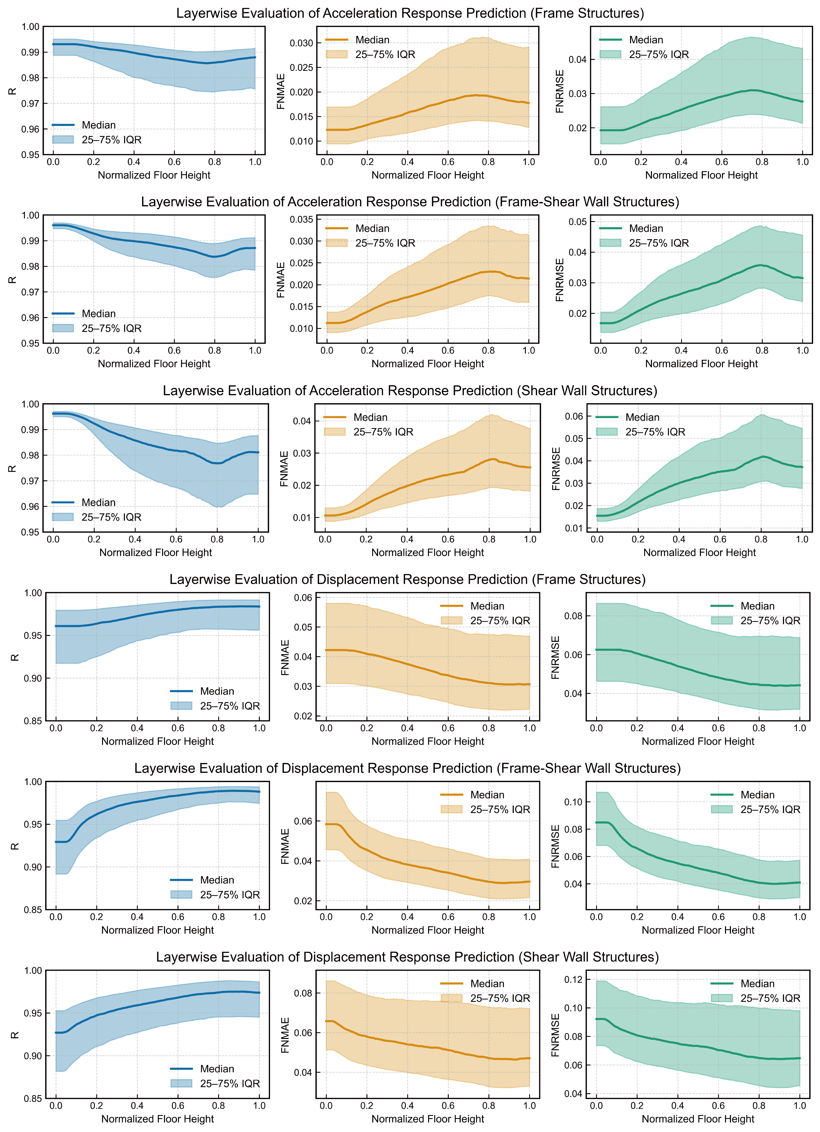
Supplementary Figure 2 | Prediction performance of SeisGPT-Base across relative floor positions in different structural types.

Second, to examine robustness under varying dynamic inputs and structural configurations, detailed time-history comparisons were conducted for a representative subset of buildings. Ten exemplar structures were selected from each typology, encompassing a range of plan geometries, aspect ratios, and stiffness distributions. For each selected building, the predicted and reference acceleration and displacement time histories at the top floor were plotted under diverse ground motions. Visualization results are shown in Supplementary Figure 3, 4, and 5. These comparisons demonstrate that SeisGPT-Base accurately reproduces both amplitude and temporal characteristics of the structural response, including peak accelerations, phase transitions, and damping-related decay.
Together, these results provide compelling evidence that SeisGPT-Base achieves height-invariant accuracy, structural-type generalization, and input-motion robustness, positioning it as a reliable surrogate model for high-resolution structural response prediction under external excitation.

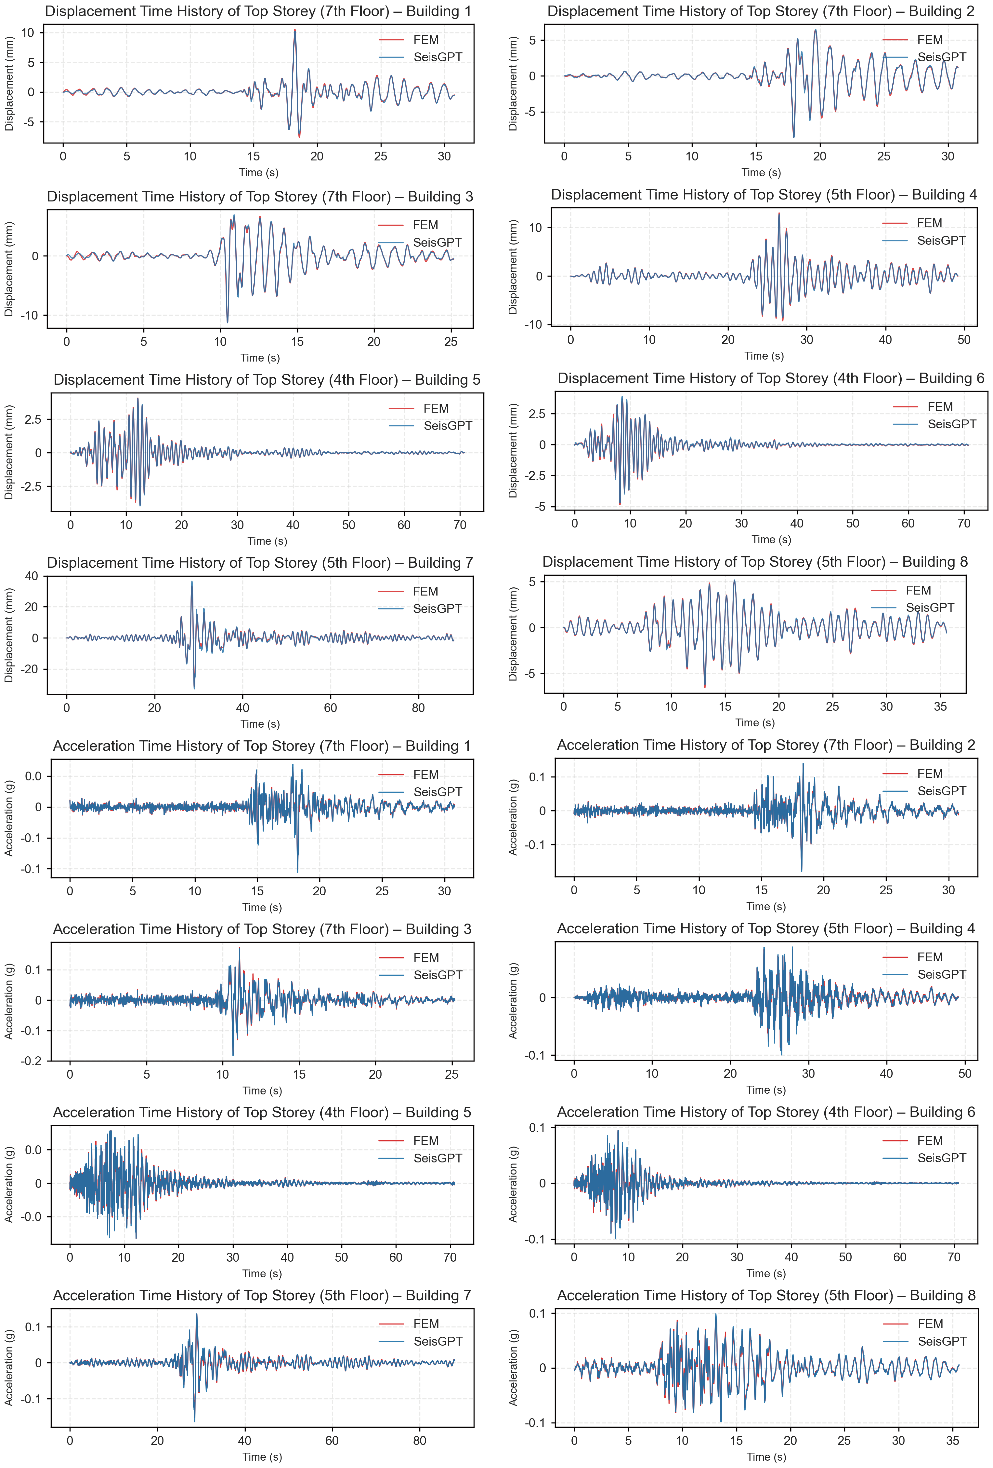
Supplementary Figure 3 | Visualization of top-storey acceleration and displacement responses in frame structures.

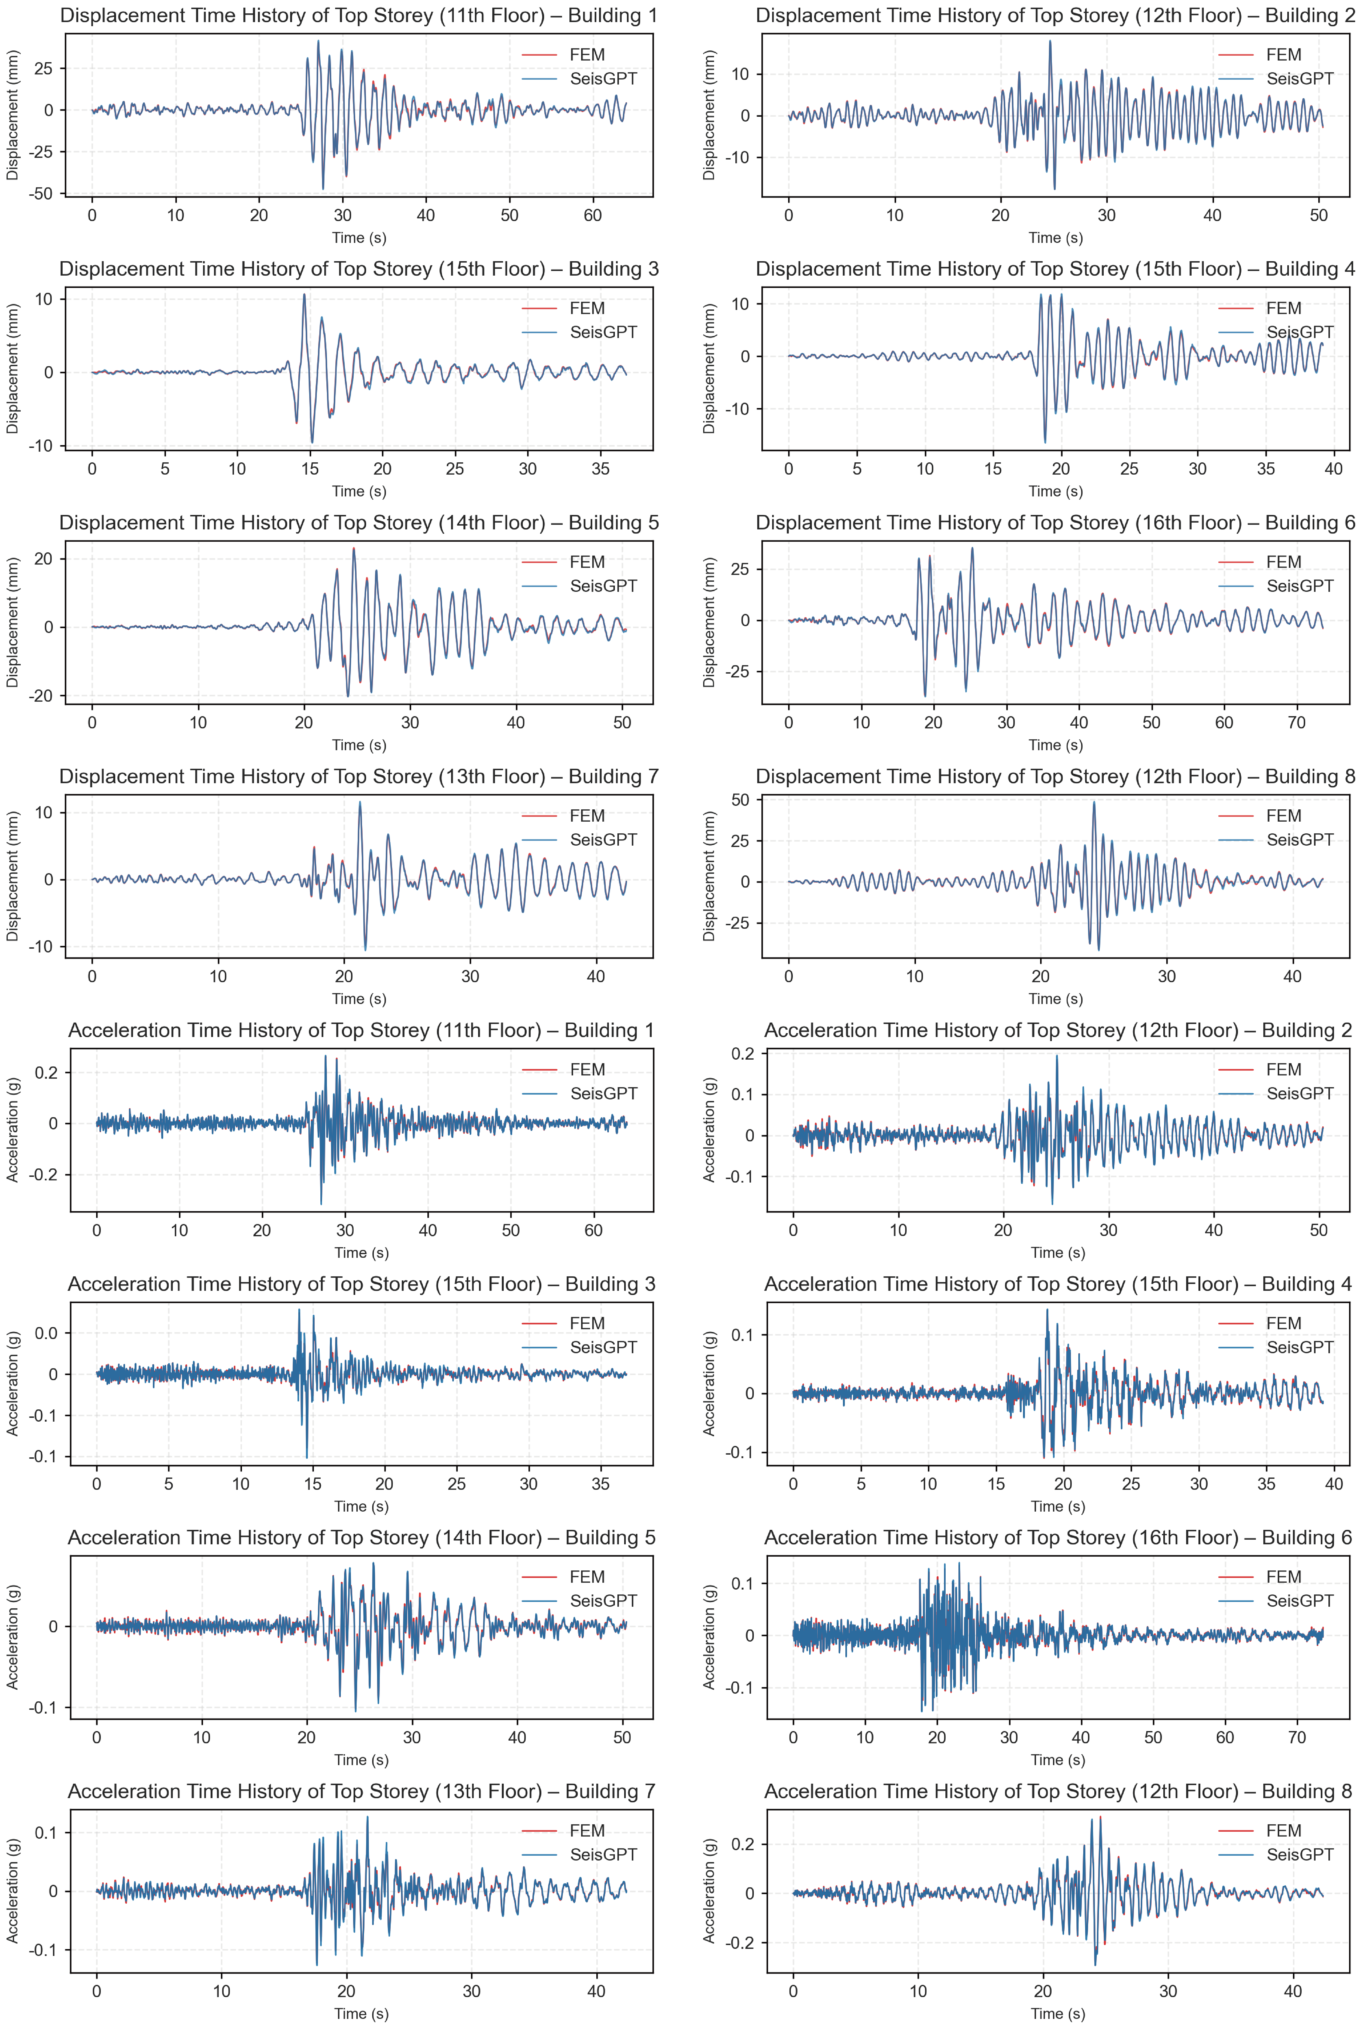
Supplementary Figure 4 | Visualization of top-storey acceleration and displacement responses in frame-shear wall structures.

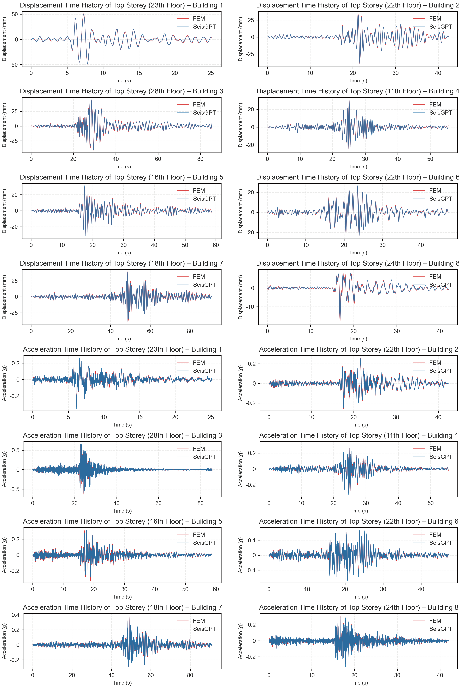
Supplementary Figure 5 | Visualization of top-storey acceleration and displacement responses in shear wall structures.

4.2 Fine-Tuning and Evaluation of SeisGPT-Enhanced on Real-World building structural response dataset
To promote generalization beyond synthetically generated data and enhance applicability to real-world structural monitoring scenarios, the pretrained SeisGPT-Base model was further fine-tuned using a curated dataset comprising nonlinear simulations of 694 as-built buildings. This dataset spans a broad spectrum of structural typologies, geometries, and material characteristics, thereby introducing significantly greater heterogeneity and complexity compared to the synthetic pretraining data.
Fine-tuning was conducted over 10 epochs using the same optimization pipeline as in the pretraining phase. The learning rate was initialized at 1×10⁻⁵ and annealed following a cosine decay schedule, with a warm-up period of 4,000 steps to ensure stable convergence during the early training iterations. Full-parameter fine-tuning was employed, with no use of parameter-efficient techniques such as Low-Rank Adaptation (LoRA), in order to retain the model’s full representational capacity and enable unconstrained adaptation to the statistical properties of real structural responses.
To further assess generalization under varied excitations and structural configurations, a representative subset of 9 real buildings was selected for qualitative analysis. These structures reflect diverse plan geometries, aspect ratios, and dynamic properties. Roof-level acceleration and displacement time histories were visualized and compared against ground-truth simulations. As shown in Supplementary Figure 6, the predicted responses consistently tracked key dynamic features, including peak amplitudes and transient decay patterns, with minimal phase lag—demonstrating strong agreement with the reference data.
These results confirm that SeisGPT-Enhanced effectively captures complex structural dynamics and maintains high predictive accuracy under real-world variability. The model’s demonstrated capability to recover fine-grained response characteristics at critical locations underscores its utility in operational scenarios involving post-earthquake damage screening, rapid prioritization of structural risks, and resilience-informed decision-making.
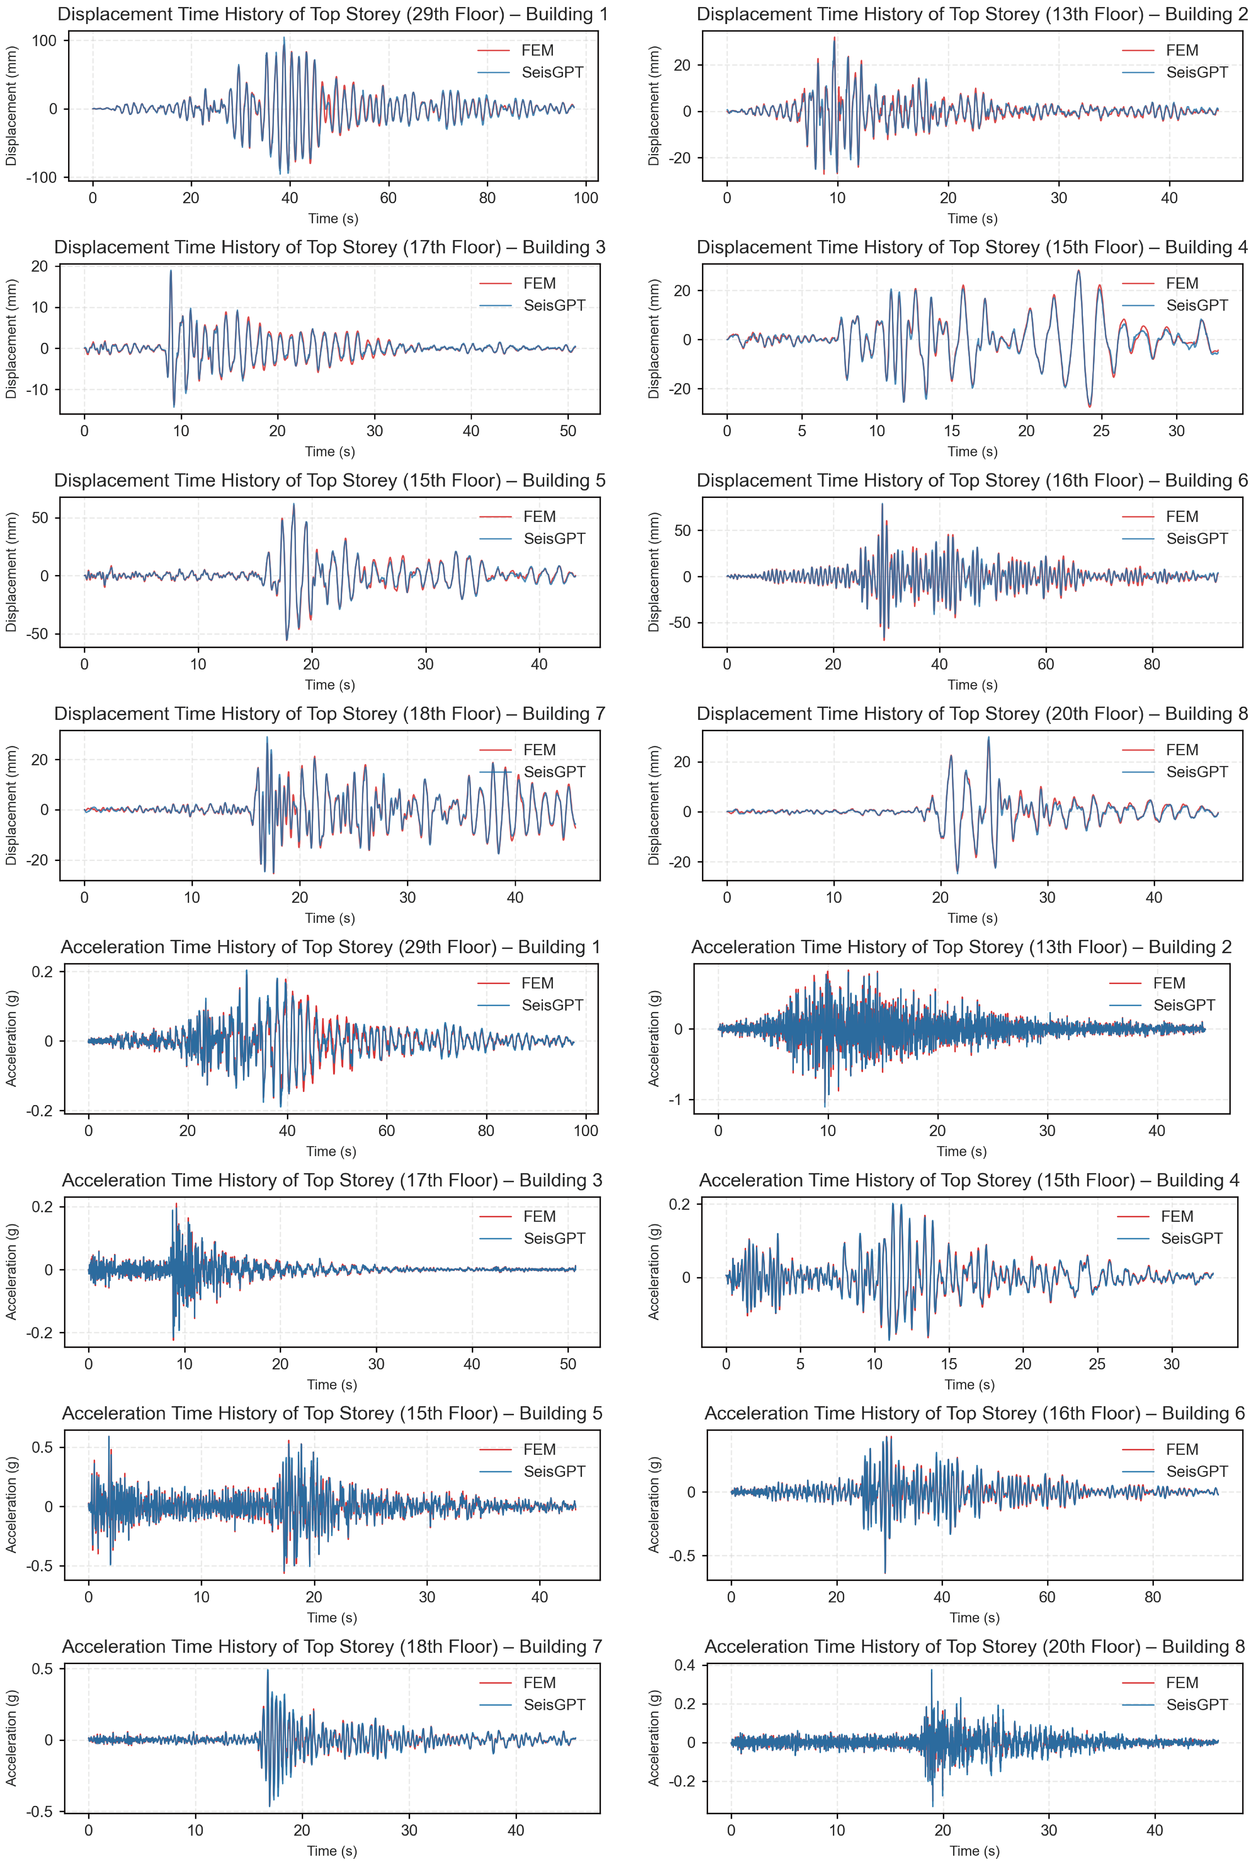
Supplementary Figure 6 | Visualization of top-storey acceleration and displacement responses in real-world structures.

4.3 Effect of Temporal Sequence Lengths on Predictive Performance
To systematically investigate the influence of temporal hyperparameters on predictive performance, a series of controlled ablation studies was conducted, with a specific focus on the lengths of both input and output sequences. These experiments aimed to identify the optimal temporal configuration for time-series forecasting of structural responses subjected to external excitation.
Models were trained and evaluated using varying input sequence lengths $L$ of 50, 100, 500, and 1,000 time steps, and output sequence lengths $P$ of 1, 5, 10, 20, and 50 time steps. All configurations employed the SeisGPT architecture, utilizing the standard two-stage training framework: initial pretraining on the synthetic structural dataset, followed by fine-tuning on the real-world building dataset. The analysis was restricted to the prediction of relative displacement responses to isolate the effects of temporal windowing on structural dynamics forecasting.
The results, summarized in Supplementary Table 2 and Supplementary Table 3, reveal consistent patterns. Increasing $L$ led to marked improvements in model accuracy, reflecting the benefit of extended temporal context for capturing structural memory effects, damping behavior, and multi-modal interactions. Conversely, the relationship between $P$ and predictive performance was non-monotonic. Short forecasting windows constrained temporal continuity and required frequent recursive predictions, which can introduce cumulative errors. Conversely, excessively long output sequences resulted in reduced accuracy due to attention dispersion and the amplification of predictive uncertainty over time. The configuration $L$= 1,000 and $P$= 20 emerged as the optimal setting, striking an effective balance between temporal coverage, model stability, and computational efficiency.
Supplementary Table 2 | Influence of Historical Input Length L on Predictive Performance
L | 50 | 100 | 500 | 1000
R | 0.9235 | 0.9334 | 0.9440 | 0.9435
FNMAE | 0.0711 | 0.0675 | 0.0634 | 0.0633
FNRMSE | 0.0998 | 0.0946 | 0.0882 | 0.0881

Supplementary Table 3 | Influence of output sequence length P on Predictive Performance
P | 1 | 5 | 10 | 20 | 50
R | 0.9291 | 0.9416 | 0.9420 | 0.9435 | 0.9422
FNMAE | 0.0688 | 0.0640 | 0.0635 | 0.0633 | 0.0635
FNRMSE | 0.0963 | 0.0895 | 0.0887 | 0.0881 | 0.0884

5. Details of Shaking Table Testing and Structural Response Reconstruction Using SeisGPT-R
This section presents the experimental validation of SeisGPT-R through a shake table test conducted by the authors, utilizing real sensor data collected from the test structure¹⁸. A scaled physical replica of a real-world reinforced concrete structure was constructed and subjected to controlled seismic excitations and white noise inputs to assess the model’s reconstruction capabilities under realistic dynamic conditions. The experimental setup, instrumentation scheme, input selection, model inference pipeline, and sensor-placement sensitivity analysis are detailed below.

5.1 Experimental Setup and Structural Model
The shake table experiment was conducted using a scaled physical model representing the over-track development situated above the Chisha Depot in Guangzhou, China. The prototype structure comprises a substructure—consisting of a basement and two skirt floors—and a superstructure primarily composed of shear walls, reaching a total height of 131.4 m above ground level, with the substructure accounting for approximately 29.2 m. To achieve mechanical similitude under laboratory conditions, a geometric scaling factor of 1:10 was applied, yielding a model footprint of 6.90 m×9.16 m. The structure was constructed using micro-aggregate concrete, galvanized steel wire mesh, and reinforcing steel to replicate the elastic and inelastic characteristics of the full-scale reinforced concrete system. A strength scaling factor of 1:5 was adopted to maintain consistent force–displacement behavior across scales.
The completed model was mounted on a tri-axial shake table capable of delivering complex multi-directional seismic inputs. Instrumentation was meticulously configured to capture dynamic responses at structurally significant locations: accelerometers and displacement transducers were installed on storeys exhibiting pronounced modal activity and stiffness discontinuities. The sensor arrangement and photographs of the scaled model are provided in Supplementary Figure 7.
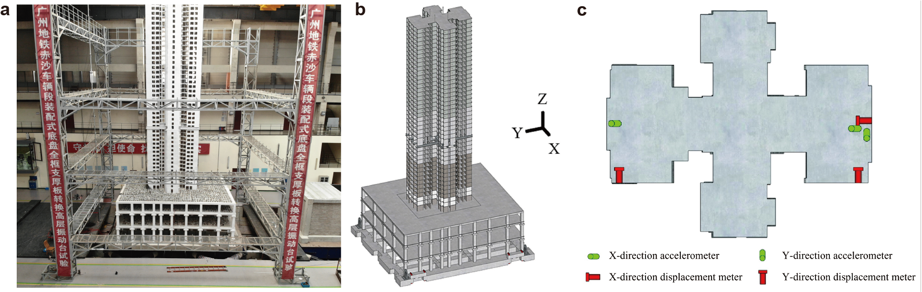
Supplementary Figure 7 | Shaking‑table test model and sensor layout used in the SeisGPT‑R experiment. a, Photograph of the 1:10‑scale physical model. b, Schematic of the 6.90 m × 9.16 m model mounted on the tri‑axial shaking table. Global X, Y and Z axes are indicated. c, Sensor layout.

External dynamic inputs consisted of both recorded and synthetic ground motions selected to span a broad range of intensity levels and spectral characteristics. Four seismic hazard levels were considered: frequent shaking at intensity VII, design-level shaking at intensity VII, rare shaking at intensity VII, and rare shaking at intensity VIII. Three representative waveforms were used as excitation inputs: RSN1164, RSN3942, and a synthetically generated artificial wave (AW). To account for discrepancies between intended waveforms and the actual excitation delivered by the shake table, only the measured acceleration and displacement signals recorded directly at the table platform were used as ground motion inputs for SeisGPT-R inference. In total, ten distinct test scenarios were conducted to evaluate SeisGPT-R’s ability to reconstruct full-structure structural responses using sparse sensor observations.

5.2 Comprehensive Assessment and Visualization of SeisGPT-R Reconstruction Performance
The reconstruction performance of SeisGPT-R was systematically evaluated against two baselines—nonlinear finite element (FEM) simulations and shake table measurements—under realistic sparse-sensing conditions, where only base excitation and mid-height floor sensor data were available. This setup reflects practical deployment scenarios in which dense instrumentation is infeasible, necessitating accurate inference from limited input. Notably, SeisGPT-R successfully inferred full-building responses from mid-height input, underscoring its capacity to model long-range spatiotemporal dependencies. As shown in Figure 5 of the main text, SeisGPT-R consistently outperformed FEM in both temporal and spatial fidelity across all test cases, achieving superior results across all three evaluation metrics, even when compared to extensively tuned FEM models. Notably, while each FEM simulation required one to two days per ground motion due to model complexity, SeisGPT-R achieved comparable or better accuracy in real time—offering prediction speeds over four orders of magnitude faster. This highlights SeisGPT-R’s fundamental advantage: real-time, high-fidelity response reconstruction at a fraction of the computational cost.
Given that the core comparative analysis is already presented in Figure 5, this section emphasizes additional visualizations. Supplementary Figure 8b shows representative top-floor displacement time histories under different ground motion inputs, further illustrating the model’s robustness and effectiveness as a surrogate for full-structure response reconstruction in hybrid digital–physical testing environments.

5.3 Influence of Sensor Placement on Reconstruction Accuracy
A critical factor affecting the performance of data-driven structural response reconstruction in real-world scenarios is the vertical placement of physical sensors. To quantitatively assess the sensitivity of SeisGPT-R to sensor location, a controlled experiment was performed using the shake table test dataset. The position of a single input sensor was systematically varied from the mid-height to the roof level, while all other experimental variables were held constant. Reconstruction performance was evaluated using three metrics—Floor-Normalized Mean Absolute Error (FNMAE), Pearson correlation coefficient (R), and Floor-Normalized Root Mean Squared Error (FNRMSE). The results are presented in Supplementary Figure 8a, with the horizontal axis indicating the relative sensor relative position and the vertical axis showing the corresponding metric values.
The analysis reveals a distinct, nonlinear relationship between sensor elevation and reconstruction fidelity. Contrary to intuitive expectations, sensors placed at the upper storeys—particularly at the roof—exhibited reduced accuracy. This is likely attributable to their limited ability to capture the globally integrated dynamic behavior of the structure. In contrast, mid-height sensors provided more balanced and informative inputs, supporting improved reconstruction of both localized and system-level response characteristics. Optimal accuracy was achieved when the input sensor was placed near the structural mid-height, a location that appears to most effectively encode modal richness and dynamic coupling effects necessary for accurate full-structure inference.
These findings highlight the critical role of sensor positioning in AI-enabled structural monitoring. By exploiting SeisGPT-R’s capacity to generalize from sparse but strategically located observations, high-fidelity reconstructions can be achieved even under stringent instrumentation constraints, offering a practical pathway toward scalable and cost-efficient deployment in structural response assessment.

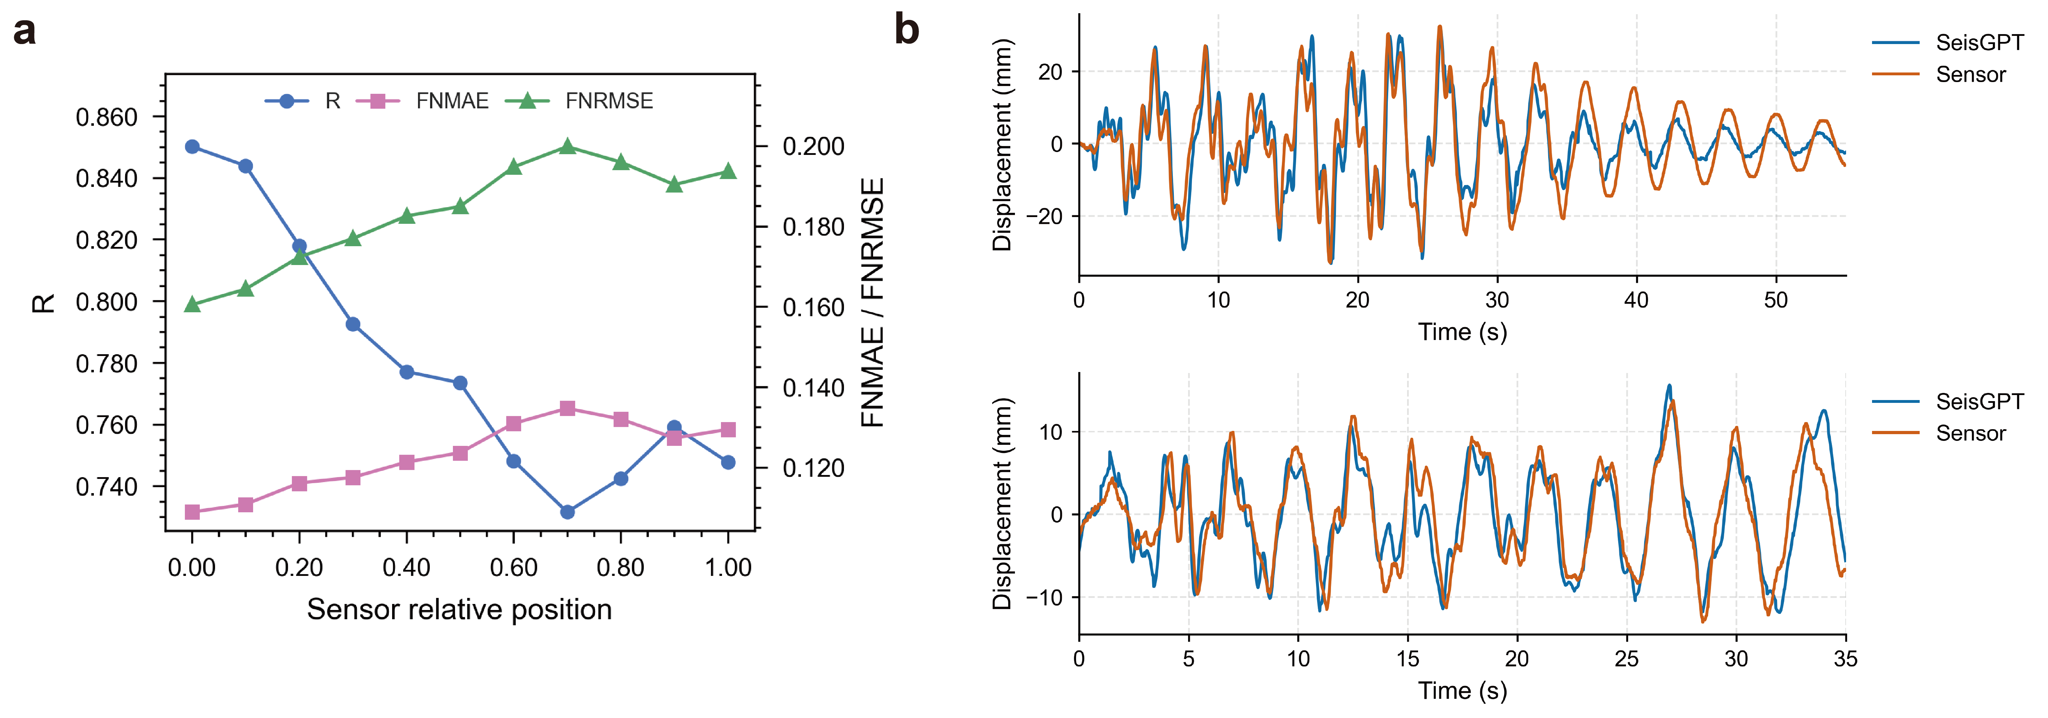
Supplementary Figure 8 | Sensor placement sensitivity and representative reconstruction results of SeisGPT-R. a, Photograph of the 1:10‑scale physical model. b, Schematic of the 6.90 m × 9.16 m model mounted on the tri‑axial shaking table. Global X, Y and Z axes are indicated. c, Sensor layout.

Reference
1 Ministry of Housing and Urban-Rural Development of the People’s Republic of China. Code for Seismic Design of Buildings. GB 50011–2010. Beijing: 2016.
2 Ministry of Housing and Urban-Rural Development of the PRC. Technical Specification for Concrete Structures of Tall Buildings. JGJ 3-2010. Beijing: China Architecture & Building Press, 2010.
3 Liu, X., Gong, C. & Liu, Q. Flow straight and fast: Learning to generate and transfer data with rectified flow. arXiv preprint arXiv:2209.03003 (2022).
4 Su, J. et al. Roformer: Enhanced transformer with rotary position embedding. Neurocomputing 568, 127063 (2024).
5 Radford, A. et al. Learning transferable visual models from natural language supervision. In Proceedings of the International conference on machine learning, 8748-8763 (2021).
6 Raffel, C. et al. Exploring the limits of transfer learning with a unified text-to-text transformer. Journal of machine learning research 21, 1-67 (2020).
7 Shazeer, N. Glu variants improve transformer. arXiv preprint arXiv:2002.05202 (2020).
8 Zhang, B. & Sennrich, R. Root mean square layer normalization. Advances in Neural Information Processing Systems 32 (2019).
9 Zhang, L., Rao, A. & Agrawala, M. Adding conditional control to text-to-image diffusion models. In Proceedings of the the IEEE/CVF international conference on computer vision, 3836-3847 (2023).
10 Martinelli, L., Martinelli, P. & Mulas, M. G. Performance of fiber beam–column elements in the seismic analysis of a lightly reinforced shear wall. Engineering structures 49, 345-359 (2013).
11 Kolozvari, K., López, C. N. & Massone, L. M. Efficient three-dimensional shear-flexure interaction model for reinforced concrete walls. Engineering Structures 294, 116700 (2023).
12 Charney, F. A. Unintended consequences of modeling damping in structures. Journal of structural engineering 134, 581-592 (2008).
13 Ainslie, J. et al. Gqa: Training generalized multi-query transformer models from multi-head checkpoints. arXiv preprint arXiv:2305.13245 (2023).
14 Hu, E. J. et al. Lora: Low-rank adaptation of large language models. ICLR 1, 3 (2022).
15 Loshchilov, I. & Hutter, F. Decoupled weight decay regularization. arXiv preprint arXiv:1711.05101 (2017).
16 Rasley, J., Rajbhandari, S., Ruwase, O. & He, Y. Deepspeed: System optimizations enable training deep learning models with over 100 billion parameters. In Proceedings of the Proceedings of the 26th ACM SIGKDD international conference on knowledge discovery & data mining, 3505-3506 (2020).
17 Rajbhandari, S., Rasley, J., Ruwase, O. & He, Y. Zero: Memory optimizations toward training trillion parameter models. In Proceedings of the SC20: International Conference for High Performance Computing, Networking, Storage and Analysis, 1-16 (2020).
18 Zhou, Y. et al. Seismic performance of a frame‐supported shear wall over‐track building through shaking table test. The Structural Design of Tall and Special Buildings 33, e2098 (2024).

