Results and Discussion
Compression test
Compression tests were utilized to evaluate the materials' mechanical performance under uniaxial compressive force. The primary metrics recorded were compressive strength, maximum displacement, displacement at maximum load, and maximum compressive force. For every test, a load vs. displacement graph was also created in order to analyze the deformation behavior. The behavior of the samples in the compression test are given in the below table – 2.
Table – 2: The results of compression test
PROPERTIES | SAMPLE-1 | SAMPLE-2 | SAMPLE-3
Max Force(kN) | 2.460 | 3.860 | 1.640
Max Displacement(mm) | 4.60 | 12.23 | 6.01
Compressive Strength(MPa) | 15.004 | 22.991 | 9.637
Sample 1 has a moderate strength and a balanced deformation profile. The highest compressive strength and ductility are shown by Sample 2, which may have a denser or better-reinforced matrix, indicating enhanced structural integrity. As Sample 3 has the lowest strength and force capacity, it is the least resistant to compression. Significant variation between samples is revealed by the compression test findings, indicating anomalies in the material's composition or processing. While Sample 3 may benefit from structural modification, Sample 2 shows the best strength and toughness overall. The graphics, which show distinct failure modes and deformation patterns for each sample, support these conclusions. The compression test graph is given below which shows the displacement change with respect to load.
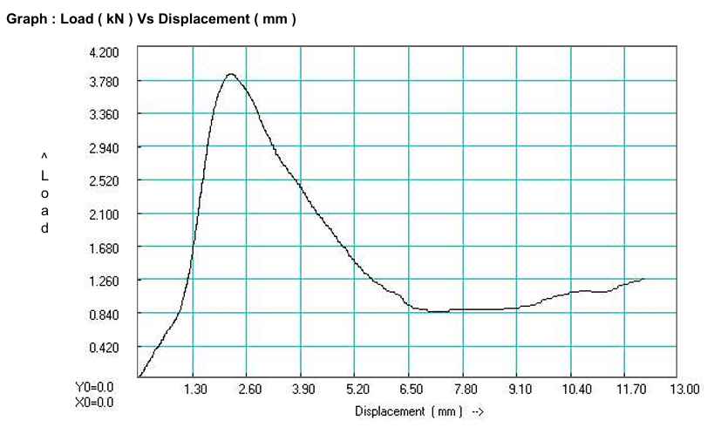
Figure – 3: Compression test graph
Tensile test
The material behaves elastically up to around 3.2 mm of displacement. There is some plastic deformation up to 3.75 mm after that. After 3.75 mm, the material fractures and can no longer support further loads. The 6.04% elongation suggests moderate ductility. A material is deemed relatively weak if its tensile strength is 11.617 MPa; it is most likely a plastic, soft metal, or polymer sample. The load versus displacement graph is shown in the below figure load in kN and displacement in mm.
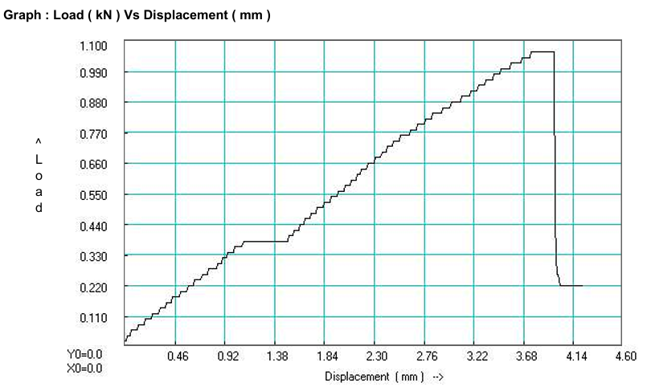
Figure – 4: Tensile test graph
Scanning Electron Microscope (SEM)
- SEM Analysis with magnification x15
Magnification: 15x
Scale Bar: 2 mm
Voltage: 5 kV
The image's internal structure is highly porous, fibrous, and vertically orientated. Anisotropic orientation, which is characterized by the clear presence of layered and channel-like structures, occurs when the material is more ordered in one direction. The fibers may aid in ventilation, fluid transfer, or mechanical strength along a single axis due to their apparent length and connection. Surface imperfections and rough textures indicate a naturally occurring or less processed product that is most likely plant-based. The general morphology points to potential uses in bio-scaffold structures, filtration, absorption materials, and insulating or cushioning applications. The SEM analysis of material with magnification of 15x is shown in given figure.
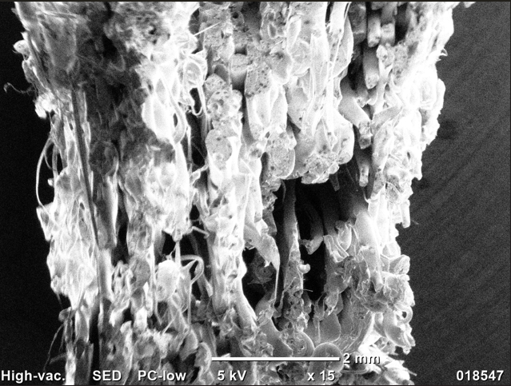
Figure – 5: SEM analysis with 15x
- SEM Analysis with magnification x50
Magnification: 50x
Scale Bar: 500 µm
Voltage: 5 kV
At a 50x magnification, the SEM picture reveals a distinctly porous and fibrous structure. The material is composed of vertically aligned tubular components with partially collapsed and wrinkled walls. The internal anatomy shows large gaps and open channels of varying sizes and forms. The uneven surface roughness increases the possibility of a natural origin or post-processing effects, like mechanical or thermal treatment. The sample is characterized by an uneven surface, aligned channels, and a fibrous, highly porous structure. These characteristics point to a lightweight material with remarkable permeability and possible uses in filtering media, thermal or acoustic insulation, bio-scaffolding for tissue design, and naturally decomposing plant-based materials or composites.

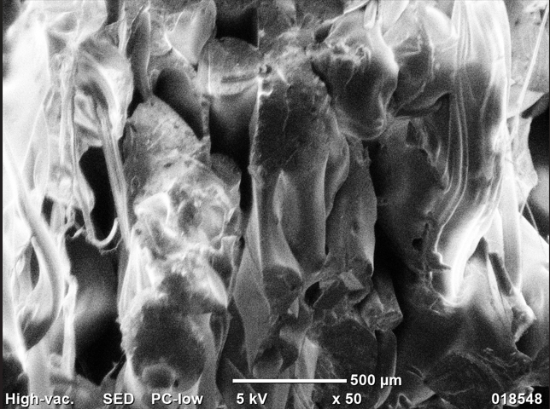
Figure - 6: SEM analysis with 50x
- SEM Analysis with magnification x75
Magnification: 75x
Scale Bar: 200 µm
Voltage: 5 kV
The fibrous structure that is visible at lower magnification is more distinct at 75x magnification. The picture displays asymmetrical bundles with numerous folds and overlapping layers. There are densified or compressed zones in some areas, which could be the result of heat or mechanical stress. Because of its interconnected pores and distinct textural diversity, the entire pattern seems to be hierarchically ordered. the existence of a fibrous network that is intricately linked. The idea that the material is bio-based or biodegradable is supported by the extra information, which demonstrates indications of structural deformation and potential natural variety. Its potential for fluid transport and absorption, machine packing or cushioning, and scaffold functions in biological applications is increased by this degree of porosity and structural complexity.

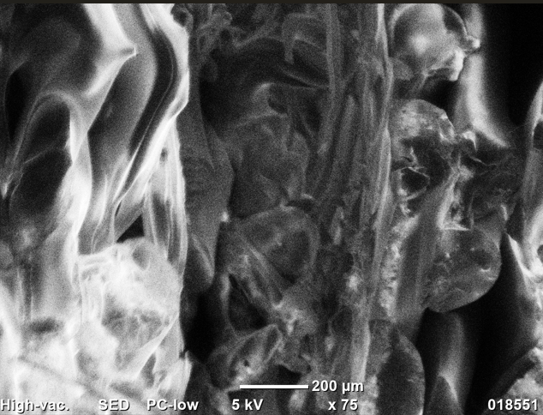
Figure – 7: SEM analysis with 75x
- SEM Analysis with magnification x150
Magnification: 150x
Scale Bar: 200 µm
Voltage: 5 kV
The SEM image displays the finer details of the material's microstructure at a magnification of 150x. It is easy to see thin, sheet-like fiber constituents with folded and wrinkled surfaces. Dehydration or processing-related mechanical forces are most likely the cause of the microcracks and delamination seen in some sections. The fiber walls' elastic, soft appearance betrays their flexibility and compressibility. Microstructural elements like wall wrinkling, thin films, and localized deformation are highlighted in the image at 150x magnification. These results imply that the material's mechanical flexibility and surface-area-to-volume ratio are high. Applications involving filtration and adsorption benefit from these properties. Biodegradable and flexible composites that can be utilized in membrane structures, foams, and cushions.

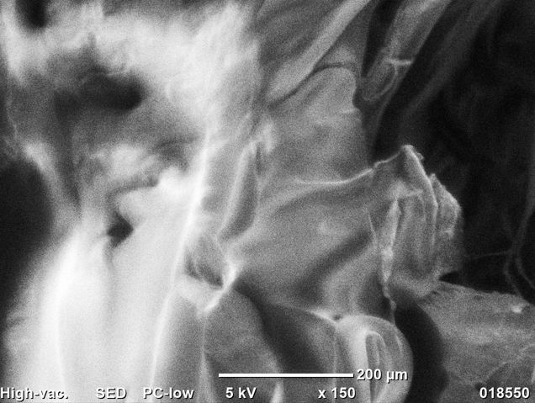
Figure – 8: SEM analysis with 150x
Energy Dispersive X-ray Spectroscopy (EDS)
To verify the elemental composition of the produced PLA-Chitosan nanocomposite suture anchor, EDS analysis was performed on a selected sample area using JEOL JCM-6000PLUS SEM/EDS equipment. An accelerating voltage of 15 kV and a real-time acquisition of 20.44 seconds were used for the analysis. In accordance with the organic nature of PLA and chitosan, the EDS spectrum showed the existence of several elements, with carbon (C) being the predominant component at 97.12 weight percent. The predicted structure of chitosan, which has hydroxyl and amino groups, and polylactic acid, which contains ester groups, was further supported by the notable presence of oxygen (1.38 weight percent).

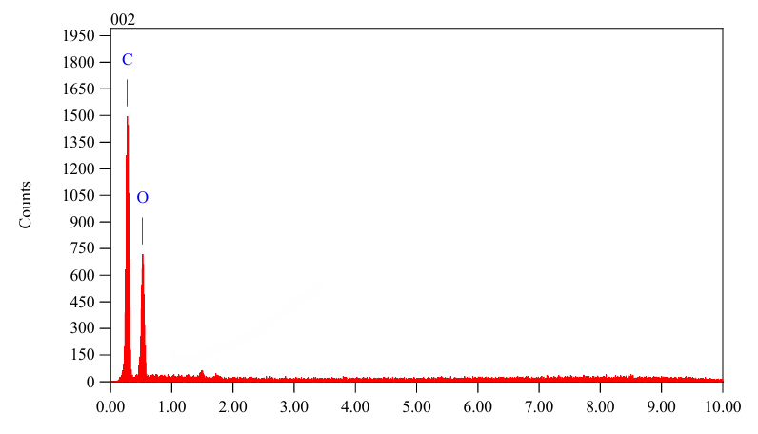
Figure – 9: Composition of material with EDS
The 3D printed PLA and chitosan nanoparticles (CNP) composite's mechanical evaluation revealed significant variations in the tested samples' compressive strengths, ranging from 9.637 MPa to 22.991 MPa. With a strength of 22.991 MPa, the sample with the highest strength demonstrated enhanced structural stability, indicating strong interfacial adhesion between the filler and matrix and efficient nanoparticle dispersion. A considerable degree of ductility and elasticity was shown by the tensile testing, which showed a peak strength of 11.617 MPa with an elongation of 6.04%. Failure occurred at 3.75 mm. Its promise for short-term orthopedic applications where flexibility and biodegradability are required was demonstrated by the composite material's elastic response up to about 3.2 mm, after which it started to show plastic deformation.
Through morphological analysis using Scanning Electron Microscopy (SEM) at different magnifications, a layered and fibrous structure with directed pores and visible connections characteristic of Fused Deposition Modeling (FDM) printed materials was revealed. Microstructural features that are advantageous for biological integration and tissue ingrowth, such as delamination, wrinkled fiber walls, and porous channels, were visible at higher magnifications. The elemental composition was determined to be mostly made up of carbon (97.12 weight percent) and oxygen (1.38 weight percent) by EDS, which is in line with the organic qualities of PLA and chitosan. Overall, the composite's favorable mechanical properties, biocompatible structure, and consistent elemental purity supported its potential application as a bioresorbable suture anchor.

