Supplementary Material
Diversified crop rotations enhance groundwater and economic sustainability of food production
Xiaolin Yang^{1*}, Tammo S. Steenhuis², Kyle Frankel Davis^{3,4},Wopke van der Werf⁵, Coen J. Ritsema⁶, Yuanquan Chen¹, Steven Pacenka², Fusuo Zhang^{7*}, Kadambot H.M Siddique⁸
1. College of Agronomy and Biotechnology, China Agricultural University, Beijing, 100193, People’s Republic of China
2. Department of Biological and Environmental Engineering, Riley-Robb Hall, Cornell University, Ithaca, NY, 14853, United States of America
3. Department of Geography and Spatial Sciences, University of Delaware, Newark, DE 19716 USA
4. Department of Plant and Soil Sciences, University of Delaware, Newark, DE 19716 USA
5. Crop Systems Analysis Group, Wageningen University, Wageningen, 6700AA, The Netherlands.
6. Soil Physics and Land Management Group, Wageningen University, Wageningen, 6700AA, the Netherlands
7. College of Resources and Environmental Science, National Academy of Agriculture Green Development, China Agricultural University, Beijing, 100193, People’s Republic of China
8. The UWA Institute of Agriculture, The University of Western Australia, Perth WA, 6001, Australia
* Corresponding authors:
Xiaolin Yang, phone: +86 10 62731436 Fax: +86 10 62731436; E-mail: yangxiaolin429@cau.edu.cn
Fusuo Zhang, phone: +86 10 62732499 Fax: +86 10 62732499; E-mail: zhangfs@cau.edu.cn
Contents
Supplementary Results
Table S1 Database of diversified crop rotations, including cropping index and water consumption indicators, in the North China Plain.
Table S2 China’s Consumer Price Index (CPI) from 1990–2018.
Table S3 Crop prices (2000–2018) in China.
Table S4 Analysis of variance of yield and economic output of eight grain-based crop rotations.
Table S5 Analysis of variance of economic output and EWUE of 31 crop rotations (P<0.05).
Table S6 Factor loadings in the principal component analysis (PCA).
Figure S1 Yearly variation in crop yield (a) and crop planting area (b) in the North China Plain from 1980–2018.
Figure S2 Annual variation in the distribution of crop yield in the North China Plain from 1985–2018. The number before comma is the absolute value of yield of each crop (unit is 10⁴ t), the number after comma is the percentage of yield of each crop accounted for the total yield.
Figure S3 Annual variation in the distribution of crop planting area in the North China Plain from 1985–2018. The number before comma is the absolute value of crop planting area of each crop (unit is 10³ ha), the number after comma is the percentage of crop planting area of each crop accounted for the total planting area.
Figure S4 Average monthly precipitation and temperature from 1965–2018 from 58 standard meteorological stations in the North China Plain.
Figure S5 Surface water (a) and groundwater resources (b) in the North China Plain (NCP) relative to China.
Figure S6 Classification of annual evapotranspiration in diversified crop rotations in the North China Plain. WS is winter wheat–summer maize double cropping system, Cont is single-crop species continuous cropping, percentage on the y-axis is the proportion of the 31 cropping systems, CI is cropping index.
Figure S7 Relationship between cropping index and groundwater table change in diversified crop rotations in the North China Plain. Blue dots are irrigation measurements and exclude the rainfed condition. The cropping index in each cropping system is the number of harvests divided by rotation years.
Figure S8 Classification of the 31 diversified crop rotations in the North China Plain based on economic output and EWUE. Ews is economic output (Yuan ha^{–1}) of WS rotation, EWUEws is economic water use efficiency (Yuan m^{–3}) of WS rotation, ‘>’ means the value increased relative to the WS rotation, ‘<’ means the value decreased relative to the WS rotation, WS is winter wheat–summer maize double cropping system, WW is winter wheat, percentage on y-axis is the proportion of cropping systems in each column of the 31 cropping systems.
Figure S9 Correlation matrix of associations between food production and groundwater use in crop rotation systems. The number values in the grid are the correlation coefficients.

Supplementary Results

Water consumption (ET_{a}) of diversified crop rotations
The conventional wheat-maize (WS) double cropping system had an average annual ET_{a} during the growing season of 733 mm across all years, crops, and sites (Fig. 3, Table S1). Seven crop alternative rotations had equal or greater ET_{a} than WS. All of which, including WS, had intensive double-cropping each year without fallow periods. A ryegrass–sorghum rotation for livestock forage produced more aboveground biomass than WS in a six-year field experiment⁷, at similar ET_{a} (730 mm) and similar irrigation (375 mm), with 416 mm rainfall (Table S1). Five winter wheat-based double-crop rotations^{2,6,8} had equal or greater ET_{a} (730–823 mm) than conventional WS. One spring maize-based rotation (spinach–spring maize) had an average ET_{a} of 743 mm in a three-year field experiment³ (Fig. 3). Supplementary Table S1 details the irrigation and rainfall information.
Single cropping (rainfed or irrigated) and perennial crops had ET_{a} values 21–54% below that of WS. Three rainfed continuous cropping systems with a cropping index of one had ET_{a} values <400 mm, half that of conventional WS: spring maize⁹⁻¹¹, spring peanut, and spring soybean² (Fig. 3). The ET_{a} of a rainfed WS in a 7-year field experiment was 460 mm⁹. The ET_{a} of perennial crops and single continuous cropping systems based on one crop per year under irrigation were all <600 mm. The ET_{a} of perennial crops—alfalfa for livestock^{2,6} and switchgrass for bioenergy¹²—were 488 mm and 504 mm, respectively. The ET_{a} of single continuous cropping with irrigation, including winter wheat, cotton, or spring maize, ranged from 518–576 mm. Thus, reduction in ET_{a} can be achieved by recuing water input with irrigation and reducing cropping index.
The multiple WS-based rotations (sweet potato→cotton→sweet potato→WS with five harvests in four years, and ryegrass–cotton→peanut→WS with five harvests in three years, both over a 12-year field experiment⁴, and modeled spring maize→spring maize→WS¹³) had ET_{a} 12-23% below that of WS. Five WS-based rotations with three harvests in two years had ET_{a} 10–28% below WS (Fig. 3). The grain-based rotation of spring maize→WS, which has received much attention in the last decade, had an average ET_{a} of 547 mm across three experimental stations in Luancheng, Quzhou, and Wuqiao^{8,10,14}.
The intensive double-cropping systems (ryegrass–spring maize, ryegrass–cotton, ryegrass–sorghum→WS, and spring maize–summer maize dual cropping) had similar ET_{a} values to WS, ranging from 694–705 mm (Fig. 3).
In summary, ET_{a} was reduced by 10–54% in a variety of cropping systems, comprising WS-based multiple cropping systems with a rotation cycle of two years or longer, single-crop species continuous cropping, and perennial crops, relative to conventional WS (Fig. 3; Fig. S6). The inset of Fig. 3 shows a negative correlation between cropping index and ET_{a}, indicating that a lower cropping index is associated with lower annual water consumption and implying that introducing a fallow period each year into intensive double-crop rotations in NCP will reduce annual ET_{a}.

Effect of diversified crop rotations on the groundwater table
The annual groundwater table change of 31 crop rotations ranged from +0.43 to –1.3 m yr^{–1} (Fig. 4). Almost 90% of these rotations exhibited a smaller groundwater table decline than conventional wheat-maize. Three single continuous cropping systems (rainfed) with one harvest per year raised the groundwater table by +0.13 to +0.43 m yr^{–1}. Nearly half of the 31 crop rotations reduced the groundwater table decline rate by 50%, achieving –0.31 to –0.52 m yr^{–1}, against –1.04 m yr^{–1} in conventional wheat-maize (Fig. 4).
The rainfed wheat-maize rotation in Fig. 4 showed a neutral groundwater table change, as reported in a 7-year field experiment at Luancheng (averaging 454 mm annual rainfall)⁹. An APSIM simulation of rainfed wheat-maize using 1982–2013 meteorological data yielded a groundwater increase of +0.05 m yr^{–115}. In another APSIM study, a rainfed wheat-maize double cropping continuous cultivation system with 50% and 100% plastic film mulching between 1961 and 2011 in Hebei Province simulated a groundwater table rise of +0.30 to +0.40 m yr^{-1Ref16}. However, the rainfed wheat-maize yielded 44% less grain than irrigated WS¹⁶. Simulated single continuous summer maize^{6,17} and spring maize→spring maize→wheat-maize rotation¹³ with 580 mm rainfall and normal irrigation resulted in a negligible groundwater table change of –0.05 to –0.07 m yr^{–1}.
Conventional wheat-maize with 470 mm rainfall and 330 mm irrigation had an average groundwater table decline of –1.04 m yr^{–1} (Fig. 4)—this value combines our 12-year field experiment⁴ with three years in Luancheng¹⁸, two years in Wuqiao¹⁹, and two years in Quzhou²⁰—which is similar to modeling results of –1.13 to –1.60 m yr^{–1} over various period^{15-17,21,22}.
Three single continuous cropping systems—spring maize, spring peanut, and spring soybean—with precipitation of 430 mm per growing season—caused the groundwater table to rise. Three other single continuous cropping systems—winter wheat, cotton, and spring maize (all irrigated)—had groundwater table change of –0.23 to –0.27 m yr^{–1}, or at least 76% better than conventional wheat-maize (Fig. 4).
Given NCP’s abundant 4500–5300°C days of accumulated growing season temperatures, intensive double-cropping of wheat-maize has dominated this area over the past 40 years, with its higher grain production for food security, but at the expense of groundwater²³. While single cropping systems per year mitigate groundwater table decline, they do not capitalize on the region’s ample light and heat resources for crop production²³. Thus, water-saving crop rotations with a cropping index between 1.25 and 2 should be favored for sustainable groundwater use (Fig. S7). The introduction of more profitable crops and a fallow period into the conventional wheat-maize rotation offers a trade-off for groundwater and grain security.

Yield, WUE, economic output, and EWUE of diversified crop rotations
Grain-based crop rotations
Annual grain yields and WUE values (Fig.5a), and annual economic output (inflation-adjusted Yuan ha⁻¹) and economic water use efficiency (EWUE) (Yuan m⁻³ of evapotranspiration) (Fig. 5b) of eight grain-based rotations provide useful insights to crop output. The annual grain yield and WUE of conventional wheat-maize were 14.1 t ha^{–1} and 1.95 kg m^{–3}, with annual economic output and EWUE of 8.0×10³ Yuan ha^{–1} and 1.13 Yuan m^{–3} (Fig. 5a, b).
Only the spring maize–summer maize dual rotation per year produced higher annual grain yields (15.9 t ha^{–1}, 12% more) than conventional wheat-maize (P>0.05) (Table S4) because spring maize produced 50% more grain yield than winter wheat^{24,25}. The higher photosynthesis and stomatal resistance of spring maize (C4 crop) than winter wheat (C3 crop) ensure higher use-efficiencies of light, water, and nitrogen¹⁵. The spring maize–summer maize rotation had 24% higher WUE than conventional wheat-maize (Fig. 5a). Winter wheat needs 225 mm irrigation during the dry growing season which is 33% more than spring maize⁷.
Meanwhile, the spring maize–summer maize rotation had 27% significantly higher economic output (P<0.05) and 38% higher WUE than conventional wheat-maize. The water needs of spring maize and summer maize almost matched the growing season rainfall in this region, saving ~75 mm of irrigation over winter wheat in wheat-maize, and decreasing seasonal ET_{a}. Although the dual maize rotation performed better than wheat-maize for yield and economic output, the need for sufficient heat resources, suitable varieties, and matched harvest times limit its adaptability and generalization in much of the NCP.
The spring maize–summer maize rotation had higher grain yield, WUE, economic output, and EWUE than conventional wheat-maize. But this cropping system requires high accumulated temperatures, heat resources for grain filling, and an early maturing spring maize variety, which primarily occurs and is limited in the southern Hebei Province²⁴. Expanding this system northward would require adaptations to sowing date, plant density, and variety²⁵. Besides, omitting winter wheat in this double maize rotation would impact national self-sufficiency in the diet²⁶. Wheat production is crucial for NCP and China diets, whereas maize is mainly used for livestock feed¹². The dual maize rotation increases the maize planting frequency, which forces much better coordination between crops and livestock to harvest for silage in spring and grain in summer¹². Double maize is an unlikely candidate for a new dominant cropping system for the whole NCP.
The spring maize→wheat-maize rotation (three harvests in two years) produced 25% lower grain yields (10.6 t ha^{–1}) and 16% lower annual economic output than conventional wheat-maize (P<0.05). Despite a 25% reduction in grain yield and 16% reduction in economic output due to reduced planting frequency of winter wheat once every two years, the spring maize→wheat-maize rotation had similar WUE and EWUE to conventional WS, reducing ET_{a} by 20% (Fig. 3) and mitigating 61% of groundwater table decline (Fig. 4). This rotation by retaining winter wheat has more promise for saving groundwater and diet sufficiency than the double maize rotation; it is worth considering the spring maize→wheat-maize rotation as superior to wheat-maize for the future.
The other five grain-based cropping systems—wheat-maize rainfed, spring maize rainfed and three single continuous croppings of spring maize, summer maize, and winter wheat—had 36–57% lower yields and 44–63% lower economic outputs than conventional wheat-maize (P<0.05), with no significant differences in WUE and EWUE (Table S4). WS rainfed saved ~300 mm of irrigation water but produced 40% lower grain yield, 54% lower economic output and 7% lower WUE, and 34% lower EWUE than wheat-maize with irrigation at 300–330 mm yr⁻¹ (P<0.05)^{4,7,10,20}. Continuous winter wheat had the lowest yield, economic output, and WUE, followed by continuous spring maize rainfed, wheat-maize rainfed, and continuous summer maize. Continuous summer maize had 8% higher WUE and similar EWUE compared to wheat-maize (Fig. 5a, b).
Single cropping systems performed better than conventional wheat-maize for mitigating groundwater table decline, but soil water evaporates unproductively and agriculturally favored light and heat resources are wasted during a long fallow period each year. Single cropping systems produced 36-70% lower net economic outputs per year than conventional wheat-maize.
Other diversified crop rotations
The 31 diversified crop rotations included crops from different families and genera, with different purposes and values, thus yields and derived WUE are not additive or comparable except within the grain group. Economic output and EWUE could be expressed for all rotations (Fig. 6).
Half of the diversified crop rotations had higher annual averaged economic outputs than conventional wheat-maize (8.0×10³ Yuan ha^{–1}). The sweet potato→cotton→sweet potato→wheat-maize rotation, with five harvests in four years, had the highest economic output (19.5 ×10³ Yuan ha^{–1}) and EWUE (4.22 Yuan m^{–3}), being 1.4 and 2.7 times significantly higher, respectively, than WS (P<0.05) (Table S5). The spinach–spring maize, ryegrass–cotton and ryegrass–cotton→peanut→WS rotations produced 58–77% higher economic outputs than wheat-maize. Spinach (an edible vegetable) and cotton (cash crop), both have higher prices and economic outputs than winter wheat and maize, which contributed strongly to the economic output of their rotations^{4,27}. The EWUEs of the above crop rotations were at least 69% higher than wheat-maize.
The spring peanut→wheat-maize rotation, continuous cotton, and spring cotton→wheat-maize rotation had 21–31% higher economic outputs, due to the higher prices for peanut and cotton⁴, and 52–89% higher EWUE than wheat-maize. Two sorghum-containing rotations surpassed the economic output of WS by 11–19% because sorghum (bioenergy crop) was harvested for its entire aboveground biomass (44.6 t ha^{–1}), aiding the 32–52% higher EWUE than wheat-maize.
The winter wheat-based double-cropping systems per year—with summer cotton, peanut, soybean, or sweet potato—had similar economic outputs (7.6–8.4 ×10³ Yuan ha^{–1}) to wheat-maize but 16–35% lower EWUE values due to their higher water use. This demonstrates that retaining winter wheat in a double-crop rotation each year in the NCP does not balance economic outputs with groundwater sustainability. In contrast, the wheat-maize–based multiple crop rotations with three harvests in two years (spring soybean→wheat-maize rotation and sweet potato→wheat-maize rotation) had similar economic outputs (7.5–7.9×10³ Yuan ha^{–1}) to WS, but 40–61% higher EWUE. The ryegrass–spring maize double rotation had a similar economic output and EWUE to wheat-maize.
Rotations with perennial crops—alfalfa and switchgrass—and single continuous cropping per year in rainfed conditions—spring peanut and spring soybean—had 36–70% lower annual economic outputs and 17–61% lower EWUE than conventional wheat-maize, indicating that these rotations would not be good future options.
In summary, multiple cropping systems with more than three harvests in two years—for example, five harvests in four years or four harvests in three years—and intensive non-winter wheat-based double-cropping in one year increased annual averaged economic outputs and EWUEs by at least 11% and 3%, respectively, relative to conventional wheat-maize. The wheat-maize-based diversified crop rotations with three harvests in two years increased annual average EWUE by at least 40% and economic output by 13%. Winter wheat-based double-cropping systems in one year had a similar economic output to conventional WS but a 26% lower EWUE. The perennial crop and single and rainfed cropping systems had no advantage in economic output over conventional wheat-maize (Fig. 6; Fig. S8). Therefore, wheat-maize -based multiple crop systems involving cash crops (cotton, peanut, sweet potato, and soybean) had better economic outputs and EWUEs, also bringing more product diversity than conventional wheat-maize. Future development of more efficient, groundwater-sustainable cropping systems should consider historical patterns of land use, cropping intensity, and irrigation practices.

Table S1 Database of diversified crop rotations, including cropping index and water consumption indicators, in the North China Plain.
No. | Crop rotations | Cycle year | Cropping index | Groundwater  table change (m yr^{–1}) | ET_{a}  (mm) | Irrigation  (mm) | Rainfall  (mm)
1 | Ryegrass–sorghum | Two harvests one year | 2 | –1.30 | 730 | 375 | 416
2 | Ryegrass–sorghum →WS | Four harvests two years | 2 | –1.17 | 694 | 353 | 416
3 | Winter wheat–summer maize (WS) | Two harvests one year | 2 | –1.04 | 733 | 330 | 470
4 | Winter wheat–summer cotton | Two harvests one year | 2 | –0.94 | 829 | 340 | 505
5 | Ryegrass–cotton→ peanut →WS | Five harvests three yeas | 1.67 | –0.84 | 647 | 285 | 415
6 | Spring maize–summer maize | Two harvests one year | 2 | –0.72 | 702 | 241 | 503
7 | Winter wheat–summer soybean | Two harvests one year | 2 | –0.52 | 730 | 213 | 480
8 | Winter wheat–sweet potato | Two harvests one year | 2 | –0.51 | 748 | 235 | 505
9 | Winter wheat–summer cotton→spring maize | Three harvests two years | 1.5 | –0.50 | 679 | 233 | 468
10 | Ryegrass–cotton | Two harvests one year | 2 | –0.43 | 705 | 225 | 553
11 | Ryegrass–spring maize | Two harvests one year | 2 | –0.42 | 705 | 222 | 460
12 | Spring cotton→WS | Three harvests two years | 1.5 | –0.42 | 661 | 278 | 525
13 | Spring peanut→WS | Three harvests two years | 1.5 | –0.42 | 591 | 203 | 490
14 | Spring maize→WS | Three harvests two years | 1.5 | –0.41 | 547 | 198 | 443
15 | Sweet potato →cotton →sweet potato →WS | Five harvests four years | 1.25 | –0.40 | 561 | 214 | 399
16 | Switchgrass | Perennial | Perennial | –0.40 | 504 | 150 | 416
17 | Sweet potato→WS | Three harvests two years | 1.5 | –0.40 | 561 | 240 | 363
18 | Spinach–spring maize | Two harvests one year | 2 | –0.36 | 743 | 205 | 460
19 | Spring soybean→WS | Three harvests two years | 1.5 | –0.34 | 525 | 206 | 415
20 | Alfalfa | Perennial | Perennial | –0.33 | 488 | 99 | 548
21 | Winter wheat–summer peanut | Two harvests one year | 2 | –0.32 | 803 | 222 | 586
22 | Cont winter wheat | One harvest one year | 1 | –0.27 | 533 | 233 | 278
23 | Cont cotton | One harvest one year | 1 | –0.27 | 576 | 180 | 496
24 | Cont spring maize | One harvest one year | 1 | –0.24 | 518 | 161 | 402
25 | Winter wheat-summer millet | Two harvests one year | 2 | –0.23 | 753 | 205 | 548
26 | Spring maize →spring maize →WS | Four harvests three years | 1.33 | –0.07 | 597 | 210 | 513
27 | Cont summer maize | One harvest one year | 1 | –0.05 | 393 | 131 | 345
28 | WS rainfed | Two harvests one year | 2 | 0.01 | 460 | 0 | 454
29 | Cont spring maize rainfed | One harvest one year | 1 | 0.13 | 364 | 0 | 428
30 | Cont spring peanut rainfed | One harvest one year | 1 | 0.43 | 333 | 0 | 430
31 | Cont spring soybean rainfed | One harvest one year | 1 | 0.43 | 343 | 0 | 430

Note: WS: winter wheat–summer maize rotation; Cont: single-crop species continuous cropping system; Cropping index is the number of harvests over the whole duration of a rotation divided by the number of years in the rotation;
Groundwater table change is the average annual value (m yr^{–1}), negative values mean groundwater table decline, positive values mean groundwater table increase.
ET_{a}, irrigation and rainfall are annual average values in the growing season (mm/growing season).The detailed datasets generated and analyzed in the current study are available from the corresponding author on request.
Abbreviations:
ET_{a}: actual evapotranspiration; WUE: water use efficiency, expressed as yield per unit of evapotranspiration; EWUE: economic water use efficiency, expressed as economic output per unit of evapotranspiration; WS: winter wheat–summer maize double-cropping system; Conventional WS: winter wheat–summer maize double-cropping system at normal irrigation measurement; Symbol ‘–’ in cropping systems: two crops within one year; Symbol ‘→’：two crops across two years, such as spring maize→WS rotation denotes three harvests in two years, spring maize is harvested in the first year followed by winter wheat and summer maize in the second year.

Table S2 China’s Consumer Price Index (CPI) from 1990–2018.
Year | CPI | Year | CPI | Year | CPI
1990 | 216.4 | 2000 | 434.0 | 2010 | 536.1
1991 | 223.8 | 2001 | 437.0 | 2011 | 565.0
1992 | 238.1 | 2002 | 433.5 | 2012 | 579.7
1993 | 273.1 | 2003 | 438.7 | 2013 | 594.8
1994 | 339.0 | 2004 | 455.8 | 2014 | 606.7
1995 | 396.9 | 2005 | 464.0 | 2015 | 615.2
1996 | 429.9 | 2006 | 471.0 | 2016 | 627.5
1997 | 441.9 | 2007 | 493.6 | 2017 | 637.5
1998 | 438.4 | 2008 | 522.7 | 2018 | 650.9
1999 | 432.2 | 2009 | 519.0
Source: China Statistical Yearbooks¹.

Table S3 Crop prices (2000–2018) in China.
Year | Price (Yuan kg^{–1})
Year | Wheat | Maize | Seed cotton | Soybean | Peanut
2000 | 1.02 | 0.88 | 3.33 | 2.53 | NA
2001 | 1.09 | 1.08 | 3.55 | 2.43 | NA
2002 | 1.06 | 1.03 | 3.35 | 2.38 | 4.32
2003 | 1.14 | 1.14 | 4.80 | 2.96 | 5.60
2004 | 1.52 | 1.40 | 5.60 | 3.88 | 6.75
2005 | 1.51 | 1.30 | 5.09 | 3.59 | 6.59
2006 | 1.47 | 1.36 | 5.53 | 3.48 | 6.84
2007 | 1.60 | 1.57 | 6.23 | 4.09 | 8.40
2008 | 1.77 | 1.72 | 5.39 | 5.51 | 10.06
2009 | 1.92 | 1.74 | 5.55 | 4.84 | 7.83
2010 | 2.07 | 2.05 | 7.66 | 5.19 | 10.02
2011 | 2.26 | 2.27 | 9.67 | 5.59 | 12.89
2012 | 2.34 | 2.39 | 7.96 | 5.85 | 14.34
2013 | 2.50 | 2.40 | 8.19 | 6.23 | 13.32
2014 | 2.57 | 2.47 | 7.97 | 6.30 | 11.95
2015 | 2.52 | 2.39 | 6.78 | 6.19 | 12.93
2016 | 2.44 | 2.09 | 6.80 | 6.02 | 13.13
2017 | 2.53 | 1.90 | 7.17 | 6.03 | 12.60
2018 | 2.58 | 1.99 | 7.10 | 5.99 | 11.95
Source: China Yearbook of Agricultural Price Survey¹.
Note:
① Crop prices (Yuan kg^{–1}) pre-2000: wheat 0.9, maize 0.55, cotton 2.2, soybean 1.50, peanut 1.80, sweet potato 0.2².
② Ryegrass 1.5 Yuan kg⁻¹³⁻⁵.
③ Sweet sorghum and switchgrass 0.21 Yuan kg^{–1}, according to crop straw price.
④ Spinach 0.6 Yuan kg⁻¹³ and http://www.vipveg.com.
⑤ Alfalfa 1.8 Yuan kg⁻¹⁶.
⑥ Crop prices for economic yield taken from the literature when included. When not included, values from the China Yearbook of Agriculture Price Survey for crop type in the correspoding year were used. In both cases, the specific year price was adjusted for inflation using the ratio of CPI values for reference year and project year.

Table S4 Analysis of variance of yield and economic output of eight grain-based crop rotations.
Crop rotation | Yield | Economic output
Cont winter wheat | a | a
Spring maize rainfed | a | a
Cont summer maize | ab | ab
WS rainfed | ab | a
Cont spring maize | ab | ab
Spring maize→WS | b | bc
WS | c | cd
Spring maize–summer maize | c | d
Note: Yield and economic output of eight grain-based crop rotations, with average value sorted from smallest to largest (P<0.05 level). WUE and EWUE of these crop rotations did not significantly differ (P<0.05).

Table S5 Analysis of variance of economic output and EWUE of 31 crop rotations (P<0.05).
Variable | Economic output | EWUE
Switchgrass | a | a
Cont spring soybean rainfed | a | ab
Cont winter wheat | a | ab
Cont spring peanut rainfed | a | abc
Spring maize rainfed | ab | abcd
WS rainfed | ab | ab
Cont summer maize | abc | abcde
Cont spring maize | abc | abc
Alfalfa | abcde | a
Spring maize→WS | bcde | abcde
Sweet potato→WS | cdef | bcdefg
Winter wheat–sweet potato | cdef | ab
Spring soybean→WS | cdef | defg
WS | cdef | abcde
Winter wheat–summer soybean | cdef | abc
Winter wheat–summer millet | cdef | ab
Ryegrass–spring maize | cdef | abcde
Winter wheat–summer peanut | cdef | abc
Winter wheat–summer cotton | cdef | ab
Ryegrass–sorghum | def | cdefg
Ryegrass–sorghum→WS | def | bcdef
Winter wheat–summer cotton–spring maize | efg | ab
Spring cotton→WS | efg | cdefg
Spring maize–summer maize | efgh | bcdefg
Cont cotton | efgh | fg
Spring peanut→WS | fgh | fg
Ryegrass–cotton→peanut→WS | ghi | g
Ryegrass–cotton | hi | fg
Spinach–spring maize | hi | efg
Sweet potato→cotton→sweet potato→WS | j | h

Table S6 Factor loadings in the principal component analysis (PCA).
Variables | PC1 | PC2
Economic output | –0.83 | 0.84
Groundwater table decline | –1.04 | 0.16
EWUE | –0.36 | 1.16
ET | –1.20 | –0.25
Irrigation | –1.07 | 0.25
Precipitation | –0.55 | –0.56
Cropping index | –1.15 | –0.41
Fallow days | 1.12 | 0.47
Growing days | –1.12 | –0.47
Crop diversity | –0.81 | 0.71

(a)
(b)
Figure S1 Yearly variation in crop yield (a) and crop planting area (b) in the North China Plain from 1980–2018.

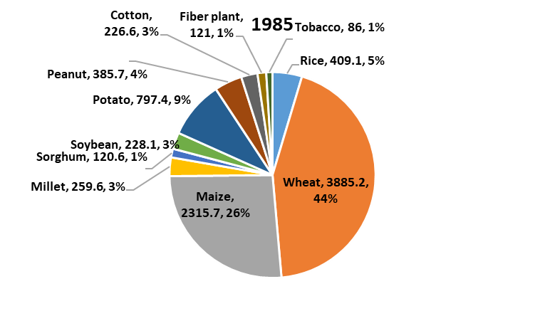 | 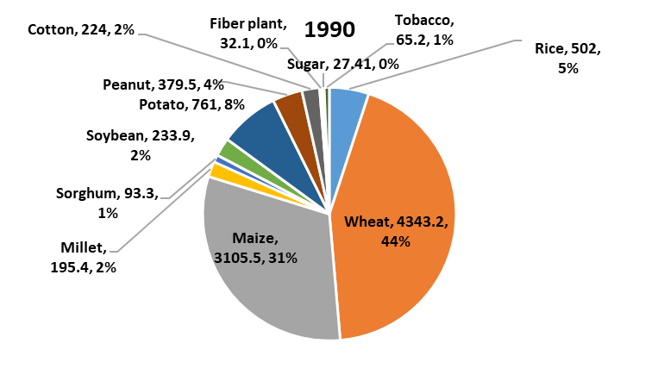
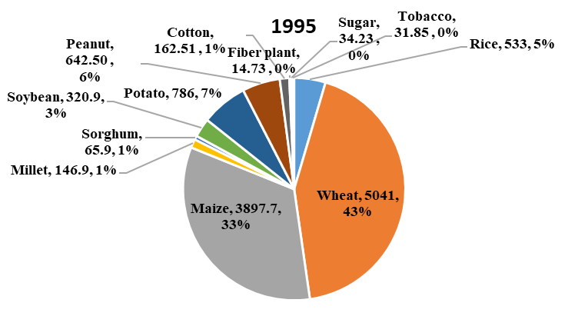 | 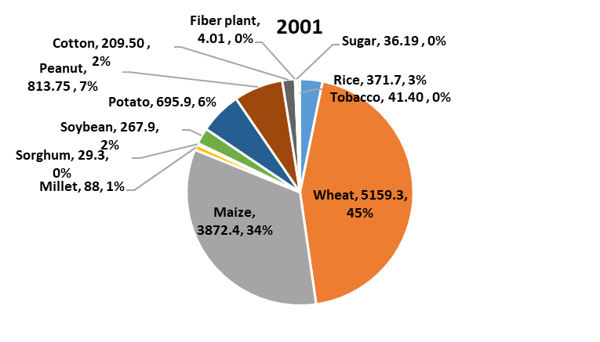
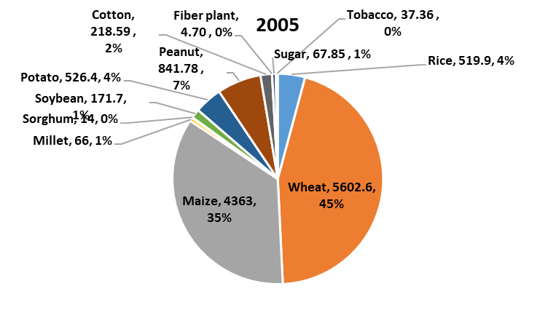 | 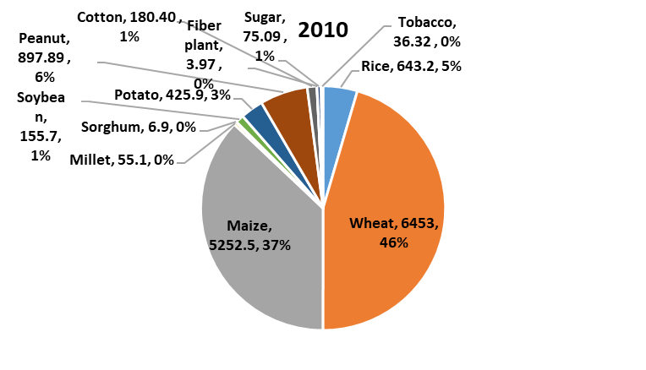
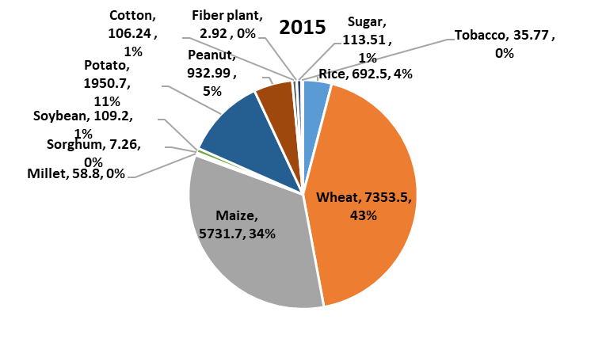 | 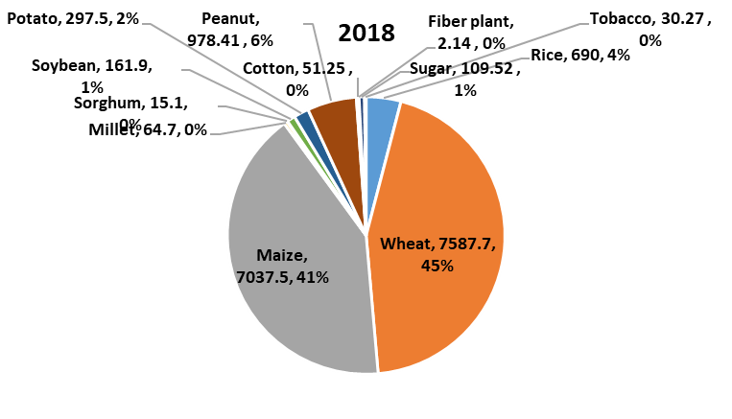
Figure S2 Annual variation in the distribution of crop yield in the North China Plain from 1985–2018. The number before comma is the absolute value of yield of each crop (unit is 10⁴ t), the number after comma is the percentage of yield of each crop accounted for the total yield.

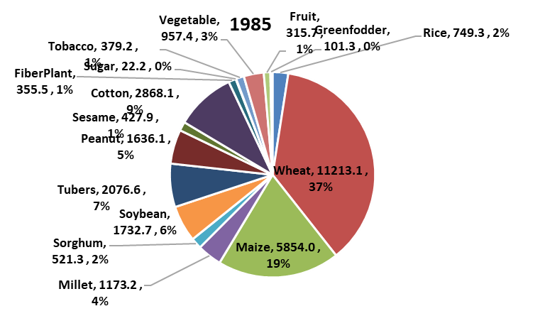 | 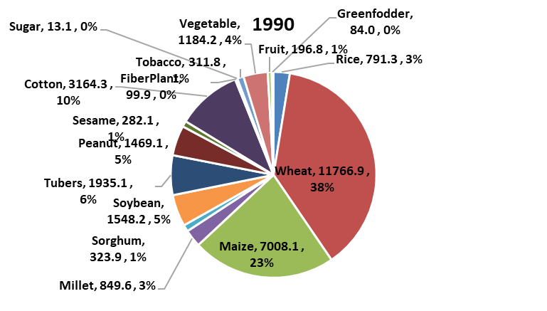
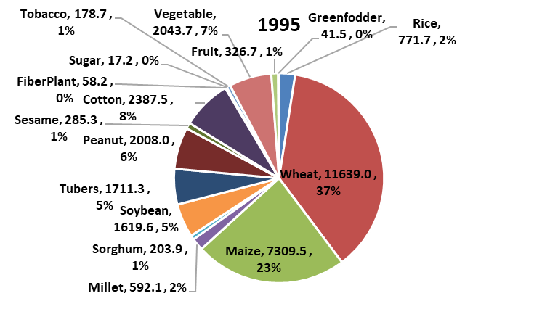 | 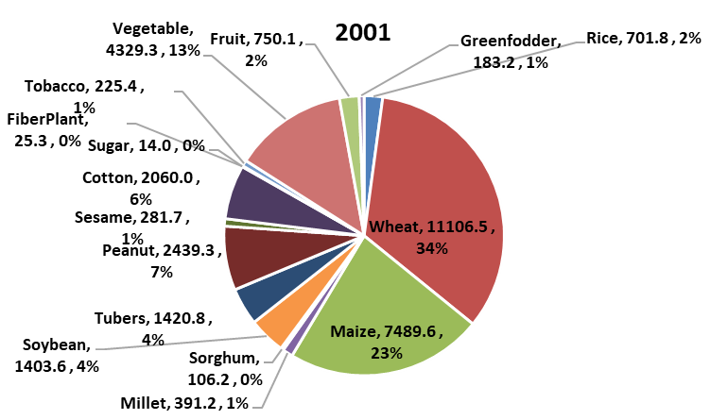
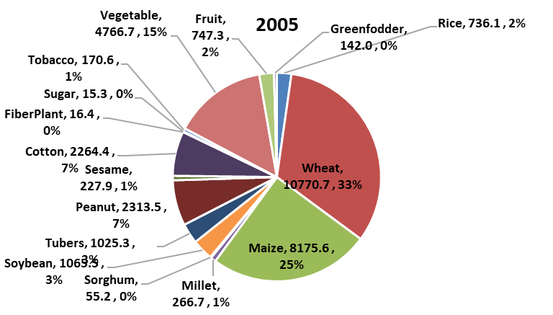 | 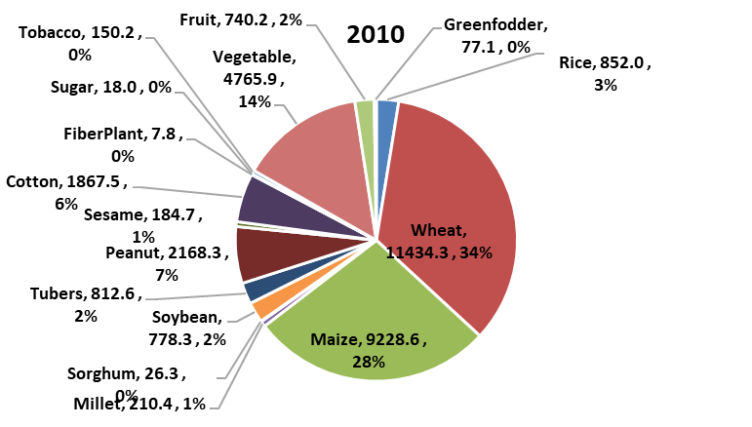
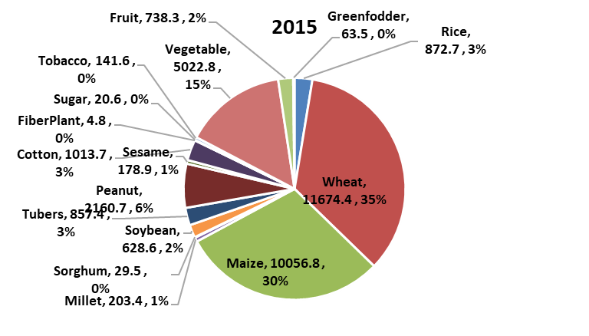 | 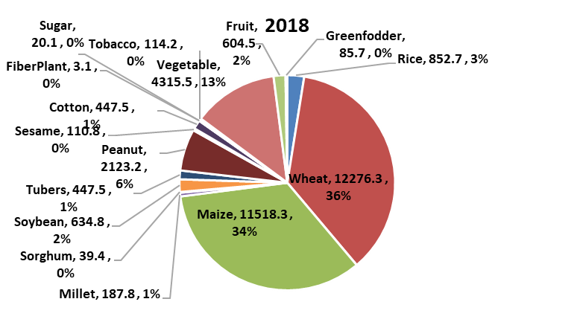
Figure S3 Annual variation in the distribution of crop planting area in the North China Plain from 1985–2018. The number before comma is the absolute value of crop planting area of each crop (unit is 10³ ha), the number after comma is the percentage of crop planting area of each crop accounted for the total planting area.

Figure S4 Average monthly precipitation and temperature from 1965–2018 from 58 standard meteorological stations distributed in the North China Plain.

Figure S5 Surface water (a) and groundwater resources (b) in the North China Plain (NCP), relative to China. Average surface water resources in the North China Plain are 554×10⁸ m³, or only 2.1% of China’s total; average groundwater resources in this region are 503×10⁸ m³, or only 6.2% of China’s total.

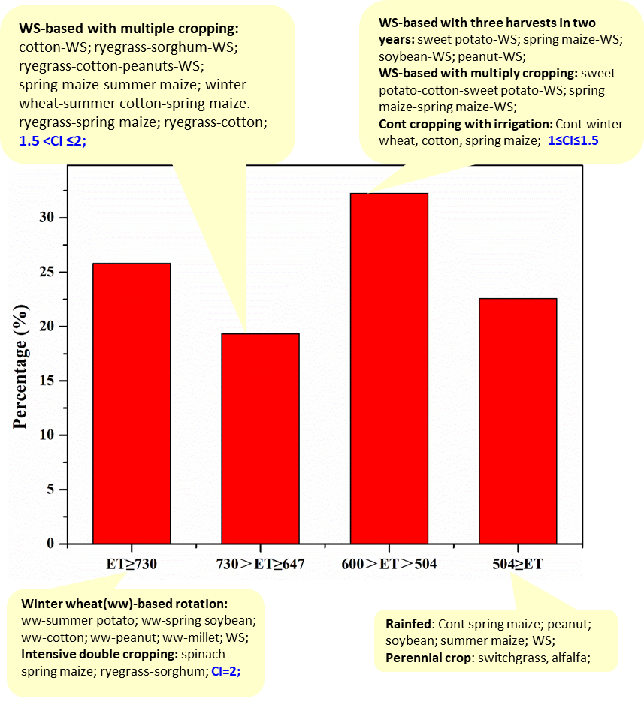
Figure S6 Classification of annual evapotranspiration in diversified crop rotations in the North China Plain. WS is winter wheat–summer maize double cropping system, Cont is single-crop species continuous cropping, percentage on the y-axis is the proportion of the 31 cropping systems, CI is cropping index.

Figure S7 Relationship between cropping index and groundwater table change in diversified crop rotations in the North China Plain. Blue dots are irrigation measurements and exclude the rainfed condition. The cropping index in each cropping system is the number of harvests divided by rotation years.

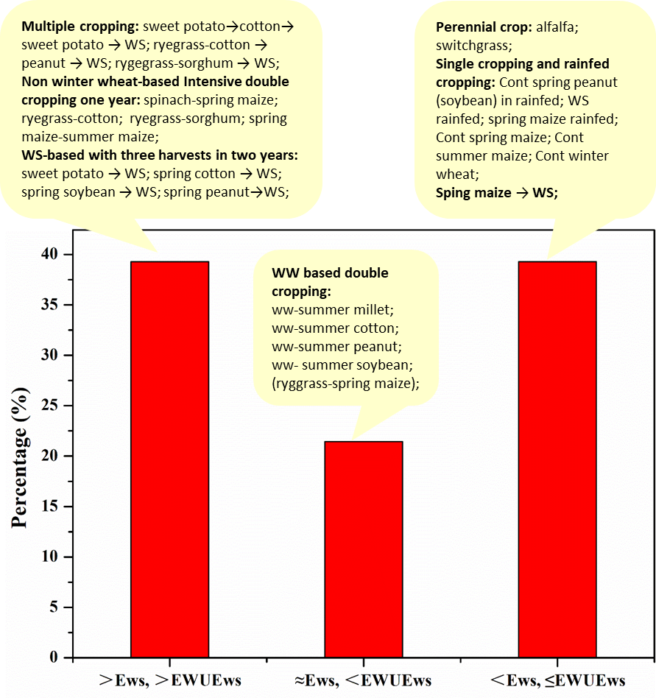
Figure S8 Classification of the 31 diversified crop rotations in the North China Plain based on economic output and EWUE. Ews is economic output (Yuan ha^{–1}) of WS rotation, EWUEws is economic water use efficiency (Yuan m^{–3}) of WS rotation, ‘>’ means the value increased relative to the WS rotation, ‘<’ means the value decreased relative to the WS rotation, WS is winter wheat–summer maize double cropping system, WW is winter wheat, percentage on y-axis is the proportion of cropping systems in each column of the 31 cropping systems.
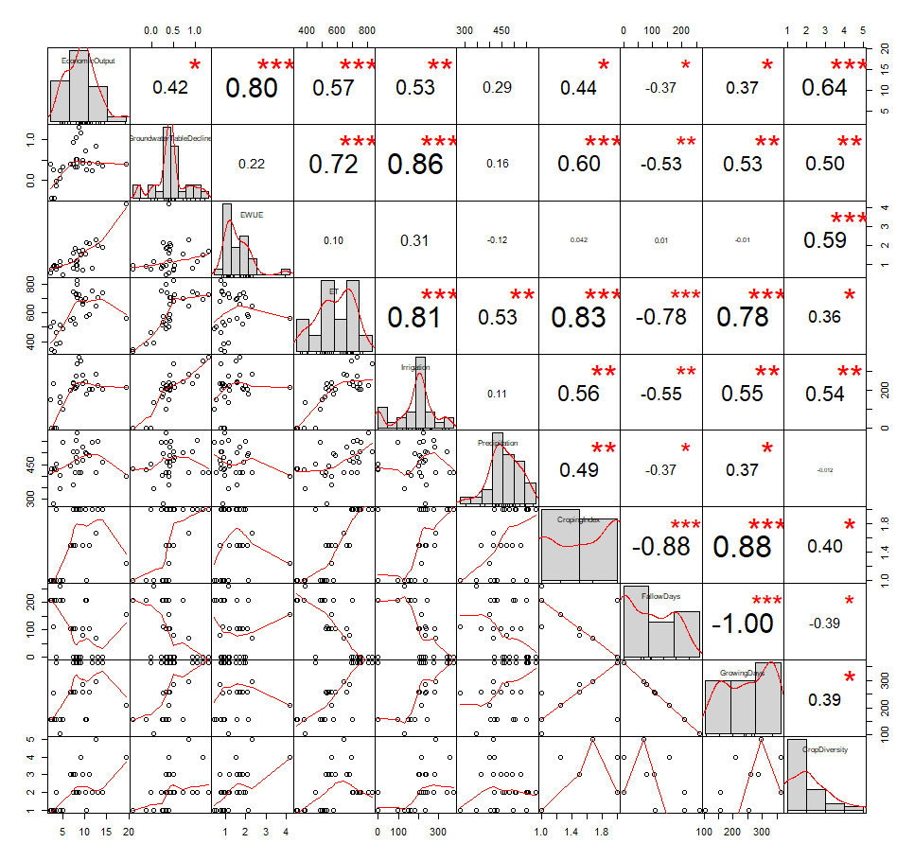
Figure S9 Correlation matrix of associations between food production and groundwater use in crop rotation systems. The number values in the grid are the correlation coefficients.
Supplementary References
1. National Bureau of Statistics of China. China statistical yearbook 2018 (China Statistics Press, 2019).
2. Liu, M. Y. & Wang, Y. X. Balance between exploitation and supply of underground water resources and plantin system in Heilonggang Region. Agric. Res. Arid Areas, 79-84 (1994).
3. Wang, D. Ecosystem services evaluation of maize-based multi-cropping systems in North China Plain. (Master Thesis, Beijing, China Agricultural University, 2018).
4. Yang, X. L. et al. Effect of diversified crop rotations on groundwater levels and crop water productivity in the North China Plain. J. Hydrol. 522, 428-438 (2015).
5. Yang, X. L. et al. Recharge and groundwater use in the North China Plain for six irrigated crops for an eleven year period. PLoS One 10, e0115269 (2015).
6. Sun, H. Y. et al. Effects of different cropping pattern on ground water and economic water use efficiency in the Hebei Low Plain. Chin. Agric. Sci. Bull. 30, 214-220 (2014).
7. Yang, X. L., Chen, Y. Q., Pacenka, S., Steenhuis, T. S. & Sui, P. Managing food and bioenergy crops with declining groundwater levels in the North China Plain. Field Crop. Res. 234, 1-14 (2019).
8. Wang, H. X. Study on resource-saving cropping systems in northern region of Huang-huai-hai Plain. (Master Thesis, China Academy of Agricultural Sciences, 2011).
9. Chen, S. Y., Zhang, X. Y., Shao, L. W., Sun, H. Y. & Niu, J. F. A comparative study of yield, cost-benefit and water use efficiency between monoculture of spring maize and double crops of wheat-maize under rain-fed condition in the North China Plain. Chinese J. Eco-Agr. 23, 535-543 (2015).
10. Guo, B. Q., Tao, H. B., Wang, P., Knorzer, H. & Claupein, W. Water utilization of different cropping production systems in North China Plain. J. Chin. Agric. Univ. 18, 53-60 (2013).
11. Yan, P. et al. Security of water-ecology and food under replacement of winter wheat-summer maize rotation with spring maize mono-cropping in Hebei Lowland Plains. Chinese J. Eco-Agr. 24, 1491-1499 (2016).
12. Yun, L. et al. Emergy-based sustainability analysis of an ecologically integrated model with maize planting for silage and pig-raising in the North China Plain. Sustainability-Basel 11, 6485 (2019).
13. Luo, J. M., Shen, Y. J., Qi, Y. Q., Zhang, Y. C. & Xiao, D. P. Evaluating water conservation effects due to cropping system optimization on the Beijing-Tianjin-Hebei plain, China. Agr. Syst. 159, 32-41 (2018).
14. Meng, Q. F. et al. Alternative cropping systems for sustainable water and nitrogen use in the North China Plain. Agr. Ecosyst. Environ. 146, 93-102 (2012).
15. Sun, H. Y. et al. Impact of different cropping systems and irrigation schedules on evapotranspiration, grain yield and groundwater level in the North China Plain. Agr. Water Manage. 211, 202-209 (2019).
16. Van Oort, P. A. J. et al. Towards groundwater neutral cropping systems in the Alluvial Fans of the North China Plain. Agr. Water Manage. 165, 131-140 (2016).
17. Xiao, D. P. et al. Impact of alternative cropping systems on groundwater use and grain yields in the North China Plain Region. Agr. Syst. 153, 109-117 (2017).
18. Qin, W. L., Zhang, X. Y., Chen, S. Y., Sun, H. Y. & Shao, L. W. Crop rotation and N application rate affecting the performance of winter wheat under deficit irrigation. Agr. Water Manage. 210, 330-339 (2018).
19. Gao, B. et al. The impact of alternative cropping systems on global warming potential, grain yield and groundwater use. Agr. Ecosyst. Environ. 203, 46-54 (2015).
20. Sun, Q. P. et al. Optimization of yield and water-use of different cropping systems for sustainable groundwater use in North China Plain. Agr. Water Manage. 98, 808-814 (2011).
21. Chen, C. et al. Modelling the effects of climate variability and water management on crop water productivity and water balance in the North China Plain. Agr. Water Manage. 97, 1175-1184 (2010).
22. Kendy, E., Zhang, Y. Q., Liu, C. M., Wang, J. X. & Steenhuis, T. S. Groundwater recharge from irrigated cropland in the North China Plain: case study of Luancheng County, Hebei Province, 1949–2000. Hydrol. Process. 18, 2289-2302 (2004).
23. Liu, X. H. & Chen, F. Farming Sytems in China (China Agriculture Press, 2005).
24. Meng, Q. F. et al. Designing a new cropping system for high productivity and sustainable water usage under climate change. Sci. Rep. 7, 41587 (2017).
25. Zhou, W. L. Evaluation of nutrients and water use efficiency of different maize weat cropping systems in the North China Plain. (PhD Thesis, Beijing, China Agricultural University, 2016).
26. Cui, K. & Shoemaker, S. P. A look at food security in China. Nature 2, 4. (2018).
27. Wang, J. et al. Evapotranspiration, crop coefficient and yield for drip-irrigated winter wheat with straw mulching in North China Plain. Field Crop. Res. 217, 218-228 (2018).

