Table 1. Flow Chart of Korean FCMD Patients.
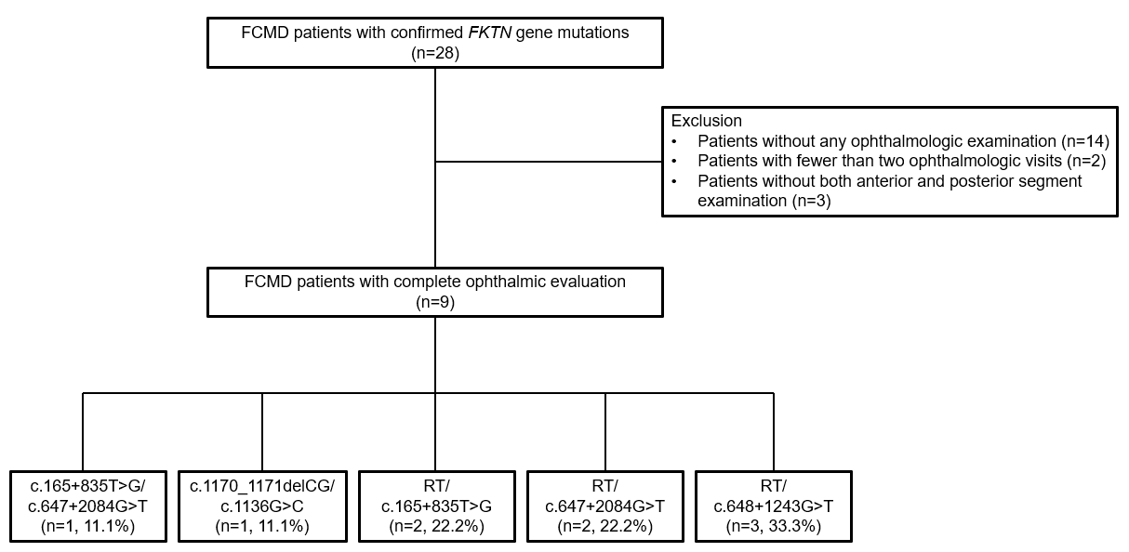
A = adenine; C = cytosine; c. = coding DNA sequence; FCMD = Fukuyama congenital muscular dystrophy; FKTN = Fukutin; del = deletion; G = guanine; n = number; RT = Retrotransposon insertion (a 3-kb SVA retrotransposon in intron 1, which is a founder mutation); T = thymine
Table 2. Demographics and Baseline Characteristics of Korean FCMD Patients.
Characteristics | FCMD Patients (n=9)
Gender
Male | 66.6% (6/9)
Age at the diagnosis (years)
Mean ± SD | 0.78 ± 0.34
Median (IQR) | 0.42 (Q1: 0.58, Q3: 1.00)
Range | 0.25-1.13
Mutation
c.165+835T>G/c.647+2084G>T | 11.1% (1/9)
c.1170_1171delCG/c.1136G>C | 11.1% (1/9)
RT/c.165+835T>G | 22.2% (2/9)
RT/c.647+2084G>T | 22.2% (2/9)
RT/c.648-1243G>T | 33.3% (3/9)
A = adenine; C = cytosine; c. = coding DNA sequence; FCMD = Fukuyama congenital muscular dystrophy; del = deletion; G = guanine; IQR = interquartile range; n = number; Q = quarter; RT = Retrotransposon insertion (a 3-kb SVA retrotransposon in intron 1, which is a founder mutation); SD = standard deviation; T = thymine
Table 3. Ocular Findings in Patients with FCMD.
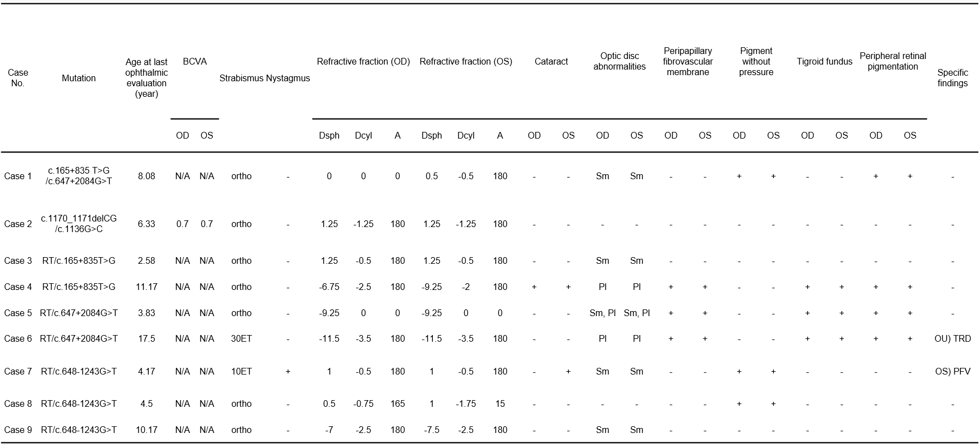
A = adenine; BCVA = best corrected visual acuity; C = cytosine; c. = coding DNA sequence; Dcyl = diopter cylindrical; Dsph = diopter spherical; DWOP = dark without pressure; ET = esotropia; FCMD = Fukuyama congenital muscular dystrophy; G = guanine; mo = month; N/A = not applicable; OD = oculus dexter, right eye; OS = oculus sinster, left eye; OU = oculus uterque, both eyes; PFV = persistent fetal vasculature; Pl = pale optic disc; RT = Retrotransposon insertion (a 3-kb SVA retrotransposon in intron 1, which is a founder mutation); Sm = small optic disc; T = thymine; TRD = tractional retinal detachment; XT = exotropia

