Supporting Information for
Complex genetic architecture underlies human hand and foot evolution

Alexander S. Okamoto, Gayani Senevirathne, Pushpanathan Muthuirulan, Campbell Rolian, Ian A. Glass, Birth Defects Research Laboratory (BDRL), Terence D. Capellini

This PDF file includes:

Supplementary Text
Note S1. Timepoint selection
Results S1. Regulatory activity in the developing human autopod skeleton
Results S2. Differential gene expression in the developing human autopod skeleton
Results S3. Relative developmental timing between limb types
Results S4. Regulatory activity in the developing mouse autopod skeleton
Results S5. Differential gene expression in the developing mouse autopod skeleton

Extended Data S1 to S10
Extended Data Fig. 1 Intraspecific differences in autopod proportions
Extended Data Fig. 2 Mouse autopod gene expression and regulation
Extended Data Fig. 3 Human gene expression modules
Extended Data Fig. 4 Human-mouse conserved accessibility and regulation
Extended Data Fig. 5 Evolutionary signals overlapping autopod regulatory elements (early)
Extended Data Fig. 6 Evolutionary signals overlapping autopod regulatory elements (late)
Extended Data Fig. 7 SDR and inversion flank enrichments
Extended Data Fig. 8 Partitioning of evolutionary signals across all autopod elements
Extended Data Fig. 9 Partitioning of evolutionary signals across human-mouse conserved autopod elements
Extended Data Fig. 10 Shared regulation of expressed genes

Captions for Supplementary Tables S1 to S6
S1 Great Ape Measurement Data
S2 Human RNA information
S3 Human ATAC information
S4 Mouse RNA information
S5 Mouse ATAC information

Supplementary References

Note S1: Timepoint Selection
Like other endochondral bones, the metapodials and phalanges initially form as cartilage templates during development¹. The structure of the initial cartilage condensations emerges over a few weeks and comes to resemble the adult structure before the beginning of ossification (e.g., ref.²). In the autopods, human-specific features such as a robust, adducted hallux and relatively long pollex are already present by eight weeks post conception (Fig. 1d). These structures remain entirely cartilaginous for weeks to months before ossification begins, starting proximally in the metapodials and proximal phalanges, and distally in the distal phalanges^{3,4}. The medial phalanges do not ossify until much later, particularly in the foot. Ossification in the metapodials is similar to, but distinct from, normal long bone development, because only one end of each of these bones develops a true growth plate⁵. At the other end, the growth plate –or physis– directly invades the epiphysis without producing a secondary ossification center. A similar pattern of ossification in mouse suggests this is likely a conserved mammalian trait⁶. The timepoints investigated in this study (human gestational day 53-74; mouse gestational day 15.5) covers a period of cartilage development when the anatomy of the skeletal elements is present in the cartilage, endochondral cartilage growth is occurring, but substantial ossification has not yet occurred.

Results S1. Regulatory activity in the developing human autopod skeleton
ATAC-seq on the human developmental samples resulted in an average of 94.6 million paired-end reads per sample (Supplementary Table 3). These reads were high quality with >87% having a QC score of Q≥30. After processing the raw reads, MACS2 peak calling produced an average of 234,613 peaks per sample. Regulatory elements accessible across biological replicates were identified by IDR with a threshold <0.05. Each tissue type had an average of 41,608 regulatory elements (minimum: 25,934, maximum: 54,089). These sets were then filtered by regulatory elements accessible in E54 brain tissue to remove elements likely associated with general cellular housekeeping processes. This filtering step reduced the regulatory element sets to an average of 29,346 elements per sample (minimum:13,921, maximum: 41,120). Altogether, we identified 60,150 regulatory elements accessible in the cartilage of at least one autopod skeletal element. Principle component analysis (PCA) of normalized data corrected for variation between biological replicates clearly separated the metapodials from phalanges (PC1) and the timepoints (PC2), with the first two PC axes explaining ~33% of the total variance (Fig. 2c).

Results S2. Differential gene expression in the developing human autopod
To identify genes differentially expressed across the human autopod skeleton, we performed RNA-seq on the pooled phalanges of each digit as well as the metapodials (20 tissues total) at two timepoints, an early timepoint ranging from E53-E59 and a later timepoint of E67-E74, henceforth, “early” and “late” timepoints. Six biological replicates were collected per tissue per timepoint for a total of 240 RNA libraries. These samples had an average (mean) of 26.8 million paired-end reads per sample. Two samples had less than 10 million reads and were excluded from downstream analyses. PCA of normalized data, corrected for variation between biological replicates, showed that gene expression profiles were highly similar across all tissues, with each PC axis explaining only a small portion of the total variance (<5%) (Fig. 2a). The clearest separation was observed between proximal and distal regions of the autopod along PC2, while no clear separation was observed for limb type or digit identity.
Pairwise comparisons of all biologically relevant tissue pairs (92 total) in the human autopod (adjacent in either the proximal-distal or anterior-posterior axes or the same tissue across timepoints, see Methods) resulted in a total of 1,235 differentially expressed genes (DEGs) (Supplementary Table 2). We identified an additional 28 genes that were expressed as a gradient across the digits at either timepoint, for a total set of 1,263 DEGs. Overall, many more DEGs were identified at the later (871 genes) timepoint compared to the earlier timepoint (357 genes). 193 genes were identified as DEGs at both timepoints (Fig. 2b). The total set of DEGs was enriched for GO terms related to “extracellular matrix organization”, “cartilage development” and “ossification.”
Since many DEGs were shared across multiple tissue comparisons, weighted gene correlation network analysis (WGCNA) was used to cluster DEGs with similar expression profiles into distinct modules for each timepoint (Extended Data Fig. 3, Supplementary Table 2). We found that the genes differentially expressed between early tissues formed two distinct modules with 114 genes unassigned to either module (Extended Data Fig. 3a). Module 1 (131 genes) contained genes highly expressed in the phalanges while module 2 (112 genes) covered the metapodials. Module 1 was enriched for GO terms related to “appendage development” while module 2 was enriched for terms such as “cartilage development” and “endochondral bone morphogenesis.” At the later stage, 4 modules were identified with 117 genes remaining unclassified (Extended Data Fig. 3b). The first two modules (334 and 248 genes, respectively) show the same expression pattern as the first two modules of the early timepoint. Module 1 was enriched for GO terms related to “skin development” while module 2 did not have any enrichments. Module 3 (115 genes) showed expression across the autopod except for the posterior phalanges in the foot (II-V) and hand phalanges digit V. Expression was higher in the metapodials than in the phalanges for each digit. This gene set was enriched for GO terms related to “extracellular matrix organization”, “cartilage development” and “ossification” and this pattern of expression is consistent with the ossification sequence of these tissues^{3,4}. Module 4 (57 genes) was similar to module 1 with high expression in the phalanges but with greater expression in digit III of the hand. This gene set was enriched for GO terms related to “extracellular matrix organization” and “ossification.” We next sought to compare these modules across timepoints. We found that the first modules of the early and late timepoints matched each other (65 shared genes). Early module 2 matched late module 2 (58 shared genes) and module 3 (30 genes). Late module 4 had a little overlap with early module 1 (9 shared genes) and no shared genes with early module 2. Directly comparing all tissues between timepoints resulted in a total of 3,031 DEGs, with 1,453 genes upregulated early and 1,578 genes upregulated late. Early DEGs were enriched for terms related to “cytoplasmic translation” while late DEGs were enriched for terms such as “extracellular matrix organization” and “ossification,” consistent with the initiation of ossification, which occurs around this stage.

Results S3. Relative developmental timing between limb types
Vertebrate development generally proceeds cranially to caudally. In the limbs, the forelimb outgrowths appear first and maintain a slightly advanced degree of development compared to the hind limb through development^{3,4}. Therefore, in comparing gene regulation and expression between homologous structures of the fore- and hind limb, there is a risk that differences observed between limb types at the same timepoint may be due to a mismatch of the developmental stage (presumably a lag in the hind limb relative to the forelimb) rather than differences likely to underpin the distinct structural features of one limb type. In our dataset specifically, the question is whether the late-stage foot samples match the early-stage hand samples better than those from the same timepoint. Based on the ATAC data, more common regulatory elements are shared between the late-stage foot and late-stage hand samples (10,036 elements) compared to late-stage foot and early-stage hand (9,750). This matches the PCA results (Fig. 2c), which show a clear separation by timepoint. At the gene expression level, we found that there were 95 DEGs between late-stage foot samples and early-stage hand samples compared to only 11 DEGs with late-stage hand samples. These results strongly suggest that for this dataset, comparisons between limb types within a stage will be more biologically meaningful than across stages. That is not to say that heterochronic shifts in developmental timing of the limb types are not important, but rather that in humans any shift is less than the time separating our two stages (~2 weeks) during the developmental window investigated, which is a period of rapid morphogenesis. Heterochronic changes may play an important role either earlier, later, or at shorter time scales (e.g., a delay of gene expression of hours or days rather than weeks).

Results S4. Regulatory activity in the developing mouse autopod skeleton
ATAC-seq on the E15.5 mouse developmental samples produced similar results with an average of 68.3 million paired-end reads per sample. These reads were high quality with >85% having a QC score of Q≥30. See Supplementary Table 5 for sequencing information including, sample, index primer, read count, and other information. After processing the raw reads, MACS2 peak calling produced an average of 219,157 peaks per sample. Reproducible regulatory elements accessible across biological replicates were identified by IDR with a threshold <0.05. Each tissue type had an average of 41,813 regulatory elements (minimum: 36,194, maximum: 53,276). These sets were then filtered by regulatory elements accessible in E15.5 brain tissue to remove elements likely associated with general cellular housekeeping processes. This filtering steps reduced the regulatory element sets to an average of 25,752 elements per sample (minimum: 20,768, maximum: 36,565). PCA of the mouse ATAC data showed separation of metapodial and phalangeal samples along PC1 (22.0% variance) and weakly separates digit V from digits I and III along PC2 (13.8% variance) (Extended Data Fig. 2a). The total set of elements (n = 50,669) was highly enriched for gene ontology terms related to cartilage biology and malformations of the skeleton in mice (Supplementary Table 5). Regulatory elements were generally accessible in all or most tissues or restricted to a single tissue, with smaller numbers of elements shared between just a few tissues (Extended Data Fig. 2b). 9,329 brain-filtered regulatory elements were common to all mouse autopod samples. Out of the 50,669 ATAC-seq chondrocyte regulatory elements identified in mouse, 47,094 (93%) successfully lifted over to human genome coordinates. Only 34% of the regulatory elements identified in human were also accessible in mouse, with a substantially bias towards regulatory conservation in regulatory elements accessible in all tissues (i.e., 58% of elements accessible in all human tissues at either stage were accessible in mouse compared to 18% for elements accessible only in a single tissue (Extended Data Fig. 4d). Accordingly, the average number of human tissues with accessibility for elements shared between human and mouse was substantially higher than was observed in the total human regulatory element set (median = 17 versus median = 10, Wilcoxon Rank Sum Test, P < 2.2 X 10⁻¹⁶). Overall, regulatory elements were more likely to be shared across limb types in mouse than human (67.6% versus 63.6%) and there were more forelimb-specific than hind limb specific elements (9,046 forelimb versus 7,383 hind limb), in contrast to human. Of those elements accessible only in a single tissue in both species, the tissue rarely matched between human and mouse (Extended Data. Fig. 4e).

Results S5. Differential gene expression in the mouse autopod skeleton
To identify genes differentially expressed across the mouse autopod skeleton, we performed RNA-seq on the pooled phalanges as well as the metapodials of digits I, III and V (12 tissues total) at E15.5. Six biological replicates were collected per tissue per timepoint for a total of 72 mouse RNA libraries (Supplementary Table 4). These samples had an average (mean) of 45.5 million paired-end reads per sample. Two mouse samples were prepared using the Kapa library method used for the human samples to control for library preparation method; this was not found to substantially alter the expression profile of these tissues (Extended Data Fig. 2c) so the Kapa samples were not considered in subsequent analyses of the mouse data. PCA of normalized count data corrected for variation between biological replicates clearly separated the metapodials from the phalanges, and forelimb tissues from hind limb tissues within each cluster, with the first two PC axes explaining ~40% of the total variance (Extended Data Fig. 2d). Comparison of all biologically relevant tissue pairs in the mouse autopod (see Methods) resulted in a total of 9,487 DEGs. Individual pairwise comparison results ranged from a minimum of 298 DEGs (forelimb phalanges III versus hind limb phalanges III) to a maximum of 3,387 DEGs (metatarsal I versus hind limb phalanges I). We identified an additional 548 genes that were expressed as a gradient across the digits, for a total set of 10,035 DEGs. The complete set of DEGs is enriched for GO terms such as “cartilage development”, “axonogenesis,” and “ossification.” We found more DEGs in mouse than in human, despite sampling fewer tissues and only a single timepoint. Performing identical pipelines on human digits I, III and V at either timepoint was insufficient to explain the difference in DEG counts between species (Supplementary Table 2).
Since many DEGs were shared across multiple tissue comparisons, WGCNA was used to cluster DEGs with similar expression profiles into distinct modules. This resulted in twelve distinct modules (Extended Data Fig. 2e). While the majority of DEGs were successfully assigned to a cluster, 1,010 genes were unassigned. This analysis shows that gene expression differs primarily between digit I and other digits along the proximal-distal axis. Small clusters define metatarsal I and metacarpal I (clusters 8 and 10, respectively). Gene ontology enrichments for each cluster are listed in Supplementary Table 4.
Overall, mouse gene expression modules are similar to human, clearly separating the metapodials from the phalanges but showing only minor differences between limb types (Extended Data Fig. 2). The most notable difference is that mouse DEGs formed modules clearly distinguishing digit I tissues from the others, which was not observed at either human timepoint. Overall, orthologous mouse DEGs were identified for 381 human DEGs (Extended Data Fig. 4f).

Extended Data Figures

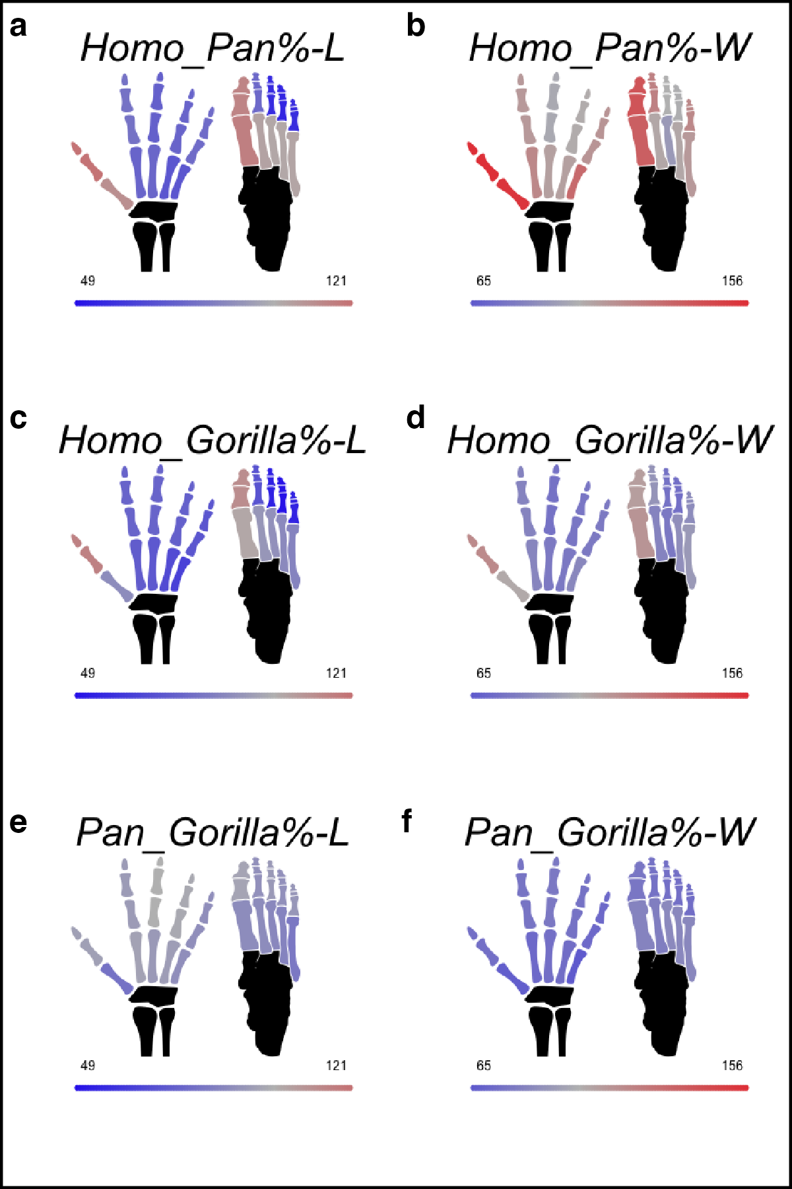
Extended Data Fig. 1 Interspecific differences in autopod proportions
a, Average percent change in length and b, width between adult human and chimpanzee autopod skeletal elements. c, Average percent change in length and d, width between adult human and gorilla autopod skeletal elements. e, Average percent change in length and f, width between adult chimpanzee and gorilla autopod skeletal elements.

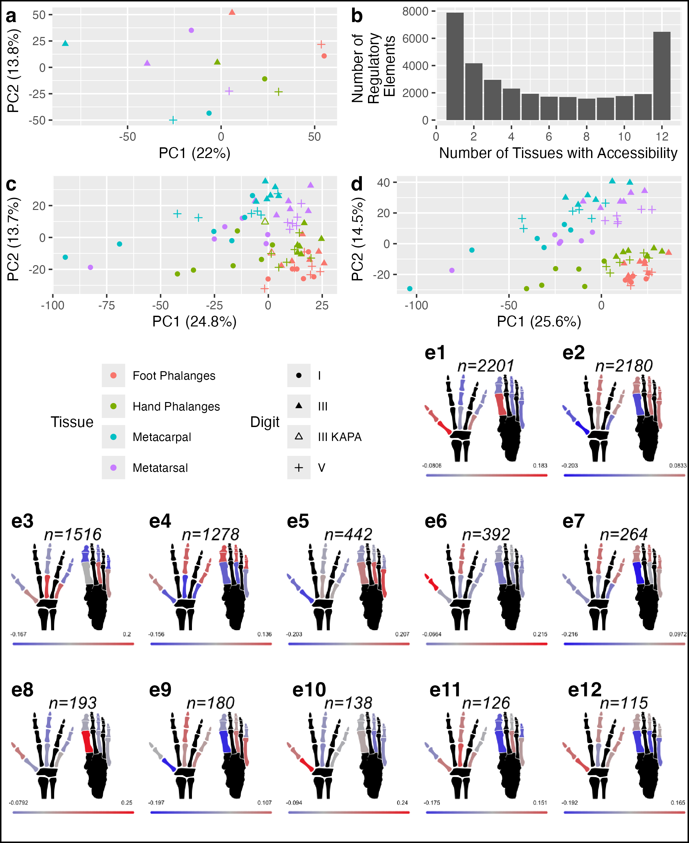
Extended Data Fig. 2 Mouse autopod gene expression and regulation
a, Principal component analysis (PCA) of mouse autopod regulatory elements. b, Bar graph of the number of mouse regulatory elements that are accessible across different numbers of autopod tissues. c, PCA of mouse autopod gene expression including samples prepared using an alternate library preparation method and corrected for library preparation method batch effect. d, PCA of mouse autopod gene expression with alternate library preparation samples removed and corrected for individual effects. e, Gene eigen-value expression for the twelve mouse autopod modules identified by weighted gene network correlation analysis, plotted onto a diagram of the human autopod skeleton. Modules are arranged by descending number of DEGs within the module

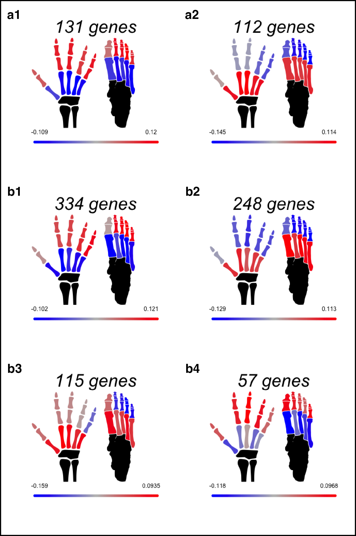

Extended Data Fig. 3 Human gene expression modules

a, Average gene eigen-value expression for early and b, late human autopod modules identified by WGNCA analysis plotted onto a diagram of the autopod skeleton to show the spatial arrangement. Modules are arranged by the number of DEGs within the module.

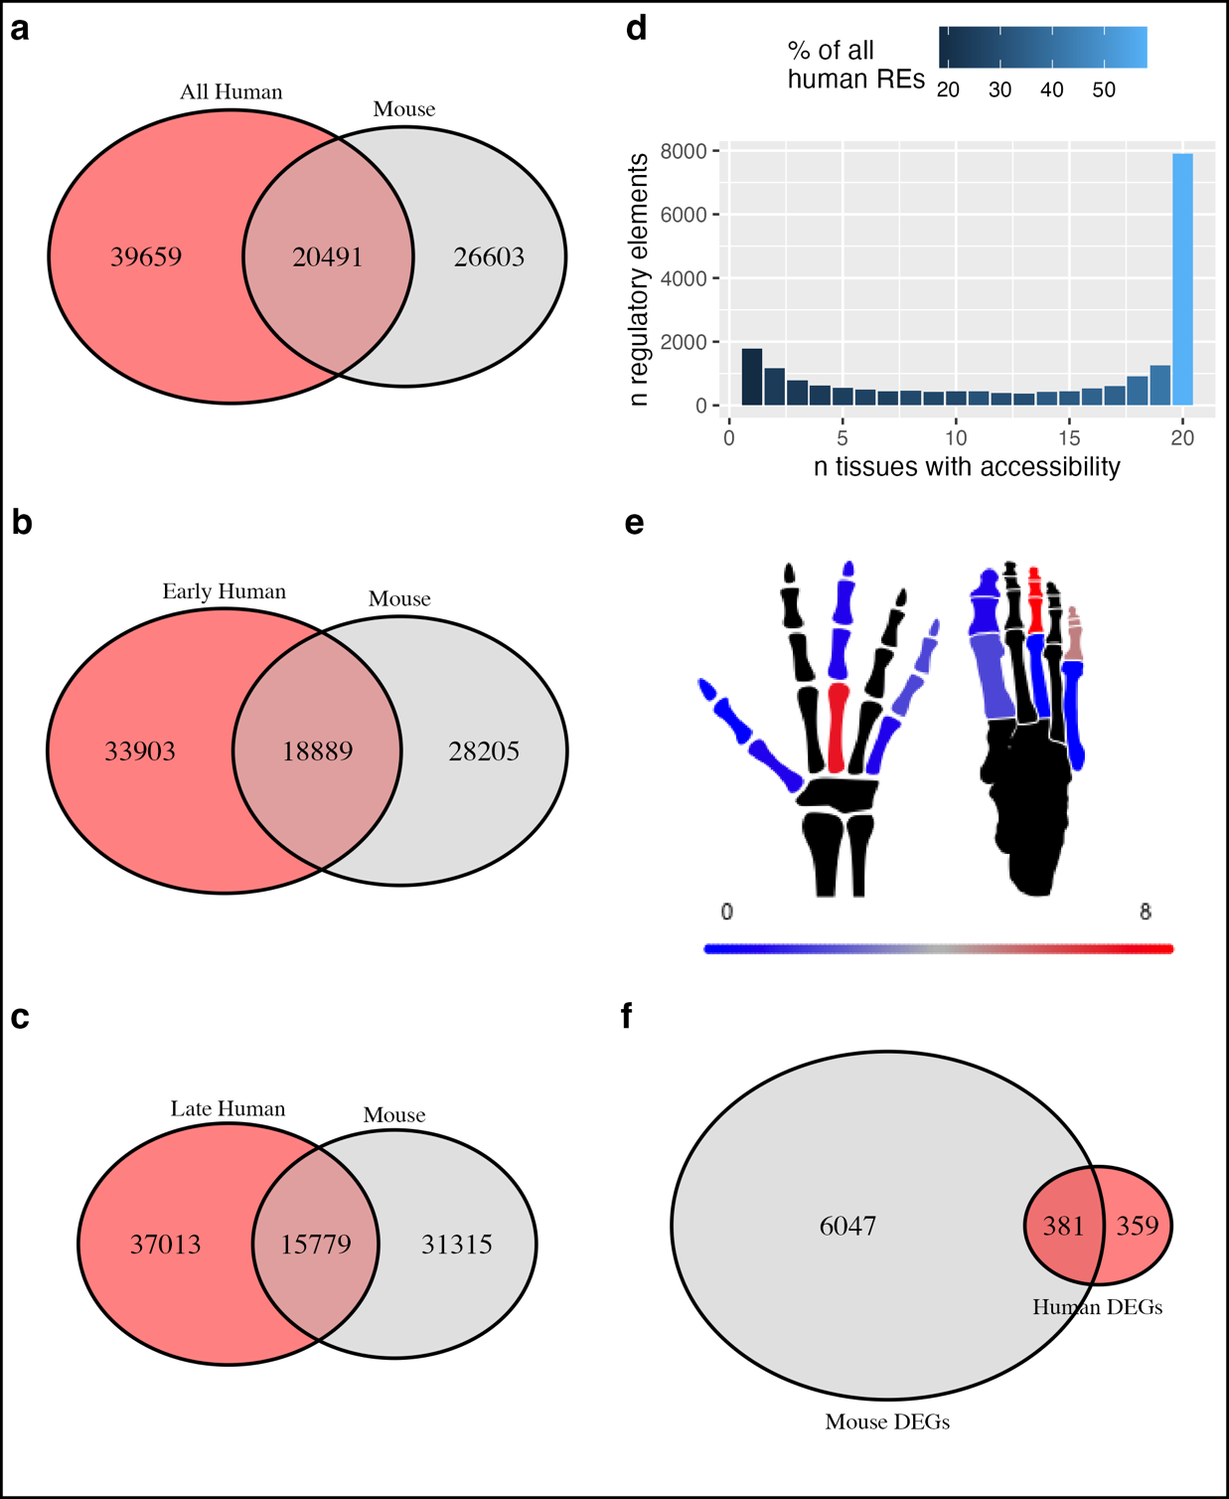
Extended Data Fig. 4 Human-mouse conserved accessibility and regulation
a, overlap between all regulatory elements accessible in human and mouse autopod skeletal elements. b,c, overlap between regions elements accessible in human samples matched to mouse (digits I, III, V only) for early and late timepoints, respectively. d, Bar plot of the number of regulatory elements with accessibility in both human and mouse with expression in different numbers of autopod elements in human (maximum at either timepoint). Color shows the percentage of all elements identified in human with a given accessibility pattern across tissues which are shared with mouse. e, number of regulatory elements uniquely accessible in only one tissue in both human and mouse. f, number of orthologous genes that were identified as differentially expressed in human and mouse.

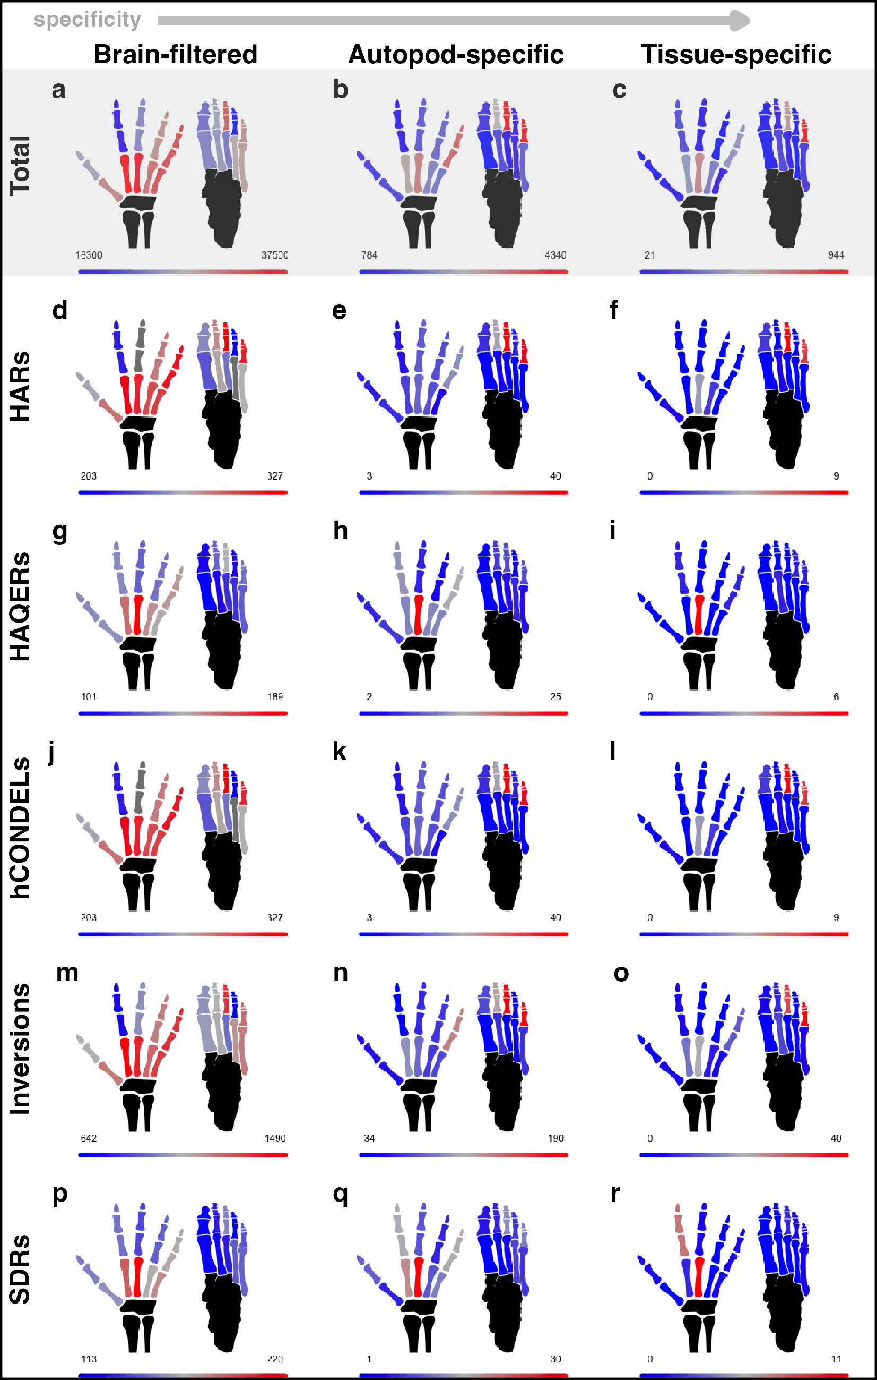
Extended Data Fig. 5 Evolutionary signals overlapping autopod regulatory elements (early)
a, total number of regulatory element accessible in each tissue at the early stage after brain-filtering. b, number of regulatory elements in each tissue that are accessible only in autopod tissues, and c, number of regulatory elements that are accessible in only a single tissue. Number of overlaps for the brain-filtered (d, g, j, m, p), autopod specific (e, h, k, n, q), or tissue-specific (f, i, l, o, r) regulatory element sets with HARs (d-f), HAQERs (g-i), hCONDELs (j-l), major human inversions (m-o), or human SDRs (p-r).

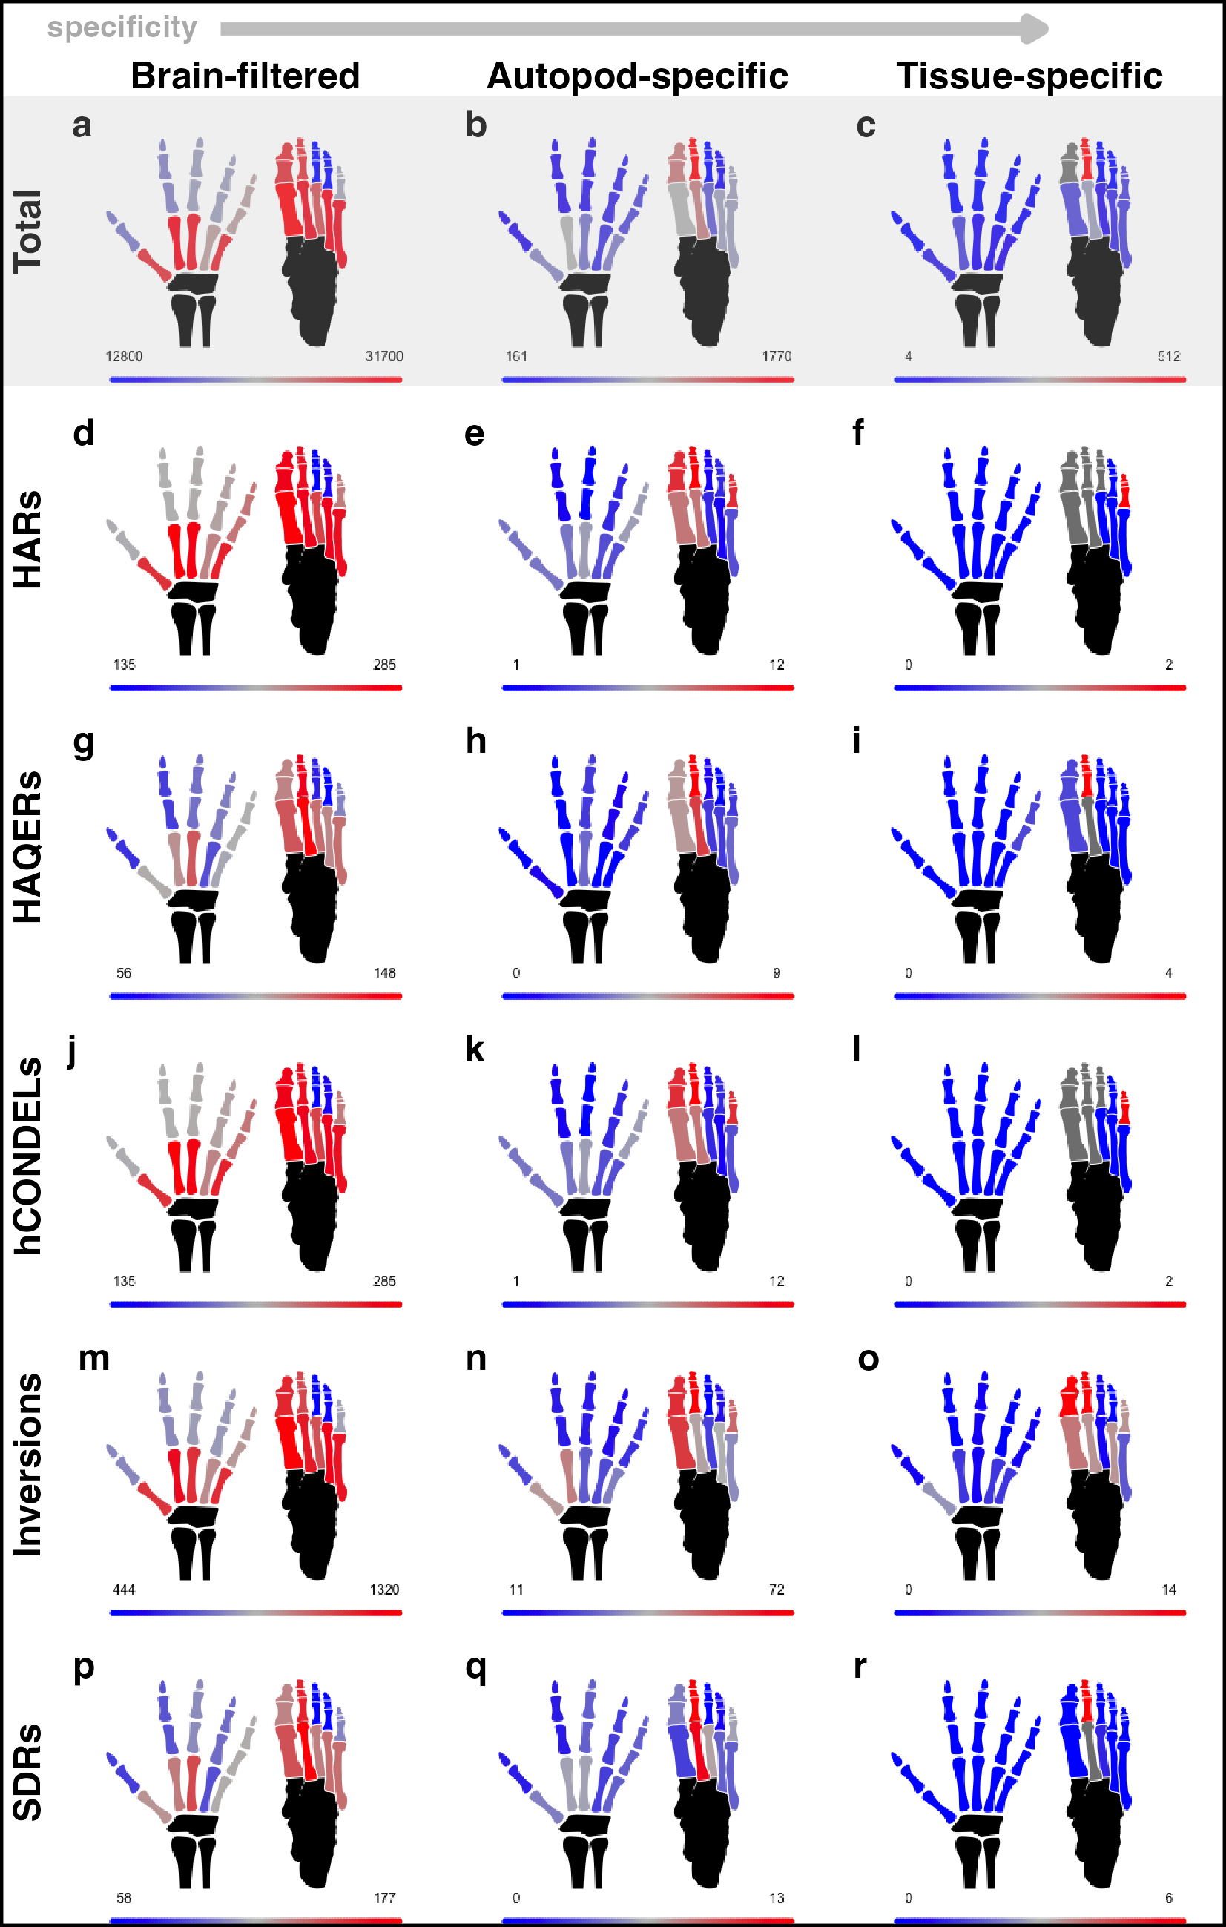
Extended Data Fig. 6 Evolutionary signals overlapping autopod regulatory elements (late)
a, total number of regulatory element accessible in each tissue at the late stage after brain-filtering. b, number of regulatory elements in each tissue that are accessible only in autopod tissues, and c, number of regulatory elements that are accessible in only a single tissue. Number of overlaps for the brain-filtered (d, g, j, m, p), autopod specific (e, h, k, n, q), or tissue-specific (f, i, l, o, r) regulatory element sets with HARs (d-f), HAQERs (g-i), hCONDELs (j-l), major human inversions (m-o), or human SDRs (p-r).

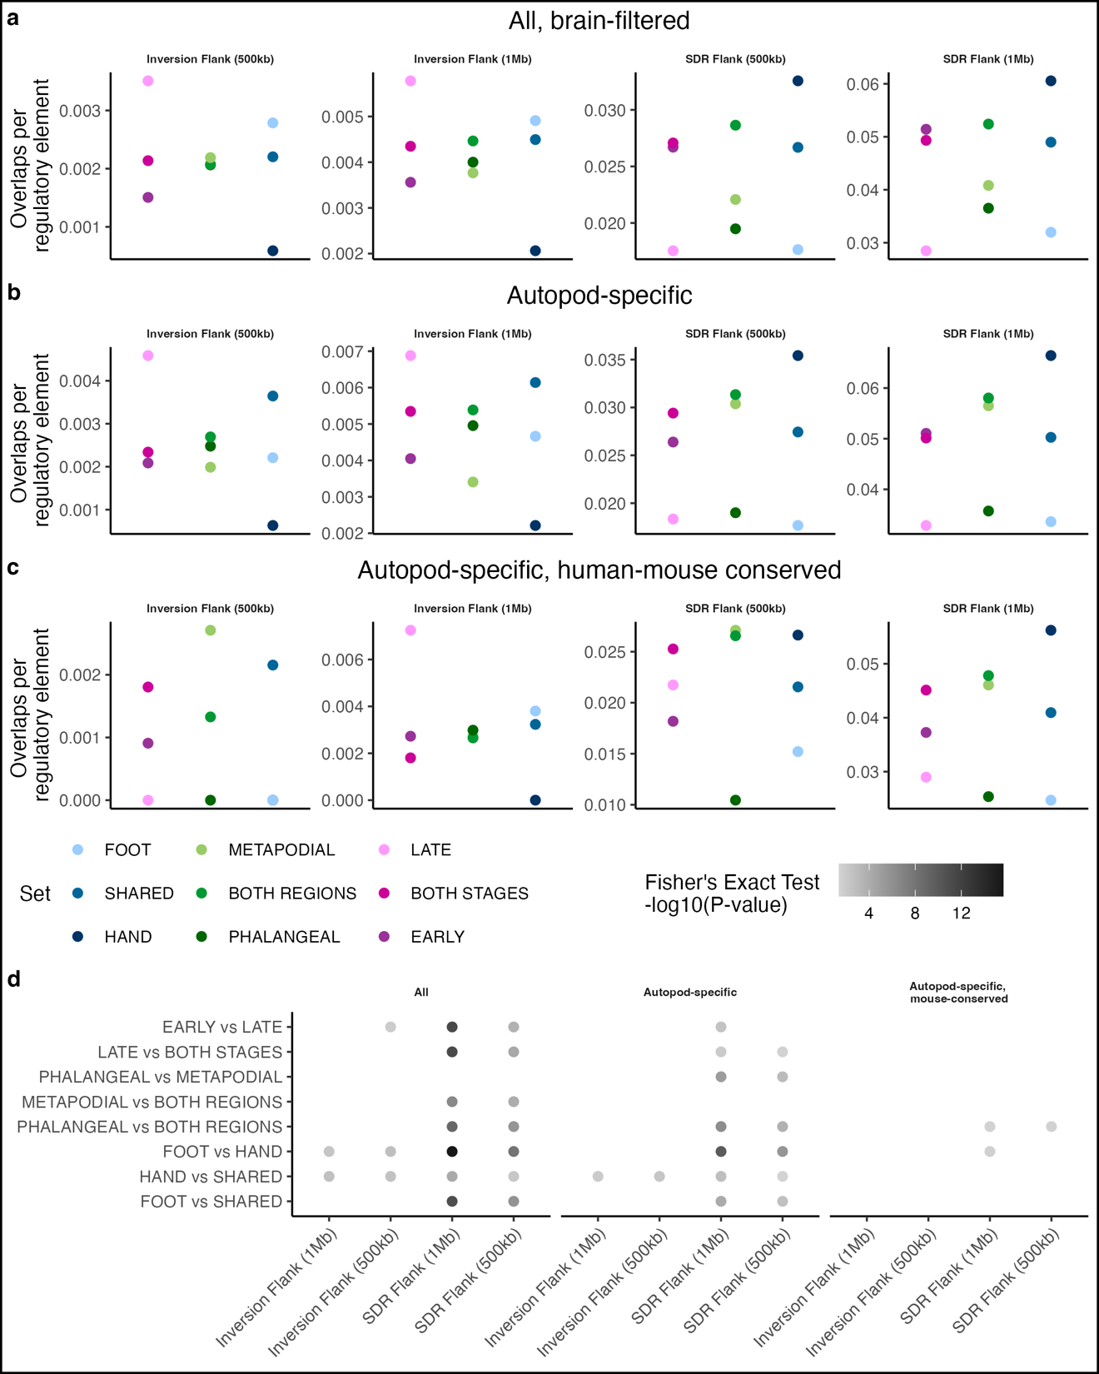
Extended Data Fig. 7 SDR and inversion flank enrichments
a, enrichment of regulatory elements falling within the 500kb or 1Mb regions flanking human-specific inversions and human SDRs for each set using the entire set of brain-filtered regulatory elements. b, c, as in a, but for the autopod-specific and autopod-specific, human-mouse conserved regulatory element sets, respectively. d, statistical significance of enrichment differences between set pairs. See Fig. 3 and Extended Data Figs. 8-9 for set information.

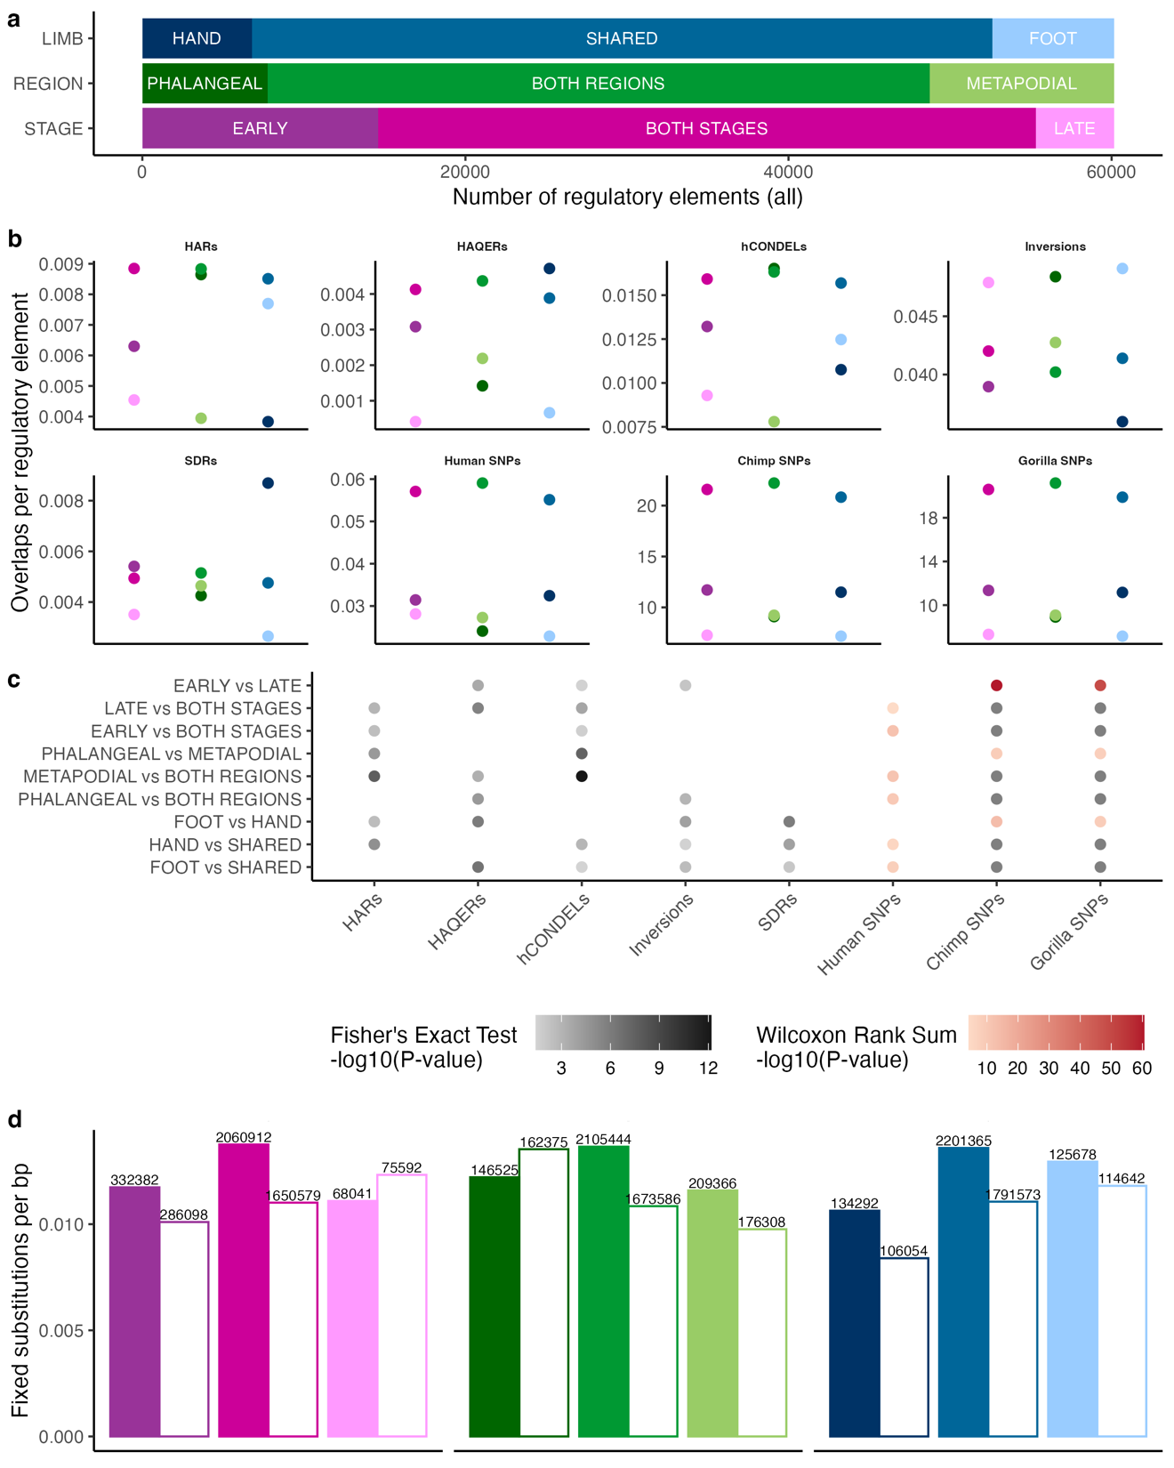
Extended Data Fig. 8 Partitioning of evolutionary signals across all autopod elements
a, division of regulatory elements accessible brain-filtered autopod tissues by the specificity of accessibility in limb type, proximal-distal region, or developmental stage. b, enrichment of each regulatory element set for HARs, HAQERs, hCONDELs, human-specific inversions, human SDRs, as well as common variants (MAF > 0.05) in human, chimpanzee, and gorilla per base pair of sequence. c, statistical significance of enrichment differences between set pairs. d, number of fixed substitutions along the human (colored bars) and chimpanzee (white bars) lineages per base pair for each set. Total number of fixed substitutions are listed above each bar. Color scheme in b,d, is the same as in a.
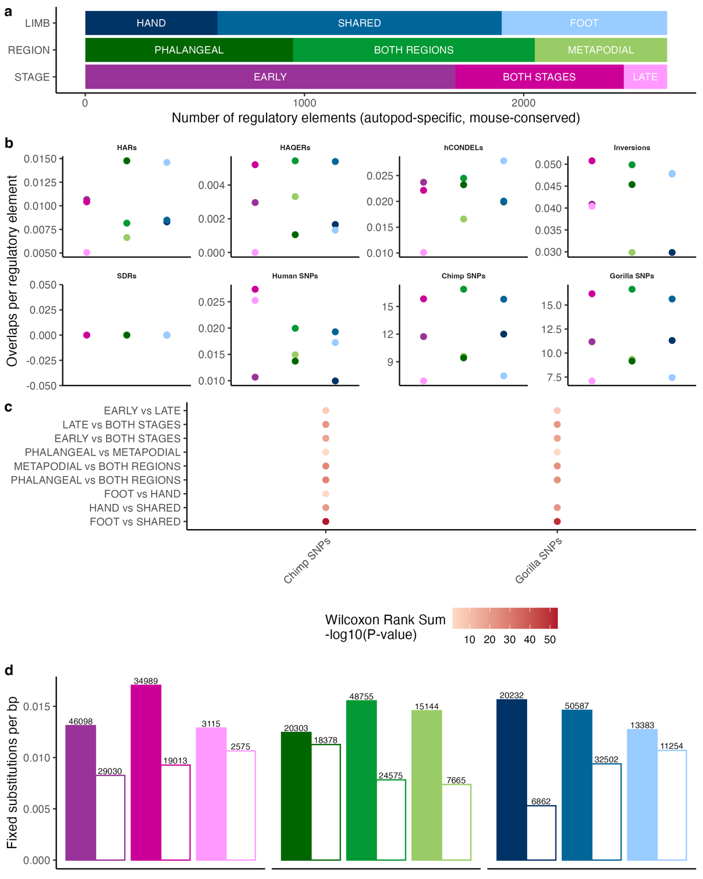Extended Data Fig. 9 Partitioning of evolutionary signals across human-mouse conserved autopod elements
a, division of regulatory elements that are autopod-specific and have accessibility in both human and mouse by the specificity of accessibility in limb type, proximal-distal region, or developmental stage. b, enrichment of each regulatory element set for HARs, HAQERs, hCONDELs, human-specific inversions, human SDRs, as well as common variants (MAF > 0.05) in human, chimpanzee, and gorilla per base pair of sequence. c, statistical significance of enrichment differences between set pairs. Only comparisons with at least one statistically significant comparison are shown. d, number of fixed substitutions along the human (colored bars) and chimpanzee (white bars) lineages per base pair for each set. Total number of fixed substitutions are listed above each bar. Color scheme in b,d, is the same as in a.

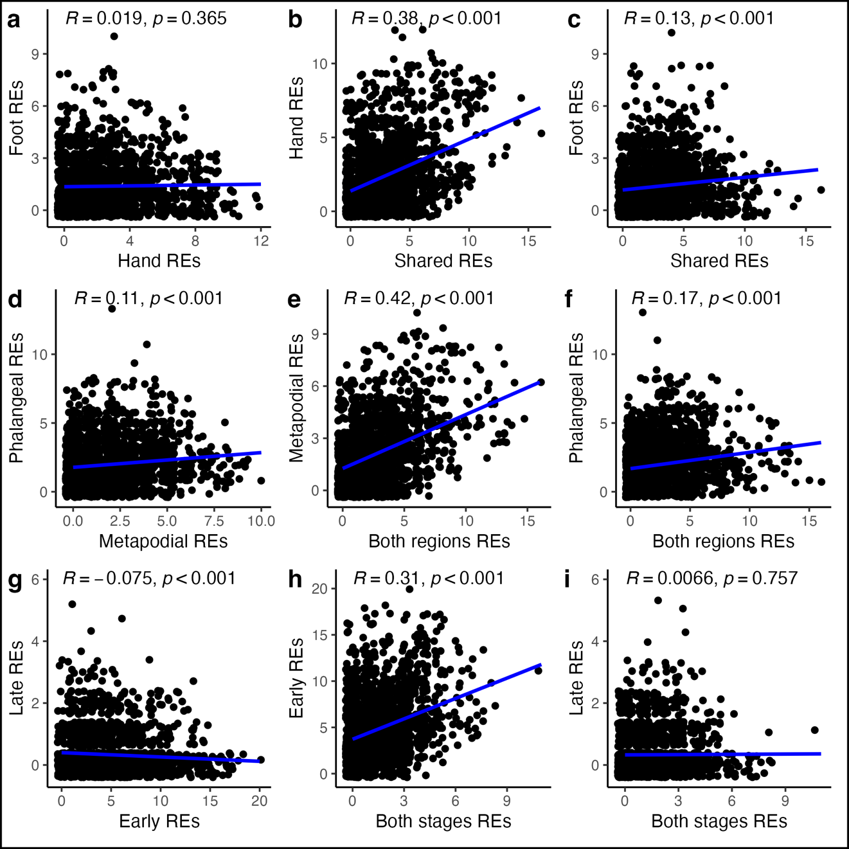
Extended Data Fig. 10 Shared regulation of expressed genes
Pairwise correlations of the number of autopod-specific regulatory elements within 500kb of expressed genes (minimum normalized expression ≧ 10 in at least one tissue) between sets. Sets are as seen in Fig 4a and include division by limb type (a-c), proximal-distal region type (d-f), and stage (g-i). Regression line shown in blue and stats for the Pearson correlation are shown. All points are jittered for clarity.

Table S1. Hominoid Measurements. Sheet 1: Summary statistics. Sheet 2: Raw measurement data for human samples, Sheet 3: Raw measurement data for chimpanzee samples. Sheet 4: Raw measurement data for gorilla samples.

Table S2. Human RNA-seq datasets. Sheet 1: Samples and sequencing information. Sheet 2: Pairwise and gradient differentially expressed genes (DEGs). Sheet 3: Weighted Gene Correlation Network Analysis module (WGCNA) assignments for the early timepoint. Sheet 4: WGCNA module assignments for the late timepoint. Sheet 5: Gene Ontology enrichment for early WGCNA modules. Sheet 6: Gene Ontology enrichment for late WGCNA modules. Sheet 7: Gene Ontology enrichment for all identified DEGs. Sheet 8: DEGs when comparing early and late samples. Sheet 9: Gene Ontology enrichment for all DEGs identified between early and late samples. Sheet 10: Pairwise and gradient differentially expressed genes (DEGs) for only digits I, III, V at each timepoint.

Table S3. Human ATAC-seq datasets. Sheet 1: Samples and sequencing information. Sheet 2: Peak counts for all human tissues. Sheet 3: GREAT enrichments for autopod-specific regulatory element sets. Sheet 4: TF motif enrichments for pairs of autopod-specific regulatory element sets. Sheet 5: All regulatory elements identified after brain filtering, including genomic coordinates (hg38), list of tissues with accessibility, and overlaps with genomic features, other human skeletal ATAC-seq, and mouse autopod ATAC-seq data.

Table S4. Mouse RNA-seq datasets. Sheet 1: Samples and sequencing information. Sheet 2: Pairwise differentially expressed genes (DEGs). Sheet 3: Weighted Gene Correlation Network Analysis (WGCNA) module assignments. Sheet 4: Gene Ontology enrichment for WGCNA modules.

Table S5. Mouse ATAC-seq datasets. Sheet 1: Samples and sequencing information. Sheet 2: Peak counts for all mouse tissues. Sheet 3: GREAT enrichments all identified mouse autopod regulatory elements. Sheet 4: All mouse regulatory elements identified after brain filtering, including genomic coordinates (mm10) and list of tissues with accessibility. Sheet 5: All mouse regulatory elements from sheet 4 lifted over to hg38.

Supplementary References

1. de Bakker, B. S. et al. An interactive three-dimensional digital atlas and quantitative database of human development. Science (1979) 354, (2016).
2. Young, M. et al. The developmental impacts of natural selection on human pelvic morphology. Sci Adv 8, 1–24 (2022).
3. Gardner, E., OʼRahilly, R. & Gray, D. J. The Prenatal Development of the Skeleton and Joints of the Human Foot. J Bone Joint Surg 41, 847–876 (1959).
4. Gray, D. J., Gardner, E. & O’Rahilly, R. The prenatal development of the skeleton and joints of the human hand. American Journal of Anatomy 101, 169–223 (1957).
5. Ogden, J. A., Ganey, T. M., Light, T. R., Belsole, R. J. & Greene, T. L. Ossification and pseudoepiphysis formation in the ‘nonepiphyseal’ end of bones of the hands and feet. Skeletal Radiol 23, (1994).
6. Reno, P. L., McBurney, D. L., Lovejoy, C. O. & Horton, W. E. Ossification of the mouse metatarsal: Differentiation and proliferation in the presence/absence of a defined growth plate. Anatomical Record - Part A Discoveries in Molecular, Cellular, and Evolutionary Biology 288, 104–118 (2006).
7. Richard, D. et al. Functional genomics of human skeletal development and the patterning of height heritability. Cell 188, 15-32.e24 (2025).
8. Richard, D. et al. Evolutionary Selection and Constraint on Human Knee Chondrocyte Regulation Impacts Osteoarthritis Risk. Cell 181, 362-381.e28 (2020).
9. McLean, C. Y. et al. GREAT improves functional interpretation of cis-regulatory regions. Nat Biotechnol 28, 495–501 (2010).

