Table S1. Fit Statistics for Quadratic Growth Mixture Models (N=2420)
Fit Statistics | 1-Class | 2-Class | 3-Class | 4-Class | 5-Class | 6-Class | 7-Class
Number of Parameters | 7 | 12 | 17 | 22 | 27 | 32 | 37
LL | -12,651 | -12,598 | -12,575 | -12,565 | -12,561 | -12,551 | -12,547
AIC | 25,317 | 25,220 | 25,183 | 25,174 | 25,176 | 25,167* | 25,168*
BIC | 25,357 | 25,290 | 25,282* | 25,302 | 25,332 | 25,352 | 25,382
CAIC | 25,357 | 25,290 | 25,282* | 25,302 | 25,332 | 25,352 | 25,382
SABIC | 25,335 | 25,252 | 25,228* | 25,232* | 25,246 | 25,250 | 25,265
Entropy | 1.00 | 0.464 | 0.491* | 0.410 | 0.410 | 0.457 | .445
Note. LL = Log-likelihood. (C)AIC = (Corrected) Akaike Information Criterion. (SA)BIC = (Sample-Adjusted) Bayes Information Criterion. All information criteria are rounded to the nearest whole number. *model of best fit for each information criterion.

Figure S1. Well-being Confirmatory Factor Model (N= 3476)
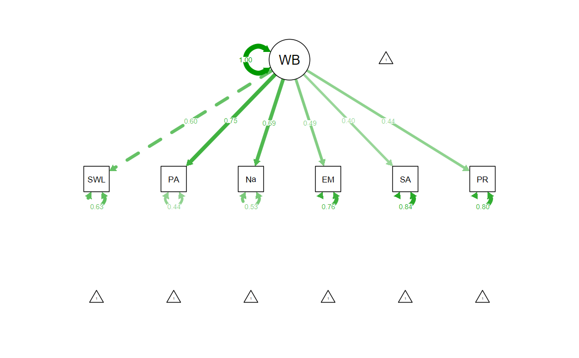
Note. Standardized loadings displayed in edge labels. WB=Well-being. SWL=Satisfaction with Life. PA=Positive Affect. Na=Negative Affect. EM=Environmental Mastery. SA=Self-acceptance. PR=Positive Relationships with Others.

Figure S2. Three-Class Model: Average Trajectories of Latent Class Grouped by Initial Well-being Level
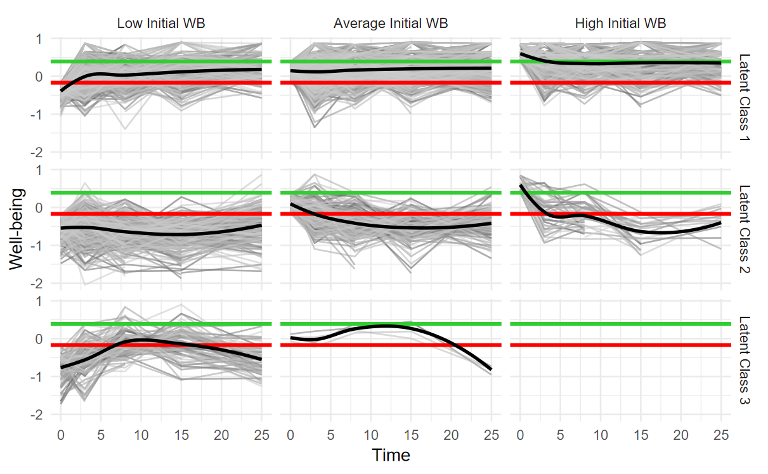
Note. Red line demarks 25th percentile. Green line demarks 75th percentile. Black lines plot the groups’ average trajectories.
Figure S3. Ambiguously Classified Participant Trajectories Alongside their Assigned Class Average Trajectory
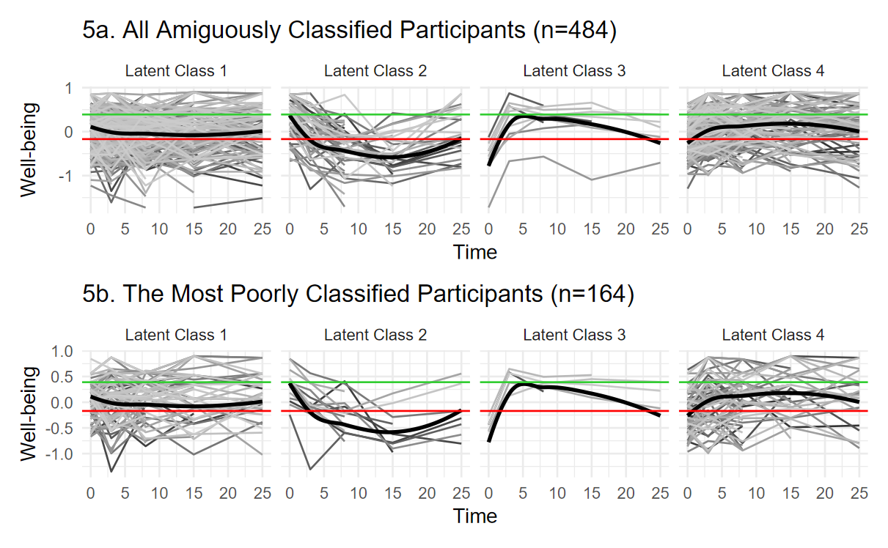
Note. Red line demarks 25th percentile. Green line demarks 75th percentile. Black lines plot the groups’ average trajectories.

Appendix SA
Patterns of association were consistent across the full and reduced samples and indicated that, although participant’s sex and age at baseline were not significant predictors of class membership, their baseline socioeconomic status and depressive symptom severity were (Table A1; Figure A1). People with lower baseline SES were more likely to experience declining well-being than persistent well-being; people with higher baseline SES were more likely to experience gradually increasing well-being than persistent well-being. People with more severe baseline depressive symptoms were significantly less likely to experience declining well-being than persistent well-being and were significantly more likely to experience gradually or rapidly increasing well-being than persistent well-being. For each one-unit increase in baseline depressive symptom severity, the odds of experiencing declining well-being (versus persistent well-being) decreased 6% and the odds of experiencing either rapidly or gradually increasing well-being (versus persistent well-being) increased by 16% and 42%, respectively.

Table A1. Multinomial Logistic Regression Model
 | Full Data (N=2420) |  |  |  | Reduced Data (N=1936)
Term | β | St.  Err | Exp(β) | 95% CI  for Exp(β) | β | St.  Err | Exp(β) | 95% CI  for Exp(β)
Class 2
Int. | -1.05** | 0.38 |  |  | -1.42** | 0.45
Age | -0.0098 | 0.005 | 0.99 | 0.98, 1.00 | -0.0010 | 0.0064 | 0.99 | 0.98, 1.00
Sex_{Female} | 0.19 | 0.17 | 1.21 | 0.87, 1.70 | 0.28 | 0.21 | 1.32 | 0.88, 1.99
SES_{LowerMC} | -0.42* | 0.21 | 0.65 | 0.43, 0.99 | -0.24 | 0.26 | 0.79 | 0.48, 1.30
SES_{UpperMC} | -0.67* | 0.22 | 0.51 | 0.33, 0.79 | -0.50 | 0.27 | 0.61 | 0.36, 1.03
SES_{Upper} | -0.78** | 0.29 | 0.46 | 0.26. 0.82 | -0.78* | 0.37 | 0.46 | 0.22, 0.94
CES-D | -0.06* | 0.026 | 0.94 | 0.89, 0.99 | -0.052 | 0.031 | 0.95 | 0.89, 1.01
Class 3
Int. | -9.17** | 0.74 |  |  | -5.84** | 0.82
Age | .0095 | 0.0095 | 1.01 | 0.99, 1.03 | 0.0019 | 0.011 | 1.00 | 0.98, 1.02
Sex_{Female} | -0.035 | 0.32 | .97 | 0.52, 1.80 | 0.062 | 0.36 | 1.06 | 0.52, 2.17
SES_{LowerMC} | .033 | 0.36 | 1.39 | 0.68, 2.83 | 0.076 | 0.40 | 1.08 | 0.49, 2.38
SES_{UpperMC} | 0.35 | 0.39 | 1.43 | 0.66, 3.06 | 0.043 | 0.42 | 1.04 | 0.45, 2.40
SES_{Upper} | -0.25 | 0.67 | 0.78 | 0.21, 2.90 | -0.59 | 0.80 | 0.56 | 0.12. 2.65
CES-D | 0.35** | 0.32 | 1.42 | 1.34, 1.51 | 0.37** | 0.036 | 1.45 | 1.35, 1.56
Class 4
Int. | -1.53** | 0.24 |  |  | -1.52** | 0.27
Age | -0.001 | 0.003 | 1.00 | 0.99, 1.00 | -0.0038 | 0.0036 | 1.00 | 0.99, 1.00
Sex_{Female} | 0.033 | 0.10 | 1.03 | 0.85, 1.26 | 0.075 | 0.11 | 1.08 | 0.86, 1.35
SES_{LowerMC} | 0.18 | 0.14 | 1.19 | 0.92, 1.56 | 0.19 | 0.15 | 1.21 | .089, 1.64
SES_{UpperMC} | 0.25 | 0.14 | 1.29 | 0.98, 1.69 | 0.14 | 0.16 | 1.15 | 0.84, 1.56
SES_{Upper} | 0.38* | 0.17 | 1.46 | 1.05, 2.03 | 0.36 | 0.19 | 1.44 | 0.99, 2.09
CES-D | 0.15** | 0.013 | 1.16 | 1.13, 1.19 | 0.17** | 0.015** | 1.18 | 1.15, 1.21
Note. MC=Middle Class. CES-D=depressive symptom severity score. * p<.05, ** p<.001

Figure A1. Predicted Probabilities of Well-being Trajectory Class
