Supplemental Table 8

Gene # of Sites # of Significant Sites Mutation adjusted P-value Odds Ratio Confidence Interval
DBP1 34 7 S18L *, **, *** 0.00494 0 (0, 0.23977)
A147E *, ** 0.02228 0 (0, 0.44229)
K264R *, **, *** 0.00741 0 (0, 0.29164)
K403S *, ** 0.03250 0.09713 (0.00868, 0.58158)
Q577K *, ** 0.01044 0 (0, 0.35709)
G673K * 0.09809 0 (0, 0.72241)
V875A *, **, *** 0.00875 0.06517 (0.00573, 0.39389)

DBP2/EBP 14 3 K307E *, ** 0.01529 0 (0, 0.44229)
I422T *, **, *** 0.00305 0 (0, 0.29164)
R817G *, **, *** 0.00305 0 (0, 0.29164)

MSP1 192 7 M106F * 0.08986 0 (0, 0.35709)
Y330N * 0.08986 0 (0, 0.44229)
V533E * 0.08986 0 (0, 0.44229)
S547T * 0.08986 0 (0, 0.44229)
I648V * 0.08986 0 (0, 0.35709)
L1070F * 0.08986 0 (0, 0.44229)
Q1479E * 0.08986 0 (0, 0.44229)

RBP1a 44 14 E168K * 0.05065 0.11779 (0.01054, 0.70907)
K215Q *, ** 0.02524 0.09713 (0.00868, 0.58158)
S249R *, **, *** 0.00384 0 (0, 0.29164)
L289I *, **, *** 0.00319 0 (0, 0.23977)
M333V * 0.06347 0 (0, 0.72241)
V391A*, **, *** 0.00320 0 (0, 0.23977)
N362T * 0.05065 0.11779 (0.01054, 0.70907)
P523Q *, **, *** 0.00772 0 (0, 0.35709)
M552T *, **, *** 0.00384 0 (0, 0.29164)
R561G *, **, *** 0.00384 0 (0, 0.29164)
N603D *, **, *** 0.00772 0 (0, 0.35709)
N1644K *, ** 0.01602 0 (0, 0.44229)
I2830V *, ** 0.01602 0 (0, 0.44229)
H2749Y * 0.06347 0 (0, 0.72241)

RBP1b 22 2 C152Y *, ** 0.02703 0 (0, 0.35709)
T2842I * 0.09148 0 (0, 0.55761)

RBP2a 35 17 R220S *, ** 0.01075 0 (0, 0.35709)
D307V * 0.09702 0 (0, 0.97648)
E439G *, ** 0.15398 0.07982 (0.00709, 0.47869)
M512K *, **, *** 0.00045 0 (0, 0.16275)
N541S * 0.06426 0 (0, 0.72241)
K574T *, ** 0.01638 0 (0, 0.44229)
T612A * 0.09702 0 (0, 0.97648)
D616N * 0.09702 0 (0, 0.97648)
R933E *, ** 0.01075 0 (0, 0.35709)
I1072K * 0.08333 0.14298 (0.01279, 0.87123)
I1603T *, ** 0.01638 0 (0, 0.44229)
E2185Q * 0.08333 0.14298 (0.01279, 0.87124)
M2268K *, ** 0.02911 0 (0, 0.55761)
I2325R *, **, *** 0.00763 0 (0, 0.29164)
G2366D * 0.09702 0 (0, 0.97648)
N2406Y *, ** 0.02911 0 (0, 0.55761)
A2487V *, ** 0.02911 0 (0, 0.55761)

TRAg38 2 2 Q201P* 0.06483 0.17437 (0.01546, 1.08434)
V271E* 0.06483 0.17437 (0.01546, 1.08434)

* reject at the 0.10 significance level, ** reject at the 0.05 significance level, *** reject at the 0.01 significance level
Adjusted p-value based on FDR (Benjamini-Hochberg correction)

Supplemental Figure 1: Flowchart of filtering of epidemiological samples.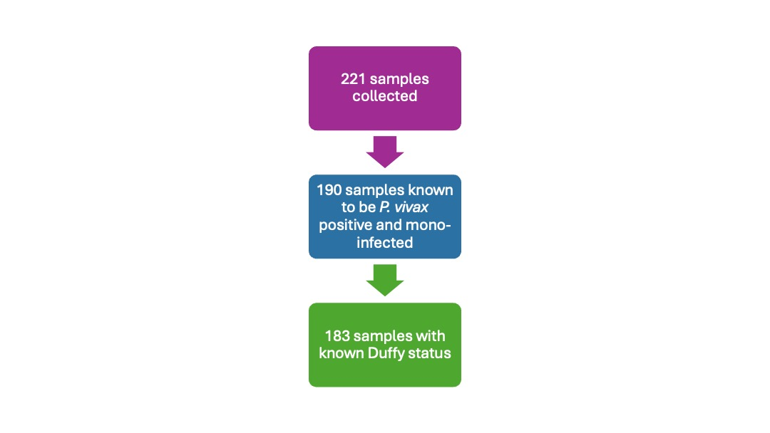
Supplemental Figure 2: Number of samples and parasitemia across collection sites of samples used in epidemiological analysis.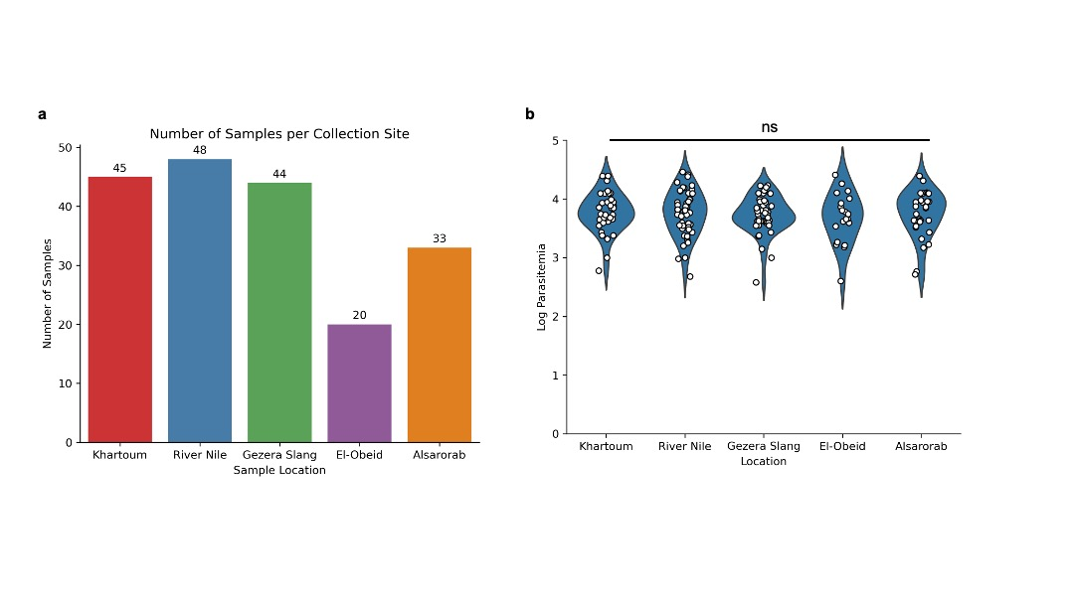
Supplemental Figure 3: Study sites of samples used in epidemiological analysis.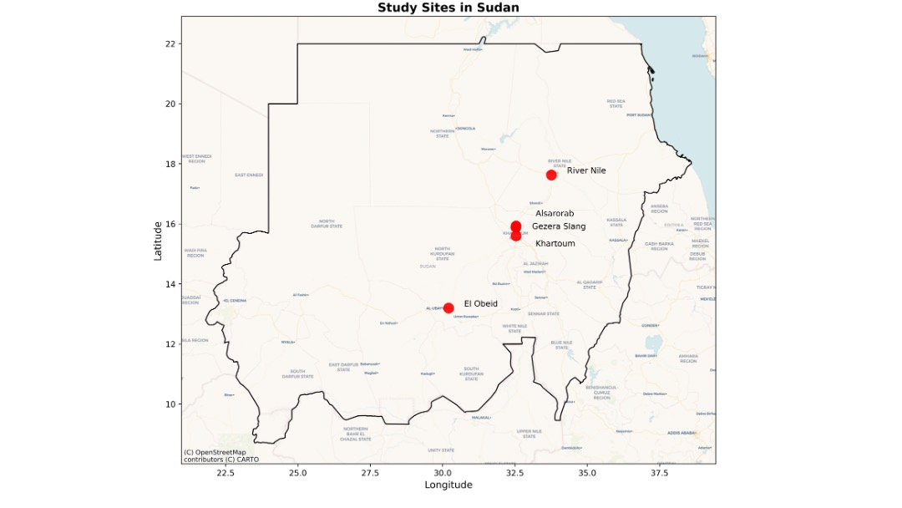Supplemental Figure 4: Parasitemia of samples across years of collection.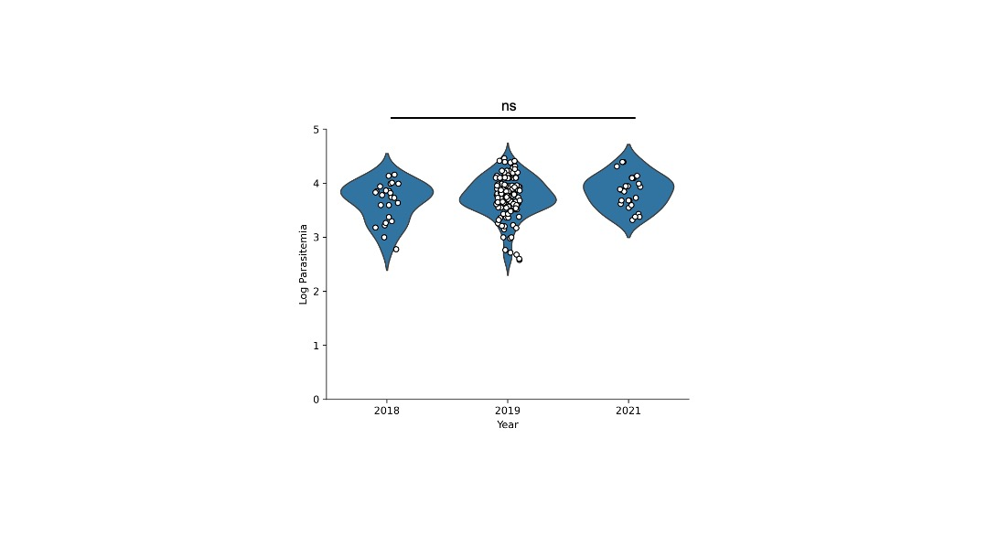
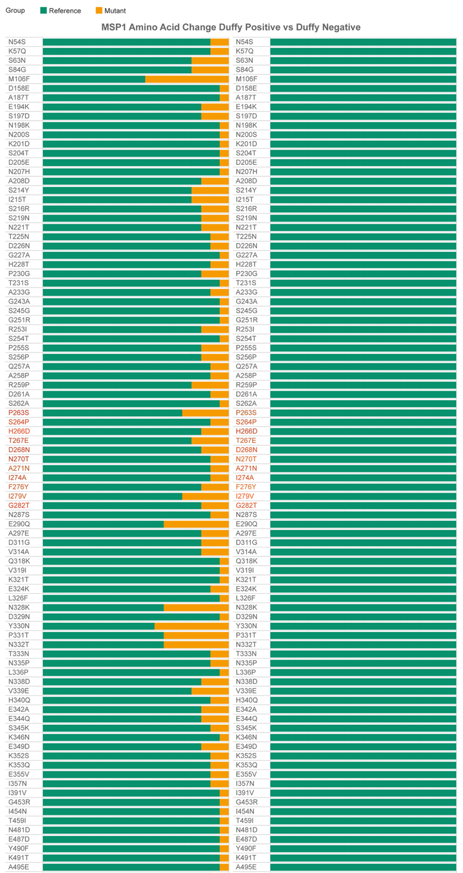
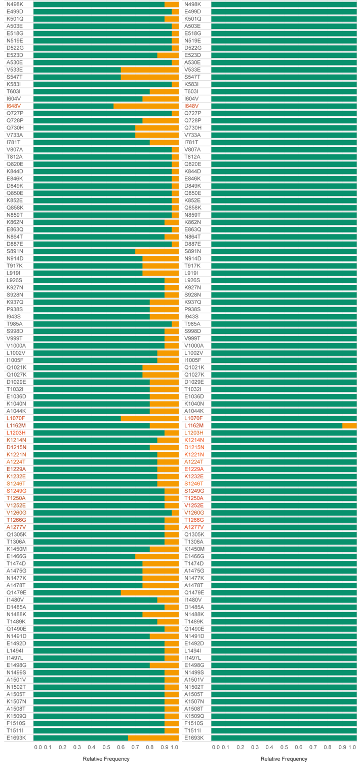
Supplemental Figure 5: Specific amino acid mutations found in the protein MSP1.

