Supporting Information (SI)

Molecular dynamics of the early stages of high temperature corrosion

Sung-Yup Kim†* and Christopher D. Taylor†
† Department of Materials Science and Engineering, Ohio State University
2041 College Road, Columbus, OH 43210

Corresponding Author
* kim.7715@osu.edu

Key Words: high temperature corrosion, ReaxFF, molecular dynamics

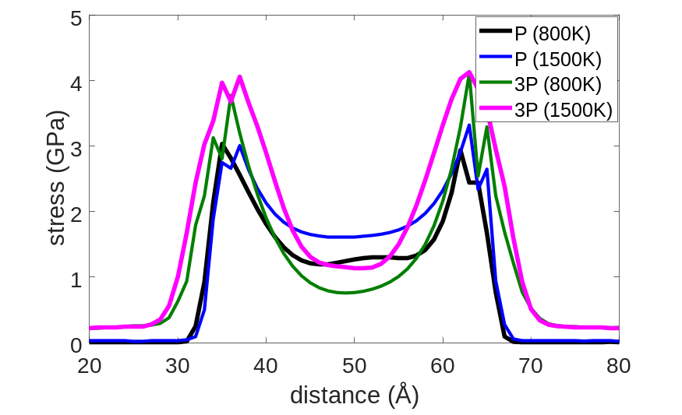
- Mean stress profile of bcc alloy (Alloy B1) at reference pressure and temperature (black), elevated temperature (blue), elevated pressure (green) and elevated pressure and temperature (pink) for 0~500 p
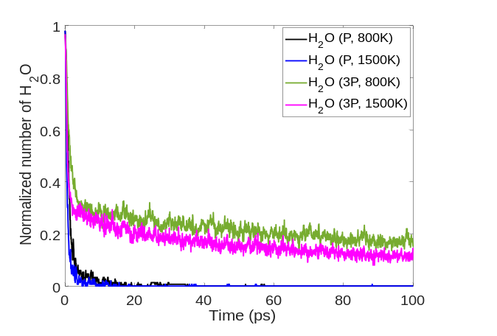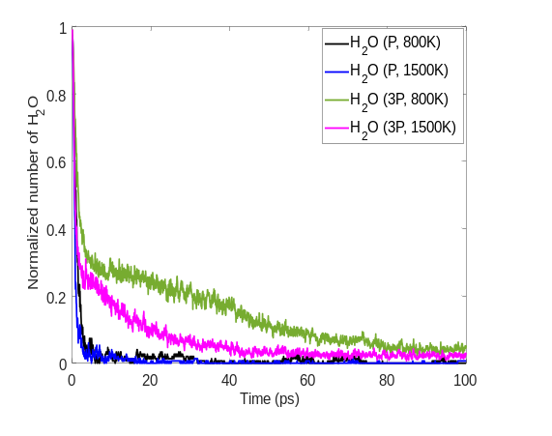
(b)Normalized number of H₂O with time for Alloy B1 (c) Normalized number of H₂O with time for Fe
Figure S1. Effect of stress gradient caused by pressure and temperature on H₂O adsorption. (a) Mean stress profile for bcc alloy (Alloy B1) at reference pressure and temperature (black), elevated temperature (blue), elevated pressure (green) and elevated pressure and temperature (pink) (b) Normalized number of H₂O with time for the 4 cases of bcc alloy (Alloy B1) and (c)pure Fe

Figure S1(a) shows how the stress profile evolves with changes in pressure and temperature. When the temperature is increased from 800K to 1500K, so does the atomic diffusivity, and this increased diffusivity makes the oxide scale thicker. When the pressure increases from reference (P) to higher state (3P), the peak stresses increase as is expected. (Reference (P): 50 O₂ and 150 H₂O, higher pressure (3P) state: 150 O₂ and 450 H₂O). Here, 50 O₂ and 150 H₂O gas pressure is approximately 10 atm, which is in the range of combustion chamber pressure. Thus, the temperature and pressure have distinct effect: temperature is responsible for diffusivity and increasing temperature increases the growth rate of the oxide scale, whereas pressure affects the maximum stress across the oxide scale. Furthermore, with increasing pressures, the stress profile moves outward, effectively lowering the stress gradient compared to the reference state. The reduced stress at higher pressures can be understood from a thermodynamic argument: The heat of formation of the metal oxide (Al₂O₃, Cr₂O₃ and Fe₂O₃) becomes more negative at higher pressures, and the heat of formation difference between Al₂O₃, Cr₂O₃ and Fe₂O₃ becomes larger, so there becomes a greater thermodynamic driving force for Al and Cr to segregate to the surface. The elemental segregation reduces the interfacial stress gradient, thus lowering the interfacial reactivity towards H₂O adsorption and dissociation. Figure S1(b) shows the change in the normalized number of H₂O molecules with time for the bcc alloy. When the pressure increases from (P) to (3P) at 800K, the reaction rate of H₂O decreases significantly, despite an expectation that the amount of collisions, and therefore reactions, will be greater. For the increased pressure (3P) and high temperature (1500K) case, the number of H₂O is a little bit smaller than (3P, 800K) case but the rate of reaction is the same. This can be interpreted as follows: Up to 5 ps, the H₂O numbers decreases very rapidly for all four cases since the stress gradient is not yet influenced by the emergent scale. From 5 ps, the reactivity of the H₂O molecules suddenly becomes reduced for the two high pressure cases because the lower stress gradient is achieved from the surface segregation. Once a lower stress gradient is achieved at the surface, H₂O reaction rate does not depend on temperature.
On the contrary to the alloy case, the higher pressure applied to pure Fe does not affect H₂O reaction rate much, although it does slow down slightly (Figure S1(c)). Also the H₂O reaction rate is sensitive to temperature even after a relatively lower stress gradient is made because this ‘lower’ stress gradient of pure Fe is still steep compared to that of the alloy materials. Higher pressure makes the peak stress in the oxide scale larger compared to a lower pressure since the higher pressure increases the rate of collisions with the surface as shown in Figure S1(a). The lower stress gradient and lower diffusivity at higher pressure makes it difficult for chemical species to adsorb and diffuse into the metal. Higher temperature does not increase the peak stress in the oxide scale, while higher temperature makes it easier for chemical species to adsorb on to the metal species and to diffuse into the metal, making thicker oxide scales. In short, the higher pressure makes the peak stress larger, and the higher temperature makes the oxide scale thicker

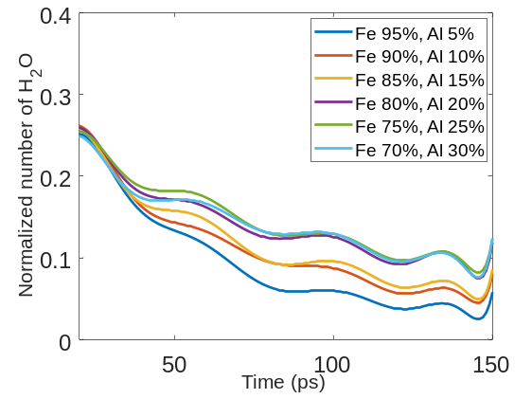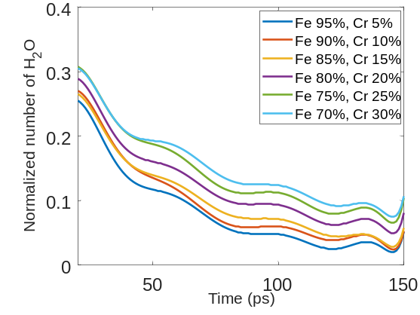
(a)Number of H₂O varying Al percentage for Fe/Al alloy (b)Number of H₂O varying Cr percentage for Fe/Cr alloy

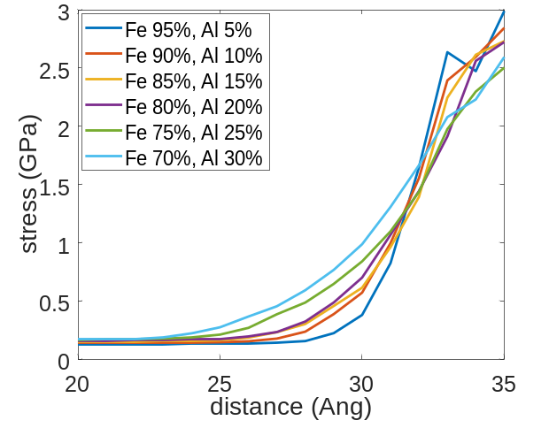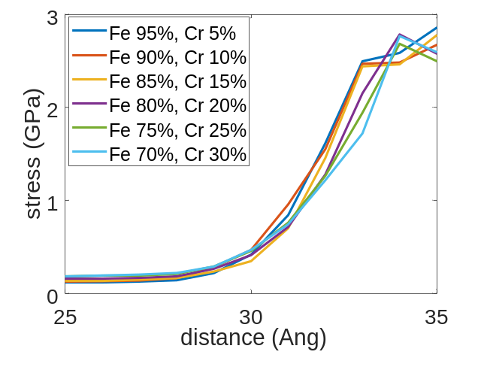
(c)Stress profiles varying Al percentage for Fe/Al alloy (d)Stress profiles varying Cr percentage for Fe/Cr alloy
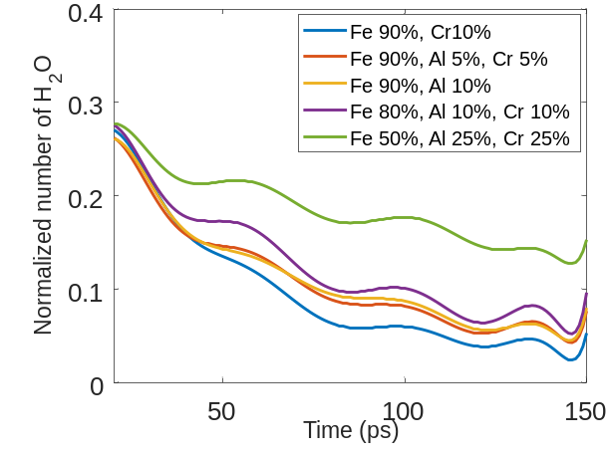
(e)Number of H₂O varying Al and Cr percentage
Figure S2. Effect of stress gradient caused by alloy composition on H₂O adsorption. (a)Normalized number of H₂O with time varying Al percentage for Fe/Al bcc alloy. (b)Normalized number of H₂O with time varying Cr percentage for Fe/Cr bcc alloy. (c)Mean stress profile varying Al percentage for Fe/Al bcc alloy. (d)Mean stress profile varying Cr percentage for Fe/Cr bcc alloy. (e)Number of H₂O with time varying Al and Cr percentage for Fe/Al/Cr alloy. Each case has 150 O₂ and 450 H₂O

Figure S2(a) and (b) shows how binary alloying affects H₂O adsorption by considering variations in only the Al percentage and Cr percentage, respectively. As the portions of Al and Cr increase, the rate of H₂O reaction with the surface slows down. The reduction in H₂O reaction rate is correlated again with the reduction in stress gradient at the surface. Figures S2(c) and (d) show that the stress gradient decreases with increasing Al or Cr composition, and this is directly related to the H₂O reaction rate. Although there are not many differences between the Al and Cr effects on the initial stages of H₂O adsorption and reaction, a few notable behaviors are observed. For the Fe-Al alloy, in Figure S2(a), a relatively big difference is observed between Al 5% and Al 10%. The surface segregation of Al is more significant at Al 10%. (Figure S3 of S.I.). On the contrary, a noticeable surface segregation does not happen for the Fe-Cr alloy system (Figure S4 of S.I.) within the timescales of the molecular dynamics simulations performed: the H₂O reaction profiles between the six variations in Cr content of the Fe-Cr alloys is minimal. Another observation is that there is considerable difference between the reactivities of Al 15% and Al 20% in Figure S2(a) and a somewhat more noticeable change in reactivity profile between Cr 15% and Cr 20% in Figure S2(b). This transition indicates that thresholding points exist for the influence of alloying. For Al, this threshold behavior appears at 15% (7.9% weight pt.) and for Cr it occurs around 15%(14.1% weight pt.). This observation is consistent with the experimental result¹ showing the minimum Al content for forming a passive film on binary Fe-Al at 25 °C is 15 at.% and passivation improves up to 25 at.% in 0.0126 M H₂SO₄. Rifai et al.² indicated that the critical threshold of Cr content required for establishing a protective layer by self-passivation in binary Fe-Cr alloy is microstructure dependent and can be reduced by grain size reduction to a sub-micron scale. They found that ultra-fine-grained Fe-Cr alloys with subcritical chromium content for passivation (8% and 10% Cr) was found to exhibit passivity and was resistant to corrosion in an aqueous 0.6 mol/L NaCl solution by experimental method. In Figure S3 and S4 of S.I., it can be seen that, in either binary alloy system, much more Al or Cr is segregated to the surface by oxidation for 20% -30 % cases compared to 5-15%. Both Al or Cr affect the stress gradient at the surface of alloy and reduce the rate of H₂O reaction. Figure S2(e) compares the rate of H₂O reaction for the 5 different alloy compositions. Al is more efficient than Cr in terms of slowing down the reaction with H₂O. For the 4 cases below the thresholding percentage of 15% of Al or Cr, there is very little difference in the surface reactivity. But for cases above the thresholding point (Fe 50% Al25% Cr25%), the H₂O reaction rate is dramatically decreased.
Revisiting Figure S2(a), the three cases of higher Al content (Al 20%, Al 25% and Al30%) are almost equivalent, which means that, beyond 20% Al, the reaction does not decrease with addition of more Al. Though a sufficient amount of Al segregates to the surface for all of these three cases, the gradient of the Fe distribution is very steep (Figure S3 (d)~(f) of S.I.) compared to the ternary alloy element distribution at the surface in Figure 3(a). The low gradient of the metal elemental distribution is directly correlated to the to lower stress gradient, which results in a slower rate of reaction with H₂O. For the Fe-Al binary alloy, adding Al alone to Fe is not the most efficient way to decrease the stress gradient significantly at the surface. To obtain a gradual elemental distribution profile and lower the stress gradient significantly at the surface during oxidation, a third element is needed, such as the selection of Cr in this study³. Hence, our calculations suggest there is a synergy between the use of Al and Cr for alloying with steel, at least as far as concerning reducing the rate of oxidation in the early stages.

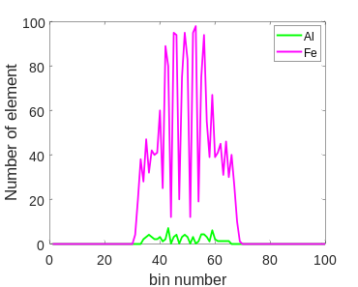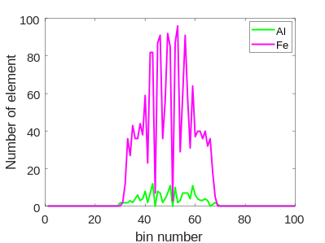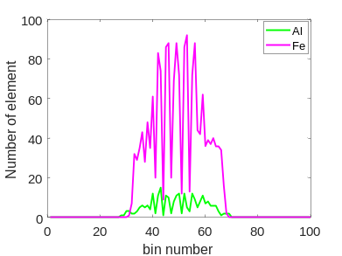
- Fe95% Al5% (b) Fe90% Al10% (c) Fe85% Al15%
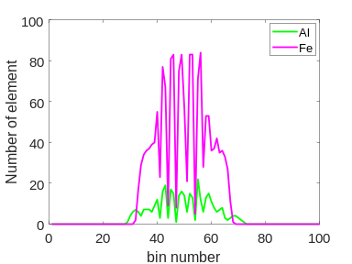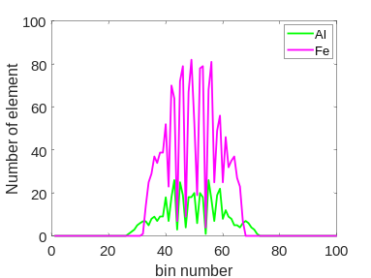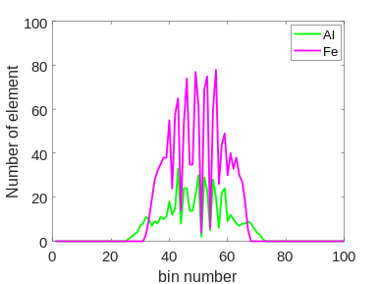
(d) Fe80% Al20% (e) Fe75% Al25% (f) Fe70% Al30%
Figure S3. Element distribution for Fe/Al binary alloy varying Al percentage during oxidation. (0 -0.5ns, 800K) Each case has 150 O₂ and 450 H₂O.

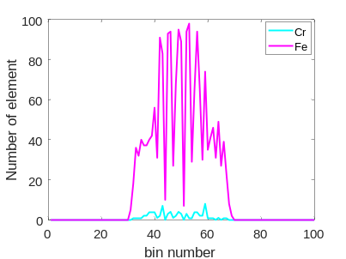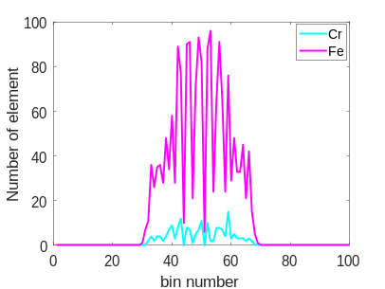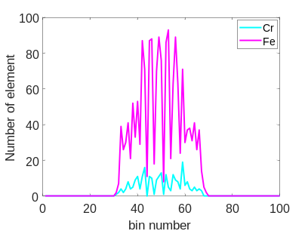
- Fe95% Cr5% (b) Fe90% Cr10% (c) Fe85% Cr15%
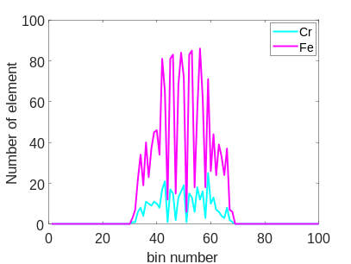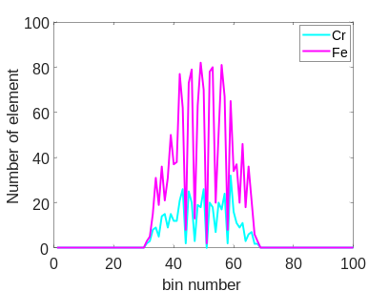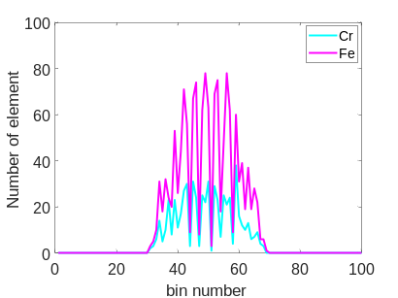
(d) Fe80% Cr20% (e) Fe75% Cr25% (f) Fe70% Cr30%
Figure S4. Element distribution for Fe/Cr binary alloy varying Cr percentage during oxidation. (0 -0.5ns, 800K) Each case has 150 O₂ and 450 H₂O.

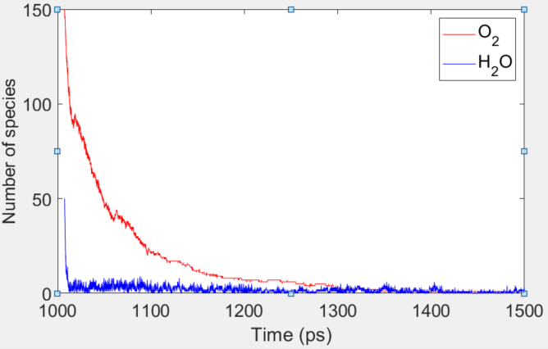
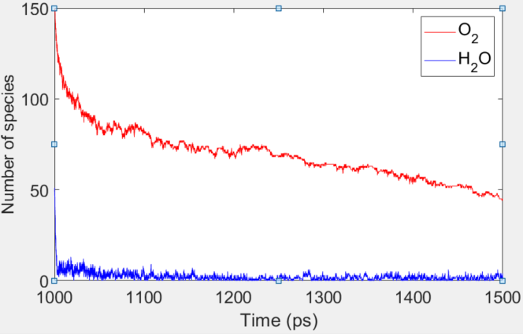
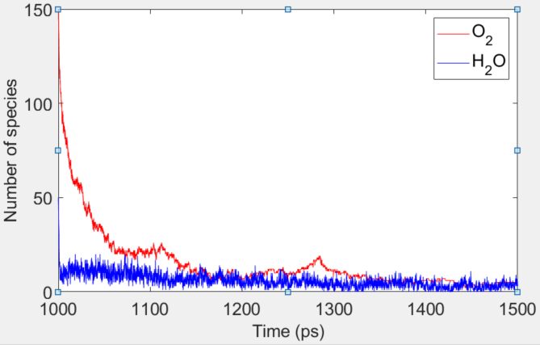
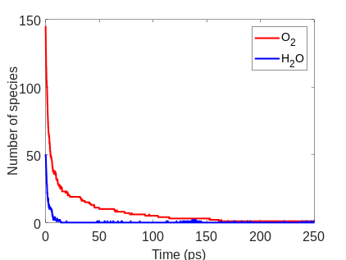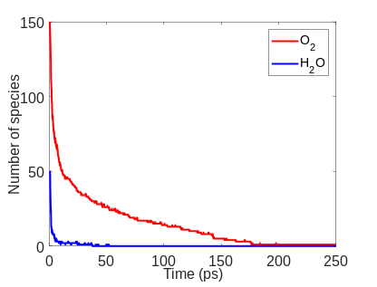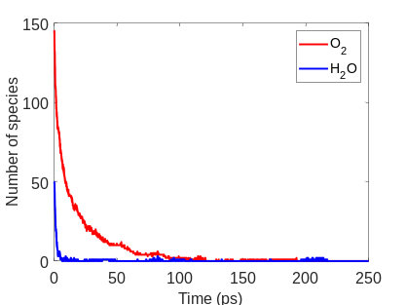
(a)Alloy B1(0 ~ 250 ps) (b)Alloy F1 (0 ~ 250 ps) (c) Fe (0~ 250 ps)
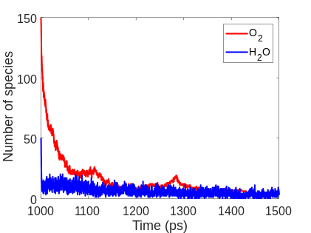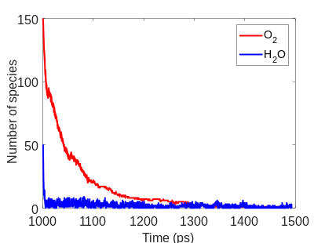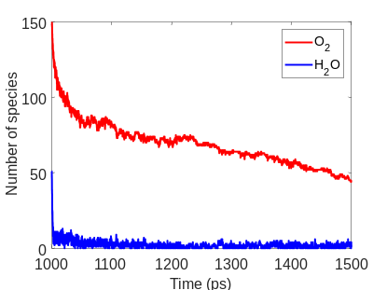
(d)Alloy B1(1.0 ~ 1.5 ns) (e)Alloy F1 (1.0 ~ 1.5 ns) (f) Fe (1.0 ~ 1.5 ns)
Figure S5. (a)Number of H₂O and O₂ with time for Alloy B1(0 ~ 250 ps) , (b) Alloy F1(0 ~ 250 ps) , (c) pure Fe (0 ~ 250 ps) , (d) Alloy B1(1.0 ~ 1.5 ns), (e) Alloy F1(1.0 ~ 1.5 ns) and (f) pure Fe (1.0 ~ 1.5 ns), respectively. (O₂: H₂O=3:1, 800K).

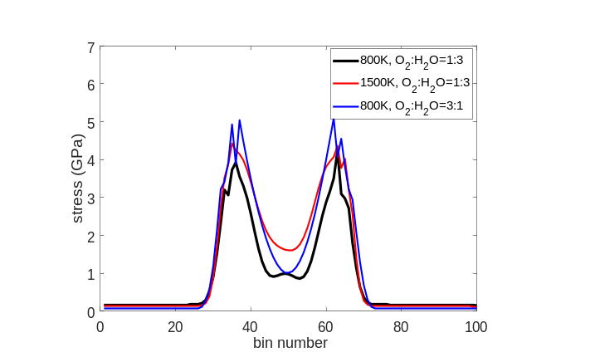
- Alloy B1
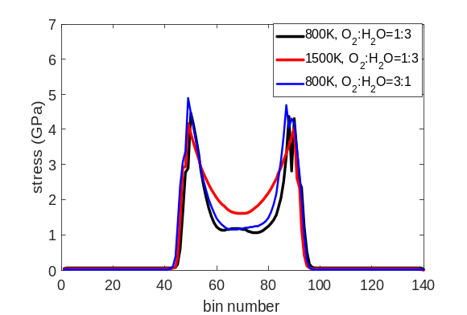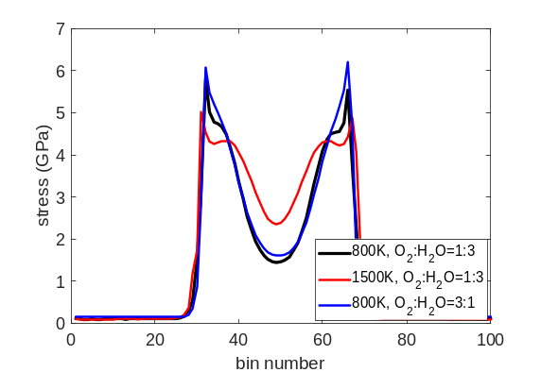
(b)Alloy F1 (c) Fe
Figure S6. Stress profiles for bcc, fcc alloys and pure Fe varying temperature and O₂: H₂O ratio. Each alloy is composed of 50% Fe, 25% Al and 25% Cr (1.0 ~1 .5ns)

Figure S6. shows stress profiles for bcc, fcc alloys and pure Fe at different temperatures and changing O₂:H₂O ratios. When the temperature is raised from 800K to 1500K, the thickness of the oxide scale is increased for all the cases. For the case of (800K, O₂: H₂O=3:1), peak stress and oxide scale thickness of bcc alloy increased compared to the case of (800K, O₂: H₂O=1:3), which indicates that bcc alloy is the most vulnerable to the oxygen rich environment.
Table S1. summarizes the quantified peak stresses, stress gradients, and the summation of the atomistically resolved stresses in the oxide scale for the metals under 3 different conditions. For (800K, O₂: H₂O=1:3) case, bcc alloy is the top ranking metal in terms of every evaluation criteria shown in Table S1. For (800K, O₂: H₂O=3:1) case, peak stress and summation of stress are lowest in value for the fcc alloy while the stress gradient is lowest for bcc alloy. Therefore, the fcc alloy ranks better than the bcc alloy for these criteria. For (1500K, O₂: H₂O=1:3) case, the bcc alloy is comparable to the fcc alloy. Overall, the alloyed material responds better to oxidation than the pure Fe for each of these criteria under every condition, and the bcc alloy is stronger in a H₂O rich environment whereas the fcc alloy is better in the O₂ rich environment.

Table S1. Peak stresses and stress gradient at the surface of the oxide scales, and summation of stresses in the oxide scales for the 3 structures varying temperature and O₂: H₂O ratio (1.0 ~ 1.5ns)
Metal | Peak stress | Stress gradient | Summation of stresses
Alloy B1 (800K, O₂: H₂O=1:3) | 3.9 GPa | 0.45 GPa/Å | 76.2 GPa
Alloy F1 (800K, O₂: H₂O=1:3) | 4.5 GPa | 0.86 GPa/Å | 78.5 GPa
Fe (800K, O₂: H₂O =1:3) | 5.8 GPa | 1.13 GPa/Å | 126.8 GPa
Alloy B1 (1500K, O₂: H₂O=1:3) | 4.4 GPa | 0.60 GPa/Å | 111.5 GPa
Alloy F1 (1500K, O₂: H₂O=1:3) | 4.2 GPa | 0.82 GPa/Å | 116.3 GPa
Fe (1500K, O₂: H₂O=1:3) | 5.0 GPa | 1.20 GPa/Å | 148.6 GPa
Alloy B1 (800K, O₂: H₂O=3:1) | 5.1 GPa | 0.60 GPa/Å | 112.8 GPa
Alloy F1 (800K, O₂: H₂O=3:1) | 4.9 GPa | 0.80 GPa/Å | 93.0 GPa
Fe (800K, O₂: H₂O=3:1) | 6.1 GPa | 1.47 GPa/Å | 129.4 GPa

References

1 Peng, J. et al. Influence of Al content and pre-oxidation on the aqueous corrosion resistance of binary Fe-Al alloys in sulphuric acid. Corrosion Science 149, 123-132, 2018; doi:10.1016/j.corsci.12.040 .
2 Rifai, M., Yuasa, M. & Miyamoto, H. Enhanced Corrosion Resistance of Ultrafine-Grained Fe-Cr Alloys with Subcritical Cr Contents for Passivity. Metals 8, 10, 2018;doi:10.3390/met8030149 .
3 Airiskallio, E. et al. High temperature oxidation of Fe-Al and Fe-Cr-Al alloys: The role of Cr as a chemically active element. Corrosion Sci. 52, 3394-3404, 2010;doi:10.1016/j.corsci.2010.06.019.

