Appendices
Appendix A Morphological distinction among old neighbourhoods in Chengdu
Urban block type | - Hutong | - Linli | - Jiefang
Urban form | 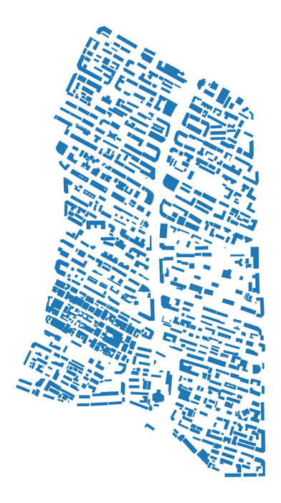 | 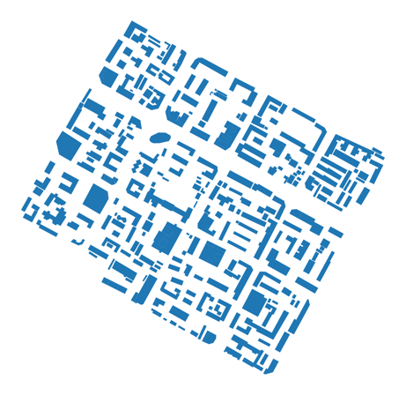 | 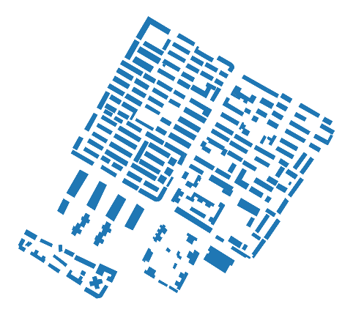
Description | Elongated grid-like arrangement with irregularly shaped blocks | Uniform, squared layout with  evenly sized blocks | Characterized by larger rectangular blocks, indicating a more  spacious urban layout.
Urban block type | - Danwei Compound | - Riverside Xiaoqu | - Non-riverside Xiaoqu
Urban form | 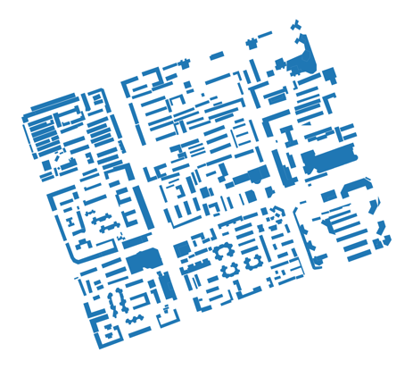 | 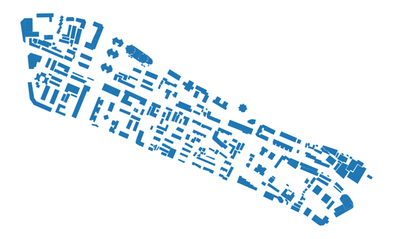 | 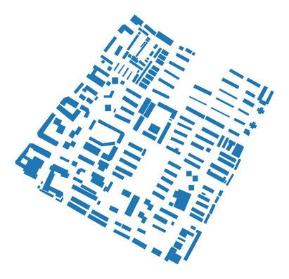
Description | A mix of large rectangular blocks and smaller irregular blocks, indicating varied urban density. | Elongated, irregular blocks,  Suggesting a linear and varied urban structure | Large, evenly spaced rectangular blocks, indicating a structured and spacious urban layout.

Appendix B Indicators for escalating socio-cultural wellbeing
Factors | Types | Place making requirements | QoL aspects addressed | Supporting literatures
1.Legibility | Mixture of both aspects | a) People’s familiarity with the space they occupy  b) Measurement of cultural human-touch signs. | Social connectivity,  Psychological security | CABE (2006)  Herzog & Leverich (2003)  Bruns & Chamberlain (2019)  Alexander, Ishikawa & Silverstein (1977)  Bombo Naya et al. (2022)  Askarizad & He (2022)
2.Diversity of use and activities | Mixture of both aspects | a) Adaptability and extensibility of space  b) Suitability of space layout  c) Versatility of space  d) Perceived interestingness and attractiveness of space | Social connectivity,  Psychological health status,  Physical security | Peinhardt & Storring (2019)  CABE (2006)  Mehta (2014)  Pena & Parshall (2012: p.84)  Ardeshiri, Esteghlal & Etesam (2016)  Mayor of London (2020: p.20)  Neighbors, Foster & Fossos (2013: p.323)
3.Space accessibility | Mixture of both aspects | a) Levels of entrance control  b) Levels of human-centric design of walkways | Social connectivity, Environmental quality,  Public services & amenities | CABE (2006)  Architecture Design (2024)  Chitrakar, Baker & Guaralda (2022)  Nemeth & Schmidt (2011)  Hodgson, Page & Tight (2004)
4.Surveillance | Mixture of both aspects | a) Density of retail stores and street vendors distribution on a street  b) Levels of visual contact from nearby residential buildings  c) Frequency of people using the public space  d) Frequency of a security patrol | Social connectivity,  Public services & amenities,  Physical security,  Psychological security | Jacobs (1961)  Sim & Gehl (2019)  Saelens, Sallis and Frank (2003)  UVS Group (2024)  Carmona et al. (2010)
5.Ease of movement | Mixture of both aspects | a) Levels of road flatness  b) Accessible transit nodes  c) Street connectivity & walkability  d) Perceived disruption in light levels | Public services & amenities,  Psychological health status,  Physical health status,  Physical security | Abulizi et al. (2016)  Streb (2022)  Hodgson, Page & Tight (2004)  Fonseca, Fernandes & Ramos (2022)  Gaglione, Cottrill & Gargiulo (2021)  Pearce, Matsunaka & Oba (2021)  Saelens et al. (2003)  Dong et al. (2023)  Sharifi (2019)  Huang, Chien & Siu (2017)
6. Diversity of people groups | User perceived | a) Age diversity  b) Gender equity  c) Ethnicity diversity | Social connectivity | Bombo Naya et al. (2020)  Collin et al. (2022)  Francis et al. (2012)  Mendez et al. (2020)
7. Meaningful social relationships | User perceived | Perceived significance of social relationship | Social connectivity,  Psychological security | Mendez et al. (2020)  Mehta (2014)  Qi, Mazumdar & Vasconcelos (2024)
8. Cultural self-awareness | User perceived | a) Existing traditions  b) Frequency of participating in traditional socio-cultural activities | Social connectivity,  Psychological health status | Y Studios (2020)  Alexander, Ishikawa & Silverstein (1977)  Degnen (2016)
9. Availability of commodities | User perceived | a) Urban forms affecting service setting  b) Availability of commodity services | Social connectivity,  Public services & amenities | Ardeshiri, Esteghlal & Etesam (2016)  Mehta (2014)
10. People participation & governance | User perceived | a) Levels of participation in decision-making  b) Levels of governance involvement | Psychological health status | Cihanger (2018)  Lampert et al. (2021)  Mehta (2014)  Bombo Naya et al. (2023)  Francis et al. (2012)  Hinrich & Johnston (2020)
11. Public space management & maintenance | User perceived | a) Greenery growing conditions  b) Hygiene condition maintenance  c) Hygiene condition maintenance | Psychological health status | Diener & Mudu (2021)  Budge et al. (2022)  Utilities One (2023)
12. Delight & comfort | User perceived | User perceived happiness | Psychological health status | Gehl (2010)  Mehta (2014)  Gasper (2010)  Schaafsma (2020)
13.Psychological inclusiveness | User perceived | Perceived being included by environment | Psychological security | Zhou (2019)  Yeh, Huang & Chang (2022)
14. Availability of additional infrastructure & amenities | Architectural design principles | a) Walkability-enhancing facilities  b) Facilities for large gatherings  c) Facilities for socio-cultural activities | Social connectivity,  Public services & amenities,  Physical health status,  Physical security | Hodgson, Page & Tight (2004)  Adetunji (2018)
15. Availability of Green Infrastructure | Architectural design principles | Presence of greenery and ecological infrastructure | Social connectivity,  Environmental quality | Yu, Zhang & Shi (2024)  Palau-Salvador et al. (2019)  Exner & Schutzenberger (2018)  Kingsley et al. (2020)  Petrovic et al. (2019)

