Supporting Information for
Metatranscriptomic changes in the propionate pathway and carbohydrate enzyme revealed the rebalancing mechanism of rumen microbiota after CH₄ inhibition by 3-NOP
Yurong Cao^{1,2}, Shizhe Zhang^{1,2}, Qiushuang Li^{1,2},, Xiumin Zhang¹, Zhiliang Tan^{1,2}, Min Wang^{1,2}

¹ Key Laboratory for Agro-Ecological Processes in Subtropical Region, Institute of Subtropical Agriculture, Chinese Academy of Sciences, Changsha, Hunan, China
² University of Chinese Academy of Sciences, Beijing, China

Email: mwang@isa.ac.cn
Competing Interest Statement: None declared.
This PDF file includes:
Figures S1
Materials and methods
SI References

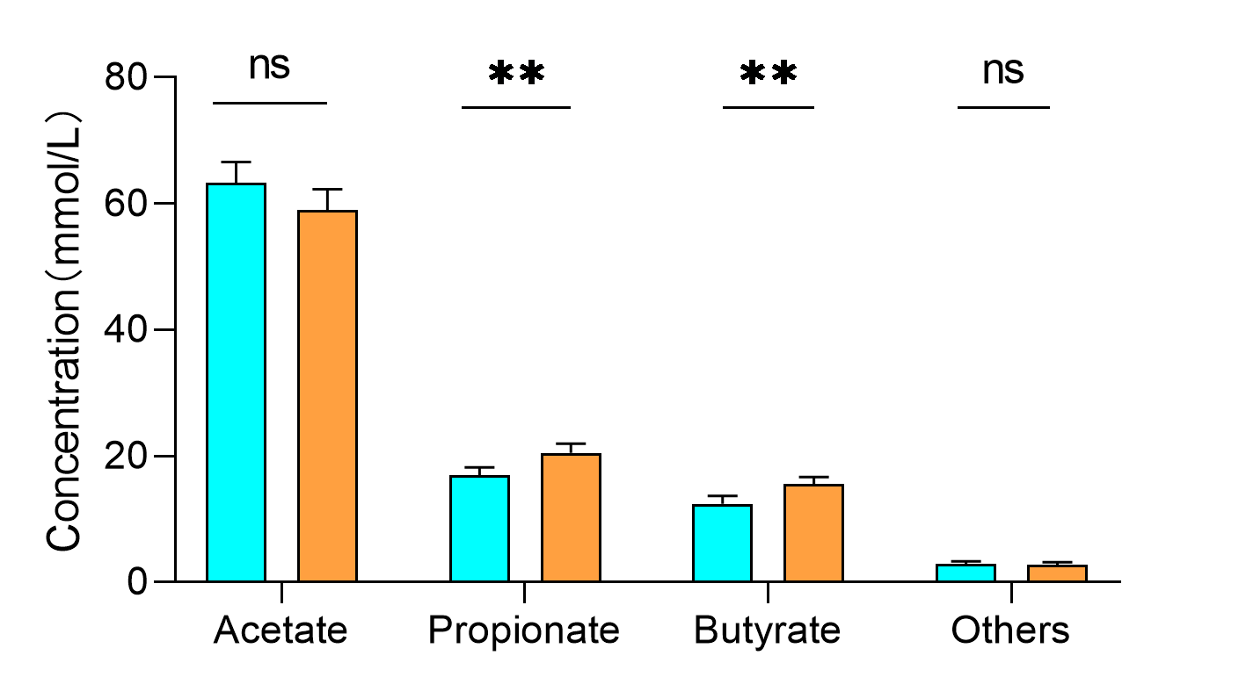
Additional Figures S1: Concentrations of individual volatile fatty acids (VFAs) in the 3-NOP and CON. * 0.05< P < 0.10, ** P < 0.05, n = 6.

Materials and methods
The present investigation serves was sanctioned by the Animal Care Committee under approval number W202502 at the Institute of Subtropical Agriculture, Chinese Academy of Sciences.
In vitro fermentation experiment
The rumen fluid in this experiment was obtained from three healthy fistula sheep. Subsequent to rumen fluid collection by 200 ml syringe, we preserve the obtained rumen fluid in a CO₂ gas-filled thermos flask and promptly transport it to the laboratory. Filter the fluid using 4 layers of gauze and reserve for further analysis.
The artificial rumen buffer was meticulously prepared following the methodology outlined by Menke et al[1]. Prior to the introduction of rumen fluid inoculation, the artificial rumen buffer solution was heated to 39.5°C utilizing a constant-temperature magnetic stirrer, while maintaining an anaerobic environment through continuous CO₂ introduction to ensure the buffer solution remained anaerobic (note: the resazurin color change to colorless). It usually takes about 1 hour to go from blue to colorless, the color process: from blue to red to colorless. Carbon dioxide is continuously introduced during this period.
The culture solution was prepared by combining 600 mL of filtered rumen fluid with 2400 mL of artificial rumen buffer in a volume ratio of 1:4. This procedure follows the guidelines outlined by Wang et al.[2] and other sources were consulted for in vitro fermentation culture procedures. Subsequently, 1.0g of substrate precisely has been prepared in advance and transferred into a 150 mL fermentation vessel preheated in a constant-temperature incubator at 39.5℃. Subsequently, the fermentation bottle was purged with CO₂ to induce anaerobic conditions. The 60 mL of the cultured solution was then added to each fermentation bottle using a syringe. These bottle were then positioned in a constant-temperature incubator. The rocker speed was set as 55 rpm, and there were 24 bottles in total. At 24h, 12 bottles were sampled, and the remaining 12 bottles continued to ferment until 48h.
To monitor fermentation progress, the exhaust pressure was regulated at 10.0 kPa, and the released gas was automatically directed into a gas chromatograph (Agilent 7890A, Agilent Inc., Palo Alto, USA) for CH₄ and H₂ concentration measurements. The gaseous sample was introduced via a six-port valve and detected using a thermal conductivity detector (TCD) in the chromatographic analysis. The analytical column employed was TDX-01 (3 mm diameter, 3m length), while the reference column was OV101 (3 mm diameter, 1m length). Argon served as the carrier gas at a flow rate of 30 mL/min, with an injection volume of 1 mL. The column and detector temperatures were maintained at 50℃ and 100℃, respectively, while the bridge current was set at 160 mA. Each batch underwent a 48-h fermentation cycle. The in vitro anaerobic fermentation apparatus comprised fermentation vessels, constant-temperature incubators, pressure monitoring systems, gas component analysis systems, and computerized CON systems. This setup facilitated fully automated gas production recording throughout the fermentation process[3].
Metatranscriptome sequencing and mapping
Total RNA was extracted from fermentation fluid samples using the TRIzol Reagent. The residual DNase was conducted using DNase I (Takara). Ribosomal RNA was depleted by using the Ribo Zero TM rRNA Removal Kit[4]. Metatranscriptome sequencing was conducted utilizing the HiSeq 2500 System by Illumina, generating paired-end reads with a length of 150 bp in both the forward and reverse directions. Metatranscriptome sequencing and analysis of rumen prokaryotic were undertaked by Shanghai Biozeron Biological Technology Co. Ltd. Read trimming and quality CON were performed using Trimmomatic (http://www.usadellab.org/cms/?page=trimmomatic (accessed on 28 September 2024)).
For the quality control of sequencing results, FASTP software is used to complete this study. The FASTP software streamlines the data processing workflow by scanning the data file, effectively integrating the functionalities of Fastqc, Cutadapt, and Trimmomatic into a single operation[5]. Post-sequencing, the removal of host DNA and adaptor contaminants yielded a collection of high-quality reads, averaging 13.5 gigabases of paired-end reads per sample, suitable for subsequent analysis. MEGAHIT (v1.2.9, minimum length threshold is 500) was used to predict the contigs from each sample[6], and Prodigal was used to predict the genes corresponding to each contig[7] and filter out coding sequences with a length less than 100. Non-redundant UniGene catalogs were constructed with 95% identity and 90% coverage by CD-HIT (https://www.bioinformatics.org/cd-hit (accessed on 28 September 2024))[8]. Then, all the sequences of samples were combined into a union set through CAT command and then redundancies were removed by CD-HIT[8].. Non redundant datasets were indexed by BWA INDEX (github-lh3/bwa: burrow Wheeler aligner for short read length alignment (see minimap2 for long read length alignment)). The clean reads of each sample was locally aligned to the non-award data set via BWA MEN . The abundance of each sample was then calculated using perl. In general, the metatranscriptomic reads of each sample were aligned to predicted Open Reading Frames (ORFs) identified in metagenomes, with Transcript Per Million (RPKM) values utilized for data analysis in this study.
Functional annotation and phylogenetic analysis
In order to assess the metabolic potential of rumen microbial communities, searches were conducted across metatranscriptomes, and against a localized protein database containing representative metabolic genes pertinent to reductant disposal reactions associated with carbohydrate degradation, amino acid synthesis, molecular hydrogen production and utilization, as well as key marker genes for essential metabolic pathways.
To clarify the composition of active microorganisms, species annotation of transcriptome sequences was performed using kranken2[9]. The reference database (https://github.com/DerrickWood/kraken2) was used to classify and annotate each sequence based on the K-mer present in each sequence. The transcriptome sequences of fungi and protozoa were extracted using the deep learning tools-GutEuk tool[10], and abundance calculations and differential analysis were performed on the two groups[11].
All UniGene catalogs were searched against NCBI non-redundant proteins (NR), String, and Kyoto Encyclopedia of Genes and Genomes (KEGG) databases using BLASTp, and their functions were inferred by the annotation of the sequence with the highest similarity. These searches were performed utilizing hidden Markov models (HMMs) and homology-based search strategies. Furthermore, gene annotations were cross-referenced with the KEGG (Kyoto Encyclopedia of Genes and Genomes) database to investigate carbohydrate metabolism[12]. This analysis involved HMM searches with default parameters, culminating in the aggregation of data based on the abundance of pathways at Level3 and Level2, together with the identification of KEGG Orthologs (KOs) implicated in volatile fatty acid production[12].
To investigate the enzymatic machinery associated with reductant disposal through electron transfer reactions pertinent to carbohydrate degradation and amino acid synthesis, crucial enzymes such as acetate production enzymes (Pta, Ld, Por), propionate production enzymes (Mdh, Fum, Frd, Sdh, Aarc, LcdA, LcdB, PC, meaA, Suc), and butyrate production enzymes (FadJ, FabV, Ptb, buk, atoA). These enzymes underwent annotation via hidden Markov model (HMM) searches against a localized protein database, except for SdhA and FrdA, which were annotated using BLAST against a customized database[13].
In order to investigate the expression of carbohydrate enzymes, this study predicted carbohydrate enzyme genes based on protein sequences using Run-dbcan V4 using dbCAN (carbohydrate enzyme gene database)[14]. And classify and organize cellulases, ligninases, hemicellulases, amylases, and fructosases. After aligning protein sequence annotation with expression abundance, we obtained the relative expression abundance of carbohydrate enzymes. Based on the classification of carbohydrate enzymes in the degradation of cellulose, hemicellulose, and lignin by Lin et al., we constructed a similar metabolic pathway diagram. NCBI-NR (October 2018; ~550M sequence) analysis of genes(marker genes and hydrogenases) for species classification and functional allocation was performed by the DIAMOND searches (v.2.0.4) based on the BLASTP search[15]. We created a classification map based on Lin et al., classification of carbohydrate-active enzymes in ruminal microorganisms of ruminant animals[16].
To figure out the response of rumen microbes to 3-NOP, the mRNA sequences were aligned to a database of ruminant microbial genomes (https://figshare.com/projects/RGMC/228963). RPKM values were used to represent the relative abundances of microorganisms. Sorted BAM files generated by SAMtools v1.9[17] were utilized for computing sample coverage using CoverM (v0.6.1, https://github.com/wwood/CoverM, contig mode for vOTUs and genome mode for MAGs) with parameters ‘-m TPM’[11]. The completeness and contamination of all bins were estimated using CheckM2 (v1.0.1), with the following criteria: >50% genome completeness, < 5% contamination, and > 50 estimated quality score (completeness-5×contamination). A total of 1717 MAGs were matched, including 59 MAGs for archaea and 1658 MAGs for bacteria. The distribution of the two key genes involved in lactate and succinate was aggregated and the MAGs corresponding to the LDH and sdhA/frdA genes in the assembled genome were curated and statistically analyzed at the class level to visualize the diagonal heatmap.
Quantification of select bacteria and methanogens using qPCR
In order to investigate the transcriptional differences of 3-NOP in fiber degrading bacteria, fungi, protozoa, and methanogenic archaea, qPCR quantification was performed in this experiment on three types of fiber degrading bacteria[18] (Fibrobacter succinogenes (F:GTTCGGAATTACTGGGCGTAAA, R:CGCCTGCCCCTGAACTATC), Ruminococcus albus (F:CCCTAAAAGCAGTCTTAGTTCG, R:CCTCCTTGCGGTTAGAACA), Ruminococcus flavefaciens (F:CGAACGGAGATAATTTGAGTTTACTTAGG, R:CGGTCTCTGTATGTTATGAGGTATTACC)), fungi[19] (F:GAGGAAGTAAAAGTCGTAACAAGGTTTC, R:CAAATTCACAAAGGGTAGGATGATT), protozoa[20] (F:GCTTTCGWTGGTAGTGTATT, R:CTTGCCCTCYAATCGTWCT), and methanogen[20] (F:GGATTAGATACCCSGGTAGT, R:GTTGARTCCAATTAAACCGCA)). This quantification was performed on LightCycler 480 (Roche Molecular Systems, Pleasanton, California) using SYBR and reference primers for qPCR detection. Absolute abundance is expressed as the copy number of 16S rRNA genes per milliliter of sample (log₁₀ copy number).
Statistical analyses
The rumen in vitro fermentation data were initially organized and compiled using Excel 2021. Subsequently, a one-way analysis of variance was conducted using JPM pro 13. The outcomes were presented as mean values accompanied by standard errors, with statistical significance denoted by P < 0.05, indicating a notable difference.
Visualization of histograms depicting variance in microbial populations and flow chart illustrating differential KEGG pathways was achieved using the Graphpad and AI (Adobe Illustrator). Differential analyses between predominant genera, species, carbohydrate enzyme gene and distinct KEGG pathways were conducted utilizing Wilcoxon rank-sum test method by the Wilcoxon rank-sum test in the JMP Pro software (JMP Pro version 13.2.1, SAS Institute, Cary, NC). Statistical significance was defined as P < 0.05 indicating significant difference, and 0.05 ≤ P < 0.10 indicating a trend of difference.

1. Menke KH, Raab L, Salewski A, Steingass H, Fritz D, Schneider W. The estimation of the digestibility and metabolizable energy content of ruminant feedingstuffs from the gas production when they are incubated with rumen liquor in vitro. The Journal of Agricultural Science. 1979;93(1):217-22.
2. Zhang X, Wang M, Wang R, Ma Z, Long D, Mao H, et al. Urea plus nitrate pretreatment of rice and wheat straws enhances degradation and reduces methane production in in vitro ruminal culture. J Sci Food Agric. 2018;98(14):5205-11.
3. Wang M, Tang SX, Tan ZL. Modeling in vitro gas production kinetics: Derivation of Logistic–Exponential (LE) equations and comparison of models. Animal Feed Science and Technology. 2011;165(3):137-50.
4. Gil JC, Hird SM. Multiomics Characterization of the Canada Goose Fecal Microbiome Reveals Selective Efficacy of Simulated Metagenomes. Microbiol Spectr. 2022;10(6):e0238422.
5. Chen S. Ultrafast one-pass FASTQ data preprocessing, quality control, and deduplication using fastp. Imeta. 2023;2(2):e107.
6. Li D, Liu CM, Luo R, Sadakane K, Lam TW. MEGAHIT: an ultra-fast single-node solution for large and complex metagenomics assembly via succinct de Bruijn graph. Bioinformatics. 2015;31(10):1674-6.
7. Hyatt D, Chen G-L, LoCascio PF, Land ML, Larimer FW, Hauser LJ. Prodigal: prokaryotic gene recognition and translation initiation site identification. BMC Bioinformatics. 2010;11(1):119.
8. Zhou Y, Yang Z, Liu J, Li X, Wang X, Dai C, et al. Crop rotation and native microbiome inoculation restore soil capacity to suppress a root disease. Nature Communications. 2023;14(1):8126.
9. Ye SH, Siddle KJ, Park DJ, Sabeti PC. Benchmarking Metagenomics Tools for Taxonomic Classification. Cell. 2019;178(4):779-94.
10. Yan M, Andersen TO, Pope PB, Yu Z. Probing the eukaryotic microbes of ruminants with a deep-learning classifier and comprehensive protein databases. Genome Res. 2025;35(2):368-78.
11. Aroney STN, Newell RJP, Nissen JN, Camargo AP, Tyson GW, Woodcroft BJ. CoverM: read alignment statistics for metagenomics. Bioinformatics. 2025;41(4).
12. Li QS, Wang R, Ma ZY, Zhang XM, Jiao JZ, Zhang ZG, et al. Dietary selection of metabolically distinct microorganisms drives hydrogen metabolism in ruminants. ISME J. 2022;16(11):2535-46.
13. Greening C, Geier R, Wang C, Woods LC, Morales SE, McDonald MJ, et al. Diverse hydrogen production and consumption pathways influence methane production in ruminants. ISME J. 2019;13(10):2617-32.
14. Huang L, Zhang H, Wu P, Entwistle S, Li X, Yohe T, et al. dbCAN-seq: a database of carbohydrate-active enzyme (CAZyme) sequence and annotation. Nucleic Acids Research. 2018;46(D1):D516-D21.
15. Buchfink B, Xie C, Huson DH. Fast and sensitive protein alignment using DIAMOND. Nature Methods. 2015;12(1):59-60.
16. Liang J, Zhang R, Chang J, Chen L, Nabi M, Zhang H, et al. Rumen microbes, enzymes, metabolisms, and application in lignocellulosic waste conversion - A comprehensive review. Biotechnology Advances. 2024;71:108308.
17. Li H, Handsaker B, Wysoker A, Fennell T, Ruan J, Homer N, et al. The Sequence Alignment/Map format and SAMtools. Bioinformatics. 2009;25(16):2078-9.
18. Koike S, Kobayashi Y. Develop and use of competitive PCR assays for the rumen cellulolytic bacteria: Fibrobactor succinogenes, Ruminococcus albus, and Ruminococcus flavefaciens. FEMS microbiology letters. 2001;204:361-6.
19. Lwin KO, Hayakawa M, Ban-Tokuda T, Matsui H. Real-Time PCR Assays for Monitoring Anaerobic Fungal Biomass and Population Size in the Rumen. Current Microbiology. 2011;62(4):1147-51.
20. Wallace RJ, Sasson G, Garnsworthy PC, Tapio I, Gregson E, Bani P, et al. A heritable subset of the core rumen microbiome dictates dairy cow productivity and emissions. Science Advances. 2019;5(7):eaav8391.

