Table S1 Description of the domains, subdomains and indicators for the operationalization of intrinsic capacity with CHARLS
Domains | Measurements | Tests | Criteria
Cognition | Mini-Mental State Examination, MMSE | Cognition orientation | If a participant’s score in either intelligence level or episodic memory is below one standard deviation for this dimension, they are assigned a score of 0; otherwise, they receive a score of 1.  The cognitive dimension score is the sum of these two scores, ranging from 0-2
Cognition | Mini-Mental State Examination, MMSE | Serial 7’s test
Cognition | Mini-Mental State Examination, MMSE | Drawing picture
Cognition | Mini-Mental State Examination, MMSE | Recall (immediate word recall + delayed word recall)
Psychological | Center for Epidemiological Studies Depression Scale-10 , CESD10 | 10 items of core symptoms of depression with following options  A. Rarely or none of the time (<1 day) = 0  B. Some or a little of the time (1-2 days) = 1  C. Occasionally or a moderate amount of the time (3-4 days) = 2  D. Most or all of the time (5-7 days) = 3  Items 5 and 8 were reverse coded.  Total score: 0-30 | If total score was  >=20, depressive disorder group = 0  10-19, depressive symptom group =1  <10, normal psychological status/non-depressive symptom = 2
Sensory | Vision | Near and distance vision, self-reported with Likert 5-scale  Near /distance vision: excellent/very good/ good = 0.5; fair = 0.25; poor = 0  Total score: Near vision + distance vision, 0-1  0, total or severe loss/alteration of vision = 0  0.25-0.75, moderate loss/alteration of vision = 0.5  1, normal or mild loss/alteration of vision = 1 | Total sensory score = Vision + hearing, 0-2  If total score was  0, total or severe loss/alteration of sensory = 0  0.5-1.5, moderate loss/alteration of sensory = 1  2, normal or mild loss/alteration of sensory = 2
Sensory | Hearing | Hearing problem, self-reported with Likert 5-scale  Hearing: excellent/very good/ good = 1; fair = 0.5; poor = 0
Vitality | Respiratory function | Peak breathing flow (average value of twice)  Male: 350L/min，if<=350=0；>350=1  Female: 220L/min, if<=220=0；>220=1 | Total sensory score = Respiratory function + Hand Grip strength, 0-2  If total score was  0, malnutrition  1, risk of malnutrition  2, normal nutritional status
Vitality | Hand Grip strength | Dominant hand strength (average value of twice)  Male: 36Kg，if <36=0；>=36=1  Female: 23Kg，if <23=0；>=23=1
Locomotion | Short Physical Performance Battery, SPPB | Chair stand test (five times repeated test)  Unable to complete or completes stands in >60 sec = 0  If chair stand time is 16.70 sec or more =1  If chair stand time is 13.70 to 16.69 sec = 2  If chair stand time is 11.20 to 13.69 sec = 3  If chair stand time is 11.19 sec or less = 4 | Total locomotion score = chair stand test + walking speed test + balance test, 0-12  If total score was  0-2, sarcopenia and cachexia = 0  3-9 possible sarcopenia = 1  10-12 robustness = 2
Locomotion | Short Physical Performance Battery, SPPB | Walking speed test (2.5 meters)  If time is more than 5.43 sec = 1  If time is 3.88 to 5.43 sec = 2  If time is 3.01 to 3.87 sec = 3  If time is less than 3.01 sec = 4
Locomotion | Short Physical Performance Battery, SPPB | Balance test (Side-by-side + Semi-Tandem + Tandem stand)  Side-by-side-stand/ Semi-Tandem Stand  If held for 10 sec = 1  Not held for 10 sec / Not attempted = 0  Tandem Stand  Held for 10 sec =2  Held for 3 to 9.99 sec = 1  Held for < than 3 sec / Not attempted = 0  Total balance test score = Side-by-side + Semi-Tandem + Tandem stand, 0-4
Total IC score level: 9-10 points=high and stable capacity, 5-8 points = declining capacity, 0-4 points = significant loss of capacity

Table S2 Association of ePWV, RFM and IC among older people in 2011~2015 across sex
 | ePWV |  | RFM
 | Model 1 | Model 2 | Model 1 | Model 2
Variables | B（95%CI） | B（95%CI） | B（95%CI） | B（95%CI）
Male
IC | -0.076 (-0.129~-0.022) * | -0.030 (-0.082~0.022) | 0.041 (0.027~0.056) ** | 0.027 (0.013~0.041) **
Cognition | -0.262 (0.067~0.139) * | -0.170 (-0.290~-0.051) * | 0.103 (0.067~0.139) ** | 0.042 (0.010~0.075) *
Psychological | -0.233 (-0.440~-0.027) * | -0.393 (-0.595~-0.191) ** | -0.129 (-0.188~-0.071) ** | -0.106 (-0.162~-0.049) **
Sensory | -0.024 (-0.041~-0.006) * | -0.022 (-0.040~-0.004) * | 0.005 (0.01~0.010) * | 0.006 (0.001~0.011) *
Locomotion | -0.074 (-0.132~-0.015) * | -0.056 (-0.117~0.005) | -0.016 (-0.030~-0.001) * | -0.021(-0.035~-0.006) *
Vitality
Respiratory function | -5.558 (-9.582~-1.534) * | -3.625 (-7.656~0.315) | 1.260 (0.098~2.423) * | 0.484 (-0.617~1.584)
Hand Grip strength | -0.136 (-0.406~0.133) | 0.021 (-0.270~0.311) | 0.139 (0.063~0.214) ** | 0.118 (0.040~0.197) *
Female
IC | -0.109 (-0.175~-0.043) * | -0609 (-0.130~-0.009) * | 0.026 (0.010~0.042) * | 0.015 (0.000~0.030) *
Cognition | -0.305 (-0.469~-0.142) ** | -0.171 (-0.308~-0.033) * | 0.082 (0.038~0.126) ** | 0.056 (0.017~0.095) *
Psychological | -0.110 (-0.369~0.148) | -0.201 (-0.452~0.051) | -0.082 (0.153~-0.011) * | -0.052 (-0.114~0.011)
Sensory | -0.014 (-0.034~0.005) | -0.010 (-0.030~0.010) | 0.003 (-0.002~0.007) | 0.003 (-0.001~0.008)
Locomotion | -0.187 (-0.259~-0.115) ** | -0.154 (-0.229~-0.079) ** | -0.020 (-0.037~-0.003) * | -0.025 (-0.042~-0.009) *
Vitality
Respiratory function | -5.948 (-8.977~-2.920) ** | -6.191 (-9.304~-3.078) ** | 1.137 (0.352~1.922) ** | 0.855 (0.057~1.652) *
Hand Grip strength | -0.098 (-0.340~0.144) | -0.040 (-0.292~0.212) | 0.062 (0.002~0.122) * | 0.055 (-0.010~0.120)
Model 1: adjusted gender and age
Model 2: adjusted gender, age, residence, education, marital status, smoking, drinking, social activities, nighttime sleep duration, nap, hypertension, dyslipidemia, diabetes or high blood sugar, cancer, chronic lung diseases, heart disease, stroke, and kidney disease, medication for hypertension, dyslipidemia, diabetes or high blood sugar, cancer, chronic lung diseases, heart disease, stroke, and kidney disease.
*P < 0.05; **P < 0.001

Table S3 Association of ePWV, RFM and IC among older people in 2011~2015 with and without hypertension
 | ePWV |  | RFM
 | Model 1 | Model 2 | Model 1 | Model 2
Variables | B（95%CI） | B（95%CI） | B（95%CI） | B（95%CI）
With hypertension
IC | -0.153 (-0.227~-0.080) ** | -0.115 (-0.183~-0.047) * | 0.024 (0.006~0.043) * | 0.012 (-0.005~0.029)
Cognition | -0.307 (-0.484~-0.129) * | -0.122 (-0.275~0.031) | 0.068 (0.015~0.120) * | 0.027 (-0.023~0.076)
Psychological | -0.100 (-0.379~0.179) | -0.112 (-0.378~0.155) | -0.121 (-0.202~-0.040) * | -0.078 (-0.152~-0.004) *
Sensory | -0.019 (-0.042~0.004) | -0.022 (-0.044~0.000) * | 0.006 (0.001~0.012) * | 0.004 (-0.001~0.010)
Locomotion | -0.152 (-0.239~-0.065) * | -0.032 (-0.053~-0.012) * | -0.029 (-0.050~-0.009) * | -0.137 (-0.223~-0.051) *
Vitality
Respiratory function | -7.309 (-11.553~-3.065) * | -6.196 (-10.427~-1.965) * | 0.258 (-0.956~1.472) | -0.397 (-1.526~0.733)
Hand Grip strength | -0.184 (-0.503~0.135) | 0.071 (-0.012~0.153) | 0.078 (0.000~0.157) | -0.115 (-0.434~0.205)
Without hypertension
IC | -0.049 (-0.102~0.005) | -0.009 (-0.059~0.040) | 0.039 (0.025~0.052) ** | 0.024 (0.012~0.037) ***
Cognition | -0.365 (-0.497~-0.234) ** | -0.208 (-0.319~-0.096) *** | 0.093 (0.059~0.127) ** | 0.054 (0.025~0.082) ***
Psychological | -0.383 (-0.589~-0.177) ** | -0.434 (-0.632~-0.236) *** | -0.120 (-0.177~-0.063) ** | -0.073 (-0.124~-0.021) **
Sensory | -0.011 (-0.027~0.006) | -0.011 (-0.028~0.006) | 0.004 (0.000~0.008) * | 0.004 (0.000~0.008) *
Locomotion | -0.102 (-0.160~-0.044) * | -0.083 (-0.140~-0.026) * | -0.011 (-0.024~0.002) | -0.020 (-0.033~-0.007) *
Vitality
Respiratory function | -6.430 (-9.865~-2.995) ** | -4.592 (-7.883~-1.301) * | 1.527 (0.663~2.391) * | 1.313 (0.467~2.160) *
Hand Grip strength | -0.021 (-0.263~0.220) | 0.041 (-0.204~0.287) | 0.127 (0.065~0.189) ** | 0.106 (0.042~0.170) *
Model 1: adjusted gender and age
Model 2: adjusted gender, age, residence, education, marital status, smoking, drinking, social activities, nighttime sleep duration, nap, hypertension, dyslipidemia, diabetes or high blood sugar, cancer, chronic lung diseases, heart disease, stroke, and kidney disease, medication for hypertension, dyslipidemia, diabetes or high blood sugar, cancer, chronic lung diseases, heart disease, stroke, and kidney disease.
*P < 0.05; **P < 0.001

Table S4 Association of ePWV, RFM and IC among older people in hypertensive older adults with and without medication
 | ePWV |  | RFM
 | Model 1 | Model 2 | Model 1 | Model 2
Variables | B（95%CI） | B（95%CI） | B（95%CI） | B（95%CI）
With medication
IC | -0.153 (-0.227~-0.080) ** | -0.105 (-0.184~-0.027) * | 0.024 (0.006~0.043) * | 0.001 (-0.017~0.020)
Cognition | -0.307 (-0.484~-0.129) * | -0.126 (-0.304~0.051) | 0.068 (0.015~0.120) * | 0.022 (-0.035~0.078)
Psychological | -0.100 (-0.379~0.179) | -0.192 (-0.498~0.114) | -0.121 (-0.202~-0.040) * | -0.062 (-0.144~-0.020)
Sensory | -0.019 (-0.042~0.004) | -0.011 (-0.036~0.014) | 0.006 (0.001~0.012) * | 0.003 (-0.003~0.009)
Locomotion | -0.152 (-0.239~-0.065) * | -0.134 (-0.232~-0.036) * | -0.029 (-0.050~-0.009) * | -0.040 (-0.064~-0.016) *
Vitality
Respiratory function | -7.309 (-11.553~-3.065) * | -6.199 (-11.055~-1.343) * | 0.258 (-0.956~1.472) | -0.804 (-2.016~0.409)
Hand Grip strength | -0.184 (-0.503~0.135) | 0.111 (-0.267~0.489) | 0.078 (0.000~0.157) | 0.038 (-0.054~0.131)
Without medication
IC | -0.049 (-0.102~0.005) | -0.127 (-0.249~-0.006) * | 0.039 (0.025~0.052) ** | 0.041 (0.007~0.075) *
Cognition | -0.323 (-0.647~0.002) | -0.043 (-0.344~ 0.259) | 0.056 (-0.045~0.156) | 0.017 (-0.067~0.100)
Psychological | -0.008 (-0.490~0.473) | 0.048 (-0.451~0.547) | -0.212 (-0.371~-0.053) * | -0.108 (-0.272~0.057)
Sensory | -0.040(-0.081~0.001) | -0.051 (-0.092~-0.009) * | 0.012 (0.000~0.024) | 0.008 (-0.004~0.019)
Locomotion | -0.162 (-0.323~-0.001) * | -0.160 (-0.331~0.010) | -0.011 (-0.051~0.029) | -0.009 (-0.050~0.032)
Vitality
Respiratory function | -6.500 (-14.517~1.517) ** | -4.570 (-13.414~4.274) | 1.550 (-1.331~4.431) | 0.694 (-2.048~3.437)
Hand Grip strength | -0.716 (-1.286~-0.145) * | -0.682 (-1.278~-0.085) * | 0.162 (0.005~0.318) * | 0.180 (0.017~0.343) *
Model 1: adjusted gender and age
Model 2: adjusted gender, age, residence, education, marital status, smoking, drinking, social activities, nighttime sleep duration, nap, hypertension, dyslipidemia, diabetes or high blood sugar, cancer, chronic lung diseases, heart disease, stroke, and kidney disease, medication for hypertension, dyslipidemia, diabetes or high blood sugar, cancer, chronic lung diseases, heart disease, stroke, and kidney disease.
*P < 0.05; **P < 0.001

Figure S1 Cross-lagged panel models of ePWV, RFM and IC in male.
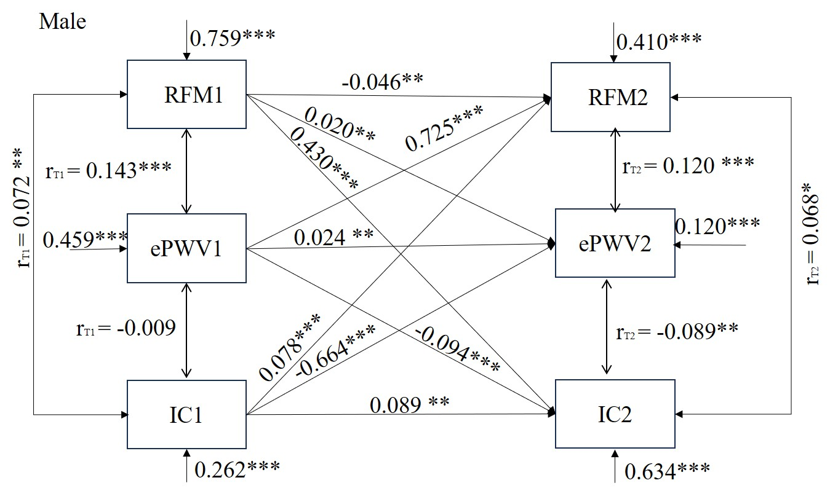

Figure S2 Cross-lagged panel models of ePWV, RFM and IC in female.
