Supplementary Information

Structural Mechanism of adhesion GPCR cleavage in the GPCR autoproteolysis site

Florian Seufert¹, Yin Kwan Chung², Fabian Pohl², Robin Schick³, Norbert Sträter³, Tobias Langenhan^{2,4,5}, Peter Werner Hildebrand¹ / Hossein Batebi⁶
¹ Institute of Medical Physics and Biophysics, Medical Faculty, Leipzig University, Germany
² Rudolf Schönheimer Institute of Biochemistry, Division of General Biochemistry, Medical Faculty, Leipzig University, Germany
³ Institute of Bioanalytical Chemistry, Leipzig University, Germany
⁴ Comprehensive Cancer Center Central Germany, Leipzig University, Leipzig, Germany
⁵ Institute of Biology, Faculty of Life Sciences, Leipzig University, Talstrasse 33, 04103 Leipzig, Germany
⁶ Freie Universität Berlin, Germany

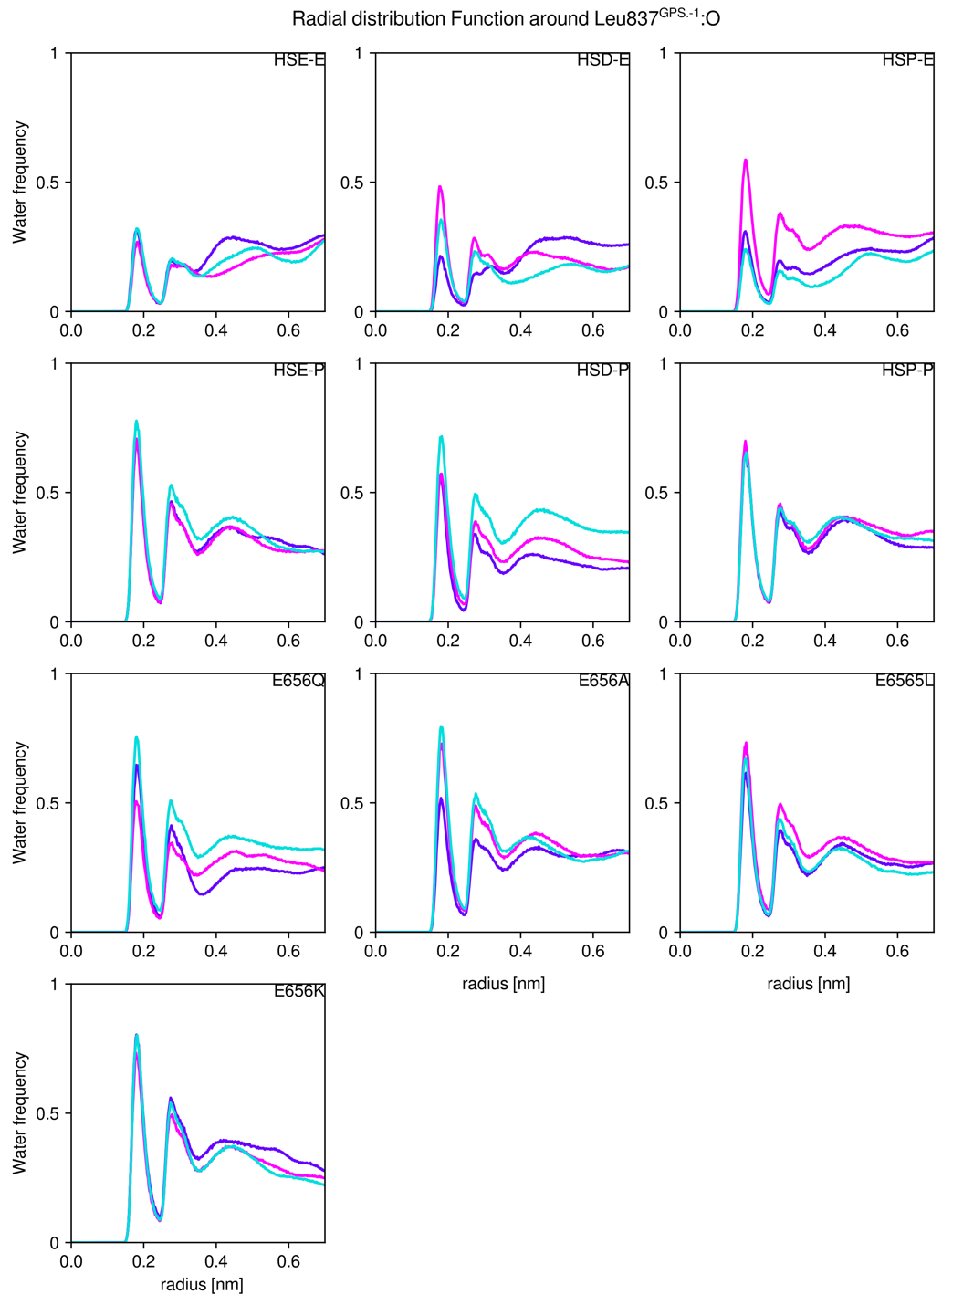
Supplementary Fig. 1 | Radial Density Function (RDF) around L837^{GPS.+1} oxygen, the oxyanion in the mechanism. HSD, HSE and HSP represent the protonation state of H836^{GPS.-2}; E, unprotonated E656^{H6.50}; P, protonated E656^{H6.50}. Also included are the four mutations E656Q, A, L and K, respectively. Water frequency depending on radius shows higher water frequency in runs with protonated E656^{H6.50}. For mutations, water frequency remains unaffected relative to runs with protonated E656^{H6.50}. Shown simulations feature the uncleaved ADGRL1 GAIN domain model.

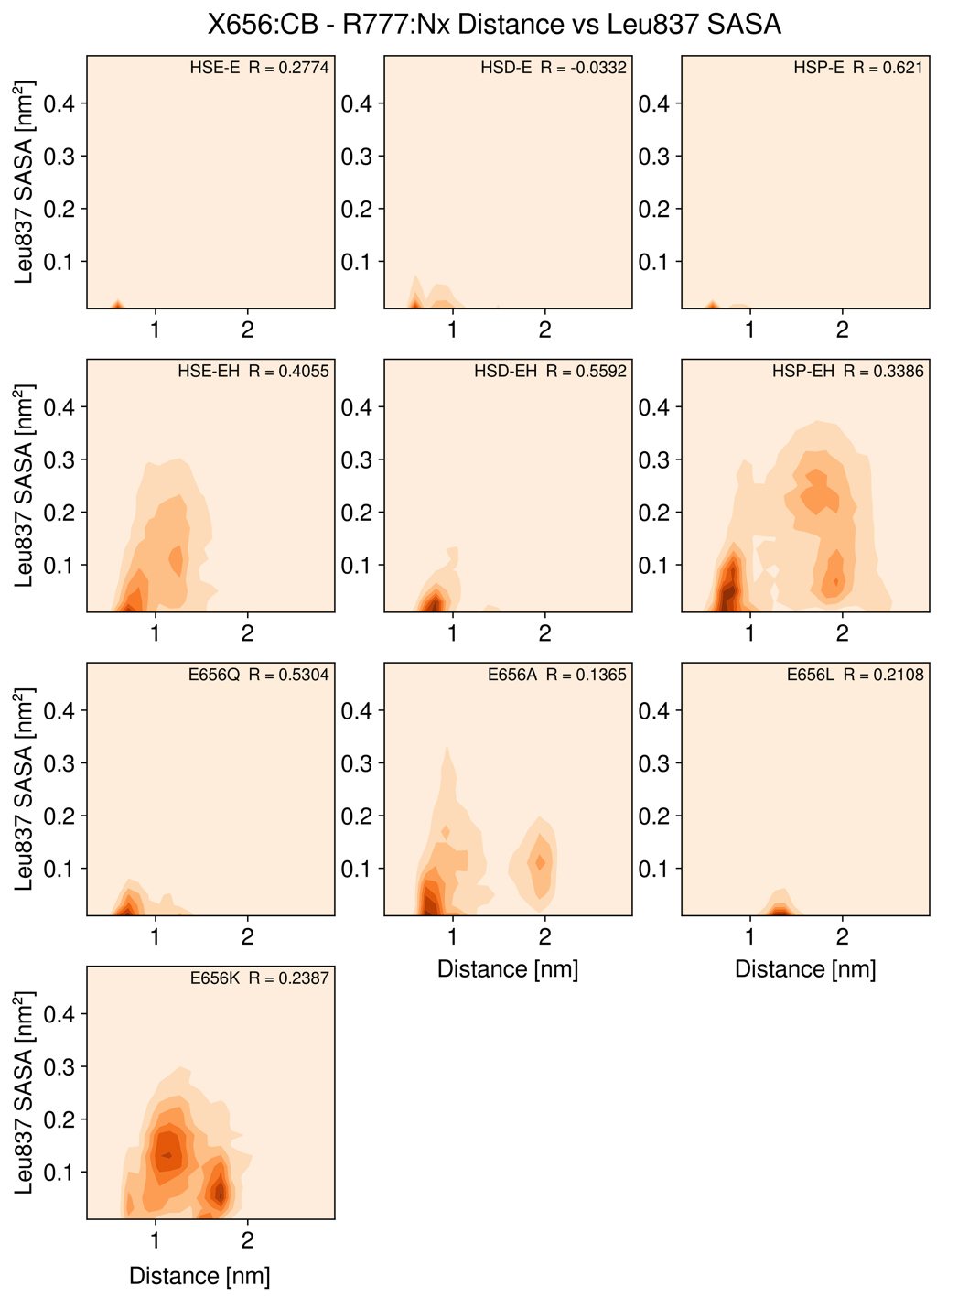
Supplementary Fig. 2 | Correlation of the R777 – X656^{H6.50} distance to L^{GPS.-1} solvent-accessible surface area (SASA). Contour plots with darker color indicating higher occupancy in arbitrary units. Displayed are the combined values of three independent MD trajectories for each uncleaved GAIN domain system of rat ADGRL1. Correlation coefficient R is displayed in top left. High SASA values are observed for HSE-EH and HSP-EH as well as the mutations E656A and E656K (with HSE).

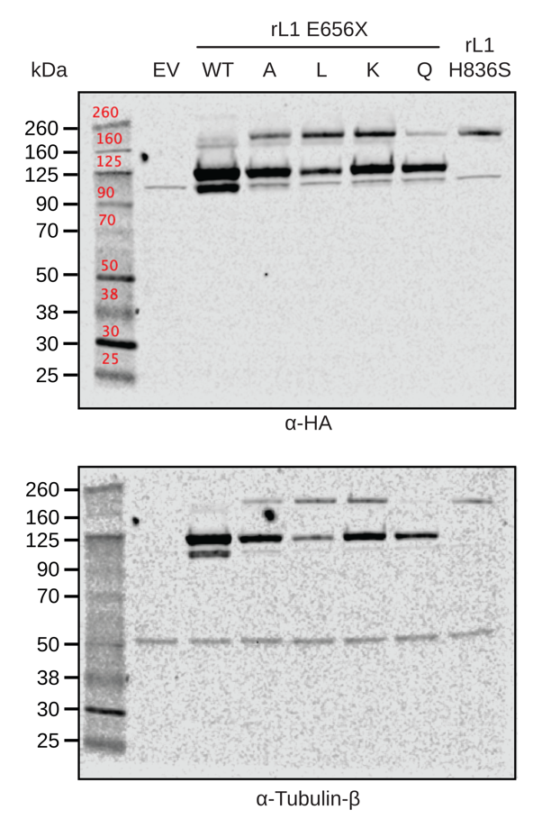
Supplementary Fig. 3: Full western blots of the E656 GAIN mutations in rat ADGRL1 GAIN. Antibody used for blotting denoted below the plot; Standard marks are indicated in kDa on the left side.

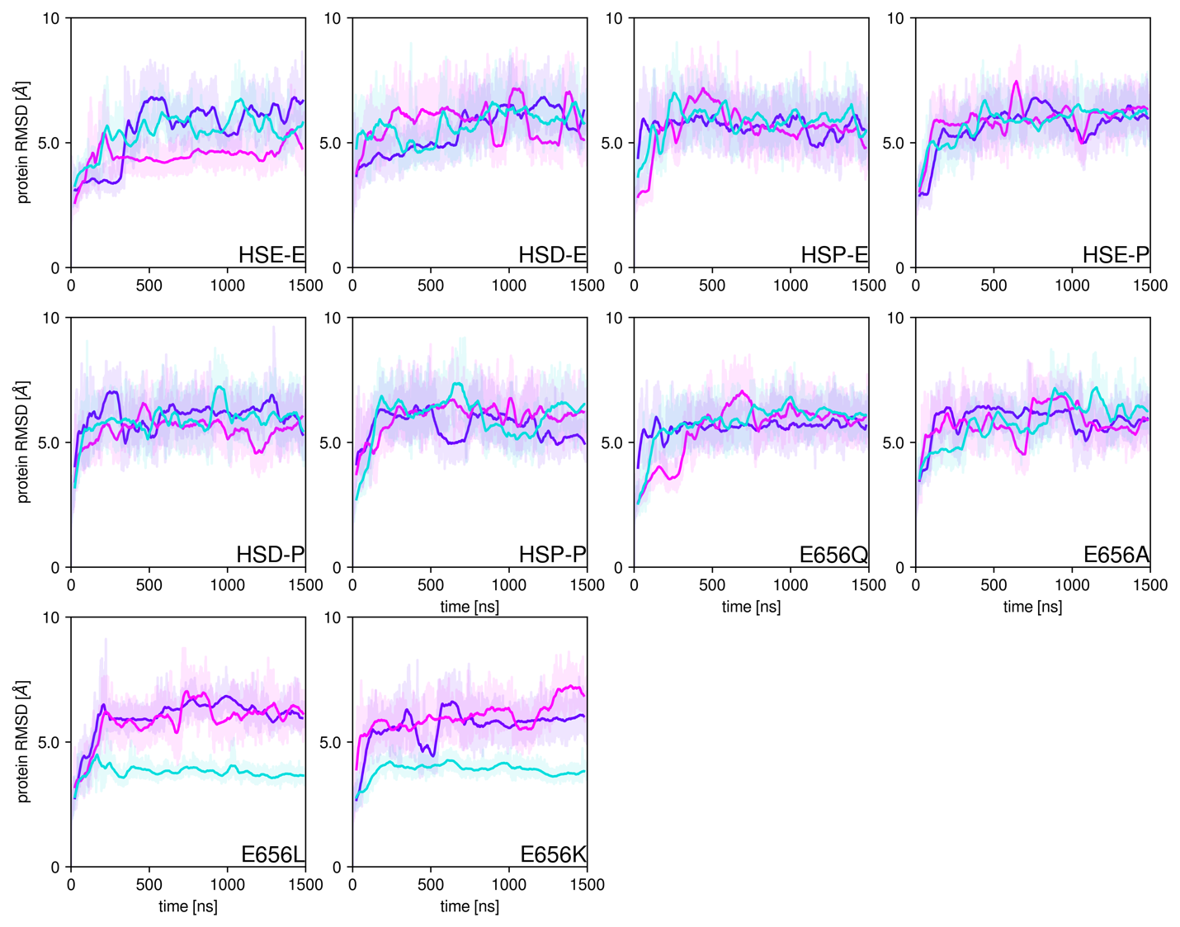Supplementary Fig. 4 | Root mean square deviation of self-superposed trajectories of the uncleaved ADGRL1 model. Time traces of three independent simulations of 1500 ns each with raw data (100 ps step) in lighter shade and moving average over 500 steps in opaque. HSD, HSE and HSP represent the protonation state of H836^{GPS.-2}; E, unprotonated E656^{H6.50}; P, protonated E656^{H6.50}. Also included are the four mutations E656Q, A, L and K, respectively.
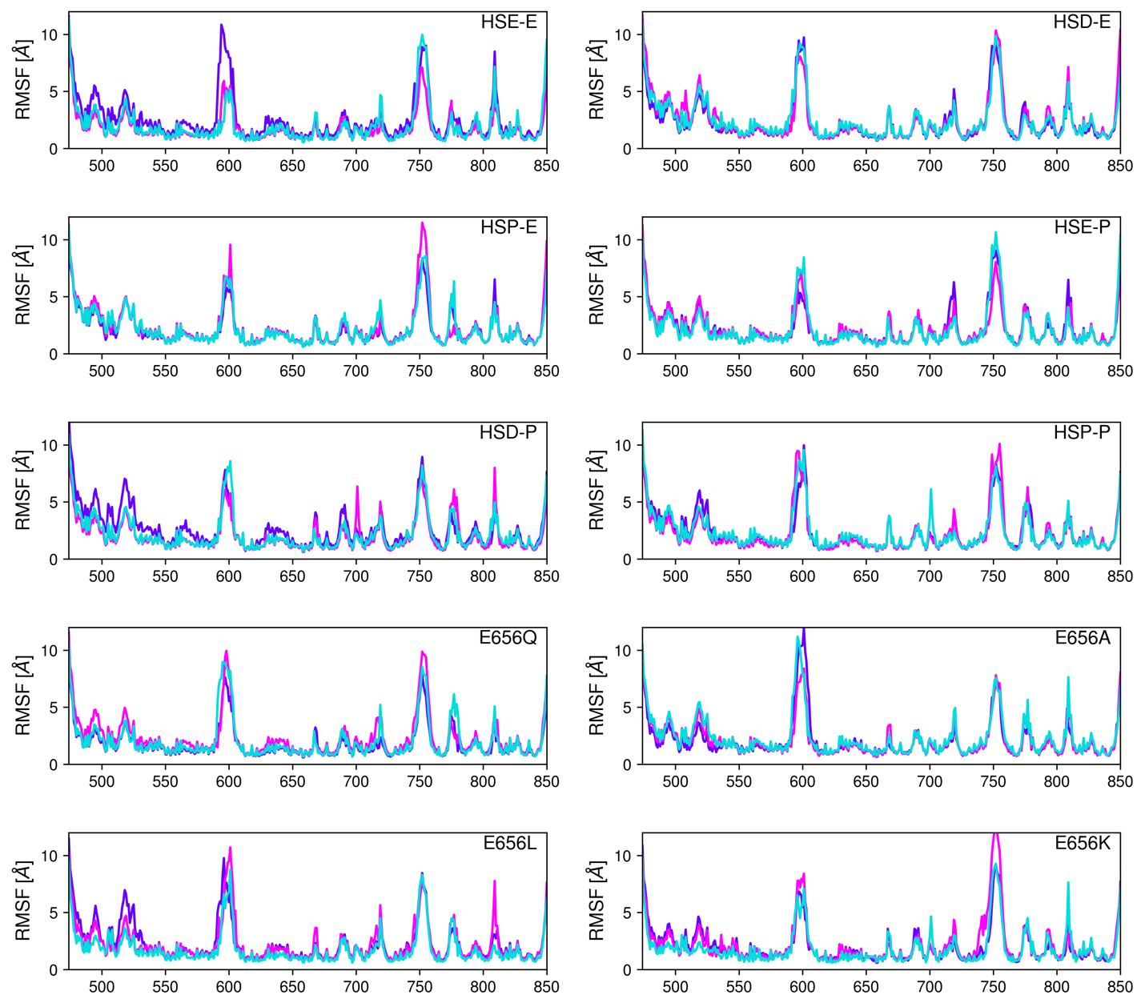
Supplementary Fig. 5 | Root mean square fluctuation (RMSF) of self-superposed trajectories of the uncleaved ADGRL1 model show no major differences between setups. Shown are per-residue traces of three independent simulations of 1500 ns. HSD, HSE and HSP represent the protonation state of H836^{GPS.-2}; E, unprotonated E656^{H6.50}; P, protonated E656^{H6.50}. Also included are the four mutations E656Q, A, L and K, respectively.
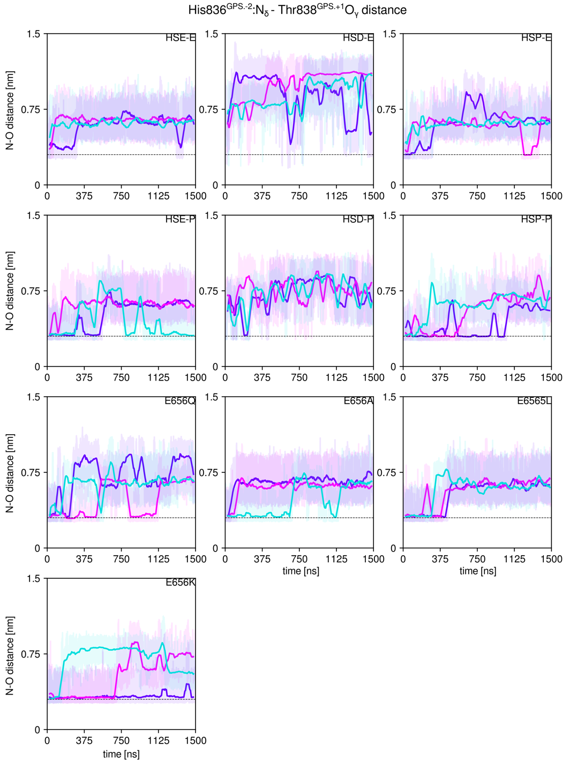
Supplementary Fig. 6 | Uncleaved ADGRL GAIN MD distance of the reactant hydrogen bond H836^{GPS.-2}N_{δ}-T838^{GPS.+1}:O_{γ} shows HSE as the preferred protonation state of the reactant. Time traces of three independent simulations of 1500 ns each with raw data (100 ps step) in lighter shade and moving average over 500 steps in opaque. HSD, HSE and HSP represent the protonation state of H836^{GPS.-2}; E, unprotonated E656^{H6.50}; P, protonated E656^{H6.50}. Also included are the four mutations E656Q, A, L and K, respectively. Destabilization occurs for HSD in both protonation states and E656Q and E6565K. Horizontal line at 0.3 nm indicates hydrogen bond distance. See also Supp. Fig. 7.

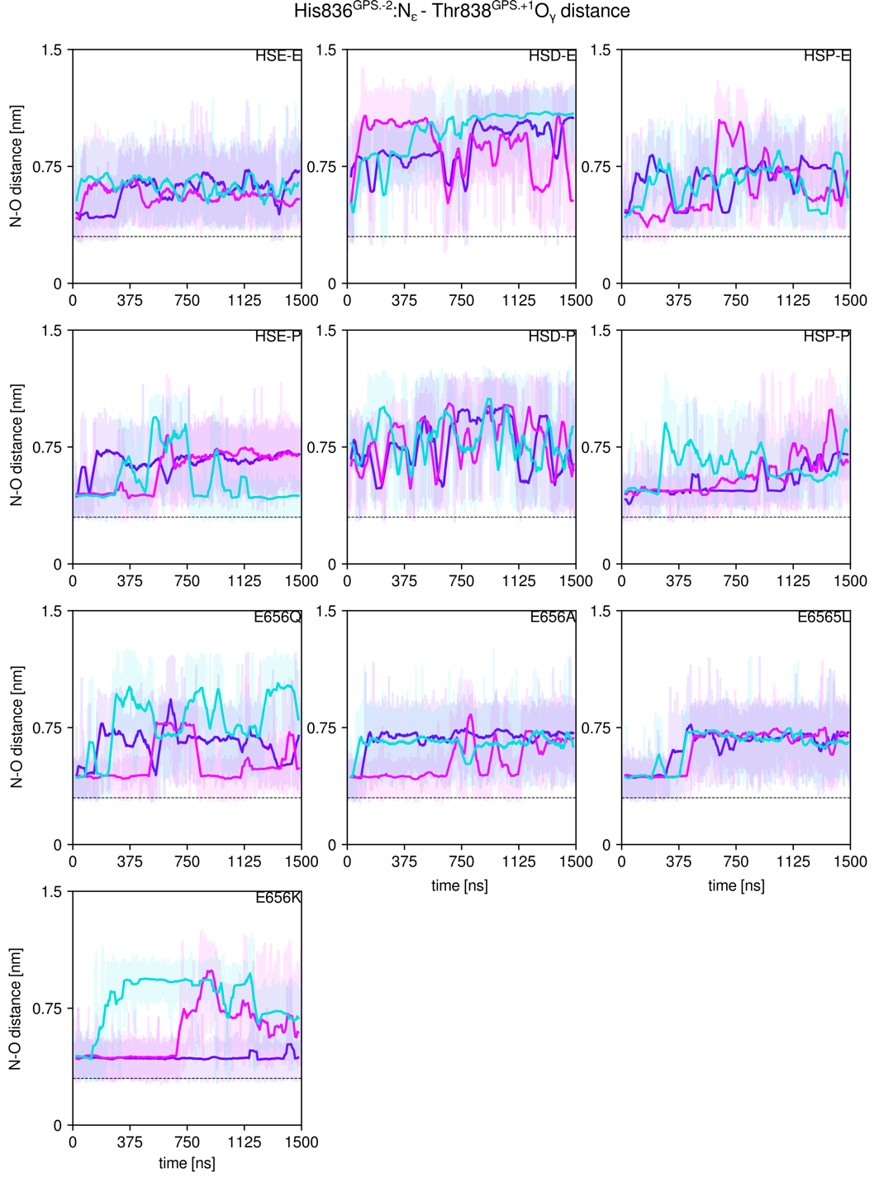
Supplementary Fig. 7 | Uncleaved ADGRL GAIN MD distance of the reactant hydrogen bond H836^{GPS.-2}N_{ε}-T838^{GPS.+1}:O_{γ} shows no heavy atom distance for hydrogen bonding. Time traces of three independent simulations of 1500 ns each with raw data (100 ps step) in lighter shade and moving average over 500 steps in opaque. HSD, HSE and HSP represent the protonation state of H836^{GPS.-2}; E, unprotonated E656^{H6.50}; P, protonated E656^{H6.50}. Also included are the four mutations E656Q, A, L and K, respectively. Destabilization occurs for HSD in both protonation states and E656Q and E6565K. Horizontal line at 0.3 nm indicates hydrogen bond distance. See also Supp. Fig. 6.

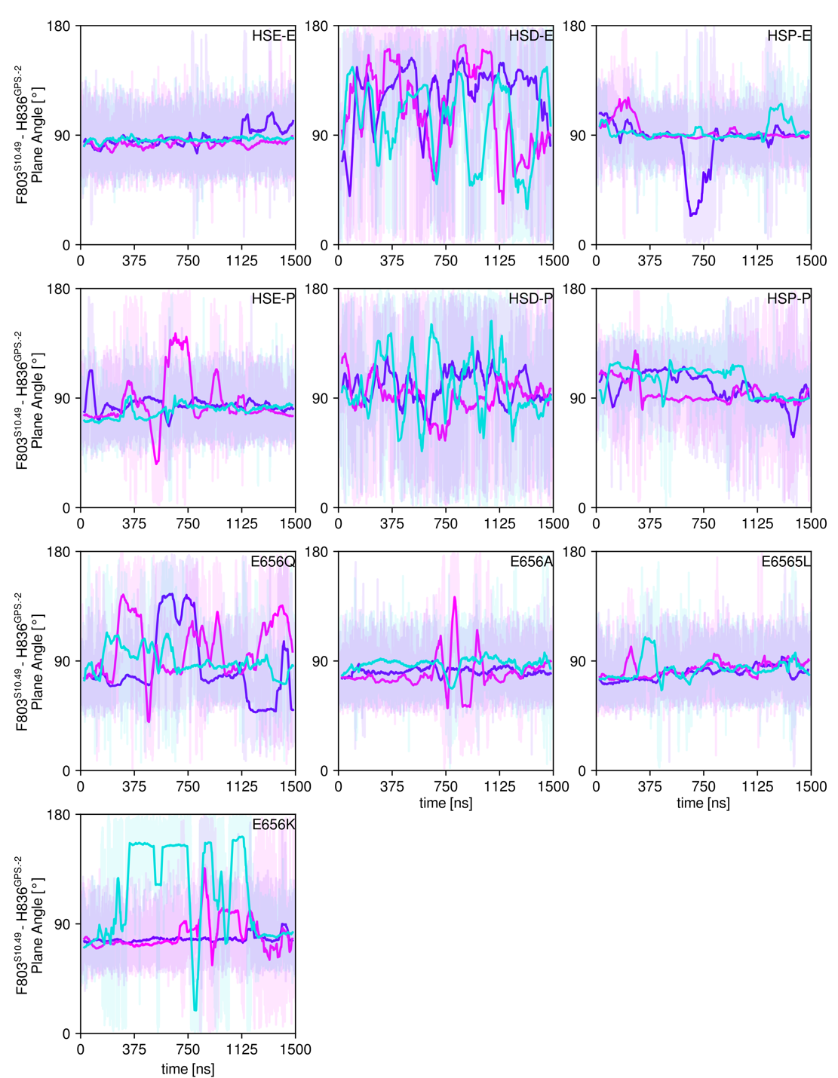
Supplementary Fig. 8 | Side chain plane angle of F803^{S10.49} and H836^{GPS.-2} confirms a stable π-edge interaction. See also Supp. Fig. 9. Time traces of three independent simulations of 1500 ns each with raw data (100 ps step) in lighter shade and moving average over 500 steps in opaque. HSD, HSE and HSP represent the protonation state of H836^{GPS.-2}; E, unprotonated E656^{H6.50}; P, protonated E656^{H6.50}. Also included are the four mutations E656Q, A, L and K, respectively. Destabilization occurs for HSD in both protonation states and E656Q and E656K. Shown simulations feature the uncleaved ADGRL1 GAIN domain model.

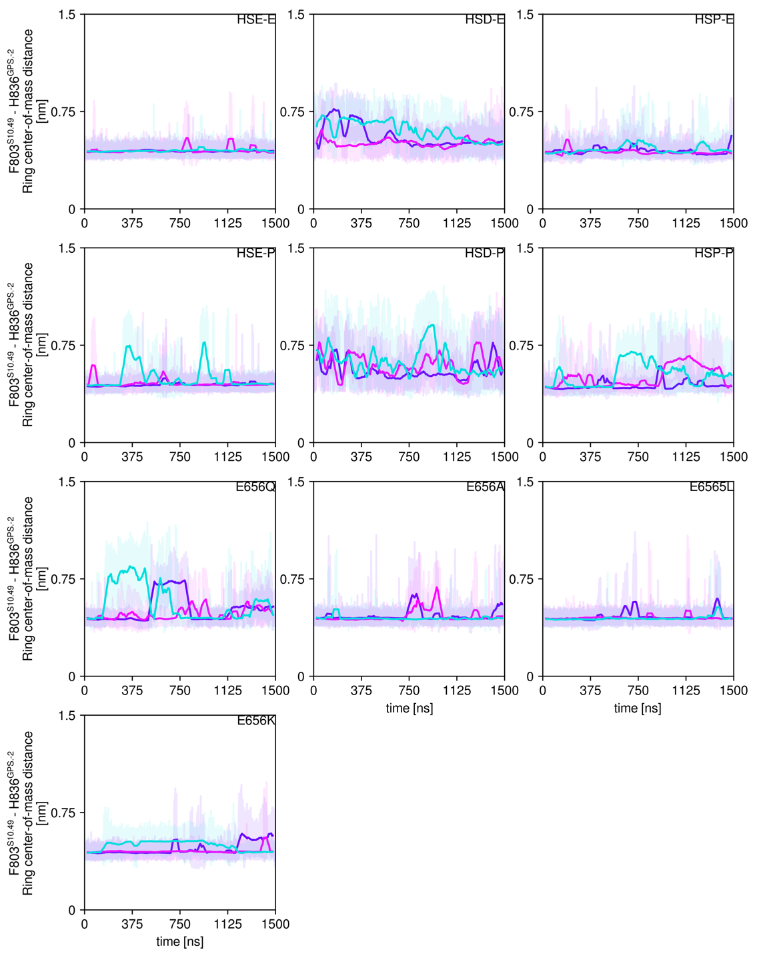
Supplementary Fig. 9 | Distance plots of ring center-of-mass F803^{S10.49} and H836^{GPS.-2} forming a conserved and stable π-edge interaction. See also Supp. Fig. 8. Time traces of three independent simulations of 1500 ns each with raw data (100 ps step) in lighter shade and moving average over 500 steps in opaque. HSD, HSE and HSP represent the protonation state of H836^{GPS.-2}; E, unprotonated E656^{H6.50}; P, protonated E656^{H6.50}. Also included are the four mutations E656Q, A, L and K, respectively. Destabilization occurs for HSD in both protonation states and E656Q and E6565K. Shown simulations feature the uncleaved ADGRL1 GAIN domain model.

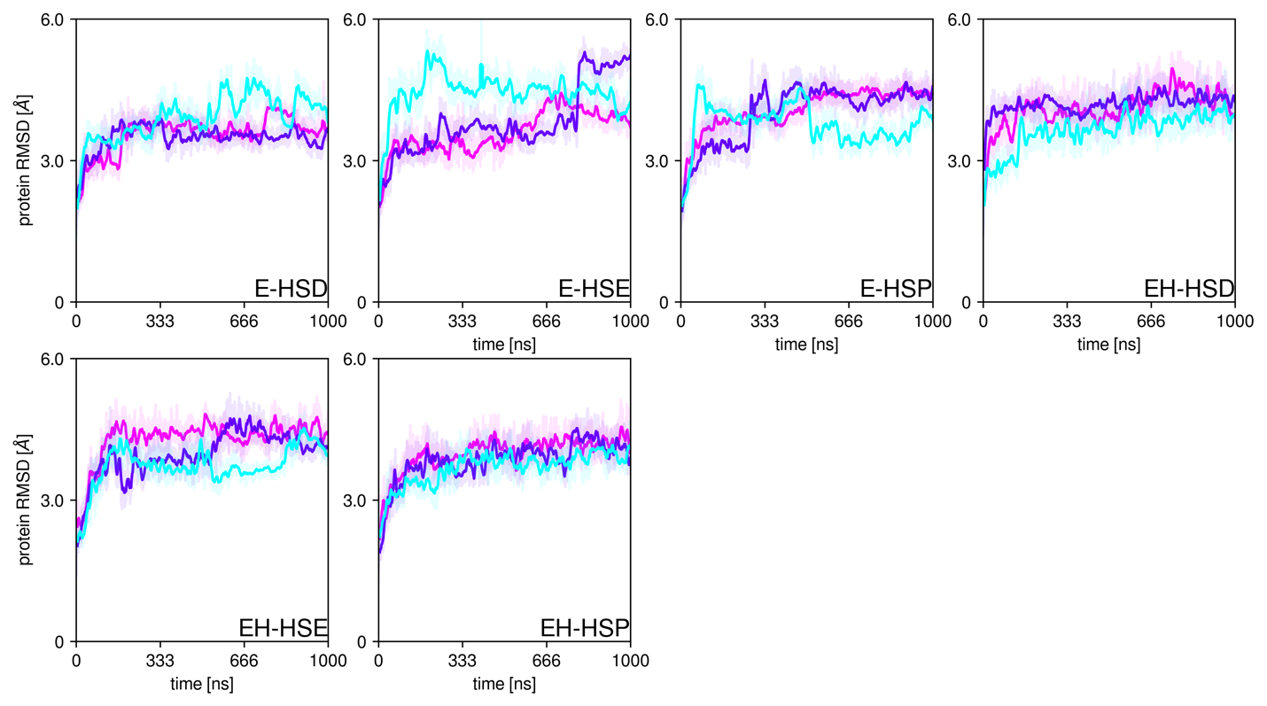
Supplementary Fig. 10 | Root mean square deviation of self-superposed trajectories of the ester intermediate ADGRL1 model. Time traces of three independent simulations of 1000 ns each with raw data (100 ps step) in lighter shade and moving average over 500 steps in opaque. HSD, HSE and HSP represent the protonation state of H836^{GPS.-2}; E, charged E656^{H6.50}; EH, neutral E656^{H6.50}. Expected hetero state in the mechanism is E-HSP.
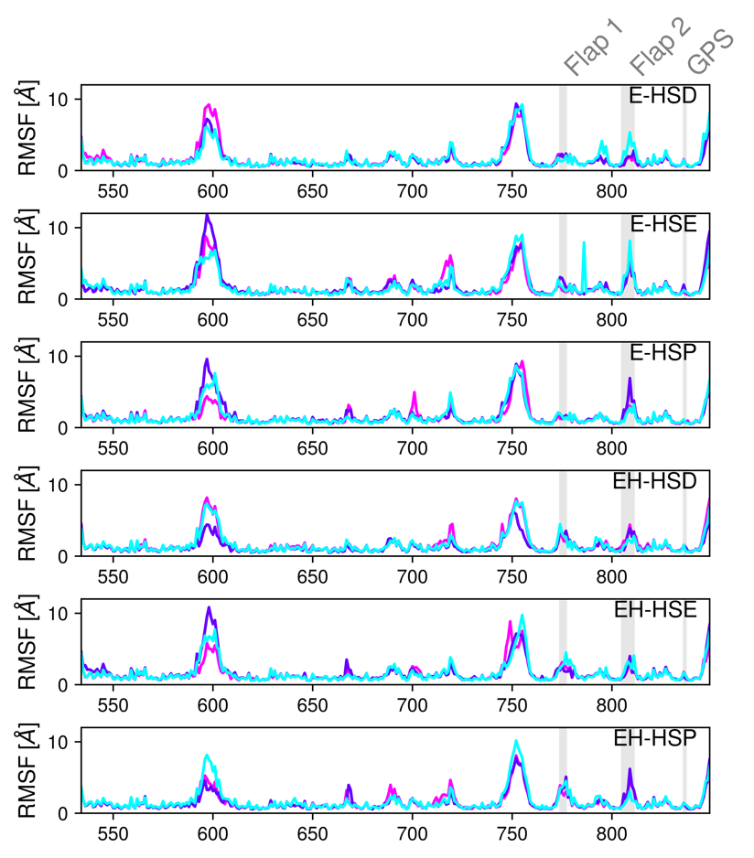
Supplementary Fig. 11 | Root mean square fluctuation (RMSF) of self-superposed trajectories of the ester intermediate model show differences in Flap 1 depending on E656^{H6.50} protonation state. Shown are per-residue traces of three independent simulations of 1000 ns. HSD, HSE and HSP represent the protonation state of H836^{GPS.-2}; E-, unprotonated E656^{H6.50}; EH, protonated E656^{H6.50}. Flap 1 RMSF is diminished due to salt-bridge formation of R777^{s8s9} to E656^{H6.50} . See Supp. Table 2. Expected hetero state in the mechanism is E-HSP.

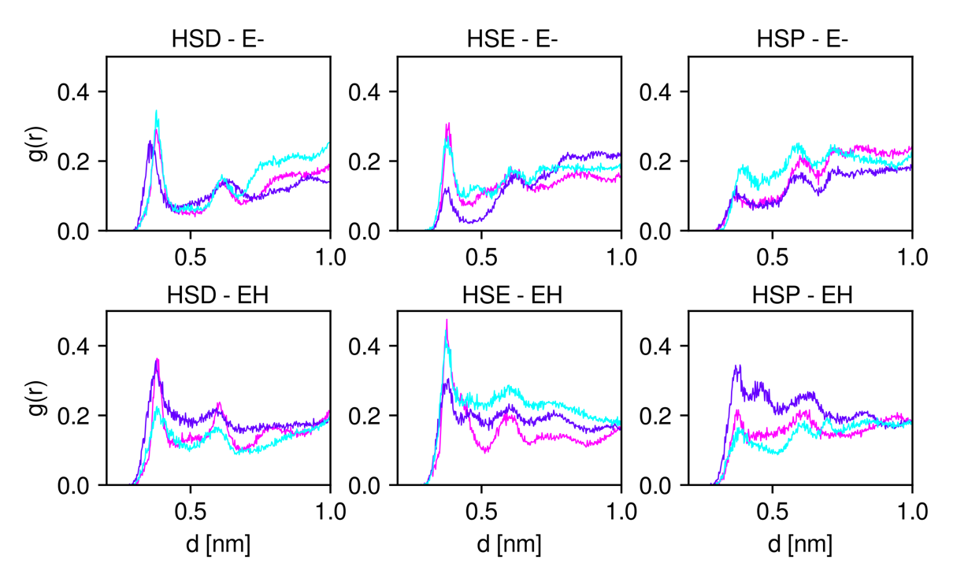
Supplementary Fig. 12 | Radial Density Function (RDF) around the Leucine-threonine ester (LTE) carbon, the electrophilic carbon for hydrolysis. HSD, HSE and HSP represent the protonation state of H836^{GPS.-2}; E-, unprotonated E656^{H6.50}; EH, protonated E656^{H6.50}. Each plot shows three individual trajectories of 1,000 ns. Differences are mostly present in the HSP – E- runs in the first shell at around 0.3 nm; however, despite low overall LTE SASA, there is still water observable in the direct vicinity of the ester carbon (see Supp. Fig. 14).

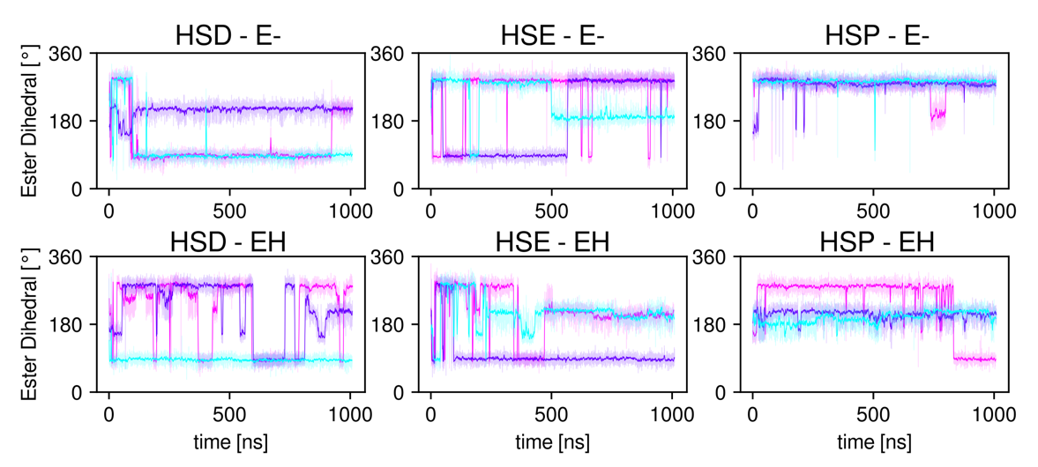
Supplementary Fig. 13 | Time traces of the ester bond dihedral for all employed leucine-threonine ester containing systems. HSD, HSE and HSP represent the protonation state of H836^{GPS.-2}; E-, unprotonated E656^{H6.50}; EH, protonated E656^{H6.50}. Each plot shows three individual trajectories of 1,000 ns. See also Ext. Data Fig. 8.

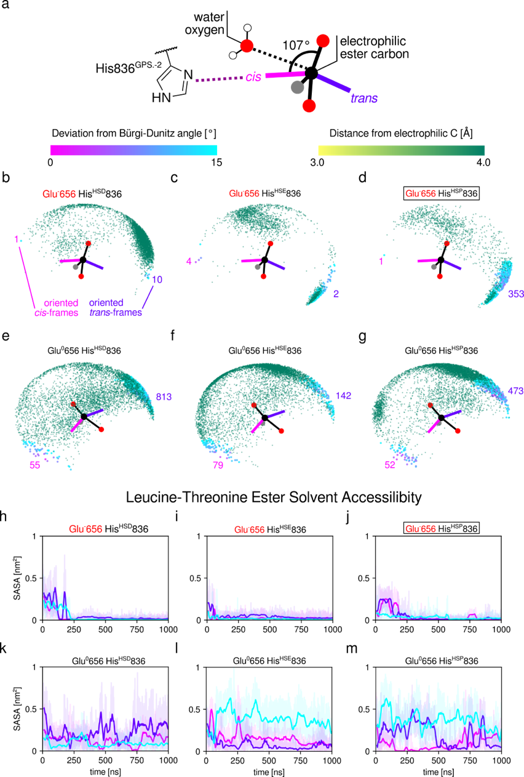

Supplementary Fig. 14 | Ester-proximal water molecules reveal preference for trans-configuration of attack. a, waters were collected from molecular dynamics (MD) trajectories within 4.0 Å of the ester carbon (green-yellow) with additional highlighting of waters within ±15° of the 107° Bürgi-Dunitz attack angle¹. Waters on the same side relative to the attack plane as His836^{GPS.-2} are defined as cis (pink), opposite as trans (purple). b-g, dot clouds of all collected water frames within three independent 1000 ns MD trajectories with number of waters with good attack angle highlighted for cis (pink) and trans (purple) respectively. Each plot represents a different setup with protonation states of His836^{GPS.-2} and Glu656^{H6.50} indicated. h-m, time trace plots of the leucine-threonine ester solvent-accessible surface area (SASA) for each system. Each color represents an independent 1,000 ns MD trajectory with solid line showing moving average over 20 ns and raw data indicated in transparent lines.

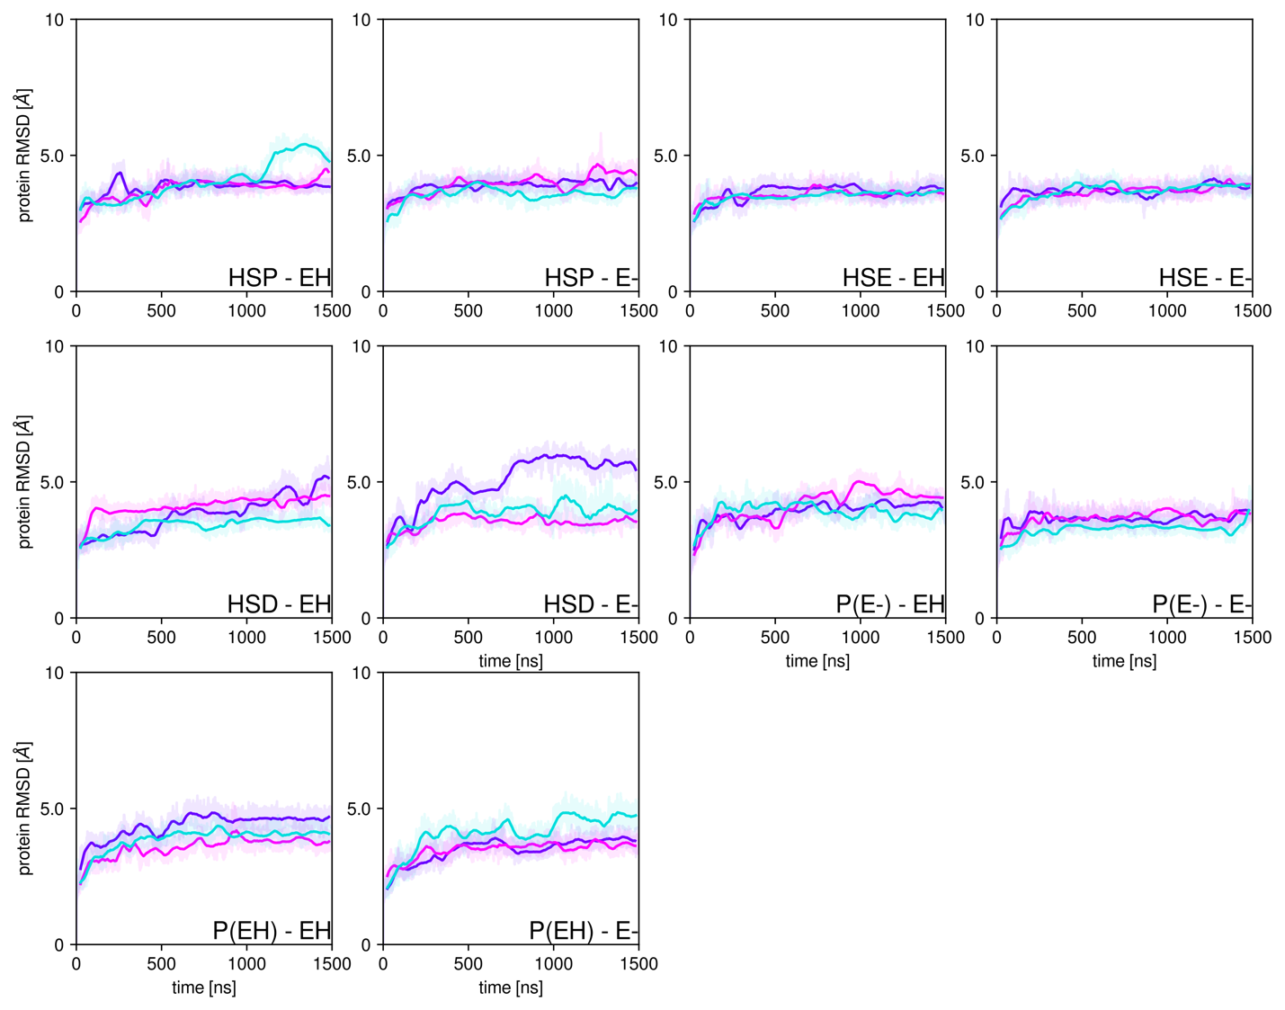
Supplementary Fig. 15 | Root mean square deviation of self-superposed trajectories of the cleaved ADGRL1 model. Time traces of three independent simulations of 1500 ns each with raw data (100 ps step) in lighter shade and moving average over 500 steps in opaque. HSD, HSE and HSP represent the protonation state of H836^{GPS.-2}; E-, unprotonated E656^{H6.50}; EH, protonated E656^{H6.50}. Also included are the four mutations E656Q, A, L and K, respectively.
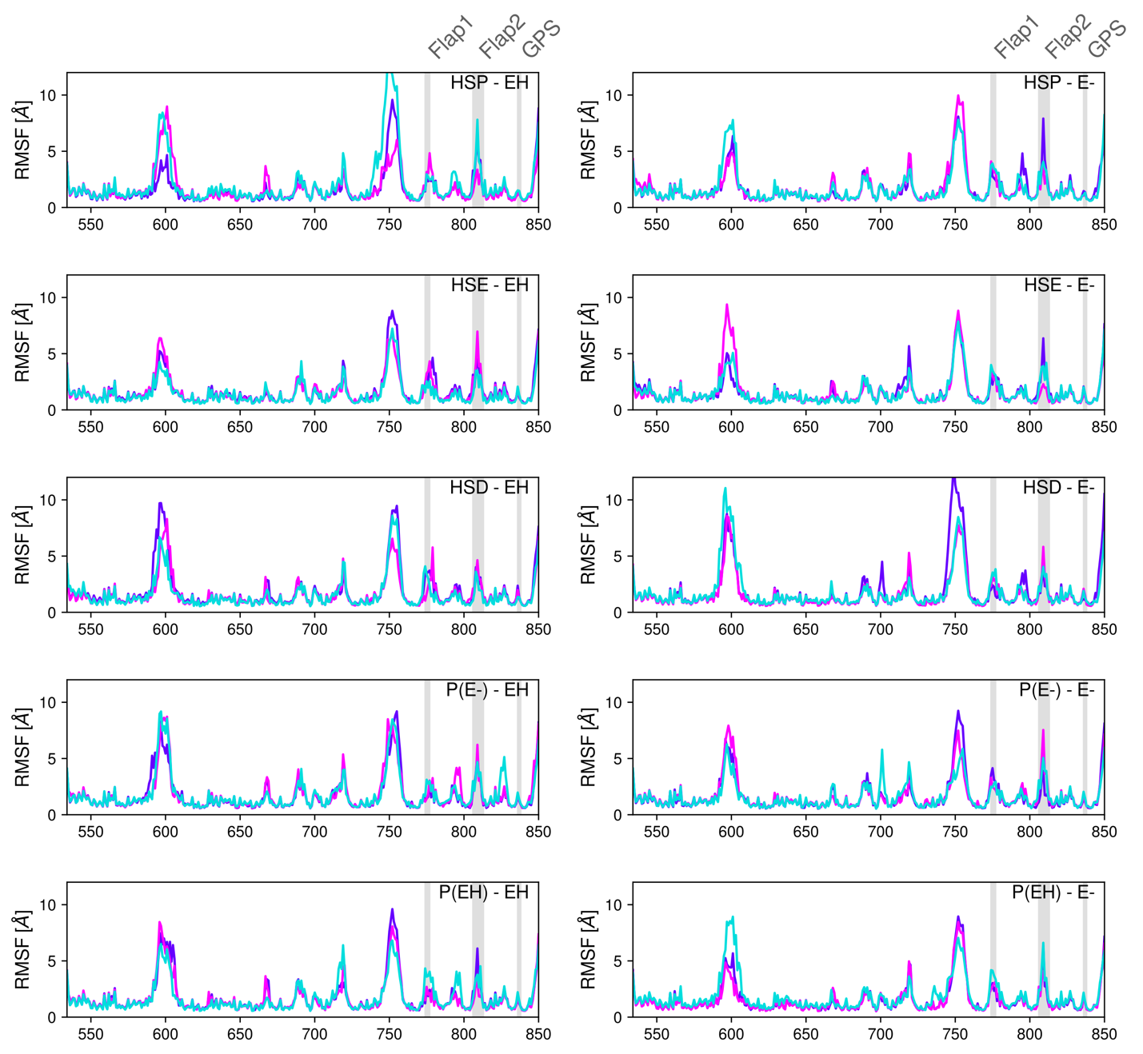

Supplementary Fig. 16 | Root mean square fluctuation (RMSF) of self-superposed trajectories of the cleaved ADGRL1 model show no major differences between setups. Shown are per-residue traces of three independent simulations of 1500 ns. HSD, HSE and HSP represent the protonation state of H836^{GPS.-2}; E-, unprotonated E656^{H6.50}; EH, protonated E656^{H6.50}. Also included are the four product state systems depending on origin (protonated E^{H6.50} in reactant: EH; unprotonated: E-).

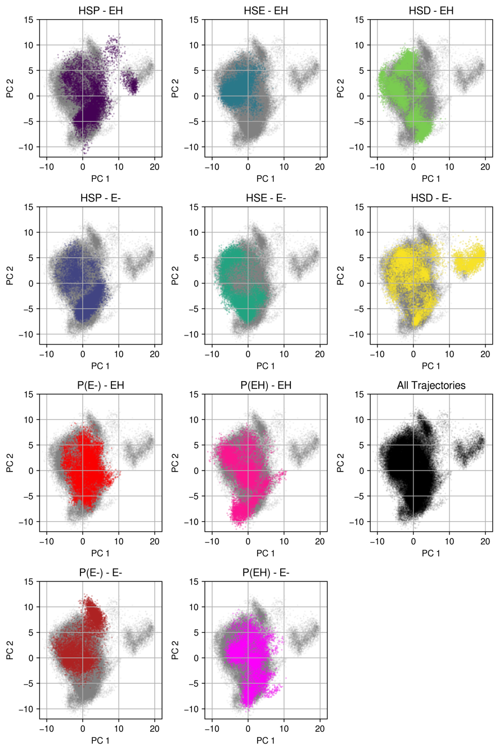
Supplementary Fig. 17 | Principal Component Analysis (PCA) of non-hydrogen cleaved ADGRL1 GAIN shows good agreement between the cleaved model and cleavage product. For the cleaved model, a GAIN domain model derived from PDB: 4DLQ was used for ab initio Molecular Dynamics (MD) simulations. Six runs were performed for each H836^{GPS.-2} protonation state (HSD, HSE, HSP) and protonation state of E656^{H6.50} (EH, E-). This was compared to two runs of two derived products; from the reactant with unprotonated E656^{H6.50} P(EH) and with protonated E656^{H6.50} P(E-); each with HSP and the two possible protonation states of E656^{H6.50} represented in independent runs. PCA was created from all runs (3 x 1,500 ns) with time spacing of 500 ps with non-hydrogen atoms and is shown in grey. Data from individual runs is shown in color. The QM/MM-derived product trajectories show good agreement with the overall data; A unique cluster is observed in the HSD – E- system with partial overlap in the HSP – EH system.

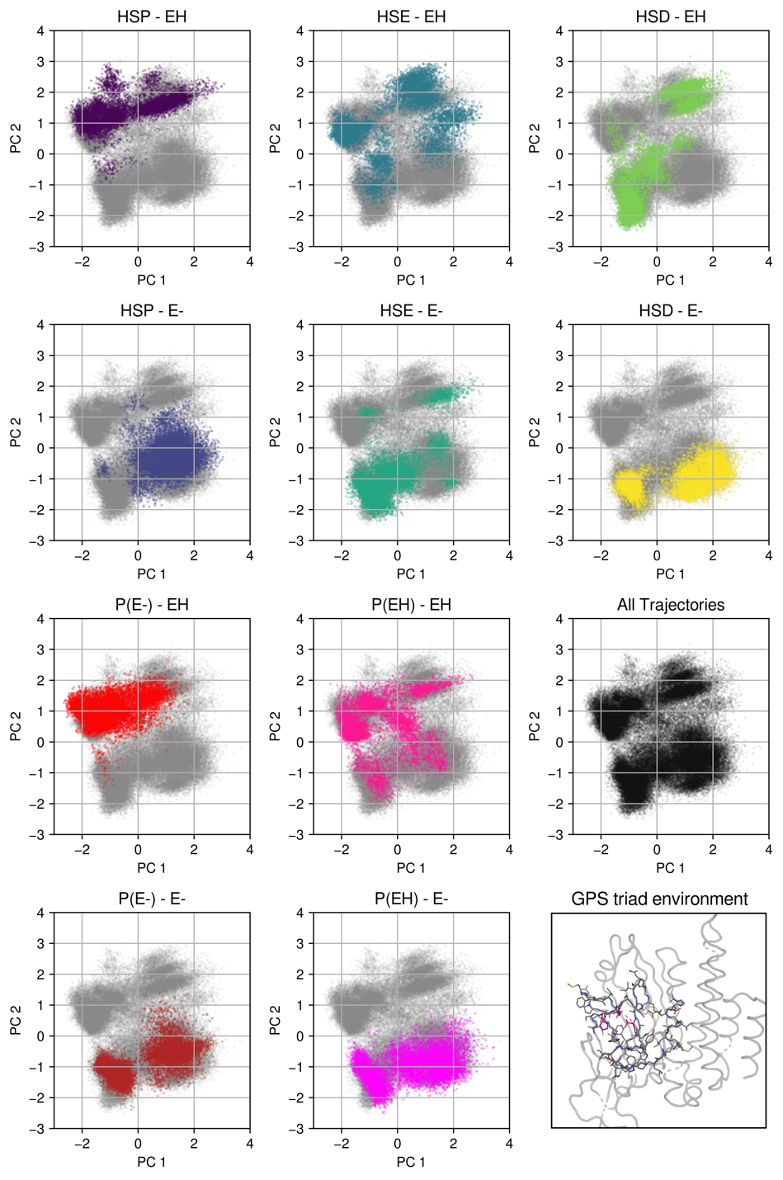
Supplementary Fig. 18 | Principal Component Analysis (PCA) of the immediate GPS cleavage site environment of non-hydrogen cleaved ADGRL1 GAIN shows good agreement between the cleaved model and cleavage product. se Supp. Fig. 17 for MD setup. PCA was created from all runs (3 x 1,500 ns) with time spacing of 500 ps with non-hydrogen atoms and is shown in grey. Data from individual runs is shown in color. The QM/MM-derived product trajectories show good agreement with the overall data. Runs have separate populations depending on the E656^{H6.50} protonation state with E- mostly at the bottom part of the plot and EH mostly at the top part with some overlap. Subselection of the GPS environment consists of residues 660-669, 763-784, 801-807 and 833-843; detail shown in bottom right as sticks with the GAIN domain as ribbon.

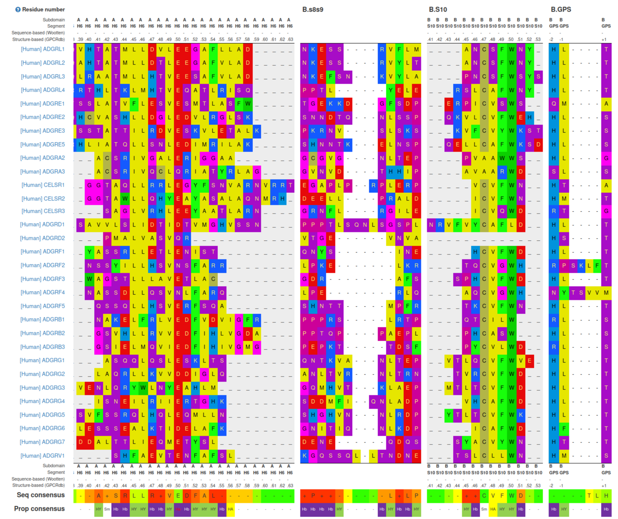
Supplementary Table 1 | Alignments of GAIN domain segments based on the generic residue numbering scheme GAIN-GRN, implemented in the GPCR database, GPCRdb.^{2–4} Segments of interest contain identified cleavage determinants (Supp. Table 5): An acidic residue at position H6.50, basic residue in Flap 1, which is within loop s8s9, an aromatic residue at position S10.49 and the sequence of the GPS triad.

System | HSE-E | HSD-E | HSP-E | HSE-EH | HSD-EH | HSP-EH | E656Q | E656A | E656L | E656K
L837 interactions
A769-L837 | 0.959 | 0.970 | 0.961 | 0.982 | 0.981 | 0.968 | 0.984 | 0.982 | 0.983 | 0.965
I771-L837 | 0.886 | 0.817 | 0.845 | 0.827 | 0.807 | 0.823 | 0.829 | 0.856 | 0.894 | 0.752
L780-L837 | 0.663 | 0.600 | 0.658 | 0.596 | 0.416 | 0.389 | 0.448 | 0.601 | 0.618 | 0.560
L837-V784 | 0.000 | 0.000 | 0.000 | 0.519 | 0.537 | 0.582 | 0.525 | 0.550 | 0.534 | 0.495
L837-R777 | 0.921 | 0.746 | 0.561 | 0.000 | 0.000 | 0.000 | 0.420 | 0.000 | 0.000 | 0.000
L709-L837 | 0.000 | 0.000 | 0.000 | 0.413 | 0.409 | 0.380 | 0.000 | 0.321 | 0.387 | 0.387
L837-V778 | 0.701 | 0.543 | 0.712 | 0.000 | 0.000 | 0.000 | 0.000 | 0.000 | 0.000 | 0.000
X656 interactions | X656 |  |  |  |  |  | Q656 | A656 | L656 | K656
X656-S770 | 0.943 | 0.944 | 0.936 | 0.645 | 0.555 | 0.685 | 0.551 | 0.000 | 0.521 | 0.328
X656-I728 | 0.173 | 0.243 | 0.165 | 0.777 | 0.815 | 0.792 | 0.682 | 0.296 | 0.433 | 0.360
X656-N839 | 0.000 | 0.000 | 0.000 | 0.672 | 0.694 | 0.580 | 0.613 | 0.000 | 0.068 | 0.000
X656-R777 | 0.922 | 0.362 | 0.374 | 0.000 | 0.000 | 0.000 | 0.000 | 0.000 | 0.000 | 0.000
X656-S775 | 0.000 | 0.348 | 0.512 | 0.000 | 0.000 | 0.000 | 0.000 | 0.000 | 0.000 | 0.000
X656-Y730 | 0.000 | 0.000 | 0.000 | 0.253 | 0.380 | 0.179 | 0.000 | 0.000 | 0.000 | 0.000
X656-E774 | 0.000 | 0.314 | 0.435 | 0.000 | 0.000 | 0.000 | 0.000 | 0.000 | 0.000 | 0.000
X656-Y806 | 0.091 | 0.000 | 0.000 | 0.207 | 0.148 | 0.000 | 0.492 | 0.000 | 0.043 | 0.431
A768-X656 | 0.000 | 0.000 | 0.000 | 0.000 | 0.000 | 0.218 | 0.000 | 0.000 | 0.000 | 0.000
X656-K773 | 0.078 | 0.000 | 0.000 | 0.000 | 0.000 | 0.000 | 0.000 | 0.000 | 0.000 | 0.000
X656 mutation-specific interactions |  |  |  |  |  |  | Q656 | A656 | L656 | K656
X656-V726 |  |  |  |  |  |  | 0.192 |  | 0.674
E774-K656 |  |  |  |  |  |  |  |  |  | 0.159
E808-K656 |  |  |  |  |  |  |  |  |  | 0.155

Supplementary Table 2 | Contact frequency of residue pairs involving L837^{GPS.-1} and E656^{H6.50}. Analysis performed with mdciao⁵. Numerical frequency indicates time of atoms of both respective residues being within 4.0 Å relative to the total trajectory. R777^{s8s9}-involving pairs are highlighted and show that only runs with unprotonated E656^{H6.50} make contact between R777^{s8s9} and L837^{GPS.-1}/E^{H6.50}, respectively, with the E656Q mutation also showing contact of L837^{GPS.-1} and R777^{s8s9}.

frequency | label | Atom-type composition
HSE-E
0.96 | L837 - A769 | 76% BB-SC, 16% BB-BB, 7% SC-SC
0.92 | L837 - R777 | 70% SC-BB, 29% BB-BB
0.89 | L837 - I771 | 81% SC-SC, 18% BB-SC
0.7 | L837 - V778 | 97% BB-BB
0.66 | L837 - L780 | 94% SC-SC, 5% SC-BB
HSD-E
0.97 | L837 - A769 | 62% BB-SC, 25% BB-BB, 12% SC-SC
0.82 | L837 - I771 | 92% SC-SC, 7% BB-SC
0.75 | L837 - R777 | 69% SC-BB, 30% BB-BB
0.6 | L837 - L780 | 83% SC-SC, 16% SC-BB
0.54 | L837 - V778 | 96% BB-BB
HSP-E
0.96 | L837 - A769 | 77% BB-SC, 12% SC-SC, 10% BB-BB
0.84 | L837 - I771 | 91% SC-SC, 8% BB-SC
0.71 | L837 - V778 | 95% BB-BB
0.66 | L837 - L780 | 83% SC-SC, 16% SC-BB
0.56 | L837 - R777 | 67% BB-BB, 30% SC-BB

Supplementary Table 3 | Decomposition of R777^{s8s9} – L837^{GPS.-1} interaction shows no sidechain (SC) interactions with the backbone (BB). Displayed are contact frequencies of selected uncleaved GAIN domain MD runs (see Supp. Table 2), decomposed into fractions involving backbone and side-chain contact. Absence of polar residue contacts indicates that the putative oxyanion is solely coordinated by water or backbone interactions. A L837^{GPS.-1} backbone to R777^{s8s9} sidechain would be denoted as BB-SC. Aside from R777^{s8s9}, L837^{GPS.-1} makes no contact to charged residues.

Domain | Protein Family | Example Proteins | Backbone  Strain | Cleavage Site | Initial Base | SolventAcces-sibility | Structure PDBs / UniProtKB | Ref.
GAIN | AGPCR, PKD | ADGRL1, ADGRB2, PKD1L1 | ++ | HL|T/S | H | + | 4DLO, 4DLQ, 6V55, 5KVM, 8OHV | ^{6–9}
Sonic Hedgehog | SHH | hSHH | ? | G|C/cholesterol | acidic/basic unknown | ++ | Q15465 | ¹⁰
ZU5-like / PIID | ZO-1 | ZO-1, CARD8, NLRP1 | ++ | SF|S | H | ++ | Q9Y2G2, 7CRV, 7CRW, 7JN7 | ¹¹
Cephalo-sporin-acetylase | Ntn Hydrolases | P.aeroginosa CA | -- | X|TxH? | ? | + | A0A2R3IZN3 | ¹²
Glycosyl-asparagi-nase | Ntn Hydrolases | human GA | -- | HD|S | E-HOH | + | 9GAA | ¹³
Inteins | -- | RecA,  Thymidylate synthase,  Hfq, aFGF | ? | HN|C/S/T/X | initial N-proto-nation | ? |  | ¹⁴
SEA | aGPCR | ADGRG6, MUC1 | +++ | xG|SVVV | H or close acidic | ++ | P15941 | ^{15–17}
Nup98 | Nup | Nup98 | ++ | HF|S | H | + | P52948 | ^{18,19}

Supplementary Table 4 | Characteristics of various cis-autoproteolytic protein domains. Criteria were qualitatively evaluated by examining literature and evaluating PDB and AlphaFolddb structures based on their UniProtKB identifiers.²⁰ Amino acids are denoted as one-letter code. Vertical bar denotes cleavage sites between residues. “?” denotes unknown parameters. See also Pohl et al.⁹

Receptor | Acidic  H6.50 | Basic residue  In s8s9 | Aromatic  S10.49 | Competent GPS triad  HXT/S | Assessed  GPS Cleavability | Experimental  GPS  Cleavability | References
ADGRL1 | + | + | + | + | +++ | Yes | ⁶
ADGRL2 | + | + | + | + | +++
ADGRL3 | + | + | + | + | +++ | Yes | ²¹
ADGRL4 | + |  | + | + | ++ | Yes | ²²
ADGRE1 | + | + |  |  | -
ADGRE2 | + |  | + | + | ++ | Yes | ^{23,24}
ADGRE3 | + | + | + | + | +++ | Yes | ²⁵
ADGRE5 | + | + | + | + | +++ | Yes | ²⁶
ADGRA2 | + |  | + |  | - | No | ²⁷
ADGRA3 |  |  |  |  | - | Yes | ²⁸
ADGRC1 | + | + | + |  | 0 | No | ²⁹
ADGRC2 | + | + | + | + | +++ | Yes | ³⁰
ADGRC3 | + | + |  |  | - | No, 37224017
ADGRD1 | + |  | + | + | ++ | Yes | ³¹
ADGRD2 |  |  | + | + | +
ADGRF1 | + |  | + | + | ++ | Yes | ²⁶
ADGRF2 |  | + |  |  | - | No | ³²
ADGRF3 | + | + | + | + | +++
ADGRF4 |  | + |  |  | - | No | ³²
ADGRF5 | + | + | + | + | +++
ADGRB1 | + |  |  |  | - | Yes | ^{33,34}
ADGRB2 | + |  |  | + | + | Yes | ^{9,35}
ADGRB3 | + | + |  |  | - | Yes (in vivo)  No (in vitro) | ⁶
ADGRG1 | + | + | + | + | +++ | Yes | ^{7,26,36}
ADGRG2 | + | + | + | + | +++ | Yes | ^{37–39}
ADGRG3 | + | + | + | + | +++ | Yes | ⁴⁰
ADGRG4 | + |  | + | + | ++ | Yes | ⁴¹
ADGRG5 | + | + | + | + | +++ | No (in vitro) | ⁴²
ADGRG6 | + | + | + | + | +++ | Yes | ^{31,43}
ADGRG7 | + |  | + | + | ++
ADRGV1 | + | + |  | + | ++ | Yes | ⁴⁴

Supplementary Table 5 | Overview of cleavage determinants present in human aGPCR GAIN domains. Presence of respective motif is indicated as “+”, with qualitatively assessed cleavability competence very strong (+++), strong (++), competent (+), no triad (0) and incompetent (-). Experimental evidence on GPS cleavage compiled and appended based on Langenhan, 2020⁴⁵.We assess ADGRE1, ADGRA2, ADGRA3, ADGRC1, ADGRC3, ADGRF2, ADGRF4, ADGRB1 and ADGRB3 as uncleaving based on the determinants identified in this work. Notably, for ADGRB1 and ADGRB3, experimental data suggests cleaved GPS in contrary to assessed cleavability (highlighted in bold).
1. Bürgi, H. B., Dunitz, J. D., Lehn, J. M. & Wipff, G. Stereochemistry of reaction paths at carbonyl centres. Tetrahedron 30, 1563–1572 (1974).
2. Seufert, F. et al. Generic residue numbering of the GAIN domain of adhesion GPCRs. Nat. Commun. 16, 246 (2025).
3. Herrera, L. P. T. et al. GPCRdb in 2025: adding odorant receptors, data mapper, structure similarity search and models of physiological ligand complexes. Nucleic Acids Res. gkae1065 (2024) doi:10.1093/nar/gkae1065.
4. Isberg, V. et al. Generic GPCR residue numbers - Aligning topology maps while minding the gaps. Trends in Pharmacological Sciences 36, 22–31 (2015).
5. Pérez-Hernández, G. & Hildebrand, Peter. W. mdciao: Accessible Analysis and Visualization of Molecular Dynamics Simulation Data. bioRxiv 2022.07.15.500163 (2022) doi:10.1101/2022.07.15.500163.
6. Araç, D. et al. A novel evolutionarily conserved domain of cell-adhesion GPCRs mediates autoproteolysis. The EMBO Journal 31, 1364–1378 (2012).
7. Salzman, G. S. et al. Structural Basis for Regulation of GPR56/ADGRG1 by Its Alternatively Spliced Extracellular Domains. Neuron 91, 1292–1304 (2016).
8. Leon, K. et al. Structural basis for adhesion G protein-coupled receptor Gpr126 function. Nat. Commun. 11, 194 (2020).
9. Pohl, F. et al. Structural basis of GAIN domain autoproteolysis and cleavage-resistance in the adhesion G-protein coupled receptors. bioRxiv (2023) doi:10.1101/2023.03.12.532270.
10. Mafi, A. et al. Hedgehog proteins create a dynamic cholesterol interface. PLOS ONE 16, e0246814 (2021).
11. D’Osualdo, A. et al. CARD8 and NLRP1 Undergo Autoproteolytic Processing through a ZU5-Like Domain. PLOS ONE 6, e27396 (2011).
12. Kim, J. K. et al. Insight into autoproteolytic activation from the structure of cephalosporin acylase: A protein with two proteolytic chemistries. Proc. Natl. Acad. Sci. 103, 1732–1737 (2006).
13. Xu, Q., Buckley, D., Guan, C. & Guo, H. C. Structural insights into the mechanism of intramolecular proteolysis. Cell 98, 651–661 (1999).
14. Shemella, P. T. et al. Electronic Structure of Neighboring Extein Residue Modulates Intein C-Terminal Cleavage Activity. Biophysical Journal 100, 2217 (2011).
15. Sandberg, A., Johansson, D. G. A., Macao, B. & Härd, T. SEA Domain Autoproteolysis Accelerated by Conformational Strain: Energetic Aspects. Journal of Molecular Biology 377, 1117–1129 (2008).
16. Johansson, D. G. A., Macao, B., Sandberg, A. & Härd, T. SEA Domain Autoproteolysis Accelerated by Conformational Strain: Mechanistic Aspects. Journal of Molecular Biology 377, 1130–1143 (2008).
17. Johansson, D. G. A. et al. Protein autoproteolysis: Conformational strain linked to the rate of peptide cleavage by the pH dependence of the N → O acyl shift reaction. Journal of the American Chemical Society 131, 9475–9477 (2009).
18. Merz, T. et al. Autoproteolytic and Catalytic Mechanisms for the β-Aminopeptidase BapA—A Member of the Ntn Hydrolase Family. Structure 20, 1850–1860 (2012).
19. Rosenblum, J. S. & Blobel, G. Autoproteolysis in nucleoporin biogenesis. Proceedings of the National Academy of Sciences of the United States of America 96, 11370–5 (1999).
20. Varadi, M. et al. AlphaFold Protein Structure Database: massively expanding the structural coverage of protein-sequence space with high-accuracy models. Nucleic Acids Research 50, D439–D444 (2022).
21. Perry-Hauser, N. A., VanDyck, M. W., Lee, K. H., Shi, L. & Javitch, J. A. Disentangling autoproteolytic cleavage from tethered agonist–dependent activation of the adhesion receptor ADGRL3. J. Biol. Chem. 298, 102594 (2022).
22. Nechiporuk, T., Urness, L. D. & Keating, M. T. ETL, a Novel Seven-transmembrane Receptor That Is Developmentally Regulated in the Heart. J. Biol. Chem. 276, 4150–4157 (2001).
23. Lin, H. H. et al. Autocatalytic cleavage of the EMR2 receptor occurs at a conserved G protein-coupled receptor proteolytic site motif. Journal of Biological Chemistry 279, 31823–31832 (2004).
24. Chang, G. W. et al. Proteolytic cleavage of the EMR2 receptor requires both the extracellular stalk and the GPS motif. FEBS Letters 547, 145–150 (2003).
25. Matmati, M. et al. The human EGF‐TM7 receptor EMR3 is a marker for mature granulocytes. J. Leukoc. Biol. 81, 440–448 (2007).
26. Stoveken, H. M., Hajduczok, A. G., Xu, L. & Tall, G. G. Adhesion G protein-coupled receptors are activated by exposure of a cryptic tethered agonist. Proc. Natl. Acad. Sci. 112, 6194–6199 (2015).
27. Vallon, M. & Essler, M. Proteolytically Processed Soluble Tumor Endothelial Marker (TEM) 5 Mediates Endothelial Cell Survival during Angiogenesis by Linking Integrin αvβ3 to Glycosaminoglycans *. Journal of Biological Chemistry 281, 34179–34188 (2006).
28. Sakurai, T. et al. GPR125 (ADGRA3) is an autocleavable adhesion GPCR that traffics with Dlg1 to the basolateral membrane and regulates epithelial apicobasal polarity. J. Biol. Chem. 298, 102475 (2022).
29. Formstone, C. J., Moxon, C., Murdoch, J., Little, P. & Mason, I. Basal enrichment within neuroepithelia suggests novel function(s) for Celsr1 protein. Mol. Cell. Neurosci. 44, 210–222 (2010).
30. Beall, S. A., Boekelheide, K. & Johnson, K. J. Hybrid GPCR/Cadherin (Celsr) Proteins in Rat Testis Are Expressed With Cell Type Specificity and Exhibit Differential Sertoli Cell—Germ Cell Adhesion Activity. J. Androl. 26, 529–538 (2005).
31. Liebscher, I. et al. A Tethered Agonist within the Ectodomain Activates the Adhesion G Protein-Coupled Receptors GPR126 and GPR133. Cell Rep. 9, 2018–2026 (2014).
32. Prömel, S. et al. Characterization and functional study of a cluster of four highly conserved orphan adhesion-GPCR in mouse. Developmental Dynamics 241, 1591–1602 (2012).
33. Kaur, B., Brat, D. J., Devi, N. S. & Meir, E. G. V. Vasculostatin, a proteolytic fragment of Brain Angiogenesis Inhibitor 1, is an antiangiogenic and antitumorigenic factor. Oncogene 24, 3632–3642 (2005).
34. Stephenson, J. R. et al. Brain-specific Angiogenesis Inhibitor-1 Signaling, Regulation, and Enrichment in the Postsynaptic Density*. J. Biol. Chem. 288, 22248–22256 (2013).
35. Okajima, D., Kudo, G. & Yokota, H. Brain-specific angiogenesis inhibitor 2 (BAI2) may be activated by proteolytic processing. J. Recept. Signal Transduct. 30, 143–153 (2010).
36. Paavola, K. J., Stephenson, J. R., Ritter, S. L., Alter, S. P. & Hall, R. A. The N Terminus of the Adhesion G Protein-coupled Receptor GPR56 Controls Receptor Signaling Activity*. J. Biol. Chem. 286, 28914–28921 (2011).
37. Obermann, H. et al. HE6, a two‐subunit heptahelical receptor associated with apical membranes of efferent and epididymal duct epithelia. Mol. Reprod. Dev. 64, 13–26 (2003).
38. Peeters, M. C. et al. The adhesion G protein-coupled receptor G2 (ADGRG2/GPR64) constitutively activates SRE and NFκB and is involved in cell adhesion and migration. Cell. Signal. 27, 2579–2588 (2015).
39. Demberg, L. M. et al. Activation of adhesion G protein-coupled receptors: Agonist specificity of Stachel sequence-derived peptides. Journal of Biological Chemistry 292, 4383–4394 (2017).
40. Valtcheva, N., Primorac, A., Jurisic, G., Hollmén, M. & Detmar, M. The Orphan Adhesion G Protein-coupled Receptor GPR97 Regulates Migration of Lymphatic Endothelial Cells via the Small GTPases RhoA and Cdc42*. J. Biol. Chem. 288, 35736–35748 (2013).
41. Peeters, M. C. et al. Getting from A to B—exploring the activation motifs of the class B adhesion G protein‐coupled receptor subfamily G member 4/GPR112. FASEB J. 30, 1836–1848 (2016).
42. Wilde, C. et al. The constitutive activity of the adhesion GPCR GPR114/ADGRG5 is mediated by its tethered agonist. FASEB J. 30, 666–673 (2016).
43. Moriguchi, T. et al. DREG, a developmentally regulated G protein-coupled receptor containing two conserved proteolytic cleavage sites. Genes to Cells 9, 549–560 (2004).
44. Hu, Q.-X. et al. Constitutive Gαi Coupling Activity of Very Large G Protein-coupled Receptor 1 (VLGR1) and Its Regulation by PDZD7 Protein*. J. Biol. Chem. 289, 24215–24225 (2014).
45. Langenhan, T. Adhesion G protein–coupled receptors—Candidate metabotropic mechanosensors and novel drug targets. Basic Clin. Pharmacol. Toxicol. 126, 5–16 (2020).

