Supplementary Materials

Supplementary Results

While the LME showed no significant condition-by-time interactions in the frontal regions like VMPFC and subcortical like the ventral striatum, we still surveyed the temporal dynamics of cue-reactivity and cue-reactivity/ inhibition interaction in these regions to enable tentative comparisons with the scant dynamic cue-reactivity literature. In our study, the VMPFC shows a habituation response to drug cues while ventral striatum has a stable response. This is in contrast to two methamphetamine cue-reactivity studies in which both regions showed a habituation response and decreasing activation ³⁷, potentially showing that the ventral striatum was differently recruited by our task components (Supplementary Fig. S6).

Supplementary Figures
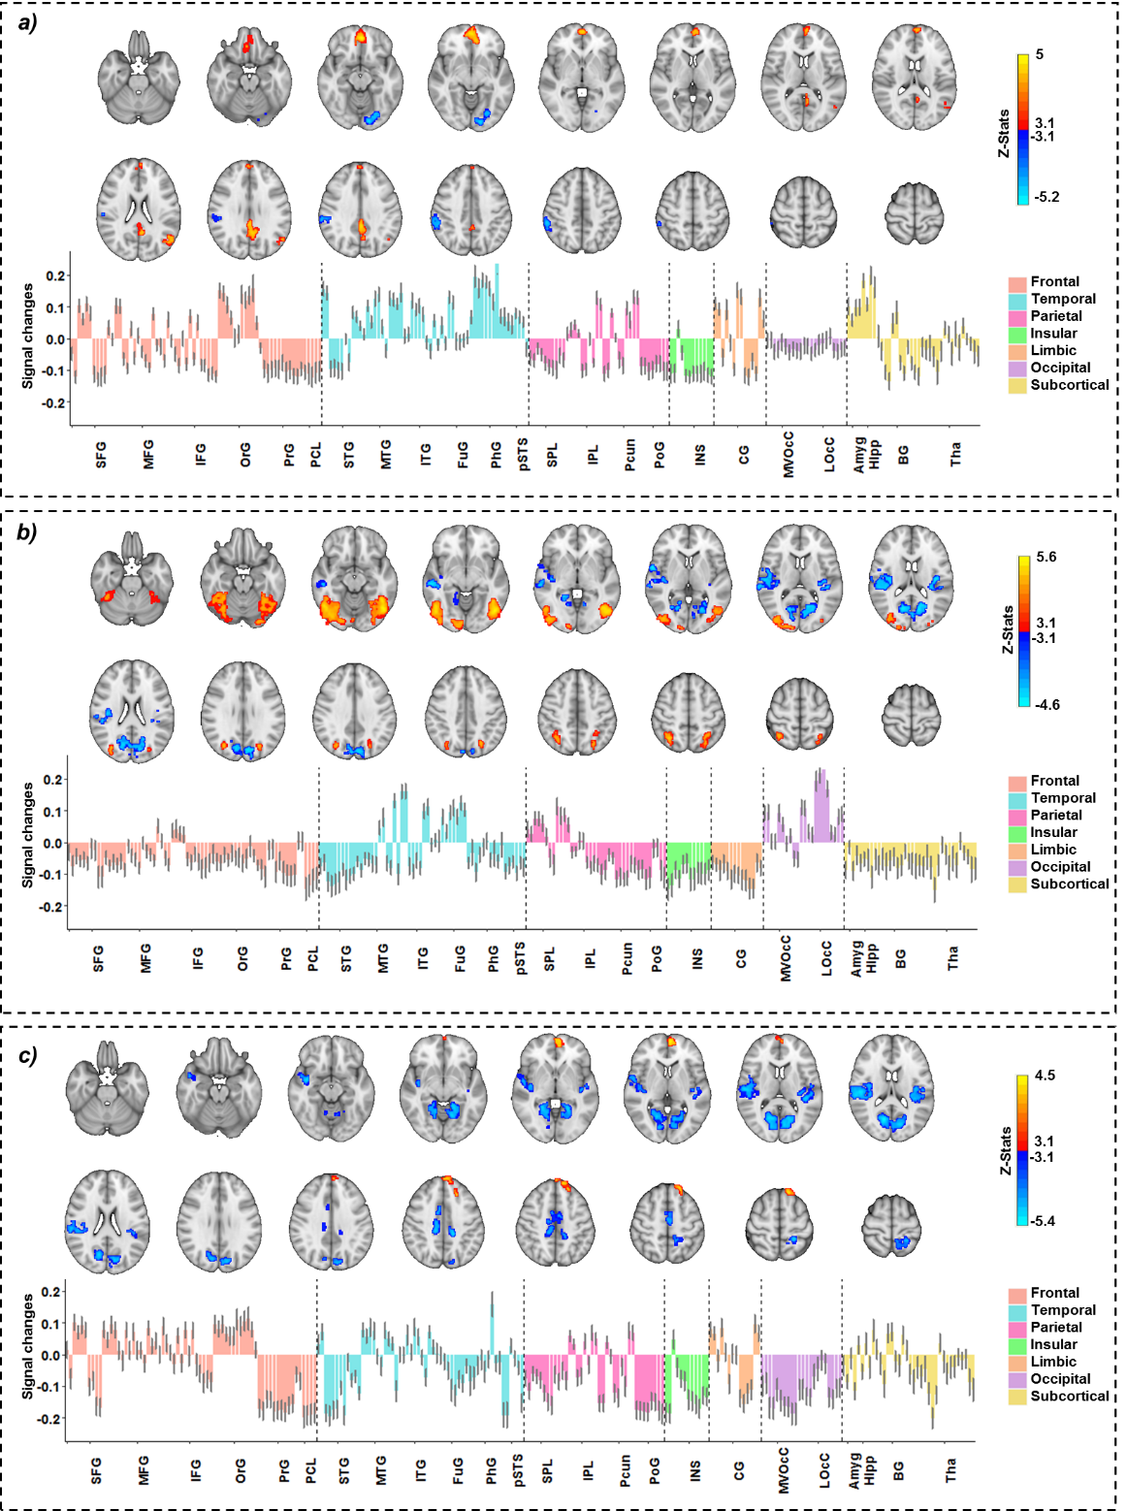

Supplementary Figure S1. Temporal behavior of the cue-reactivity contrast ((Drug Successful NoGo+Drug Successful Go) > (Neutral Successful NoGo + Neutral Successful Go)). Brain activation maps (Z-threshold > 3.1, alpha corrected p-value<0.001) and changes in brain activation in Brainnetome (BNA) regions. The colored bars show mean parameter estimates, and the error bars show the standard error of z-statistic values across 53 methamphetamine use disorders (MUD). (a) Window one. (b) Window two. (c) Window three.
Abbreviation: SFG: superior frontal gyrus, MFG: middle frontal gyrus, IFG: inferior frontal gyrus, OrG: orbital gyrus, PrG: precentral gyrus, PCL: paracentral lobule, STG: superior temporal Gyrus, MTG: middle temporal gyrus, ITG: inferior temporal gyrus, FuG: fusiform gyrus, PhG: parahippocampal gyrus, pSTS: posterior superior temporal sulcus, SPL: superior parietal lobule, IPL: inferior parietal lobule, Pcun: precuneus, PoG: postcentral gyrus, INS: insular gyrus, CG: cingulate gyrus, MVOcC: medioventral occipital cortex, LOcC: lateral occipital cortex, Amyg: amygdala, Hipp: hippocampus, BG: basal ganglia, Tha: thalamus.

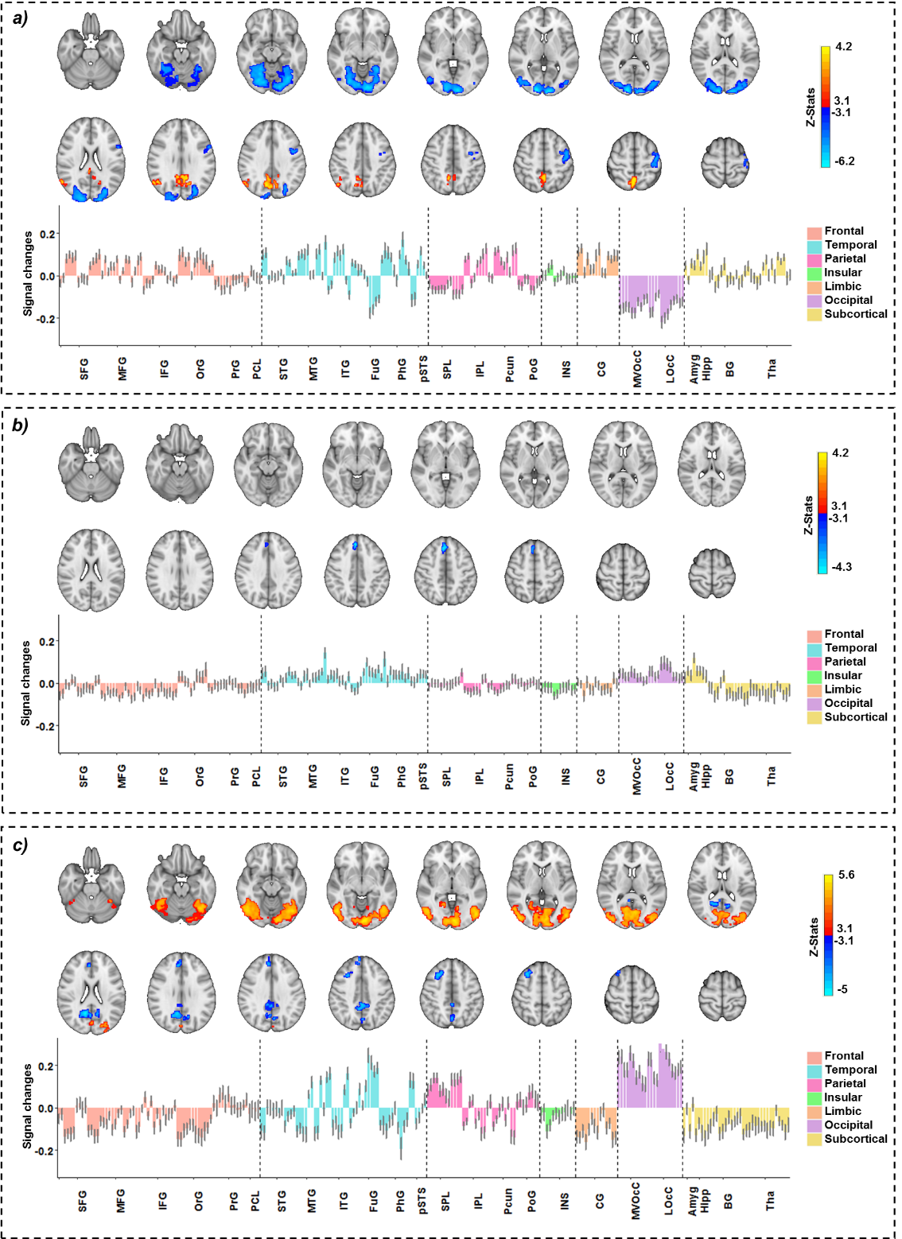

Supplementary Figure S3. Temporal behavior of the cue-reactivity/inhibition interaction contrast (Drug Successful NoGo>Drug Successful Go) > (Neutral Successful NoGo>Neutral Successful Go). Brain activation maps (Z-threshold > 3.1, alpha corrected p-value<0.001) and changes in brain activation in Brainnetome (BNA) regions. The colored bars show mean parameter estimates, and the error bars show the standard error of z-statistic values across 53 methamphetamine use disorders (MUD). (a) Window one. (b) Window two. (c) Window three.
Abbreviation: SFG: superior frontal gyrus, MFG: middle frontal gyrus, IFG: inferior frontal gyrus, OrG: orbital gyrus, PrG: precentral gyrus, PCL: paracentral lobule, STG: superior temporal Gyrus, MTG: middle temporal gyrus, ITG: inferior temporal gyrus, FuG: fusiform gyrus, PhG: parahippocampal gyrus, pSTS:: posterior superior temporal sulcus, SPL: superior parietal lobule, IPL: inferior parietal lobule, Pcun: precuneus, PoG: postcentral gyrus, INS: insular gyrus, CG: cingulate gyrus, MVOcC: medioventral occipital cortex, LOcC: lateral occipital cortex, Amyg: amygdala, Hipp: hippocampus, BG: basal ganglia, Tha: thalamus.

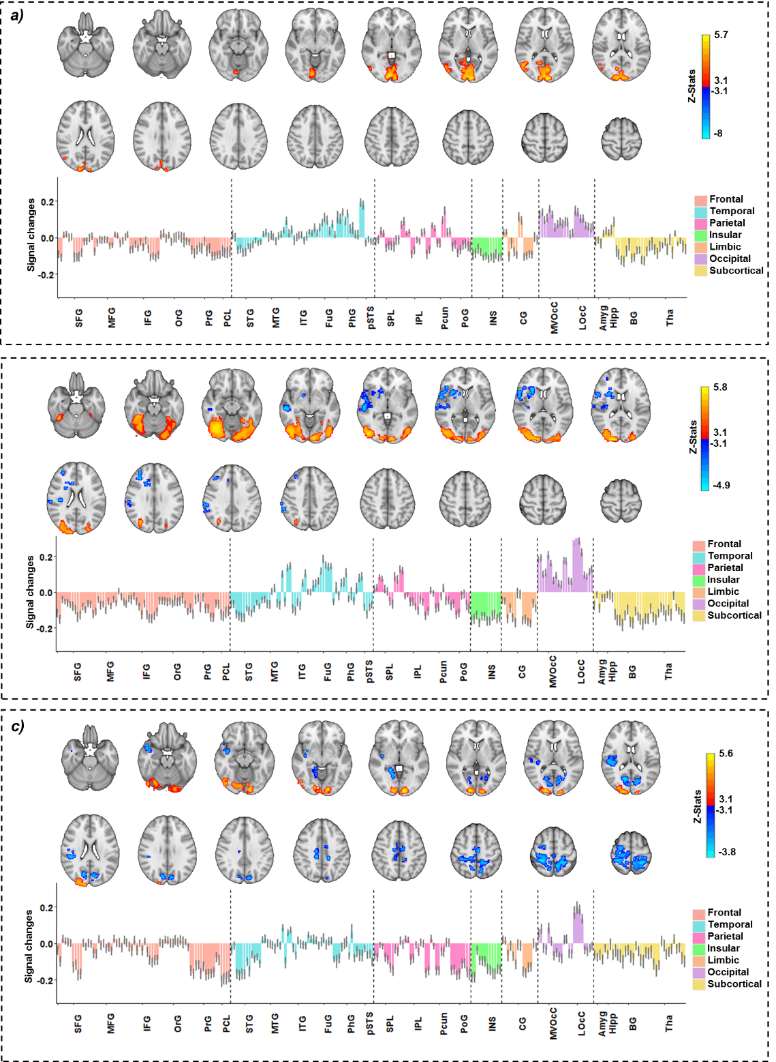

Supplementary Figure S3. Temporal behavior of the cue-reactivity/inhibition interaction contrast (Drug Successful NoGo>Drug Successful Go) > (Neutral Successful NoGo>Neutral Successful Go). Brain activation maps (Z-threshold > 3.1, alpha corrected p-value<0.001) and changes in brain activation in brainnetome (BNA) regions. The colored bars show mean parameter estimates and the error bars show the standard error of z-statistic values across 53 MUDs. (a) Window one. (b) Window two. (c) Window three.
Abbreviation: SFG: superior frontal gyrus, MFG: middle frontal gyrus, IFG: inferior frontal gyrus, OrG: orbital gyrus, PrG: precentral gyrus, PCL: paracentral lobule, STG: superior temporal Gyrus, MTG: middle temporal gyrus, ITG: inferior temporal gyrus, FuG: fusiform gyrus, PhG: parahippocampal gyrus, Psts: posterior superior temporal sulcus, SPL: superior parietal lobule, IPL: inferior parietal lobule, Pcun: precuneus, PoG: postcentral gyrus, INS: insular gyrus, CG: cingulate gyrus, MVOcC: medioventral occipital cortex, LOcC: lateral occipital cortex, Amyg: amygdala, Hipp: hippocampus, BG: basal ganglia, Tha: thalamus.

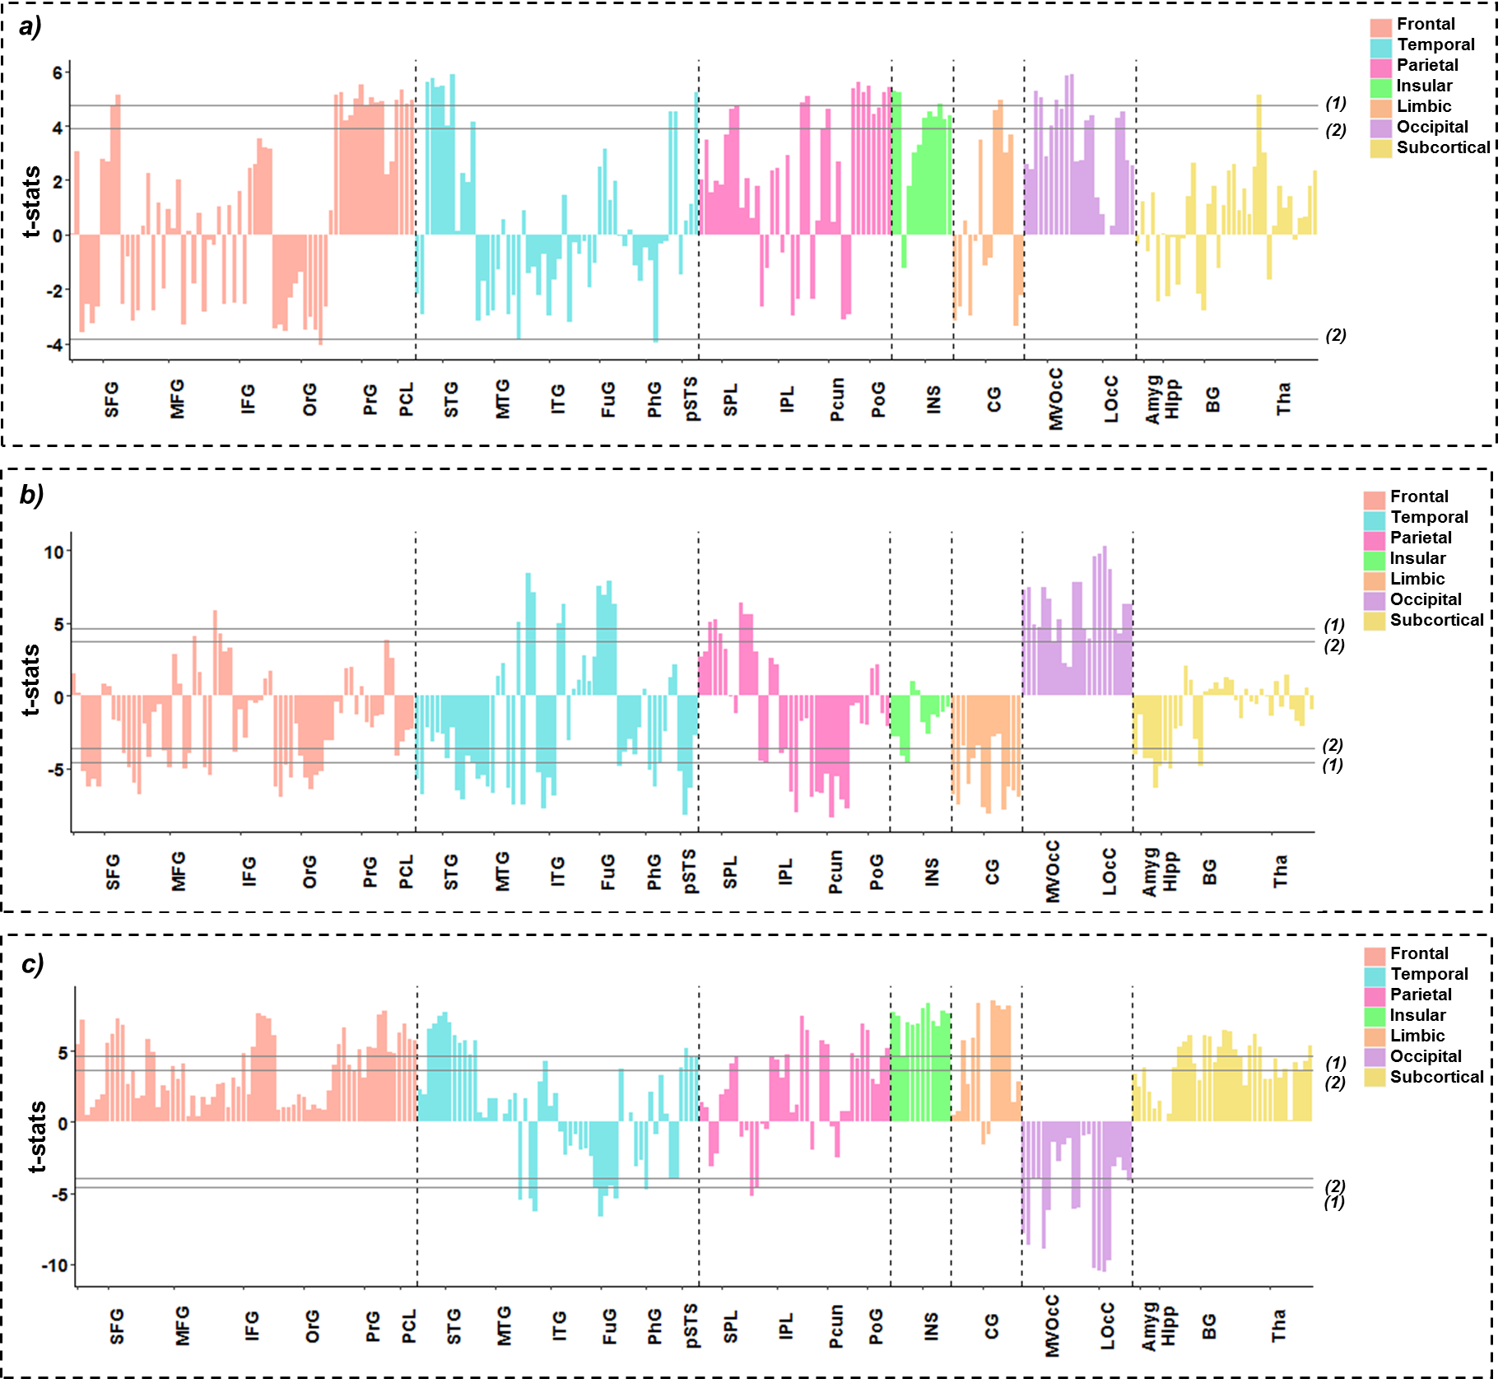

Supplementary Figure S4. The main effect of conditions in the three linear mixed effects (LME) models. Colored bars show the coefficient of the main effect of the condition term in the LME model for each Brainnetome (BNA) subregion. (a) The main effect of condition in the cue-reactivity LME ((Drug Successful NoGo+Drug Successful Go) or (Neutral Successful NoGo+Neutral Successful Go)). (b) The main effect of condition in the inhibition LME ((Drug Successful NoGo+Neutral Successful NoGo) or (Drug Successful Go + Neutral Successful Go)). (c) The main effect of condition in the cue-reactivity/response-inhibition interaction LME ((Drug Successful NoGo>Drug Successful Go) or (Neutral Successful NoGo>Neutral Successful Go)). (1) FDR corrected p-value<0.001. (2) FDR corrected p-value<0.05.
Abbreviation: SFG: superior frontal gyrus, MFG: middle frontal gyrus, IFG: inferior frontal gyrus, OrG: orbital gyrus, PrG: precentral gyrus, PCL: paracentral lobule, STG: superior temporal Gyrus, MTG: middle temporal gyrus, ITG: inferior temporal gyrus, FuG: fusiform gyrus, PhG: parahippocampal gyrus, pSTS:: posterior superior temporal sulcus, SPL: superior parietal lobule, IPL: inferior parietal lobule, Pcun: precuneus, PoG: postcentral gyrus, INS: insular gyrus, CG: cingulate gyrus, MVOcC: medioventral occipital cortex, LOcC: lateral occipital cortex, Amyg: amygdala, Hipp: hippocampus, BG: basal ganglia, Tha: thalamus.

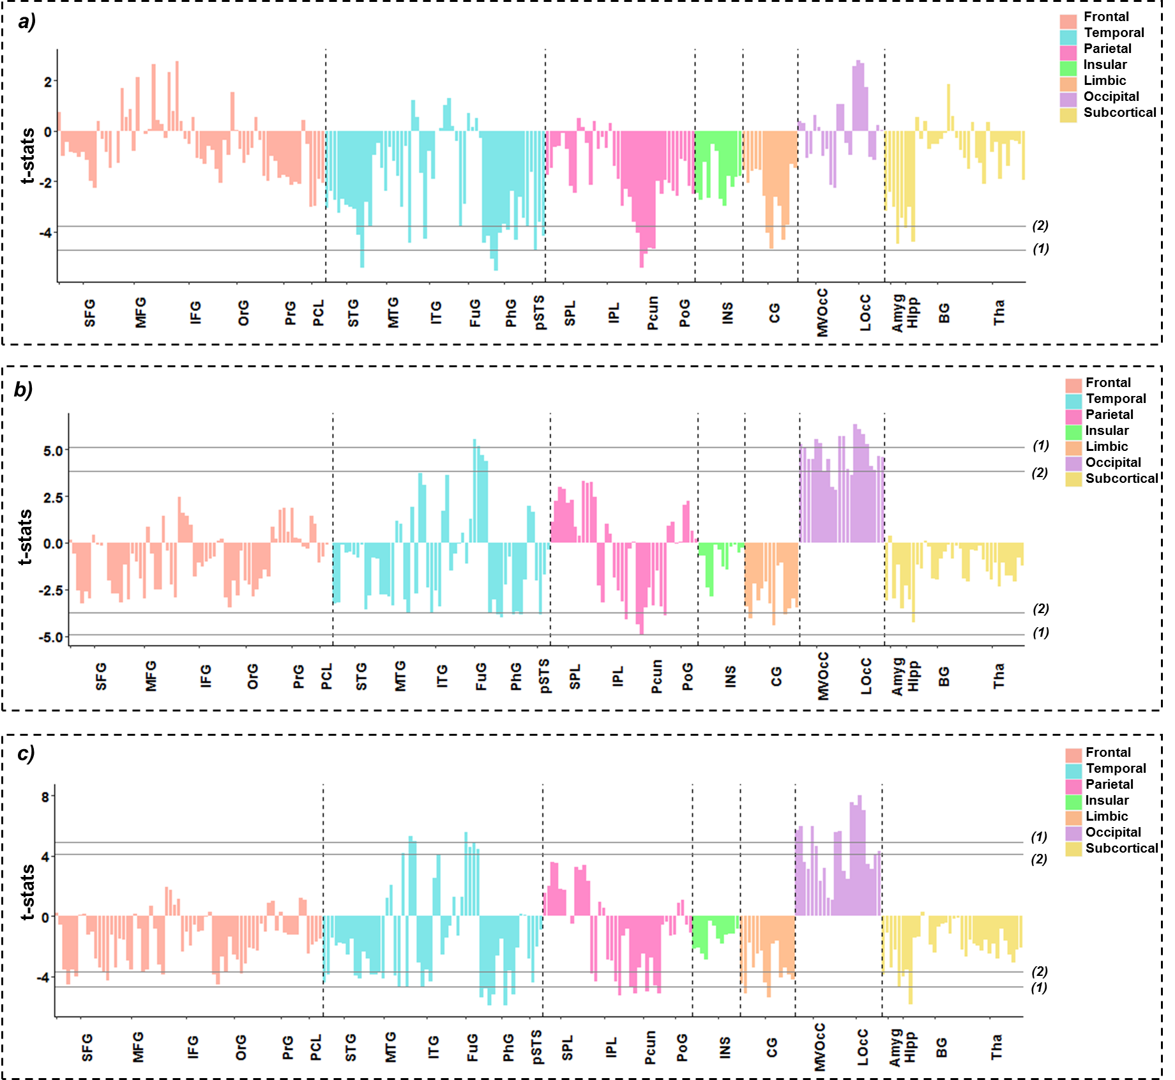

Supplementary Figure S5. The main effect of time (three windows) in the three linear mixed effects (LME) models. Colored bars show the coefficient of the main effect of the time term in the LME model for each Brainnetome (BNA) subregion. (a) The main effect of time in the cue-reactivity LME ((Drug Successful NoGo+Drug Successful Go) or (Neutral Successful NoGo+Neutral Successful Go)). (b) The main effect of time in the inhibition LME ((Drug Successful NoGo+Neutral Successful NoGo) or (Drug Successful Go + Neutral Successful Go)). (c) The main effect of time in the cue-reactivity/response-inhibition interaction LME ((Drug Successful NoGo>Drug Successful Go) or (Neutral Successful NoGo>Neutral Successful Go)). (1) FDR corrected p-value<0.001. (2) FDR corrected p-value<0.05.
Abbreviation: SFG: superior frontal gyrus, MFG: middle frontal gyrus, IFG: inferior frontal gyrus, OrG: orbital gyrus, PrG: precentral gyrus, PCL: paracentral lobule, STG: superior temporal Gyrus, MTG: middle temporal gyrus, ITG: inferior temporal gyrus, FuG: fusiform gyrus, PhG: parahippocampal gyrus, pSTS:: posterior superior temporal sulcus, SPL: superior parietal lobule, IPL: inferior parietal lobule, Pcun: precuneus, PoG: postcentral gyrus, INS: insular gyrus, CG: cingulate gyrus, MVOcC: medioventral occipital cortex, LOcC: lateral occipital cortex, Amyg: amygdala, Hipp: hippocampus, BG: basal ganglia, Tha: thalamus.

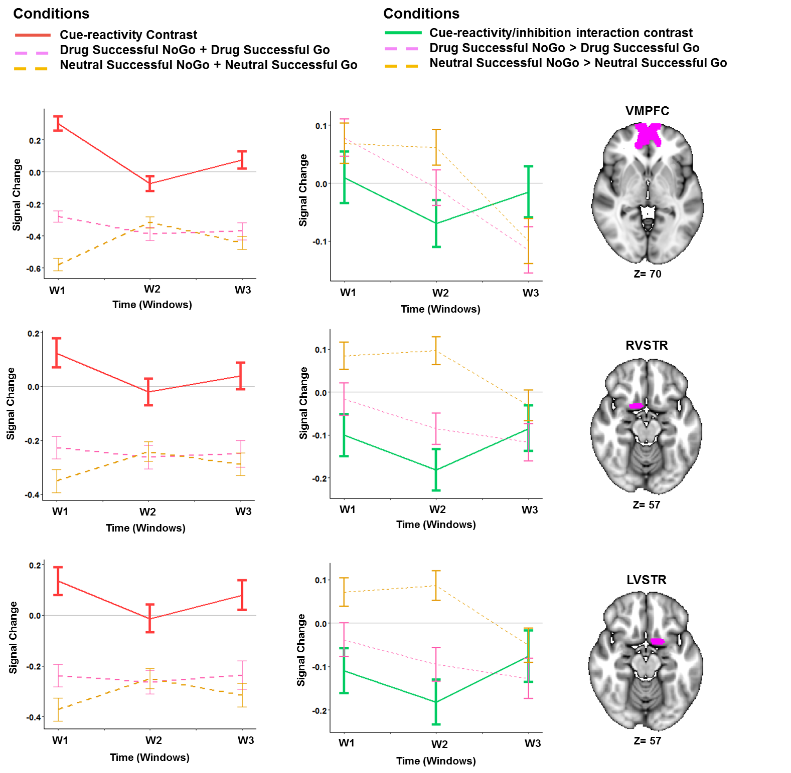

Supplementary Figure S6. Temporal behavior of the selected ROIs with condition by time interaction extracted from linear mixed effect (LME) model. Left panel: Cue/reactivity contrast (Drug Successful NoGo+Drug Successful Go) > (Neutral Successful NoGo+Neutral Successful Go). Lines show the average main effect of Drug (Drug Successful NoGo+Drug Successful Go) or Neutral (Neutral Successful NoGo+Neutral Successful Go) cue-exposure condition in the Brainnetome (BNA) regions or the result of Drug vs. Neutral contrast. Right panel: Cue-reactivity/inhibition contrast ((Drug Successful NoGo>Drug Successful Go) > (Neutral Successful NoGo>Neutral Successful Go)). Lines show the average main effect of Drug-related inhibition (Drug Successful NoGo-Drug Successful Go) or Neutral inhibition (Neutral Successful NoGo-Neutral Successful Go) interaction condition or the result of Cue-reactivity/response inhibition contrast in the brainnetome (BNA) regions. Error bars in both panel show the standard error of z-statistic values across 53 methamphetamine use disorders (MUD) at each temporal window (FDR corrected p-value<0.001).
Abbreviation: VMPFC: ventromedial prefrontal cortex, RVSTR: right ventral striatum. LVSTR: left ventral striatum.

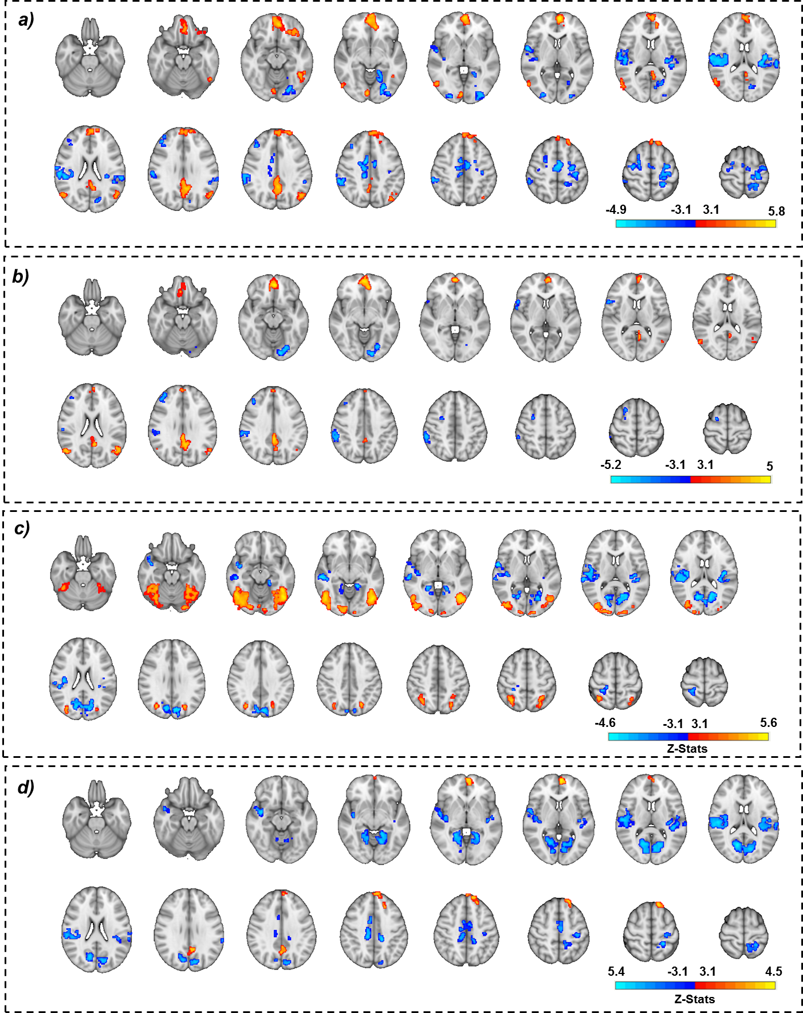

Supplementary Figure S7. Response to the fMRI cue-reactivity contrast ((Drug Successful NoGo+Drug Successful Go)>(Neutral Successful NoGo+Neutral Successful Go)) (Z-threshold > 3.1, alpha corrected p-value<0.05). (a) Whole brain overall activation maps. (b) Window One. (c) Window two. (d) Window three.

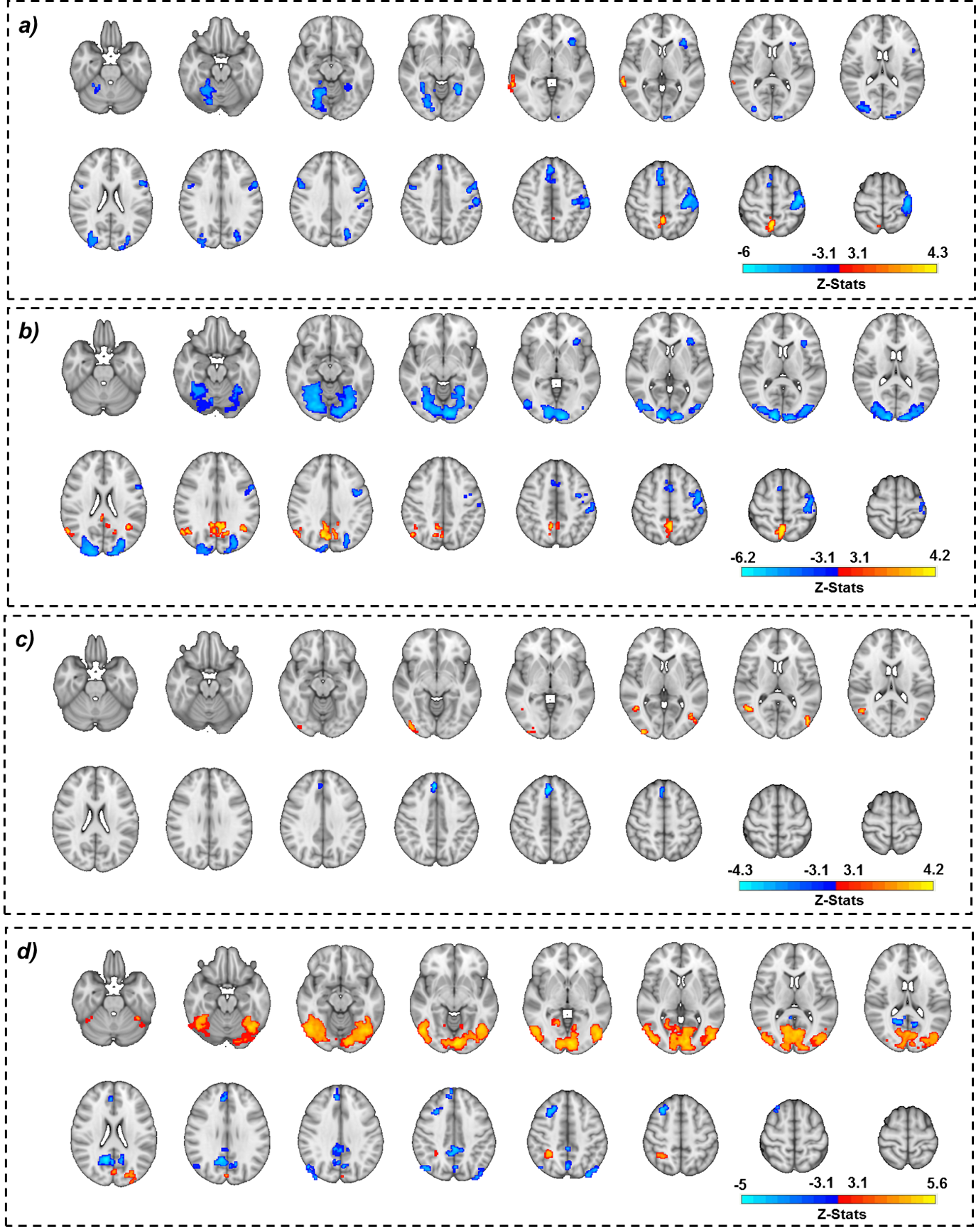

Supplementary Figure S8. Response to the fMRI inhibition contrast ((Drug Successful NoGo+Neutral Successful NoGo)>(Drug Successful Go+Neutral Successful Go)) (Z-threshold > 3.1, alpha corrected p-value<0.05). (a) Whole brain overall activation maps. (b) Window One. (c) Window two. (d) Window three.

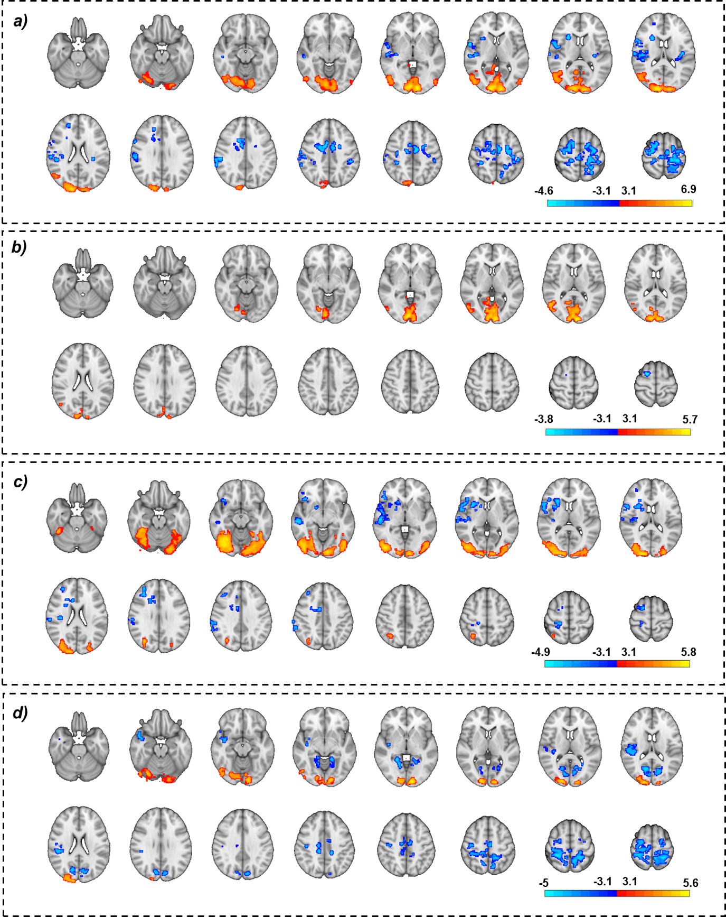

Supplementary Figure S9. Response to the fMRI cue-reactivity/inhibition interaction contrast ((Drug Successful NoGo>Drug Successful Go)>(Neutral Successful NoGo> Neutral Successful Go)) (Z-threshold > 3.1, alpha corrected p-value<0.05). (a) Whole brain overall activation maps. (b) Window One. (c) Window two. (d) Window three.

Supplementary Tables

Supplementary Table S1. Significantly active clusters in the whole-brain cue-reactivity contrast, based on the cluster-defining threshold method. Regions determined based on the Brainnetome atlas.
(Z-threshold > 3.1, Alpha corrected p-value<0.05).
Abbreviation: (cLinG): caudal lingual gyrus part of medioventral occipital cortex, polar part of lateral occipital cortex.

Drug Cue Reactivity Activation
(Drug Successful NoGo + Drug Successful Go) > (Neutral Successful NoGo + Neutral Successful Go)
Cluster Location in BNA | Cluster size  (Voxels) | Z-value  in peak | MNI Peak Coordinate
Cluster Location in BNA | Cluster size  (Voxels) | Z-value  in peak | X(mm) | Y(mm) | Z(mm)
Left superior frontal gyrus (medial) | 1734 | 5.82 | -4 | 60 | 4
Left precuneus | 736 | 5.11 | -4 | -54 | 30
Left inferior parietal lobule (rostroventral) | 277 | 4.33 | -46 | -68 | 34
Right lateral occipital cortex | 259 | 4.15 | 54 | -68 | 2
Left orbital gyrus (lateral) * | 144 | 3.93 | -26 | 36 | -16
Left inferior temporal gyrus (extreme lateroventral) * | 143 | 4.66 | -44 | -50 | -12
Right medioventral occipital cortex (cLinG) * | 130 | 4.73 | 6 | -86 | -6
Left superior frontal gyrus (dorsolateral) * | 88 | 3.9 | -22 | 36 | 54
Drug Cue Reactivity Deactivation
(Neutral Successful NoGo + Neutral Successful Go) > (Drug Successful NoGo + Drug Successful Go)
Cluster Location in BNA | Cluster size  (Voxels) | Z-value  in peak | MNI Peak Coordinate
Cluster Location in BNA | Cluster size  (Voxels) | Z-value  in peak | X(mm) | Y(mm) | Z(mm)
Right inferior parietal lobule (rostroventral) | 1326 | 4.55 | 54 | -18 | 18
Right cingulate gyrus (caudodorsal) | 746 | 4.95 | 10 | -2 | 40
Left precentral gyrus (caudal dorsolateral) | 564 | 4.2 | -30 | -10 | 56
Left fusiform gyrus (medioventral) | 414 | 4.35 | -24 | -74 | -10
Left insular gyrus (hypergranular) | 379 | 4.79 | -34 | -26 | 18
Right precentral gyrus (upper limb region) | 248 | 4.07 | 32 | -16 | 68
Left superior parietal lobule (postcentral) * | 155 | 4.15 | -24 | -48 | 64
Right precentral gyrus (tongue and larynx region)* | 139 | 4.27 | 56 | 0 | 6
Left medioventral occipital cortex (vmPOS) * | 133 | 3.72 | -12 | -80 | 24
Right middle temporal gyrus (ventrolateral) * | 131 | 3.82 | 38 | 32 | 36
Left medioventral occipital cortex (rostral lingual gyrus) * | 118 | 3.95 | -16 | -46 | -6
Right lateral occipital cortex (OPC) * | 81 | 4.15 | 28 | -92 | 0
* Clusters with p value<0.05 that not survived alpha corrected p-value<0.001

Supplementary Table S2. Significantly active clusters in the whole-brain response-inhibition contrast, based on the cluster-defining threshold method. Regions determined based on the Brainnetome atlas (Z-threshold > 3.1, Alpha corrected p-value<0.05).
Abbreviation: (lsOccG): lateral superior part of lateral occipital cortex, INS: insular gyrus.

Inhibition Activation (Drug Successful NoGo + Neutral Successful NoGo) > (Drug Successful Go + Neutral Successful Go)
Cluster Location in BNA | Cluster size  (Voxels) | Z-value  in peak | MNI Peak Coordinate
Cluster Location in BNA | Cluster size  (Voxels) | Z-value  in peak | X(mm) | Y(mm) | Z(mm)
Right precuneus (medial) | 183 | 4.31 | 0 | -56 | 60
Right middle frontal gyrus ((dorsolateral) * | 114 | 4.4 | 64 | -44 | 2
Inhibition Deactivation (Drug Successful Go + Neutral Successful Go) > (Drug Successful NoGo + Neutral Successful NoGo)
Cluster Location in Brainnetome Atlas | Cluster size  (Voxels) | Z-value  in peak | MNI Peak Coordinate
Cluster Location in Brainnetome Atlas | Cluster size  (Voxels) | Z-value  in peak | X(mm) | Y(mm) | Z(mm)
left-precentral gyrus (head and face region) | 1220 | 6.1 | -44 | -14 | 60
Right fusiform gyrus (medioventral) | 879 | 5.25 | 24 | -60 | -14
Right inferior parietal lobule (caudal) | 355 | 4.16 | 34 | -76 | 20
Left precentral gyrus (caudal ventrolateral) | 319 | 4.39 | -54 | 12 | -34
Right superior frontal gyrus (medial) | 316 | 5.27 | 4 | 32 | 50
Left lateral occipital cortex (lsOccG) | 256 | 4.37 | -24 | -72 | 32
Left fusiform gyrus (medioventral) * | 142 | 5.06 | -28 | -54 | -8
Left insular gyrus (dorsal agranular) * | 117 | 4.26 | -34 | 24 | 2
Right precentral gyrus (caudal ventrolateral) * | 104 | 3.75 | 52 | 6 | 34
* Clusters with p value<0.05 that not survived alpha corrected p-value<0.001

Supplementary Table S3. Significantly active clusters in the whole-brain cue-reactivity/response-inhibition interaction contrast, based on the cluster-defining threshold method. Regions determined based on the Brainnetome atlas.
(Z-threshold > 3.1, Alpha corrected p-value<0.05).
Abbreviation: dmPOS: dorsomedial parietooccipital sulcus part of precuneus, msOccG: medial superior part of lateral occipital cortex.

Interaction Activation (Drug Successful NoGo > Drug Successful Go) > (Neutral Successful NoGo > Neutral Successful Go)
Cluster Location in BNA | Cluster size  (Voxels) |  | Z-value  in peak | MNI Peak Coordinate
Cluster Location in BNA |  |  | Z-value  in peak | X(mm) | Y(mm) | Z(mm)
left-medioventral occipital cortex (caudal cuneus gyrus) | 5129 |  | 6.94 | -10 | -94 | -2
Right precuneus (dmPOS) * | 137 |  | 4.28 | 8 | -58 | 10
Right lateral occipital cortex (msOccG) * | 116 |  | 4.05 | 16 | -82 | 48
Left lateral occipital cortex (V5/MT+) * | 98 |  | 3.67 | -48 | -82 | -2
Interaction Deactivation (Neutral Successful NoGo > Neutral Successful Go) > (Drug Successful NoGo > Drug Successful Go)
Cluster Location in BNA | Cluster size  (Voxels) | Z-value  in peak |  | MNI Peak Coordinate
Cluster Location in BNA | Cluster size  (Voxels) |  |  | X(mm) | Y(mm) | Z(mm)
Left postcentral gyrus (trunk region) | 1647 | 4.49 |  | -30 | -32 | 64
Right cingulate gyrus (caudodorsal) | 1317 | 4.61 |  | 10 | -2 | 40
Right inferior parietal lobule (rostroventral) | 776 | 4.36 |  | 56 | -28 | 32
Left superior frontal gyrus (medial) | 352 | 4.15 |  | -6 | -14 | 66
right precentral gyrus (tongue and larynx region) | 319 | 4.54 |  | 58 | 4 | 4
Right insular gyrus (dorsal agranular) * | 152 | 4.32 |  | 26 | 16 | 10
Left insular gyrus (hypergranular) * | 124 | 4.09 |  | -32 | -28 | 20
Right superior parietal lobule (lateral) * | 84 | 3.91 |  | 34 | -38 | 52
Right middle frontal gyrus (dorsal) * | 69 | 3.67 |  | 22 | 46 | 20
* Clusters with p value<0.05 that not survived alpha corrected p-value<0.001

