Supplementary Information
Supramolecular nanomedicine for enhanced chemotherapy against drug-resistant colorectal cancer
Xiangjie Yan¹, Feihe Ma², Qixian Chen³, Xiangbo Gou¹, Xiaohui Li², Liuwei Zhang³, Hui Gao^{1, 2}*

¹School of Materials Science and Engineering, Tianjin Key Laboratory of Drug Targeting and Bioimaging, Tianjin Enterprise Key Laboratory for Application Research of Hyaluronic Acid, Tianjin University of Technology, Tianjin, China.
²State Key Laboratory of Separation Membranes and Membrane Processes, School of Materials Science and Engineering, Tiangong University, Tianjin, China.
³School of Bioengineering, Dalian University of Technology, No. 2 Linggong Road, Dalian, China.

*Corresponding author, e-mail: huigao@tiangong.edu.cn

Methods
Drug release: To examine the OxPt release profiles of PG-Pt-LA/CB[7] in vitro, 5 mg of prepared sample in 2 mL of buffered solution (PBS, 10 mM, pH 7.4 or pH 5.0) was injected into a preswelled dialysis tube with a molecular weight cutoff of 3,500 Da, followed by immersion into 8 mL of the PBS buffered solution (pH 7.4 or pH 5.0) at 37 °C in a shaking culture incubator. Among them, spermine (15 mM) and glutathione (GSH, 10 mM) were added to pH 5.0 solution as stimulation-induced release factors. Periodically, the dialysis solution was collected to measure the released concentration of Pt using inductively coupled plasma mass spectrometer (ICP-MS) measurement.
Cell and bacterial culture: All cell lines were obtained from the cell bank of the Chinese Academy of Sciences (Shanghai, China). Normal human colon mucosal epithelial cell line (NCM460 cells) and mouse fibroblast cells (L929 cells) were cultured in RPMI-1640 supplemented with 10% fetal bovine serum (FBS) and 1% antibiotics in a humidified incubator at 37 °C (95% room air, 5% CO₂). Human HT29 colorectal cancer cells were maintained in McCoy's 5A Medium (Invitrogen) containing 10% of FBS. F. nucleatum (ATCC 25586) and Clostridium butyricum (ATCC 19398) were purchased from Shanghai Huzheng Biological Technology Co., Ltd (China) and used for bacterial experiments cultured with BHI broth (Qingdao Hope Biotechnology, China). And Escherichia coli (gram-negative bacterium) were cultured with Luria-Bertani (LB) culture medium.
Observation the morphology of F. nucleatum by SEM: The F. nucleatum solution was incubated with the samples under anaerobic conditions of 37 °C for 5 h. Then, the bacteria were collected by centrifugation at 8,000 rpm and were fixed with a small amount of 2.5% glutaraldehyde solution at room temperature. At the end of immobilization, dehydration was performed with ethanol of 30%, 50%, 70%, 85%, 95% and 100% at gradient concentrations for 20 min each time. Finally, isoamyl acetate was used for replacement and air-dried under dust-free conditions. The morphology of bacteria was analyzed by scanning electron microscope (SEM).
Cell viability assay: For viability assay, the cells were cultured and grown in 96-well plates for 24 h, with 5,000 cells seeded into each well. When cells reached 70% confluences, they were incubated with the fresh complete medium containing test samples with appropriate concentrations for another 24 h. Cell proliferation was measured using the cell counting kit-8 (CCK-8) according to the manufacturer’s instructions. And the absorbance intensity was measured at 450 nm using a Versamax microplate reader (Germany). Results were quantified by determining cell viability relative to that of untreated cells.
Antibacterial experiments: F. nucleatum was cultured in brain heart infusion (BHI) broth in an anaerobic box at 37 °C. The samples were then added into the prepared bacteria suspension (10⁵ CFU mL⁻¹) kept shaking (170 rpm) at 37 °C for 5 h. Later on, the test bacterial suspensions were taken out and 100 μL of the bacterial suspensions at the concentration of 10⁴ CFU mL⁻¹ was used for solid nutrient agar plate. And then the colonies were counted after being kept for 16 h at 37 °C. The solution in absent of NPs was used as a control. The bacterial viability rates were determined by the ratio of colony counts to the blank groups.
The cultivation protocol of the Escherichia coli and Clostridium butyricum was similar to that of the F. nucleatum. Specifically, Escherichia coli were incubated to a liquid state Luria-Bertani (LB) culture medium. After the samples and bacteria suspensions were co-cultured for 12 h at 37 °C, the LB solid nutrient agar plates were used for detecting the ability to resist Escherichia coli and OD600 value was determined to detect the antibacterial ability about Clostridium butyricum.
Western blot: Western blotting was performed to detect the expression levels of autophagy protein (Beclin-1, LC3). Briefly, HT29 cells seeded in 6-well plates were washed slowly with cold PBS and lysed with RIPA buffer (RIPA: PMSF=100:1, v/v) on ice. Then full soluble lysates were harvested by centrifugation at 4 °C (12, 000 rpm, 10 min). Protein content was detected using a BCA protein assay kit. And 15 μg of protein samples were separated with a 10% SDS-PAGE gel. After proteins were transferred to polyvinylidene fluoride (PVDF) membrane, 5% skimmed milk was utilized to block the membranes at room temperature. Then the membranes were incubated overnight at 4 °C containing primary antibodies and exposed to secondary antibodies at 37 °C for 1 h. Immunoreactive bands were developed by ECL chemiluminescent agent and visualized using BIO-RAD imaging system. ImageJ analysis software was used for densitometric analysis. Expression levels of autophagy protein were calculated using GAPDH as an internal control.
In vivo anti-tumor effects: For animal experiments, male BALB/c nude mice aged 4-6 weeks were purchased from Beijing Vital River Laboratory Animal Technology Co., Ltd. (China). The animal studies were carried out under a protocol approved by the Guide for the Care and Use of Laboratory Animals of the Institute of Laboratory Animal Resources. 5×10⁶ HT29 cells were inoculated into the right axilla subcutaneous tissues of each mouse to develop the xenograft model of CRC. When the mean tumor size reached ~100 mm³, the mice were randomly divided into six groups: PBS (-), OxPt (-), PBS (+), OxPt (+), PG-Pt-LA/CB[7] (+), PG-Pt-LA (+) at a dose of 8 mg/kg (wherein (+) and (-) were referred to injection with or without F. nucleatum through tail vein), which were administered every three days by tail vein injection for three weeks.
Tumor volume was recorded every three days and calculated using the formula: (L×W²)/2, where L and W are the length and width of the tumor, respectively. In addition, body weight of each mouse was recorded every three days. After three weeks, all mice were sacrificed and major organs (heart, liver, spleen, kidney and lung) together with tumors of mice were collected, after which a part of the organs and tumors were fixed in 4% paraformaldehyde buffer to carry out hematoxylin and eosin (H&E) staining of organs and tumor slices. After fresh tumor tissues were ground and supernatant was cultured in anaerobic conditions about 12 h, the content of F. nucleatum in tumor tissues was detected by coating plate method.
Pharmacokinetic profile: Female Wistar (180±10 g in mass) rats were intravenously injected with OxPt, PG-Pt-LA/CB[7] and PG-Pt-LA at an OxPt dose of 8 mg/kg. The blood samples were withdrawn at 2 min, 5 min, 15 min, 45 min, 1 h, 2 h, 4 h, 8 h, 12 h, and 24 h, and then were immediately centrifuged to harvest plasma samples at 3,000 rpm for 10 min. Finally, the blood concentration of platinum was quantitatively examined using ICP-MS.
Biodistribution of OxPt: After tail vein injection of free ICG or ICG labeled nanoparticles, the male BALB/c nude mice aged 4-6 weeks were subjected to whole-body imaging scans at predetermined 3 h, 6 h, 9 h, 12 h and 24 h using to obtain the distribution of nanoparticles in the body. Meanwhile, the mice were sacrificed after injection of 24 h, and the main tissues and tumors were collected for ex vivo imaging by animal optical imaging system (IVIS SPECTRUM, PE, USA).

Supplementary Fig. 1 a Synthetic scheme of PG. b ¹H-NMR spectrum of PG in D₂O.
a
b
1
2, 3
1
1
2
3
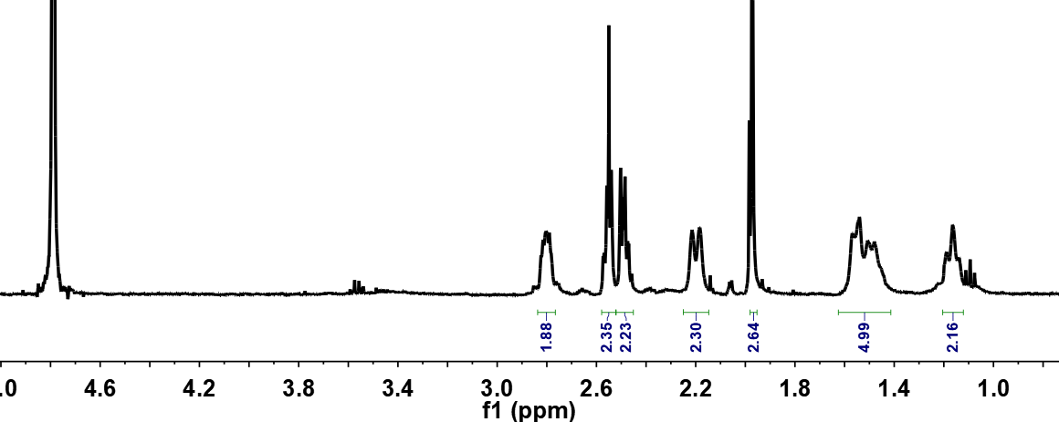
Supplementary Fig. 2 a Synthetic scheme of OxPt-COOH. b ¹HNMR spectrum of OxPt-COOH in D₂O.
a
3
2
4
8
5, 6
7
1
b
12
6,7,10
4
9
6,8
2, 3
5
11
2
9
3
12
4
6
4
7
10
11
11
11
11
11
11
11
11
5
a
b
Supplementary Fig. 3 a Synthetic schme of PG-Pt-LA. b ¹H-NMR spectrum of PG-Pt-LA in D₂O.
Supplementary Fig. 4 The hydrodynamic diameter of OxPt-COOH/CB[7] by DLS.

Supplementary Fig. 5 The cumulative release profiles of PG-Pt-LA/CB[7] at pH 7.4 or pH 5.0 in presence of spermine and GSH.

Supplementary Fig. 6 Cell viability of L929 under treatment of OxPt and PG-Pt-LA/CB[7].

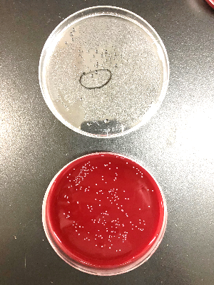
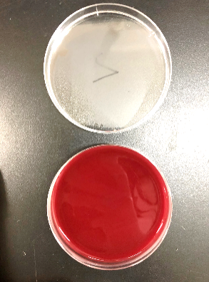
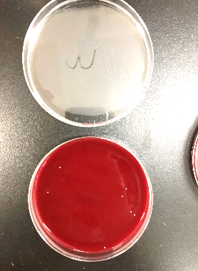
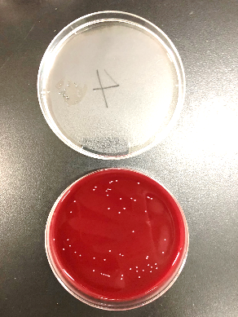
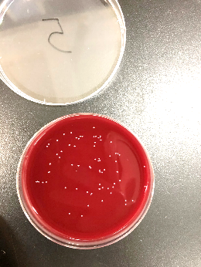
Supplementary Fig. 7 The spread plate and quantification of F. nucleatum under treatment of LA at varied concentrations. ***p < 0.001 compared with PBS group.
LA
PBS
20 μg/mL
40 μg/mL
60 μg/mL
80 μg/mL

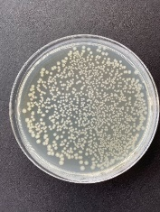
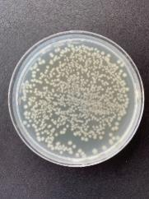
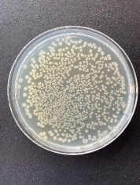
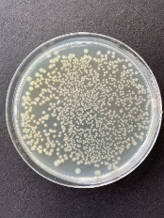
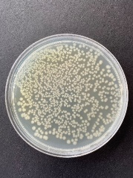
Supplementary Fig. 8 The spread plate and quantification of Escherichia coli under treatment of PG-Pt-LA/CB[7] at varied concentrations.
PBS
25 μM
50 μM
75 μM
100 μM
PG-Pt-LA/CB[7]

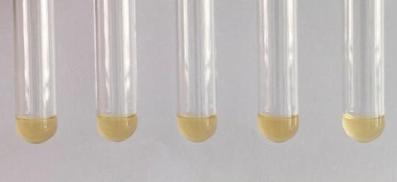
Supplementary Fig. 9 The antibacterial activities of Clostridium butyricum under treatment of PG-Pt-LA/CB[7] at varied concentrations.
PBS
25 μM
50 μM
75 μM
100 μM

Supplementary Fig. 10 The disrupting potencies of PG-Pt-LA/CB[7] to F. nucleatum-based biofilm.

PBS
PG-Pt-LA/CB[7]
Supplementary Fig. 11 The confocal 3D laser imaging of biofilms incubated with PG-Pt-LA/CB[7] on biofilm. (width: 37.87 μm, height: 37.87 μm, depth: 8.10 μm).

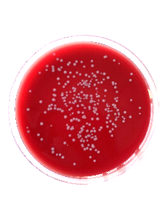
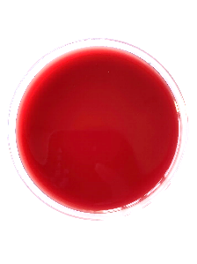
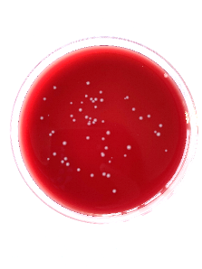
PG-Pt-LA/CB[7] (+)
PBS (-)
PBS (+)
Supplementary Fig. 12 The spread plate and quantification of F. nucleatum after HT29 cells treated with PBS, F. nucleatum, and F. nucleatum followed by PG-Pt-LA/CB[7]. ***p < 0.001.

Supplementary Table 1 Pharmacokinetic indexes of OxPt, PG-Pt-LA/CB[7] and PG-Pt-LA.

pharmacokinetic parameters | OxPt | PG-Pt-LA/CB[7] | PG-Pt-LA
t_{1/2α} (h) | 0.23±0.1 | 0.43±0.1 | 0.34±0.1
t_{1/2β} (h) | 15.9±1.4 | 10.5±0.8 | 15.3±3.8
CL (L/h/kg) | 2.1±1.2 | 0.7±0.3 | 1.7±1.0
Vd (L/kg) | 3.3±0.6 | 1.6±0.1 | 2.6±0.1
AUC_{0→t} (μg/mL*h) | 4.0±0.3 | 8.9±0.3 | 6.4±0.7
AUC_{0→∞} (μg/mL*h) | 5.5±1.8 | 10.6±0.7 | 8.2±0.7

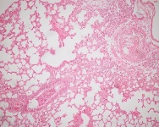
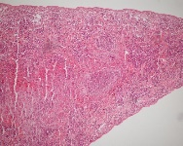
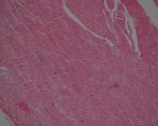
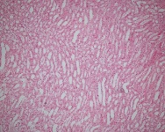
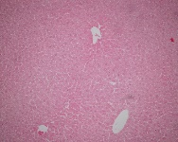
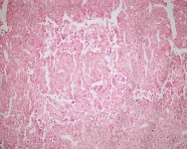
Lung
Spleen
Heart
Kidney
Liver
Tumor
Supplementary Fig. 13 Hematoxylin and eosin (H&E) staining for the fundamental organs and tumors of tumor-bearing mice under treatment of PG-Pt-LA/CB[7].

