Self-limiting population suppression gene drive in the West Nile vector mosquito, Culex quinquefasciatus

Xuechun Feng^{1,2#*}, Jinying Ding^{2#}, Yiran Liu³, Víctor López Del Amo⁴, Valentino M. Gantz⁵, Xuexin Chen¹, Jackson Champer ^{3*}, Feng Liu^{2,6*}.

¹ Key Laboratory of Biology of Crop Pathogen and Insects of Zhejiang Province, College of Agricultural and Biotechnology, Zhejiang University, Hangzhou, China
² Institute of Infectious Diseases, Shenzhen Bay Laboratory, Shenzhen, China
³ Center for Bioinformatics, School of Life Sciences, Center for Life Sciences, Peking University, Beijing, China
⁴ Center for Infectious Diseases, Department of Epidemiology, Human Genetics, and Environmental Sciences, School of Public Health, University of Texas Health Science Center, Houston, TX, USA
⁵ Section of Cell and Developmental Biology, University of California San Diego, La Jolla, CA, USA
⁶ Guangdong Provincial Key Laboratory of Infection Immunity and Inflammation, Shenzhen, China
# Authors contributed equally
* Corresponding authors: liufeng@szbl.ac.cn; xfeng24@zju.edu.cn; jchamper@pku.edu.cn.

Keywords: Culex mosquitoes, population suppression, gene drives, doublesex, RIDD.

Supplementary Figures
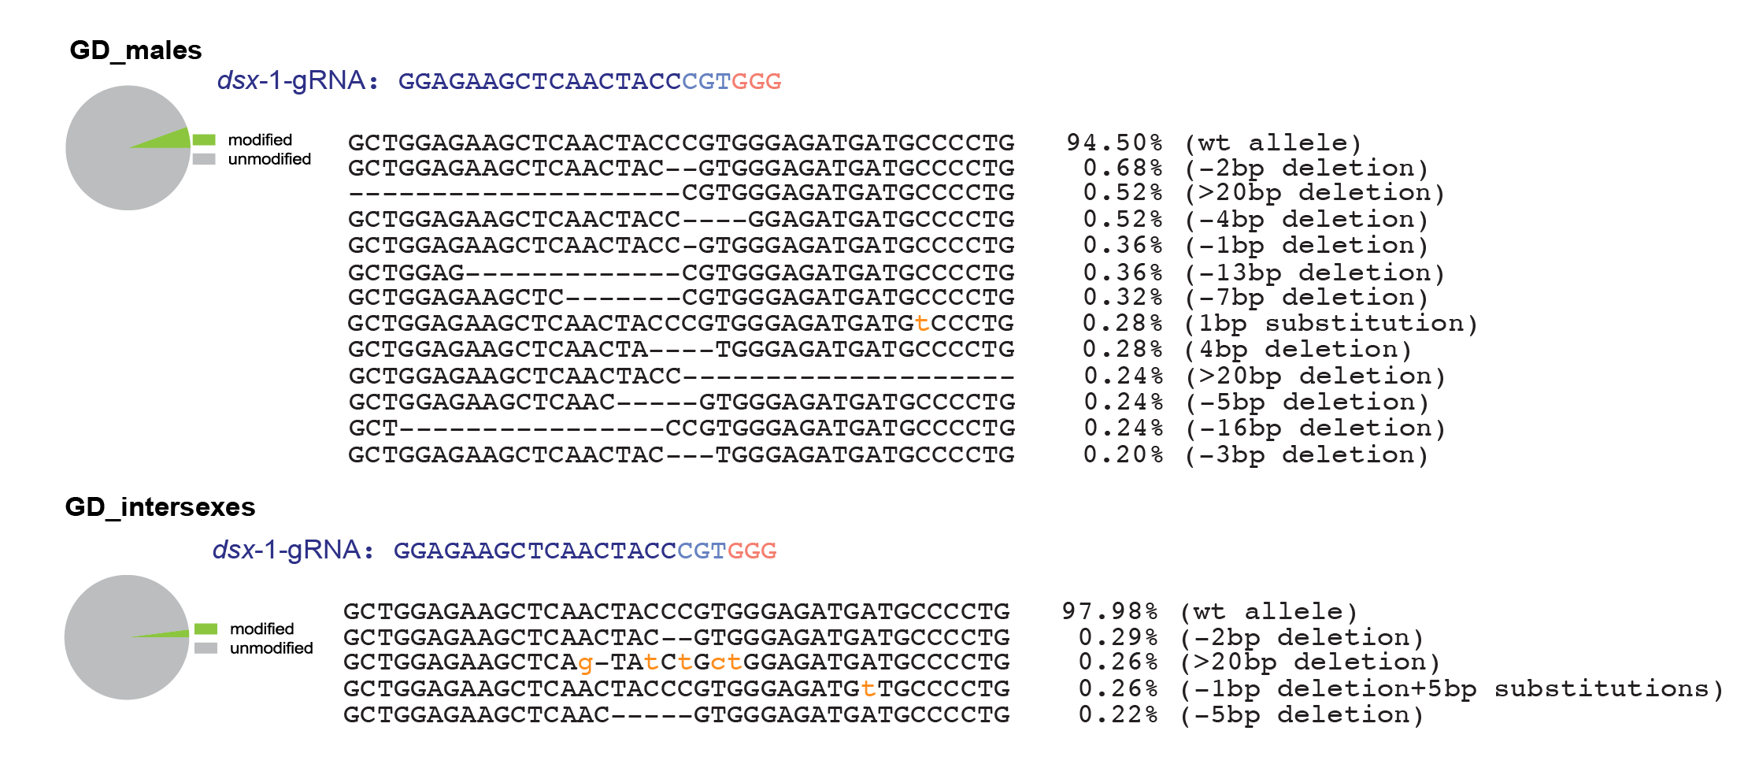
Supplementary Figure 1: Editing outcomes at dsx-gRNA-1 target site in GD individuals. Deep sequencing analysis (Supplementary Data 3) of GD males and intersexes revealed editing outcomes at the dsx-gRNA-1 target site. The proportions of modified versus unmodified alleles are shown as pie charts (left), while the types and frequencies of observed indels are listed on the right.

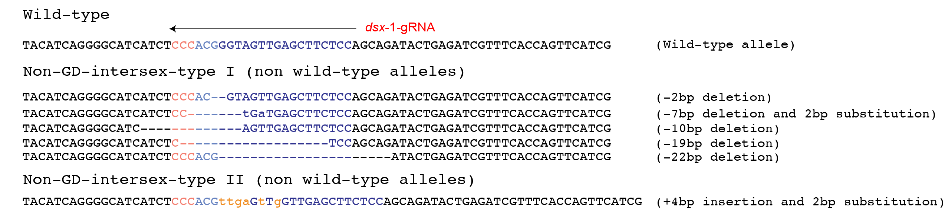
Supplementary Figure 2: ICE CRISPR analysis of dsx-gNRA-1 editing in non-GD intersex individuals. Sanger sequencing traces from ten non-GD-intersex type I and one non-GD-intersex type II individuals were analyzed using ICE CRISPR. The identified non wild-type indel variants are listed.

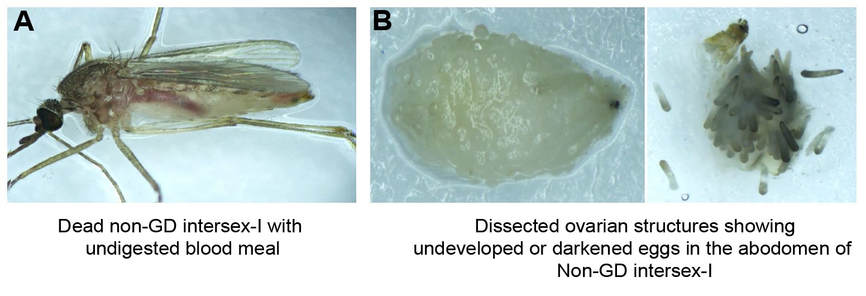
Supplementary Figure 3: Dissection images of non-GD intersex-I individuals with oviposition defects. A: A dead non-GD intersex-I after blood feeding, showing retention of an undigested blood meal in the abdomen. B: Dissected abdomen revealing underdeveloped or darkened eggs, indicating impaired oogenesis or oviposition failure.

Supplementary Tables

Supplementary Table 1-Primer List

Name | Primer
Primers used for building a population suppression GD construct
0493 | AAGTGCAACAACTCTCGGCTCGACCAAG
0494 | ACAGTGGAGTAACGAAAAATGGCAGAG
0526 | CATGAGTGGCATCATTTCCCAtGGaTAGTTGAGCTTCTCCAGCAGATACTGAG
0582 | TGTACGTGATACTGAAGGGTGCCGACG
0525 | CTCAGTATCTGCTGGAGAAGCTCAACTAtCCaTGGGAAATGATGCCACTCATG
0527 | CTTGCAAGTCGTCGTCGTCGTCTGGTTGTACAATTAATCTAGTTGCATGCG
0522 | GTTTTAGAGCTAtgctgGAAAcagcaTAG
0523 | ACGGGTAGTTGAGCTTCTCCTCGGAGGGTGCCCTCGTTGC
0528 | CGCATGCAACTAGATTAATTGTACAACCAGACGACGACGACGACTTGCAAG
0529 | caaactcatcaatgtatcttaaagcttAAGGAACACCTGTTCCCTCTGCGAG
0530 | CTCGCAGAGGGAACAGGTGTTCCTTaagctttaagatacattgatgagtttg
0531 | ACCTTATTATCTTCGTAGATTTTGAcatactcggtggcctccccaccacc
0522 | GTTTTAGAGCTAtgctgGAAAcagcaTAG
0524 | TGATGTACGTGATACTGAAGTGTAGGGCCGGGAAAGTGCTTATATAG
0532 | ggtggtggggaggccaccgagtatgTCAAAATCTACGAAGATAATAAGGT
0583 | CGTCGGCACCCTTCAGTATCACGTACAAAAAAAAAAGCACCGACTCGGTGCCAC
Primers used for PCR-based verification of correct transgenesis
X155 | CGCGAGTCAATATATCATTCGTG
X301 | ATGGTGCGCTCCTCCAAGAAC
X309 | TGAACTCCTTGATGACGTTCTTGGAGGAGCG
X310 | GGTTCGCCGAAGAAGAAGCGCAAGGTGTAAAATTG
X304 | ACAGTATaAAAAGTGCGTTAAAAAAACAAG
X51 | ATGGATAAGAAGTACTCGATCGG
X314 | TGGAAGAACGAATCATCCACCTTGGCCATC
X312 | AAAAATTTCACACCGTTCACGCAAGGCACTG
X313 | ACGTTATGTTCCTCCCAGTTCTGGCTGG
X157 | TGACCCAGGTCATGATCAACGACGACC
Primers used for dsx-1 and dsx-2 Deep sequencing analysis
X01 | GCTCAAAATAAACCTGATACGGGTG
X237 | GATCCAACCGCCACCGTTCCGTACC
Primers used for RT-PCR amplification of dsxM, dsxF and dsxM-recoded transcript fragments
Com_F | X281-ATGGTTTCGCAAGATACCTGGATGG
dsxF_R | X315-CGTTTGTTTGCTCTCGGCAATAAAC
dsxM_R | X283-TCAGCGGATGGGGTGGATCACTACC
dsxM.rec_R | X298-GAGTGGATGTGGTGGGTCCGAACCGC
Actin5C-F | GTCGACAATGGATCCGGTATGTGCAAG
Actin5C-R | GAAGCACTTTCGGTGGACGATGGAC

Supplementary Data

Supplementary Data 1- Microinjection and transgenesis data for the population suppression gene drive

This table represents raw counting data based on the presence of the DsRed fluorescent marker, indicating successful transgenesis. All hatched G0 individuals were sexed and pooled by sex, then crossed with wild-type individuals of the opposite sex. Egg rafts from each pool were hatched collectively, and the resulting offspring were screened and counted in pooled batches.

Supplementary Data 2- Deep sequencing analysis

Summary of the CRISPRessp2 batch analysis of allele editing frequencies based on deep sequencing data from categorized samples collected in GD experiments. The calculated allele editing frequencies are presented in Fig. 2C and Supplementary Fig 1. The data are organized into the following file tabs:

- Allele type and frequency at dsx-gRNA-1 editing site
- Allele type and frequency at dsx-gRNA-2 editing site

Supplementary Data 3- Suppression gene drive data

This dataset contains raw counts of G2 progeny with phenotypic scoring for DsRed+ males, DsRed+ intersexes, non-fluorescent males, females and intersexes. Inheritance of the gene drive element was tracked using DsRed fluorescence. Two independent batches of gene drive experiments were conducted at different times, and the resulting data were pooled for analysis. Transgene inheritance rates were calculated for each single-pair cross with mean values and standard deviations summarized in the table. Data were analyzed using a “batch effect” approach in R, employing a generalized linear mixed model fitted by maximum likelihood to account for variance between cross batches. These results are presented in Fig 2B.

Supplementary Data 4- Raw data on the fitness costs of gene drive and non-gene drive intersexes

This dataset includes raw measurements of adult survival, female blood-feeding behavior, egg laying performance, and hatch rates per egg raft from various genetic crosses. The summarized results are shown in Fig. 4A-C. Each tab corresponds to a specific cross scheme as follows:

- Control group- 10 wild-type males X 10 wild-type female
- GD♂ × WT♀- 10 gene drive (GD) males X 10 wild-type females
- GD intersexes × WT♂-10 GD intersexes X 10 wild-type males
- Non-GD intersexes × WT♂- 10 non-GD intersexes X 10 wild-type males (two biological replicates).
- Statistical analysis details

Supplementary Data 5-Mating competition between gene drive (GD) males and wild-type males

This table presents the results of mating competition assays between GD and wild-type males. Ten newly emerged GD males and 10 wild-type males were pooled together with 10 virgin wild-type females. After 3 days of cohabitation, females were blood fed, and oviposition was induced 3 days post-feeding. Egg rafts were collected and hatched individually. Fourth instar larvae were screened under a fluorescence microscope, and the presence of DsRed+ marker was recorded to evaluate successful mating.
Supplementary method

Cloning details for the plasmid constructs
P69_Culex.q population suppression gene drive (GD) construct
The homology arms were amplified from Culex quinquefasciatus doublesex gene using genomic DNA and cloned into a TOPO vector to serve as the backbone for the GD construct. The recoded dsxM fragment was synthesized by GenScript, incorporating an Anopheles gambiae Kh 3’UTR. The nanos-Cas9 fragment was amplified from the plasmid pVMG0212 (Addgene #169348). The U6:1_dsx-gRNA-1 fragment was amplified from the Cq_U6:1_dsx-gRNA-1-LOOP plasmid modified from pVMG0302 (Addgene #169369). The U6:6_dsx-gRNA-2 fragment was amplified from the Cq_U6:6_dsx-gRNA-2-LOOP plasmid modified from pVMG0303 (Addgene #169370). The Opie2-DsRed-SV40_3’UTR fragment was amplified from pVMG0252 (NCBI accession # MW925705) and assembled with other components using Gibson Assembly. All primers used in this construct are listed in Supplementary Table 1.
Plasmid sequences and availability:
The plasmid sequence of the Culex quinquefasciatus population suppression gene drive (GD) construct generated in this study has been deposited in the GenBank database with accession number PV864762.

