Table 1: PICOS framework
Review Question: What are the published randomised controlled trials of systemic treatments for advanced and metastatic gastric cancer in the second- or later-line setting?
Population | Individuals with a diagnosis of advanced or metastatic gastric cancer in the second- or later-line setting.
Intervention | All systemic treatments approved by both ESMO (Lordick et al., 2022) and NCCN Guidelines (Ajani et al., 2022) and that are also aligned with Expert Clinical opinion.  Studies evaluating at least one of the following treatments:  - Paclitaxel  - Docetaxel  - Irinotecan  - FOLFIRI  - Ramucirumab  - Ramucirumab + Paclitaxel  - Pembrolizumab  - Trastuzumab deruxtecan (for HER2 overexpression-positive adenocarcinoma)  - DostarlimabEntrectinib  - trifluridine-tipiracil  - Best supportive care
Comparator | Unrestricted
Outcomes | Overall survival, progression-free survival, overall response rate, Grade ≥ 3 Treatment-related adverse events
Study design | randomised controlled trials
Exclusion criteria | Studies in first-line treatment for advanced and metastatic gastric cancer, conference papers, commentaries, abstracts, and letters, where the full paper was unobtainable.  Subgroup, exploratory and post-hoc analysis of original trials.
Language | English only
Time period | 2009 to 29 May 2024
*ESMO: European Society for Medical Oncology; NCCN: National Comprehensive Cancer Network

Fig 1: PRISMA flow chart
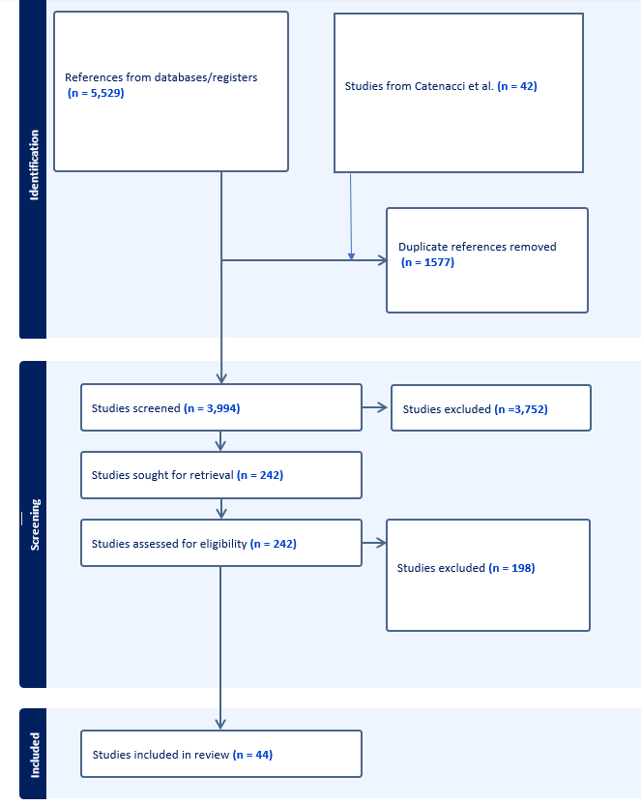

Fig 2: Bayesian Network Meta-Analysis of Overall Survival
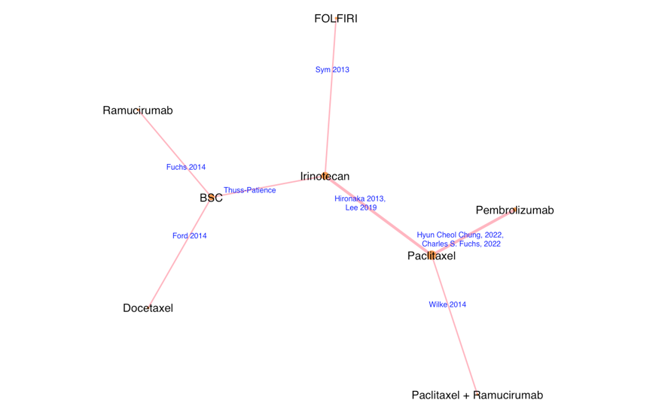
Fig 3: Bayesian Network Meta-Analysis of Progression Free Survival
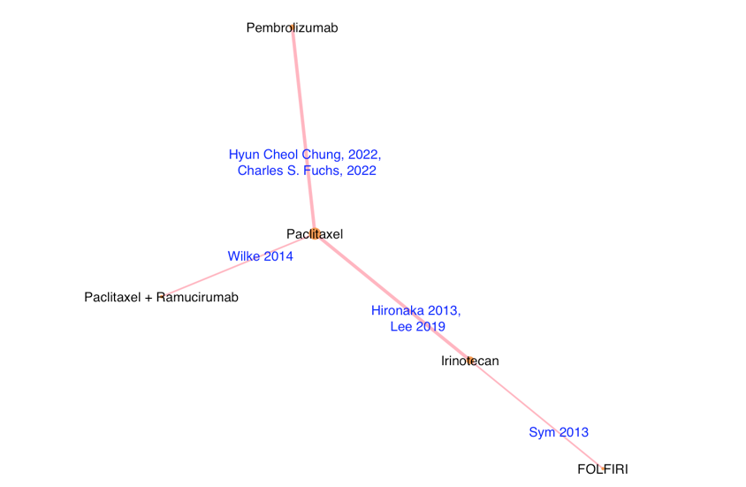

Fig 4: Bayesian Network Meta-Analysis of Objective Response Rate
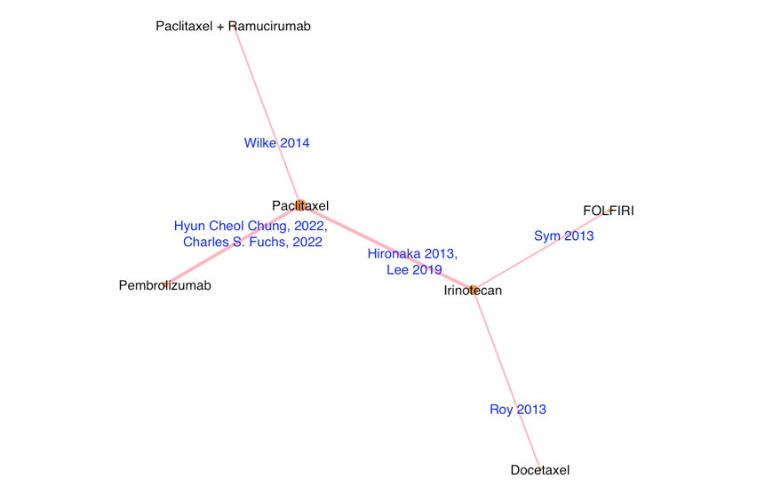
Fig 5: Bayesian Network Meta-Analysis of Grade ≥ 3 TRAEs
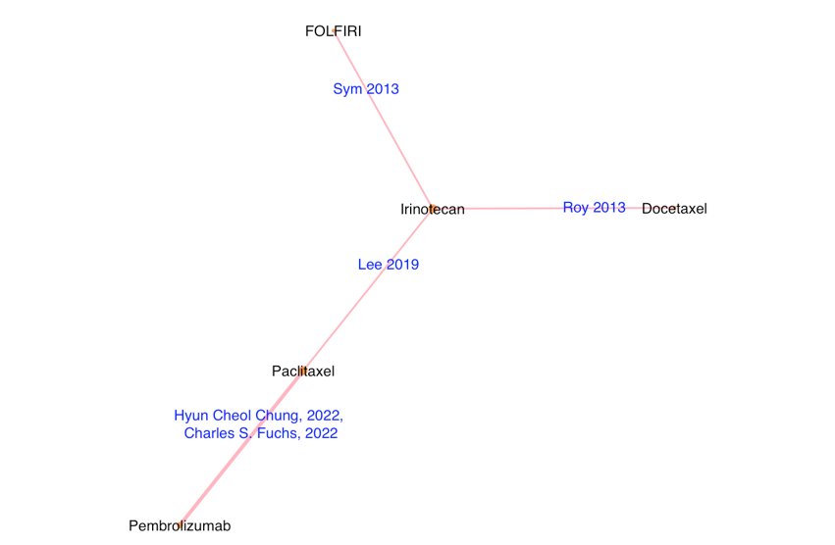

Fig 6: Flow chart depicting the process of exclusion and final inclusion of studies in the OS network
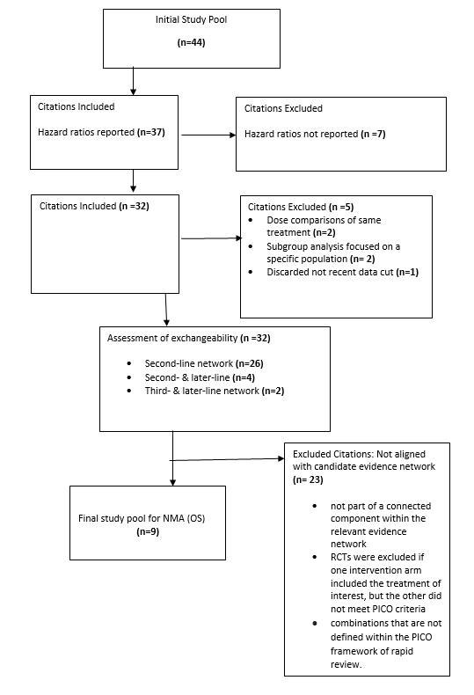

Fig 7: Flow chart depicting the process of exclusion and final inclusion of studies in the PFS network
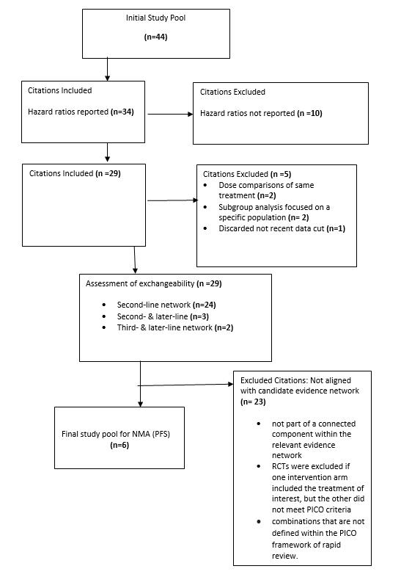

Fig 8: Flow chart depicting the process of exclusion and final inclusion of studies in the ORR network
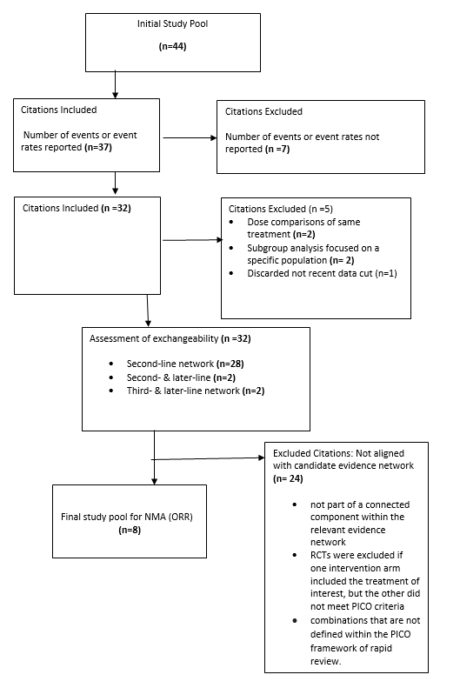

Fig 9: Flow chart depicting the process of exclusion and final inclusion of studies in the Grade ≥ TRAEs network
