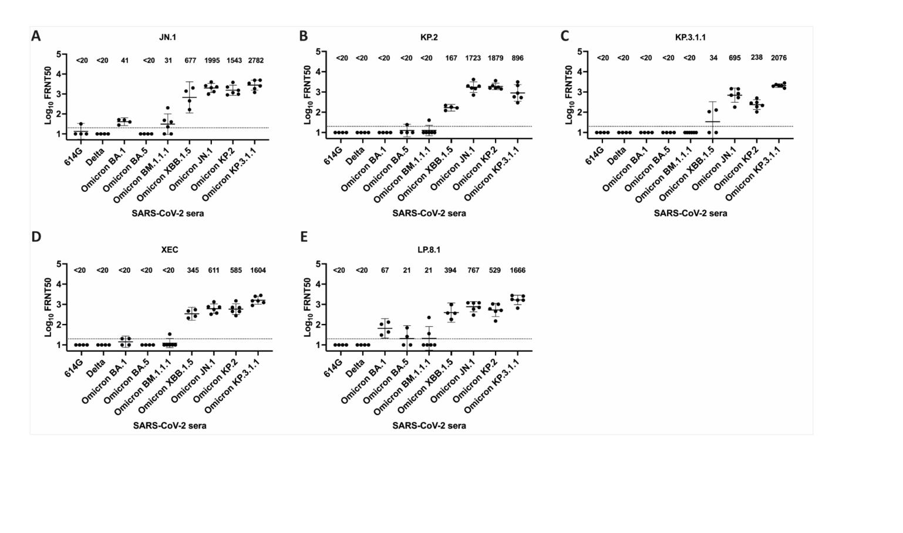
1 Supplemental information
2
3 Figure S1. Neutralizing titers against recently circulating SARS-CoV-2 variants
4 (A) JN.1, (B) KP.2, (C) KP.3.1.1, (D) XEC and (E) LP.8.1 FRNT50 neutralizing antibody titers were tested in hamster sera generated against viruses indicated on the X-
5 axis. Geometric mean titers with 95% CI are shown and indicated above. The dotted line represents the lower limit of detection.
6

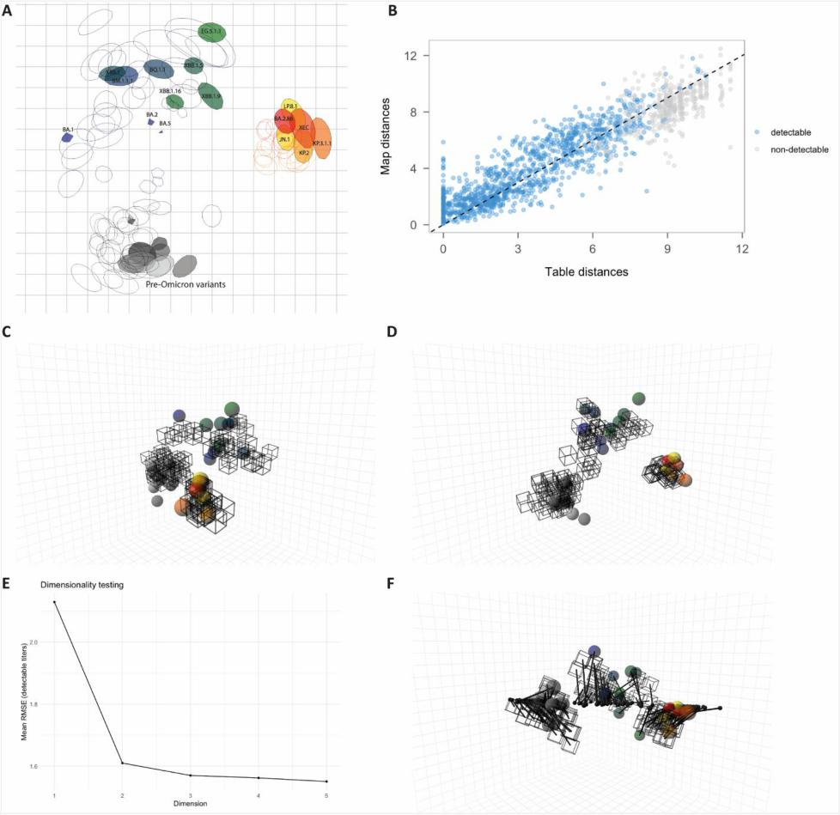
7

8 Figure S2. Antigenic map validation and 3D projection
9 (A) Antigenic map from Figure 1, whereby each region (triangulation blob) represents the space
10 where each serum and variant can position without increasing map stress by more than one unit. (B)
11 Correlation between Table distance (obtained from FRNT) and Map distance. (C-D) Three-dimensional
12 view of the antigenic map shown from two different perspectives. (E) Dimensionality test indicating
13 the mean root mean square error (RMSE) of detectable neutralizing titers. (F) A 3D antigenic map
14 connecting the positions of antigen and antisera to a two-dimensional plane.

15 | 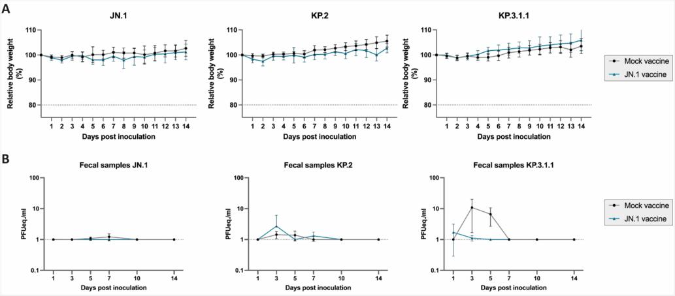

16 Figure S3. JN.1 vaccine-induced effects in vivo
17 (A) Progression of relative body weight over a course of 14 dpi. Dotted line indicates the humane
18 endpoint of maximum body weight loss. (B) qRT-PCR results of bulk fecal samples that were collected
19 for each cage. Results are depicted in PFUeq./ml. Statistical significant differences were measured by
20 Mann-Whitney test with multiple comparisons according to the Holm-Šídák method. Error bars
21 represent interquartile range.
22

23 | 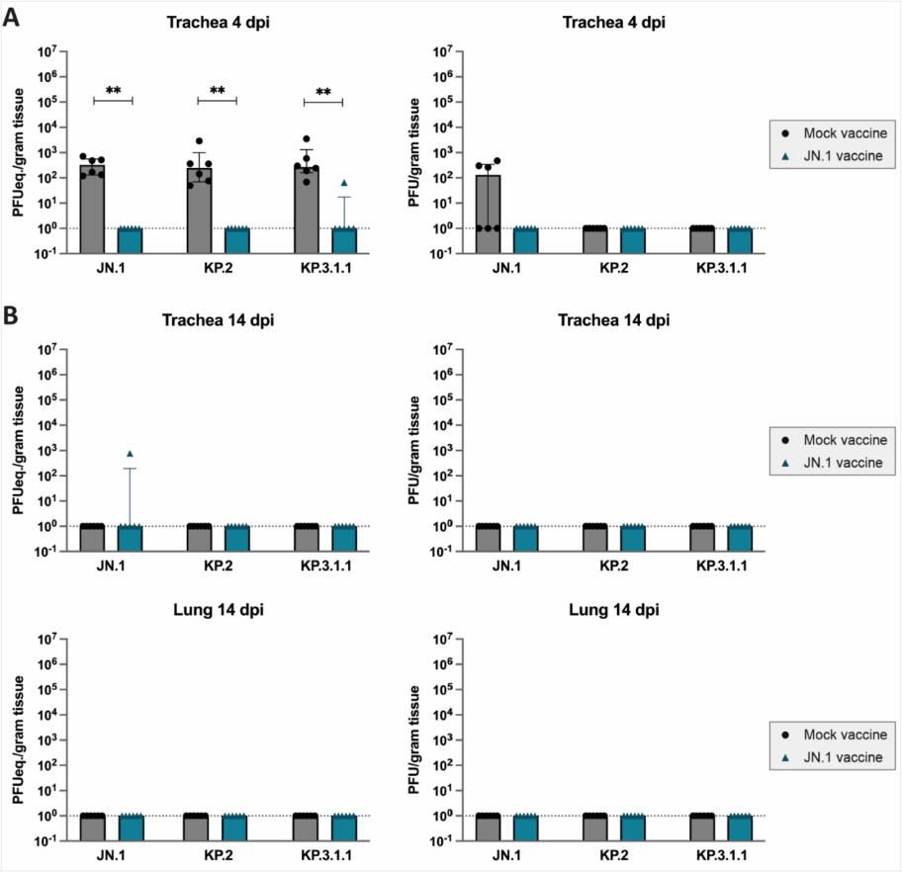

24 Figure S4. Viral titration of lower respiratory tract tissues
25 qRT-PCR results of respiratory tissue homogenates from (A) trachea 4 dpi and (B) trachea and lung 14
26 dpi, depicted in PFUeq./g tissue and results of plaque assay to determine infectious virus in PFU/g
27 tissue. Statistical significant differences were measured by Mann-Whitney test. Error bars represent
28 interquartile range. Dotted lines represent the lower limit of detection and symbols represent
29 individual measurements for each animal. Six animals were included per experimental condition.
30 *p<0.05, **p<0.005.

31 | 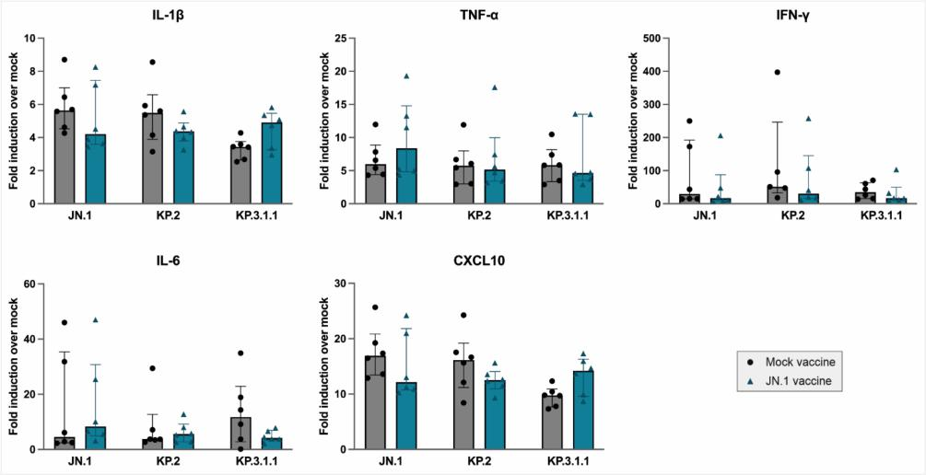

32 Figure S5. JN.1 vaccine-induced effects on host gene expression in lungs
33 qRT-PCR results of host gene expression. Values of challenged animals were compared to a historical,
34 non-infected control group and with the ΔΔCt-method, the fold-change induction was calculated.
35 Symbols represent individual measurements for each animal. Six animals were included per
36 experimental condition.

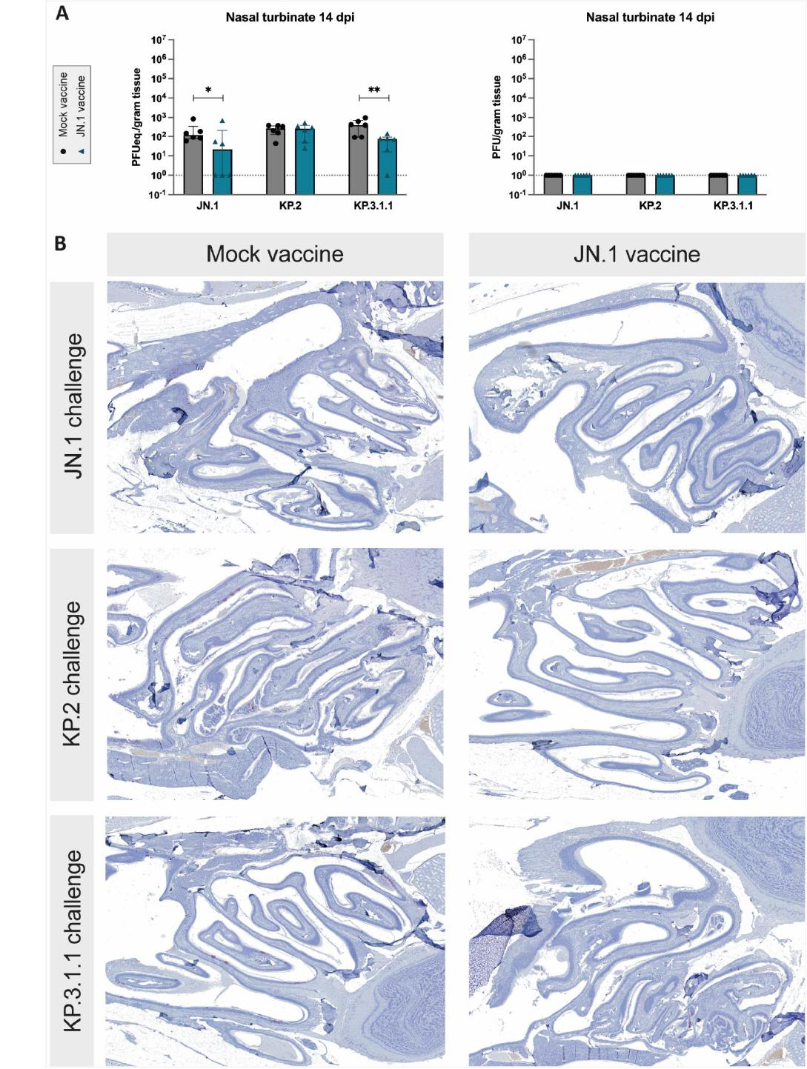
37

38 Figure S6. JN.1 vaccine-induced effects in the upper respiratory tract
39 (A) qRT-PCR results of nasal turbinate 14 dpi, depicted in PFUeq./g tissue and results of plaque assay
40 to determine infectious virus in PFU/g tissue. Statistical significant differences were measured by
41 Mann-Whitney test. Error bars represent interquartile range. Dotted lines represent the lower limit of
42 detection and symbols represent individual measurements for each animal. Six animals were included
43 per experimental condition. *p<0.05, **p<0.005. (B) Histopathology panel showing
44 immunohistochemistry (IHC) of the nasal turbinate at 4 dpi of mock-vaccinated hamsters compared
45 to JN.1-vaccinated hamsters after intranasal challenge with one of three SARS-CoV-2 variants JN.1,
46 KP.2, and KP.3.1.1, from top to bottom respectively. Virus antigen is expressed as reddish-brown
47 staining by AEC immunoperoxidase, and hematoxylin counterstain.
48
49
50
51
52
53
54
55

56 | 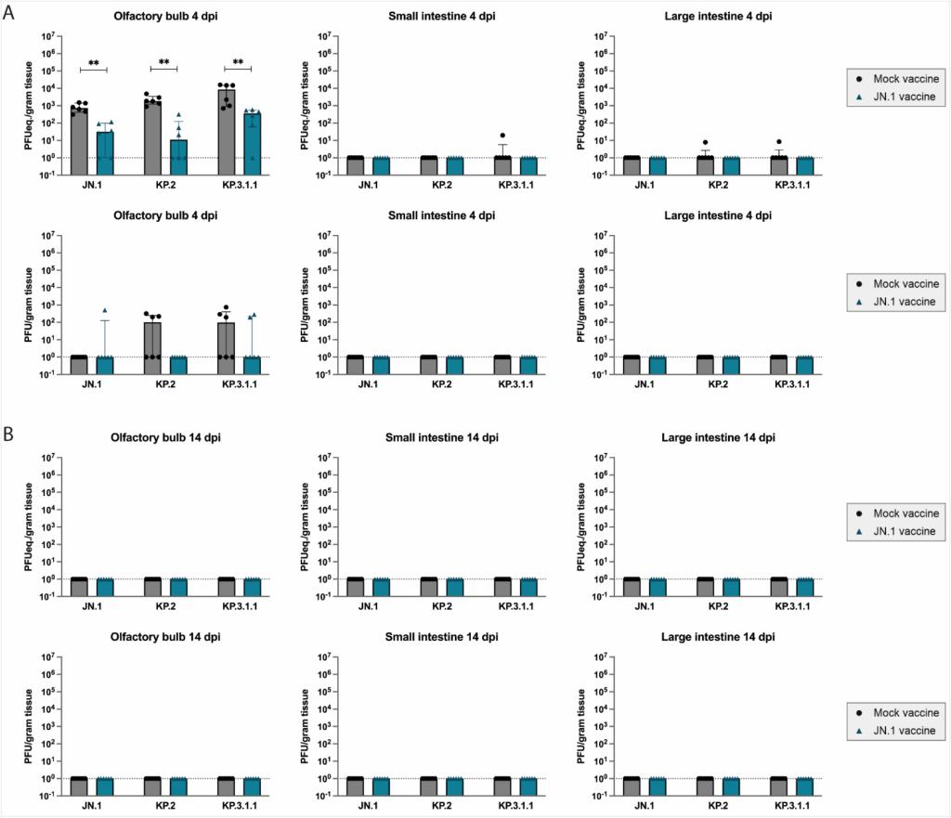

57 Figure S7. JN.1 vaccine-induced effects on extra respiratory tissues
58 (A) qRT-PCR results of extra respiratory tissue homogenates from 4 dpi, depicted in PFUeq./g tissue
59 and results of plaque assay to determine infectious virus in PFU/g tissue. Statistical significant
60 differences were measured by Mann-Whitney test. Error bars represent interquartile range. (B) qRT-
61 PCR results of extra respiratory tissue homogenates from 14 dpi, depicted in PFUeq./g tissue and
62 results of plaque assay to determine infectious virus in PFU/g tissue. Statistical significant differences
63 were measured by Mann-Whitney test. Error bars represent interquartile range. Dotted lines
64 represent the lower limit of detection and symbols represent individual measurements for each
65 animal. *p<0.05, **p<0.005. Six animals were included per experimental condition.
66
67
68
69
70
71

72  73 | 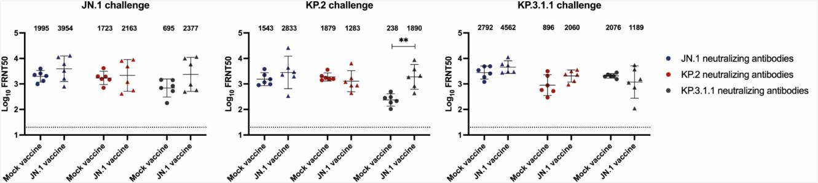

74 Figure S8. Effect of JN.1 vaccination on neutralizing antibody titers
75 FRNT50 neutralizing antibody titers were determined in hamster sera 14 dpi against JN.1, KP.2, and KP.3.1.1. The geometric mean is displayed above the graph,
76 error bars indicate 95% confidence interval. Statistical significant differences were measured by Mann-Whitney test. Dotted lines represent the lower limit of
77 detection and symbols represent individual measurements for each animal. *p<0.05, **p<0.005. Six animals were included per experimental condition.
78
79
80
81
82
83
84
85
86

 | Mock vaccinated, JN.1 challenge |  |  |  | JN.1 vaccinated, JN.1 challenge |  |  |  |  | Mock vaccinated, KP.2 challenge |  |  |  | JN.1 vaccinated, KP.2 challenge |  |  |  |  | Mock vaccinated, KP3.1.1 challenge |  |  |  | JN.1 vaccinated, KP.3.1.1 challenge
Severity alveolitis  (0-3) | 1 (1, 1, | 1, 0, | 2, 1) |  | 0.3 (0, | 0, 0, | 1, 0, | 1) |  | 0.8 (1, | 0, 1, | 1, 1, | 1) | 0.8 (0, | 1, 1, | 1, 1, | 1) |  | 1.7 (1, | 2, 1, | 2, 2, | 2) | 1 (1, 0, | 2, 1, | 1, 1)
Presence edema alveolar / perivascular (0/1) | 1 (1, 1, | 1, 1, | 1, 1) |  | 0.3 (0, | 0, 0, | 1, 1, | 0) |  | 1 (1, 1, | 1, 1, | 1, 1) |  | 0.5 (0, | 1, 1, | 0, 1, | 0) |  | 1 (1, 1, | 1, 1, | 1, 1) |  | 0.7 (1, | 0, 1, | 0, 1, | 1)
Presence alveolar haemorrhage (0/1) | 0.5 (0, | 0, 0, | 1, 1, | 1) | 0.2 (0, | 0, 0, | 0, 1, | 0) |  | 0.2 (0, | 0, 1, | 0, 0, | 0) | 0.5 (0, | 1, 1, | 0, 1, | 0) |  | 0.7 (0, | 1, 0, | 1, 1, | 1) | 0.5 (0, | 0, 1, | 0, 1, | 1)
Presence type II  hyperplasia (0/1) | 0 (0, 0, | 0, 0, | 0, 0) |  | 0 (0, 0, | 0, 0, | 0, 0) |  |  | 0 (0, 0, | 0, 0, | 0, 0) |  | 0 (0, 0, | 0, 0, | 0, 0) |  |  | 0 (0, 0, | 0, 0, | 0, 0) |  | 0 (0, 0, | 0, 0, | 0, 0)
Severity bronch(iol)itis (0-3) | 0.9 (1, | 1, 1, | 0, 1, | 1) | 0 (0, 0, | 0, 0, | 0, 0) |  |  | 0.9 (1, | 0, 1, | 1, 1, | 1) | 0.2 (0, | 0, 0, | 0, 1, | 0) |  | 1.4 (1, | 2, 1, | 1, 2, | 1) | 0.3 (0, | 0, 1, | 0, 0, | 1)
Degree perivascular  cuffing (0-3) | 1.3 (1, | 2, 1, | 0, 2, | 2) | 0.3 (0, | 0, 1, | 0, 0, | 1) |  | 1.2 (1, | 0, 2, | 2, 1, | 1) | 0.3 (0, | 0, 1, | 0, 0, | 1) |  | 1.7 (1, | 2, 1, | 2, 2, | 2) | 0.2 (0, | 0, 1, | 0, 0, | 0)
Severity lung vasculitis (diapedesis) (0-3) | 1.3 (2, | 1, 1, | 0, 2, | 1) | 0.3 (0, | 0, 1, | 0, 0, | 1) |  | 1.7 (2, | 0, 2, | 2, 2, | 2) | 0.3 (0, | 0, 1, | 0, 0, | 1) |  | 1.3 (2, | 2, 1, | 2, 2, | 2) | 0.2 (0, | 0, 1, | 0, 0, | 0)
Severity tracheitis (0-3) | 0 (0, 0, | 0, 0, | 0, 0) |  | 0 (0, 0, | 0, 0, | 0, 0) |  |  | 0 (0, 0, | 0, 0, | 0, 0) |  | 0 (0, 0, | 0, 0, | 0, 0) |  |  | 0 (0, 0, | 0, 0, | 0, 0) |  | 0 (0, 0, | 0, 0, | 0, 0)
IHC trachea  (0-3) | 1 (1, 1, | 1, 1, | 1, 1) |  | 1 (1, 1, | 1, 1, | 1, 1) |  |  | 1 (1, 1, | 1, 1, | 1, 1) |  | 1 (1, 1, | 1, 1, | 1, 1) |  |  | 1 (1, 1, | 1, 1, | 1, 1) |  | 1 (1, 1, | 1, 1, | 1, 1)
Small intestine / IHC (0-3) | 0 (0, 0, | 0, 0, | 0, 0) |  | 0 (0, 0, | 0, 0, | 0, 0) |  |  | 0 (0, 0, | 0, 0, | 0, 0) |  | 0 (0, 0, | 0, 0, | 0, 0) |  |  | 0 (0, 0, | 0, 0, | 0, 0) |  | 0 (0, 0, | 0, 0, | 0, 0)
Large intestine / IHC (0-3) | 0 (0, 0, | 0, 0, | 0, 0) |  | 0 (0, 0, | 0, 0, | 0, 0) |  |  | 0 (0, 0, | 0, 0, | 0, 0) |  | 0 (0, 0, | 0, 0, | 0, 0) |  |  | 0 (0, 0, | 0, 0, | 0, 0) |  | 0 (0, 0, | 0, 0, | 0, 0)

87
88 Supplementary table S1. Histopathological scoring of respiratory and enteric tissue
89 Tissues from 4 dpi were stained in HE and for viral antigen (n=6 per experimental group). Slides were evaluated by a board-certified veterinary pathologist.
90 Semiquantitative scoring was performed, with ranking from 0-3 (0=non, 1 = mild; 2 = moderate; 3 = severe) or 0-1 (0 = not evident; 1 = evident).
91

