Tables
Demographic characteristics
Variables |  | n = 138
Athletes (n) |  | 138
Height (cm) |  | 166.2 (4.8)
Weight (kg) |  | 58.7 (5.8)
Career duration (yr) |  | 13.54 (3.76)
Position
Striker |  | 22 (15.9)
Midfielder |  | 32 (23.1)
Defender |  | 53 (38.4)
Goalkeeper |  | 16 (11.5)
Two or more positions |  | 15 (10.8)
Injury incidence and athletes’ exposure
 | Total |  | Training | Match
Injuries (n) | 132 |  | 64 (48.48%) | 68 (51.52%)
Athlete exposure (h) | 22,523 |  | 20,618 | 1,905
Injury incidence (95% CI)
Clinical incidence/  100 athletes | 95.65 (79.33–111.97) |  | 46.38 (35.01–57.74) | 49.28 (37.56–60.99)
Incidence rate/1,000 HEsª | 5.86 (4.86–6.86) |  | 3.10 (2.34–3.86) | 35.70 (27.21–44.18)

Table 1. Demographic characteristics and the rate of injuries in the 2020 Women’s Korean League
Note. Data are expressed as mean (standard deviation) or n (%).
ªInjury incidence rates per 1,000 h of exposure

Table 2. Injury characteristics and the incidence rate ratio between training and competition
 |  | Total (n = 132) |  | Training (n = 64) |  | Match (n = 68)
 |  | n (%) | Incidenceª  (95% CI) | n (%) | Incidenceª  (95% CI) | n (%) | Incidenceª  (95% CI) | Rate ratio^{b}  (95% CI)
Injury location
Head and trunk | Head/face | 5 (3.79) | 0.22 (0.03–0.42) | 0 (0) | — | 5 (7.35) | 2.62 (0.32–4.93) | 10.36 (0.56–191.09)
Head and trunk | Neck/cervical spine | 2 (1.52) | 0.09 (−0.03–0.21) | 1 (1.56) | 0.05 (−0.05–0.14) | 1 (1.47) | 0.52 (−0.50–1.55) | 0.94 (0.06–15.37)
Head and trunk | Sternum/ribs/upper back | 2 (1.52) | 0.09 (−0.03–0.21) | 0 (0) | — | 2 (2.94) | 1.05 (−0.41–2.50) | 4.71 (0.22–99.95)
Head and trunk | Abdomen | 0 (0) | — | 0 (0) | — | 0 (0) | — | —
Head and trunk | Lower back/pelvis/sacrum | 10 (7.58) | 0.44 (0.17–0.72) | 7 (10.94) | 0.34 (0.09–0.59) | 3 (4.41) | 1.57 (−0.21–3.36) | 0.40 (0.10–1.63)
Upper extremities | Shoulder/clavicula | 2 (1.52) | 0.09 (−0.03–0.21) | 0 (0) | — | 2 (2.94) | 1.05 (−0.41–2.50) | 4.71 (0.22–99.95)
Upper extremities | Upper arm | 0 (0) | — | 0 (0) | — | 0 (0) | — | —
Upper extremities | Elbow | 1 (0.76) | 0.04 (−0.04–0.13) | 0 (0) | — | 1 (1.47) | 0.52 (−0.50–1.55) | 2.82 (0.11–70.61)
Upper extremities | Forearm | 0 (0) | — | 0 (0) | — | 0 (0) | — | —
Upper extremities | Wrist | 1 (0.76) | 0.04 (−0.04–0.13) | 1 (1.56) | 0.05 (−0.05–0.14) | 0 (0) | — | 0.31 (0.01–7.85)
Upper extremities | Hand/finger/thumb | 1 (0.76) | 0.04 (−0.04–0.13) | 0 (0) | — | 1 (1.47) | 0.52 (−0.50–1.55) | 2.82 (0.11–70.61)
Lower extremities | Hip/groin | 0 (0) | — | 0 (0) | — | 0 (0) | — | —
Lower extremities | Thigh | 21 (15.91) | 0.93 (0.53–1.33) | 9 (14.06) | 0.44 (0.15–0.72) | 12 (17.65) | 6.30 (2.74–9.86) | 1.25 (0.50–3.18)
Lower extremities | Knee | 30 (22.73) | 1.33 (0.86–1.81) | 20 (31.25) | 0.97 (0.54–1.40) | 10 (14.71) | 5.25 (2.00–8.50) | 0.47 (0.20–1.08)
Lower extremities | Lower leg/Achilles tendon | 12 (9.09) | 0.53 (0.23–0.83) | 6 (9.38) | 0.29 (0.06–0.52) | 6 (8.82) | 3.15 (0.63–5.67) | 0.94 (0.29–3.07)
Lower extremities | Ankle | 33 (25.00) | 1.47 (0.97–1.97) | 16 (25.00) | 0.78 (0.40–1.16) | 17 (25.00) | 8.92 (4.68–13.17) | 1.00 (0.47–2.15)
Lower extremities | Foot/toe | 12 (9.09) | 0.53 (0.23–0.83) | 4 (6.25) | 0.19 (0.0–0.38) | 8 (11.76) | 4.20 (1.29–7.11) | 1.88 (0.54–6.56)
Injury type
Bone | Fracture | 10 (7.6) | 0.44 (0.17–0.72) | 1 (1.56) | 0.05 (−0.05–0.14) | 9 (13.24) | 4.72 (1.64–7.81) | 8.47 (1.04–68.76)
Bone | Other bone injuries | 7 (5.3) | 0.31 (0.08–0.54) | 2 (3.13) | 0.10 (−0.04–0.23) | 5 (7.35) | 2.62 (0.32–4.93) | 2.35 (0.44–12.56)
Joint and ligament | Dislocation/subluxation | 1 (0.8) | 0.04 (−0.04–0.13) | — | — | 1 (1.47) | 0.52 (−0.50–1.55) | 2.82 (0.11–70.61)
Joint and ligament | Sprain/ligamentous injury | 41 (31.1) | 1.82 (1.26–2.38) | 22 (34.38) | 1.07 (0.62–1.51) | 19 (27.94) | 9.97 (5.49–14.46) | 0.81 (0.40–1.64)
Joint and ligament | Lesion of the meniscus/cartilage | 19 (14.4) | 0.84 (0.46–1.22) | 14 (21.88) | 0.68 (0.32–1.03) | 5 (7.35) | 2.62 (0.32–4.93) | 0.34 (0.11–0.99)
Muscle and tendon | Muscle rupture/strain/tear | 30 (22.7) | 1.33 (0.86–1.81) | 16 (25.00) | 0.78 (0.40–1.16) | 14 (20.59) | 7.35 (3.50–11.20) | 0.82 (0.37–1.82)
Muscle and tendon | Tendon injury/bursitis | 10 (7.6) | 0.44 (0.17–0.72) | 7 (10.94) | 0.34 (0.09–0.59) | 3 (4.41) | 1.57 (−0.21–3.36) | 0.40 (0.10–1.63)
Brain and nerve | Concussion | 1 (0.8) | 0.04 (−0.04–0.13) | — | — | 1 (1.47) | 0.52 (−0.50–1.55) | 2.82 (0.11–70.61)
Brain and nerve | Nerve injury | 2 (1.5) | 0.09 (−0.03–0.21) | — | — | 2 (2.94) | 1.05 (−0.41–2.50) | 4.71 (0.22–99.95)
Others | Hematoma/contusion/bruise | 11 (8.3) | 0.49 (0.20–0.78) | 2 (3.13) | 0.10 (−0.04–0.23) | 9 (13.24) | 4.72 (1.64–7.81) | 4.24 (0.88–20.35)
Injury mechanisms
Contact | Contact with  another person | 35 (26.5) | 1.55 (1.04–2.07) | 7 (10.94) | 0.34 (0.09–0.59) | 28 (41.18) | 14.70 (9.25–20.14) | 3.76 (1.54–9.22)
Contact | Contact with  the playing surface | 17 (12.9) | 0.75 (0.40–1.11) | 10 (15.63) | 0.49 (0.18–0.79) | 7 (10.29) | 3.67 (0.95–6.40) | 0.66 (0.24–1.84)
Contact | Contact with  The soccer ball | 9 (6.8) | 0.40 (0.14–0.66) | 3 (4.69) | 0.15 (−0.02–0.31) | 6 (8.82) | 3.15 (0.63–5.67) | 1.88 (0.45–7.84)
Contact | Contact with  other playing equipment | 6 (4.5) | 0.27 (0.05–0.48) | 2 (3.13) | 0.10 (−0.04–0.23) | 4 (5.88) | 2.10 (0.04–4.16) | 1.88 (0.33–10.63)
Contact | Contact with an  out of bounds object | 2 (1.5) | 0.09 (−0.03–0.21) | 2 (3.13) | 0.10 (−0.04–0.23) | — | — | 0.19 (0.01–4.00)
Noncontact | Noncontact | 36 (27.3) | 1.60 (1.08–2.12) | 20 (31.25) | 0.97 (0.54–1.40) | 16 (23.53) | 8.40 (4.28–12.51) | 0.75 (0.36–1.58)
Overuse/chronic | Overuse/chronic | 27 (20.5) | 1.20 (0.75–1.65) | 20 (31.25) | 0.97 (0.54–1.40) | 7 (10.29) | 3.67 (0.95–6.40) | 0.33 (0.13–0.83)
Injury severity
Slight |  | 5 (3.8) | 0.22 (0.03–0.42) | 2 (3.1) | 0.10 (−0.04–0.23) | 3 (4.4) | 1.57 (−0.21–3.36) | 1.41 (0.23–8.73)
Minimal |  | 13 (9.8) | 0.58 (0.26–0.89) | 7 (10.9) | 0.34 (0.09–0.59) | 6 (8.8) | 3.15 (0.63–5.67) | 0.81 (0.26–2.53)
Mild |  | 23 (17.4) | 1.02 (0.60–1.44) | 12 (18.8) | 0.58 (0.25–0.91) | 11 (16.2) | 5.77 (2.36–9.19) | 0.86 (0.36–2.09)
Moderate |  | 38 (28.8) | 1.69 (1.15–2.22) | 15 (23.4) | 0.73 (0.36–1.10) | 23 (33.8) | 12.07 (7.14–17.01) | 1.44 (0.69–3.01)
Severe |  | 53 (40.2) | 2.35 (1.72–2.99) | 28 (43.8) | 1.36 (0.86–1.86) | 25 (36.8) | 13.12 (7.98–18.27) | 0.84 (0.44–1.60)
Total |  | 132 (100) | 5.86 (4.86–6.86) | 64 (100) | 3.10 (2.34–3.86) | 68 (100) | 35.70 (27.21–44.18) | 11.50 (8.15–16.23)
ªInjury incidence rate: number of injuries per 1,000 player hours.
^{b}Rate ratio: odds of injuries in competition/odds of injuries in training.
Top injury | Ankle (n =33, %) | Knee (n =30, %) | Thigh (n =21, %) | Lower leg/  Achilles tendon  (n =12, %) | Foot/toe  (n =12, %)
Injury circumstance
Training | 16 (48.48) | 20 (66.67) | 9 (42.86) | 6 (50.00) | 4 (33.33)
Competition | 17 (51.52) | 10 (33.33) | 12 (57.14) | 6 (50.00) | 8 (66.67)
Re injury
No previous injury | 22 (66.67) | 18 (60.00) | — | — | —
Previous injury | 11 (33.33) | 12 (40.00) | — | — | —
Injury type
Fracture | 1 (3.03) | — | — | 3 (25.00) | 3 (25.00)
Other bone injuries | 5 (15.15) | — | — | — | 1 (8.33)
Muscle rupture/strain/tear | — | — | 18 (85.71) | 5 (41.67) | —
Sprain/ligamentous injury | 23 (69.70) | 13 (43.33) | — | — | 1 (8.33)
Lesion of the meniscus/cartilage | 3 (9.09) | 16 (53.33) | — | — | —
Hematoma /contusion/bruise | — | — | 3 (14.29) | — | 3 (25.00)
Tendon injury/bursitis | 1 (3.03) | 1 (3.33) |  | 4 (33.33) | 4 (33.33)
Injury mechanism
Contact | 24 (72.73) | 11 (36.67) | 4 (19.05) | 1 (8.33) | 11 (91.67)
Contact with another player | 13 (39.39) | 5 (16.67) | 4 (19.05) | — | 4 (33.33)
Contact with the playing surface | 3 (9.09) | 4 (13.33) | — | 1 (8.33) | 7 (58.33)
Contact with the soccer ball | 5 (15.15) | — | — | — | —
Contact with other playing equipment | 3 (9.09) | — | — | — | —
Contact with an out of bounds object | — | 2 (6.67) | — | — | —
Noncontact | 6 (18.18) | 13 (43.33) | 8 (38.10) | 4 (33.33) | 1 (8.33)
Overuse/chronic | 3 (9.09) | 6 (20.00) | 9 (42.86) | 7 (58.33) | —
Severity
Slight (0days) | 2 (6.06) | 1 (3.33) | 2 (9.52) | — | —
Minimal (1–3 days) | 2 (6.06) | 3 (10.00) | 3 (14.29) | — | 1 (8.33)
Mild (4–7 days) | 4 (12.12) | 4 (13.33) | 4 (19.05) | 1 (8.33) | 1 (8.33)
Moderate (8–28 days) | 10 (30.30) | 5 (16.67) | 8 (38.10) | 4 (33.33) | 5 (41.67)
Severe (>28 days) | 15 (45.45) | 17 (56.67) | 4 (19.05) | 7 (58.33) | 5 (41.67)
Playing positions
Goalkeeper | 1 (3.03) | 3 (10.00) | 1 (4.76) | 1 (8.33) | —
Defender | 19 (57.58) | 9 (30.00) | 9 (42.86) | 4 (33.33) | 6 (50.00)
Midfielder | 7 (21.21) | 8 (26.67) | 6 (28.57) | 5 (41.67) | 4 (33.33)
Striker | 6 (18.18) | 10 (33.33) | 5 (23.81) | 2 (16.67) | 2 (16.67)
Number of injuries  at different locations on the pitch | 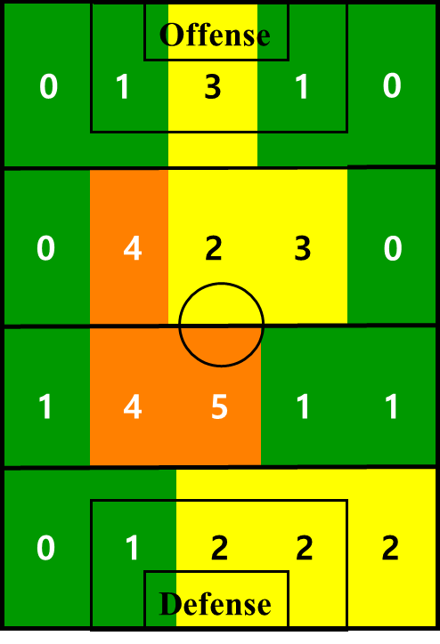 | 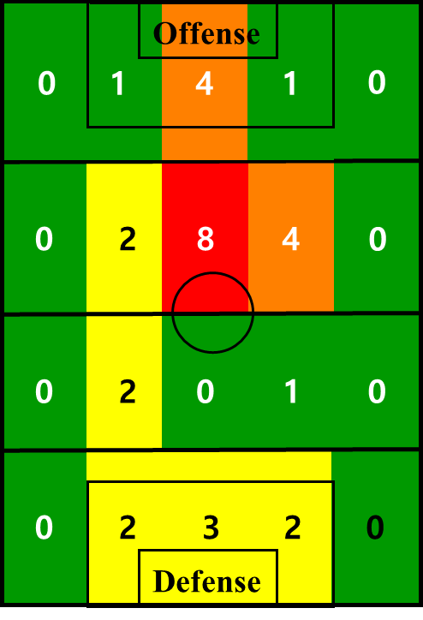 | 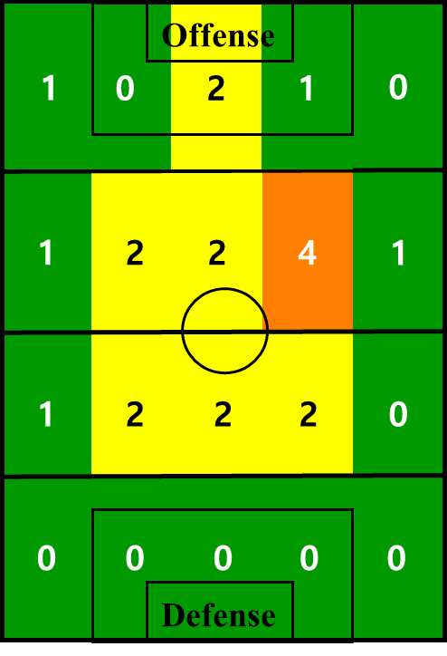 | 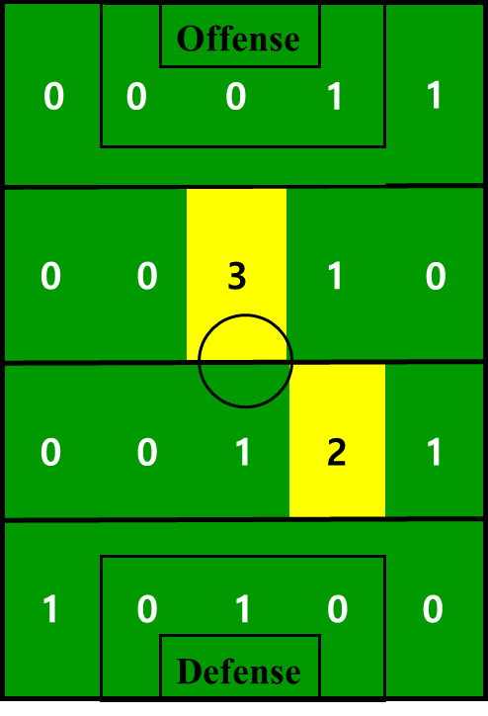 | 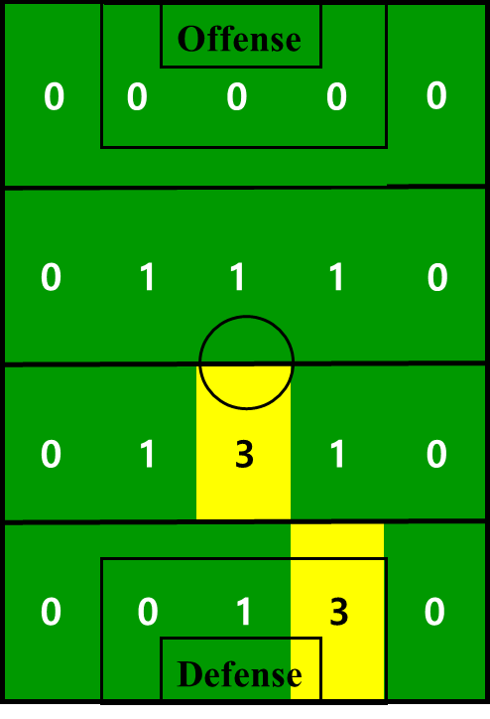
Table 3. Summary of the top five injuries

