Supplementary Material

Title: Parvovirus enteritis and other risk factors associated with persistent gastrointestinal signs in dogs later in life: A retrospective cohort study.

Authors: Kanae Takada, Anne M. Flemming, Maarten J. Voordouw, and Anthony P. Carr

Table of Contents
Section 1 – Questionnaires given to the clients 2
Section 2 – General statistical methods 5
Section 3 – Analysis of general organ signs in control dogs and post-parvo dogs (n = 138 dogs) 6
Section 4 – Analysis of persistent GI signs in post-parvo dogs; explanatory variables taken from questionnaire and hospital management (n = 79 post-parvo dogs) 9
Section 5 – Analysis of persistent GI signs in post-parvo dogs; explanatory variables taken from questionnaire, hospital management and the CBC panel (n = 60 post-parvo dogs) 12
Section 6 – Analysis of general organ signs in post-parvo dogs with or without persistent GI signs (n = 80 post-parvo dogs) 15
Section 7 – Dog breeds used in the study. 19

Section 1 – Questionnaires given to the clients

Section 1.1 – Interpretation of the data
The answers from the owners were recorded and converted into the decision of whether each of 6 organ systems (ear, gastrointestinal, orthopedic, respiratory, skin, and urinary system) tested positive for “signs” at the time of follow-up phone interview. The ear signs were considered positive (maximum 3/31 questions), when the dog was showing more than mild signs of shaking head, or scratching the ears, redness of the ear, ear discharge, or diagnosis of ear infection. The ear signs were not considered positive when the owner was not sure the frequency or severity of scratching was truly more than expected degree for a normal dog. The gastrointestinal signs were considered positive (maximum 6/31 questions), if vomiting, diarrhea, or both were noted. However, if there was only one episode of vomiting or soft stool with dietary indiscretion (i.e. excessive feeding, or fed steak bone) associated scenario, or one episode of vomiting associated with the scenario of too rapid consumption of the food, those were not considered to be the GI signs. The orthopedic signs were considered positive (maximum 2/31 questions) when the owner reported previously diagnosed such conditions mentioned during the questionnaire (i.e. difficulty getting up or using stairs, stiffness, etc). Respiratory signs were considered positive (maximum 2/31 questions), when the owner reported previously diagnosed specific diseases mentioned to the owner during the questionnaire (i.e. coughing, pneumonia, asthma, etc). Skin signs were considered positive (maximum 3/31 questions), when the owner reported ongoing itchiness, skin redness, chewing at the paw, etc. The urinary signs were considered positive (maximum 2/31 questions), when the owner reported conditions such as polyuria-polydipsia (including one due to diuretic use) and urinary accident in the house. When specific conditions were recognized in a dog (i.e. pneumonia), the organ signs were considered positive although by the time of phone interview the dog may have had recovered.

Section 1.2 – Questionnaire
[Agreement to answer the questionnaire]
Do you still own (animal’s name)?
If no is the dog deceased?
If the dog has died Would you be willing to answer some questions about his/her health?

[Environmental information]
- Is (animal’s name) an inside or an outside dog?
- Do you consider your dog to be healthy?
- What kind of food do you feed your dog?
- How long have you fed this food? If food has been switched, why?
- Do you give your dog;
- Treats or cookies?
- Rawhides?
- Vitamins?
- Any “people food”?

[Weight gain/loss, vaccination/deworming histories, medications]
- Has a veterinarian ever told you that your dog might need to gain weight or lose weight?
- Is your dog currently on any medication? If so, for what condition?
- Has your dog been treated by a veterinarian in the past for any serious condition other than regular check-ups and vaccinations? (for parvo dogs, ask “only after being treated for parvovirus”)
- Has your dog received regular vaccinations? When was the last vaccination?
- Has your dog ever reacted to the vaccinations?
If so, what happened?
- Has your dog ever been given dewormer?
- Has your dog ever been on medication for any condition? (only ask this if they are not currently on meds.) If so, do you recall what the medication was and what it was for?

[Skin signs]
- Does your dog ever seem to be especially itchy? (No = 0)
If so, would you say it is:
__every now and then (mild=1)/__every day (moderate=2)/
__multiple times a day or all the time (severe = 3)
- Are there any areas on your dog where there is;
missing hair/ flaky skin/ redness
- Has your dog had any problems with its toenails or feet?
If so, what kind of problems?

[Ear signs]
- Has your dog ever had any problems with its ears?
If so, what kind of problems?
- Does your dog ever chew on its feet? (No = 0)
If so, would you say it is:
__ every now and then (mild = 1)/__ every day (moderate = 2)/
__ multiple times a day / all the time (severe = 3)
- Does your dog shake its head a lot? (No = 0)
If so, would you say it is:
__ every now and then (mild = 1)/__ every day (moderate = 2)/
__ multiple times a day/all the time (severe = 3)

[GI signs]
- Has your dog ever had stomach problems?
- Do you recall any times the dog has had diarrhea or loose stool?
What were the circumstances?
- Do you recall any times the dog has vomited more than once in a day?
How often/how many times?
Did it vomit up digested or undigested food?
- Would you say your dog has a sensitive stomach?
- Does your dog seem to have more gas when it eats a particular food?
If so, what food is it?
- Is there any food that doesn’t seem to agree with him/her?

[Respiratory signs]
- Has your dog ever had a problem with one of the following:
- coughing
- wheezing
- nasal discharge
- weeping eyes
If so, what were the circumstances?
- Has your dog ever been diagnosed with;
- a “cold”
- a chest infection
- asthma
- pneumonia
- any other respiratory problem
If so, what were the circumstances?

[Urinary signs]
- Does your dog ever have any “accidents” in the house?
If so, was it urine or feces?
If feces, was it diarrhea? (If diarrhea, count as GI signs)
- Does your dog drink more water than it used to, or want to go outside to urinate more often?

[Orthopedic signs]
- Does your dog ever:
- have difficulty standing up
- seem stiff in its joints
- Has your dog been diagnosed with any problems in its joints, muscles, or ligaments?
- Do you have any other concerns about your dog’s health that we haven’t discussed already?

Section 2 – General statistical methods
GLMs and GLMMs with binomial errors: The prevalence of signs is a binomial variable; dogs with and without signs were given a 1 or a 0, respectively. We analysed this binomial response variable using generalized linear models (GLMs) with binomial errors or Generalized Linear Mixed effects Models (GLMMs) with binomial errors. GLMs with binomial errors were used if each dog occurred only once in the analysis, which was the case for the analysis of the prevalence of persistent GI signs at follow up. GLMMs with binomial errors were used when signs at follow up were analysed for multiple organ system from the same dog to account for non-independence of repeated measures on the same animal. For all the GLMMs, the dog ID was used as the random effect.
Model simplification: Each statistical analysis started with the full model that contained all of the explanatory variables of interest. We simplified the models by sequentially removing explanatory variables that were the least statistically significant. After removing an explanatory variable, the model was updated, and the next least significant explanatory variable was selected for removal. Model simplification continued until all explanatory variables had a p-value of < 0.100. These p-values were calculated using type II log-likelihood ratio (LLR) tests. LLR tests compare nested models that differ with respect to the variable of interest. The change in deviance between the two models follows a Chi-square distribution, which is used to calculate the p-values.
Parameter estimates: We determined the effect of the explanatory variables by investigating the sign and magnitude of the parameter estimates. In GLMs or GLMMs with binomial errors, the parameter estimates are calculated on the logit scale. To back-calculate these parameter estimates to the original scale of probabilities (or percentages) requires the following transformation: P = exp(Y)/(1 + exp(Y)), where Y is the predicted value (based on the parameter estimates) on the logit scale. R calculates the statistical significance of each parameter estimate by dividing it by its standard errors, which gives a z-statistic that can be used to calculate a p-value. The p-values of the LLR tests (based on Chi-square distribution) and the p-values of the parameter estimates (based on the z-statistic) are generally similar, they are not always identical. The p-values from the LLR tests are generally more sensitive (i.e. more statistically significant) compared to the p-values from the parameter estimates. In the manuscript, we present the more conservative p-values from the parameter estimates. A P value < 0.05 is considered statistically significant.
Effect sizes of explanatory variables: When a model contains numerous explanatory variables (i.e. a multiple regression model), each parameter estimate is a partial regression coefficient, which indicates the effect of the explanatory variable on the response variable, when all other explanatory variables are held constant. To visualize the effects of the explanatory variables, we used the ggeffects() package in R to calculate the marginal effects at the mean (MEM) or at representative values (MER) from statistical models, i.e. predictions generated by a model when one holds the non-focal variables constant and varies the focal variable(s). The effects of the explanatory variables are shown on the original probability scale.
R software functions and packages: All the statistical analyses were done using R version 1.2.5019. The glm() function in the base package and the glmer() function in the lme4 package were used to create the Generalized Linear Models (GLMs) and the Generalized Linear Mixed effects Models (GLMMs), respectively. The Anova() function in the car package was used to generate the p-values from the type II LLR tests; these p-values were used to simplify the model by the sequential removal of non-significant explanatory variables. We used the ggeffect() function in the ggeffects package to calculate the marginal effects at the mean and these were plotted using the ggplot() function in the ggplot2 package. Finally, we used the ggarrange() function in the ggpubr package to create multi-panel plots.

Section 3 – Analysis of general organ signs in control dogs and post-parvo dogs (n = 138 dogs)
Statistical Methods: We used a GLMM with binomial errors to analyze whether an individual dog experiences signs for a given organ system (0 = no signs, 1 = signs). The identity of the dog was modelled as a random factor to account for non-independence of organ signs for the same dog. There were 11 explanatory variables: (1) parvoviral infection history (control, post-parvo), (2) organ system (ear, gastro-intestinal, orthopedic, respiratory, skin, and urinary system), (3) sex (female, male), (4) purebred (no, yes), (5) lifestyle (indoors only, indoors and outdoors, outdoors only), (6) up-to-date vaccination (no, yes), (7) deworming treatment given (no, yes), (8) previous medication (no, yes), (9) age of the dog at admission (days), (10) time of follow up (days), and (11) dog weight at admission (kg). The continuous variables were transformed to z-scores (mean of zero, units of standard deviations) to facilitate comparison of the effect size between variables measured in different units. We simplified the model by sequentially removing non-significant explanatory variables. For this analysis, there were 52 control dogs and 86 post-parvo dogs (total of 138 dogs).
Results: The residuals of the simplified model met the assumptions of the GLMM, as the ratio of the residual deviance to the residual degrees of freedom was < 1.000 (res dev/res df = 745.7/813 = 0.917). After model simplification, 8 of the 11 explanatory variables remained in the model, of which 6 were significant according to the LLR tests in Table S1: parvoviral infection history (χ² = 23.153, df = 1, p < 0.001), organ system (χ² = 59.588, df = 5, p < 0.001), time of follow up (χ² = 23.204, df = 1, p < 0.001), purebred (χ² = 5.168, df = 1, p = 0.023), previous medication (χ² = 4.439, df = 1, p = 0.035), lifestyle (χ² = 7.340, df = 2, p = 0.025), sex (χ² = 3.312, df = 1, p = 0.069), and deworming treatment (χ² = 2.842, df = 1, p = 0.092).
We investigated the parameter estimates in Table S2 to determine the direction and magnitude of the effect of each explanatory variable. Post-parvo dogs were significantly more likely to have signs than control dogs (Figure S1; contrast = 1.211, s.e. = 0.252, z = 4.812, p < 0.001). Compared to other organs, dogs (both control and post-parvo) had significantly more signs in the GI tract (Figure S1; contrast = 1.278, s.e. = 0.293, z = 4.357, p < 0.001) and significantly fewer signs in the urinary system (Figure S1; contrast = -1.364, s.e. = 0.406, z = -3.356, p = 0.001). The probability of signs was positively associated with the time of follow up (Figure S1; slope = 0.548, s.e. = 0.114, z = 4.817, p < 0.001). Purebred dogs had significantly fewer signs than mixed breed dogs (Figure S1; contrast = -0.486, s.e. = 0.214, z = -2.273, p = 0.023). Dogs with a previous medical history had significantly more signs than dogs with no previous medical history (Figure S1; contrast = 0.485, s.e. = 0.230, z = 2.107, p = 0.035). Indoor dogs had significantly more signs than outdoor dogs (Figure S1; contrast = 0.866, s.e. = 0.331, z = 2.621, p = 0.009).

Table S1. Analysis of the prevalence of general organ signs using a GLMM with binomial errors. The simplified model contained 8 explanatory variables of which 6 were statistically significant. Shown are the results from the type II log-likelihood test: the change in deviance ( Δ Dev), the change in degrees of freedom ( Δ Df), and the p-value. The sample size included 52 control dogs and 86 post-parvo dogs (total of 138 dogs).

Variable | Δ Dev | Δ Df | P
Parvoviral infection history | 23.153 | 1 | <0.001
Organ system | 59.588 | 5 | <0.001
Time of follow up | 23.204 | 1 | <0.001
Purebred | 5.168 | 1 | 0.023
Previous medication | 4.439 | 1 | 0.035
Lifestyle | 7.340 | 2 | 0.025
Sex | 3.312 | 1 | 0.069
Deworm treatment | 2.842 | 1 | 0.092

Table S2. Parameter estimates of the model shown in Table S1. This model analyzed the prevalence of general organ signs using a GLMM with binomial errors. For each explanatory variable, the type of parameter is defined (e.g. intercept, contrast, slope), and the parameter estimate, standard error (S.E.), z-value, and p-value are shown. The sample size included 52 control dogs and 86 post-parvo dogs (total of 138 dogs).

Variable | Parameter definition | Estimate | S.E. | Z | P
*** | Intercept | -3.274 | 0.516 | -6.349 | <0.001
Parvoviral infection history | Post-parvo - Control | 1.211 | 0.252 | 4.812 | <0.001
Organ system | GI - Ear | 1.278 | 0.293 | 4.357 | <0.001
Organ system | Orthopedic - Ear | 0.125 | 0.309 | 0.406 | 0.685
Organ system | Respiratory - Ear | -0.526 | 0.338 | -1.556 | 0.120
Organ system | Skin - Ear | 0.028 | 0.312 | 0.090 | 0.928
Organ system | Urinary - Ear | -1.364 | 0.406 | -3.356 | 0.001
Time of follow up | Slope | 0.548 | 0.114 | 4.817 | <0.001
Purebred | Purebred - Mixed | -0.486 | 0.214 | -2.273 | 0.023
Previous medication | No - Yes | 0.485 | 0.230 | 2.107 | 0.035
Lifestyle | In and out - Outdoor | 0.532 | 0.349 | 1.522 | 0.128
Lifestyle | Indoor - Outdoor | 0.866 | 0.331 | 2.621 | 0.009
Sex | Male - Female | 0.382 | 0.210 | 1.820 | 0.069
Deworm treatment | No - Yes | 0.388 | 0.230 | 1.686 | 0.092

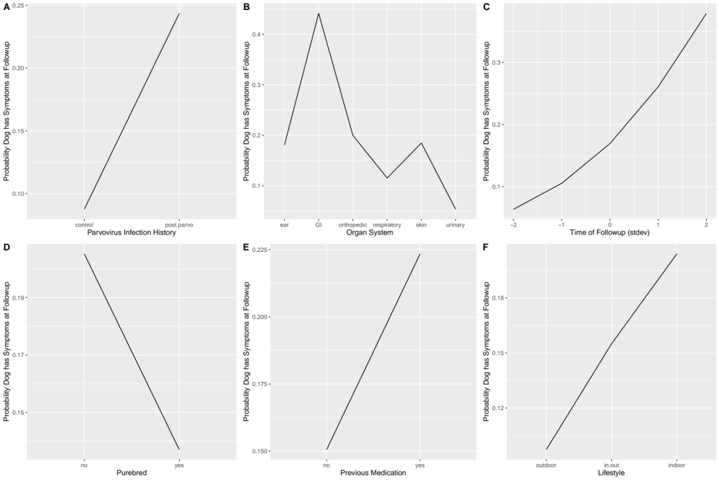

Figure S1. Effects of six explanatory variables on the probability that the dogs have signs at the time of follow up. The six explanatory variables are as follows: (A) parvovirus infection status (control, post-parvo), (B) organ system (ear, GI, orthopedic, respiratory, skin, urinary), (C) time of follow up with owners, (D) purebred (no, yes), (E) previous medication (no, yes), and (F) lifestyle (outdoor, indoor and outdoor, indoor). The sample size included 52 control dogs and 86 post-parvo dogs (total of 138 dogs).

Section 4 – Analysis of persistent GI signs in post-parvo dogs; explanatory variables taken from questionnaire and hospital management (n = 79 post-parvo dogs)

Statistical Methods: We used a GLM with binomial errors to investigate the variables associated with persistent GI signs in the post-parvo dogs. There were 15 explanatory variables: (1) sex (male, female), (2) purebred (no, yes), (3) lifestyle (indoors only, indoors and outdoors, outdoors only), (4) up-to-date vaccination (no, yes), (5) deworming treatment given (no, yes), (6) previous medication (no, yes), (7) metoclopramide treatment (no, yes), (8) number of prescribed of anti-vomiting agents (0 – 4), (9) number of prescribed antacids (0 – 3), (10) number of prescribed antibiotics (0 – 10), (11) age of the dog at admission (days), (12) time of follow up (days), (13) duration of hospitalization (hours), (14) dog weight at admission (kg), and (15) dog body temperature at admission (°C). The continuous variables (variables 11, 12, 13, 14, and 15) were transformed to z-scores. We simplified the model by sequentially removing explanatory variables with a p-value > 0.10. For this analysis, there were 44 and 35 post-parvo dogs with and without persistent GI signs, respectively (total of 79 post-parvo dogs).
Results: The PE-affected dogs that were included in the analysis (n = 79) received the following treatments during their hospitalization: 25.3% (20/79) were given metoclopramide, 38.0% (30/79) were given antiemetics (mean = 0.53; range = 0 – 3 antiemetics per dog), 24.0% (19/79) were given antacids (mean = 0.25; range = 0 – 2 antacids per dog), 96.2% (76/79) were given antimicrobials (mean = 1.51; range = 0 – 4 antimicrobials per dog), with ampicillin being the most common type.
The residuals of the simplified model met the assumptions of the GLM, as the ratio of the residual deviance to the residual degrees of freedom was close to 1.000 (res dev/res df = 79.663/73 = 1.091). After model simplification, 5 of the 15 explanatory variables remained in the model, of which 5 were significant according to the LLR tests in Table S3: purebred (χ² = 12.462, df = 1, p < 0.001), previous medication (χ² = 6.420, df = 1, p = 0.011), metoclopramide treatment during hospitalization (χ² = 5.570, df = 1, p = 0.018), time of follow up (χ² = 6.305, df = 1, p = 0.012), and body temperature of the dog at admission (χ² = 9.056, df = 1, p = 0.003).
We investigated the parameter estimates in Table S4 to determine the direction and magnitude of the effect of each explanatory variable. Purebred dogs were significantly less likely to have persistent GI signs than mixed breed dogs (Figure S2; contrast = -1.965, s.e. = 0.602, z = -3.266, p = 0.001). Dogs with a previous medical history were significantly more likely to have persistent GI signs than dogs with no previous medical history (Figure S2; contrast = 1.817, s.e. = 0.778, z = 2.335, p = 0.020). Dogs treated with metoclopramide during hospitalization were significantly more likely to have persistent GI signs than dogs not treated with metoclopramide (Figure S2; contrast = 1.668, s.e. = 0.763, z = 2.187, p = 0.029). The probability of persistent GI signs was positively associated with the time of follow up (Figure S2; slope = 0.741, s.e. = 0.318, z = 2.332, p = 0.020). The probability of persistent GI signs was negatively associated with the body temperature of the dog at admission (Figure S2; slope = -0.949, s.e. = 0.349, z = -2.714, p = 0.007). Thus, dogs with high fever at admission were less likely to have persistent GI signs.

Table S3. Analysis of the persistent GI signs using a GLM with binomial errors. The simplified model contained 5 explanatory variables of which 5 were statistically significant. Shown are the results from the type II log-likelihood test: the change in deviance ( Δ Dev), the change in degrees of freedom ( Δ Df), and the p-value. The sample size included 44 and 35 post-parvo dogs with and without persistent GI signs, respectively (total of 79 post-parvo dogs).

Variable | Δ Dev | Δ Df | P
Purebred | 12.462 | 1 | <0.001
Previous Medication | 6.420 | 1 | 0.011
Metoclopramide | 5.570 | 1 | 0.018
Time of follow up | 6.305 | 1 | 0.012
Temperature at admission | 9.056 | 1 | 0.003

Table S4. Parameter estimates of the model shown in Table S3. This model analyzed the prevalence of persistent GI signs using a GLM with binomial errors. For each explanatory variable, the type of parameter is defined (e.g. intercept, contrast, slope), and the parameter estimate, standard error (S.E.), z-value, and p-value are shown. The sample size included 44 and 35 post-parvo dogs with and without persistent GI signs, respectively (total of 79 post-parvo dogs).

Variable | Parameter definition | Estimate | S.E. | Z | P
*** | Intercept | 0.465 | 0.440 | 1.057 | 0.290
Purebred | Yes - No | -1.965 | 0.602 | -3.266 | 0.001
Previous Medication | Yes - No | 1.817 | 0.778 | 2.335 | 0.020
Metoclopramide | Yes - No | 1.668 | 0.763 | 2.187 | 0.029
Time of follow up | Slope | 0.741 | 0.318 | 2.332 | 0.020
Temperature at admission | Slope | -0.949 | 0.349 | -2.714 | 0.007

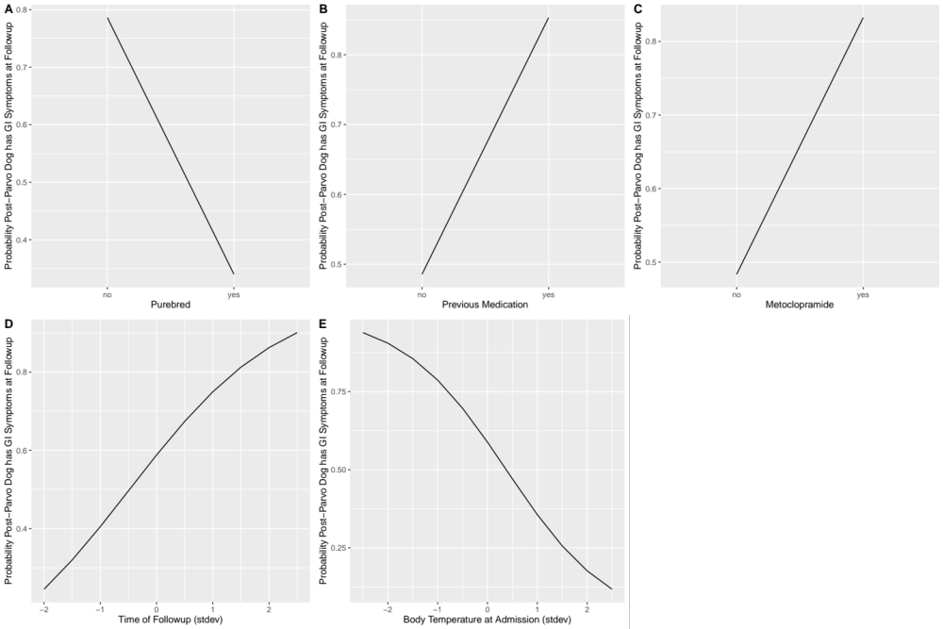

Figure S2. Effects of five explanatory variables on the probability that the post-parvo dogs has persistent GI signs at follow up. The five explanatory variables are as follows: (A) purebred (no, yes), (B) previous medication (no, yes), (C) metoclopramide treatment (no, yes), (D) time of follow up with owners (standard deviations), and (E) body temperature at admission (standard deviations). The sample size included 44 and 35 post-parvo dogs with and without persistent GI signs, respectively (total of 79 post-parvo dogs).

Section 5 – Analysis of persistent GI signs in post-parvo dogs; explanatory variables taken from questionnaire, hospital management and the CBC panel (n = 60 post-parvo dogs)

Statistical Methods: We used a GLM with binomial errors to investigate the variables associated with persistent GI signs in the post-parvo dogs. There were 15 explanatory variables from the questionnaire and hospital management: (1) sex (male, female), (2) purebred (no, yes), (3) lifestyle (indoors only, indoors and outdoors, outdoors only), (4) up-to-date vaccination (no, yes), (5) deworming treatment given (no, yes), (6) previous medication (no, yes), (7) metoclopramide treatment (no, yes), (8) number of prescribed of anti-vomiting agents (0 – 4), (9) number of prescribed antacids (0 – 3), (10) number of prescribed antibiotics (0 – 10), (11) age of the dog at admission (days), (12) time of follow up (days), (13) duration of hospitalization (hours), (14) dog weight at admission (kg), and (15) dog body temperature at admission (°C). There were another 9 explanatory variables from the CBC panel: (1) total WBC, (2) segmented neutrophils, (3) banded neutrophils, (4) lymphocytes, (5) eosinophils, (6) basophils, (7) monocytes, (8) hematocrit, and (9) toxic change. As before, the continuous variables were transformed to z-scores and we simplified the model by sequentially removing explanatory variables with a p-value > 0.10. For this analysis, there were 31 and 29 post-parvo dogs with and without persistent GI signs, respectively (total of 60 post-parvo dogs).

Results: The PE-affected dogs that were included in the analysis (n = 60) received the following treatments during their hospitalization: 23.3% (14/60) were given metoclopramide, 35.0% (21/60) were given antiemetics (mean = 0.50; range = 0 – 3 antiemetics per dog), 25.0% (15/60) were given antacids (mean = 0.27; range = 0 – 2 antacids per dog), 98.3% (59/60) were given antimicrobials (mean = 1.53; range = 0 – 4 antimicrobials per dog), with ampicillin being the most common type.
The residuals of the simplified model met the assumptions of the GLM, as the ratio of the residual deviance to the residual degrees of freedom was close to 1.000 (res dev/res df = 50.410/51 = 0.988). After model simplification, 8 of the 24 explanatory variables remained in the model, of which 7 were significant according to the LLR tests in Table S5: purebred (χ² = 2.776, df = 1, p = 0.096), previous medication (χ² = 4.078, df = 1, p = 0.043), metoclopramide treatment during hospitalization (χ² = 6.525, df = 1, p = 0.011), time of follow up (χ² = 4.208, df = 1, p = 0.040), body temperature of the dog at admission (χ² = 7.822, df = 1, p = 0.005), white blood cell count (χ² = 5.384, df = 1, p = 0.020), segmented neutrophil count (χ² = 6.536, df = 1, p = 0.011), and banded neutrophil count (χ² = 6.088, df = 1, p = 0.014).
We investigated the parameter estimates in Table S6 to determine the direction and magnitude of the effect of each explanatory variable. Purebred dogs were less likely to have persistent GI signs than mixed breed dogs (Figure S3; contrast = -1.247, s.e. = 0.776, z = -1.607, p = 0.108). Dogs with a previous medical history were more likely to have persistent GI signs than dogs with no previous medical history (Figure S3; contrast = 1.907, s.e. = 1.029, z = 1.853, p = 0.064). Dogs treated with metoclopramide during hospitalization were significantly more likely to have persistent GI signs than dogs not treated with metoclopramide (Figure S3; contrast = 2.733, s.e. = 1.238, z = 2.207, p = 0.027). The probability of persistent GI signs was positively associated with the time of follow up (Figure S3; slope = 0.843, s.e. = 0.439, z = 1.923, p = 0.054). The probability of persistent GI signs was negatively associated with the body temperature of the dog at admission (Figure S3; slope = -1.286, s.e. = 0.546, z = -2.355, p = 0.019). Thus, dogs with high fever at admission were less likely to have persistent GI signs. Total white blood cell count was positively associated with persistent GI signs (Figure S3; slope = 3.643, s.e. = 1.743, z = 2.091, P = 0.037), whereas segmented neutrophils (Figure S3; slope = -4.010, s.e. = 1.764, z = -2.273, P = 0.023) and banded neutrophils (Figure S3; slope = -1.171, s.e. = 0.543, z = -2.158, P = 0.031) were negatively associated with persistent GI signs.

Table S5. Analysis of the persistent GI signs using a GLM with binomial errors. The simplified model contained 8 explanatory variables of which 7 were statistically significant. Shown are the results from the type II log-likelihood test: the change in deviance ( Δ Dev), the change in degrees of freedom ( Δ Df), and the p-value. The sample size included 31 and 29 post-parvo dogs with and without persistent GI signs, respectively (total of 60 post-parvo dogs).

Variable | Δ Dev | Δ Df | P
Purebred | 2.776 | 1 | 0.096
Previous Medication | 4.078 | 1 | 0.043
Metoclopramide | 6.525 | 1 | 0.011
Time of follow up | 4.208 | 1 | 0.040
Temperature at admission | 7.822 | 1 | 0.005
White blood cell count | 5.384 | 1 | 0.020
Segmented neutrophil count | 6.536 | 1 | 0.011
Banded neutrophil count | 6.088 | 1 | 0.014

Table S6. Parameter estimates of the model shown in Table S5. This model analyzed the prevalence of persistent GI signs using a GLM with binomial errors. For each explanatory variable, the type of parameter is defined (e.g. intercept, contrast, slope), and the parameter estimate, standard error (S.E.), z-value, and p-value are shown. The sample size included 31 and 29 post-parvo dogs with and without persistent GI signs, respectively (total of 60 post-parvo dogs).

Variable | Parameter definition | Estimate | S.E. | Z | P
*** | Intercept | -0.254 | 0.601 | -0.423 | 0.672
Purebred | Yes - No | -1.247 | 0.776 | -1.607 | 0.108
Previous Medication | Yes - No | 1.907 | 1.029 | 1.853 | 0.064
Metoclopramide | Yes - No | 2.733 | 1.238 | 2.207 | 0.027
Time of follow up | Slope | 0.843 | 0.439 | 1.923 | 0.054
Temperature at admission | Slope | -1.286 | 0.546 | -2.355 | 0.019
White blood cell count | Slope | 3.643 | 1.743 | 2.091 | 0.037
Segmented neutrophil count | Slope | -4.010 | 1.764 | -2.273 | 0.023
Banded neutrophil count | Slope | -1.171 | 0.543 | -2.158 | 0.031

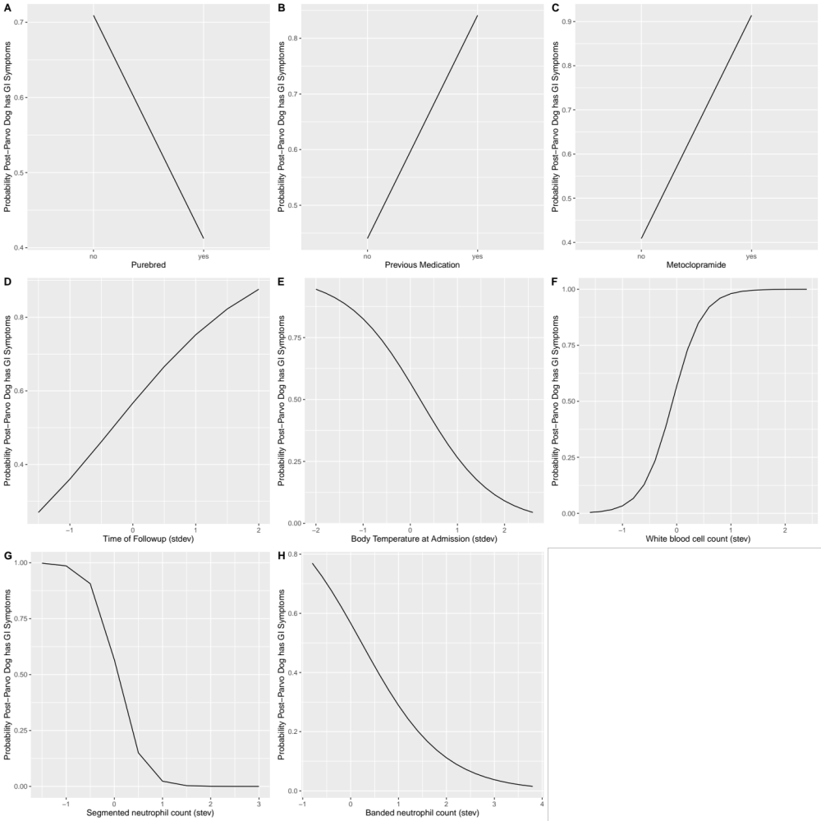

Figure S3. Effects of eight explanatory variables on the probability that the post-parvo dogs had persistent GI signs at follow up. The eight explanatory variables are as follows: (A) purebred (no, yes), (B) previous medication (no, yes), (C) metoclopramide treatment (no, yes), (D) time of follow up with owners, (E) body temperature at admission, (F) white blood cell count, (G) segmented neutrophil count, and (H) banded neutrophil count. The sample size included 31 and 29 post-parvo dogs with and without persistent GI signs, respectively (total of 60 post-parvo dogs).

Section 6 – Analysis of general organ signs in post-parvo dogs with or without persistent GI signs (n = 80 post-parvo dogs)

Statistical Methods: We used a GLMM with binomial errors to compare the prevalence of signs in five other organ systems between dogs with or without persistent GI signs. The identity of the dog was modelled as a random factor to account for non-independence of organ signs for the same dog. We included 17 explanatory variables: organ (ear, orthopedic, respiratory, skin, and urinary system), presence of persistent GI signs (no, yes), and the same 15 explanatory variables as above. The sample size was the same as above (total of 80 post-parvo dogs).
Results: The residuals of the simplified model met the assumptions of the GLMM, as the ratio of the residual deviance to the residual degrees of freedom was < 1.000 (res dev/res df = 352.1/390 = 0.903). After model simplification, 4 of the 17 explanatory variables remained in the model, of which 4 were significant according to the LLR tests in Table S7: persistent GI signs (χ² = 5.759, df = 1, p = 0.016), organ system (χ² = 8.374, df = 4, p = 0.079), lifestyle (χ² = 5.378, df = 2, p = 0.068), and body temperature of the dog at admission (χ² = 6.842, df = 1, p = 0.009).
We investigated the parameter estimates in Table S8 to determine the direction and magnitude of the effect of each explanatory variable. Post-parvo dogs with persistent GI signs were significantly more likely to have signs in the other 5 organs compared to post-parvo dogs without persistent GI signs (Figure S4; contrast = 0.741, s.e. = 0.309, z = 2.400, p = 0.016). The prevalence of signs in post-parvo dogs with GI signs (22.2% = 50/225) was 1.7 times higher than that in post-parvo dogs without GI signs (Figure 3; 13.1% = 23/175). Compared to other organs, post-parvo dogs had significantly fewer signs in the urinary system (Figure S4; contrast = -1.167, s.e. = 0.491, z = -2.375, p = 0.018). Indoor post-parvo dogs had significantly more signs than outdoor post-parvo dogs (Figure S4; contrast = 0.884, s.e. = 0.384, z = 2.300, p = 0.021). The probability of signs in the 5 other organs was positively associated with the body temperature of the dog at admission (Figure S4; slope = 0.375, s.e. = 0.143, z = 2.616, p = 0.009). Thus, dogs with high fever at admission were more likely to have signs in other organ systems.

Table S7. Analysis of the prevalence of general organ signs using a GLMM with binomial errors. The simplified model contained four significant explanatory variables. Shown are the results from the type II log-likelihood test: the change in deviance ( Δ Dev), the change in degrees of freedom ( Δ Df), and the p-value. The sample size included 45 and 35 post-parvo dogs with and without persistent GI signs, respectively (total of 80 post-parvo dogs).

Variable | Δ Dev | Δ Df | P
GI signs | 5.759 | 1 | 0.016
Organ system | 8.374 | 4 | 0.079
Lifestyle | 5.378 | 2 | 0.068
Temperature at admission | 6.842 | 1 | 0.009

Table S8. Parameter estimates of the model shown in Table S7. This model analyzed the prevalence of general organ signs using a GLMM with binomial errors. For each explanatory variable, the type of parameter is defined (e.g. intercept, contrast, slope), and the parameter estimate, standard error (S.E.), z-value, and p-value are shown. The sample size included 45 and 35 post-parvo dogs with and without persistent GI signs, respectively (total of 80 post-parvo dogs).

Variable | Parameter definition | Estimate | S.E. | Z | P
*** | Intercept | -2.346 | 0.472 | -4.973 | 0.000
GI signs | Yes - No | 0.741 | 0.309 | 2.400 | 0.016
Organ system | Orthopedic - Ear | -0.078 | 0.396 | -0.198 | 0.843
Organ system | Respiratory - Ear | -0.529 | 0.425 | -1.244 | 0.213
Organ system | Skin - Ear | 0.076 | 0.389 | 0.195 | 0.845
Organ system | Urinary - Ear | -1.167 | 0.491 | -2.375 | 0.018
Lifestyle | In and out - Outdoor | 0.571 | 0.432 | 1.319 | 0.187
Lifestyle | Indoor - Outdoor | 0.884 | 0.384 | 2.300 | 0.021
Temperature at admission | Slope | 0.375 | 0.143 | 2.616 | 0.009

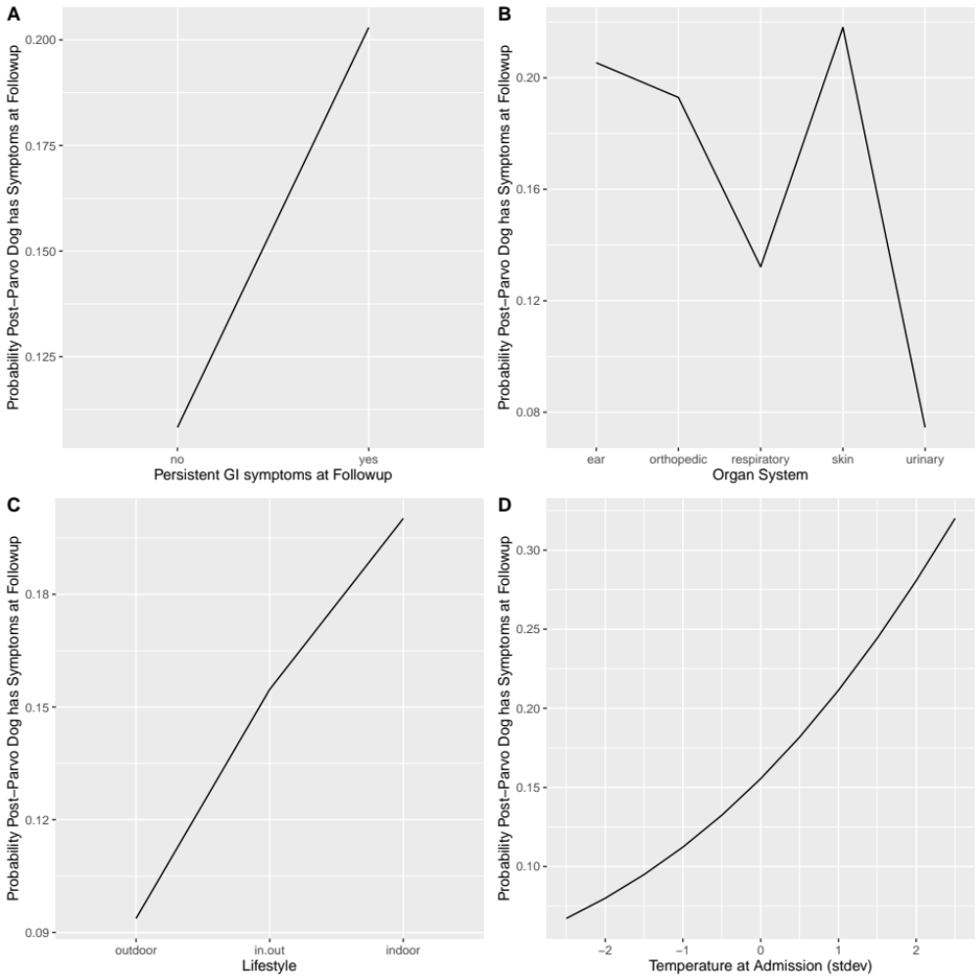

Figure S4. Effects of four explanatory variables on the probability that the dogs have general organ signs at the time of follow up. The four explanatory variables are as follows: (A) persistent GI signs at follow up, (B) organ system (ear, GI, orthopedic, respiratory, skin, urinary), (C) lifestyle (outdoor, indoor and outdoor, indoor), and (D) body temperature at admission. The sample size included 45 and 35 post-parvo dogs with and without persistent GI signs, respectively (total of 80 post-parvo dogs).

Section 7 – Dog breeds used in the study.

Table S9. Dog breeds included in the control group and the post-parvo group. The dog breeds are ranked from most abundant to least abundant.

Dog breed | Control  n (%) | Post-parvo  n (%)
Mix | 26 (50%) | 44 (52%)
Rottweiler | 0 | 5 (5.8%)
Boston Terrier | 0 | 3 (3.5%)
Border Collie | 0 | 2 (2.4%)
Chesapeake Bay Retriever | 0 | 3 (3.5%)
Labrador Retriever | 1 (1.9%) | 3 (3.5%)
American Pitbull | 1 (1.9%) | 2 (2.4%)
German Shepherd Dog | 4 (7.7%) | 2 (2.4%)
Golden Retriever | 2 (3.8%) | 2 (2.4%)
Shih Tzu | 3 (5.8%) | 0
Spitz | 2 (3.8%) | 1 (1.2%)
Chihuahua | 2 (3.8%) | 1 (1.2%)
Others | 11 (21.2%) | 17 (19.8%)
Total | 52 (100.0%) | 86 (100.0%)

The control group contained a single individual from the following 11 breeds: Beagle, Bloodhound, Brittany Spaniel, English Springer Spaniel, Jack Russell Terrier, Lhasa Apso, Papillon, Pug, Shetland Sheepdog, Toy poodle, West Highland White Terrier. The post-parvo group contained a single individual from the following 17 breeds: Akita, American Cocker Spaniel, Australian Shepherd, Bulldog, Cane-Corso, English Springer Spaniel, Great Pyrenes, Irish Setter, Miniature Poodle, Norwegian Elkhound, Pomeranian, Pug, Saint Bernard, Siberian Huskey, Shiba Inu, Toy poodle, Weimaraner

