Abbreviations
SSI, Surgical site infections;
CEZ, cefazolin;
CEZ+AG, cefazolin combined with aminoglycosides;
GM, gentamycin;
AMK, amikacin;
PIPC/TAZ, piperacillin/tazobactam;
CTX, cefotaxime;
ABPC/SBT, ampicillin/sulbactam;
CTRX, ceftriaxone;
SD, standard deviation;
CNY, Chinese Yuan;
ICER, incremental cost-effectiveness ratio;
EV, expected value.
WTP, Willingness-to-pay.

Table S1. SSI Infection Rates by Antibiotic Regimen in the Model
Regimens | Base value | Low value | High value | Beta distribution
 |  |  |  | α | β
CEZ | 0.0747 | 0.0456 | 0.2903 | 36 | 446
CEZ+AG | 0.0854 | 0.0376 | 0.1786 | 27 | 289
PIPC/TAZ | 0.0946 | 0.0568 | 0.1892 | 7 | 67
CTX | 0.1351 | 0.0811 | 0.2703 | 5 | 32
ABPC/SBT | 0.2333 | 0.1400 | 0.4667 | 7 | 23
CTRX | 0.2381 | 0.1429 | 0.4762 | 5 | 16
Notes:
- Infection rates for each antibiotic regimen are presented to the fourth decimal place.
- In the PSA, the infection rates were determined using the beta distribution values obtained from the specified α and β parameters.

Table S2. Costs of SSI and Antibiotic Regimens in the Model
Regimens | Base value | SD | Low value | High value
SSI | 16131.31 | 3828.90 | 6038.85 | 24794.99
CEZ | 67.64 | 46.36 | 20.58 | 149.80
GM | 6.06 | 4.54 | 2.38 | 20.86
AMK | 3.45 | 0.25 | 3.15 | 3.90
PIPC/TAZ | 216.33 | 19.24 | 180.60 | 232.40
CTX | 19.37 | 5.50 | 11.55 | 30.10
ABPC/SBT | 36.19 | 4.22 | 30.52 | 42.28
CTRX | 24.15 | 9.20 | 10.56 | 36.48
Notes:
- All costs in the table are in CNY and are rounded to two decimal places.
- In the PSA, costs were modeled using a gamma distribution, derived from the specified mean values and SD of the respective costs.

Table S3. Dosing Regimens for Antibiotic Prophylaxis
Drug | Pre - Operation | Intra - Operation | Post - Operation | Common Specifications | Average Unit Price
CEZ | 1g | - | 1g tid 48h | 0.5g, 1g | 8.46
GM | 80mg | - | 80mg tid 48h | 40mg, 80mg | 0.80
AMK | 0.2g | - | 0.2g bid 48h | 0.1g, 0.2g | 3.45
PIPC/TAZ | 4.5g | - | 4.5g q8h 48h | 2.25g, 4.5g | 18.87
CTX | 1g | 1g | 1g tid 48h | 0.5g, 1g | 2.56
ABPC/SBT | 3g | - | 4.5g q8h 48h | 0.75g, 1.5g | 36.19
CTRX | 2g | - | 2g qd 48h | 0.25g, 0.5g, 1g | 2.33
Notes:
- The dosing regimens for each antibiotic were obtained from a combination of product labels, clinical guidelines, and clinical experience to ensure that the prescribed dosages reflect commonly accepted practices in the treatment of Type III open fractures.
- The cost for each regimen, as shown in Table 2, was calculated based on the dosing regimen outlined in this table.
- In our study, the CEZ+AG regimen includes the CEZ dosing from this table, with the addition of either the GM or AMK dosing from this table.

Table S4. Utility Values for SSI and Non-SSI at 90 Days Post-Surgery
State | Mean | SD | 95% Confidence Interval
State | Mean | SD | Low value | High value
SSI | 0.2500 | 0.3117 | 0.1266 | 0.3734
No SSI | 0.3500 | 0.3453 | 0.3108 | 0.3892
Notes:
- All utility values in the table are rounded to four decimal places.
- In the PSA, health utility values were modeled using a normal distribution, derived from the specified mean values and SD.

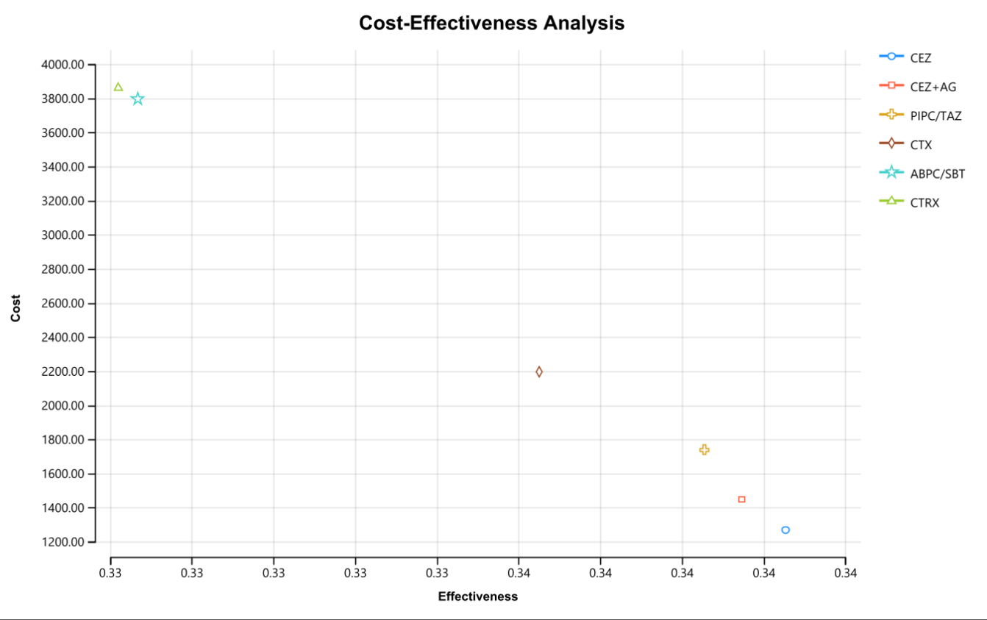
Figure S1. Cost-Effectiveness Acceptability Curve

Figure S2. Tornado Diagram Comparing CEZ with CEZ+AG

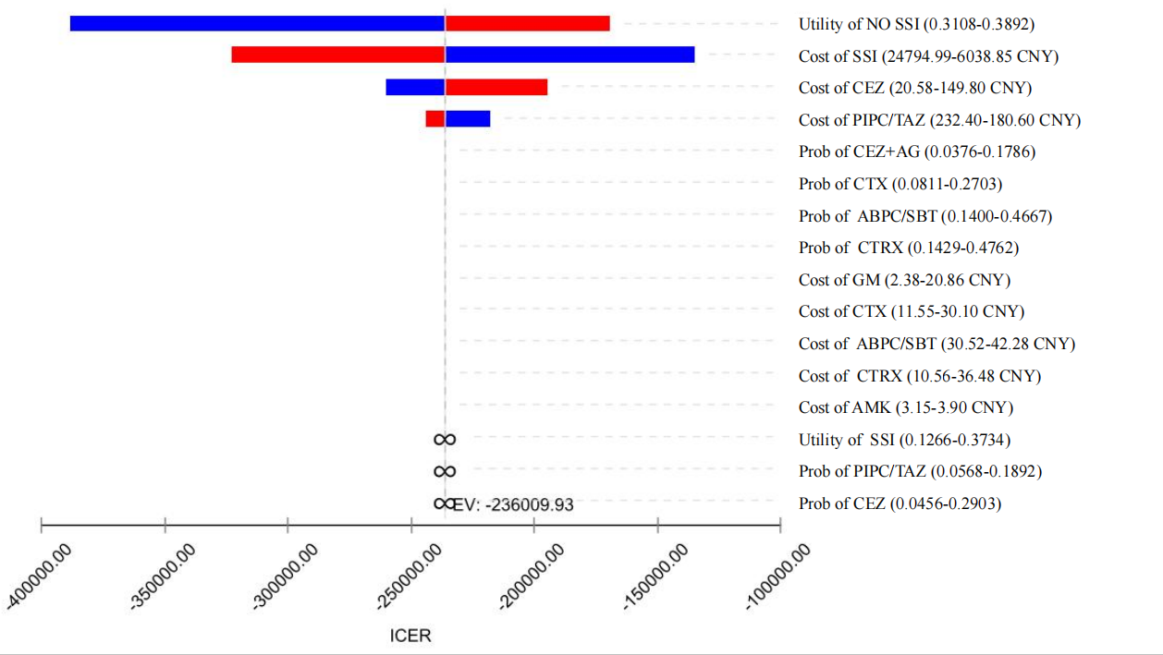
Figure S3. Tornado Diagram Comparing CEZ with PIPC/TAZ

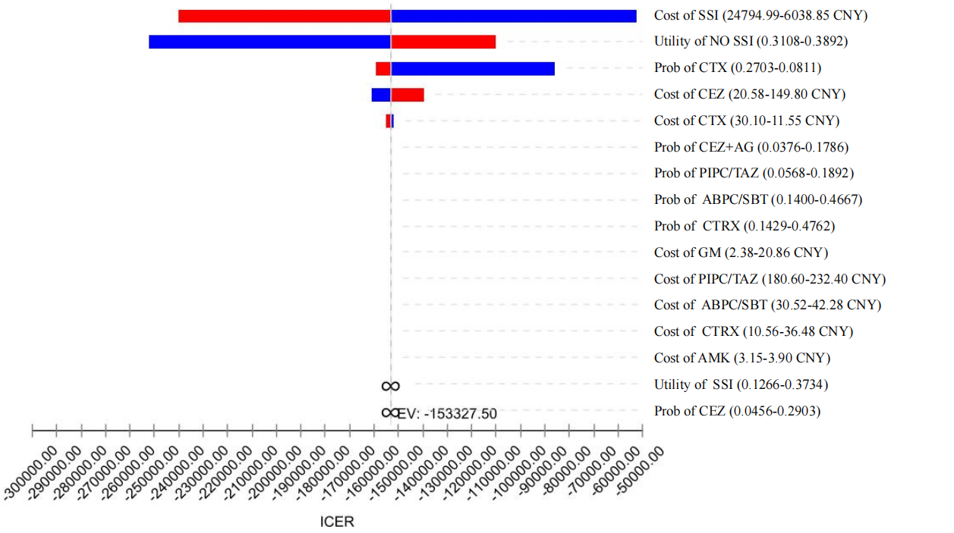
Figure S4. Tornado Diagram Comparing CEZ with CTX

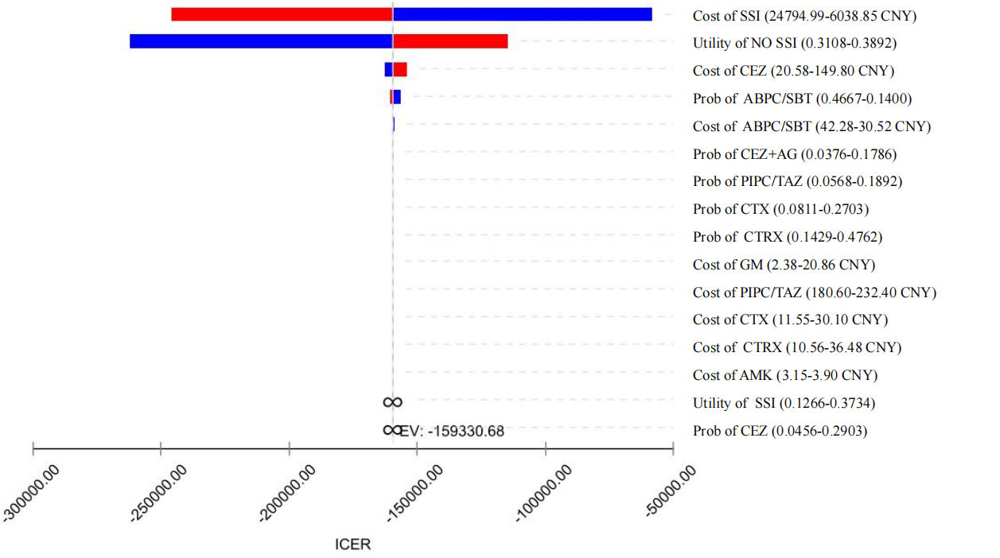
Figure S5. Tornado Diagram Comparing CEZ with ABPC/SBT

Figure S6. Monte Carlo Simulation Scatter Plot (comparing CEZ to PIPC/TAZ)

Figure S7. Monte Carlo Simulation Scatter Plot (comparing CEZ to CTX)

Figure S8. Monte Carlo Simulation Scatter Plot (comparing CEZ to ABPC/SBT)

Figure S9. Monte Carlo Simulation Scatter Plot (comparing CEZ to CTRX)

