SUPPLEMENTARY INFORMATION
METHODS
Cognitive data
Data processing. Participants with times to complete the Trailmaking test (TMT) that exceeded 4 standard deviations from the mean were excluded; participants who took less than 100 second to complete TMT were excluded; TMT alphanumeric score was calculated by penalizing each error made with a 5 second penalty and adding this penalty time to the time to complete alphanumeric path.
Other UKB cognitive tests. In addition to the tests of cognitive function we included in the main analysis, there were several other cognitive tests that we decided not to include. We selected several tests that were previously shown to be impaired in major depressive disorder (MDD) or anxiety and that showed clear relevance to executive function and related cognitive tasks. The tests selected were guided by our hypotheses that executive dysfunction provides a shared neurocognitive mechanism underlying MDD and anxiety.
We nevertheless present the effects of the clinical groups and MDD polygenic risk scores on these measures of cognition after correcting for age, age², age*sex and sex and site (Newcastle, Cheadle, Reading) in Supplementary Table 2. While pairs matching is a popular online game (Mah-jong being one of the most famous examples of tile/card matching), it is less commonly used in cognitive neuroscience and psychiatry research although some evidence suggests that playing Mah-jong can have beneficial effects on cognitive functioning in older adults (Cheng et al, 2006). We also decided against including reaction times for two reasons: firstly, they lack specificity and are affected in different neurodegenerative conditions (Maia and Kutz, 2017) as well as schizophrenia (Schwartz et al, 1989). However, the underlying aetiology that leads to reaction time differences is likely different across these disorders. Next, digit span is a common measure of working memory, yet we only found reduced digit span in the MDD group, with no effects of comorbid MDD and anxiety or anxiety disorders. Matrix completion test was not included as it provided an additional fluid intelligence measure to the already included fluid intelligence battery. Tower test as a measure of planning that was not impaired in any other disorder apart from anxiety. Finally, neuroticism is a personality trait rather than a cognitive test and was not included among tests of cognitive function. Correlations between the cognitive variables can are shown in Supplementary Figure S1.
Clinical Data
One of the key limitations of the UKB data is the cross-sectional nature of the dataset, whereby ICD diagnoses refer to lifetime presence of the respective psychiatric disorder. In order to illustrate the duration since the first time a diagnosis was reported, we used the age at the time of scan (Data Field 21003), year of birth (Data Field 34) and the date when a diagnosis was first reported (Data Fields 130894 for MDD, 130906 for ANX and 130910 for STR). Further, we explored the duration since the last episode based on self-reported symptoms of depression (Data Field 20434). Antidepressant prescription data was extracted from linked electronic health records (primary care prescription records, Data-Field 42039).
We used the following Data-Fields as an exclusion criteria for being part of the Control group: 130979, 130981, 130983, 130985, 130987, 130989, 130991, 130993, 130995, 130997, 130999, 131001, 131003, 131005, 131007, 131009, 131011, 131013, 131015, 131017, 131019, 131021, 131023, 131025, 131027, 131029, 131031, 131033, 131037, 131039, 131041, 131043, 131045, 131047, 131049, 131051, 131053, 131055, 131057, 131059, 131061, 131063, 131065, 131067, 131069, 131071, 131073, 131075, 131077, 131079, 131081, 131083, 131085, 131087, 131089, 131091, 131093, 131095, 131097, 131099, 131101, 131103, 131105, 131107, 131109, 131111, 131113, 131115, 131117, 131119, 131121, 131123, 131125, 131127.
Supplementary Figure S1. Correlation structure of cognitive variables and neuroticism. For each pair of variables, rows with missing values in either variable were excluded from the correlation. TMT and Gf showed the strongest associations with other variables. TMT - trailmaking test; Gf – fluid intelligence; PAL – paired associated learning; DSST – digit-symbol substitution test; Pairs – pair matching game; RT – reaction times; DS – digit span; Matrices – matrix completion test; Tower – Tower test. Correlates significant at P<0.0001 are shown in bold.

Mapping the UK Biobank ICA components to Yeo 7 networks
In order to map the UKB ICA components to the Yeo 7 networks, we obtained a volumetric parcellation of the Yeo networks from Freesurfer online resources (https://surfer.nmr.mgh.harvard.edu/fswiki/CorticalParcellation_Yeo2011). We calculated the proportion of voxels in each of the ICA components that fell in each of the 7 Yeo networks (Supplementary Table 1) and assigned each independent component (IC) to the network that encapsulated the highest proportion of voxels of that IC. Exceptions were first, IC-18 that encompassed subcortical regions, notably the striatum; second, IC-15 that encompassed the cerebellum; third IC-3 that was part of both dorsal and ventral attention networks; fourth, IC-21 that was part of the FPN, DMN and to a lesser extent VAN and finally IC-10, IC-11 and IC-12 that fell into Yeo motor and attentional networks.
ICA_d25_ID | VIS | MOT | DAN | VAN | LIM | FPN | DMN | Yeo7N
1 | 0.01 | 0.04 | 0.08 | 0.02 | 0.05 | 0.03 | 0.78 | 1.DMN
2 | 0.58 | 0.04 | 0.31 | 0.02 | 0.00 | 0.04 | 0.01 | 2.VIS
3 | 0.03 | 0.11 | 0.39 | 0.26 | 0.01 | 0.15 | 0.05 | 3.DA/VA
4 | 0.76 | 0.08 | 0.03 | 0.07 | 0.00 | 0.02 | 0.04 | 4.VIS
5 | 0.01 | 0.07 | 0.23 | 0.03 | 0.01 | 0.42 | 0.22 | 5.FPN
6 | 0.01 | 0.01 | 0.15 | 0.05 | 0.04 | 0.41 | 0.32 | 6.FPN
7 | 0.16 | 0.01 | 0.24 | 0.06 | 0.02 | 0.14 | 0.37 | 7.DMN
8 | 0.84 | 0.01 | 0.02 | 0.03 | 0.00 | 0.08 | 0.02 | 8.VIS
9 | 0.01 | 0.11 | 0.01 | 0.11 | 0.01 | 0.22 | 0.53 | 9.DMN
10 | 0.04 | 0.53 | 0.27 | 0.08 | 0.00 | 0.02 | 0.06 | 10.MOT/AN
11 | 0.02 | 0.67 | 0.04 | 0.25 | 0.01 | 0.00 | 0.02 | 11.MOT/AN
12 | 0.02 | 0.65 | 0.11 | 0.19 | 0.00 | 0.00 | 0.04 | 12.MOT/AN
13 | 0.00 | 0.08 | 0.16 | 0.11 | 0.05 | 0.14 | 0.46 | 13.DMN
14 | 0.05 | 0.13 | 0.01 | 0.15 | 0.04 | 0.14 | 0.48 | 14.DMN
15 | 0.71 | 0.03 | 0.03 | 0.18 | 0.02 | 0.00 | 0.03 | 15.CRB
16 | 0.00 | 0.01 | 0.09 | 0.20 | 0.01 | 0.40 | 0.29 | 16.FPN
17 | 0.09 | 0.38 | 0.06 | 0.19 | 0.03 | 0.02 | 0.22 | 17.MOT
18 | 0.02 | 0.36 | 0.14 | 0.39 | 0.00 | 0.07 | 0.02 | 18.STR
19 | 0.85 | 0.02 | 0.05 | 0.04 | 0.00 | 0.03 | 0.01 | 19.VIS
20 | 0.06 | 0.05 | 0.12 | 0.15 | 0.01 | 0.22 | 0.39 | 20.DMN
21 | 0.01 | 0.02 | 0.06 | 0.17 | 0.06 | 0.28 | 0.41 | 21.FP/DM
Supplementary Table 1. Proportion of voxels in each of the ICA components falling under each of the Yeo 7 networks. Initial ICA results included 25 components, but 4 of them were deemed to be representing noise by the UKB preprocessing pipeline, resulting in 21 components mapped here. FPN – frontoparietal network; DMN – default mode network; VIS – visual network; MOT – motor network; DA/VA – dorsal and ventral attentional networks; AN – attentional networks; STR – striatal network; CRB – cerebellum.

RESULTS
As shown in the Supplementary Figure S1A, the first time a clinical diagnosis was reported was within 10-20 years from the time of the MRI scan for most participants. Moreover, many of the participants in the MDD- and MDD+ANX groups also showed higher PHQ-2 scores suggesting that depressive symptoms were present in these groups at the time of scan (Supplementary Figure S2A, Table 1).
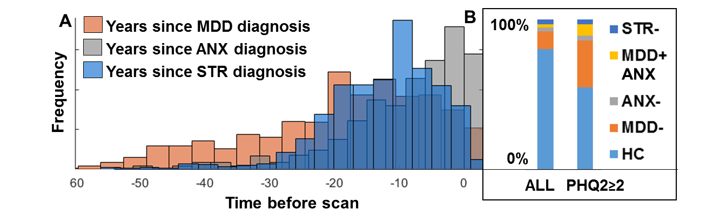
Supplementary Figure S2. Clinical sample characteristics. Histograms (A) illustrate the number of years since the first time a diagnosis of major depressive disorder (MDD, F32), a non-phobic anxiety disorder (ANX, F41) or a stressor-related disorder (STR, F43) was reported. We further broke the sample down into each of the groups shown in (B). The stacked bar chart on the left includes the proportion of all participants (with functional connectivity data) who had a lifetime diagnosis of MDD-, ANX-, MDD+ANX or STR- at the time of scan. The stacked bar chart on the right shows the proportion of participants falling into each of the clinical groups when considering only participants with a PHQ-2 score of two or higher.
As shown in Supplementary Figure S3, over 33% of participants with a lifetime diagnosis of MDD, ANX, or STR reported experiencing the most recent MDD episode during the last five years and over 60% of participants with a lifetime diagnosis of MDD, ANX, or STR reported such an episode in the last ten years.
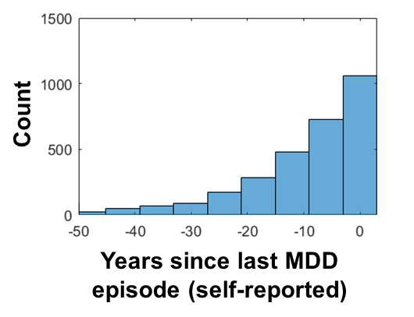
Supplementary Figure S3. Number of years since the last MDD diagnosis based on self-report (Data Field 20434).

Cognitive Test | Statistic | MDD- | ANX- | MDD+ANX | STR- | MDD PRS | ANX PRS | PTSD PRS
TMT | beta | 12.35 | 42.71 | 13.57 | 27.51 | 0.77 | 0.08 | 0.35
 | SE | 4.82 | 9.99 | 8.80 | 9.52 | 0.20 | 0.09 | 0.12
 | T-stat | 2.56 | 4.27 | 1.54 | 2.89 | 3.92 | 0.94 | 2.92
 | P-val | 0.010 | 0.000 | 0.123 | 0.004 | 0.000 | 0.345 | 0.003
Gf | beta | -0.08 | -0.30 | -0.14 | -0.28 | -0.01 | 0.00 | 0.00
 | SE | 0.04 | 0.08 | 0.07 | 0.08 | 0.00 | 0.00 | 0.00
 | T-stat | -2.11 | -3.81 | -1.95 | -3.56 | -3.25 | -1.98 | -2.79
 | P-val | 0.035 | 0.000 | 0.051 | 0.000 | 0.001 | 0.048 | 0.005
PAL | beta | -0.11 | -0.13 | -0.18 | -0.38 | 0.00 | 0.00 | 0.00
 | SE | 0.06 | 0.12 | 0.11 | 0.12 | 0.00 | 0.00 | 0.00
 | T-stat | -1.95 | -1.10 | -1.70 | -3.25 | 0.03 | -0.47 | -2.63
 | P-val | 0.051 | 0.272 | 0.088 | 0.001 | 0.980 | 0.638 | 0.009
DSST | beta | -0.70 | -1.50 | -0.54 | -0.65 | -0.01 | 0.00 | -0.01
 | SE | 0.11 | 0.23 | 0.20 | 0.22 | 0.00 | 0.00 | 0.00
 | T-stat | -6.33 | -6.52 | -2.67 | -2.95 | -1.31 | -1.00 | -3.21
 | P-val | 0.000 | 0.000 | 0.008 | 0.003 | 0.189 | 0.319 | 0.001
Pairs | beta | 0.15 | 0.73 | 0.17 | 0.15 | 0.01 | 0.00 | 0.00
 | SE | 0.06 | 0.12 | 0.11 | 0.12 | 0.00 | 0.00 | 0.00
 | T-stat | 2.52 | 6.20 | 1.61 | 1.29 | 2.37 | 1.42 | 2.23
 | P-val | 0.012 | 0.000 | 0.108 | 0.198 | 0.018 | 0.155 | 0.026
RT | beta | 6.23 | 13.86 | 1.76 | 7.40 | -0.12 | 0.01 | 0.01
 | SE | 1.74 | 3.58 | 3.23 | 3.60 | 0.07 | 0.03 | 0.05
 | T-stat | 3.57 | 3.87 | 0.54 | 2.06 | -1.69 | 0.24 | 0.32
 | P-val | 0.000 | 0.000 | 0.586 | 0.040 | 0.091 | 0.807 | 0.752
Digit Span | beta | -0.08 | -0.01 | -0.07 | -0.08 | 0.00 | 0.00 | 0.00
 | SE | 0.03 | 0.06 | 0.05 | 0.06 | 0.00 | 0.00 | 0.00
 | T-stat | -2.99 | -0.09 | -1.39 | -1.48 | -0.44 | 1.36 | -2.28
 | P-val | 0.003 | 0.927 | 0.164 | 0.138 | 0.663 | 0.174 | 0.023
Matrices | beta | -0.09 | -0.23 | -0.07 | -0.21 | 0.00 | 0.00 | 0.00
 | SE | 0.05 | 0.10 | 0.09 | 0.09 | 0.00 | 0.00 | 0.00
 | T-stat | -1.92 | -2.34 | -0.83 | -2.25 | -1.23 | -3.17 | -2.19
 | P-val | 0.056 | 0.019 | 0.408 | 0.024 | 0.217 | 0.002 | 0.029
Tower | beta | -0.06 | -0.58 | -0.22 | -0.13 | 0.00 | 0.00 | 0.00
 | SE | 0.07 | 0.15 | 0.14 | 0.15 | 0.00 | 0.00 | 0.00
 | T-stat | -0.85 | -3.82 | -1.66 | -0.92 | 0.43 | -0.45 | -1.68
 | P-val | 0.396 | 0.000 | 0.097 | 0.357 | 0.664 | 0.655 | 0.093
Neuroticism | beta | 2.65 | 3.43 | 1.03 | 1.83 | 0.02 | 0.00 | 0.02
 | SE | 0.06 | 0.12 | 0.11 | 0.12 | 0.00 | 0.00 | 0.00
 | T-stat | 43.89 | 28.15 | 9.33 | 14.88 | 7.54 | 2.41 | 9.96
 | P-val | 0.000 | 0.000 | 0.000 | 0.000 | 0.000 | 0.016 | 0.000
Supplementary Table 2. Effects of clinical groups and polygenic risk scores (PRS) for major depressive disorder (MDD), post-traumatic stress disorder (PTSD) and anxiety disorders (ANX) on cognition and neuroticism. Uncorrected P-values are shown. P_{UNCORRECTED}<0.05 are highlighted in bold.
Significant effects of clinical groups and MDD PRS on cortical thickness

The regions of significant differences after permutation testing are shown in Supplementary Table 3. In order to correct for multiple comparisons with the case-control differences, we used the following thresholds: P_{PERMUTATON}<0.05 to assess whether the overall group effect was significant and in addition, we Bonferroni-corrected P<0.0125 the post-hoc case-control comparisons of MDD-, ANX-, STR- and MDD+ANX vs control group). We report the effects of PRS corrected at P_{PERMUTATON}<0.05.

Supplementary Table 3A. Significant effects of MDD- on cortical thickness
HCP Region | HOA region | T-statistic | P-Value (uncorrected) | Effect Size
Right a32pr | Anterior Cingulate | -2.85 | 0.0044 | -0.033
Right p24pr | Anterior Cingulate Cortex | -2.66 | 0.0078 | -0.031
Left p32pr | Anterior Cingulate Cortex (anterior) | -2.98 | 0.0029 | -0.034
Right 8BL | Frontal Pole | -2.92 | 0.0036 | -0.033
Left 9a | Frontal Pole (dorsal anterior) | -3.16 | 0.0016 | -0.036
Left A1 | Heschls Gyrus | 3.54 | 0.0004 | 0.041
Right A1 | Heschls Gyrus | 3.15 | 0.0016 | 0.036
Left 6r | Inferior Frontal Gyrus, pars opercularis | -3.28 | 0.0010 | -0.038
Left IFSa | Inferior Frontal Gyrus, pars triangularis | -2.62 | 0.0087 | -0.030
Left IFSp | Inferior Frontal Gyrus/Middle Frontal Gyrus | -2.78 | 0.0055 | -0.032
Left LO1 | Lateral Occipital Cortex | 2.66 | 0.0079 | 0.030
Left MIP | Lateral Occipital Cortex | 2.77 | 0.0056 | 0.032
Right MIP | Lateral Occipital Cortex | 3.06 | 0.0023 | 0.035
Left 8BM | Medial Superior Frontal Gyrus | -3.56 | 0.0004 | -0.041
Right 8BM | Medial Superior Frontal Gyrus | -2.68 | 0.0073 | -0.031
Left 46 | Middle Frontal Gyrus | -2.96 | 0.0030 | -0.034
Right 8Av | Middle Frontal Gyrus | -3.11 | 0.0019 | -0.036
Right s6-8 | Middle Frontal Gyrus | -2.69 | 0.0071 | -0.031
Left V1 | Occipital Cortex | 3.30 | 0.0010 | 0.038
Right V1 | Occipital Cortex | 3.49 | 0.0005 | 0.040
Left d32 | Paracingulate Gyrus | -4.12 | 0.0000 | -0.047
Right d32 | Paracingulate Gyrus | -3.87 | 0.0001 | -0.044
Left PeEc | Parahippocampal Gyrus | -3.66 | 0.0003 | -0.042
Right PeEc | Parahippocampal Gyrus | -2.59 | 0.0097 | -0.030
Left RI | Parietal Opercular Cortex | -3.09 | 0.0020 | -0.035
Left POS1 | Precuneous | -2.86 | 0.0042 | -0.033
Left 7PL | Precuneous Cortex | 3.29 | 0.0010 | 0.038
Right 7PL | Precuneous Cortex | 2.55 | 0.0108 | 0.029
Left SFL | Superior Frontal Gyrus | -3.48 | 0.0005 | -0.040
Left 6ma | Superior Frontal Gyrus | -2.83 | 0.0046 | -0.033
Right SFL | Superior Frontal Gyrus | -3.38 | 0.0007 | -0.039
Right 6ma | Superior Frontal Gyrus | -3.00 | 0.0027 | -0.034
Left SCEF | Supplementary Motor Cortex | -4.20 | 0.0000 | -0.048
Right SCEF | Supplementary Motor Cortex | -3.28 | 0.0010 | -0.038
Left TGd | Temporal Pole | -2.76 | 0.0058 | -0.032
Left STGa | Temporal Pole (aTL) | -2.58 | 0.0099 | -0.030
Supplementary Table 3B. Significant effects of comorbid MDD+ANX on cortical thickness
HCP Region | HOA region | T-statistic | P-Value (uncorrected) | Effect Size
Right PFm | Angular Gyrus/Supramarginal Gyrus | -2.56 | 0.0105 | -0.029
Left a32pr | Anterior Cingulate | -3.28 | 0.0010 | -0.038
Right a32pr | Anterior Cingulate | -2.59 | 0.0097 | -0.030
Right p24 | Anterior Cingulate | -4.51 | 0.0000 | -0.052
Right p24pr | Anterior Cingulate Cortex | -2.92 | 0.0035 | -0.033
Left p32pr | Anterior Cingulate Cortex (anterior) | -3.63 | 0.0003 | -0.042
Right a24pr | Anterior Cingulate Cortex (anterior) | -2.80 | 0.0050 | -0.032
Right p32pr | Anterior Cingulate Cortex (anterior) | -3.76 | 0.0002 | -0.043
Left FOP1 | Central Opercular Cortex | -2.61 | 0.0090 | -0.030
Right 47s | Frontal Orbital Cortex (Medial) | -3.03 | 0.0025 | -0.035
Right 9-46d | Frontal Pole | -3.04 | 0.0023 | -0.035
Right 9p | Frontal Pole (anterior) | -2.94 | 0.0033 | -0.034
Left p10p | Frontal Pole (medial) | -2.62 | 0.0088 | -0.030
Right p10p | Frontal Pole (medial) | -2.80 | 0.0052 | -0.032
Left 6r | Inferior Frontal Gyrus, pars opercularis | -3.09 | 0.0020 | -0.035
Right 6r | Inferior Frontal Gyrus, pars opercularis | -2.82 | 0.0048 | -0.032
Right TGv | Inferior Temporal Gyrus, anterior division | -2.94 | 0.0033 | -0.034
Left PoI1 | Insular Cortex | -3.61 | 0.0003 | -0.041
Left AAIC | Insular Cortex (anterior) | -2.77 | 0.0056 | -0.032
Left PoI2 | Insular Cortex (posterior) | -3.14 | 0.0017 | -0.036
Right PoI2 | Insular Cortex (posterior) | -3.07 | 0.0021 | -0.035
Left Ig | Insular Cortex/Parietal Operculum | -2.52 | 0.0119 | -0.029
Left TPOJ2 | Lateral Occipital Cortex, inferior division | -2.87 | 0.0042 | -0.033
Left 24dv | Medial Postcentral Gyrus | -3.90 | 0.0001 | -0.045
Left TE1a | Middle Temporal Gyrus (anterior) | -2.66 | 0.0077 | -0.031
Right STSvp | Middle Temporal Gyrus (posterior) | -3.33 | 0.0009 | -0.038
Right STSva | Middle Temporal Gyrus, posterior division | -2.60 | 0.0094 | -0.030
Left d32 | Paracingulate Gyrus | -3.16 | 0.0016 | -0.036
Left EC | Parahippocampal Gyrus | -2.70 | 0.0069 | -0.031
Left H | Parahippocampal Gyrus | -3.59 | 0.0003 | -0.041
Right EC | Parahippocampal Gyrus | -3.19 | 0.0014 | -0.037
Right H | Parahippocampal Gyrus | -4.60 | 0.0000 | -0.053
Right PeEc | Parahippocampal Gyrus | -3.79 | 0.0001 | -0.044
Left RI | Parietal Opercular Cortex | -2.73 | 0.0064 | -0.031
Left PFcm | Parietal Opercular Cortex | -2.66 | 0.0079 | -0.030
Right RI | Parietal Opercular Cortex | -3.86 | 0.0001 | -0.044
Right PBelt | Planum Temporale (STG) | -3.02 | 0.0026 | -0.035
Right LBelt | Planum Temporale (STG) | -2.53 | 0.0113 | -0.029
Left 4 | Postcentral Gyrus | -2.98 | 0.0029 | -0.034
Right 4 | Postcentral Gyrus | -3.36 | 0.0008 | -0.039
Left PFop | Postcentral Gyrus (ventral) | -2.54 | 0.0111 | -0.029
Right 23d | Posterior Cingulate Cortex | -2.54 | 0.0112 | -0.029
Right ProS | Posterior Cingulate Cortex (ventral) | -3.52 | 0.0004 | -0.040
Right 6mp | Precentral Gyrus | -2.92 | 0.0035 | -0.034
Right 6a | Precentral Gyrus (medial) | -2.79 | 0.0053 | -0.032
Right 25 | Subcallosal Cortex (Subgenual ACC) | -4.52 | 0.0000 | -0.052
Left SFL | Superior Frontal Gyrus | -2.90 | 0.0037 | -0.033
Left 6ma | Superior Frontal Gyrus | -2.94 | 0.0033 | -0.034
Right SFL | Superior Frontal Gyrus | -2.98 | 0.0029 | -0.034
Right 9m | Superior Frontal Gyrus/Frontal Pole | -2.81 | 0.0049 | -0.032
Left SCEF | Supplementary Motor Cortex | -2.98 | 0.0029 | -0.034
Left STV | Supramarginal Gyrus (posterior)/Angular Gyrus | -3.13 | 0.0017 | -0.036
Right IP2 | Supramarginal Gyrus, posterior division | -3.47 | 0.0005 | -0.040
Right PHA2 | Temporal Fusiform Cortex, posterior division | -2.95 | 0.0032 | -0.034
Right TGd | Temporal Pole | -3.15 | 0.0016 | -0.036
Supplementary Table 3C. Significant effects of ANX- on cortical thickness
HCP Region | HOA region | T-statistic | P-Value (uncorrected) | Effect Size
Left STSdp | Middle Temporal Gyrus (posterior) | -2.52 | 0.0117 | -0.029
Left STSvp | Middle Temporal Gyrus (posterior) | -2.53 | 0.0114 | -0.029
Right 7PL | Precuneous Cortex | 2.51 | 0.0119 | 0.029
Left STV | Supramarginal Gyrus (posterior)/Angular Gyrus | -2.87 | 0.0041 | -0.033
Left TF | Temporal Fusiform Cortex, posterior division | -2.57 | 0.0103 | -0.029
Supplementary Table 3D. Significant effects of STR- on cortical thickness
HCP Region | HOA region | T-statistic | P-Value (uncorrected) | Effect Size
Right TGv | Inferior Temporal Gyrus, anterior division | 2.54 | 0.0111 | 0.029
Left VMV1 | Lingual Gyrus | -2.67 | 0.0076 | -0.031
Left EC | Parahippocampal Gyrus | -2.68 | 0.0074 | -0.031
Left PHA1 | Parahippocampal/Lingual Gyrus | -2.63 | 0.0084 | -0.030
Supplementary Table 3E. Significant effects of MDD PRS on cortical thickness
HCP Region | HOA region | T-statistic | P-Value (Permutation) | Effect Size
Left PGs | Angular Gyrus/Lateral Occipital Cortex | 2.00 | 0.0460 | 0.024
Left p24 | Anterior Cingulate | 1.99 | 0.0480 | 0.024
Right 47s | Frontal Orbital Cortex (Medial) | 2.22 | 0.0220 | 0.026
Left 9a | Frontal Pole (dorsal anterior) | 2.21 | 0.0250 | 0.026
Left LO2 | Lateral Occipital Cortex | 2.28 | 0.0170 | 0.027
Right IPS1 | Lateral Occipital Cortex | 2.04 | 0.0380 | 0.024
Right V3B | Lateral Occipital Cortex | 2.19 | 0.0270 | 0.026
Right VIP | Lateral Occipital Cortex | 2.75 | 0.0070 | 0.033
Left 55b | Middle Frontal Gyrus | 2.22 | 0.0270 | 0.026
Right 8C | Middle Frontal Gyrus/ Inferior Frontal Gyrus | 2.27 | 0.0210 | 0.027
Left STSdp | Middle Temporal Gyrus (posterior) | 2.04 | 0.0420 | 0.024
Right V2 | Occipital Cortex | 2.25 | 0.0260 | 0.027
Right V4 | Occipital Cortex | 2.62 | 0.0070 | 0.031
Right V8 | Occipital Cortex | 2.94 | 0.0020 | 0.035
Right 2 | Postcentral Gyrus | 2.59 | 0.0120 | 0.031
Left FEF | Precentral Gyrus | 2.32 | 0.0160 | 0.028
Left 6v | Precentral Gyrus | 2.01 | 0.0460 | 0.024
Right 6mp | Precentral Gyrus | 2.04 | 0.0440 | 0.024
Right 7Pm | Precuneous | 2.31 | 0.0270 | 0.028
Left 31a | Precuneous Cortex | 2.04 | 0.0430 | 0.024
Right 7Am | Precuneous Cortex | 1.99 | 0.0470 | 0.024
Right 31pd | Precuneous Cortex | 2.72 | 0.0030 | 0.032
Right 31a | Precuneous Cortex | 2.11 | 0.0380 | 0.025
Left 7AL | Superior Parietal Lobule | 2.04 | 0.0400 | 0.024
Right 5L | Superior Parietal Lobule | 2.28 | 0.0230 | 0.027
Right LIPv | Superior Parietal Lobule | 2.50 | 0.0130 | 0.030
Supplementary Table 3F. Significant effects of Anxiety PRS on cortical thickness
HCP Region | HOA region | T-statistic | P-Value (Permutation) | Effect Size
Right a24pr | Anterior Cingulate Cortex (anterior) | -2.12 | 0.0300 | -0.025
Right 47s | Frontal Orbital Cortex (Medial) | -3.54 | 0.0010 | -0.042
Right 9p | Frontal Pole (anterior) | -2.11 | 0.0360 | -0.025
Right LO1 | Lateral Occipital Cortex | 2.02 | 0.0370 | 0.024
Left TPOJ3 | Lateral Occipital Cortex, superior division | 2.01 | 0.0490 | 0.024
Left VMV2 | Lingual Gyrus | 2.12 | 0.0320 | 0.025
Right VMV2 | Lingual Gyrus | 2.12 | 0.0340 | 0.025
Left 5m | Medial Postcentral Gyrus | -2.54 | 0.0100 | -0.030
Right V7 | Occipital Cortex | -2.06 | 0.0400 | -0.024
Left OP1 | Parietal Opercular Cortex | -1.88 | 0.0490 | -0.022
Right RSC | Posterior Cingulate Cortex | 2.09 | 0.0250 | 0.025
Left 7m | Precuneous | -2.06 | 0.0470 | -0.025
Left 25 | Subcallosal Cortex (Subgenual ACC) | -2.29 | 0.0150 | -0.027
Left 5L | Superior Parietal Lobule | -1.97 | 0.0400 | -0.023
Right 5L | Superior Parietal Lobule | -2.21 | 0.0240 | -0.026
Supplementary Table 3G. Significant effects of PTSD PRS on cortical thickness
HCP Region | HOA region | T-statistic | P-Value (Permutation) | Effect Size
Left a24 | Anterior Cingulate Cortex (ventral, anterior) | 2.01 | 0.0460 | 0.024
Left 10d | Frontal Pole (anterior) | 2.45 | 0.0200 | 0.029
Left 44 | Inferior Frontal Gyrus, pars opercularis | 2.36 | 0.0220 | 0.028
Right Ig | Insular Cortex/Parietal Operculum | -2.63 | 0.0010 | -0.031
Left V6A | Lateral Occipital Cortex | 1.96 | 0.0440 | 0.023
Left LO2 | Lateral Occipital Cortex | 2.79 | 0.0040 | 0.033
Left VMV1 | Lingual Gyrus | 2.57 | 0.0090 | 0.031
Right VMV1 | Lingual Gyrus | 3.70 | 0.0000 | 0.044
Left TE1a | Middle Temporal Gyrus (anterior) | -2.18 | 0.0230 | -0.026
Left STSvp | Middle Temporal Gyrus (posterior) | -2.24 | 0.0320 | -0.027
Left V1 | Occipital Cortex | 2.04 | 0.0370 | 0.024
Left V2 | Occipital Cortex | 3.19 | 0.0000 | 0.038
Right V1 | Occipital Cortex | 1.96 | 0.0480 | 0.023
Right V6 | Occipital Cortex | 2.38 | 0.0220 | 0.028
Right V2 | Occipital Cortex | 3.07 | 0.0030 | 0.037
Right V3 | Occipital Cortex | 2.18 | 0.0290 | 0.026
Left H | Parahippocampal Gyrus | -2.43 | 0.0100 | -0.029
Left PeEc | Parahippocampal Gyrus | -2.25 | 0.0230 | -0.027
Right H | Parahippocampal Gyrus | -3.99 | 0.0000 | -0.048
Left 1 | Postcentral Gyrus | 2.07 | 0.0390 | 0.025
Right 23d | Posterior Cingulate Cortex | -2.39 | 0.0160 | -0.028
Right d23ab | Posterior Cingulate Cortex | -1.97 | 0.0490 | -0.023
Right ProS | Posterior Cingulate Cortex (ventral) | -2.33 | 0.0120 | -0.028
Left 6v | Precentral Gyrus | 2.02 | 0.0410 | 0.024
Right PEF | Precentral Gyrus | -2.66 | 0.0120 | -0.032
Right 7m | Precuneous | -1.91 | 0.0450 | -0.023
Left 7PL | Precuneous Cortex | 2.14 | 0.0330 | 0.025
Left 25 | Subcallosal Cortex (Subgenual ACC) | 2.26 | 0.0260 | 0.027
Right pOFC | Subcallosal Cortex (Subgenual ACC) | -2.25 | 0.0230 | -0.027
Right TF | Temporal Fusiform Cortex, posterior division | -2.37 | 0.0170 | -0.028
Right VMV3 | Temporal Occipital Fusiform Cortex | 2.14 | 0.0280 | 0.025

Effects of MDD polygenic risk on functional connectivity and cortical thickness
In addition to the group effects of diagnosis shown in Figure 1, we also estimated the effects of MDD PRS on resting state partial connectivity and cortical thickness. The results are summarized in Supplementary Figure S4.
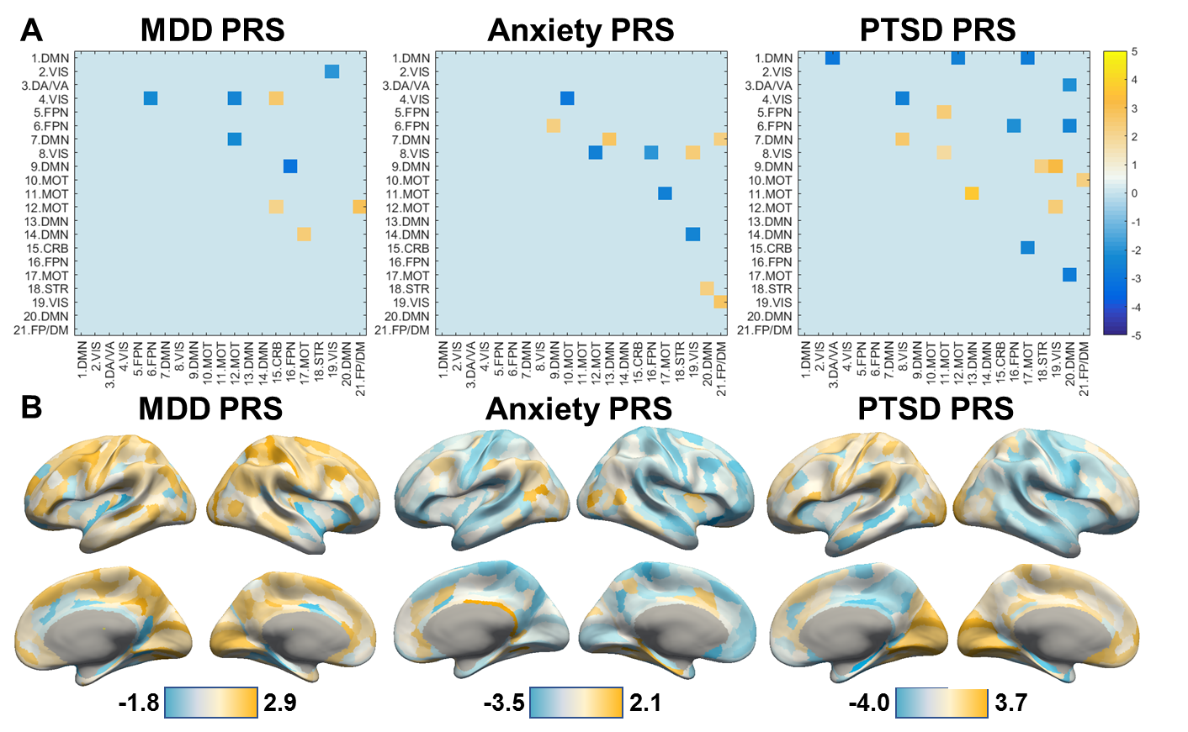
Supplementary Figure S4. Effects of MDD, anxiety and post-traumatic stress disorder PRS on functional connectivity (A) and cortical thickness (B). T-statistics are shown only for connectivities significantly associated with the respective PRS (P_{PERMUTATION}<0.05) in (A).

Disorder Similarity
Neural correlates of cognitive function in clinical groups
In addition to presenting the correlation matrices showing the relationships between cognitive tests (TMT, Gf, PAL, and DSST) with PLS latent variable scores, we also show scatterplots of these relationships in Supplementary Figure S5A. We also provide more details on PLS2 weights in Supplementary Figure S5B.
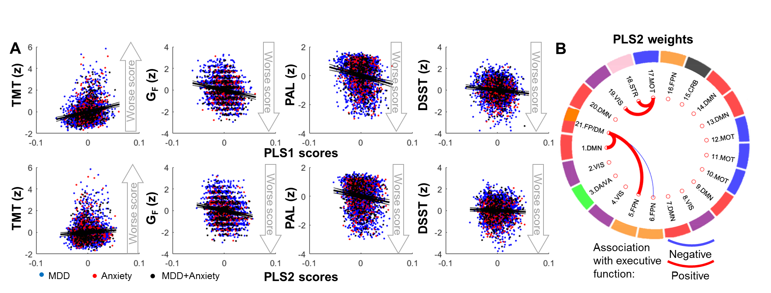
Supplementary Figure S5. (A) Associations between PLS1, PLS2 and PLS3 scores and cognitive function tests. In addition to scatterplots, lines of best fit and 99% confidence intervals (obtained using MATLAB R2016a, fitlm and predict functions) are shown. (B) Thresholded PLS2 weights implicated connectivities between independent components corresponding to the default mode (DMN), frontoparietal (FPN) and striatal (STR) networks (B). Blue connections between network components suggest that higher connectivity of those components was associated with worse fluid intelligence and paired associates learning. Red connections between network components suggest that higher connectivity of those components predicted better fluid intelligence and paired associates learning. Network labels include: MOT – motor; CRB – cerebellum; VIS – visual; DA/VA – dorsal/ventral attention. TMT – Trailmaking path; Gf – fluid intelligence test; PAL – paired associates learning; DSST – digit-symbol substitution test.
Neural correlates of executive function in MDD-, ANX- MDD+ANX and STR-
A separate PLS regression found three latent variables that together explained a significant amount of variance (P_{PERMUTATION}<0.001) in the cognitive scores in MDD- (n=1,895). PLS1, PLS2 and PLS3 explained 5.2%, 0.8% and 1.6% of variance in cognitive scores. PLS1 scores were associated with longer times to complete trailmaking and worse scores on fluid intelligence, digit-symbol substitution and paired associate learning. Since no PLS2 or PLS3 weights showed reliable weights (|Z|<3) after bootstrapping, we did not focus on these PLS latent variables.
A PLS regression in ANX- (n=426) identified three latent variables that together explained a significant amount of variance in the cognitive scores (P_{PERMUTATION}=0.009). PLS1, PLS2 and PLS3 explained 10.0%, 6.9% and 6.3% of variance in cognitive scores. Similar to the other PLS analyses, PLS1 scores were associated with longer times to complete Trailmaking and worse scores on fluid intelligence, digit-symbol substitution and paired associate learning. No significant brain-cognition relationships were found in MDD+ANX or STR- (P_{PERM}>0.1).
Next, we aimed to juxtapose the significant differences in MDD- and ANX- with the network connectivity pairs contributing to the brain-cognition relationships from PLS1 in MDD- and ANX- (Supplementary Figure S6). We found that partial connectivity between IC-7 and IC-17 was increased in MDD- and that was also negatively associated with cognitive performance in MDD-. Conversely, connectivity of IC-5 with IC-21 and IC-15 with IC-20 was reduced in MDD- and was positively associated with cognitive performance. Lower connectivity of IC-5 with IC-16 was found in ANX- and was also positively associated with cognitive performance in ANX-.
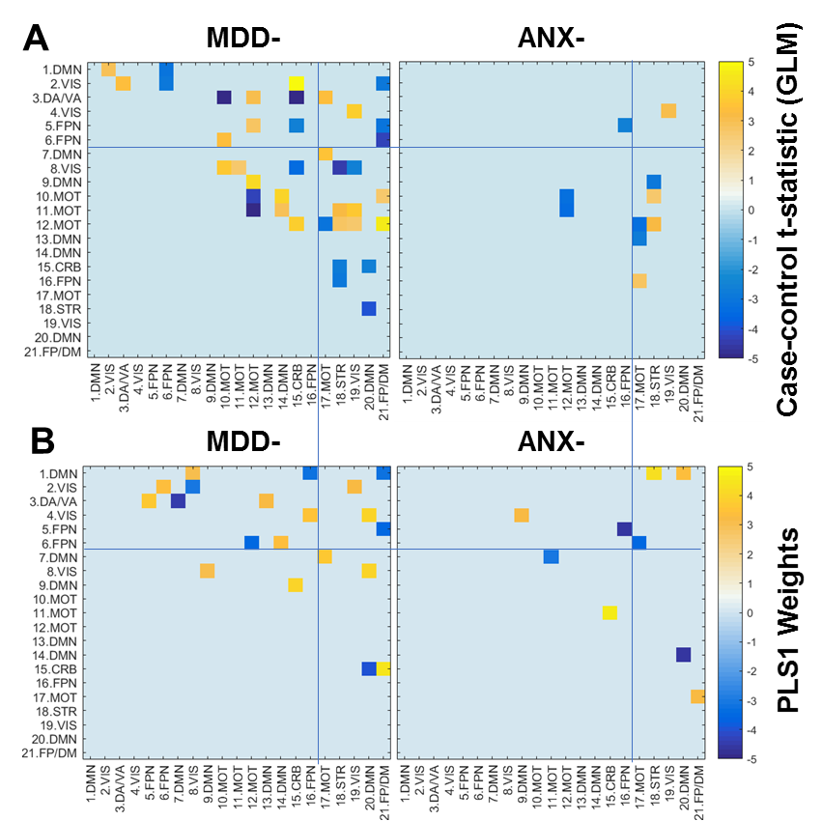
Supplementary Figure S6. Juxtaposition of the networks affected in MDD- and ANX- (A) with networks identified in the brain-cognition PLS regression analyses in these groups (B). Higher loadings on PLS1 (shown in yellow and orange) indicate that higher connectivity predicted worse cognitive performance.
Neural correlates of executive function in healthy controls
We aimed to uncover the neural correlates of worse executive function and verbal memory of the Control group (n=14,199) aiming to test whether the neural correlates of executive function is similar to those of the clinical groups presented in Figure 3. These results are shown in Supplementary Figure S6. PLS regression identified three components that explained 2.0%, 1.2% and 0.4% of variance in the four executive function tests (TMT, G_{F}, PAL and DSST). Permutation testing showed that these components together explained a significant amount of variance in executive function (P_{PERM}<0.001). The first component, PLS1, captured the most variance in the outcome variables (Supplementary Figure S7A) and was associated with worse performance on each of the tests. The second component, PLS2, was associated with better performance on each of the tests.
We found 20 connectivities with normalized PLS1 weights with Z>4 and 11 connectivities with normalized PLS1 weights with Z<-4 (Figure S7B). There were 14 PLS2 weights with Z>4 and 19 PLS2 weights with Z<-4. Functional correlates of worse executive and memory performance were similar to the functional correlates of worse performance in the clinical groups, although more functional connectivity correlates were identified in the bigger sample of healthy controls.
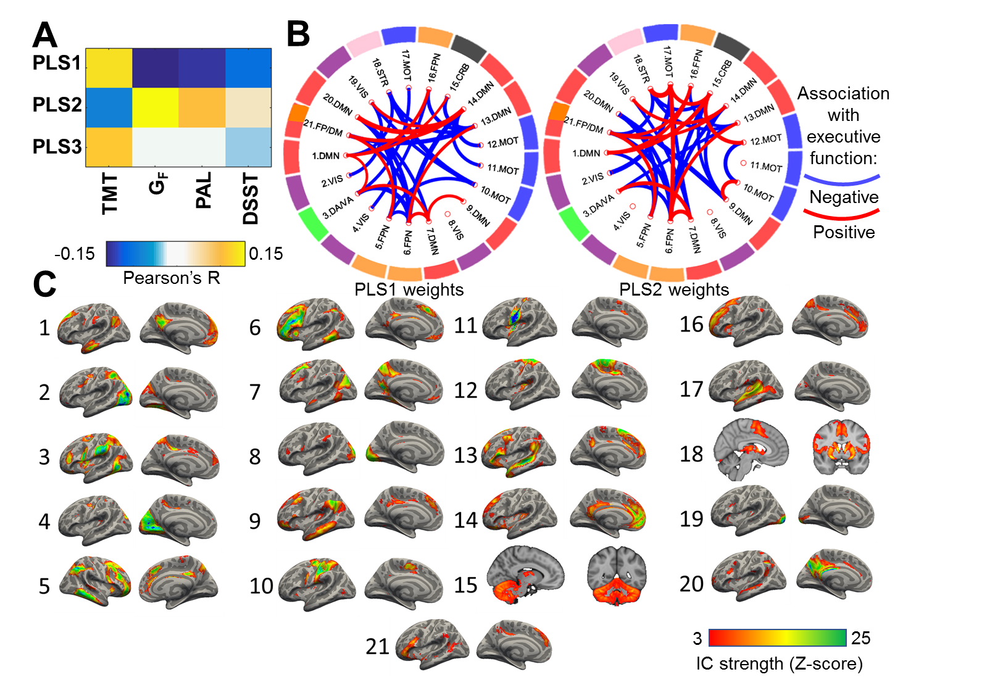
Supplementary Figure S6. Dimensional relationships between functional connectivity and executive function from a partial least squares (PLS) regression in healthy controls. Higher loadings on PLS1 were associated with worse executive function, while higher loadings on PLS2 were associated with better executive function (A). Thresholded PLS1 and PLS2 weights implicated pairwise connectivities between independent components corresponding to the default mode (DMN), frontoparietal (FPN) and dorsal/ventral attention (DA/VA) networks (B). Blue connections between network components suggest that higher connectivity of those components was associated with worse cognitive performance. Red connections between network components suggest that higher connectivity of those components predicted better cognitive performance. Anatomical locations of the independent components are shown in (C). Network labels include: MOT – motor; CRB – cerebellum; VIS – visual; STR – striatum. TMT – Trailmaking path; Gf – fluid intelligence test; PAL – paired associates learning; DSST – digit-symbol substitution test.

Supplementary Figure S7. Breakdown of sample sizes for each of the analyses. We pulled MRI data for 40,669 participants, of whom 31,291 participants were categorized as either HC, MDD- (Major depressive disorder), ANX- (non-phobic anxiety disorders), MDD+ANX, and STR- (stress-related disorders). Some of these participants were missing either cortical thickness, resting-state fMRI (due to quality issues) or cognitive data. Different patterns of missingness were found for cognitive tests. We also show the sample sizes for participants with both fMRI and cognitive data, which formed the basis of the brain-cognition analyses. TMT: Trailmaking; Gf: fluid intelligence; PAL: paired associate learning; DSST: digit-symbol substitution.
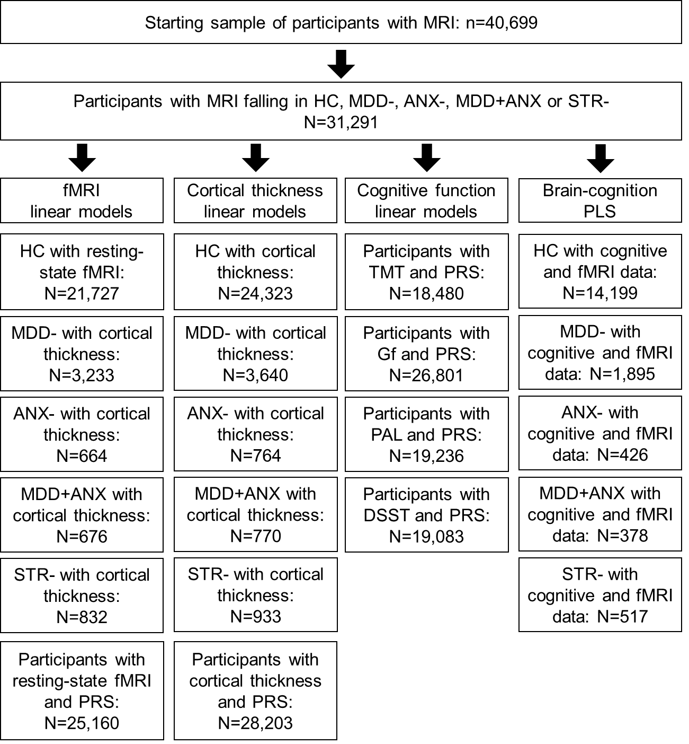

Supplementary Table 4. Medications included in each of the medication classes. SSRI, selective serotonin reuptake inhibitor; SARI: Serotonin antagonist and reuptake inhibitors; SNRI, selective noradrenaline (or adrenaline) reuptake inhibitor; NaSSA: Noradrenergic and specific serotonergic antidepressants; TCA: tricyclic antidepressants; MAO-I, monoamine oxidase inhibitors; Atypical – atypical antidepressants.
Medication | Class | Category
Citalopram | SSRI | 1
Fluoxetine | SSRI | 1
Sertraline | SSRI | 1
Paroxetine | SSRI | 1
Escitalopram | SSRI | 1
Fluvoxamine | SSRI | 1
Vortioxetine | SSRI | 1
Trazodone | SARI | 1
Nefazodone | SARI | 1
Amitriptyline | TCA | 2
Dosulepin | TCA | 2
Lofepramine | TCA | 2
Clomipramine | TCA | 2
Nortriptyline | TCA | 2
Imipramine | TCA | 2
Trimipramine | TCA | 2
Doxepin | TCA | 2
Maprotiline | TCA | 2
Protriptyline | TCA | 2
Amoxapine | TCA | 2
Phenelzine | MAOI | 3
Moclobemide | MAOI | 3
Tranylcypromine | MAOI | 3
Isocarboxazid | MAOI | 3
Venlafaxine | SNRI | 4
Duloxetine | SNRI | 4
Reboxetine | NRI | 4
Mianserin | NaSSA | 5
Mirtazapine | NaSSA | 5

