Pilot Neoadjuvant Study of Niraparib in Patients With HER2-Negative, BRCA-Mutated Resectable Breast Cancer

Supplemental Material

Supplementary Table 1. Baseline patient demographics and characteristics
Supplementary Table 2. Summary of most common niraparib-related TEAEs (any grade, reported in ≥10% patients)

Supplementary Figure 1. Clinical and pathological response patient journeys by MRI
Supplementary Table 1. Baseline patient demographics and characteristics

Characteristic | Total  (N=21)
Age, years
Median (min, max) | 43.0 (21, 73)
Age group, years, n (%)
<65 | 19 (90.5)
≥65 | 2 (9.5)
Race, n (%)
White | 19 (90.5)
Black or African American | 1 (4.8)
Asian | 1 (4.8)
Body weight, kg
Median (min, max) | 68.0 (47, 110)
BMI, kg/m²
Median (min, max) | 25.1 (18, 41)
ECOG PS score, n (%)
0 | 20 (95.2)
1 | 1 (4.8)
Stage at initial diagnosis, n (%)
I | 8 (38.1)
II | 10 (47.6)
III | 3 (14.3)
Histologic type, n (%)
Invasive ductal carcinoma | 20 (95.2)
Invasive lobular carcinoma | 1 (4.8)
BRCA mutation status, n (%)
BRCA1 | 14 (66.7)
BRCA2 | 6 (28.6)
BRCA1 and BRCA2ª | 1 (4.8)
Hormone receptor status, n (%)
TNBC | 15 (71.4)
ER-positive and/or PR-positive disease | 6 (28.6)
ªOne patient was positive for both BRCA1 and BRCA2 mutations.
BMI, body mass index; ECOG PS, Eastern Cooperative Oncology Group performance status; ER, estrogen receptor; PR, progesterone receptor; TNBC, triple-negative breast cancer.

Supplementary Table 2. Summary of most common niraparib-related TEAEs (any grade, reported in ≥10% patients)
Event, n (%) | Total  (N=21)
Event, n (%) | Grade 1–2 | Grade 3–4 | Total  Any Gradeª
Any niraparib-related TEAE | 12 (57.1) | 7 (33.3) | 19 (90.5)
Nausea | 14 (66.7) | 0 | 14 (66.7)
Fatigue | 10 (47.6) | 0 | 10 (47.6)
Anemia | 2 (9.5) | 3 (14.3) | 5 (23.8)
Decreased appetite | 4 (19.0) | 0 | 4 (19.0)
Insomnia | 4 (19.0) | 0 | 4 (19.0)
Neutrophil count decreased | 1 (4.8) | 2 (9.5) | 3 (14.3)
White blood cell count decreased | 3 (14.3) | 0 | 3 (14.3)
ªNo Grade 5 TEAEs were reported.
TEAE, treatment-emergent adverse event.

Supplementary Figure 1. Clinical and pathological response patient journeys by MRI

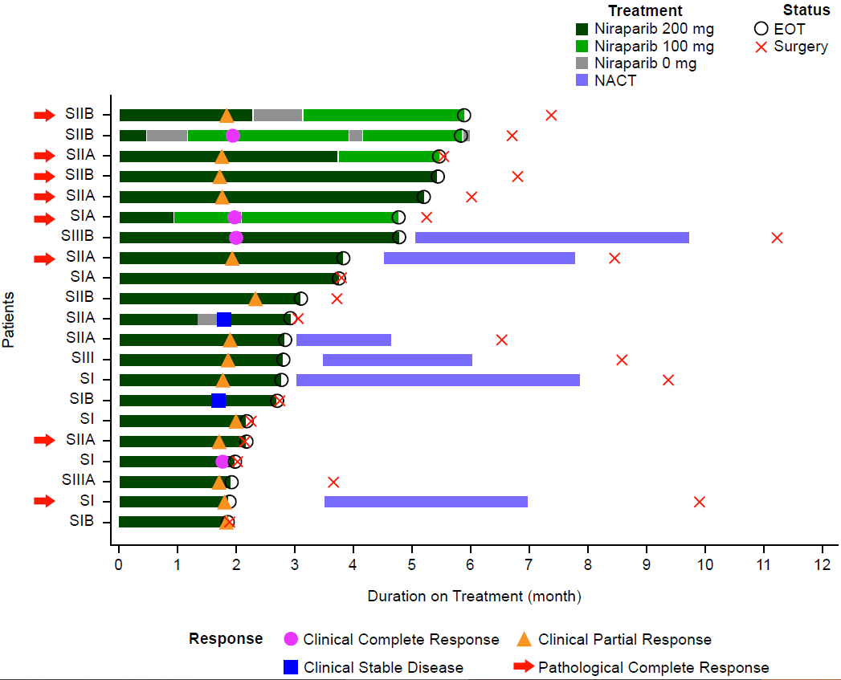

Red arrows indicated pCR. EOT, end of treatment; MRI, magnetic resonance imaging; NACT, neoadjuvant chemotherapy; pCR, pathological complete response; SI, Stage I; SII, Stage II; SIII; Stage III.

